Testimonials grid box

* Mobile-first responsive design solution using flexbox

<div class="attribution">

Challenge by <a href="https://www.frontendmentor.io?ref=challenge" target="_blank">Frontend Mentor</a>.

Coded by <a href="#">Your Name Here</a>.

</div>

This code gives



In head,

<link rel="icon" type="image/png" sizes="32x32" href="./images/favicon-32x32.png">

It shows an icon on the bar. As highlighted by the pink circle below.



Once we are happy with the mobile design (don’t have to finish it) but it does look similar to what’s needed that’s when we should move to desktop design.

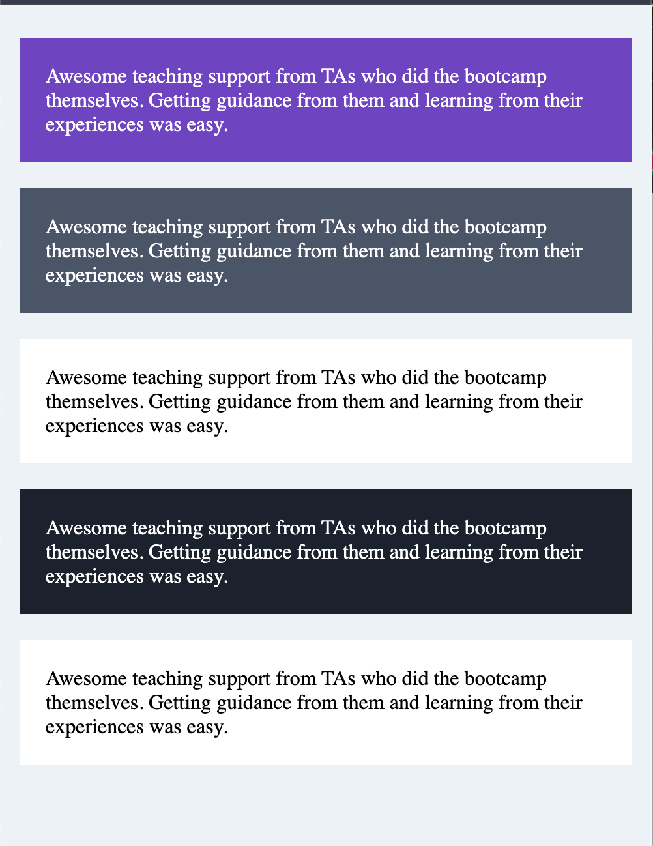

We need to get the layout correct first.

Now, we got the mobile design correct, now when we have desktop then it should look like

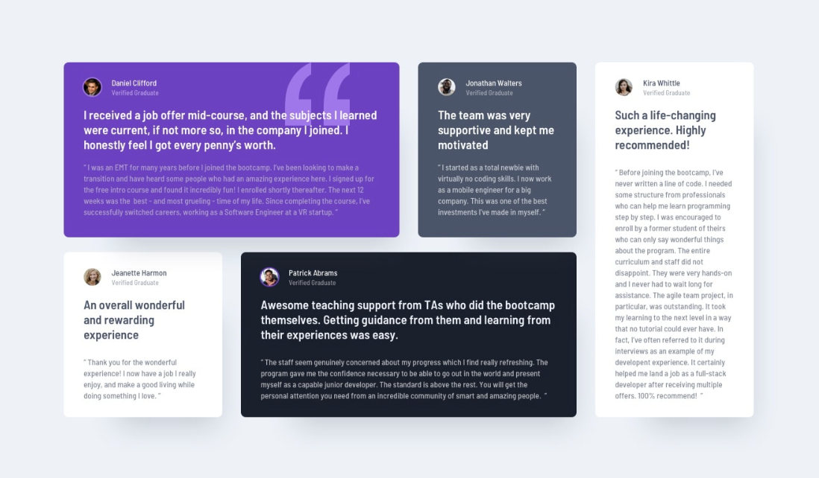

So, how do we get this?

Using Flexbox

We can have two containers

And make them flex and put them side by side

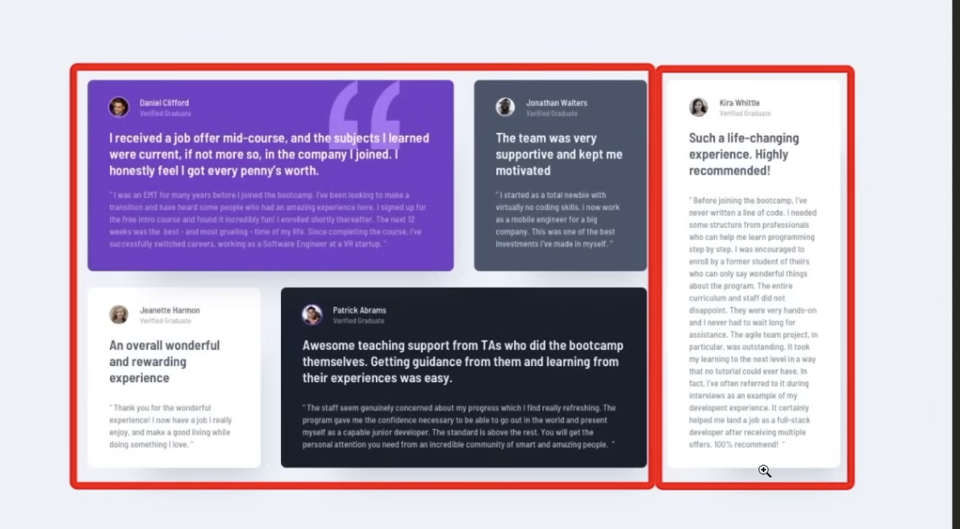

But this doesn’t solve the placement of boxes inside the left container.

So, we can further have 2 containers in the left section.

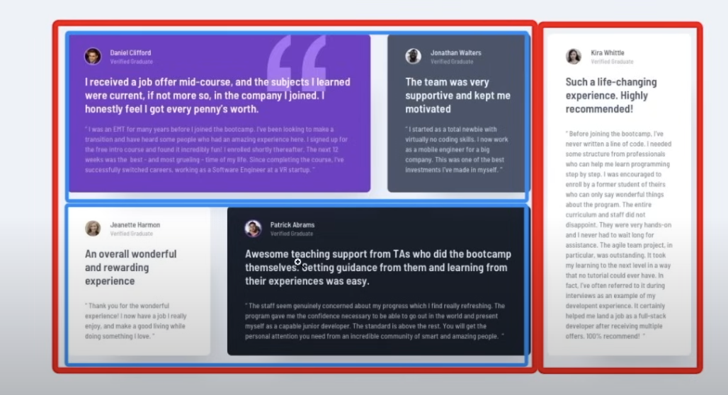

And we can use flex-basis to get the dimensions of these boxes correct.

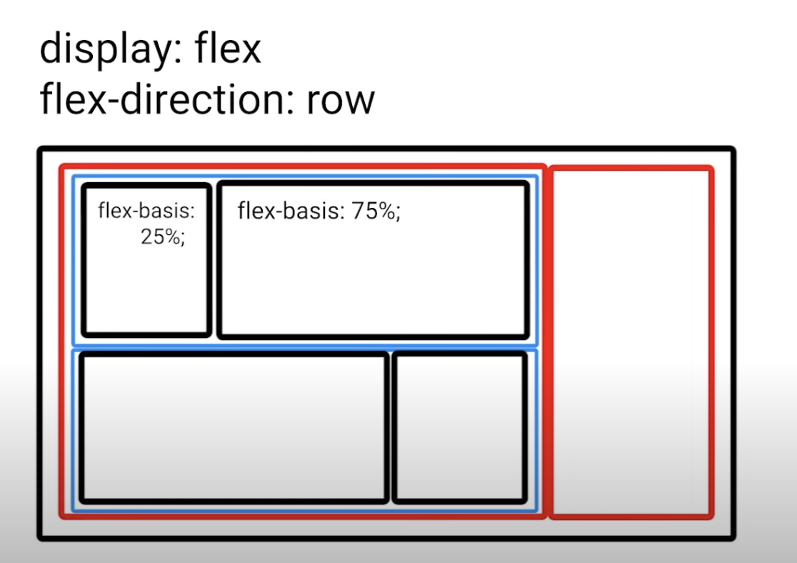

If we set the flex containers as mentioned then we get an issue

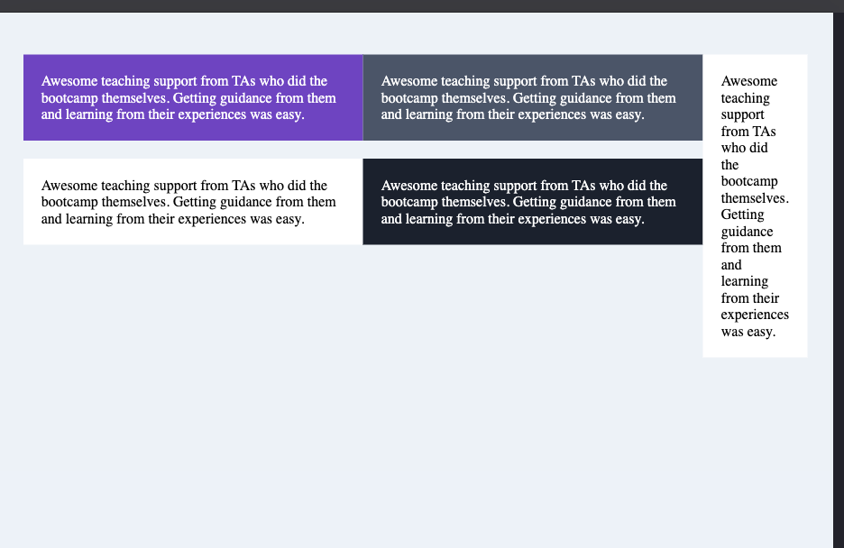

The height of the left container is not the same as the right one.

To make both of these with the same height we make the left-container as the flex container.

#main-left {

display: flex;

}

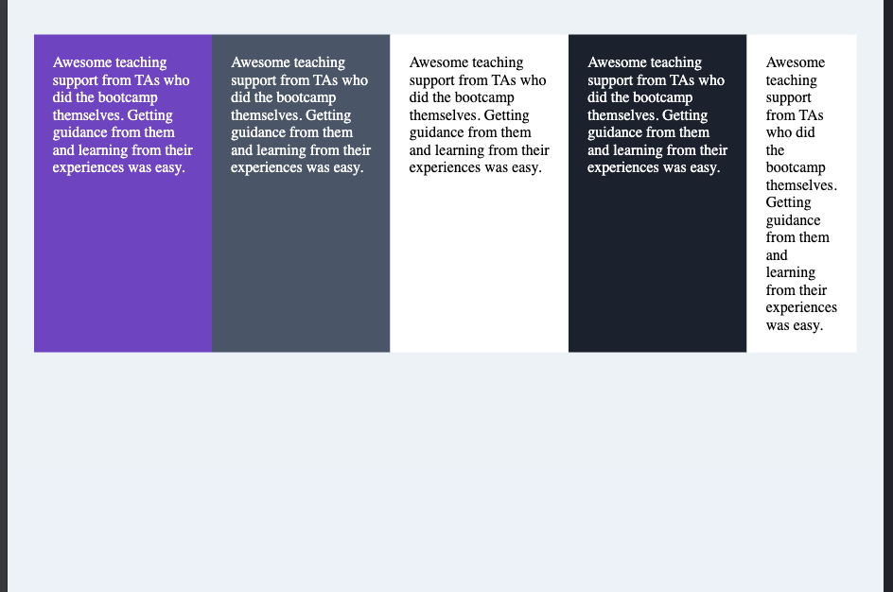

But here we see everything is side by side, if we change the flex-direction to column it will be fine.

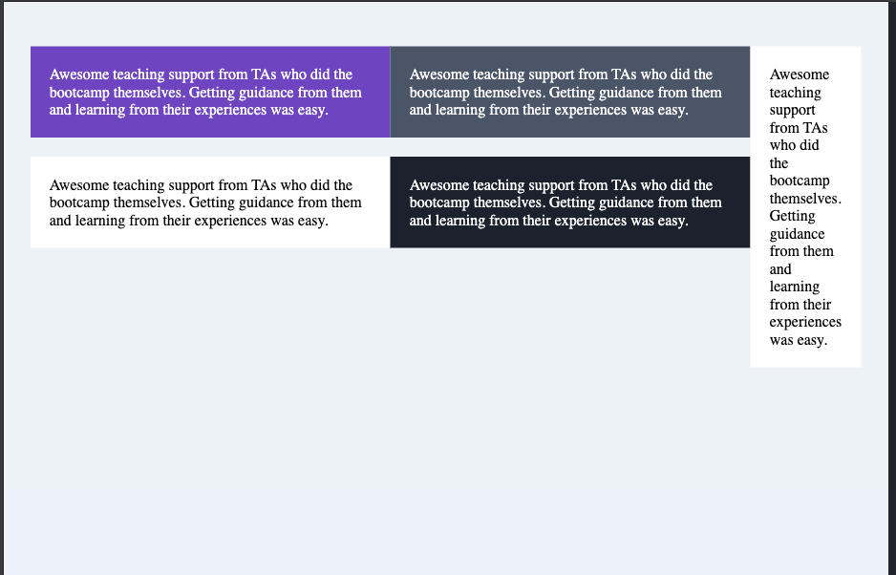

Top and bottom are direct children of the main-left flex container and they themselves are containers as well.

Since we set the column as flex direction for main-left, the main axis is the vertical one hence justify-content will go vertical.

Now, to add space between main-left and testimonial 5,

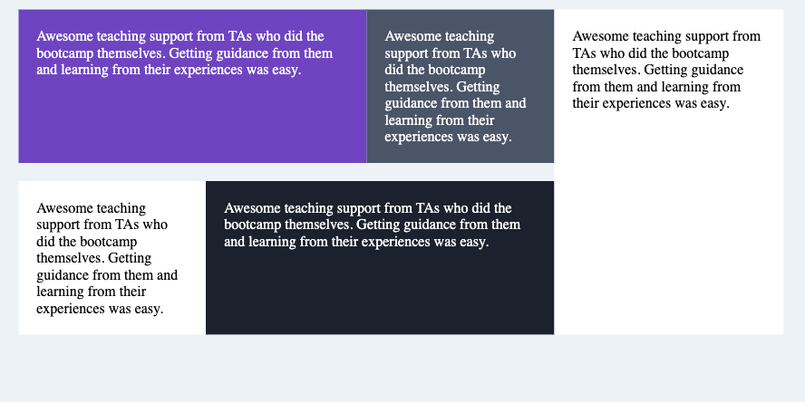

We have

#testimonial-5 {

flex-basis: 30%;

}

#main-left {

display: flex;

flex-direction: column;

flex-basis: 70%;

}

Now, we change main-left flex-basis to 68% ; 2% is left empty

Now, we go to whole container and make justify content as space between.

#testimonial-grid-container {

display: flex;

max-width: 900px;

margin: 0 auto;

justify-content: space-between;

}

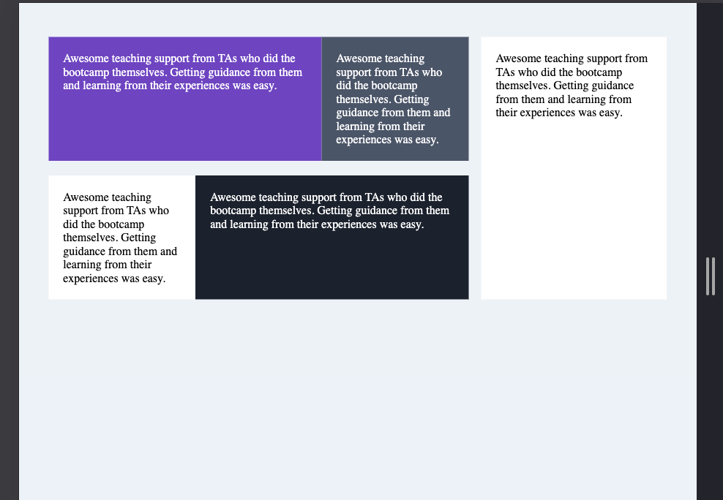

Now, we can see space

We can do the same exact things with the other flex items too.

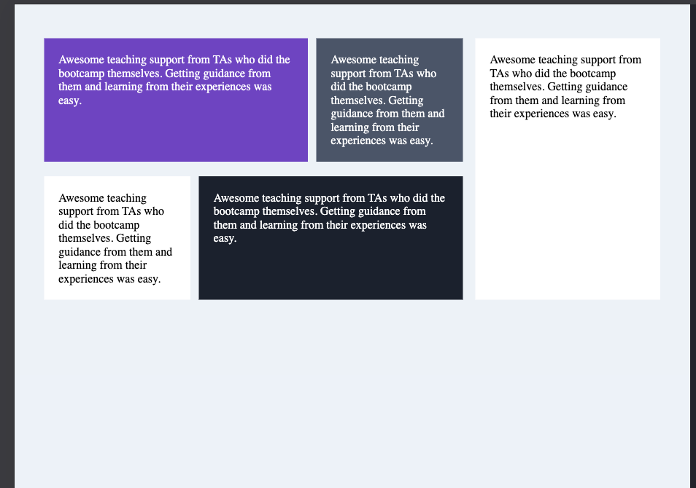

Or we can just add margin to the all the testimonials in the main-left container

#main-left .grid-item {

margin-right: 15px;

}

If we do this we get the same spacing.

After adding the text and images we see below

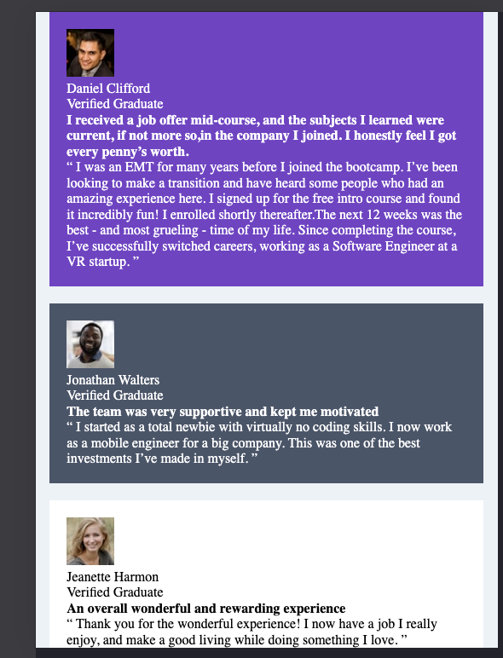

Now, when we observe we need to arrange each of these grids in the same manner i.e pic then some info left then paragraph basically the arrangement is the same we can work on all the same things at once instead of working individually.

To get image and name side by side we use flex box container as parent for both.

To make image circular -> we use

border-radius: 50%;

To place the quote we have svg image so we place it in the html code



<img src="./images/bg-pattern-quotation.svg" alt="quote">

To position it, we give it an id as quote

#quote {

position: absolute;

right: 15%;

top: 0;

}

And we make testimonial-1 as relative position so that this quote moves w.r.t testimonial-1

Now to make the quote behind the text but above the testimonial card we set the z-index of the quote to 1 and testimonial card to 0 and text on the card to 2 and make this text position relative to work z-index.