

Operating System Lab

Lab Task 3

SUBMITTED BY:
NAME | : | Mekal Asif
ROLL NO | : | F2024376309
SECTION | : | D1
SUBMITTED TO:

INSTRUCTOR NAME | : | Taha Khalid
COURSE | : | OS Lab

Lab Task :

Build a basic calculator in shell – Linux
Code:
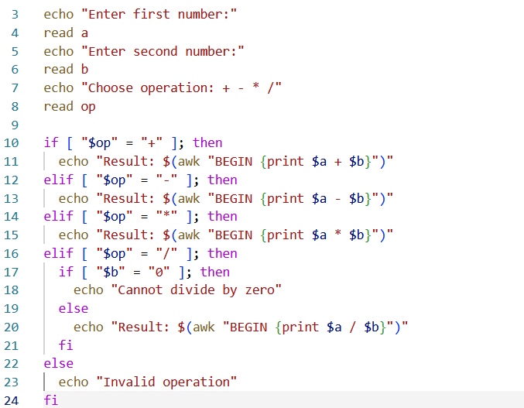

Output:


