**PHASE3:**

**WATER QUALITY ANALYSIS**

1.Obtaining the Water Quality Dataset**:

- You can obtain a water quality dataset from various sources, such as government agencies, environmental organizations, or research institutions. Common sources include the U.S. Environmental Protection Agency (EPA), the World Health Organization (WHO), or other relevant local or international bodies.

2. **Loading the Dataset**:

- Use appropriate tools or libraries in your preferred programming language (e.g., Python with pandas) to load the dataset into your working environment.

3. **Exploring the Dataset**:

- Begin by examining the structure of your dataset to understand the columns and data types. This can be done with commands like `info()`, `head()`, and `describe()` in Python's pandas.

4. **Handling Missing Values**:

- Identify and handle missing values in the dataset. Common techniques include:

- Removing rows with missing values if they are a small portion of the data.

- Imputing missing values using statistical measures like mean, median, or mode.

- Using machine learning algorithms to predict and fill missing values.

5. **Dealing with Outliers**:

- Detect and address outliers in your data. Common methods include:

- Visualizing data using box plots, scatter plots, and histograms to identify outliers.

- Employing statistical methods like the IQR (Interquartile Range) to detect and handle outliers, which can involve removing them or transforming the data.

6. **Visualizing Parameter Distributions**:

- Create visualizations to understand the distribution of water quality parameters. Common plots and graphs include histograms, density plots, and violin plots.

7. **Exploring Correlations**:

- Analyze the relationships between different water quality parameters by calculating and visualizing correlation matrices. Heatmaps and scatter plots are useful tools for this purpose.

8. **Comparing with Standards**:

- If applicable, compare the dataset with established water quality standards or guidelines. You can create visualizations to highlight where the water quality parameters deviate from the standards.

9. **Additional EDA**:

- You can also perform more specific EDA tasks, depending on the goals of your analysis. This might include time-series analysis, geographical mapping, or other relevant explorations.

10. **Report and Documentation**:

- Document your findings, insights, and the steps you took during the preprocessing and EDA. This documentation will be valuable for future analysis and for communicating your results to others.

Remember that the specific methods and tools you use for each of these steps can vary depending on your dataset, your goals, and the software you are using. Additionally, as the data you're working with is related to water quality, it's essential to ensure that your analysis is scientifically rigorous and adheres to any relevant environmental regulations or guidelines.

**Choloramines:**

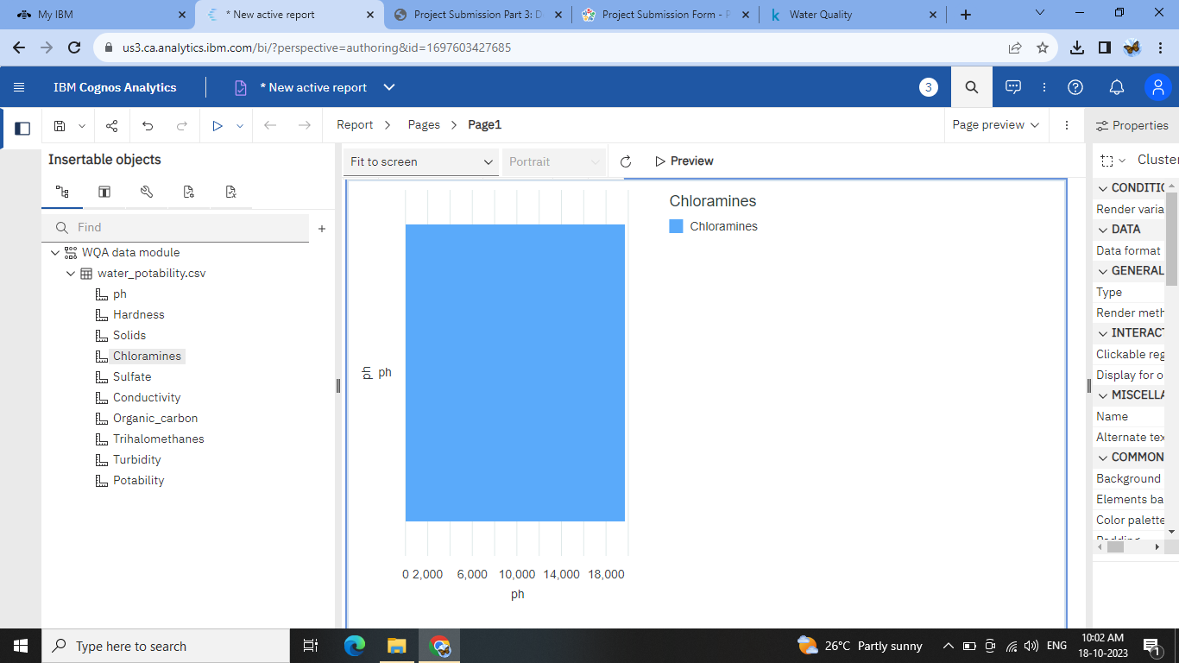

**Turbidity:**

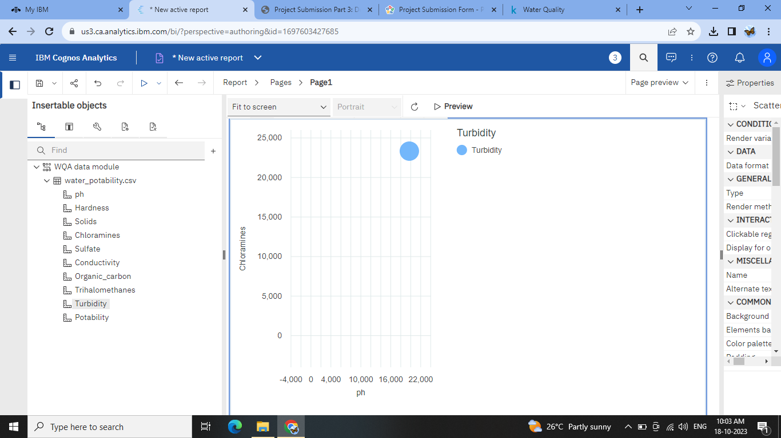

**Solids:**

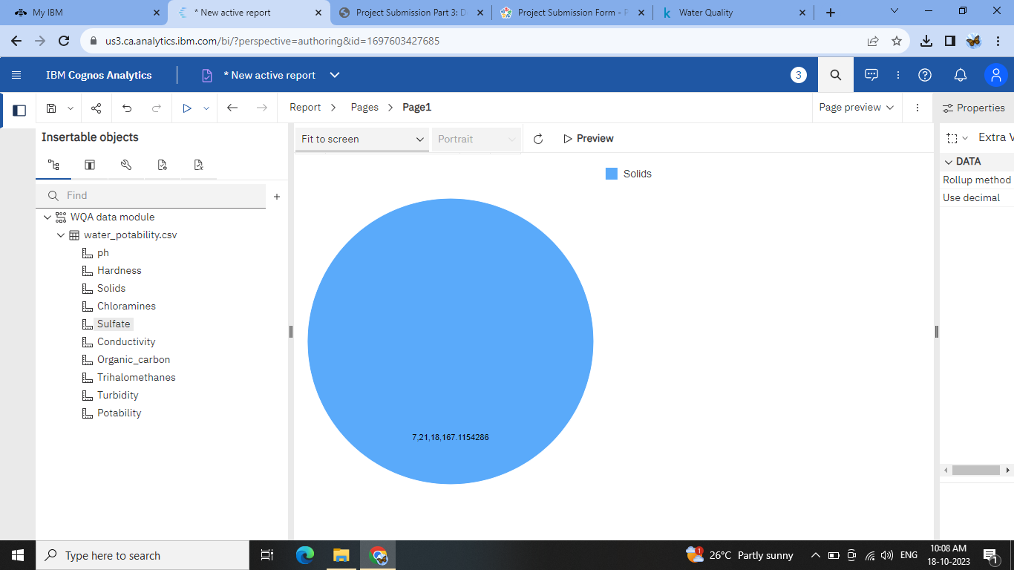

**Color:**

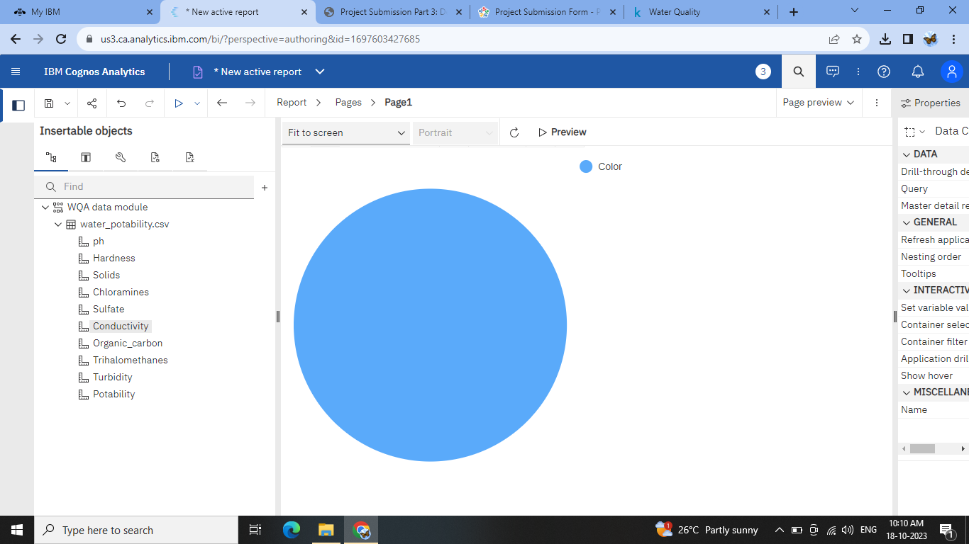

**Sulfate:**

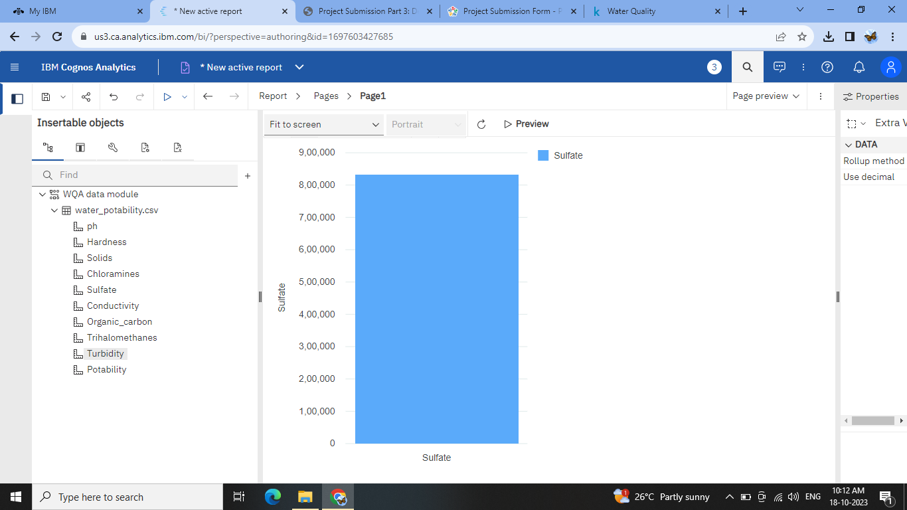

**Organic_carbon:**

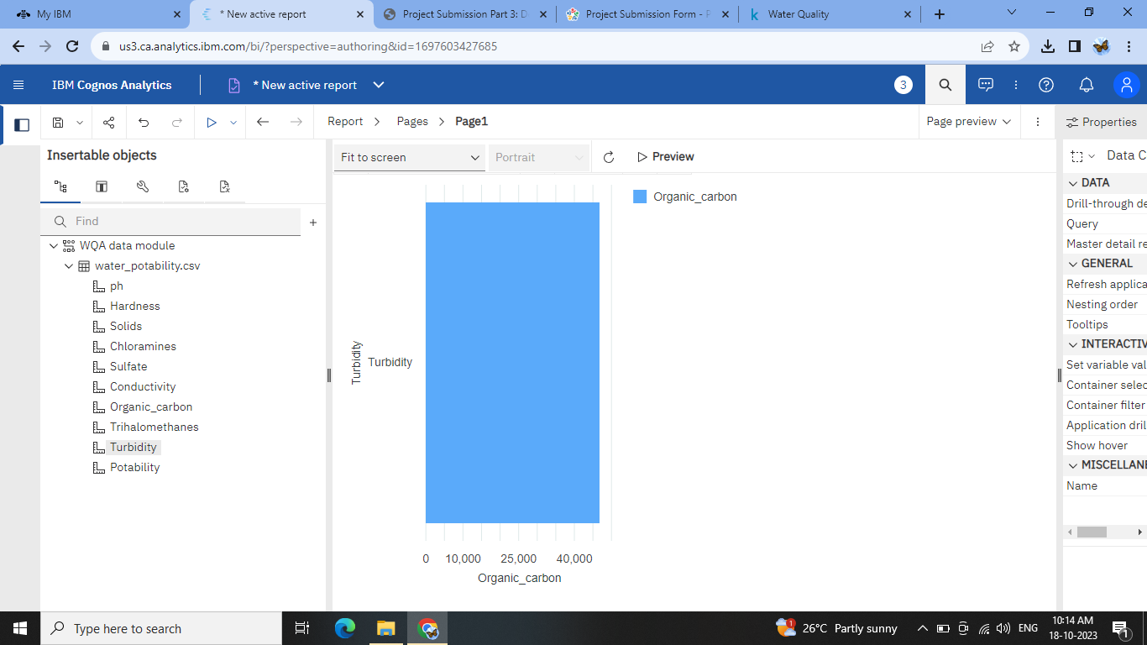

**Turability:**

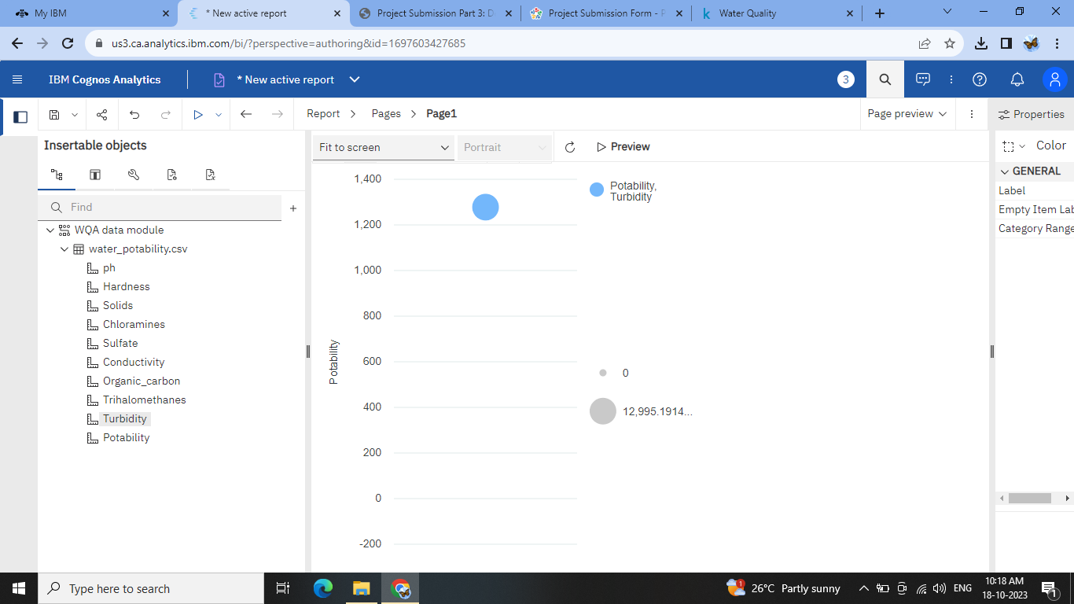

**Potability:**

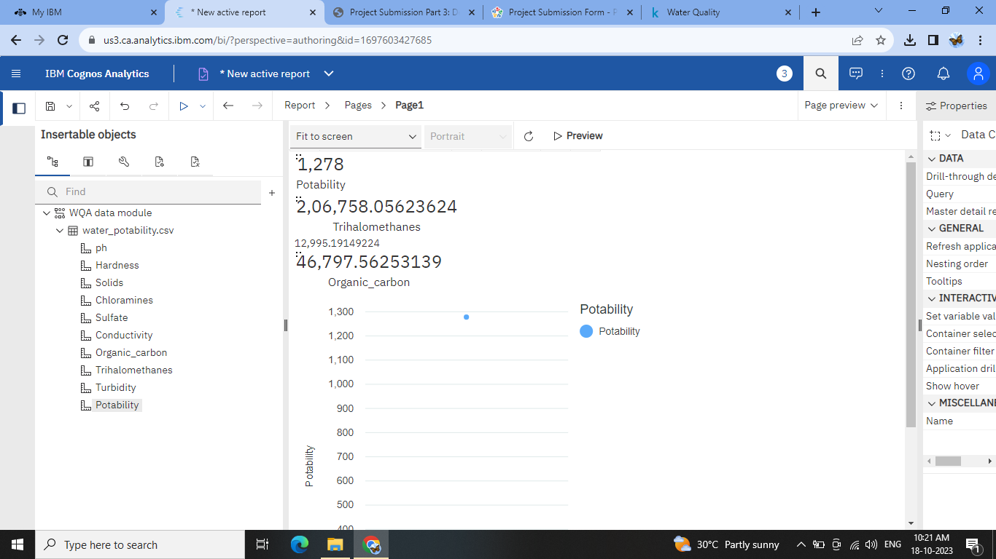

Conclusion:

In conclusion, this initial phase of the water quality analysis has laid a strong foundation for further investigation. The dataset is now in a more suitable form for advanced analysis, and we have a better understanding of the data's characteristics and potential deviations from standards. The insights gained from this EDA will guide our next steps in addressing water quality-related questions and concerns, potentially leading to informed decision-making for environmental and public health initiatives.

Top of Form