Execution plans for the time-based analyses (analyses of trends over time)
- Calculation of average speeds for each year:
Code:
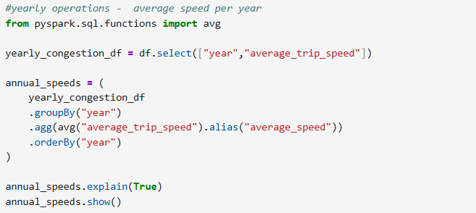
Execution plan:
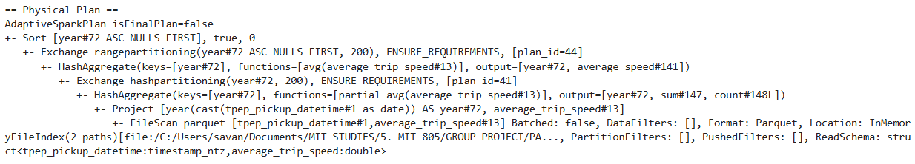
- Calculation of cost per mile for each year
Code:
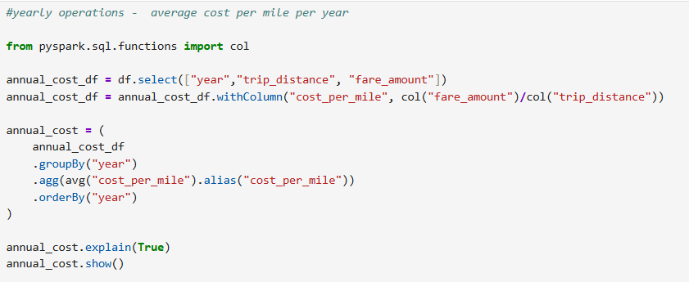
Execution plan:
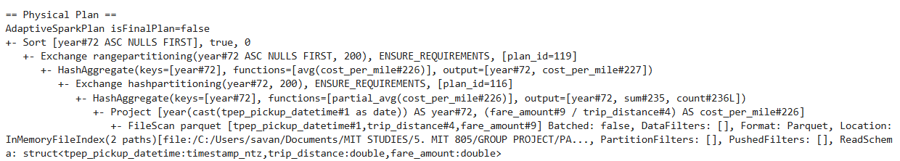

- Calculation of passenger count per year for the sampled data:
Code:
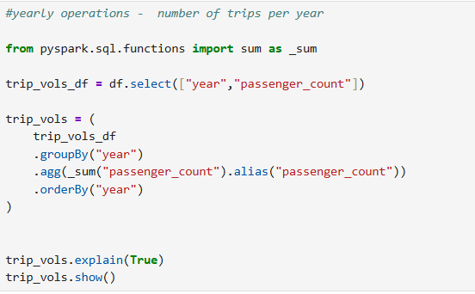
Execution plan:
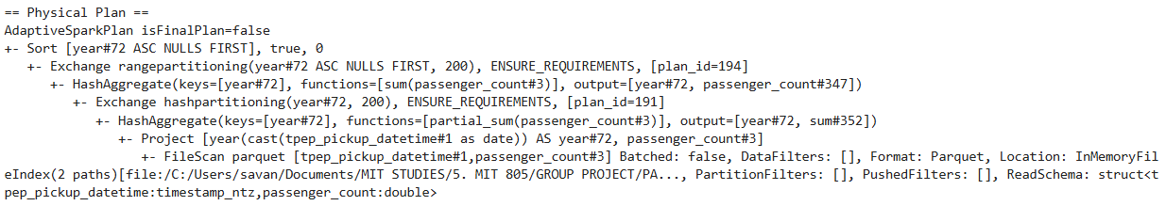
- Calculation of average speeds per hour of the day:
Code:
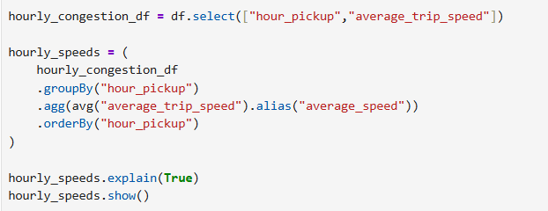
Execution plan:
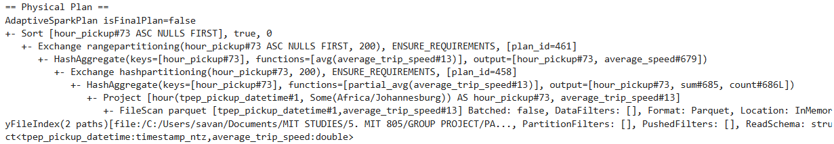

- Calculation of average taxi fare/ cost per mile:
Code:
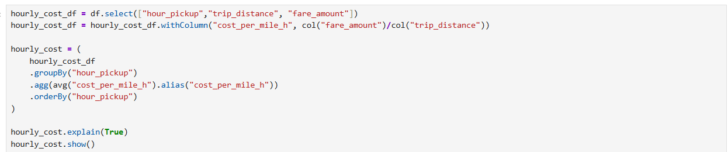
Execution plan:
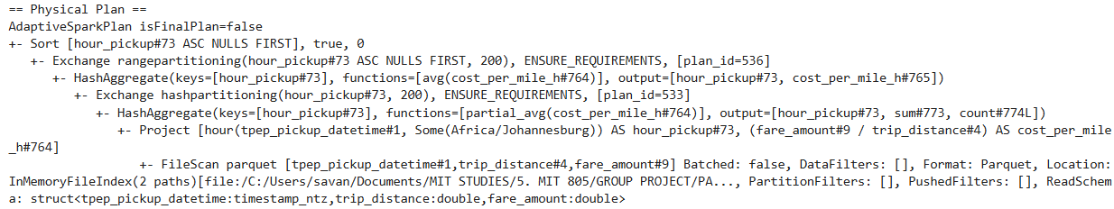
- Calculation of trip volumes per hour for the sampled data:
Code:
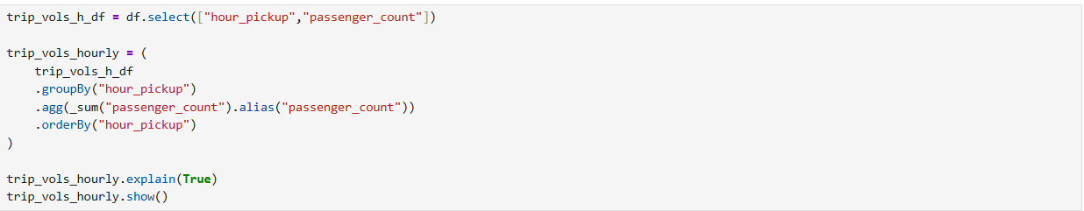
Execution plan:
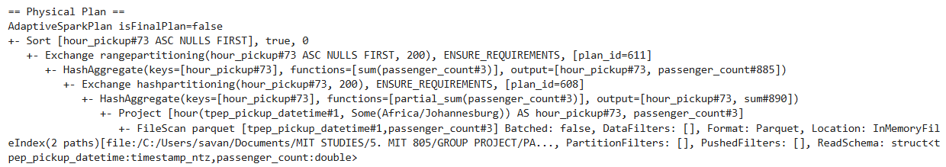

- Calculation of the average cost per trip per year:
Code:
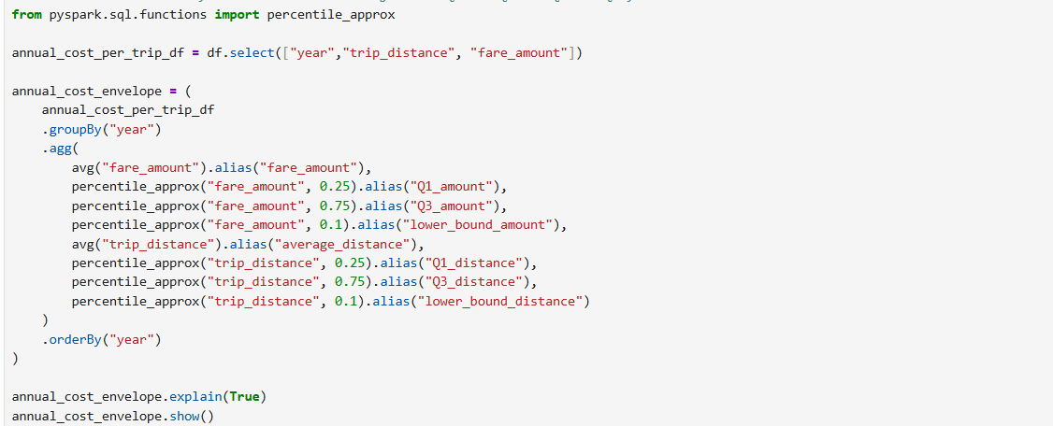
Execution plan:
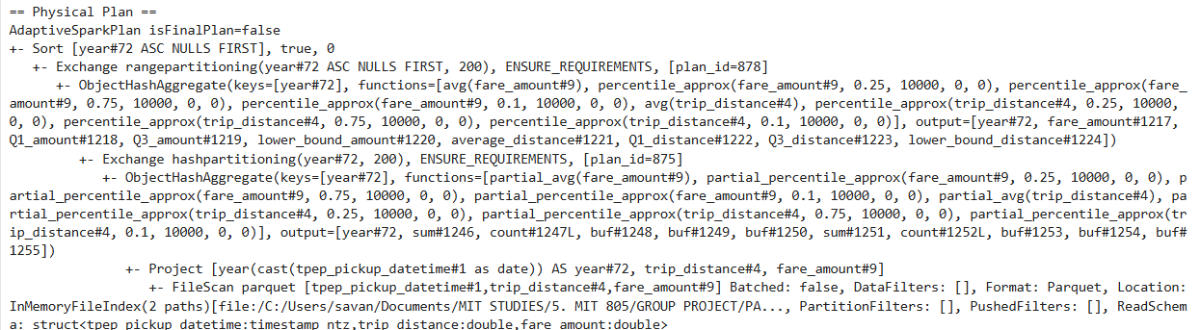
- Calculation of the upper and lower bound costs per trip:
Code:
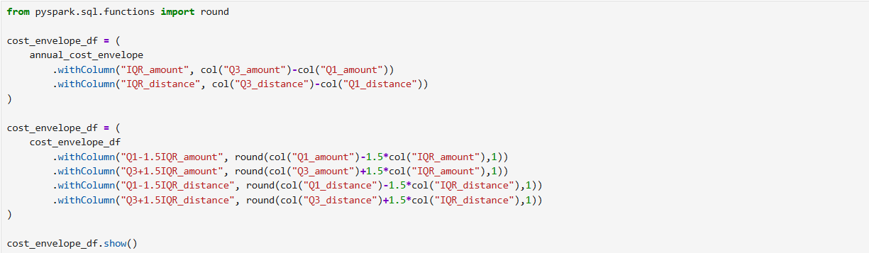
Execution plan:
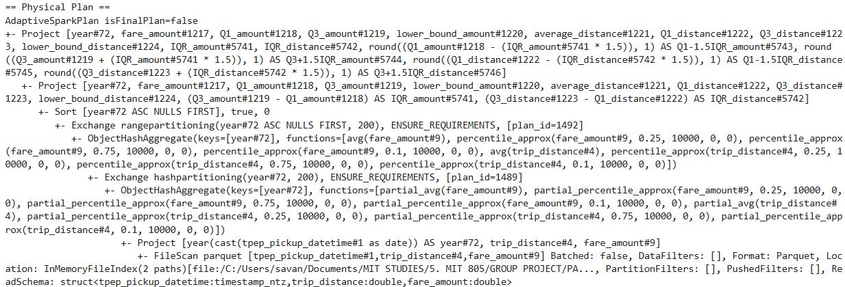
- Comparison of short to long trip lengths:
Code:
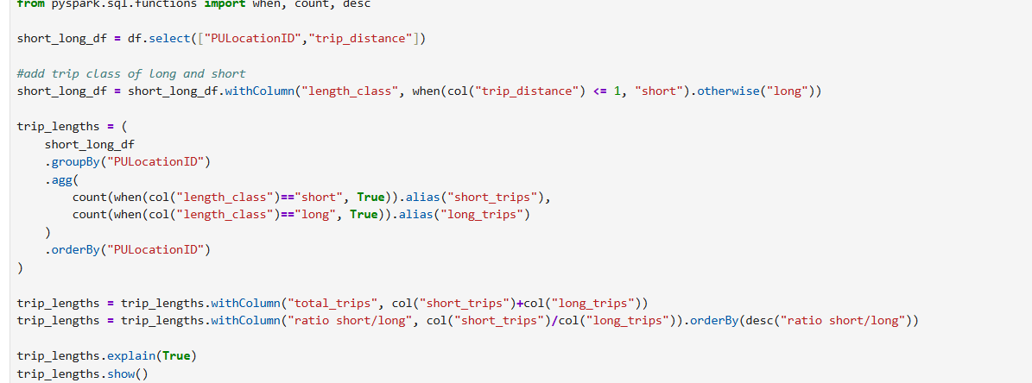
Execution plan:
