MIT 805 Group Project - Group 8, Part 2
Savannah Canto: u17131406 and Mekayle Rajoo: u26834414
Github repository link: https://github.com/MekayleRajoo/MIT_805_PROJECT_GROUP_8
*for the video presentation please see the link in the appendix to where it is saved on Google Drive
- Introduction
This assignment follows on from the Part 1 Group 8 assignment and makes use of the NYC TLC Yellow Taxi Trip Record dataset, which contains information on trips completed by Yellow Taxis in the New York Boroughs and is available at https://www.nyc.gov/site/tlc/about/tlc-trip-record-data.page. The dataset used in Part 2 comprises the cleaned and sampled data subset described in Part 1.
- Processing Objectives
The City Planning Office of New York City has allocated funding to improve and expand the city’s public transportation system, specifically the bus network. Group 8 was approached to provide data-driven recommendations by analysing the NYC TLC Yellow Taxi Trip Record dataset.
New York City’s bus network operates approximately 2.75 million trips per day across roughly 1,600 miles of city streets. However, more than 90% of these streets lack dedicated bus lanes (New York City Department of Transportation and Metropolitan Transportation Authority, 2026). Since buses can transport significantly more passengers while using the same road space, prioritising bus infrastructure could improve public transport efficiency and help reduce congestion.
The main objective is to assess patterns in the New York City transportation network using yellow taxi trip data and translate these findings into practical recommendations for the City Planning Office. This analysis uses yellow taxi trip speeds as a proxy for road congestion. By analysing trip speeds across different areas and time periods, the study aims to identify significantly congested locations where dedicated bus lanes or improvements to bus routes/ schedules could provide the greatest benefit. The following recommendations, among others, can then be made to the City Planning Office:
- A list of areas in order or priority that would benefit from implementation of additional bus services and bus infrastructure (dedicated bus lanes etc).
- Economic guidance on bus fares to incentivise bus over taxi use, through analysis of current fees per distance in different areas.
- Recommendations in determining bus schedules (through determining times in the day when maximum congestion occurs/ peak hours).
- Recommendations on payment systems for public transport/bus systems – though analysis of current payment trends (cash vs card etc).

- Data analysis and interpretation
Data analytics were completed using PySpark’s MapReduce style framework. Generally, this was done by using the ‘groupBy’ function to group the relevant parameters (values) by key (where the key is specified as a column in the dataset, e.g., “year”). The groupBy function completes tasks similar to the mapping and shuffling stages of traditional MapReduce, as the data is mapped to key-value pairs and data containing the same key is moved to the same PySpark partition. The ‘aggregate’ function was then applied, along with operations (such as averaging or summing). This is equivalent to implementation of the combiner and reducer functions in MapReduce - some intermediate summing of data (values) with the same key is completed within the PySpark partitions (i.e., implementing a similar function to a combiner function), so that eventually the global sum or average can be computed. Unlike traditional MapReduce, where each operation such as mapping and shuffling is completed as it is called, with outputs written to the disk, PySpark follows a lazy execution strategy, and an execution plan is created (in the form of a Directed Acyclic Graph) and these functions are only implemented once a function that triggers the action, such as show() is run. All of the execution plans used in the analysis can be found in Appendix A.
The analysis covers both normal routes (more than one mile), to find where dedicated bus lanes would help most, and last-mile routes (less than one mile), to find areas that need public transport over short distances and will be covering:
- Analysis of trends per area – the data set contains area codes for the different New York boroughs. Trends per area, such as congestion and fee prices, were analysed to determine which areas are in need of greatest attention for streamlining of transport services.
- Analysis of trends over time – this was important to determine whether there were any trends in factors such as congestion, fees, and taxi usage over the years of the dataset (2014 – 2025) to obtain an indication of the need for public transport, and whether this need is growing.
3.1 Busiest Routes by Zone Pair (>1 mile)
To identify where dedicated bus lanes would help the most people, we begin by finding the routes with the most recorded trips during peak times (8am to 6pm, as shown in Part 1). Because the data records pickup and dropoff zones rather than exact streets, a route here means a pair of taxi zones, with trips in both directions combined.
Figure 1 ranks the top 100 routes by trip count for 2025. Demand is highly concentrated. The busiest route records over 70,000 trips, roughly double the second, after which counts fall steeply and then level off at around 10,000 trips. A small number of routes are therefore considerably busier than the rest.
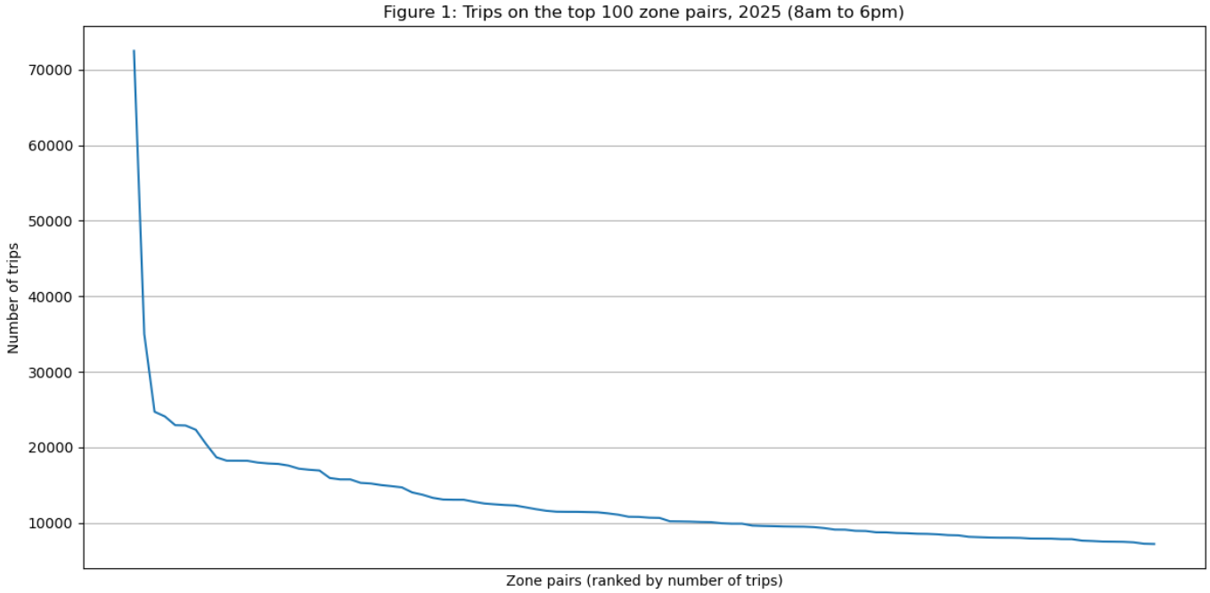
Figure 2 shows the 20 busiest routes. Several link Upper East Side and Upper West Side zones, or connect Midtown locations such as Times Square/Theatre District, Penn Station/Madison Sq West and Midtown Center. Peak-time taxi demand is concentrated in a few parts of Manhattan, which makes them the strongest starting point for bus lanes. .
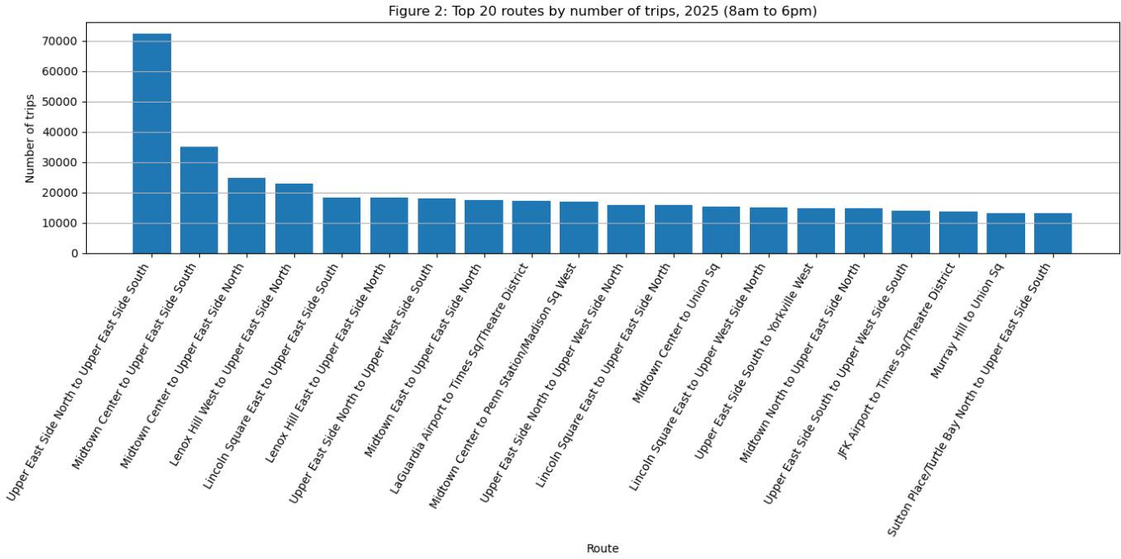
Figure 3 shows if we were to further filter this view by taking the 10 routes with the lowest average speed, ie, the highest congestion.
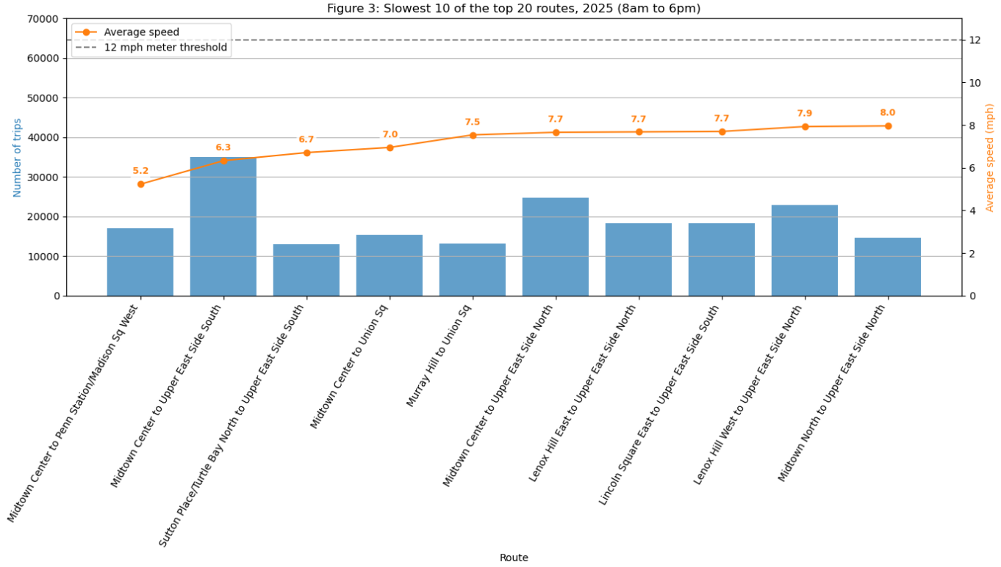
This results in the following routes being candidates for the development of bus lanes. Note that the areas indicated in bold text are those that were also flagged as possibly benefitting from the bus systems in the analysis completed in Section 3.2:
The 10 slowest of the 20 busiest routes by zone pair, 2025
Midtown Center | Penn Station/Madison Sq West
Midtown Center | Upper East Side South
Sutton Place/Turtle Bay North | Upper East Side South
Midtown Center | Union Square
Murray Hill | Union Square
Midtown Center | Upper East Side North
Lenox Hill East | Upper East Side North
Lincoln Square East | Upper East Side North
Lenox Hill West | Upper East Side North
Midtown North | Upper East Side North

3.2) Last mile (< 1mile)
Another way of identifying areas with a need for public transport is to determine in which areas there are a large number of short trips made (< 1 mile). For each area, the ratio of short to long trips distance (> 1 mile) was calculated. Out of the 263 zones, the areas with the highest short/long trip ratios (short/long > 0.4) are indicated in the below chart. This was also compared to the total number of trips in the area (see the black line chart), as investing in the bus systems will only be valuable and economically feasible if there is a sufficient number of customers. Based on observing where a high short/long trip ratio and a high total number of trips (> 4 million total trips) coincide, the following areas can identified with a possible need for public transport: 237 (Manhattan Upper East Side South), 141 (Manhattan Lenox Hill West), 236 (Manhattan Upper East Side North), 100 (Manhattan Garment District), 170 (Manhattan Murray Hill), 164 (Manhattan Midtown South), 161 (Manhattan Midtown Centre), 48 (Manhattan Lower East Side), 230 (Manhattan, Times Square/ Theatre District), 234 (Manhattan Union Square), 107 (Manhattan Gramercy), 239 (Manhattan Upper West Side South), 162 (Manhattan Midtown East) , 163 (Manhattan Midtown North), 142 (Manhattan Lincoln Square East), 68 (Bronx - Mott Haven/ Port Morris), 79 (Manhattan, East Village), 233 (Manhattan, UN/ Turtle Bay South) , 186 (Manhattan - Penn Station/ Madison Square West). The areas highlighted in bold were also identified as target areas in the zone pair analysis for trips > 1 mile.
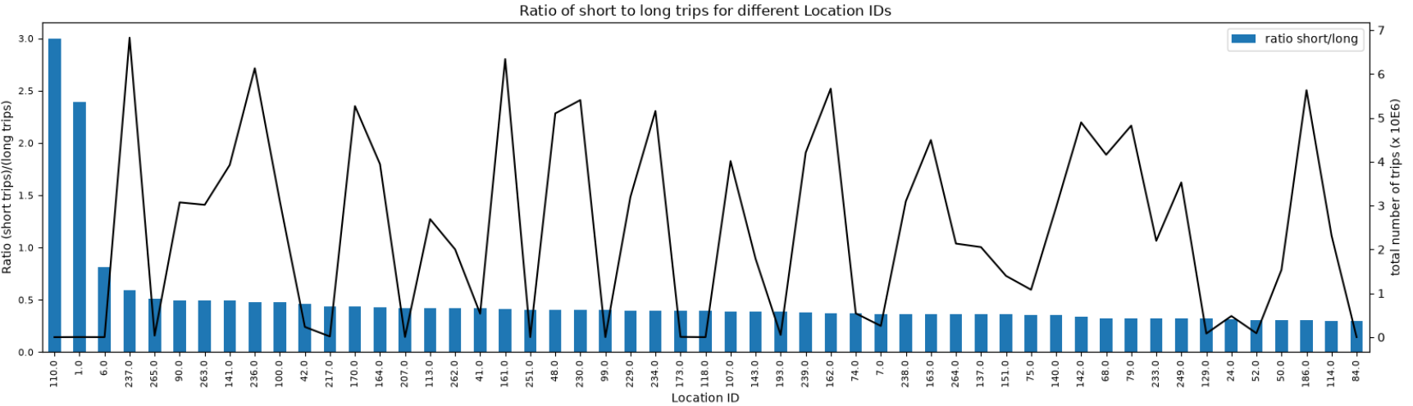
3.2 Analysis and interpretation of trends over time
The data was analysed for annual and hourly trends to obtain insights into the market behaviour and its suitability for the investment in public transport.
3.2.1 Annual Trends
Factors over the years studied (2014-2025) were analysed. These included analysis of the average speed per mile over time, which was seen as a measure of congestion (i.e., slower speeds pointing to worsening congestion), cost per mile over time and sampled volume over time. Note that since a sampled subset of data was used the reported passenger volumes are not the entire passenger volume but still give an idea of trends in passenger volumes (increase, decrease etc). These trends are indicated on the figure below.
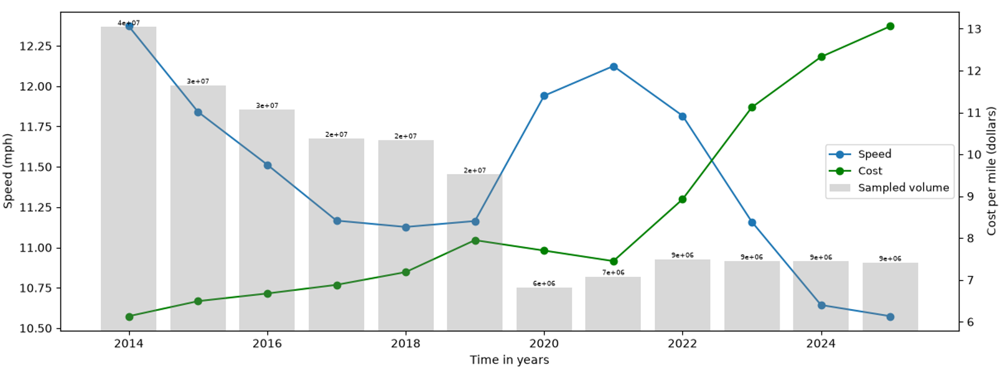
These trends indicate that over time congestion has increased (shown by a reduction in average speed per mile). Since the total number of passengers has reduced (seemingly after the Covid-19 pandemic), this congestion is likely from other sources of transport, such as people using their own cars or other services such as Uber. As congestion increases over time the cost per mile also increases. These two factors highlight the need for alleviation of congestion in New York City, demonstrating the need for public transport systems such as buses and dedicated bus lanes.
3.2.2 Daily and Hourly Trends
The same trends as those in 3.2.1 were analysed but on an hourly basis, these are indicated on the figure below. This chart indicates increased congestion between 08h00 and 18h00 marked by a drop in speed (and an associated increase in cost per mile) between these times as taxis increase their fare once the speed drops below a certain value (congestion surcharge). This information is useful in determining frequency of bus routes - more frequent buses should be scheduled to run their routes during these peak times.
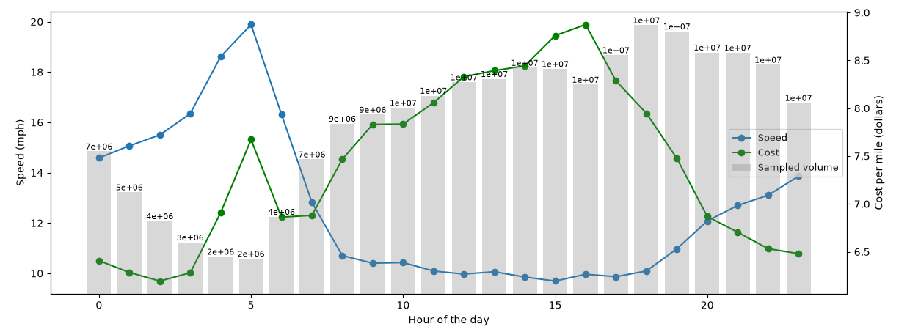
3.3 Additional analytics and interpretation
In the below graph, the average total fare per trip over time was studied, as well as the upper and lower bound envelopes for the fees (with an upper bound fee per year taken as the value excluding upper bound outliers (i.e., Q3 + 1.5IQR per year), while the lower bound of the envelope was taken to be the 10th percentile. Similar envelopes for representative minimum, average and maximum trip distances were also calculated in this way. These values were compared to the current $3 fixed bus fee on the limited bus services available in New York (Metropolitan Transportation Authority, 2026). This indicated that the taxi trips are generally more expensive than current bus prices. This chart also provides guidance for pricing of new bus routes - prices should remain below 5 dollars for short trips below a mile, for intermediate trips (2-3 miles) prices should remain below $11 and for longer trips above 6 miles, ticket prices should remain below $20 to remain attractive to the consumer, and to incentivise commuters to take a bus instead of taxis.
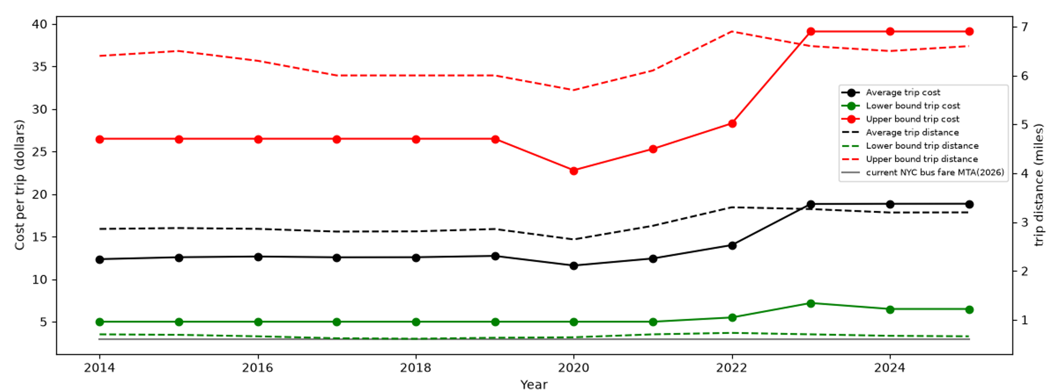
4. Business and societal interpretation
Based on the analyses completed, recommendations to be made to the City Planning Office for rollout of bus public transport systems and improvements such as additional bus lanes are summarised in the table below:
Factor | Recommendation
Areas to Prioritise for rollout of bus routes and lanes | The areas listed in the table in Section 3.1, in the order of occurrence in the table should be prioritised, especially those indicated in bold text, as in these areas congestion is worse, and many short trips are taken that would be feasible as bus trips.
Scheduling of bus routes | More frequent scheduling is recommended during the hours identified as peak hours (8am to 18h00, especially at 15h00, where the highest congestion is reached for the day).
Ticket Prices | Required to remain below taxi trip prices, as described in (3.3).
Payment Systems | Cards or scanning apps on which money can be loaded is recommended as the EDA completed in Part 1 indicated growth in the card payments and a decline in cash payments.

These recommendations have the following business and societal benefits:
- Positive environmental impact: The implementation of bus lanes and increased frequency of bus routes in the targeted areas will alleviate congestion, as a single bus can hold more passengers than multiple cars or taxis. This will reduce the carbon footprint and have a positive environmental impact.
- Saving citizens time and money: Bus tickets will generally be cheaper than a taxi fare, as the cost is split over more passengers. Reduction in congestion and dedicated bus lanes results in faster travel times. These benefits make the bus system an attractive alternative to taxis or private vehicles that saves the NYC citizens time and money.
  - Limitations to the study
Some limitations to the study include the fact that only taxi data and not other means of transport such as e-hailing services were used in this study.
6. Reference List
Metropolitan Transportation Authority (n.d-a) Fares and tolls. Available at https://www.mta.info/fares-tolls (Accessed: 4 October 2026).
New York City Taxi and Limousine Commission (n.d.-a) TLC trip record data. Available at: https://www.nyc.gov/site/tlc/about/tlc-trip-record-data.page (Accessed: 2 September 2026).
New York City Taxi and Limousine Commission (n.d.-b) Taxi fare. Available at: https://www.nyc.gov/site/tlc/passengers/taxi-fare.page (Accessed: 2 September 2026).
New York City Department of Transportation and Metropolitan Transportation Authority (2026) Next Stop: Fast Buses, Better Service. Available at: https://www.nyc.gov/html/dot/downloads/pdf/next-stop-fast-buses-better-service.pdf (Accessed: 4 October 2026).
List of Appendices
Appendix | Description | Github Repository Link
A | Execution Plans | https://github.com/MekayleRajoo/MIT_805_PROJECT_GROUP_8/tree/main/output
B | Video Presentation | https://drive.google.com/file/d/1_wBuma2bKrgtdq9_0PXEe4xAkcqzuYUB/view?usp=sharing
C | Notebooks | https://github.com/MekayleRajoo/MIT_805_PROJECT_GROUP_8/tree/main/notebooks
D | UP AI and Plagiarism Declarations | https://github.com/MekayleRajoo/MIT_805_PROJECT_GROUP_8/tree/main/report

