MIT 805 Group Project - Group 8, Part 1
Savannah Canto: u17131406 and Mekayle Rajoo: u26834414
Github repository link: https://github.com/MekayleRajoo/MIT_805_PROJECT_GROUP_8
- Data provenance and description
The NYC TLC Yellow Taxi Trip Record dataset, containing information on trips completed by Yellow Taxis in the New York Boroughs and available at https://www.nyc.gov/site/tlc/about/tlc-trip-record-data.page was selected. The data was collected by the NYC Taxi and Limousine Commission and is made publicly available every month by the City of New York. This trip record data can be downloaded immediately and no “Freedom of Information Law” requests are required (New York City Taxi and Limousine Commission, 2026).
- Dataset size and characteristics
Table 1: NYC Yellow Taxi dataset size and characteristics.
Parameter | Description
Raw dataset size | The current size of the raw NYC Yellow Taxi dataset is in excess of 50 GB.
Downloaded dataset size | 12 GB
Processing dataset size | The size of the dataset after cleaning, processing to only contain the required processing variables and working with a 20% random sample was 4 GB.
Period | The data downloaded and analysed was for the period from 2014 – 2026. 2
Publication and update dates | Data is usually uploaded monthly with a 2 month delay. (New York City Taxi and Limousine Commission, n.d.)
Characteristics | Each row represents a single taxi trip, with variables covering vendor identity, pickup/dropoff timestamps, passenger count, trip distance, fare/tip/total amounts, payment type, and rate code. We have also created fields for trip duration and average speed.
Format | The data is released in the form of one parquet file per month.

- Preparation and quality of the dataset
The following was done to prepare the dataset for analysis:
- For uniformity, numerical data types (long, integer, doubles) were converted to doubles.
- The business objective was defined as described in Section 6 and columns seen as redundant to the business objective (see list in Table 3 , Appendix B) were removed.
- The ranges of each numerical variable of the raw data were investigated and are presented in Table 4 of Appendix B. These revealed some non-realistic entries and outliers, such as negative distances. This provided insight on how to filter the data for valid trips.
- The dataset was filtered for “valid trips”, using the conditions presented in Table 5 in Appendix B.
- All duplicate data entries were removed from the dataset.
- Columns titled trip_duration and average_trip_speed were added to the dataset (calculated using the pickup and drop off times and trip distance).
.
- Exploratory data analysis (EDA)
This section presents an exploratory data analysis (EDA) of the cleaned and sampled NYC Yellow Taxi dataset. The analysis focuses on trip volume trends over time, variable correlation, fare amounts over time and the average cost per mile. All visuals regarding the below can be found in Appendix C
Statistical summaries of the ranges (minimum and maximum values) and averages of each numerical variable in the cleaned data set are summarised in Table 4 of Appendix C. The correlation matrix for the variables is indicated in Figure 1 in Appendix C. Variables such as trip distance and fare amount had high correlation with one another, as would be expected. Some initial trends investigated are described in the paragraphs that follow.
Number of trips over time (Figure 2 Appendix C): Yellow cab trip volumes gradually decreased between 2014 and 2019, which could be attributed to untracked vendors or the reduced reliance on e-hailing services such as Uber. However, the 70%+ drop from 2019 to 2020 can be directly attributed to the COVID-19 pandemic and the resulting decline in travel demand.
Average fare vs speed (Figure 3 Appendix C): In the early mornings, average speeds are high due to quieter roads, yet fares remain elevated - likely due to surcharges or a higher amount of airport trips. As roads get busier from 6-7am and speeds drop, average fare climbs further still. This is due to how the taxi meter is structured: fares are normally based on a flat per-mile rate, but below a certain speed, an additional time-based fee is applied to account for the slower progress (New York City Taxi and Limousine Commission, n.d.-b). This relationship holds fairly consistently across the graph, up until the trend eases off around 16:00-17:00.
Average tip vs time (Figure 4 Appendix C): The average tip per ride generally increases over time, possibly due to considerations such as inflation.
Cash vs Credit Card payments over time (Figure 5 Appendix C): Both cash and credit card payments saw a decline between 2014-2020, however, following COVID-19, credit card usage gradually increased while cash continued to decline, likely due to the preference for contactless payments.
- The dataset in the context of the 7 Vs of big data
Table 2: NYC Yellow Taxi dataset in the context of the 7Vs of big data.
Characteristic | NYC Yellow Taxi dataset context
Volume | The total volume of the dataset (more than 50 GB in compressed parquet format) and the fact that there are close to one billion entries in our downloaded dataset from 2014-2017, made it large enough that it was more efficient to process it with libraries such as Pyspark where the entire dataset does not need to be loaded into RAM at once.
Velocity | The TLC publishes this data in monthly batches with a roughly two-month reporting delay.
Variety | The data are structured, however, there is variety in changes in the fields collected over time, for example the TLC reports that a CBD congestion fee field was added to the data in 2025.
Veracity | The TLC explicitly states it makes no representations as to the accuracy of the data.  As a regulated government dataset, it is reasonable to assume a baseline level of structural accuracy and legitimacy.
Value | Societal and business value can be extracted from the data, for example - analytics can help identify areas of high traffic congestion that can be targeted for infrastructure upgrades.
Variability | Trip volumes and fares fluctuate by time, season and destination
Visualisation | Due to the substantial size of the dataset, visualisation of the data in the form of charts is the only way of understanding the trends present. The TLC has a PowerBI dashboard displaying some of the data over time (specifically trip volumes for different taxi types), so that the public can visualise the data (New York City Taxi and Limousine Commission, 2026).

- Dataset business value and limitations
This section considers the business value and limitations of the NYC Yellow Taxi dataset, outlining the practical applications the data supports as well as the constraints that should be considered when interpreting results derived from it.
Business Value and objectives: The data can be analysed to determine whether it would be profitable to invest in the Taxi market or find gaps in the market for other public transport services to improve efficiency. Analysing traffic conditions in the city by calculating speeds per trip at different times for example can offer insights into this. The large timespan of data available (2009 to date) allows us to do in-depth analysis of industry trends over time (impact of e-hailing, pre vs post covid, fare changes, growth etc)
Limitations: The dataset may not capture all vendors operating within the city. Data is released with a 2 month lag making it not suitable for near real time analysis.
- Reference List
New York City Taxi and Limousine Commission (n.d.-a) TLC trip record data. Available at: https://www.nyc.gov/site/tlc/about/tlc-trip-record-data.page (Accessed: 2 September 2026).
New York City Taxi and Limousine Commission (n.d.-b) Taxi fare. Available at: https://www.nyc.gov/site/tlc/passengers/taxi-fare.page (Accessed: 2 September 2026).
Appendix A – Code for cleaning of the downloaded dataset
Please see the link to the Github repository for all the code used to clean the dataset. The dataset was cleaned in two batches (2014-2017 and 2018-2026), using the filters presented in Appendix C and then extracted as parquet files used in the EDA.
Github repository link: https://github.com/MekayleRajoo/MIT_805_PROJECT_GROUP_8

Appendix B – Data cleaning summaries
To obtain an idea of the distribution of the data in the raw dataset, the ranges of the raw numerical data were checked and are presented in Table 3.
These indicate that there are some unrealistic ranges present (such as a fare for billions of dollars, negative distances, or large numbers of passengers that would not fit into a typical yellow taxi that can take 4 passengers and a driver, or zero passengers).
Table 3: Columns removed from the dataset.
Variable
store_and_fwd_flag
extra
mta_tax
tolls_amount
improvement_surcharge
congestion_surcharge
airport_fee

Table 4: Minimum and maximum ranges of the raw data set, obtained in order to better filter the dataset.
Variable | Minimum | Maximum
passenger_count | 0 | 208
trip_distance | -4.08E7 | 1.35E8
fare_amount | -1.33E8 | 998 310
tip_amount | -448.91 | 1.333914E8
total_amount | -2 567.8 | 1E07
trip_duration | -1016695.4 | 21308.13
average_trip_speed | -4.9 | 9.9E9

Table 5: Filters applied.
Variable | Filter applied
passenger_count | 0 < passenger_count < 5
trip_distance | 0 miles < trip_distance < 20 miles
fare_amount | 0 dollars < fare_amount < 100 dollars
tip_amount | tip_amount >= 0 dollars
total_amount | 0 dollars < total_amount < 2000 dollars
trip_duration | 0 < trip_duration < 3 hours
average_trip_speed | 0 < average_trip_speed < 55  (The maximum speed limit of 55 mph was considered as the upper bound)
Pickup and dropoff | Filtered to only include the years 2014-2026

Table 6: Data cleaning summary.
Variable | 2014 - 2017 | 2017 - present | Total
Total original entries | 521 176 000 | 429 881 159 | 951 057 159
Final no. entries after cleaning (before sampling) | 468 713 819 | 355 237 231 | 823 951 040
Final no. entries (after sampling) | 93 742 763 | 71 047 446 | 164 790 208

Appendix C – Exploratory Data Analysis Summaries
Table 4: Numerical variables statistical summary - for the cleaned, processing data set.
Variable | Range |  | Average
 | Minimum value | Maximum Value
passenger_count | 1 | 4 | 1
trip_distance (miles) | 0.01 | 20 | 2.9
fare_amount ($) | 0.01 | 100 | 13.38
tip_amount ($) | 0.00 | 1100 | 2.03
total_amount ($) | 0.01 | 1737.18 | 17.75
trip_duration (h) | 0 | 3 | 0.24
average_trip_speed (mph) | 0 | 55 | 11.55

Figure 1: Correlation matrix for numerical variables
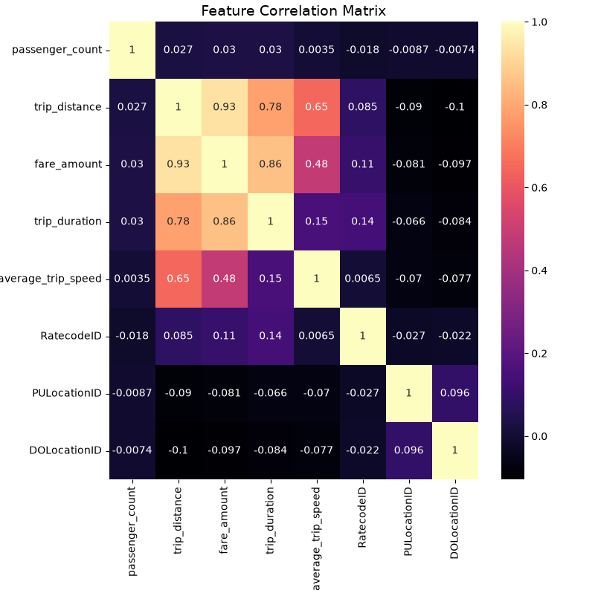

Figure 2: Trips vs Years
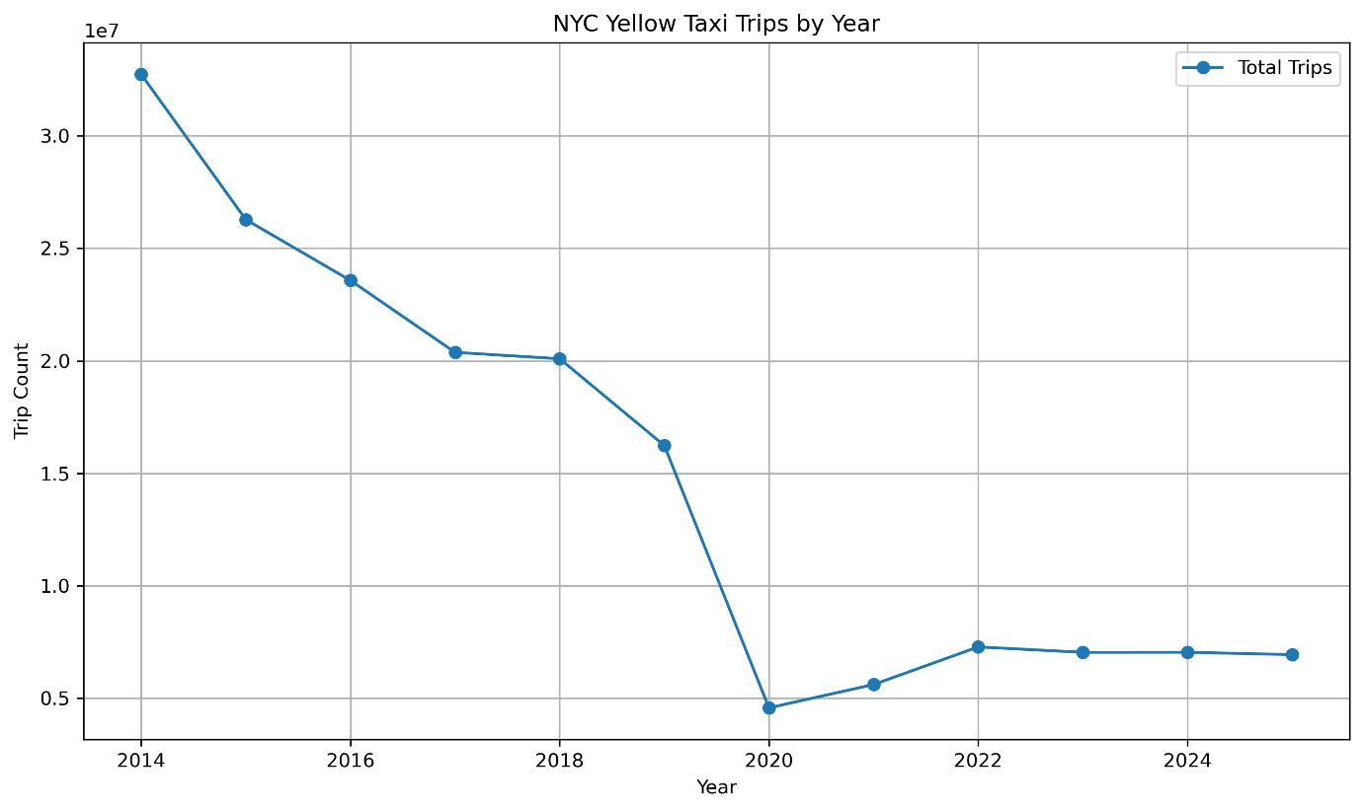

Figure 3: Average fare and Speed vs hour of day
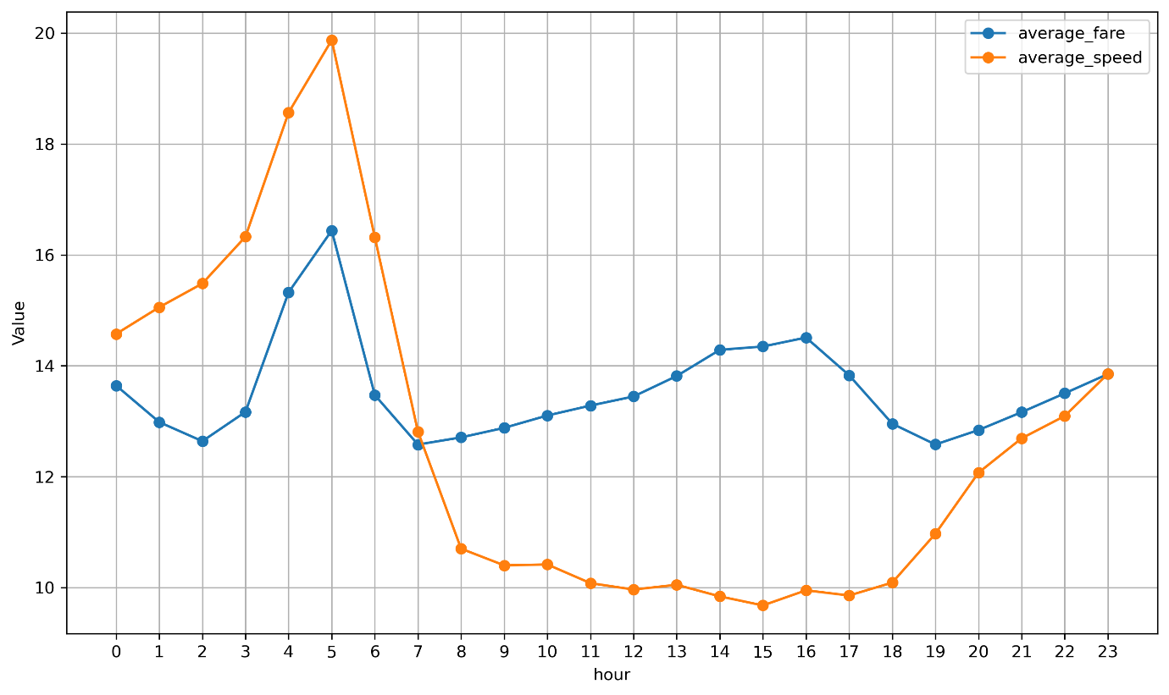

Figure 4: Average tip amount per year
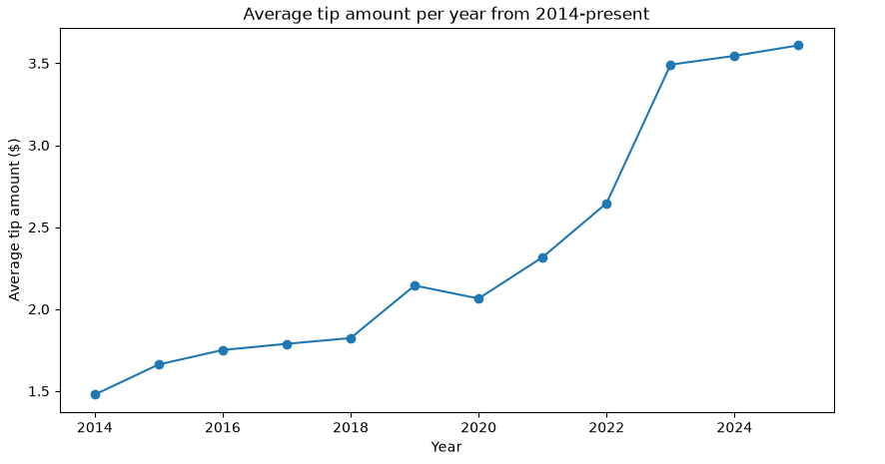
Figure 5: Cash vs Credit Card payments over time
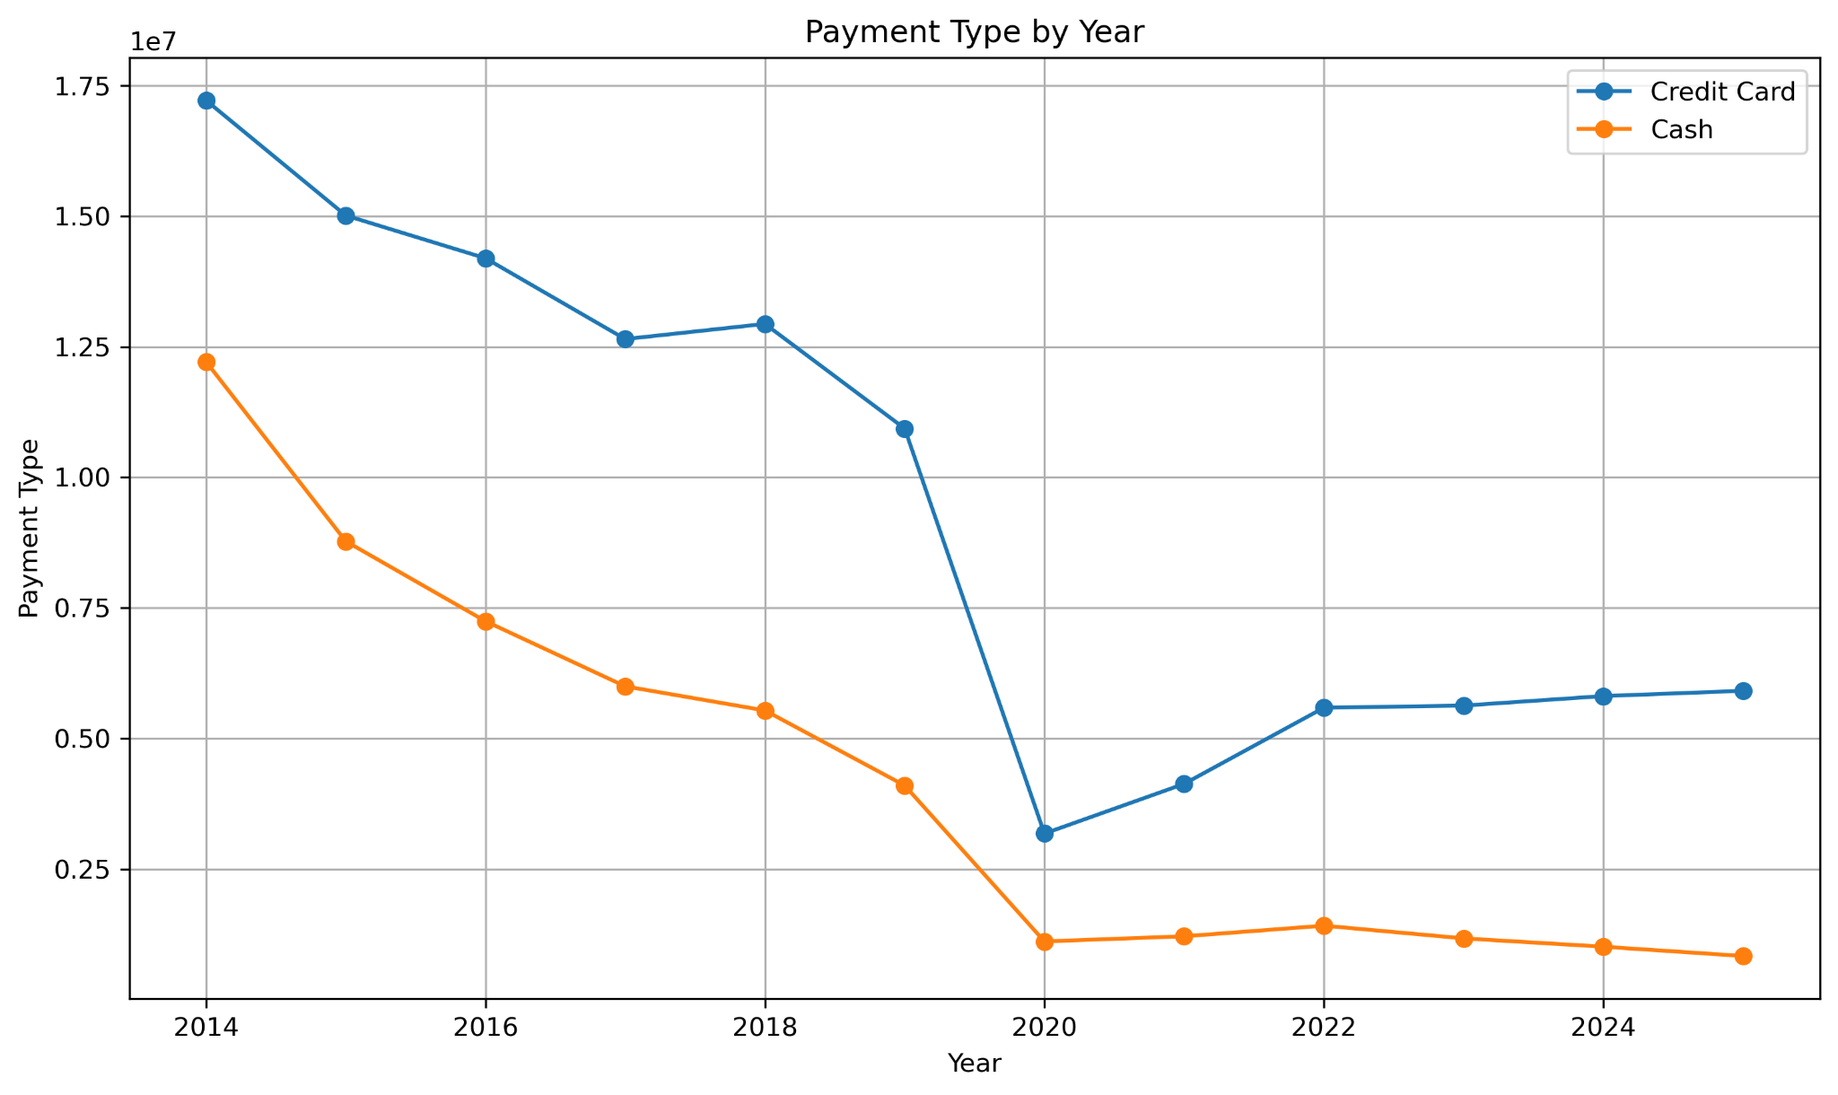
Appendix D – Code used for the EDA
Please see the link to the Github repository for all the code used in the EDA.
Github repository link: https://github.com/MekayleRajoo/MIT_805_PROJECT_GROUP_8

Appendix E – UP AI and Plagiarism Declarations
Please see the link to the Github repository for all declarations from the group members.
Github repository link: https://github.com/MekayleRajoo/MIT_805_PROJECT_GROUP_8

