Project virtualization

**Product initiation document**

Author : Arnoud Smit, Iva Kapel, Batu Demir, Sander van Himst, Jandrik Blom & Thom Mekelenkamp

Version : 1.0

Date : 19 September ‘14

Table of contents

Current and desired situation 3

Current situation: 3

Desired situation: 3

MoSCoW 4

Must haves: 4

Should haves: 4

Could haves 4

Won’t / would haves: 4

Costs 5

Man-hours: 5

Sales 5

Return on investment 6

Break even 6

Pay-off time 6

Project organization 7

Roles and responsibilities 8

Roles 8

Project Schedule 8

# Current and desired situation

Plaintech is a company based in the UK who provide hosting services for their customers. New hosting technologies have shown that their resources are being used inefficiently, which results in unnecessary high costs. Because they are renting their servers to their customers, a lot of servers are constantly running. With the virtualization software available, it is now possible to use the hardware resources more efficiently.

## Current situation:

Plaintech currently only provides services in physical server hosting. Because there are many servers that use little resources, a lot of resources go to waste. A few disadvantages are shown below:

* High electricity cost because their servers are constantly turned on
* Resources going to waste
* Many servers use a lot of space
* Hard to manage
* Low security
* Long time to market

Plaintech has submitted a request for proposal at ITopia, hoping they would come up with a proposal to solve their problem.

## Desired situation:

Plaintech would like to move to a virtualized environment in order to be more cost-efficient and reduce their time to market. There will be multiple virtual servers running on their machines, reducing the resources wasted. There will be servers that won’t have to run anymore, so the resources of these unused machines can be used to expand the machines on which the virtual servers will be running. This will reduce the space required for their machines and reduce the electricity cost of their machines. Below is a short summary of the advantages of switching to a virtual environment:

* Save on electricity
* Save on space
* Faster time to market
* Easily managed
* High security
* Resources being used optimally

# MoSCoW

## Must haves:

The final product must contain the following parts in order to operate:

* There has to be new website where new customers can register and order their products.
* The system needs a database that stores the customer information.
* The customers must be able to configure and order a virtual machine with an OS, RAM and storage of their own choice.
* There has to be a new ordering system that gets an update as soon as a customer orders a system.
* The order that a customer placed has to be processed by the ordering system.
* After ordering, the customer must get a notification on email that its virtual machine is ready for use. That same email also has to contain the customer’s log in data for the machine.

## Should haves:

* There should be functioning security on the website to protect the customer details and log in data.
* The customers should be able to update their personal information on the website.
* The website should be available on every platform such as PC, tablet and Smartphone
* There should be a security system on the virtual machines to protect customers from unauthorized actions by strangers.

Could haves:

## Won’t / would haves:

* The customers would be able to choose from more OS types.
* The customers would be able to link multiple virtual machines to each other.
* The customers would be able to upgrade the hardware that they configured on the machine in order to get more performance when they need it.

# Costs

* Server : €6153,- * 2000 = €12.306.000,-
* Server software : €1555,-
* Windows server 2012 : Deal with Microsoft ®: annually €150.000

to get as many licenses we need

## Man-hours:

1 hour = €45,- Estimated hours needed: 1800

260 hrs: Building the website

300 hrs: Installing the server

760 hrs: Implementation and connecting of the website and server

200 hrs: Documentation

480 hrs: Security

260 * 45= € 11.700,-

300 * 45= € 13.500,-

760 * 45= € 34.200,-

200 * 45= € 9000,-

480 * 45= € 21.600,-

Total €90.000,-

**Total costs = € 12.396.000,-**

# Sales

Service levels:

* Low : € 20,- Server rent = € 15,- /month
* Medium : € 40,-
* High : € 60,- Service costs are monthly payments

Monthly costs for the client (includes server rent):

* Low : € 35,-

*note* for the RIO calculation we assume at least 50.000 contracts annually with a medium service level

* Medium : € 55,-
* High : € 75,-

50.000 * 12 months = 600.000 annual payments

600.000 * € 55,- = € 33.000.000,- each year

# Return on investment

Estimated sales: € 33.000.000,-

Estimated costs: € 12.396.000,-

€ 33.000.000,- / € 12.396.000,- * 100 = 266

## Break even

€ 12.396.000,- / € 55,- = ~225.381 monthly payments to break even on the investment of the project

## Pay-off time

€ 33.000.000,- / 12 months = € 2.750.000,- each month

|  |  |  |  |  |  |  |  |  |  |
| --- | --- | --- | --- | --- | --- | --- | --- | --- | --- |
| Jan | Feb | Mar | Apr | May | Jun | Jul | Aug | Sep | oct |
| 2.75 | 5.5 | 11 | 22 | 44 | 88 |  |  |  |  |

*All the numbers listed in this table are millions.

The pay-off time for the project is approximately 4 months

# Project organization

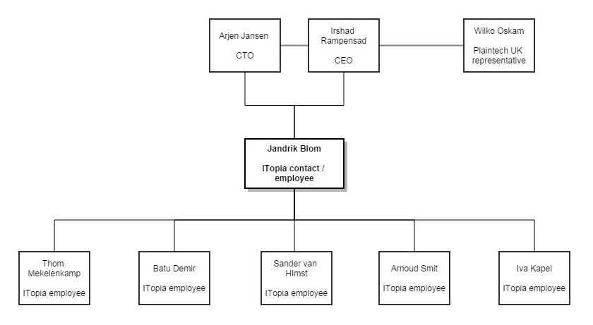

# Roles and responsibilities

The matrix shows the dividing of roles in our team

|  |  |  |  |  |  |  |
| --- | --- | --- | --- | --- | --- | --- |
| **Name** | **Contact** | **Java** | **Networking** | **Secretary** | **HTML/CSS** | **Python** |
| Jandrik | V | V | V |  | V | V |
| Batu |  | V | V |  | V | V |
| Iva |  | V | V |  | V | V |
| Arnoud |  | V | V | V | V | V |
| Thom |  | V | V | V | V | V |
| Sander |  | V | V |  | V | V |

## Roles

**Contact:**

This is the first person on the team to communicate with the Plaintech representatives. And he will form the main connection for the team to Plaintech.

**Java:**

All the team members listed in ‘Java’ are working on the Java-script on the website, and the Java programming for additional software that might be required for the project

**Networking:**

The team members listed for ‘networking’ will work on the connection between the server, the client, the website and the database. And make sure that the servers are configured correctly.

**Secretary:**

The secretaries are the team members that take notes on every important moment (team and Plaintech meetings) during two weeks. After the period of two weeks the secretary job circulates to other team members.

**HTML / CSS:**

All the team members that are listed on ‘HTML / CSS’ are building the website that will make customers able to order and access their products.

**Python:**

The team members listed in ‘Python’ are creating software that is required for the system.

# Project Schedule

The project Schedule is placed in a separate file:

Project Schedule V1.0.xslx

Project virtualization

**Cooperation contract**

Author : Arnoud Smit, Iva Kapel, Batu Demir, Sander van Himst, Jandrik Blom & Thom Mekelenkamp

Version : 1.0

Date : 16 September ‘14

Table of contents

Team members 11

Collaboration Targets 12

The main objective of cooperation 12

Secondary objectives for cooperation 12

Important aspects during the project 12

Target of this project 12

Chosen write style 13

Arrangements within the group 13

Signatures: 14

# Team members

* Iva Kapel  
  Email: iva.kapel@hva.nl

Tel: 0634208184

* Arnoud Smit  
  Email:Arnoud1789@gmail.com  
  Tel: 0624273404
* Thom Mekelenkamp  
  Email: thom.mekelenkamp@hva.nl  
  Tel: 0634353210
* Sander van Himst  
  Email: sander.van.himst@hva.nl  
  Tel: 0648247989
* Jandrik Blom  
  Email: jandrik.blom@hva.nl   
  Tel: 0646270911
* Batu Demir  
  Email: batu.demir@hva.nl  
  Tel: 0683171613

# Collaboration Targets

## The main objective of cooperation

Our main objective is to create a stable virtual machine platform for Plaintech. This platform will provide a variety of new opportunities for Plaintech. The customers will be able to select their own virtual machine and specifications.

## Secondary objectives for cooperation

Improve skills in the area of cooperation. Improve our communication skills between our team members and the employer.

## Important aspects during the project

* Trust each other
* Treat each other with respect
* Deliver work with high standards
* Work efficient
* Be on time for appointments
* Work is delivered at the arranged moments
* The choices
* Make jointly decisions and consultations about the choices that has to be made
* Right division of labor
* Motivation
* Supporting each other where necessary

## Target of this project

Target of this project is Plaintech and there costumers.

# Chosen write style

Within our team we use the following write style for our documents:

* Text size Arial 11
* Head size 12 in Bolt
* Line distance 1.0

Templates of the ITopia write style can be found on the VLO.

# Arrangements within the group

* Members within our project group always arrive on time.
* In case of any problems within our project we keep each other updated.
* All arrangements made within the group will be fulfilled by each team member.
* The first warning will be punished with a yellow card. The second warning will give you a red card and will result in to a crisis meeting.
* When a team member is ill he should immediately inform the rest of his team members. This can be done with whatsapp or email.
* On Tuesdays we will always work from 10:00 till at least 14:00.

# Signatures:

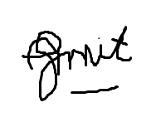

Arnoud Smit Batu Demir Jandrik Blom



Sander van Himst Iva Kapel Thom Mekelenkamp