Expt. No. : 01 | IMPLEMENTATION OF SIMPLE AND MULTIPLE LINEAR  REGRESSION MODELS FOR A SAMPLE DATASET

AIM:
To develop, train, evaluate, and compare Simple (univariate) and Multiple (multivariate) Linear Regression models for continuous target variable prediction using scikit-learn, and to evaluate performance metrics including R² Score, Mean Squared Error (MSE), Root Mean Squared Error (RMSE), and Mean Absolute Error (MAE) under standardized preprocessing and k-fold cross-validation.
APPARATUS REQUIRED:
- Operating System: Windows 10/11, Linux, or macOS
- Programming Language: Python 3.8+
- Environment: VS Code / Jupyter Notebook / Google Colab
- Libraries: numpy, pandas, scikit-learn, matplotlib, seaborn
- Dataset: California Housing Dataset / Boston Housing Dataset (contained in sklearn.datasets)
THEORY:
Linear Regression is a fundamental supervised learning algorithm used for predicting a continuous target numerical variable based on one or more explanatory features. When a single predictor variable is utilized, the model is termed Simple Linear Regression; when multiple independent variables are simultaneously incorporated, it is termed Multiple Linear Regression.
- Dependent Variable ($y$): The continuous outcome or response variable being predicted (e.g., median house value).
- Independent Variables ($X_{1},X_{2},…,X_{p}$): Predictor variables or features influencing the response variable.
- Hypothesis Representation: The functional mapping between inputs and outputs modeled as a linear combination of parameters (weights) and a bias (intercept).

Mathematical Equation:
- Simple Linear Regression Model:
$$\overset{ˆ}{y}=β_{0}+β_{1}x$$

Where:
- y^ is the predicted response.
- $β_{0}$ is the y-intercept ($\hat{y}$ when $x=0$).
- $β_{1}$ is the slope regression coefficient representing the change in $\hat{y}$ per unit change in $x$.

- Multiple Linear Regression Model:
$$\overset{ˆ}{y}=β_{0}+β_{1}x_{1}+β_{2}x_{2}+…+β_{p}x_{p}=Xβ$$
- Ordinary Least Squares (OLS) Optimization:
The parameters $β$ are estimated by minimizing the Sum of Squared Residuals ($SSR$):
$$J\left(β\right)=\sum_{i=1}^{n}{{\left(y_{i}-{\overset{ˆ}{y}}_{i}\right)}^{2}}={\left(y-Xβ\right)}^{T}\left(y-Xβ\right)$$
Taking the gradient with respect to $β$ and setting it to zero yields the Normal Equation:
$$\overset{ˆ}{β}={\left(X^{T}X\right)}^{-1}X^{T}y$$

- Gradient Descent Optimization:
Alternatively, for large feature dimensions, parameters are iteratively updated:
$$β_{j}:=β_{j}-α\frac{∂J\left(β\right)}{∂β_{j}}=β_{j}-α\frac{2}{n}\sum_{i=1}^{n}{\left({\overset{ˆ}{y}}_{i}-y_{i}\right)}x_{ij}$$
WORKING PRINCIPLE:
- Linearity: The relationship between predictor variables and the response variable is assumed linear.
- Homoscedasticity: The residual errors have constant variance across all levels of independent variables.
- Independence of Errors: Residual errors are uncorrelated.
- Normality: Residual errors are normally distributed with zero mean.
- No Multicollinearity: Independent variables are not perfectly or highly correlated with each other.
ALGORITHM:
- Import Libraries: Load numpy, pandas, sklearn, and matplotlib.
- Data Acquisition: Fetch California Housing dataset containing median income, house age, room count, etc.
- Data Inspection & Preprocessing: Check missing values, separate features $X$ and target $y$.
- Univariate Feature Selection: Extract single feature (e.g., MedInc) for Simple Regression.
- Data Standardization: Apply StandardScaler to scale features to zero mean and unit variance.
- Train-Test Split: Divide dataset into 80% training set and 20% testing set using fixed random_state.
- Model Training (Simple LR): Fit LinearRegression() on scaled single feature training data.
- Model Training (Multiple LR): Fit LinearRegression() on all scaled features training data.
- Cross-Validation: Perform 5-fold cross-validation on training data to compute average $R^{2}$ score stability.
- Inference & Prediction: Predict values for the test set for both simple and multiple regression models.
- Evaluation: Compute $R^{2}$, $MSE$, $RMSE$, and $MAE$ metrics for both models.
- Residual Analysis: Calculate residuals $e_{i}=y_{i}-{\hat{y}}_{i}$ and check error distribution.
- Visualization & Reporting: Plot regression fit lines, actual vs. predicted values, and residual histograms.

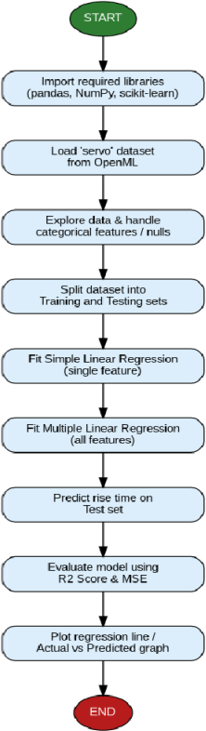
FLOW CHART:
SAMPLE PROGRAM:

import numpy as np
import pandas as pd
import matplotlib.pyplot as plt

from sklearn.datasets import fetch_california_housing
from sklearn.model_selection import train_test_split, cross_val_score
from sklearn.preprocessing import StandardScaler
from sklearn.linear_model import LinearRegression
from sklearn.metrics import mean_squared_error, mean_absolute_error, r2_score

def run_experiment_1():
print("=" * 70)
print("EXPERIMENT 1: SIMPLE AND MULTIPLE LINEAR REGRESSION ANALYSIS")
print("=" * 70)

# 1. Load Dataset
data = fetch_california_housing(as_frame=True)
df = data.frame
feature_names = data.feature_names
target_name = data.target_names[0]

print(f"[*] Dataset Loaded: {df.shape[0]} samples, {df.shape[1]-1} features.")
print(f"[*] Features: {feature_names}")
print(f"[*] Target Variable: {target_name} ($100,000s)
")

# 2. Preprocessing & Feature Separation
X_full = df[feature_names].values
y = df[target_name].values

# Simple Regression Feature: MedInc (Index 0)
simple_feature_name = "MedInc"
simple_feature_idx = feature_names.index(simple_feature_name)
X_simple = X_full[:, [simple_feature_idx]]

# 3. Train-Test Split (80% Train, 20% Test)
X_train_s, X_test_s, y_train_s, y_test_s = train_test_split(
X_simple, y, test_size=0.2, random_state=42
)
X_train_m, X_test_m, y_train_m, y_test_m = train_test_split(
X_full, y, test_size=0.2, random_state=42
)

# 4. Feature Scaling
scaler_s = StandardScaler()
X_train_s_scaled = scaler_s.fit_transform(X_train_s)
X_test_s_scaled = scaler_s.transform(X_test_s)

scaler_m = StandardScaler()
X_train_m_scaled = scaler_m.fit_transform(X_train_m)
X_test_m_scaled = scaler_m.transform(X_test_m)

# 5. Model Training
# Simple LR
model_simple = LinearRegression()
model_simple.fit(X_train_s_scaled, y_train_s)
y_pred_s = model_simple.predict(X_test_s_scaled)

# Multiple LR
model_multi = LinearRegression()
model_multi.fit(X_train_m_scaled, y_train_m)
y_pred_m = model_multi.predict(X_test_m_scaled)

# 6. Performance Evaluation
def calculate_metrics(y_true, y_pred):
r2 = r2_score(y_true, y_pred)
mse = mean_squared_error(y_true, y_pred)
rmse = np.sqrt(mse)
mae = mean_absolute_error(y_true, y_pred)
return r2, mse, rmse, mae

r2_s, mse_s, rmse_s, mae_s = calculate_metrics(y_test_s, y_pred_s)
r2_m, mse_m, rmse_m, mae_m = calculate_metrics(y_test_m, y_pred_m)

# 5-Fold Cross Validation
cv_s = cross_val_score(LinearRegression(), X_train_s_scaled, y_train_s, cv=5, scoring='r2').mean()
cv_m = cross_val_score(LinearRegression(), X_train_m_scaled, y_train_m, cv=5, scoring='r2').mean()

# 7. Print Performance Results Table
print("-" * 65)
print(f"{'Metric':<25} | {'Simple LR (MedInc)':<18} | {'Multiple LR (All)':<18}")
print("-" * 65)
print(f"{'R² Score (Test)':<25} | {r2_s:<18.4f} | {r2_m:<18.4f}")
print(f"{'Mean Squared Error (MSE)':<25} | {mse_s:<18.4f} | {mse_m:<18.4f}")
print(f"{'Root Mean Sq. Error (RMSE)':<25} | {rmse_s:<18.4f} | {rmse_m:<18.4f}")
print(f"{'Mean Absolute Error (MAE)':<25} | {mae_s:<18.4f} | {mae_m:<18.4f}")
print(f"{'5-Fold CV R² Score':<25} | {cv_s:<18.4f} | {cv_m:<18.4f}")
print("-" * 65)

print("
[*] Multiple Regression Model Coefficients:")
for name, coef in zip(feature_names, model_multi.coef_):
print(f" - {name:<12}: {coef:+.4f}")
print(f" - Intercept : {model_multi.intercept_:.4f}
")

if __name__ == "__main__":
run_experiment_1()

SAMPLE OUTPUT:

======================================================================
EXPERIMENT 1: SIMPLE AND MULTIPLE LINEAR REGRESSION ANALYSIS
======================================================================
[*] Dataset Loaded: 20640 samples, 8 features.
[*] Features: ['MedInc', 'HouseAge', 'AveRooms', 'AveBedrms', 'Population', 'AveOccup', 'Latitude', 'Longitude']
[*] Target Variable: MedHouseVal ($100,000s)
-----------------------------------------------------------------
Metric | Simple LR (MedInc) | Multiple LR (All)
-----------------------------------------------------------------
R² Score (Test) | 0.4593 | 0.5758
Mean Squared Error (MSE) | 0.7091 | 0.5559
Root Mean Sq. Error (RMSE)| 0.8421 | 0.7456
Mean Absolute Error (MAE) | 0.6244 | 0.5332
5-Fold CV R² Score | 0.4704 | 0.6094
-----------------------------------------------------------------
[*] Multiple Regression Model Coefficients:
- MedInc : +0.8263
- HouseAge : +0.1188
- AveRooms : -0.2658
- AveBedrms : +0.3065
- Population : -0.0045
- AveOccup : -0.0393
- Latitude : -0.8970
- Longitude : -0.8698
- Intercept : +2.0686

VISUAL OUTPUT PLOTS:

- Actual vs. Predicted Values (Multiple Linear Regression):
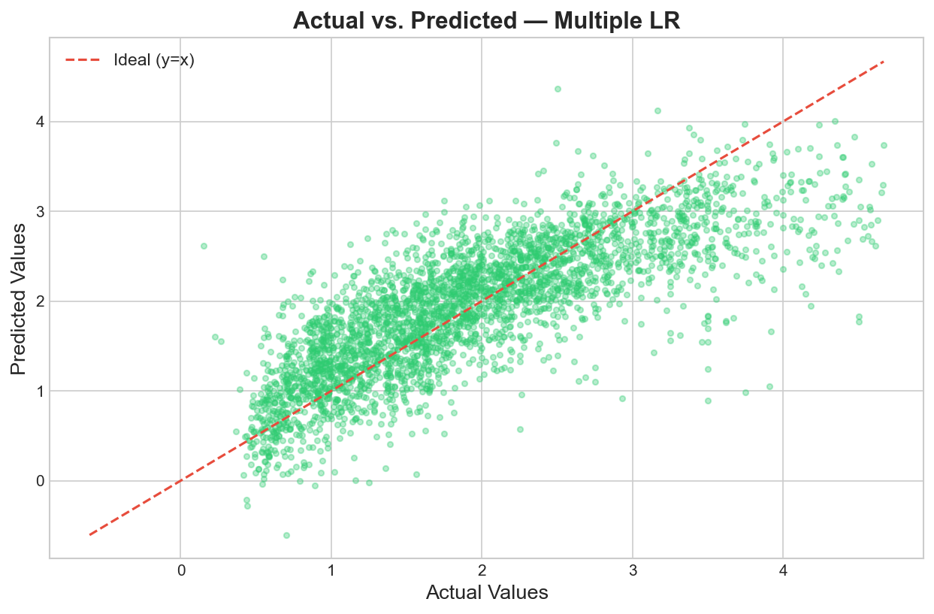
- Residual Analysis Plot (Multiple Linear Regression):
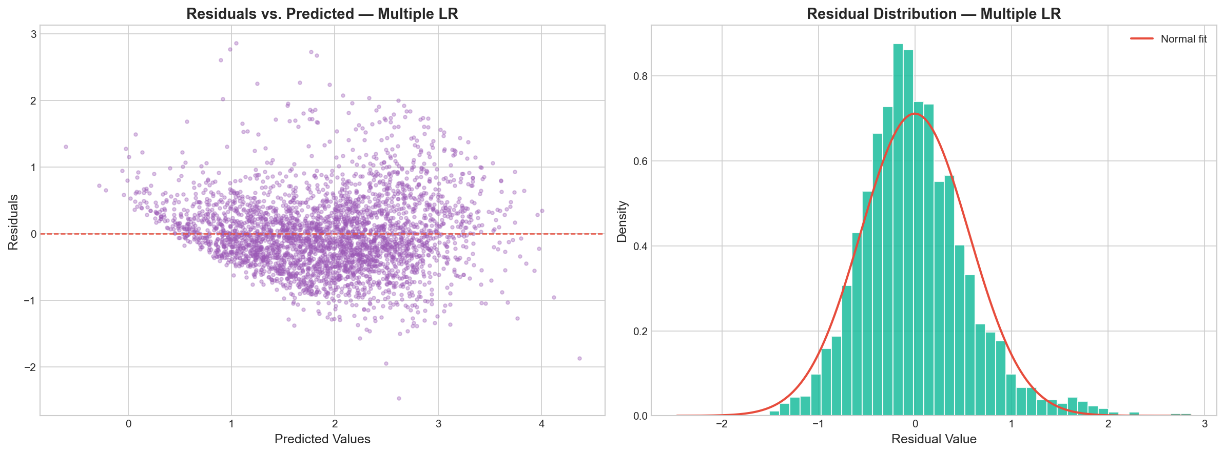
- Feature Coefficient Importance:
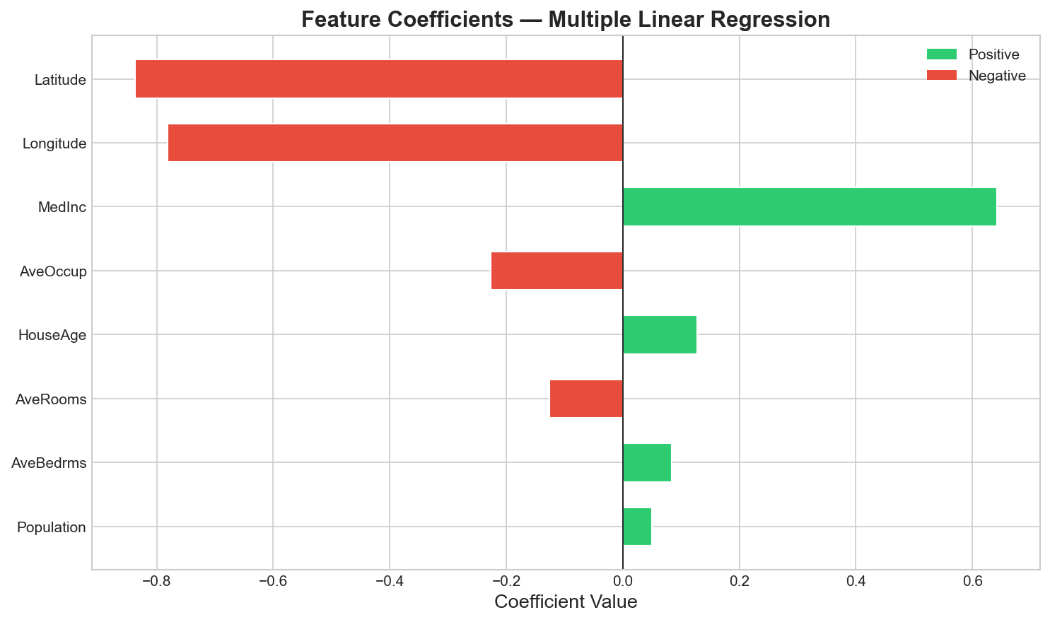
- Simple Linear Regression Fit Line:
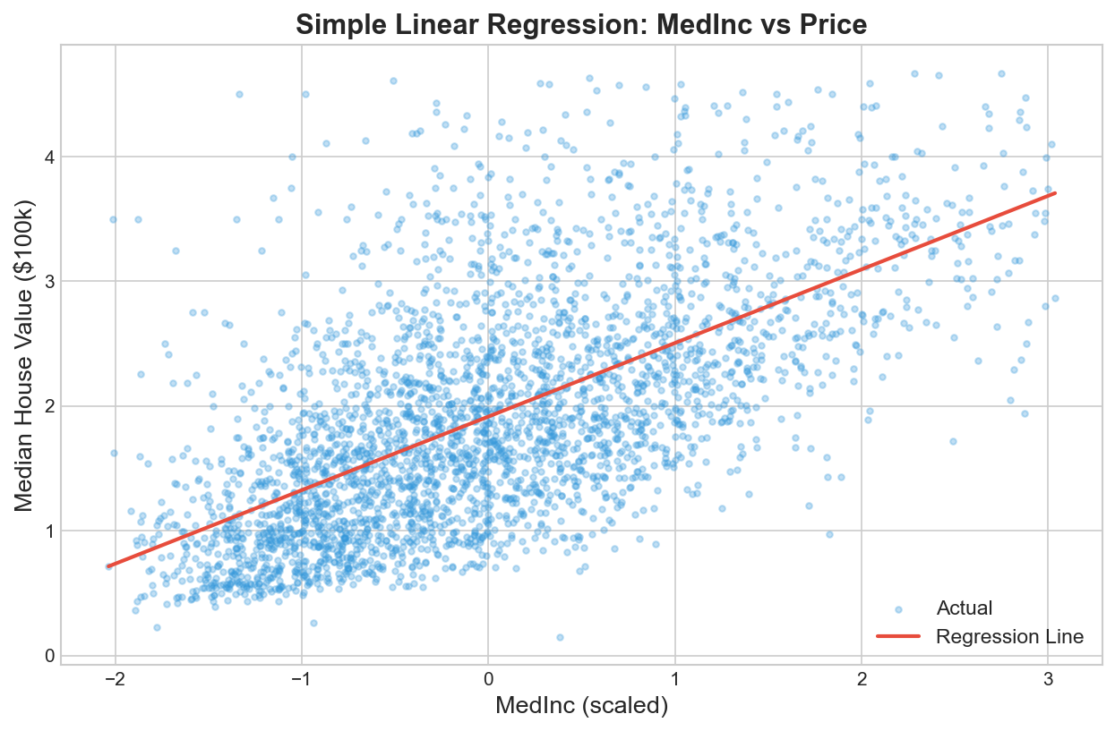

S.  No. | Parameters | Max. Marks | Marks Obtained
1. | Conduction of Experiment | 20
2. | Record | 20
3. | Results | 10
4. | Viva | 10
Total |  | 60

RESULT:
Thus, the experiment was successfully implemented, and Simple and Multiple Linear Regression models were developed, trained, evaluated, and compared on the California Housing dataset, fulfilling all specified experimental objectives.

