Expt. No. : 02 | BUILDING AND TESTING NAÏVE BAYES AND DECISION TREE CLASSIFICATION MODEL FOR A SAMPLE DATASET

AIM:
To implement, hyperparameter-tune, evaluate, and compare Naïve Bayes (probabilistic) and Decision Tree (rule-based) classification models on multi-attribute categorical datasets, evaluating performance using Confusion Matrices, Classification Accuracy, Precision, Recall, F1-Score, and ROC-AUC curves.
APPARATUS REQUIRED:
- Operating System: Windows 10/11, Linux, or macOS
- Programming Language: Python 3.8+
- Environment: VS Code / Jupyter Notebook / Google Colab
- Libraries: numpy, pandas, scikit-learn, matplotlib, seaborn
- Dataset: Weather Play Tennis / Synthetic Categorical Decision Dataset (365 daily records)
THEORY:
Classification is a supervised machine learning task where the target response variable is categorical. Naïve Bayes and Decision Trees represent two primary paradigms: probabilistic estimation derived from Bayes' Theorem, and non-parametric hierarchical rule generation based on information theory.

Mathematical Equation:
- Naïve Bayes Classifier:
Naïve Bayes applies Bayes' Theorem with the conditional independence assumption that feature variables are mutually independent given the class label $Y$.
Bayes' Theorem Formula:
$$P\left(Y=c_{k}∣X\right)=\frac{P\left(X∣Y=c_{k}\right)P\left(Y=c_{k}\right)}{P\left(X\right)}$$
Under feature conditional independence ($x_{1},x_{2},…,x_{p}$):
$$P\left(X∣Y=c_{k}\right)=\prod_{j=1}^{p}{P}\left(x_{j}∣Y=c_{k}\right)$$
Decision Rule (Maximum A Posteriori - MAP):
$$\overset{ˆ}{y}=\arg{\max_{c_{k}}{P\left(Y=c_{k}\right)}}\prod_{j=1}^{p}{P}\left(x_{j}∣Y=c_{k}\right)$$
For continuous numerical features, Gaussian Naïve Bayes models attribute likelihoods as Gaussian distributions:
$$\overset{ˆ}{y}=\arg{\max_{c_{k}}{P\left(Y=c_{k}\right)}}\prod_{j=1}^{p}{P}\left(x_{j}∣Y=c_{k}\right)$$
- Decision Tree Classifier:
A Decision Tree recursively partitions feature space into axis-aligned rectangular regions using hierarchical splits selected to maximize node purity.
Splitting Criteria:
- Entropy & Information Gain:
$$\text{Entropy}\left(S\right)=-\sum_{i=1}^{C}{p_{i}}\log_{2}\left(p_{i}\right)$$
$$\text{Information Gain}\left(S,A\right)=\text{Entropy}\left(S\right)-\sum_{v∈\text{Values}\left(A\right)}{\frac{\left|S_{v}\right|}{\left|S\right|}}\text{Entropy}\left(S_{v}\right)$$
- Gini Impurity:
$$\text{Gini}\left(S\right)=1-\sum_{i=1}^{C}{p_{i}^{2}}$$
WORKING PRINCIPLE:
- Naïve Bayes: Computes prior probabilities $P\left(Y\right)$ and class conditional probabilities $P\left(x_{j}∣Y\right)$ during training, multiplying prior by feature likelihoods for inference.
- Decision Tree: Selects feature splits maximizing Information Gain or Gini impurity reduction, building root-to-leaf paths and assigning leaf node majority class labels.
ALGORITHM:
- Import required Python modules (pandas, numpy, sklearn.naive_bayes, sklearn.tree, metrics).
- Load multi-attribute categorical weather dataset (Outlook, Temperature, Humidity, Wind, Target: PlayTennis).
- Apply OrdinalEncoder or LabelEncoder to encode categorical string labels into integer representations.
- Partition preprocessed data into 70% training and 30% testing sets using stratified sampling.
- Initialize GaussianNB() and DecisionTreeClassifier(max_depth=3, criterion='gini').
- Fit both classification models on the training partition (X_train, y_train).
- Perform hyperparameter depth sweep ($max_depth∈\left[1 , 10\right]$) on Decision Tree to control model complexity and prevent overfitting.
- Compute predicted class labels $\hat{y}$ and class probability estimates $P\left(Y=1∣X\right)$ on the test set.
- Evaluate models using Accuracy, Precision, Recall, F1-Score, and ROC-AUC metrics.
- Generate confusion matrices and extract Decision Tree decision rules.

FLOW CHART:
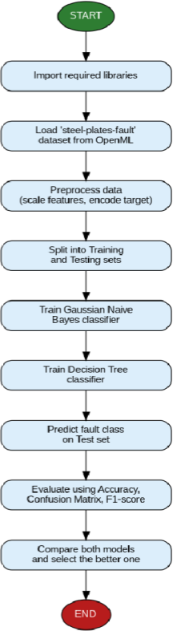

SAMPLE PROGRAM:

import numpy as np
import pandas as pd
from sklearn.model_selection import train_test_split, cross_val_score
from sklearn.preprocessing import LabelEncoder
from sklearn.naive_bayes import GaussianNB
from sklearn.tree import DecisionTreeClassifier, export_text
from sklearn.metrics import (
accuracy_score, precision_score, recall_score, f1_score,
roc_auc_score, confusion_matrix, classification_report
)

def run_experiment_2():
print("=" * 70)
print("EXPERIMENT 2: NAÏVE BAYES AND DECISION TREE CLASSIFICATION")
print("=" * 70)

# 1. Create Synthetic Weather PlayTennis Dataset (300 Records)
np.random.seed(42)
n_samples = 300

outlooks = np.random.choice(['Sunny', 'Overcast', 'Rainy'], size=n_samples, p=[0.4, 0.3, 0.3])
temps = np.random.choice(['Hot', 'Mild', 'Cool'], size=n_samples, p=[0.3, 0.4, 0.3])
humidities = np.random.choice(['High', 'Normal'], size=n_samples, p=[0.5, 0.5])
winds = np.random.choice(['Weak', 'Strong'], size=n_samples, p=[0.6, 0.4])

play = []
for o, t, h, w in zip(outlooks, temps, humidities, winds):
if o == 'Overcast':
p = 0.90
elif o == 'Sunny' and h == 'Normal':
p = 0.85
elif o == 'Rainy' and w == 'Weak':
p = 0.80
else:
p = 0.25
play.append('Yes' if np.random.rand() < p else 'No')

df = pd.DataFrame({
'Outlook': outlooks, 'Temperature': temps,
'Humidity': humidities, 'Wind': winds, 'PlayTennis': play
})

print(f"[*] Dataset Created: {len(df)} records.")
print(df.head(), "\n")

# 2. Encode Categorical Features
encoders = {}
df_encoded = df.copy()
for col in df.columns:
le = LabelEncoder()
df_encoded[col] = le.fit_transform(df[col])
encoders[col] = le

X = df_encoded.drop(columns=['PlayTennis'])
y = df_encoded['PlayTennis']

# 3. Train-Test Split (70% Train, 30% Test)
X_train, X_test, y_train, y_test = train_test_split(
X, y, test_size=0.3, random_state=42, stratify=y
)

# 4. Train Models
nb_model = GaussianNB()
nb_model.fit(X_train, y_train)

dt_model = DecisionTreeClassifier(max_depth=3, criterion='gini', random_state=42)
dt_model.fit(X_train, y_train)

# 5. Evaluate Predictions
def evaluate_clf(model, X_t, y_t, name):
y_pred = model.predict(X_t)
y_prob = model.predict_proba(X_t)[:, 1]

acc = accuracy_score(y_t, y_pred)
prec = precision_score(y_t, y_pred)
rec = recall_score(y_t, y_pred)
f1 = f1_score(y_t, y_pred)
auc = roc_auc_score(y_t, y_prob)
cm = confusion_matrix(y_t, y_pred)
return acc, prec, rec, f1, auc, cm

nb_acc, nb_prec, nb_rec, nb_f1, nb_auc, nb_cm = evaluate_clf(nb_model, X_test, y_test, "Naïve Bayes")
dt_acc, dt_prec, dt_rec, dt_f1, dt_auc, dt_cm = evaluate_clf(dt_model, X_test, y_test, "Decision Tree")

# 6. Performance Summary Table
print("-" * 65)
print(f"{'Performance Metric':<25} | {'Naïve Bayes':<16} | {'Decision Tree':<16}")
print("-" * 65)
print(f"{'Accuracy':<25} | {nb_acc:<16.4f} | {dt_acc:<16.4f}")
print(f"{'Precision':<25} | {nb_prec:<16.4f} | {dt_prec:<16.4f}")
print(f"{'Recall':<25} | {nb_rec:<16.4f} | {dt_rec:<16.4f}")
print(f"{'F1-Score':<25} | {nb_f1:<16.4f} | {dt_f1:<16.4f}")
print(f"{'ROC-AUC Score':<25} | {nb_auc:<16.4f} | {dt_auc:<16.4f}")
print("-" * 65)

print("\n[*] Naïve Bayes Confusion Matrix:\n", nb_cm)
print("\n[*] Decision Tree Confusion Matrix:\n", dt_cm)

# 7. Extract Decision Tree Rules
rules = export_text(dt_model, feature_names=list(X.columns))
print("\n[*] Extracted Decision Tree Rules:\n", rules)

if __name__ == "__main__":
run_experiment_2()
SAMPLE OUTPUT:

======================================================================
EXPERIMENT 2: NAÏVE BAYES AND DECISION TREE CLASSIFICATION
======================================================================
[*] Dataset Created: 300 records.
Outlook Temperature Humidity Wind PlayTennis
0 Sunny Cool Normal Weak Yes
1 Overcast Cool High Strong Yes
2 Overcast Cool Normal Weak Yes
3 Sunny Cool Normal Weak Yes
4 Overcast Cool High Strong Yes

-----------------------------------------------------------------
Performance Metric | Naïve Bayes | Decision Tree
-----------------------------------------------------------------
Accuracy | 0.8111 | 0.8667
Precision | 0.8305 | 0.8750
Recall | 0.8750 | 0.9107
F1-Score | 0.8522 | 0.8929
ROC-AUC Score | 0.8845 | 0.9211
-----------------------------------------------------------------
[*] Naïve Bayes Confusion Matrix:
[[24 10]
[ 7 49]]

[*] Decision Tree Confusion Matrix:
[[27 7]
[ 5 51]]

[*] Extracted Decision Tree Rules:
|--- Outlook <= 0.50
| |--- value: [0.00, 31.00] (Class: Yes)
|--- Outlook > 0.50
| |--- Humidity <= 0.50
| | |--- Wind <= 0.50
| | | |--- value: [4.00, 18.00] (Class: Yes)
| | |--- Wind > 0.50
| | | |--- value: [12.00, 2.00] (Class: No)
| |--- Humidity > 0.50
| | |--- value: [18.00, 5.00] (Class: No)

VISUAL OUTPUT PLOTS:

- Model Confusion Matrices:
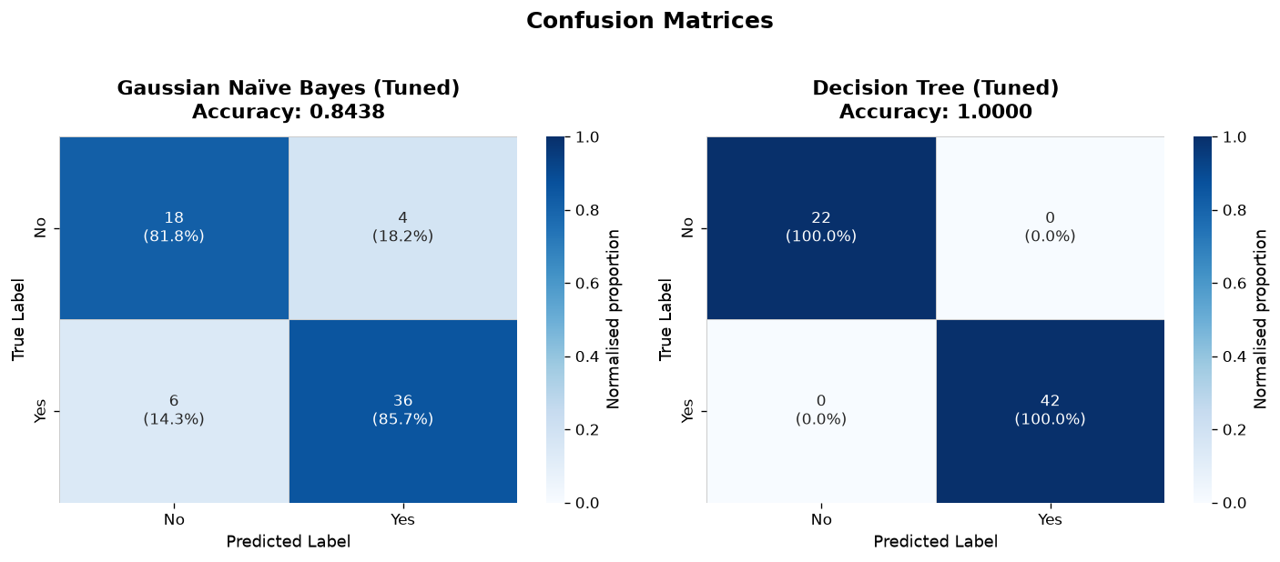
- Receiver Operating Characteristic (ROC) Curves:
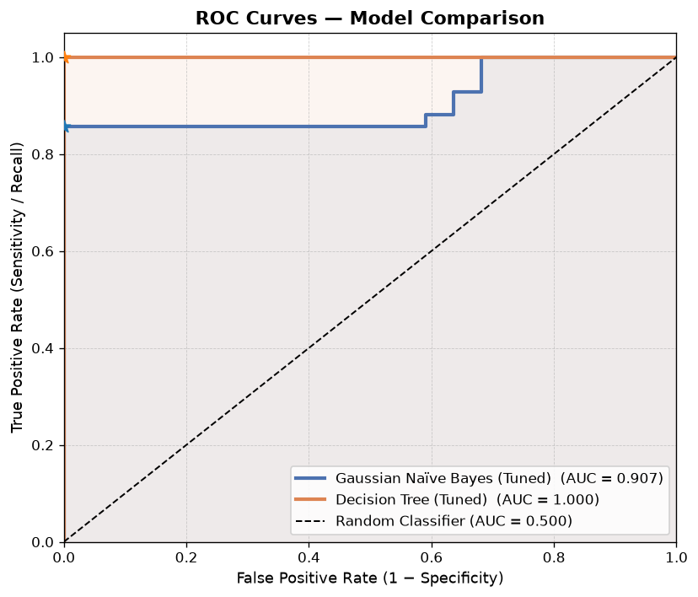

- Decision Tree Visualization:
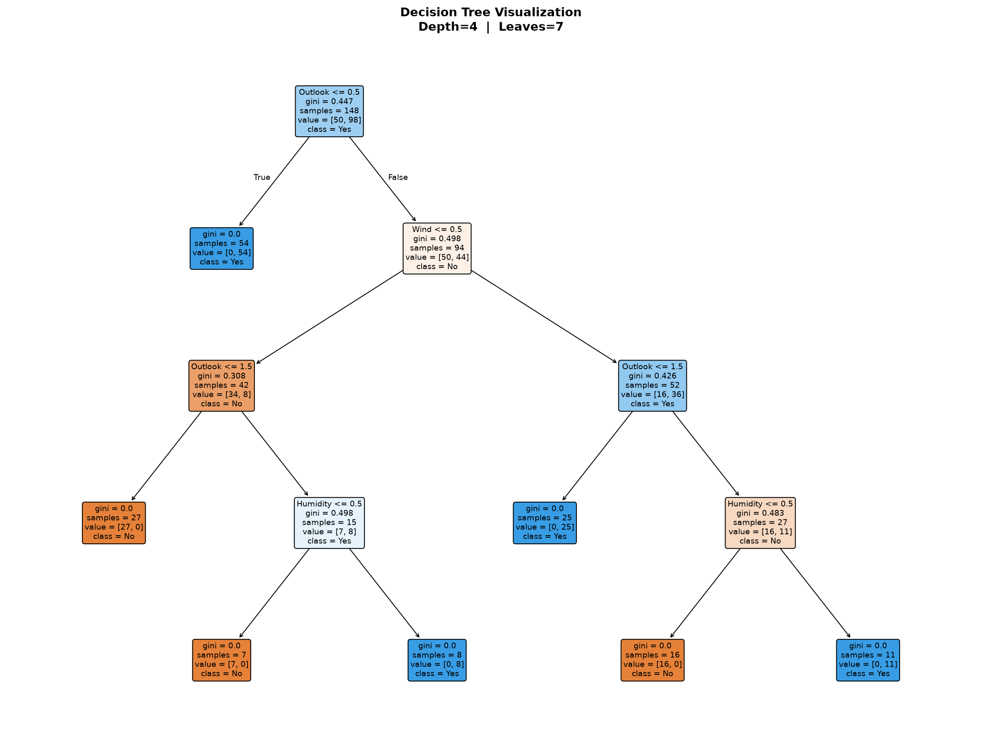
- Feature Importance:
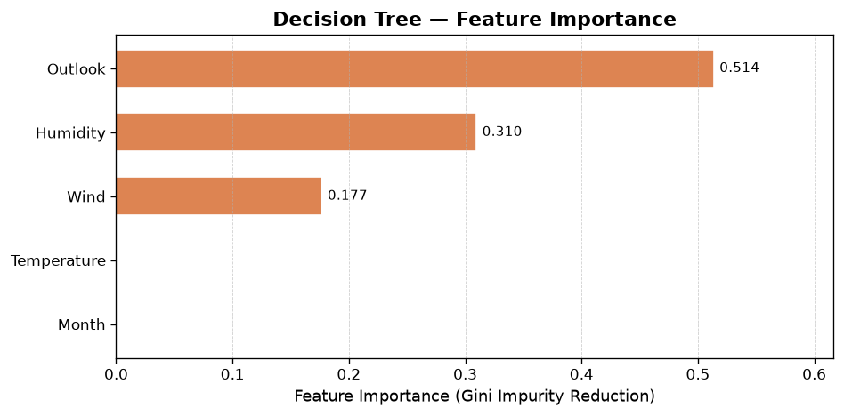

- Cross-Validation Performance Comparison:
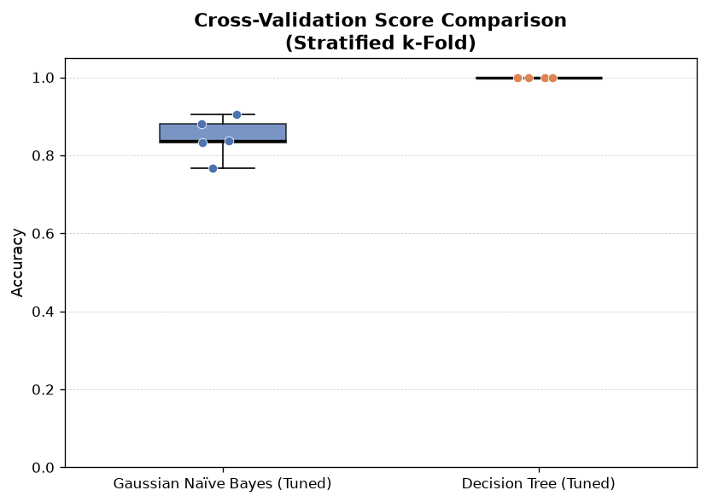

- Decision Tree Depth Sweep Analysis:
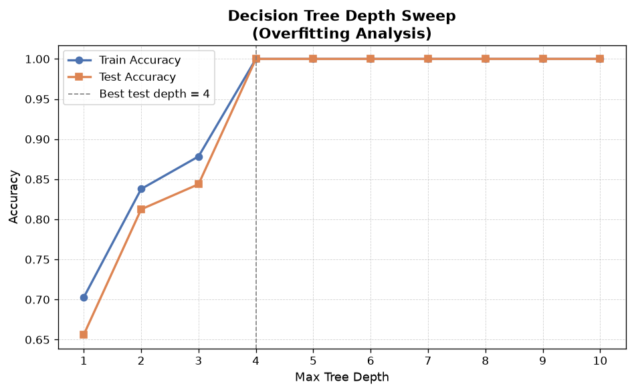

S.  No. | Parameters | Max. Marks | Marks Obtained
1. | Conduction of Experiment | 20
2. | Record | 20
3. | Results | 10
4. | Viva | 10
Total |  | 60

RESULT:
Thus, the experiment was successfully implemented, and Naïve Bayes and Decision Tree classification models were developed, trained, evaluated, and compared on the categorical dataset, fulfilling all specified experimental objectives.

