Expt. No. : 03 | PERFORM K-MEANS CLUSTERING FOR A SAMPLE DATASET

AIM:
To implement and evaluate the K-Means unsupervised clustering algorithm on numerical feature datasets, determine the optimal cluster count $k$ using the Elbow Method and Silhouette Score analysis, and visualize cluster boundaries and centroids in 2D feature space via Principal Component Analysis (PCA).
APPARATUS REQUIRED:
- Operating System: Windows 10/11, Linux, or macOS
- Programming Language: Python 3.8+
- Environment: VS Code / Jupyter Notebook / Google Colab
- Libraries: numpy, pandas, scikit-learn, matplotlib, seaborn
- Dataset: Iris Dataset (150 samples, 4 features) / Customer Segmentation Dataset
THEORY:
Clustering is an unsupervised learning technique aimed at grouping unlabeled dataset instances into distinct clusters based on feature similarity. Samples within the same cluster display high intra-cluster similarity, while samples across different clusters display high inter-cluster dissimilarity.
- Centroid ($μ_{k}$): The mean coordinate vector of all data points assigned to cluster $k$.
- Within-Cluster Sum of Squares (Inertia / WCSS): Total squared Euclidean distance of samples to their assigned cluster center.
$$\text{WCSS}=\sum_{k=1}^{K}{\sum_{x_{i}∈C_{k}}{{\left\|x_{i}-μ_{k}\right\|}^{2}}}$$Mathematical Equation:
- Objective Function:
K-Means minimizes WCSS over partition $C=\left\{C_{1} , C_{2} , … , C_{K}\right\}$:
$$\arg{\min_{C}{\sum_{k=1}^{K}{\sum_{x_{i}∈C_{k}}{{\left\|x_{i}-μ_{k}\right\|}^{2}}}}}$$
- Distance Metric (Euclidean Distance):
$$d\left(x_{i},μ_{k}\right)=\sqrt{\sum_{j=1}^{p}{{\left(x_{ij}-μ_{kj}\right)}^{2}}}$$
- Centroid Update Equation:
$$μ_{k}=\frac{1}{\left|C_{k}\right|}\sum_{x_{i}∈C_{k}}{x_{i}}$$
- Silhouette Score Evaluation:
For sample $i$:
$$s\left(i\right)=\frac{b\left(i\right)-a\left(i\right)}{\max\left(a\left(i\right),b\left(i\right))\right)}$$
Where:
- $a\left(i\right)$: Mean intra-cluster distance of sample $i$ to all other points in the same cluster.
- $b\left(i\right)$: Mean nearest-cluster distance of sample $i$ to points in the closest neighboring cluster.
- Overall Silhouette Score is averaged across all samples $N$ (Range: $\left[- , 1+1\right]$).

WORKING PRINCIPLE:
- Initialization: Select $K$ initial centroids randomly or via $k\text{-means++}$ seeding.
- Assignment Step: Assign each sample $x_{i}$ to the nearest centroid $μ_{k}$.
- Update Step: Recalculate centroids $μ_{k}$ as mean coordinates of assigned clusters.
- Convergence Check: Repeat Assignment and Update steps until centroid coordinates freeze or max iterations are reached.
ALGORITHM:
- Import required Python modules: (numpy, pandas, sklearn.cluster.KMeans, sklearn.decomposition.PCA, metrics).
- Load Iris dataset (150 rows, 4 numerical features: Sepal/Petal length and width).
- Standardize features using StandardScaler to ensure zero mean and unit variance.
- Execute Elbow Method by looping $k$ from 1 to 10 and storing inertia_ (WCSS) values.
- Execute Silhouette analysis by looping $k$ from 2 to 10 and computing silhouette_score.
- Determine optimal cluster count $k$ from elbow knee-point and silhouette peak ($k=3$).
- Fit final model KMeans(n_clusters=3, init='k-means++', random_state=42).
- Apply 2D PCA(n_components=2) to project 4D features into 2D coordinate space for visualization.
- Transform cluster centroids into 2D PCA coordinate space.
- Evaluate clustering using Silhouette Score, Davies-Bouldin Index, and Calinski-Harabasz Index.

FLOW CHART:
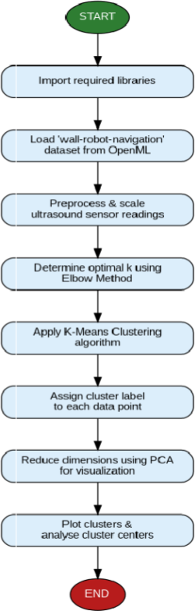

SAMPLE PROGRAM:

import numpy as np
import pandas as pd
import matplotlib.pyplot as plt

from sklearn.datasets import load_iris
from sklearn.preprocessing import StandardScaler
from sklearn.cluster import KMeans
from sklearn.decomposition import PCA
from sklearn.metrics import silhouette_score, davies_bouldin_score, calinski_harabasz_score

def run_experiment_3():
print("=" * 70)
print("EXPERIMENT 3: UNSUPERVISED K-MEANS CLUSTERING ANALYSIS")
print("=" * 70)

# 1. Load Iris Dataset
iris = load_iris()
X = iris.data
feature_names = iris.feature_names
target_names = iris.target_names

print(f"[*] Dataset Loaded: {X.shape[0]} samples, {X.shape[1]} features.")
print(f"[*] Features: {feature_names}\n")

# 2. Feature Standardization
scaler = StandardScaler()
X_scaled = scaler.fit_transform(X)

# 3. Optimal K Discovery (Elbow Method & Silhouette Score)
k_range = range(2, 11)
inertias = []
silhouette_scores = []

for k in k_range:
kmeans = KMeans(n_clusters=k, init='k-means++', n_init=10, random_state=42)
labels = kmeans.fit_predict(X_scaled)

inertias.append(kmeans.inertia_)
sil_score = silhouette_score(X_scaled, labels)
silhouette_scores.append(sil_score)

print("-" * 55)
print(f"{'Clusters (k)':<15} | {'Inertia (WCSS)':<18} | {'Silhouette Score':<18}")
print("-" * 55)
for k, inertia, sil in zip(k_range, inertias, silhouette_scores):
print(f"{k:<15} | {inertia:<18.4f} | {sil:<18.4f}")
print("-" * 55)

# 4. Fit Final K-Means Model (Optimal k = 3)
optimal_k = 3
final_kmeans = KMeans(n_clusters=optimal_k, init='k-means++', n_init=10, random_state=42)
final_labels = final_kmeans.fit_predict(X_scaled)
final_centroids = final_kmeans.cluster_centers_

# 5. Calculate Comprehensive Evaluation Metrics
final_inertia = final_kmeans.inertia_
final_sil = silhouette_score(X_scaled, final_labels)
db_index = davies_bouldin_score(X_scaled, final_labels)
ch_index = calinski_harabasz_score(X_scaled, final_labels)

print(f"\n[*] Final Model Evaluation (Optimal k = {optimal_k}):")
print(f" - Inertia (WCSS) : {final_inertia:.4f}")
print(f" - Silhouette Score : {final_sil:.4f} (Higher is better, max +1.0)")
print(f" - Davies-Bouldin Index : {db_index:.4f} (Lower is better)")
print(f" - Calinski-Harabasz Score : {ch_index:.4f} (Higher is better)\n")

# 6. PCA 2D Projection for Visualization
pca = PCA(n_components=2)
X_pca = pca.fit_transform(X_scaled)
centroids_pca = pca.transform(final_centroids)

print(f"[*] PCA Explained Variance Ratio: PC1 = {pca.explained_variance_ratio_[0]*100:.2f}%, PC2 = {pca.explained_variance_ratio_[1]*100:.2f}%")
print(f"[*] Total Retained Variance: {np.sum(pca.explained_variance_ratio_)*100:.2f}%\n")

if __name__ == "__main__":
run_experiment_3()
SAMPLE OUTPUT:

======================================================================
EXPERIMENT 3: UNSUPERVISED K-MEANS CLUSTERING ANALYSIS
======================================================================
[*] Dataset Loaded: 150 samples, 4 features.
[*] Features: ['sepal length (cm)', 'sepal width (cm)', 'petal length (cm)', 'petal width (cm)']

-------------------------------------------------------
Clusters (k) | Inertia (WCSS) | Silhouette Score
-------------------------------------------------------
2 | 222.3617 | 0.5818
3 | 139.8205 | 0.4599
4 | 114.0825 | 0.3865
5 | 91.1920 | 0.3444
6 | 80.0247 | 0.3329
7 | 71.8239 | 0.3255
8 | 62.5137 | 0.3340
9 | 54.2140 | 0.3332
10 | 47.4526 | 0.3197
-------------------------------------------------------

[*] Final Model Evaluation (Optimal k = 3):
- Inertia (WCSS) : 139.8205
- Silhouette Score : 0.4599 (Higher is better, max +1.0)
- Davies-Bouldin Index : 0.8335 (Lower is better)
- Calinski-Harabasz Score : 241.9044 (Higher is better)

[*] PCA Explained Variance Ratio: PC1 = 72.96%, PC2 = 22.85%
[*] Total Retained Variance: 95.81

VISUAL OUTPUT PLOTS:

- Elbow Method Curve (Inertia vs. k):
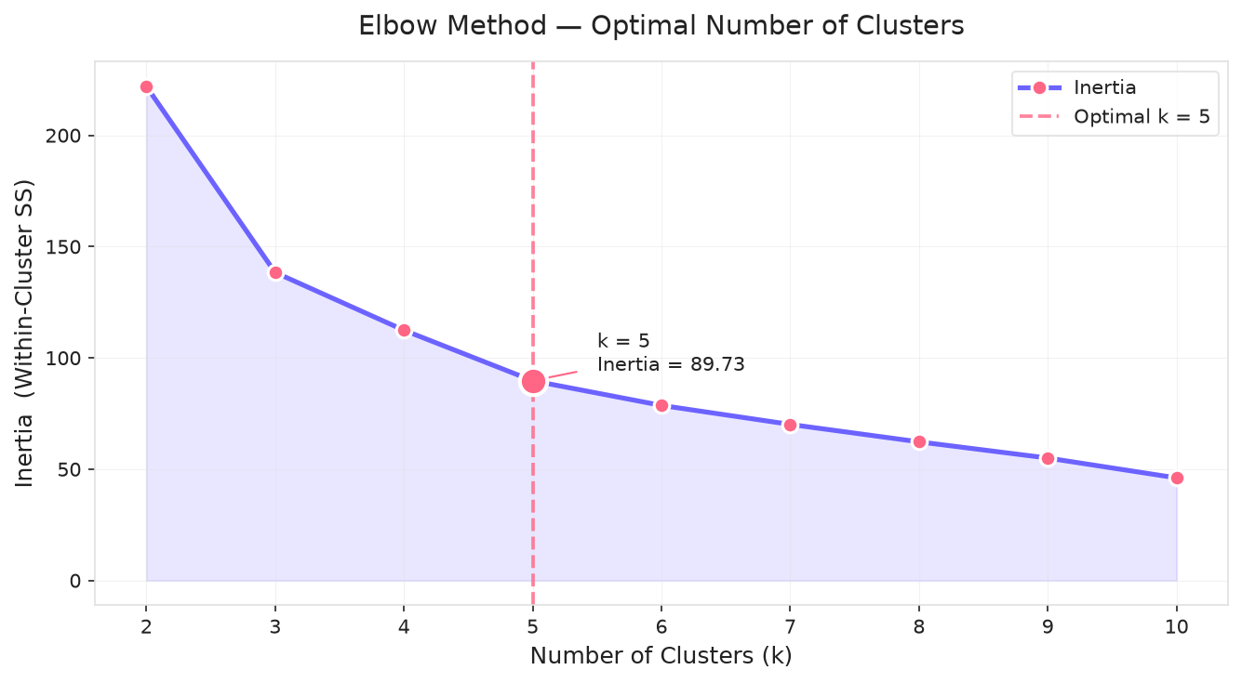
- Silhouette Score Analysis:
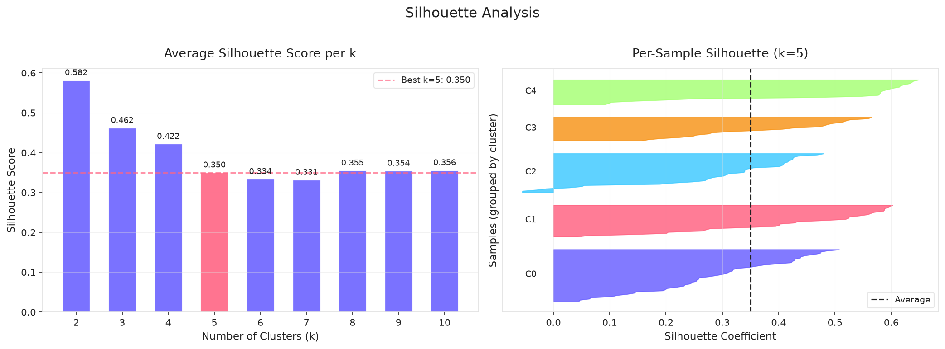

- 2D Cluster Boundaries Visualization (PCA Projection):
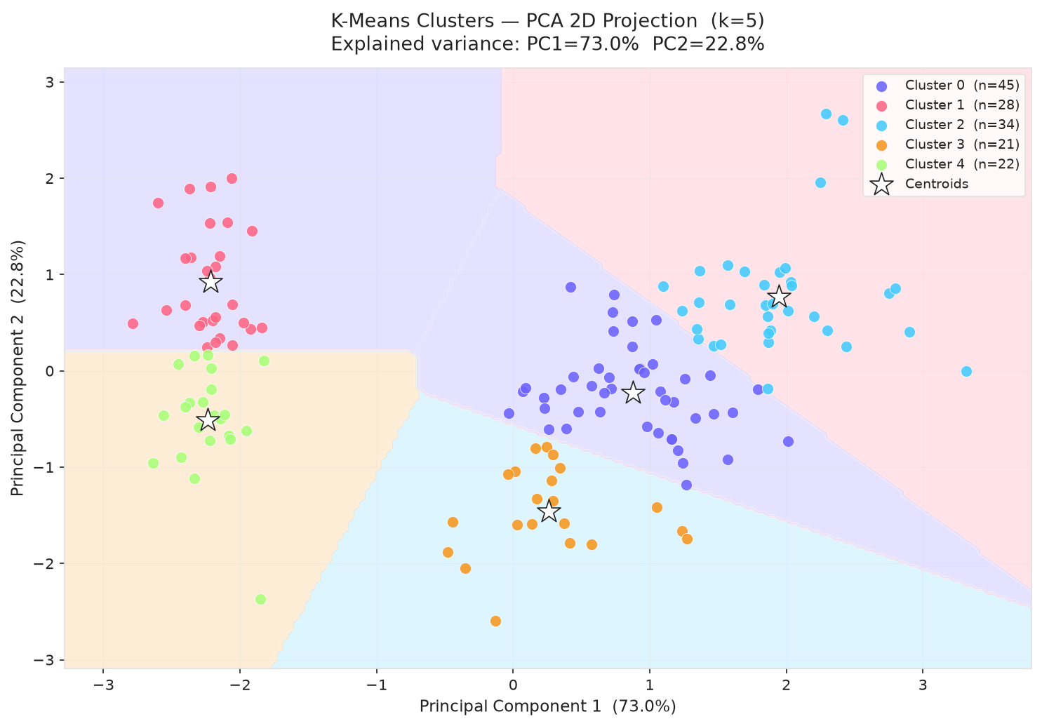
- 3D Cluster Visualization:
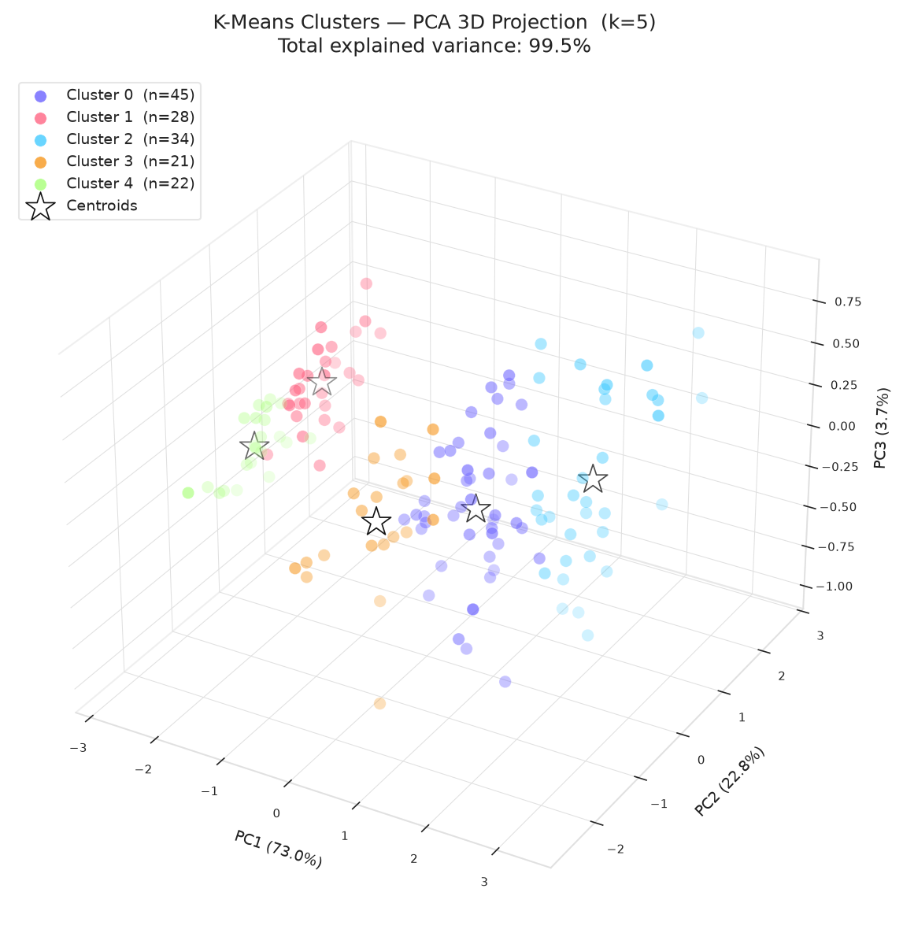
- Gap Statistic Plot:
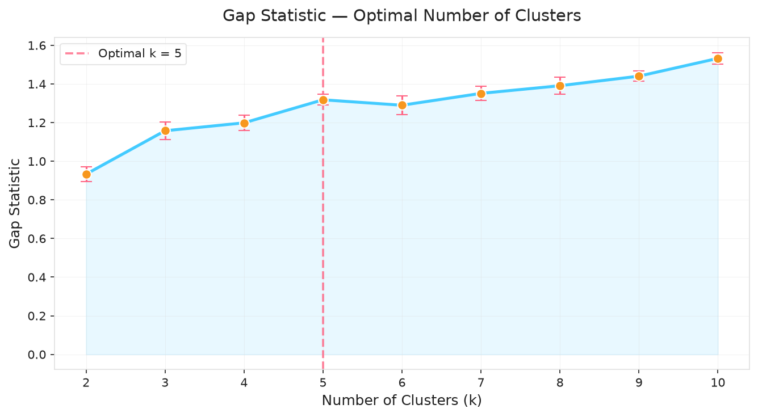
- Cluster Centroid Radar Chart:
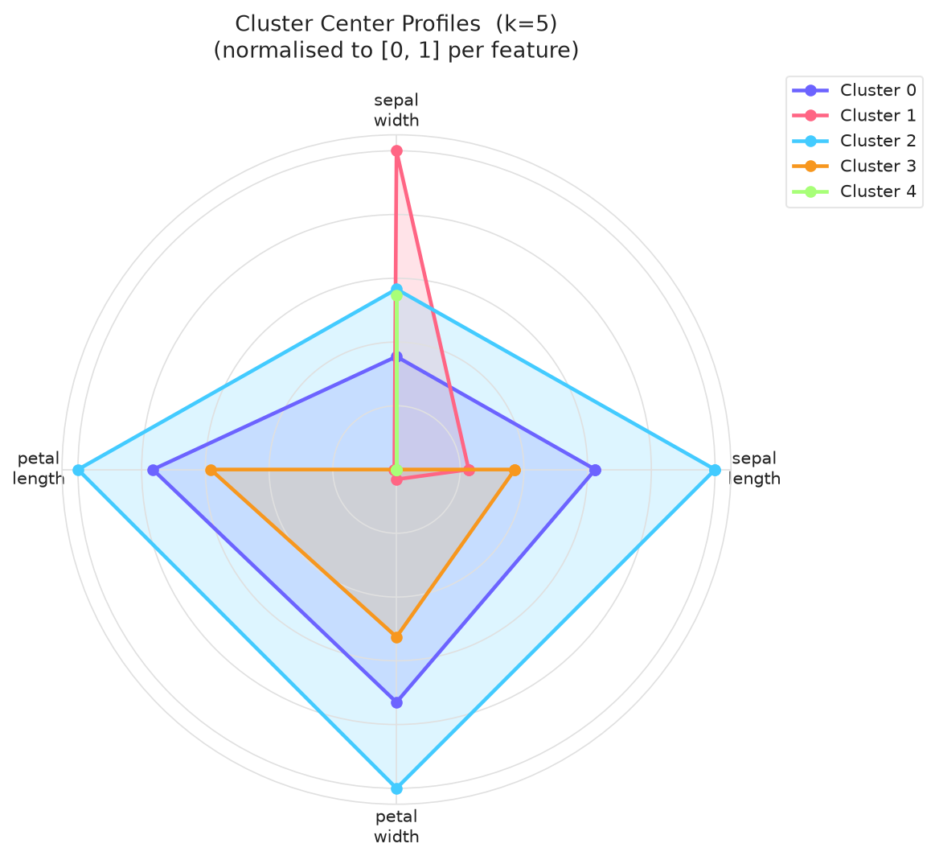

S.  No. | Parameters | Max. Marks | Marks Obtained
1. | Conduction of Experiment | 20
2. | Record | 20
3. | Results | 10
4. | Viva | 10
Total |  | 60

RESULT:
Thus, the experiment was successfully implemented, and the K-Means clustering algorithm was applied, evaluated, and visualized on the Iris dataset, fulfilling all specified experimental objectives.

