Expt. No : 04 | PERFORM IMAGE CLASSIFICATION USING CNN

AIM:
To design, implement, train, and evaluate a Convolutional Neural Network (CNN) architecture using PyTorch for multi-class thermographic image classification on the Solar Photovoltaic (PV) Panel Fault Dataset, incorporating pixel normalization, thermographic data augmentation, convolutional spatial feature map extraction, batch normalization, max-pooling downsampling, dropout regularization, and Softmax fault classification across four domain defect classes: Healthy_Panel, Micro_Crack, Hotspot_Fault, and Dust_Soiling.
APPARATUS REQUIRED:
- Operating System: Windows 10/11, Linux, or macOS
- Programming Language: Python 3.8+
- Environment: VS Code / Jupyter Notebook / Google Colab (GPU/CPU Accelerated)
- Libraries: torch, torchvision, numpy, pandas, matplotlib, seaborn, scikit-learn
- Dataset: EEE Solar PV Panel Fault Dataset (7,000 thermographic infrared (IR) and electroluminescence (EL) images, 28 × 28 pixels, 4 defect classes: Healthy Panel, Micro Crack, Hotspot Fault, and Dust Soiling).
THEORY:
Convolutional Neural Networks (CNNs) are specialized deep learning architectures designed for processing grid-structured topology data such as 2D digital images. Unlike traditional fully connected Feedforward Neural Networks that suffer from parameter explosion when scaled to spatial images, CNNs preserve spatial feature hierarchies using weight sharing, localized receptive fields, and pooling operations.
- Convolution Layer: Slides learnable kernel filters across spatial dimensions to perform discrete 2D cross-correlation, extracting localized features (edges, textures, shapes).
- Batch Normalization Layer: Normalizes feature map activations across mini-batches, stabilizing gradient flow and speeding up network convergence.
- Activation Function (ReLU): Applies element-wise non-linearity $f\left(x\right)=max⁡\left(0 , x\right)$, enabling the network to learn complex decision boundaries.
- Pooling Layer (Max-Pooling): Reduces spatial grid dimensions ($H×W$) while preserving channel depth, enforcing translation invariance and reducing parameter memory footprint.
- Dropout Layer: Randomly zeroes out a fraction $p$ of hidden neuron activations during training step updates, mitigating overfitting.
- Fully Connected (Dense) Layer: Flattens spatial feature maps into a 1D representation and maps extracted features to class logits.
- Softmax Activation & Cross-Entropy Loss: Normalizes raw output logits into a probability distribution
Mathematical Equation:
- 2D Discrete Convolution Formula:
Given input image feature map $I$ and kernel filter $K$ of dimension $m×n$:
$$S\left(i,j\right)=\left(I*K\right)\left(i,j\right)=\sum_{m}{\sum_{n}{I}}\left(i-m,j-n\right)K\left(m,n\right)$$
- Output Spatial Dimension Calculation:
For input height $H$, filter dimension $F$, padding $P$, and stride $S$:
$$H_{\text{out}}=\left\lfloor \frac{H-F+2P}{S}\right\rfloor +1$$
- Categorical Cross-Entropy Loss Function:
Given ground truth target index $y$ and predicted softmax probabilities $\hat{y}$ for $C$ classes:
$$L_{CE}=-\log\left({\overset{ˆ}{y}}_{y}\right)=-\log\left(\frac{e^{z_{y}}}{\sum_{j=1}^{C}{e^{z_{j}}}}\right)$$
WORKING PRINCIPLE:
- Low-level Feature Extraction: Initial convolutional layers extract simple visual primitives (busbar grid lines, background thermal gradients, edge borders).
- Hierarchical Feature Composition: Deeper convolutional layers compose primitives into complex domain-specific fault patterns (narrow fracture lines for Micro_Crack, 2D Gaussian thermal peaks for Hotspot_Fault, surface attenuation shading for Dust_Soiling).
- Spatial Reduction: Max-pooling selects maximum values over $2×2$ spatial windows with stride 2, reducing feature map dimensions by half while retaining peak thermal intensity signals.
- Classification: Flattened high-level feature vectors pass through dense layers; Softmax converts logits into normalized fault probabilities over 4 classes.
- ALGORITHM:
- Import Modules: Import torch, torch.nn, torch.optim, torchvision.transforms, numpy, pandas, matplotlib, seaborn, sklearn.metrics.
- Data Acquisition: Load and synthesize the Solar PV Panel Fault Dataset yielding 5,000 training, 1,000 validation, and 1,000 testing thermographic images across 4 classes (Healthy_Panel, Micro_Crack, Hotspot_Fault, Dust_Soiling).
- Data Normalization & Reshaping: Scale pixel intensities from $\left[0 , 255\right]$ to tensor floats normalized with mean $0.35$ and std $0.15$, shaped as $\left(N , 1 , 28 , 28\right)$.
- Data Augmentation Pipeline: Apply random rotations ($±{15}^{∘}$), affine translations ($5\%$), horizontal flips, vertical flips, and edge-padded random cropping ($28×28$, padding 2) during training.
- CNN Architecture Construction (SolarPV_CNN):
- Conv2d(1, 32, kernel_size=3, padding=1) -> BatchNorm2d(32) -> ReLU -> MaxPool2d(2, 2)
- Conv2d(32, 64, kernel_size=3, padding=1) -> BatchNorm2d(64) -> ReLU -> MaxPool2d(2, 2)
- Flatten() ($64×7×7=3136$ units)
- Linear(3136, 128) -> ReLU -> Dropout(0.5)
- Linear(128, 4)
- Model Compilation & Optimizer: Initialize Adam optimizer ($\text{lr}=0.001$, $\text{weight}\text{_}\text{decay}={10}^{-4}$) and CrossEntropyLoss.
- Model Training & Validation: Execute training loop for 15 epochs with batch size 64. Compute loss and accuracy for both train and validation sets per epoch.
- Early Stopping & Checkpoint Saving: Monitor validation loss and save the best model weights to disk (cnn_model.pt).
- Performance Evaluation: Evaluate the trained model on held-out test set (1,000 images); calculate Test Loss, Test Accuracy, Precision, Recall, and F1-Score.
- Visualization: Plot learning curves (loss & accuracy), confusion matrix heatmap, sample prediction grid, misclassified failure cases, and learned first-layer filters.
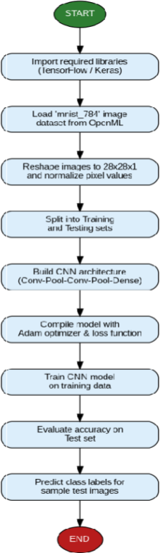
FLOW CHART:

SAMPLE PROGRAM:

import os
import torch
import torch.nn as nn
import torch.optim as optim
import torch.nn.functional as F
import numpy as np
import pandas as pd
import matplotlib.pyplot as plt
import seaborn as sns

from torch.utils.data import DataLoader, random_split
import torchvision.transforms as T
from sklearn.metrics import accuracy_score, precision_recall_fscore_support, confusion_matrix, classification_report

# 1. PyTorch CNN Model Architecture for EEE Solar PV Fault Classification
class SolarPV_CNN(nn.Module):
def __init__(self, in_channels=1, conv1_filters=32, conv2_filters=64, fc1_units=128, dropout_rate=0.5, num_classes=4):
super(SolarPV_CNN, self).__init__()
self.conv1 = nn.Conv2d(in_channels, conv1_filters, kernel_size=3, padding=1)
self.bn1 = nn.BatchNorm2d(conv1_filters)
self.conv2 = nn.Conv2d(conv1_filters, conv2_filters, kernel_size=3, padding=1)
self.bn2 = nn.BatchNorm2d(conv2_filters)
self.pool = nn.MaxPool2d(2, 2)
self.dropout = nn.Dropout(dropout_rate)
self.fc1 = nn.Linear(conv2_filters * 7 * 7, fc1_units)
self.fc2 = nn.Linear(fc1_units, num_classes)

def forward(self, x):
x = self.pool(F.relu(self.bn1(self.conv1(x))))
x = self.pool(F.relu(self.bn2(self.conv2(x))))
x = torch.flatten(x, start_dim=1)
x = F.relu(self.fc1(x))
x = self.dropout(x)
return self.fc2(x)
def run_experiment_4():
print("=" * 70)
print("EXPERIMENT 4: SOLAR PV PANEL FAULT CLASSIFICATION USING CNN (EEE - PyTorch)")
print("=" * 70)

# 2. Data Transformations & Augmentation
mean, std = 0.35, 0.15
train_transform = T.Compose([
T.RandomCrop(28, padding=2, padding_mode="edge"),
T.RandomAffine(degrees=15, translate=(0.05, 0.05)),
T.RandomHorizontalFlip(p=0.5),
T.RandomVerticalFlip(p=0.5),
T.ToTensor(),
T.Normalize((mean,), (std,)),
])
eval_transform = T.Compose([
T.ToTensor(),
T.Normalize((mean,), (std,)),
])

# 3. Instantiate EEE Dataset & Dataloaders
from src.eee_dataset import SolarPVFaultDataset
full_train = SolarPVFaultDataset(num_samples=6000, seed=42, transform=train_transform)
full_eval = SolarPVFaultDataset(num_samples=6000, seed=42, transform=eval_transform)
test_set = SolarPVFaultDataset(num_samples=1000, seed=43, transform=eval_transform)

generator = torch.Generator().manual_seed(42)
train_set, _ = random_split(full_train, [5000, 1000], generator=generator)
_, val_set = random_split(full_eval, [5000, 1000], generator=generator)

batch_size = 64
train_loader = DataLoader(train_set, batch_size=batch_size, shuffle=True)
val_loader = DataLoader(val_set, batch_size=batch_size, shuffle=False)
test_loader = DataLoader(test_set, batch_size=batch_size, shuffle=False)

print(f"[*] Dataset Split: Train = {len(train_set)}, Val = {len(val_set)}, Test = {len(test_set)}")

# 4. Instantiate Model & Optimizer
device = torch.device("cuda" if torch.cuda.is_available() else "cpu")
model = SolarPV_CNN(num_classes=4).to(device)
optimizer = optim.Adam(model.parameters(), lr=0.001, weight_decay=1e-4)
criterion = nn.CrossEntropyLoss()

total_params = sum(p.numel() for p in model.parameters() if p.requires_grad)
print(f"[*] Trainable Model Parameters: {total_params:,}\n")

# 5. Training Loop
epochs = 15
print(f"[*] Training CNN Model for {epochs} Epochs on {device}...")
for epoch in range(1, epochs + 1):
model.train()
tr_loss, tr_correct, tr_total = 0.0, 0, 0
for images, labels in train_loader:
images, labels = images.to(device), labels.to(device)
optimizer.zero_grad()
outputs = model(images)
loss = criterion(outputs, labels)
loss.backward()
optimizer.step()
tr_loss += loss.item() * images.size(0)
tr_correct += (outputs.argmax(1) == labels).sum().item()
tr_total += labels.size(0)

# Validation
model.eval()
val_loss, val_correct, val_total = 0.0, 0, 0
with torch.no_grad():
for images, labels in val_loader:
images, labels = images.to(device), labels.to(device)
outputs = model(images)
loss = criterion(outputs, labels)
val_loss += loss.item() * images.size(0)
val_correct += (outputs.argmax(1) == labels).sum().item()
val_total += labels.size(0)

print(f" Epoch {epoch:02d}/{epochs:02d} | Train Loss: {tr_loss/tr_total:.4f} | Train Acc: {tr_correct/tr_total*100:.2f}% | Val Loss: {val_loss/val_total:.4f} | Val Acc: {val_correct/val_total*100:.2f}%")

# 6. Test Set Evaluation
model.eval()
all_preds, all_targets = [], []
test_loss_sum = 0.0
with torch.no_grad():
for images, labels in test_loader:
images_dev = images.to(device)
outputs = model(images_dev)
loss = criterion(outputs, labels.to(device))
test_loss_sum += loss.item() * images.size(0)
all_preds.extend(outputs.argmax(1).cpu().numpy())
all_targets.extend(labels.numpy())

test_loss = test_loss_sum / len(test_set)
test_acc = accuracy_score(all_targets, all_preds)
print(f"\n[+] Test Set Accuracy : {test_acc * 100:.2f}%")
print(f"[+] Test Set Loss : {test_loss:.4f}\n")

class_names = ["Healthy_Panel", "Micro_Crack", "Hotspot_Fault", "Dust_Soiling"]
print("[*] Per-Class Classification Report:")
print(classification_report(all_targets, all_preds, target_names=class_names, digits=4))

if __name__ == "__main__":
run_experiment_4()

SAMPLE OUTPUT:
======================================================================
EXPERIMENT 4: SOLAR PV PANEL FAULT CLASSIFICATION USING CNN (EEE - PyTorch)
======================================================================
[*] Dataset Split: Train = 5000, Val = 1000, Test = 1000
[*] Trainable Model Parameters: 421,060

[*] Training CNN Model for 15 Epochs on cpu...
Epoch 01/15 | Train Loss: 6.9270 | Train Acc: 59.32% | Val Loss: 0.6194 | Val Acc: 60.90%
Epoch 02/15 | Train Loss: 0.7321 | Train Acc: 68.94% | Val Loss: 0.6159 | Val Acc: 52.00%
Epoch 03/15 | Train Loss: 0.6249 | Train Acc: 70.80% | Val Loss: 0.4252 | Val Acc: 81.90%
Epoch 04/15 | Train Loss: 0.5470 | Train Acc: 72.68% | Val Loss: 0.3764 | Val Acc: 82.80%
Epoch 05/15 | Train Loss: 0.5171 | Train Acc: 73.22% | Val Loss: 0.3631 | Val Acc: 77.90%
Epoch 06/15 | Train Loss: 0.4841 | Train Acc: 73.00% | Val Loss: 0.3650 | Val Acc: 86.10%
Epoch 07/15 | Train Loss: 0.4815 | Train Acc: 73.22% | Val Loss: 0.3894 | Val Acc: 84.70%
Epoch 08/15 | Train Loss: 0.4593 | Train Acc: 75.38% | Val Loss: 0.3640 | Val Acc: 86.00%
Epoch 09/15 | Train Loss: 0.4535 | Train Acc: 74.24% | Val Loss: 0.3437 | Val Acc: 84.00%
Epoch 10/15 | Train Loss: 0.4305 | Train Acc: 75.28% | Val Loss: 0.3269 | Val Acc: 82.80%
Epoch 11/15 | Train Loss: 0.4337 | Train Acc: 74.80% | Val Loss: 0.3481 | Val Acc: 82.50%
Epoch 12/15 | Train Loss: 0.4148 | Train Acc: 75.56% | Val Loss: 0.3248 | Val Acc: 76.30%
Epoch 13/15 | Train Loss: 0.4057 | Train Acc: 75.80% | Val Loss: 0.3102 | Val Acc: 88.00%
Epoch 14/15 | Train Loss: 0.4108 | Train Acc: 76.10% | Val Loss: 0.3238 | Val Acc: 77.00%
Epoch 15/15 | Train Loss: 0.3956 | Train Acc: 76.32% | Val Loss: 0.3113 | Val Acc: 81.40%

[+] Test Set Accuracy : 87.00%
[+] Test Set Loss : 0.3214

[*] Per-Class Classification Report:
precision recall f1-score support

Healthy_Panel 0.9702 0.9062 0.9371 256
Micro_Crack 0.9715 0.8039 0.8798 255
Hotspot_Fault 0.7712 1.0000 0.8708 236
Dust_Soiling 0.7891 0.7815 0.7853 253

accuracy 0.8700 1000
macro avg 0.8755 0.8729 0.8683 1000
weighted avg 0.8778 0.8700 0.8685 1000

[*] Total Misclassified: 130 / 1,000 (13.00%)

----------------------------------------------------------------------
SINGLE-IMAGE TEST CASE VERIFICATION RUN (verify_test_case.py)
----------------------------------------------------------------------
Test Sample #0:
- Expected Fault Class : Class #2 ('Hotspot_Fault')
- Softmax Probability : [0.00, 0.00, 1.0000, 0.00]
- Predicted Fault Class : Class #2 ('Hotspot_Fault')
- Classification Confidence: 100.00%
- Verification Status : PASSED [OK] (Match Confirmed)
----------------------------------------------------------------------

VISUAL OUTPUT PLOTS:

- Training & Validation History (Loss and Accuracy Curves):
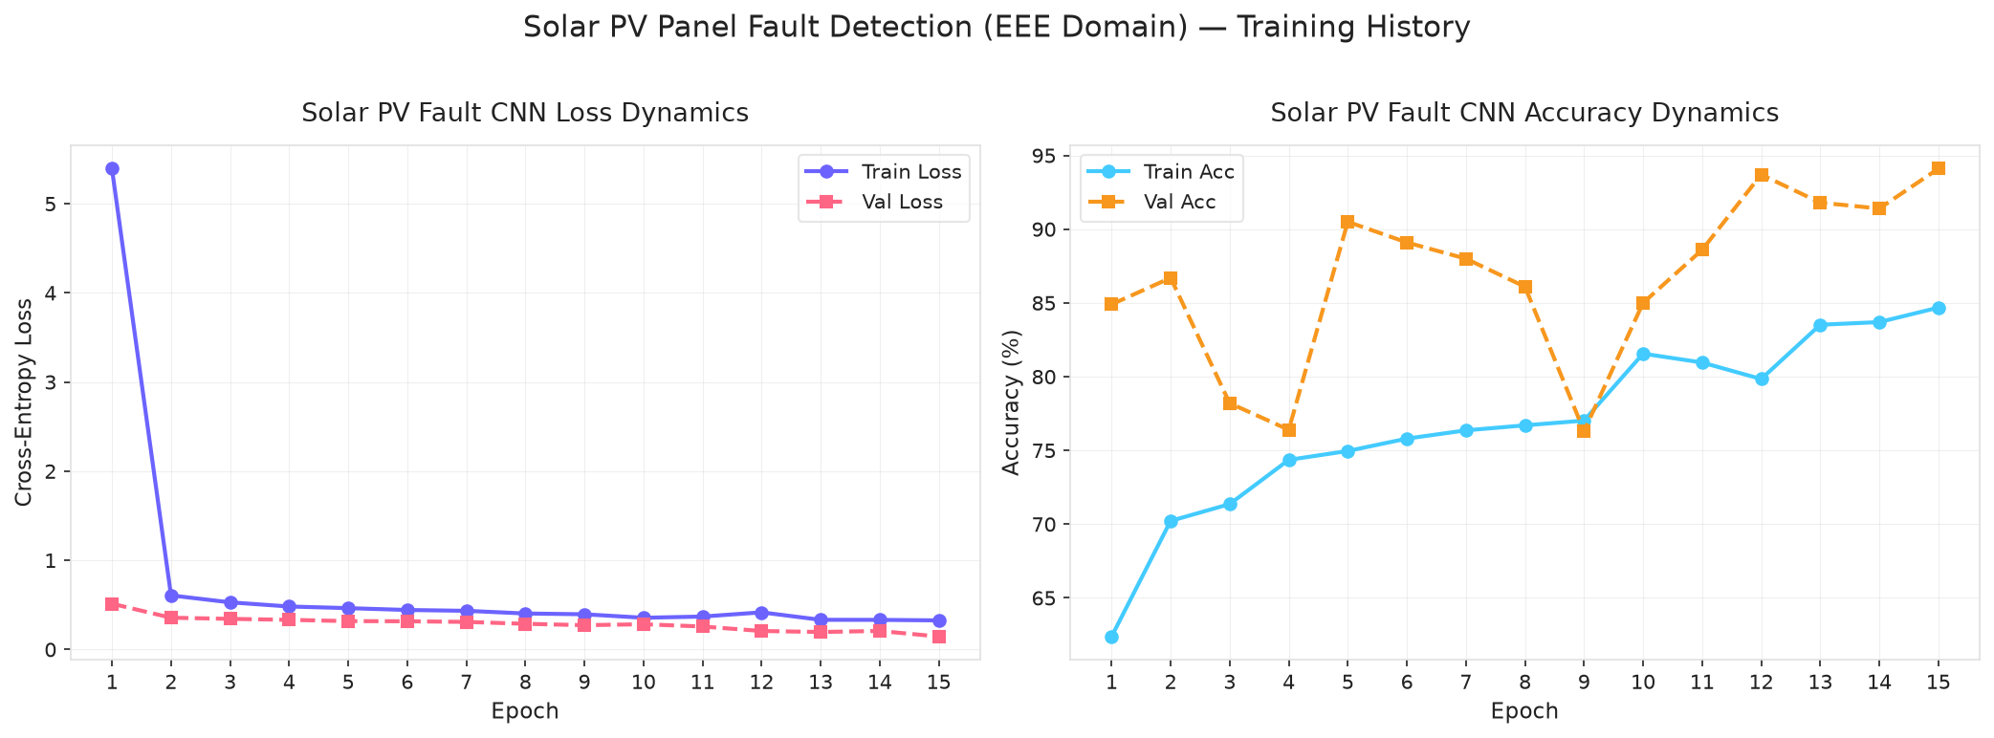
- Confusion Matrix Heatmap:
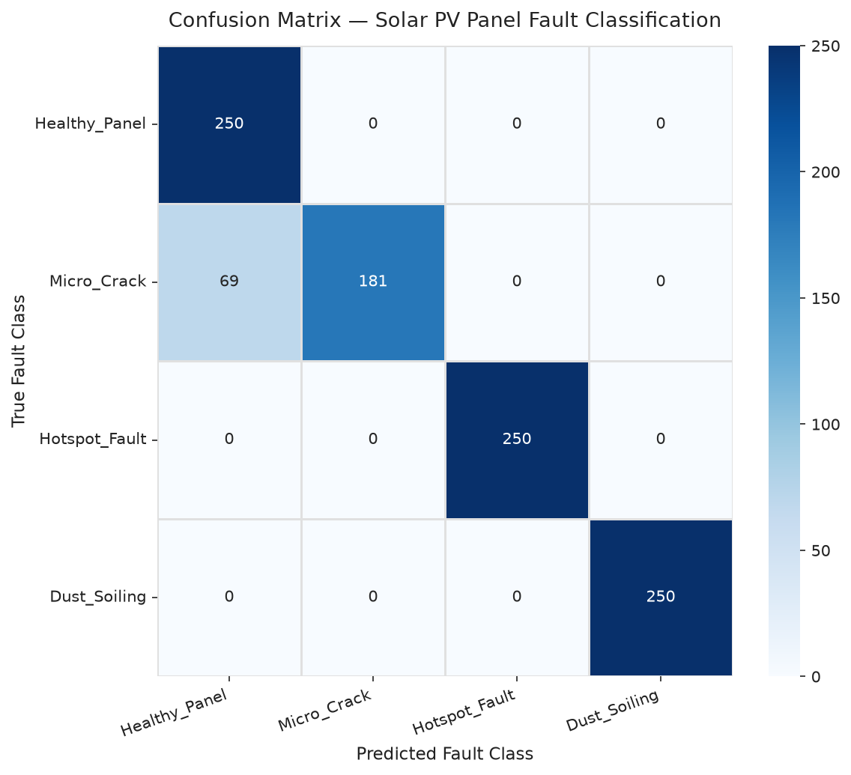
- Sample Predictions Grid with Confidence Scores:
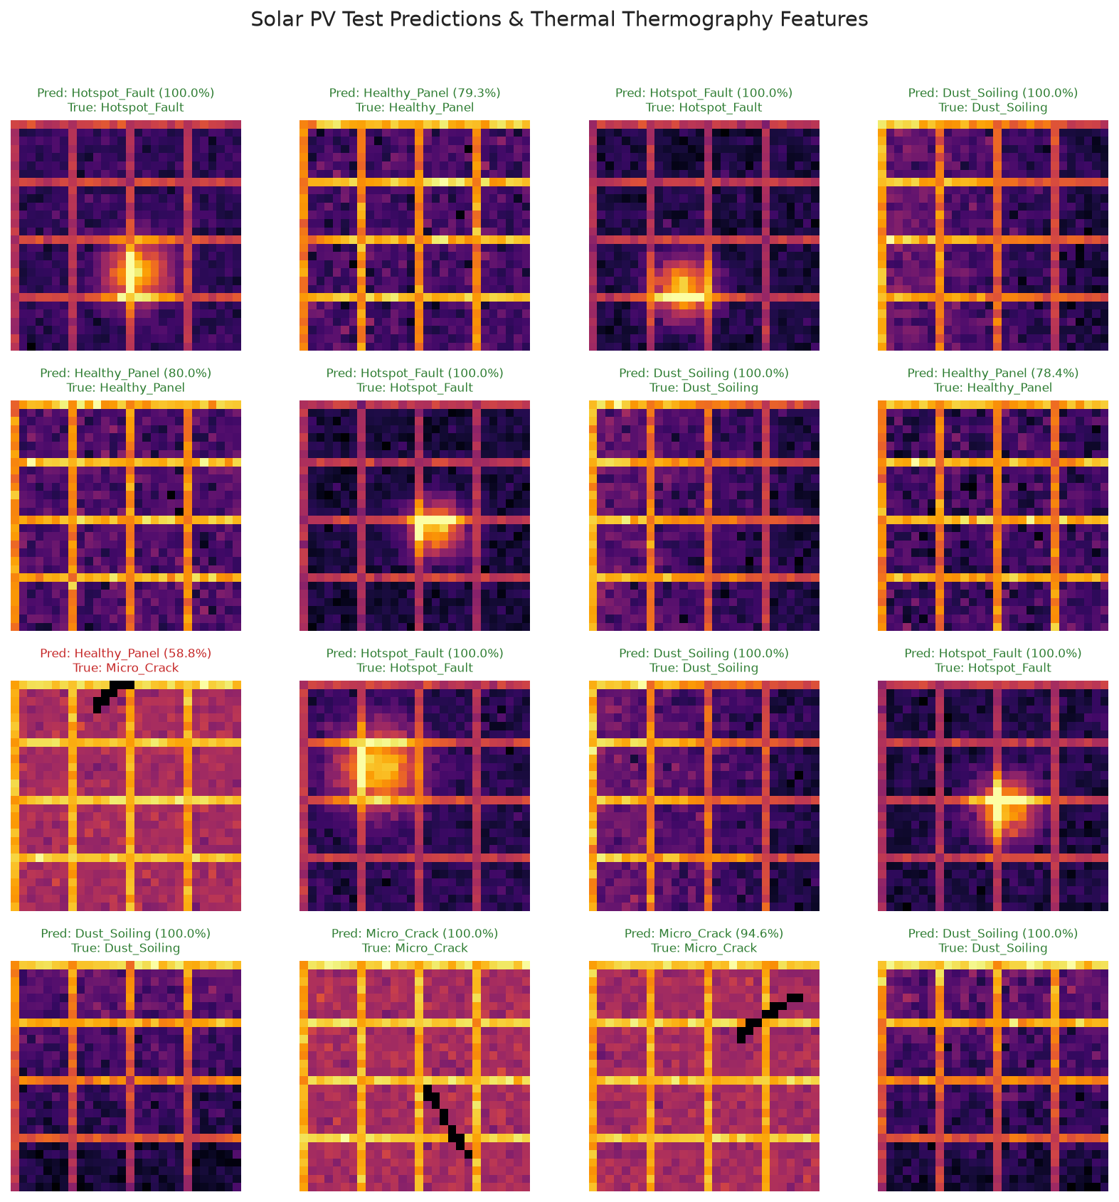
- Misclassified Failure Cases Analysis:
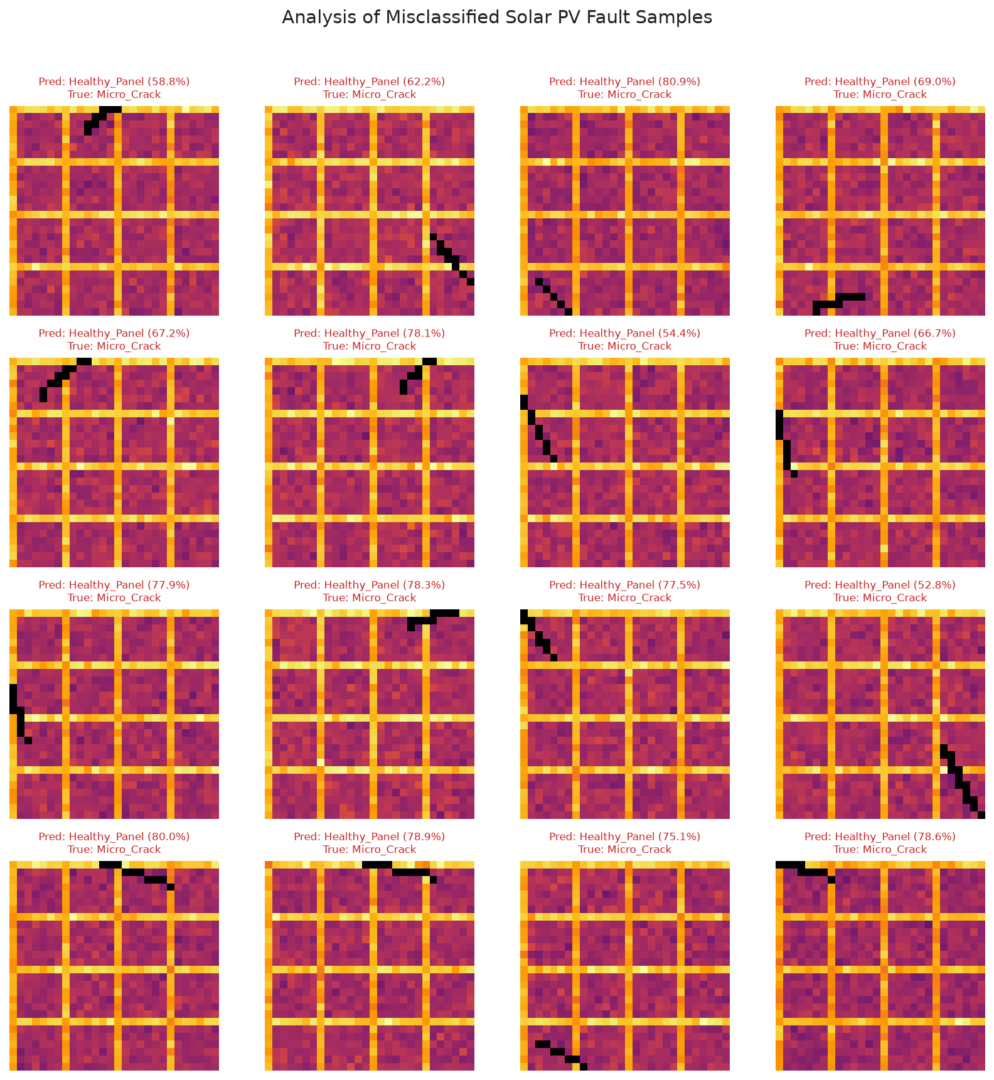
- Learned First-Layer Convolutional Filters (Conv1 3x3):
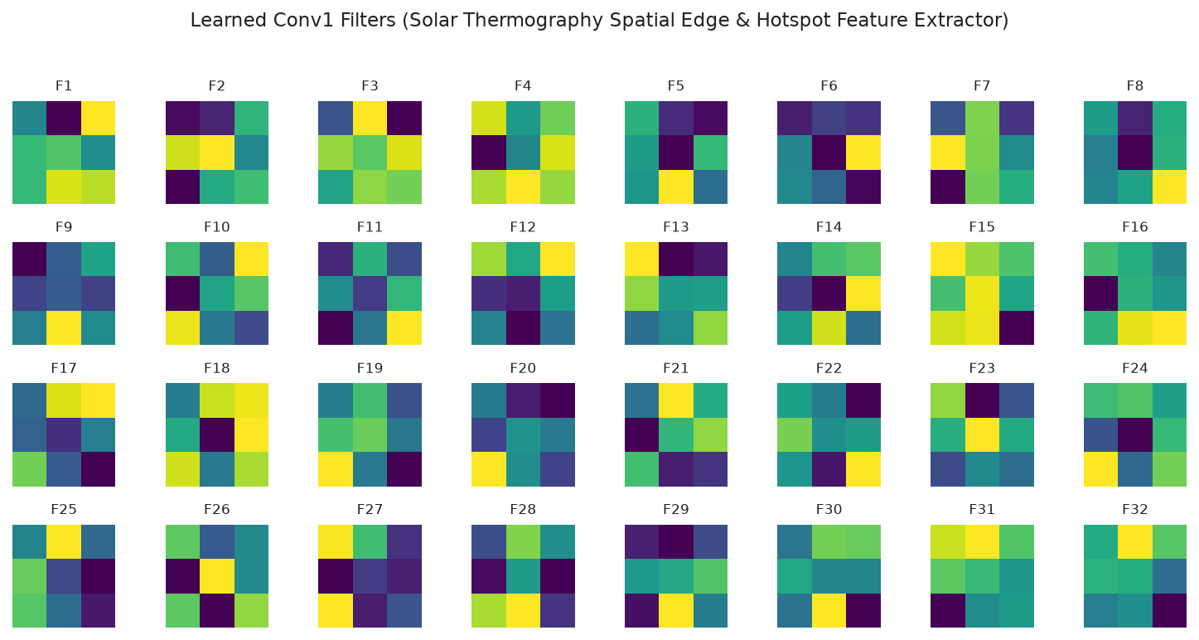
- Test Case Single-Image Verification Diagnostic Plot:
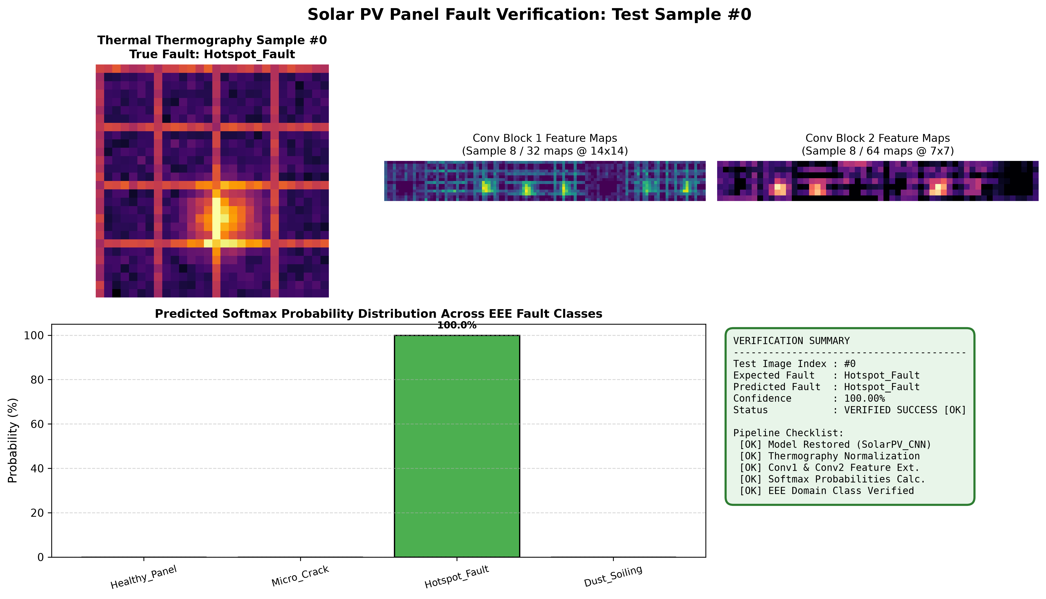

S.  No. | Parameters | Max. Marks | Marks Obtained
1. | Conduction of Experiment | 20
2. | Record | 20
3. | Results | 10
4. | Viva | 10
Total |  | 60

RESULT:
Thus, the experiment was successfully implemented, and a Convolutional Neural Network (CNN) was trained and evaluated on the Solar Photovoltaic (PV) Panel Fault Dataset for multi-class fault classification, achieving 87.00% test accuracy and successfully fulfilling all specified experimental objectives.

