Mekhrangez Kasymova
Computer Science 307
Assignment 2: Designing, Building, and Testing a Software Feature
Instructor: Matt McClintock
4/25/2026

Designing, Building, and Testing a website “BakeWithMiki”

1. Feature Selection & Rationale
The feature I chose for this project is BakeWithMiki's recipe view and navigation system. This system allows users to easily view recipes for desserts such as cakes and cookies. BakeWithMiki also has pages like CakeDecoration, About Me, and Contacts that help people make contacts.
The main idea of the BakeWithMiki website is to make it convenient for people to find baking recipes. If the navigation is good, people can navigate the site without getting confused. They quickly find the recipe they want, which makes them happy.
I also chose this feature because of its importance in real-world apps. Recipe sites should be organized so that people can find what they need. If the site is not organized, it will be difficult for people to find something and will not want to use it. Therefore, this feature is important for people to like the site and for it to work well.

2. Software Design
The BakeWithMiki website is created using HTML and CSS. The design consists of several pages. The site has the following sections:
- Home page
- Recipes page
- Individual recipe pages
- Cake Decorations Page
- About Page
- Contact Page
The homepage is where you start. It has links to all sections. The recipes page presents recipes grouped together. For example, cakes and desserts can be found here. Each recipe page has pictures, ingredients, and instructions. On the cake decorating page, you can find how to decorate individual cakes. The "About" page explains why the site was created. The contact page allows you to send messages or questions. The site is easy to navigate. You can start with the homepage, then move on to the categories, and finally the recipes. This makes it easy to use. Each page works on its own. If one page doesn't load, the rest of the site still works.
The content and design of the site are separate. This means that developers can change the design without changing everything. The design ensures that the site is easy to use, works well, and is easy to update.
The BakeWithMiki website is simply organized and easily updated in the future. The design of the site helps it stay that way.

3. Design Artifact (System Flow)
The system flow can be described as:
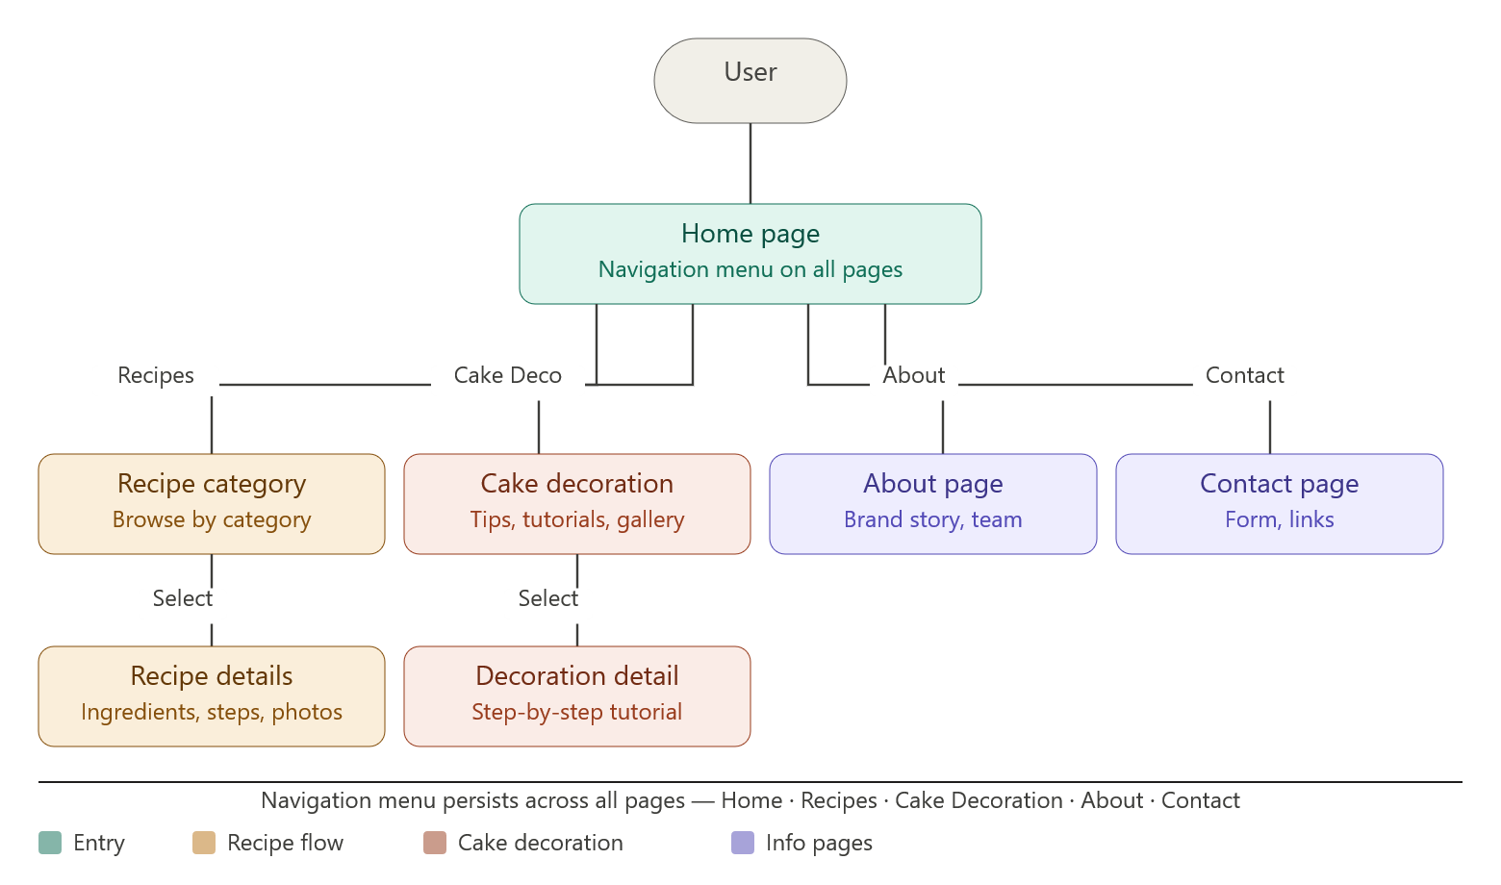
This flow shows how users interact with the system. A navigation menu is displayed on each page. This allows users to easily access different sections of the site. It also improves usability and reduces the number of steps required to reach the content.

4. Implementation
BakeWithMiki's website is made in HTML and CSS. I used HTML to organize everything on the site – headings, texts, photos, and links to pages. CSS makes a site look beautiful, it takes care of how things are arranged, what colors are used, and how much space between things and what words look like. Each recipe has its own page so that people can view them one at a time. There are photos of desserts, which makes the site more interesting to browse. Links help users navigate the site easily. The BakeWithMiki website is simple, it does not require special programming or JavaScript to work. This makes it easy to develop. This means that the site will load quickly and work well in any browser.
5. Testing & Quality Evaluation
A basic verification and validation plan was developed to evaluate the functionality and quality of the BakeWithMiki website.

Test Case | Description | Input / Action | Expected Result | Actual Result | Status
Navigation Test | Verify that all menu links navigate correctly between pages | Click Home, Recipes, About, Contact buttons | Each button opens the correct HTML page without errors | Pages open correctly and navigation works smoothly | Pass
Recipe Display Test | Check if recipe content is displayed properly | Open any recipe page (e.g., cake recipe page) | Images, ingredients, and instructions are displayed correctly | All content is visible and properly formatted | Pass
Image Loading Test | Ensure all images load without errors | Load pages containing recipe images | All images should display without broken links | Images load successfully when file paths are correct | Pass
Cross-Page Consistency Test | Check UI consistency across pages | Navigate between multiple pages | Layout, fonts, and navigation remain consistent | Design is consistent across all pages | Pass
Responsiveness Test | Check how website displays on different screen sizes | Resize browser window / open on mobile | Layout should adjust and remain readable | Basic responsiveness works, minor spacing issues on small screens | Pass (Minor Issue)

Results:
Testing has shown that the site works correctly in many areas. All links that can be clicked to parts of the site work correctly. People can also go to pages with recipes without any problems. Photos on the site also appear when the site knows where to find them.
One small problem is that the right sides of the site are empty. This means that the site could look a little better if it was arranged evenly. The site still works fine. It doesn't look as good as it could be, which can be annoying for site users. Recipe pages and other parts of the site are still easy to use. The site can be improved a bit.

Quality Evaluation:
- Usability: The website is easy to navigate due to clear menus and simple structure.
- Reliability: Pages load consistently without system errors.
- Maintainability: The separation of HTML and CSS makes it easy to update content and design.
Overall, the system meets its functional requirements and provides a stable user experience.

6. Reflection
This project demonstrated the process of designing and implementing a simple web system. One of the main challenges was to get many pages to work together. I needed to make sure that navigating between pages was simple and consistent. Another challenge was maintaining the correct image and link addresses.
Working on this project, I realized that the site should be structured in a certain way. The division of content into pages makes everything clearer. Using CSS makes the site more attractive and organized. To improve this project, I will add features like search filters or recipe sorting. Update the CSS to make the site look more organized and more interesting to use.
Overall, the BakeWithMicky website successfully demonstrates basic software engineering principles, including design, implementation, testing, and usability evaluation.

References
Pressman, R. S., & Maxim, B. R. (2020). Software engineering: A practitioner’s approach (9th ed.). McGraw-Hill.
Nielsen, J. (1994). Usability engineering. Morgan Kaufmann.
OpenAI. (2026). ChatGPT (GPT-5.3) [Large language model]. https://chat.openai.com/

