Final Project

Project (2)-RAM:

1. Verification plan
2. Asynchronous Reset functionality.
3. Testing writing operation in All Addresses of the memory by checking the waveform and compare to the golden model
4. Testing reading operation From All Addresses of the memory by checking dout in the waveform and compare to the golden model
5. Testing if rx_valid is low No operation is done the dout and the memory stayed stable or not.
6. Checking when Read the Functionality of tx_valid and if it still high or when read only.

Note:

-Reset randomization is closed during the first two loops to check all places in the memory and make sure every address in the memory wrote and read from it.

-addr_wr is not assigned a reset value which may cause a problem if the master started with the writing data operation.

1. A screenshot of a computer

   Description automatically generatedVerification Document
2. Coverage reports:

**Toggle Coverage** is 100%

**Branch Coverage** is 87.5% as All values were handled no wrong branch in the design.

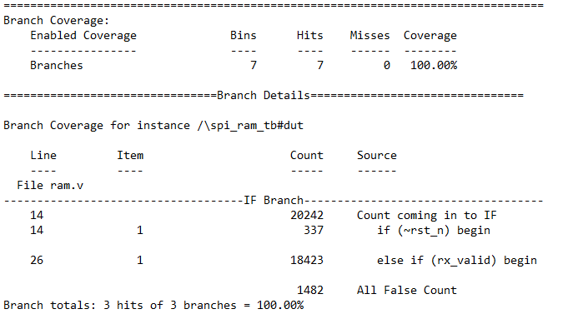

**Statement Coverage** is 100%

**Function Coverage** For din is 100% All values were reached

**Some Questa Pic** to Verify the RAM:

When rst_n =0 All ram values and dout = 0.

Writing in All Memory values.

Example For checking Read:

Din [9:8] is 10 so we will save 10100 in add_rd so we will check place 40 in memory.

After the Din[9:8] is 11 so it will go to address 40 to read and dout must = the value in memory [40].

In memory the address of 40 is = 8’h47 .

Dout is equal to the memory address 40 so read is true.

**After examining the wave form and check all possible values for dout there is NO BUGS in the RAM memory.**