SENIOR PROJECT II (SPRING 2016)

FINAL REPORT

INSTRUCTOR: DR. DONG H. JEONG

**Designing a Web-Based Restaurant Food Ordering System**

Meseret Meressa (N00243196, Meseret.meressa@udc.edu)

Mekonnen Senbeta (N00252839), Mekonnen.senbeta@udc.edu

Department of Computer Science and Information Technology

University of the District of Columbia

4200 Connecticut Avenue NW

Washington, DC 20008

**Contents**

1 Project Summary 2

2 Introduction 2

3 Key Milestones Table 2

4 Previous work 3

4.1 Assessment of similar web-based order management system 3

5 System Design 4

5.1 user interface designe 4

5.1.1 Customer view 4

5.1.2 kitchen view 5

5.2 technologies 6

5.2.1 bootstrap includes html, css and javescript 6

5.2.2 mvc, php and mysql 6

5.2.3 library jquery 8

6 deviations 8

7 Results 9

8 Conclusion AND FUTURE WORK 10

8.1 CONCLUSION 10

8.2 FUTURE WORK 10

9 Acknowledgements 11

10 Bibliography 12

# 

# Project Summary

The Restaurant is one of such place where the crowd is frequently immense at all times to get their choice during their convenient time either by group or individually. Most of the time the restaurants have a long queue and this is very time consuming for the customers. This project aims at developing a web based restaurant food ordering system that allow users to order their choice of meal using the system. The system help customers decide and order their meal of choice, from the comfort of their tables and shall let them break the waiting time, moreover, it allow the restaurant to quickly and easily manage the menu which customers can browse and use to place orders with just a few clicks. The system also relays these orders to employees through an easy to navigate graphical interface for efficient processing.

# Introduction

Restaurants use a slow manual food ordering system that involves customers placing orders through waiters/waitresses. Waiter might forget to add a specific item to an order, delete an ingredient from an order because the customer is allergic to it, or forget to give the correct order to the kitchen. Customers have to wait for a server to take their order. They must rely on the waiter to remember their order and specific details. Their food may take longer to be served to them if the server has multiple tables or the waiter may bring them the wrong order. But how much is the service going to be fast if the customer get the chance to place the order using a web-based ordering application system. To solve this approach and to increase efficiency designing a web-based Restaurant food ordering system will play a vital role in competitive business industry. The main advantage of this project is that it greatly simplifies the ordering process for both the customer and the restaurant.

# Key Milestones Table

Table : A summary of key milestones.

|  |  |  |  |  |
| --- | --- | --- | --- | --- |
| **Item** | **Tasks** | **Plan completion**  **Date** | **Revised**  **completion date** | **Actual**  **completion date** |
|  |  |  |  |  |
| 1 | Initial development environment setting | 3/05/2016 |  |  |
|  |  |  |  |  |
| 2 | Understanding libraries | 3/05/2016 | 3/10/2016 |  |
|  |  |  |  |  |
| 3 | Creating an initial draft system | 04/10/2016 |  |  |
|  |  |  |  |  |
| 4 | Performing a debugging | 04/10/2016 |  |  |
|  |  |  |  |  |
| 5 | Testing and evaluation | 04/15/2016 |  | 04/21/2016 |
|  |  |  |  |  |
| 6 | Publishing | 04/28/2016 |  | 04/22/2016 |
|  |  |  |  |  |

As shown in 1, all proposed 6 tasks have been completed successfully.

# Previous work

Restaurants food service is becoming increasing from time to time as restaurants look to attract diners from other types of restaurants in order to increase the traffic. Restaurants that demonstrate innovation and creativity to improve convenience and service will be those that archive differentiation from compotators. Those restaurants that are able to provide new concepts that can be appeal to a wider variety of customers will be also realized increased returns.

**4.1 Assessment of similar web-based order management system**

Similar applications have been performed to understand the use of web based restaurant food ordering system and its effectiveness. For example some of the related applications we found are:

Andrey Chapovskiy, designed on a restaurant and bar order managing system by providing an electronic user interface that can be used on any handheld device or computer with a web browser. According to the author, the system is concentrated on improving the speed and the accuracy of entering orders by the serving staff and improve communication of orders to the kitchen. The application is designed to be used on the major web browsers, which are capable of rendering HTML5 and CSS3.

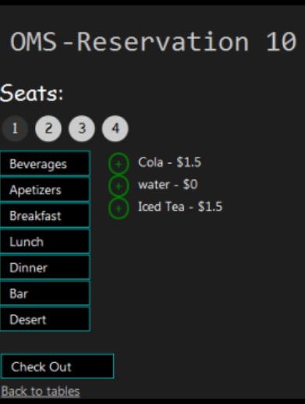 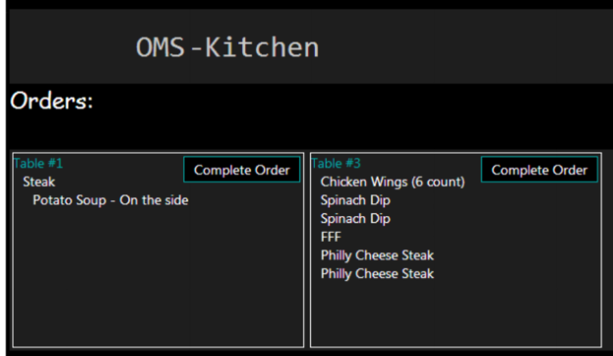  
Figure 1. Entering order for each customer Figure 2. Kitchen Staff User Interface

Khairunnisa K et al. provided wireless food ordering system using on PDA devices. They design and implement data access points and client applications for food ordering based on web-based application and they develop system using a suitable interface with the computer. The wireless food ordering system is useful for restaurants to improve the management, increase efficiency, saving time for waiter, reducing human errors and provide higher quality customer service. Wireless food ordering system has been developed using PHP, JavaScript, MS Access 2003 and Visual Basic 6.0.

# System Design

The system design for web based food ordering system includes three main user interfaces. These are customer view, Kitchen view, and waiter view. The system is built using the Bootstrap framework, HTML and CSS for the frontend. I utilized PHP for the server side and MYSQL for the database management system. Utilizing Bootstrap ensures that my application’s user interface will scale relatively on different screen sizes. Also, several possible libraries have been identified. Among them, jQuery library has been selected to be used for designing our proposed system due to several major benefits compared to others. A detailed explanation about this section will be mentioned below.

## 5.1 user interface design

User Interface Design focuses on what users might need to do and ensuring that the interface has elements that are easy to access, understand, and use to facilitate those actions. The user interface for web based food ordering system is design to be used on any platform.

**5.1.1 Customer View**

The customer view will allow the user to place an order and supply all the necessary details. As soon as they click on the menu bar the data will be fetched from the database and displayed on the menu. Then the user has to insert the table number and the quantity of the food items. After that the user will be able to place an order.

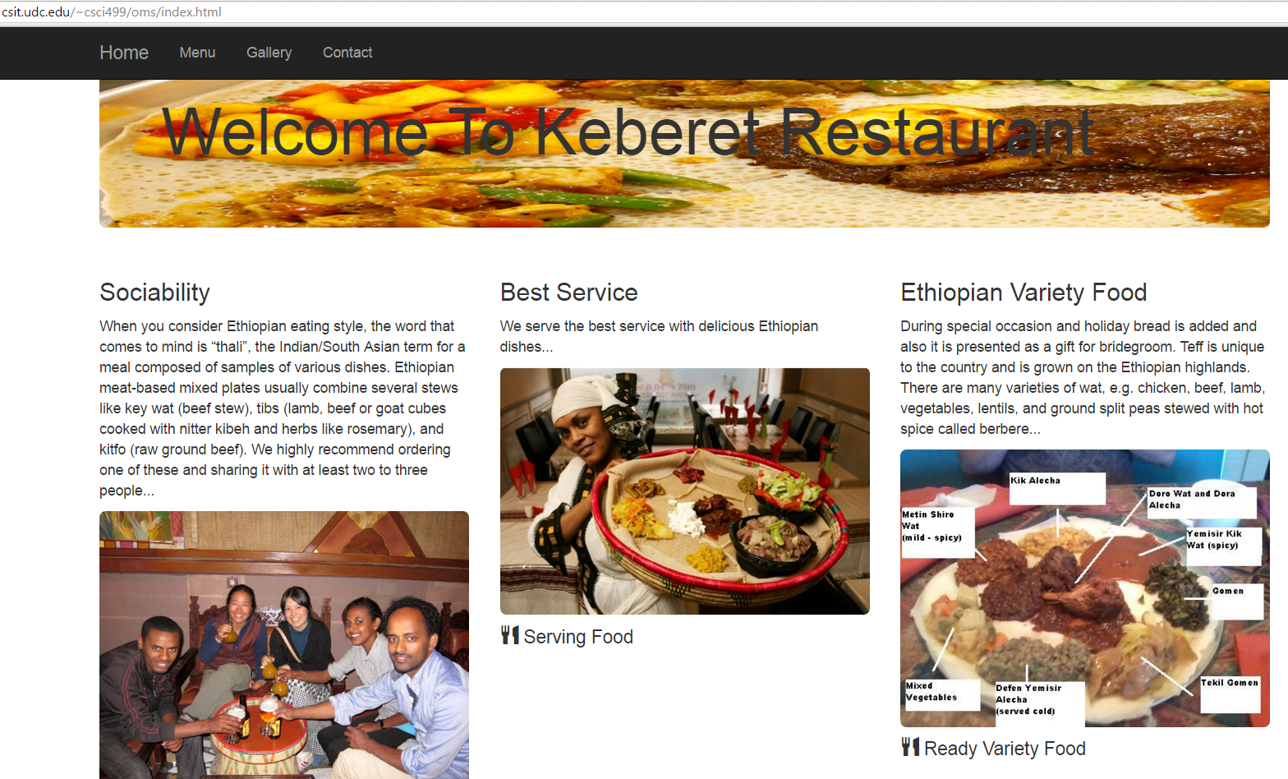 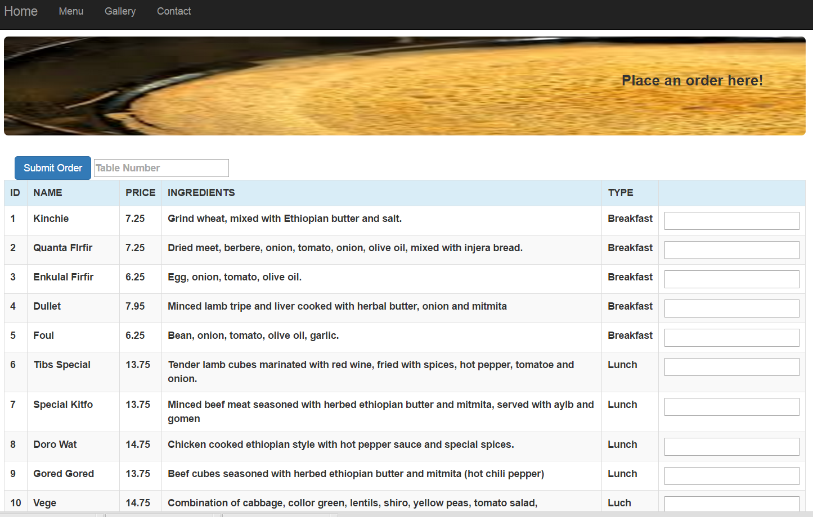

Figure 3. Customer User Interface Figure 4. Menu page

**5.1.2 Kitchen View**

The kitchen view is for the kitchen staff so they can view orders from customer. Once the order is placed, the kitchen staff will see it on their devices. The orders that were entered first will be first in the queue. Once the order is completed, the kitchen staff will hit the complete button.

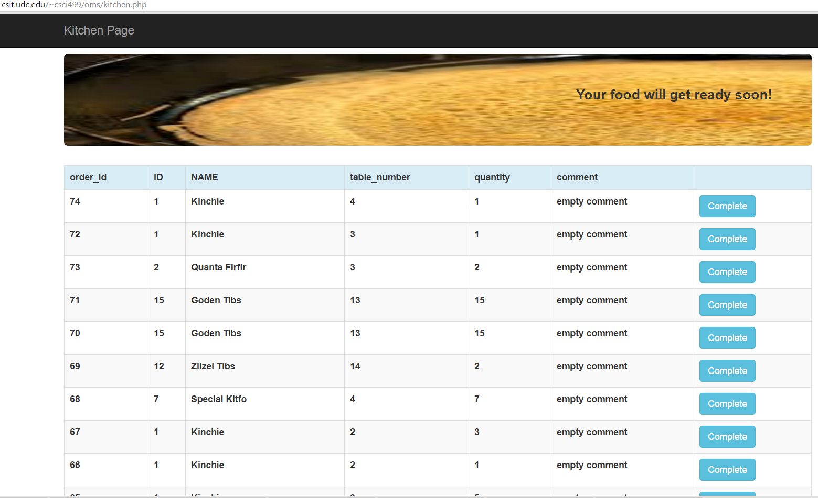

Figure 5. Kitchen Staff User Interface

## 5.2 TECHNOLOGIES

The software takes advantage of the latest technologies available for best user experience. Our application created using the Bootstrap framework, HTML and CSS for the frontend. We utilized PHP for the server side and MYSQL for the database management system.

**5.2.1 bootstrap includes html, css and JavaScript**

Our web based food ordering system built using bootstrap which is a free front-end framework for faster and easier web development. It includes HTML and CSS based design templates for typography, forms, buttons, tables, navigation, modals, image carousels and many other, as well as optional JavaScript plugins. Utilizing Bootstrap ensures that my application’s user interface will scale relatively on different screen sizes. We chose to create a mobile web application to ensure portability across various platforms for e.g. Android.

## 5.2.2 mvc, php and mysql

MVC (Model View Controller) is a software architecture or the structure of the system that separates application logic from the rest of the user interface. It does this by separating the application into three parts: the model, the view, and the controller. The model manages fundamental behaviors and data of the application. It can respond to requests for information, respond to instructions to change the state of its information, and even to notify observers in event-driven systems when information changes. This could be a database, or any number of data structures or storage systems. In short, it is the data and data-management of the application. The view effectively provides the user interface element of the application. It'll render data from the model into a form that is suitable for the user interface. The controller receives user input and makes calls to model objects and the view to perform appropriate actions. The picture below shows the basic Model-View-Controller relationship:

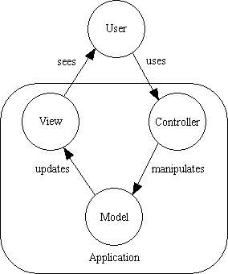

Figure 6. Model-View-Controller relationship

For the backend we use PHP server side scripting language. It is a powerful scripting language that fits gracefully into HTML and puts the tools for creating dynamic websites. After we connect the server with the database we are able to fetch and store data from MySql database and displayed to the customer menu page view and also kitchen view. Below is the screen shot for PHP code to store and retrieve the data.

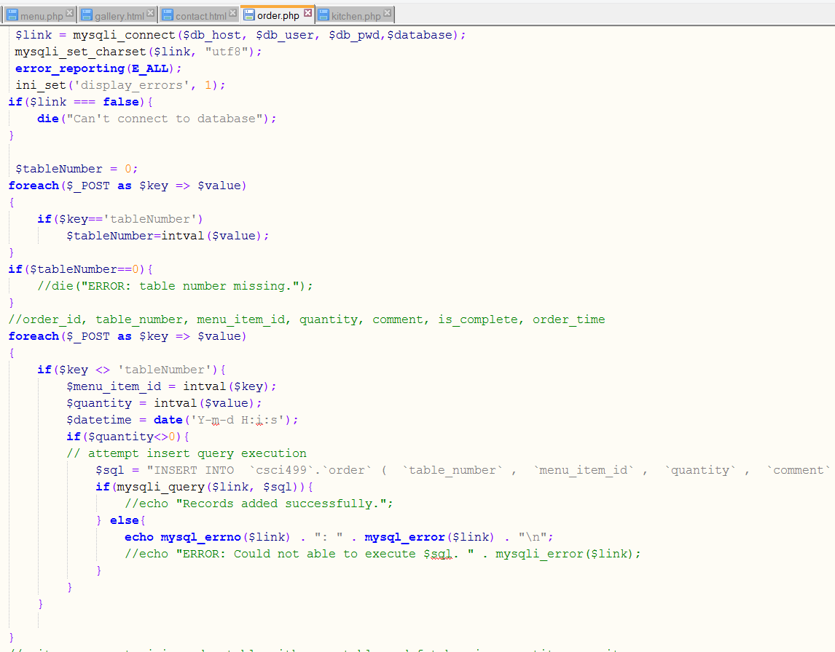 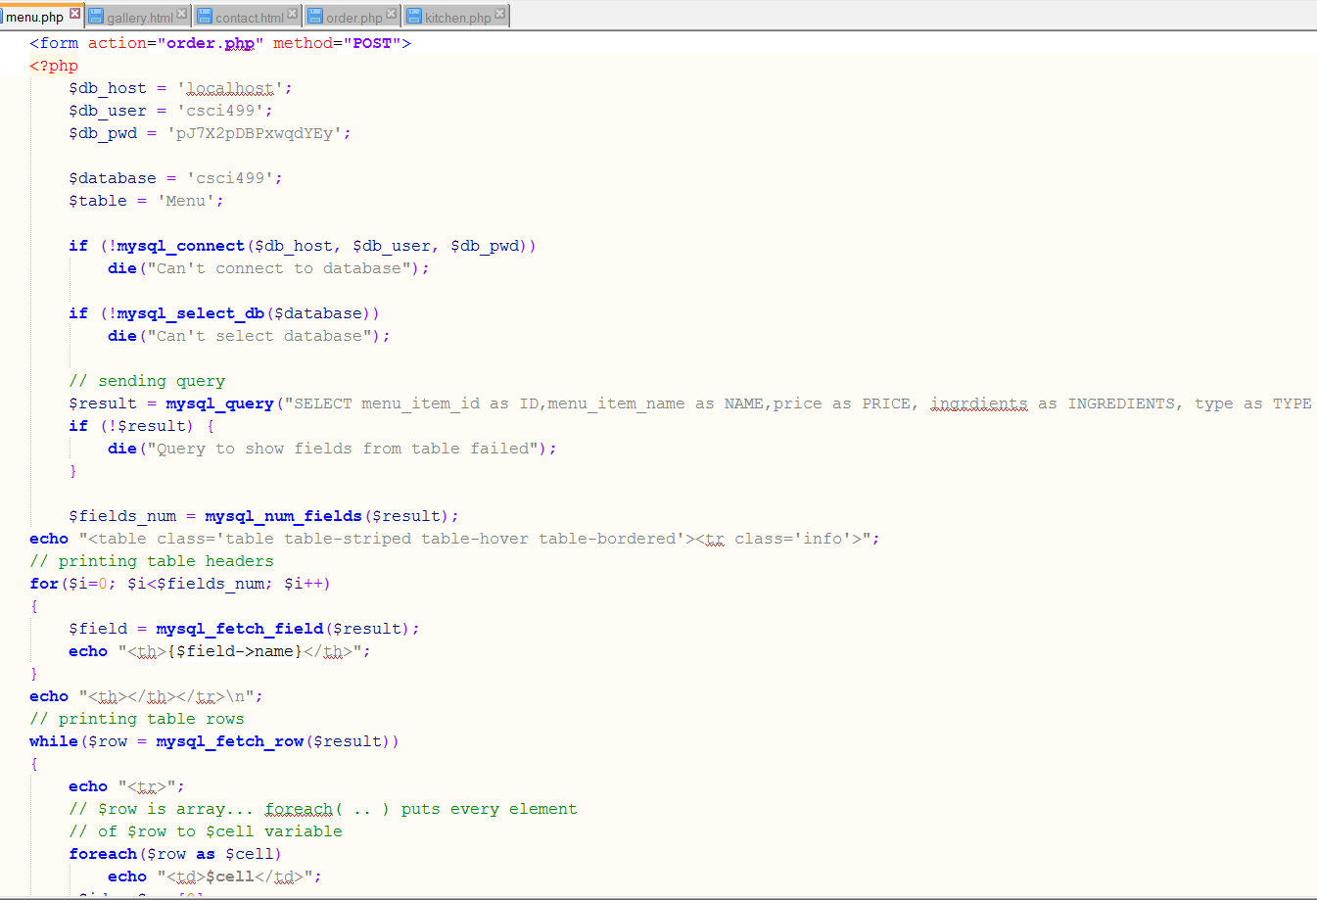

Figure 7. PHP code for storing and fetching data

For our database management system we used MySql which is the database engine to work with web based food ordering system. It is a software optimization for our data storage and retrieval. Below is a picture for our database:

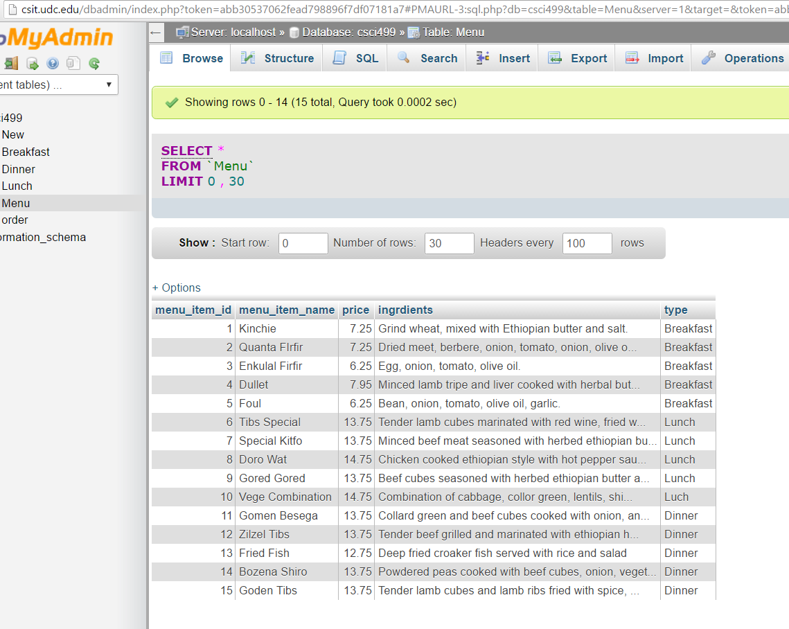

Figure 8. MySql database

## 5.2.3 Library jQuery

JQuery is a library for JavaScript that easily manipulate programming with JavaScript providing very simple to use, abridge syntax to achieve complex tasks with JavaScript. One of the most important advantages of using jQuery in relation to other JavaScript libraries or interactive applications is that it does not take away from the visibility of web page content from the search engines.  The problem with other applications, is that your content is lost if JavaScript is turned off in the user’s browser.  Even though some of these other applications are getting better at being picked up by the search engines, they’re still not able to compete with the functionality of jQuery. JQuery also simplifies the client-side web development techniques for creating interactive web applications.

# Deviations

Each step of the life cycle of our project was challenging and we learned a lot from it. Working with team help us to come up with different ideas and helped us achieve our goals even if our project is not completely finished. The challenges we faced during working on our project are:

* Luck of in-depth skill and experiences on usage and application of server side scripting: Creating comprehensive and integrating website using all these client side and server side scripting with databases needs long time concentration, and experiences. We started from the scratch working on PHP and Bootstrap, and this took most of our time. Making connection database with server, selecting the right videos and recent published journals that consists detailed and comprehensive idea in short time consumed our time.
* Lack of scientific training in the methodology of research: Our project is pretty comprehensive and needs practical application in every development life cycle. We have more theoretical knowledge and lack of experience association with practical application is highly influenced us on the project work.
* Lack of availability or access to literature needed: This is the major problem faced during the literature review. The lack of availability of latest the required articles from various magazines, journals and from other related databases. Searching books and recent scientific journals articles takes a lot of our time and efforts.
* Attitude: Particularly information that gathered through interaction from previous senior students. They already found difficulty with their project works to make research upon it, tells us the hardship they suffer or suffered. This change our outlook and has directly or indirectly impacted on our confidence.
* Network interruption: Some times when we tried to test our code after we installation of database on the server there are a lot of erratic and ups and down connection of the network and this also one of the most common problem we faced.

# Results

After completing the system the following result have been achieved.

* The system allows the user to place order directly from the menu page.
* The system can show list of menus on a page
* The system sends a confirmation page to the user whenever the food ordered successfully.
* The system allows the kitchen page to display the ordered food so kitchen staff can start preparing the food based on food item name, quantity, food item name id and so on.
* The system allows first come first served for the preparation of the food based on the time.
* The system have navigational view through the application of Google map that shows the location of the restaurant and also allow to find and choose nearby restaurant.
* The system have the gallery page which display frequently prepared foods.
* This designed ordering system allows the customer to browse the page in different platform. It could be used Window, Linux and MAC operating system. And it can easily open in various browsers like Internet explorer, Opera, Firefox, Safari, Chrome and Mozilla.
* The system is designed responsive and flexible so that the user can get full information in small and large screen size.

# Conclusion and Future work

## 8.1. Conclusion

The manual Restaurant ordering system is depends on manpower to manage all the transactions from taking order from user to placing order to the kitchen. Waiters can take long time to drop orders to the kitchen or they might miss the order. Our system is developed to increase the efficiency and services of the restaurant to enable the customers to have a visual confirmation that the order was placed correctly, minimizing paper work, increase speed of the services, sales volume and customer satisfaction. This system enables customers to place their order directly.

The system is designed using Hyper Text Markup Language version 5 ( HTML5), Bootstrap which is helpful to develop responsive and mobile support website and also scripting language like client-side and server-side scripting language that is java script and PHP respectively. For the database purpose we use MySql.

To enhance our project and understand web based restaurant food ordering system we summarized previous related works like online food ordering system and automated food ordering system with real time customer feedback which was done by different scholars. At the end the result the project was tested and conclusion was drawn and finally the recommendation for future expansion of the project was pointed.

## 8.2 Future Works

## 

Due to time constraints this project is focused mainly on restaurant dining ordering system. The following section describes the work that will be implemented with future release of the system.

* Customer order: It is more useful for the restaurant if the project is so extended the ordering system online outside of the restaurant from any location. Allow customer to order online from their respective places. That is, either home, work place or with family on certain occasional time to serve in their convenient place.
* Enhancing user interface: By adding more interactive feature like dropdown box, more navigation menu with related page, and related design like parallax scrolling which create more animated effect.
* Payment System: Adding different payment options like credit card, debit card, check and other system including pay pal. And obtaining confirmation the amount charged, time and date of charged on their email or sending short message (SMS).
* Login system should be added: creating login account with password as interface which prompts either to shows details of the menu or other page which help for protection and securing the database and available menu details.
* Delivery option: This is option that can be created on specific page either by option box or button which indicate delivery services like either carryout or dinning with service charge.
* Service for drinks: To fill full the needs of the customer and to show the availability of restaurant services the system should be include drinks available in the restaurants.
* Restriction: Restaurant users have different behavior and needs depends on their cultural backgrounds. It is advisable to indicate the rule, regulation and policy for mutual benefits of the services.
* View and comment: collection of ideas, information for future development and further expansion about the restaurant is necessary. As a result the page should allow users and customer to write the comment and the system automatically generate total view of the site.

# Acknowledgements

Working on this project under the guidance and assistance of Dr.Dong H. Jeong, assistant professor and graduate program Director, Department of Computer Science and Information Technology University of the District of Columbia. We express our gratitude toward him for his continuous support on this project from the beginning to the end.

# Bibliography

1. Andrey Chapovskiy. Restaurant and Bar Order Managing System. University of Cincinnati College of Education, Criminal Justice, and Human Services. April 2013.
2. Ashutosh Bhargave, Niranjan Jadhav, Apurva Joshi, Prachi Oke,Prof. Mr. S. R Lahane ,“Digital Ordering System for Restaurant Using Android “International Journal of Scientific and Research Publications, Volume 3, Issue 4, April 2013 ISSN 2250-3153
3. Khairunnisa K., Ayob J., Mohd. Helmy A. Wahab, M. Erdi Ayob, M. Izwan Ayob, M. Afif Ayob. The Application of Wireless Food Ordering System. MASAUM Journal of Computing, Volume 1 Issue 2, September.
4. Kirti Bhandge, Tejas Shinde, Dheeraj Ingale, Neeraj Solanki,Reshma Totare, “A Proposed System for Touchpad Based Food Ordering System Using Android Application”, International Journal of Advanced Research in Computer Science & Technology Vol. 3, Issue 1 (IJARCST 2015).
5. Mr. Maderla Rajesh, Mrs. Prof. G.Satya Prabha, Mr. P.V.Vara Prasad Ra, “ E-Restaurant: Online Restaurant Management System for Android”,International Journal & Magazine of Engineering,
6. Paresh.R.Bora, Eshan Gupta, “ APPLICATION ON ORDER MANAGEMENT SYSTEM INRESTAURANTS“International Journal of Application or Innovation in Engineering & Management (IJAIEM), Volume 1, Issue 2, October 2012.
7. Technology, Management and Research, ISSN No: 2348-4845, Volume No: 2 (2015).
8. Jingjing Li, Chunlin Peng, “ jQuery-based Ajax General Interactive Architecture “IEEE 978-1-4673-2008-5, ©2012.
9. <http://www.baatmedical.com/review-of-related-literature-for-online-ordering-system/>