Regression lineaire

Melissa Fils-Aime

2022-12-12

Devoir=read.csv("CreditBancaire.csv")  
attach(Devoir)

regression=lm(Jours~Credit+Type, data = Devoir)  
regression

##   
## Call:  
## lm(formula = Jours ~ Credit + Type, data = Devoir)  
##   
## Coefficients:  
## (Intercept) Credit TypeConsommation TypeProduction   
## 8.519e+01 -5.484e-06 -1.486e+01 1.498e+01

Objet=summary(regression)  
Objet

##   
## Call:  
## lm(formula = Jours ~ Credit + Type, data = Devoir)  
##   
## Residuals:  
## Min 1Q Median 3Q Max   
## -96.26 -69.22 -49.06 17.29 270.22   
##   
## Coefficients:  
## Estimate Std. Error t value Pr(>|t|)   
## (Intercept) 8.519e+01 1.275e+01 6.681 1.63e-10 ***  
## Credit -5.484e-06 1.182e-05 -0.464 0.643   
## TypeConsommation -1.486e+01 1.472e+01 -1.009 0.314   
## TypeProduction 1.498e+01 2.532e+01 0.591 0.555   
## ---  
## Signif. codes: 0 '***' 0.001 '**' 0.01 '*' 0.05 '.' 0.1 ' ' 1  
##   
## Residual standard error: 104 on 241 degrees of freedom  
## Multiple R-squared: 0.007512, Adjusted R-squared: -0.004842   
## F-statistic: 0.608 on 3 and 241 DF, p-value: 0.6104

Affichage=Objet$coefficients[,c(1,3,4)]  
Affichage

## Estimate t value Pr(>|t|)  
## (Intercept) 8.519082e+01 6.6809256 1.630050e-10  
## Credit -5.483559e-06 -0.4637417 6.432514e-01  
## TypeConsommation -1.485726e+01 -1.0090929 3.139421e-01  
## TypeProduction 1.497503e+01 0.5913659 5.548295e-01

Colonne=Objet$coefficients[,c(1,3)]  
Colonne

## Estimate t value  
## (Intercept) 8.519082e+01 6.6809256  
## Credit -5.483559e-06 -0.4637417  
## TypeConsommation -1.485726e+01 -1.0090929  
## TypeProduction 1.497503e+01 0.5913659

plot(Devoir$Credit, Devoir$Jours, pch=20, main="Droite de regression", xlab="Credit", ylab="Jours")  
abline(regression,col="blue")

## Warning in abline(regression, col = "blue"): utilisation des deux premiers des 4  
## coefficients de régression

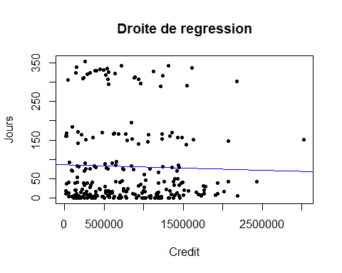

fstatistic<-function(data){  
 abc=summary(lm(y~.,data=data))  
 Colonne=Objet$coefficients[,c(1,3)]  
 return(data.frame(Colonne))  
}