Lab Zero – Setup

Arzel Andrei Israel
Lynxie Jagonob
John Walter Pediangco
John Christian Setubal
Emmanuel Siastres

Steps Taken:
1. Installed Node.js
2. Verified Installation using node -v
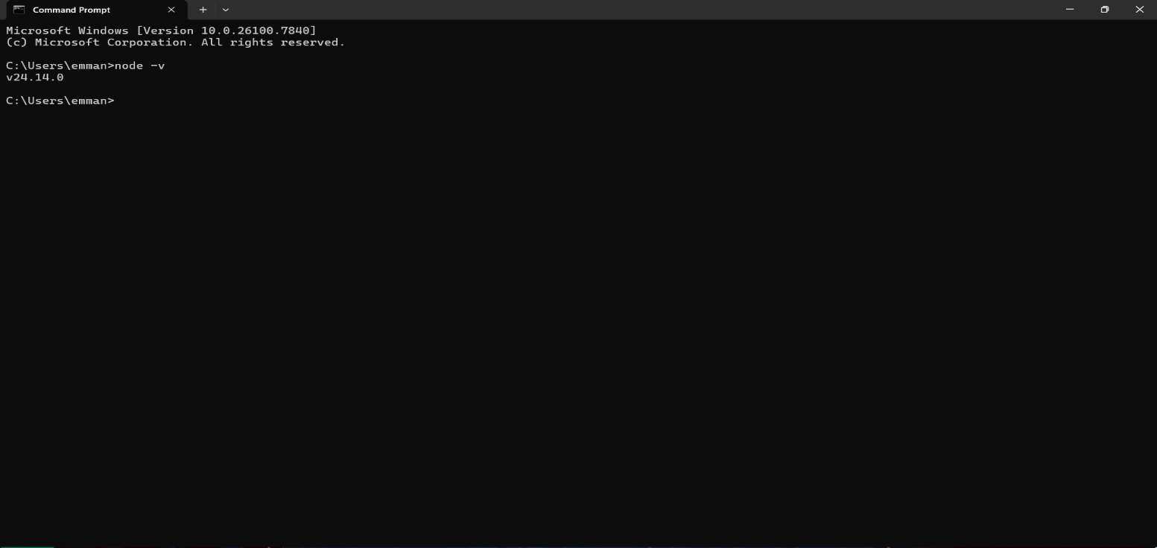
3. Verified npm using npm -v
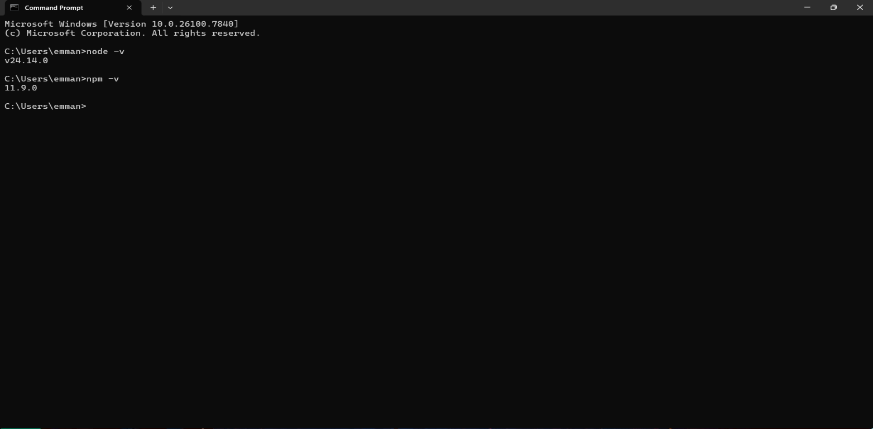
4. Created the lab folder

