Daniel Jericho Estaris BSIT-3B INFOT 6 Lab 2

Documentation: Running curl command
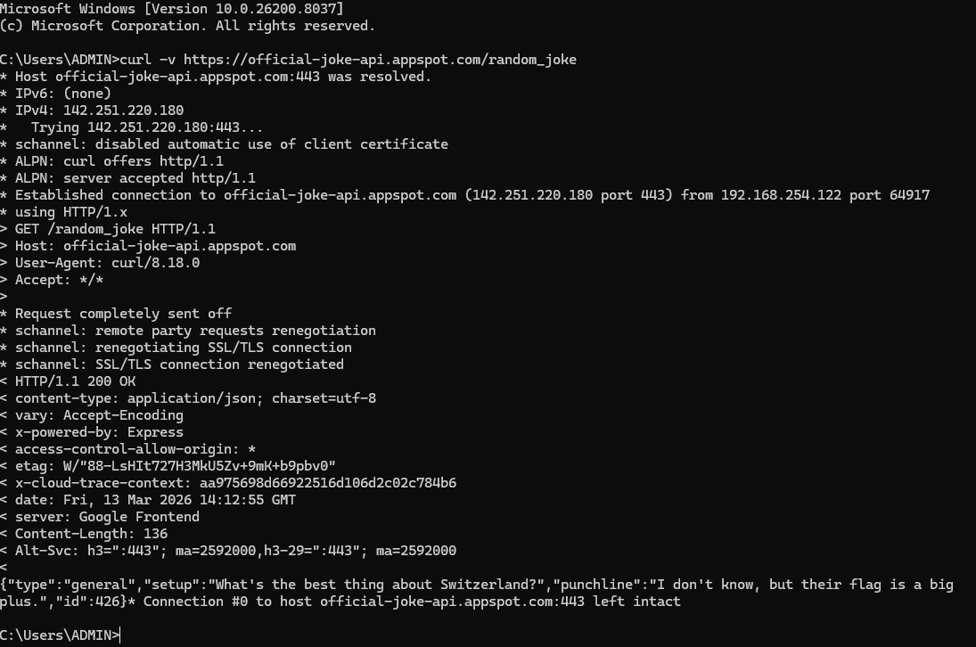

1. The method used in the output returned by the presented curl command is GET, allowing the retrieval of data without any modifications.
2. Examples of headers returned by the output is the content-type, indicating that the data was encoded using UTF 8, another one is the server, being google frontend which shows which server this output was retrieved from.
3. As for the actual joke itself, the payload returned as JSON which is widely used for such web API’s allowing seamless exchange of structured data between a client and a server.

