**References:**

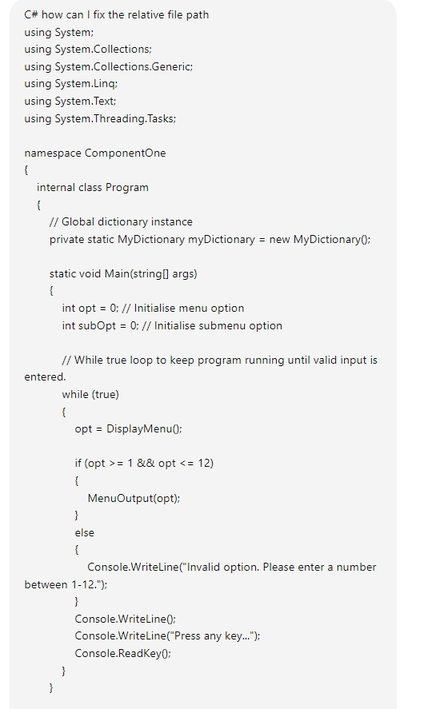

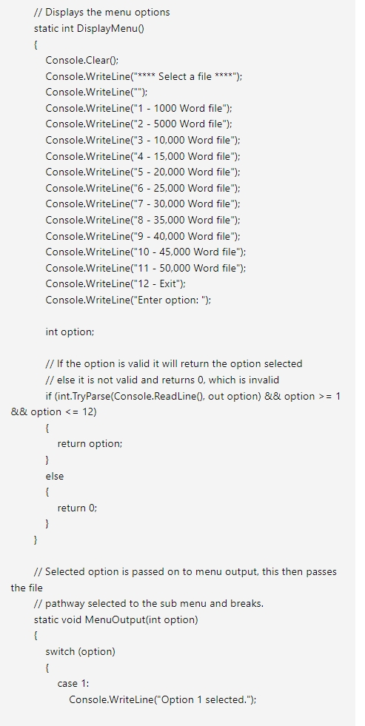

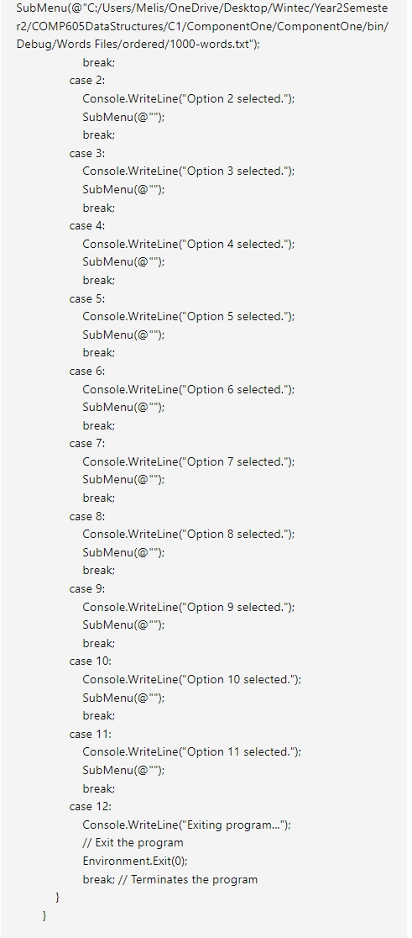

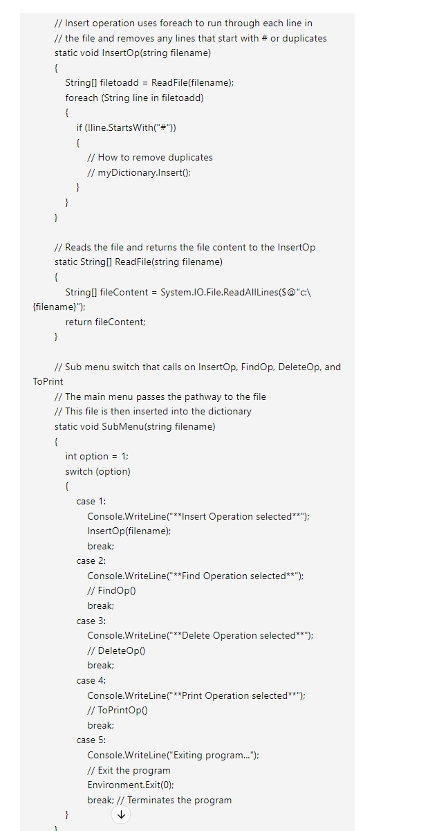

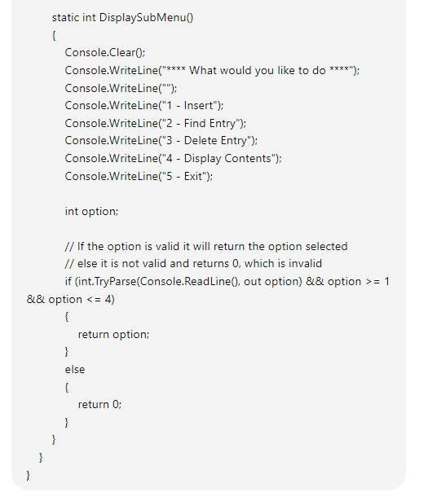

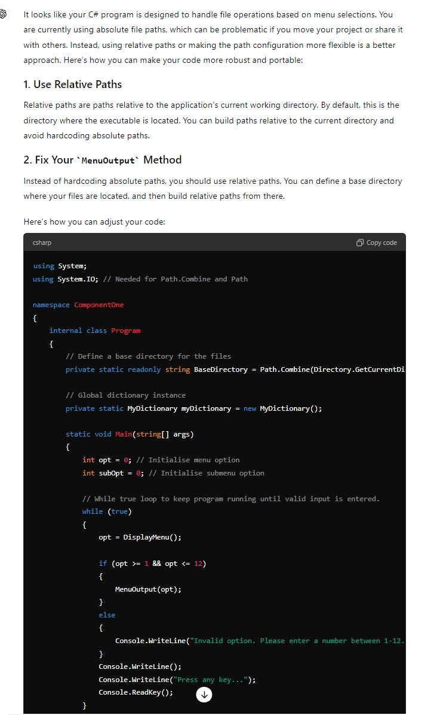

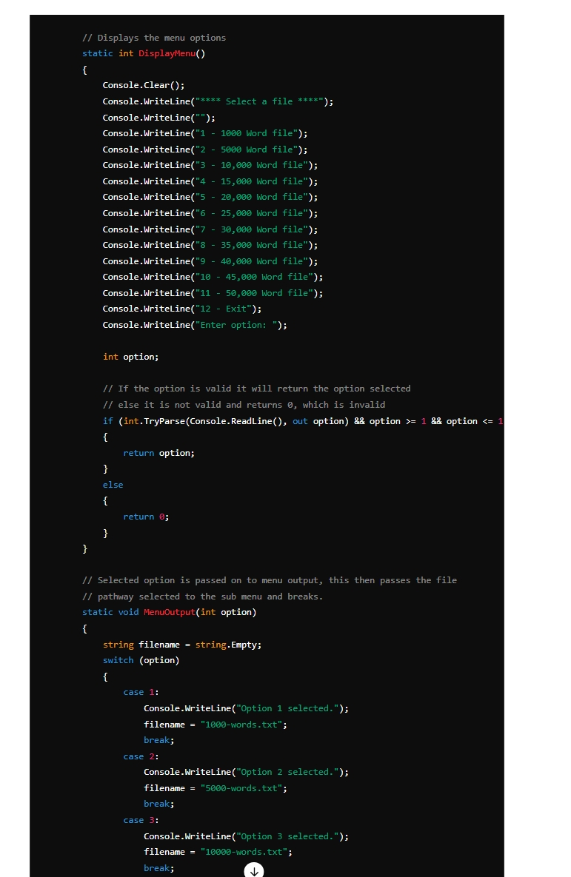

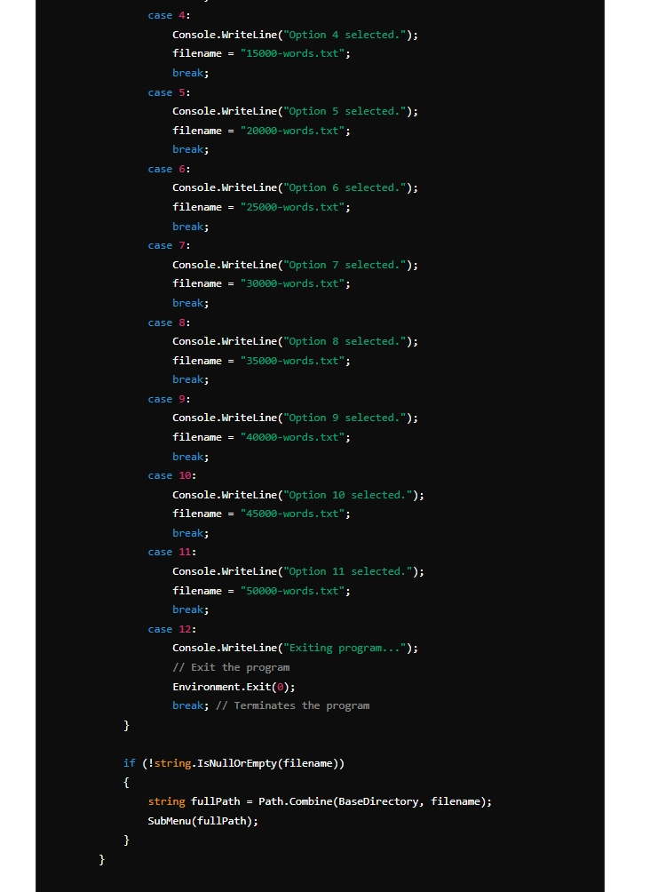

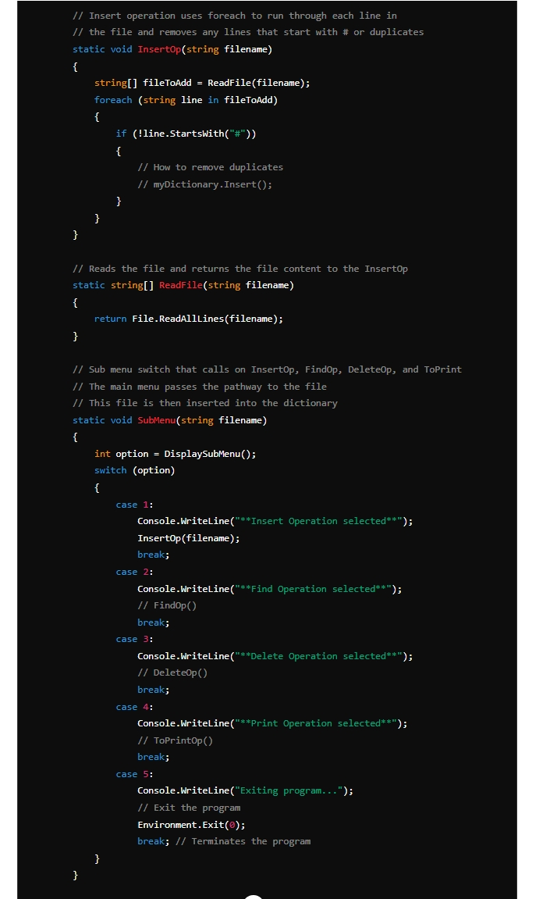

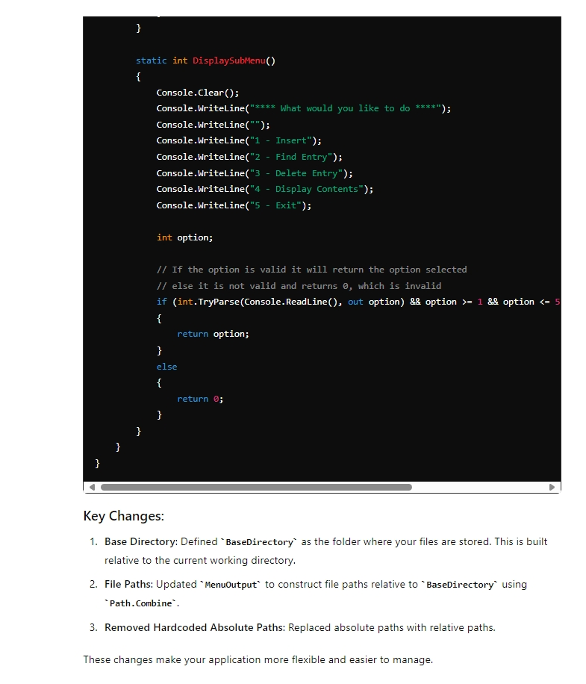

Accidentally pressed enter without finishing typing but it still gave me a good idea to use a try-catch in my code to show if the file path was working or not.

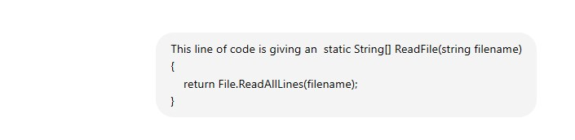

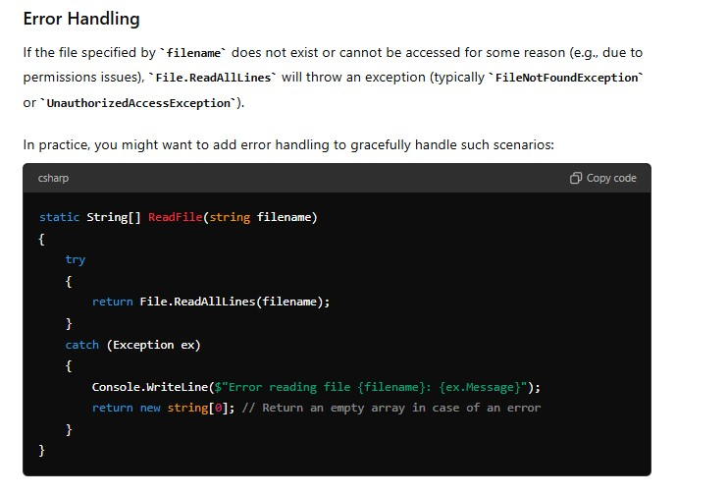

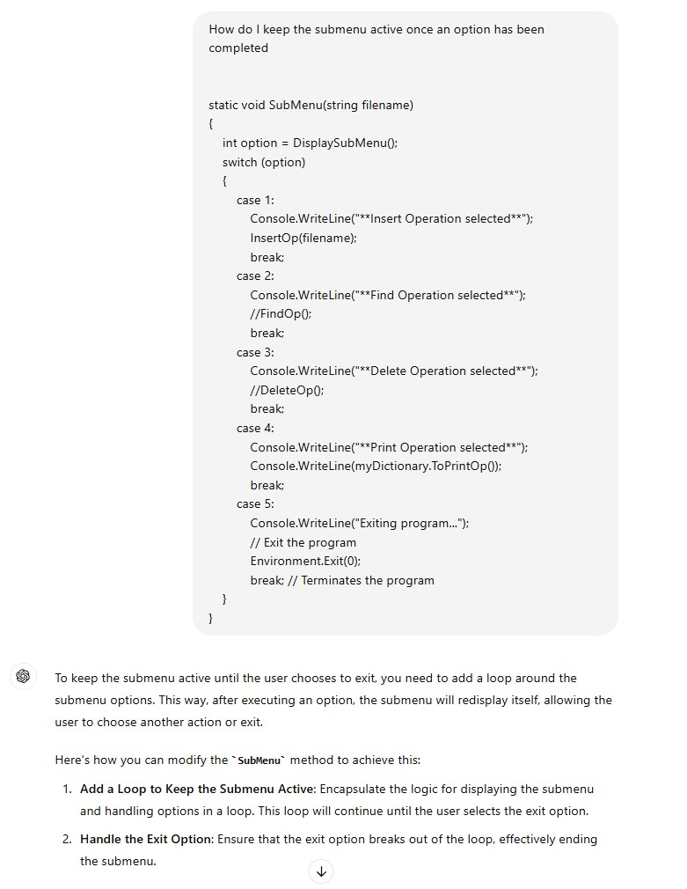

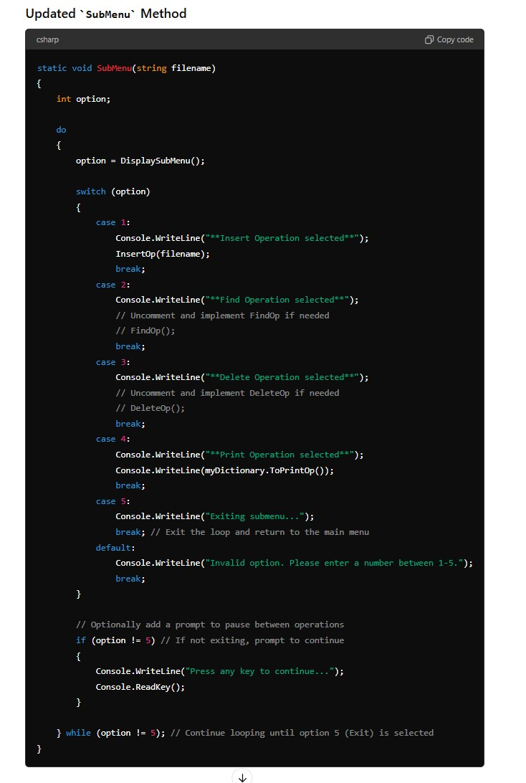

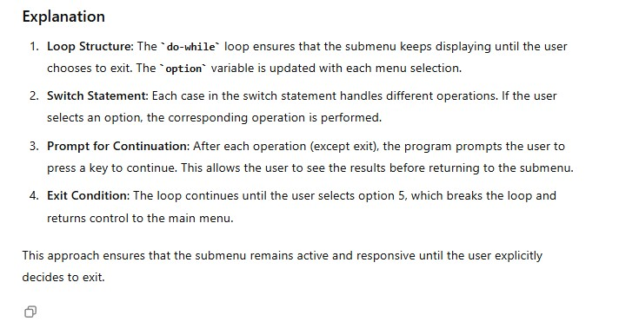

I realised I had made a mistake with my code so a lot of these are no longer in my code, but they were a good pathway for me to understand the code.

**APA References:**

OpenAI(2024). ChatGPT(3.5). <https://chatgpt.com/>.

Wood, B. (Personal communication, August 21, 2024). Spark. Help with excel graphs and feedback.

Wood, M. (Personal communication, August 18, 2024). Affco. Taught debugging and helped with errors in code.

Southcombe Nguyen, J. (Personal communication, August 21, 2024). Wintec Student. Helped each other.