# Milestone Project 1

Build a website for a Gym

### Strategy

* Product Objectives
  + Attract and retain customers.
* User Needs
  + The site's users are gym members and potential members, who want to know more about the gym and its procedures.

### Scope (Content Requirements - what people will visit the site to find out)

* Gym Information (primarily for attracting new customers)
  + About (ethos)
  + Aims (how it differs from competitors)
  + Unique Selling point (USP)
* Opening Hours
* Contact Information
* Class information
* Class timetable
* Membership Options
* Location information

### Structure (what will be on each page and how to navigate the site)

* Home page (Fun, attractive., retain interest, contain most things users are looking for.)
  + Gym images – possible image carrousel
    - CTA – take to gallery page
  + USP - What makes this Gym special. Just few sentences
    - CTA – join our Gym - About
  + Contact information and opening hours
    - Location Information
    - CTA – take to Contact us page
* About
  + Membership options
  + Class information
  + Downloadable Class timetable
* Gallery
  + Images of people working out
    - Use Fancy box
    - Maybe add a CTA to Membership
  + Videos (optional)
* Contact Information
  + Manager details
  + Phone number
  + Email address
  + Location information Embedded map
  + Ask us / get in touch form – email phone number etc.. (include check for correct information, however, does not need to be functional)

Navigation – Nav bar with links to all pages on each page.

Figure 1 - Navigation Flow

HOME

GALLERY

ABOUT

CONTACT US

### Skeleton (wireframes)

* Home

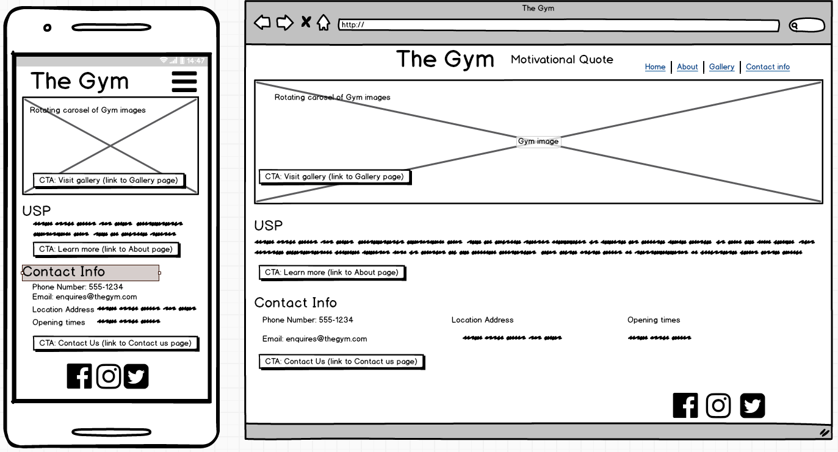

* About

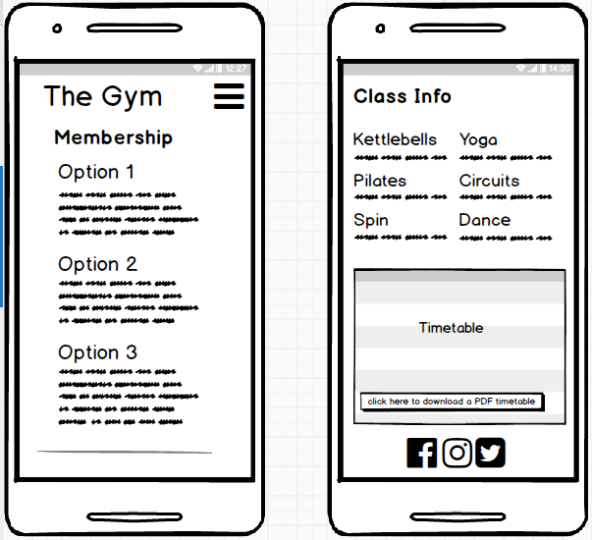

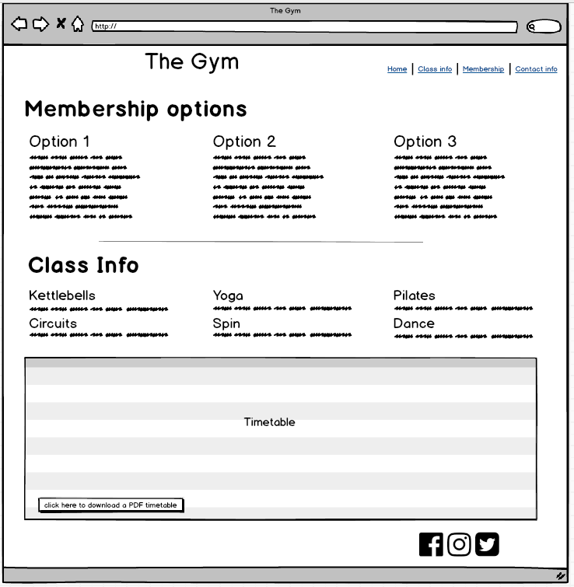

* Gallery

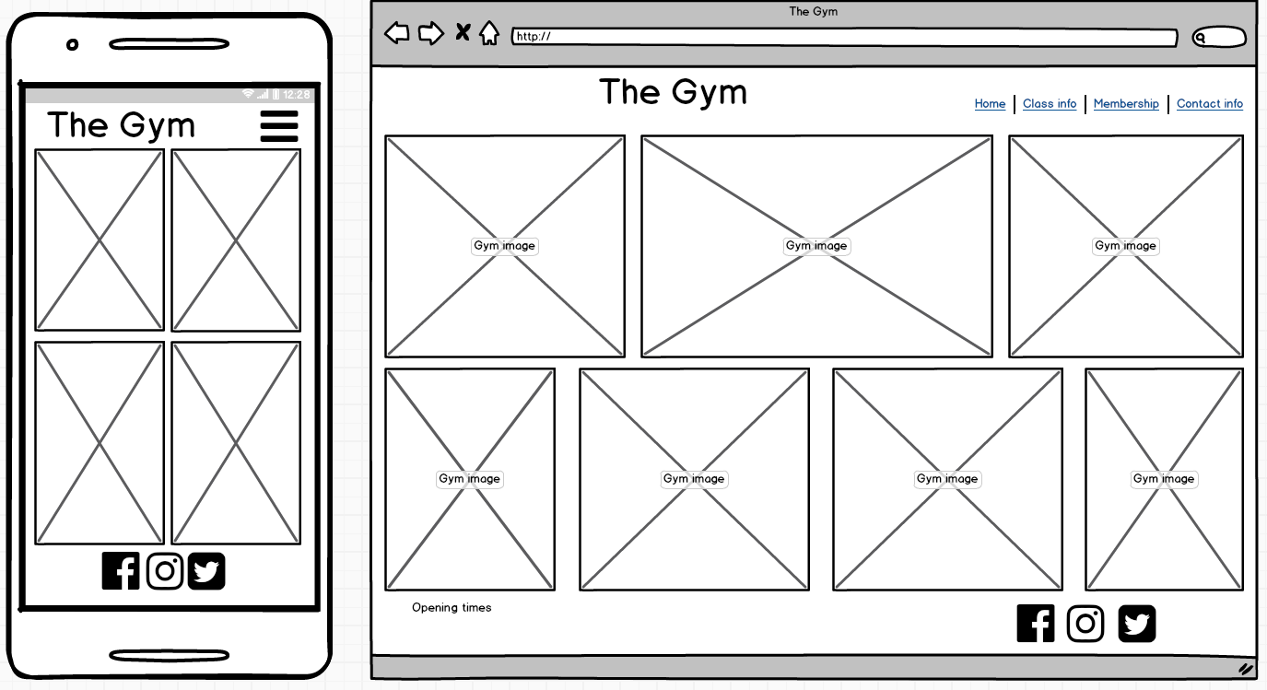

* 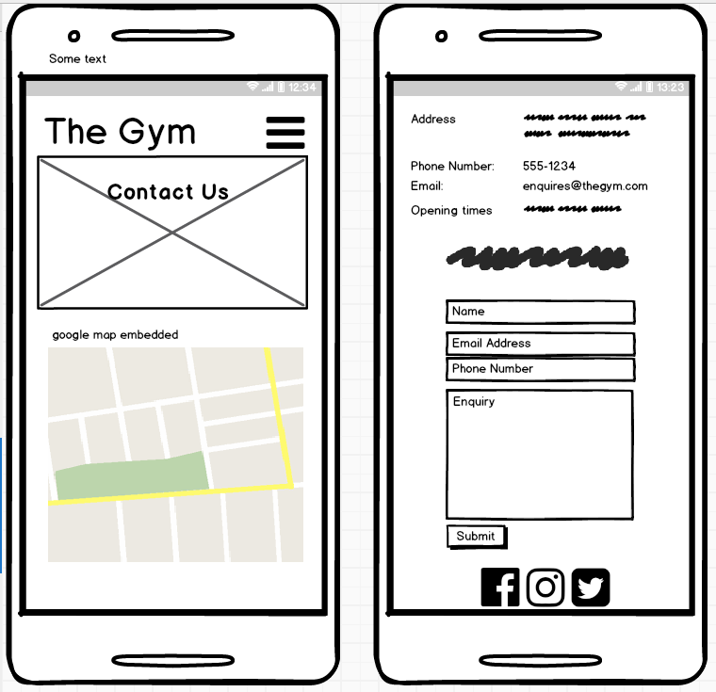Contact Us

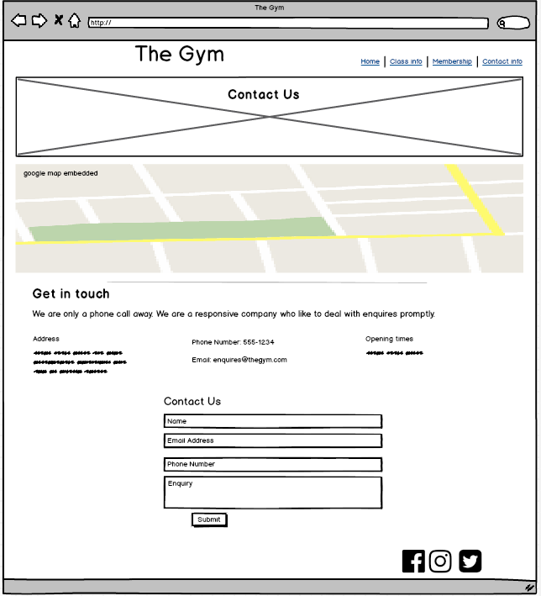

### Surface (Images, Typography, colours, language)

* Lots of images of people working out, that look like they are enjoying themselves.
* Modern font
* Monochrome with an accent colour. Keep simple.