

**DEMO Test**

**VOD Demo**

**By: Moataz Ibrahim Eldesouki**

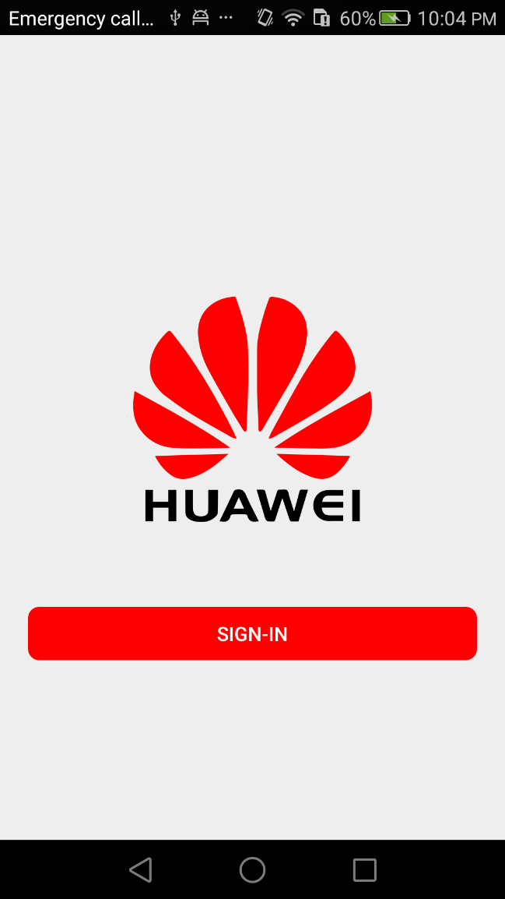

**Sign-in Screen**

* User can sign-in by Huawei ID
* After login successfully, Takes you to **Video Screen**

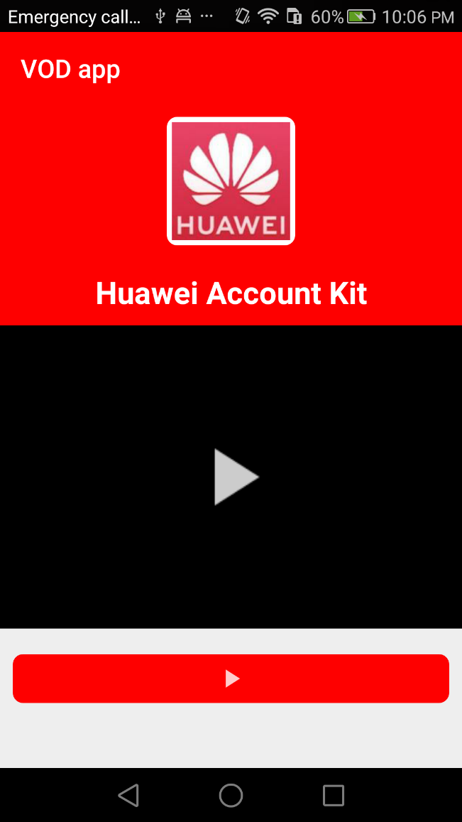 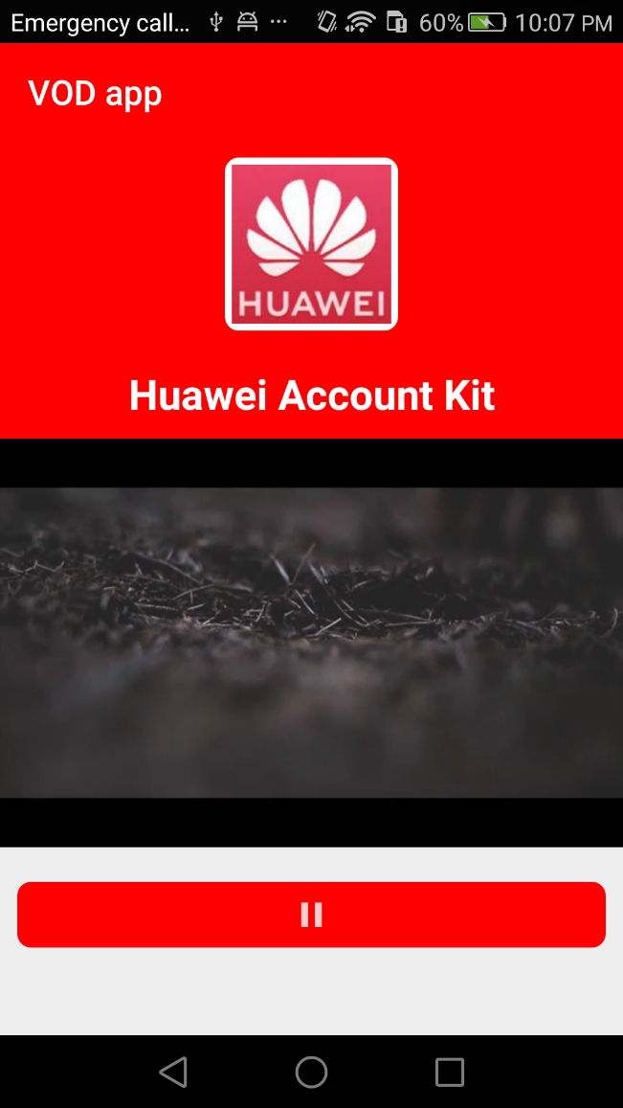

**Video Screen**

* **User can see user’s Huawei ID nickname and picture in the head of the app.**
* **User can see also a video poster in the body of the app.**
* **User can watch video by click on the video poster or (Play/Pause) button.**
  + If user wants to watch the video, he has to pay first.
  + User have to pay by Huawei IAP Kit to finish the payment, after payment, user can watch the video.

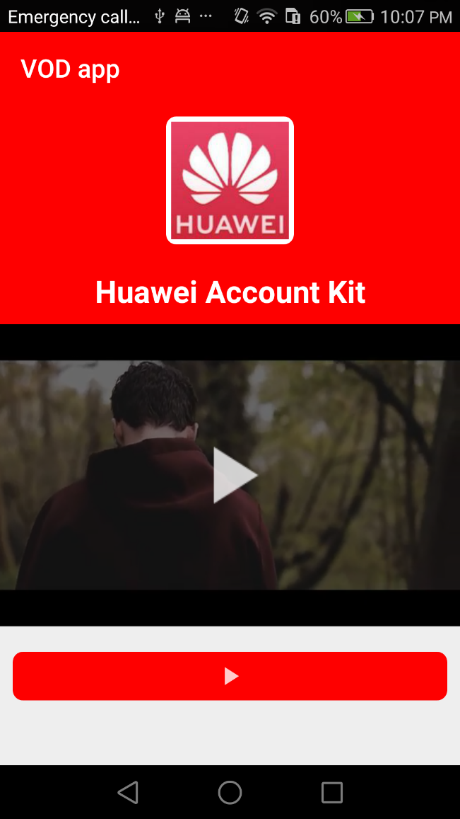

**Video Screen**