20076

Assessment, validity, prescribed accounting periods; certificate of registration; late registration; partnership; Value Added Tax Act sections 73, 76, 77, Schedule 1; Value Added Tax Regulations 1995 SI 1995/2518, regulation 25.

THE RAJ RESTAURANT
Appellant

- and –

THE COMMISSIONERS FOR HER MAJESTY’S
REVENUE & CUSTOMS
Respondents

Tribunal Chairman: J Gordon Reid, QC., FCIArb
Tribunal Members: J D Crerar, WS., NP
R L H Crawford, BA.,CA., ATII

Sitting in Edinburgh on the 12th, 13th and 14th February 2007.

For the Appellant Taher Nawaz, FCA

For the Respondents Iain Artis, Advocate

© CROWN COPYRIGHT 2007.

DECISION

Introduction
- This is the Tribunal’s unanimous decision on a preliminary point taken at the outset of the Hearing set down for the week commencing 12th February 2007. The Appellants were represented by Taher Nawaz, FCA, MBA. The Respondents (“Customs”) were represented by Iain Artis, Advocate.

- The Respondents have assessed the Appellants as a partnership trading as the “Raj Restaurant” with effect from 18th September 1995. They have been assessed to VAT and related penalties from that date until 31st July 2002.

- A Hearing before a differently constituted tribunal, to determine whether the Appellants truly carried on business in partnership, took place over fifteen days between March and October 2005. The Tribunal, in its decision released on 21st February 2006, concluded that each of the Appellants was a member of a partnership running the Raj Restaurant and related business interests during the period between 18th September 1995 and 31st July 2002 (Decision page 35).

The Preliminary Issue before this Tribunal
- At the outset of the Hearing, a variety of practical matters concerning mainly witnesses and productions were discussed. Mr Artis indicated inter alia that the statutory certificate of registration had been required by the Appellants. Mr Artis had produced a copy and indicated that the original print was available. There was no dispute about the provenance or authenticity of the certificate produced. Mr Nawaz, for the Appellants, submitted that the assessments were invalid. We consider below the detail of the competing submissions which we heard on Monday 12th February and Tuesday 13th February. After Mr Nawaz had addressed us on the first day, we adjourned until the following day to enable Mr Artis to consider Mr Nawaz’s submissions. We heard further submissions from both parties on 13th February. After the conclusion of submissions, we adjourned until noon on Wednesday 14th February when we gave our decision together with a summary of our reasons. We indicated that we would provide a fully detailed and reasoned decision in due course and this we now do.

Factual Background
- The findings of fact made by the Tribunal in relation to the partnership issue disclose broadly that between 1995 and 2002, a number of entities and persons were involved in the Raj Restaurant. Several limited companies feature, namely Bengal Tiger Limited, Spice Aroma Limited, Goa 1510 Limited, Pick ‘n Mix Limited and On the Shore Limited among others.

- Following various investigations, Customs decided to deregister On the Shore Ltd for the purposes of VAT with effect from 18/9/95. By letter dated 28/6/02 [R3/107] Customs intimated to the present appellants (being essentially those whom they considered to be the partners of the Raj Restaurant) that they had commenced action to register them for VAT with effect from 18/9/95. A few days later a notice of compulsory registration was issued (1/7/02-R3/132] but nothing was said to turn on that document; we do not need to give it further consideration.

- By letter dated 22/7/02 [R3/118] Customs wrote stating that several individuals had been registered for VAT purposes as partners in the Raj Restaurant. The letter stated that You will already have received formal notification of the registration from the VAT Registration Unit in Grimsby. Before us it was denied that any such notification was ever given. Mr Artis indicated that he was unable point to any document vouching such formal notification. Nor would he lead any evidence about it. Moreover, there was no evidence establishing the issuing of any certificate of registration other than the certificate dated 30/1/07 and tendered on Monday 12/2/07 when the Hearing before us began.

- The letter of 22/7/02 referred to schedules and notes. However, they did not form part of production R3/118. It was not suggested that these schedules and notes were to be found elsewhere in the bundles of productions. Page 2 of the letter contained inter alia the following:-
“Please refer to the enclosed schedules and notes in relation to the amounts deemed due by the new registration. Your account at the VAT Central Unit will be adjusted accordingly when the first VAT period is on file.

Please note that the Commissioners, in exercise of their powers, require that VAT returns be rendered on a monthly basis.

The enclosed schedule covers the period 18th September 1995 - 31st May 2002. You will be required to account for the amount due for June and July 2002 on your first VAT return. The Commissioners reserve the right to raise further assessments where the declared liability for these periods is deemed to be incorrect .…………….”(underlining added)

- Notification of an assessment was intimated by letter dated 10/9/02 [R1/1]. The letter begins by intimating that four individuals as partners in the Raj Restaurant have been registered for VAT with effect from 18/9/95. The registration number is noted and it is stated that the individuals will already have received formal notification of the registration from the VAT Registration Unit Grimsby. As noted above, such formal notification above is denied and there is no documentation to vouch any such formal notification.

- The letter of 10/9/02 [R1/1] continues as follows:-
“Since you have failed to render a VAT return for period 07/02 (18th September 1995 to 31st July 2002) an assessment to VAT has been made under S73 VAT Act 1994 …………..

The assessment, which covers the period 18th September 1995 to 31st July 2002, in the sum of £400,217.16 is enclosed. ………………..

Please refer to Schedules 1 and 2 (enclosed) which detail the method of calculation. ……………..

Please note that the Commissioners, in the exercise of their powers, require that VAT Returns be rendered on a monthly basis.”
(underlining added)

- The copy schedules attached to the letter in the productions are not easy to read but appear to contain calculations by reference to a mixture of periods, some monthly, some three monthly, the first period mentioned being “Period 12/95” (presumably the quarter consisting of the months October November and December 1995, or possibly the period 18/9/95 to 31/12/95- although we cannot identify where any such accounting period may have been prescribed); the last period mentioned is for the month of May 2002.

- The letters of 28/6/02, 22/7/02 and 10/9/02 were the only letters to which we were addressed in any detail in the course of submissions.

- The only other document of importance is the Certificate of Registration dated 30/1/07 [Appellants’ bundle, un-numbered]. The Certificate states that the Certificate was issued on 30 January 2007 (although on the second sheet it records that copy of the certificate was issued on 31 January 2007); it contains a registration number; it refers to the effective date as being 18 September 1995. There is endorsed on the first and second sheet the following:-
“RETURNS TO BE MADE IN RESPECT OF PERIOD ENDING 28 FEBRUARY 2007 AND MONTHLY THEREAFTER

LEGAL ENTITY PARTNERSHIP”

- On the second sheet there are the words:-
“DATE LAST AMENDED 15/12/06”
That entry remains unexplained and was not discussed before us.

Legislative Framework
- The following statutory provisions have or may have some relevance to the preliminary issue we have to determine:-
Value Added Tax Act 1994;-
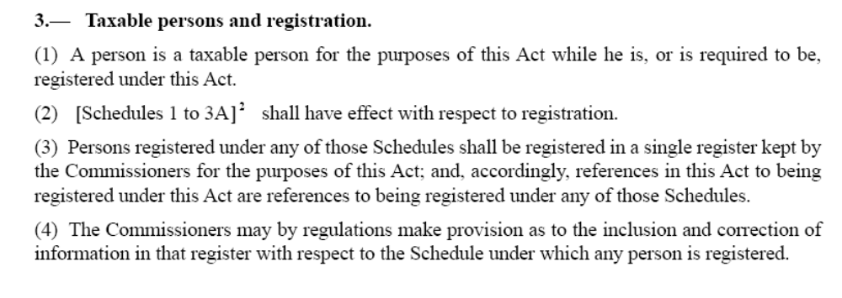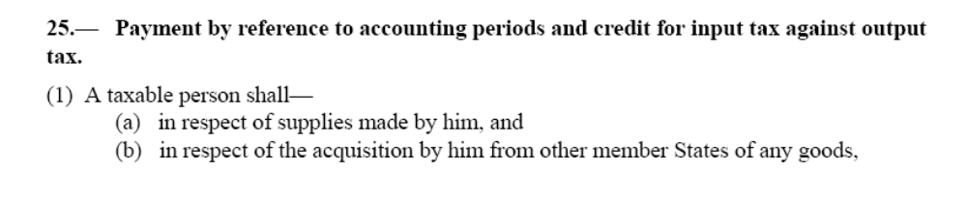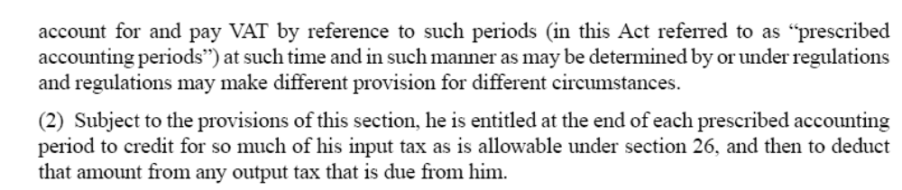
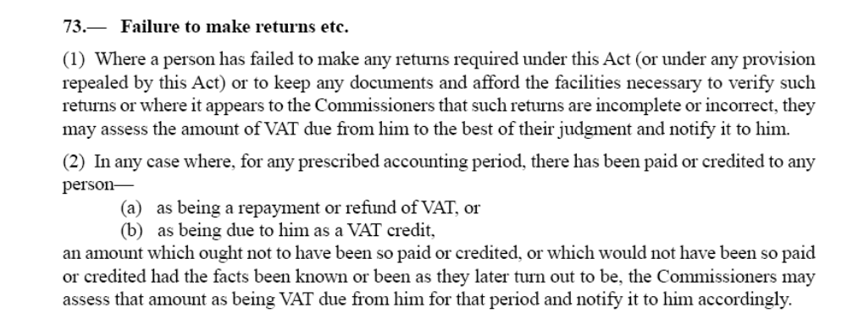..........................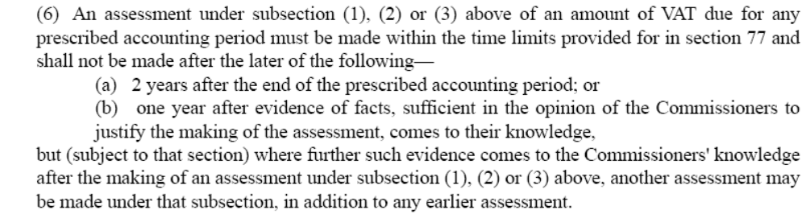
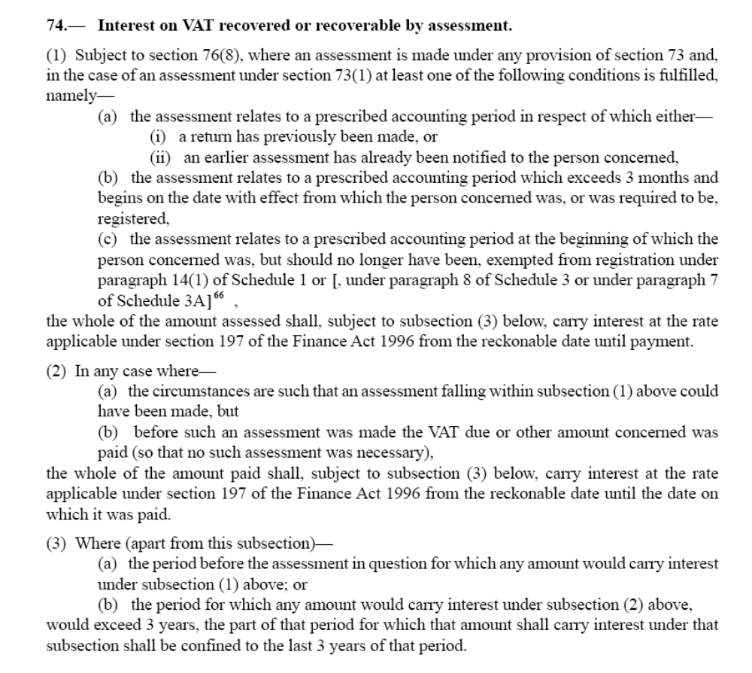

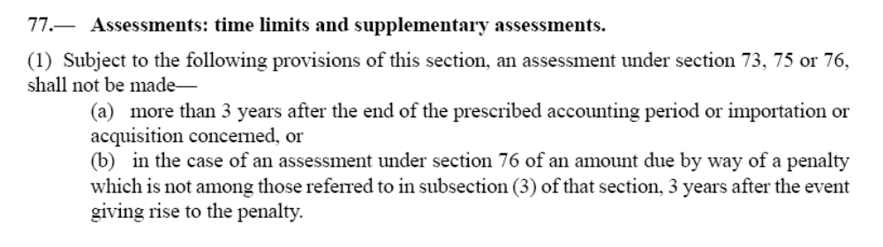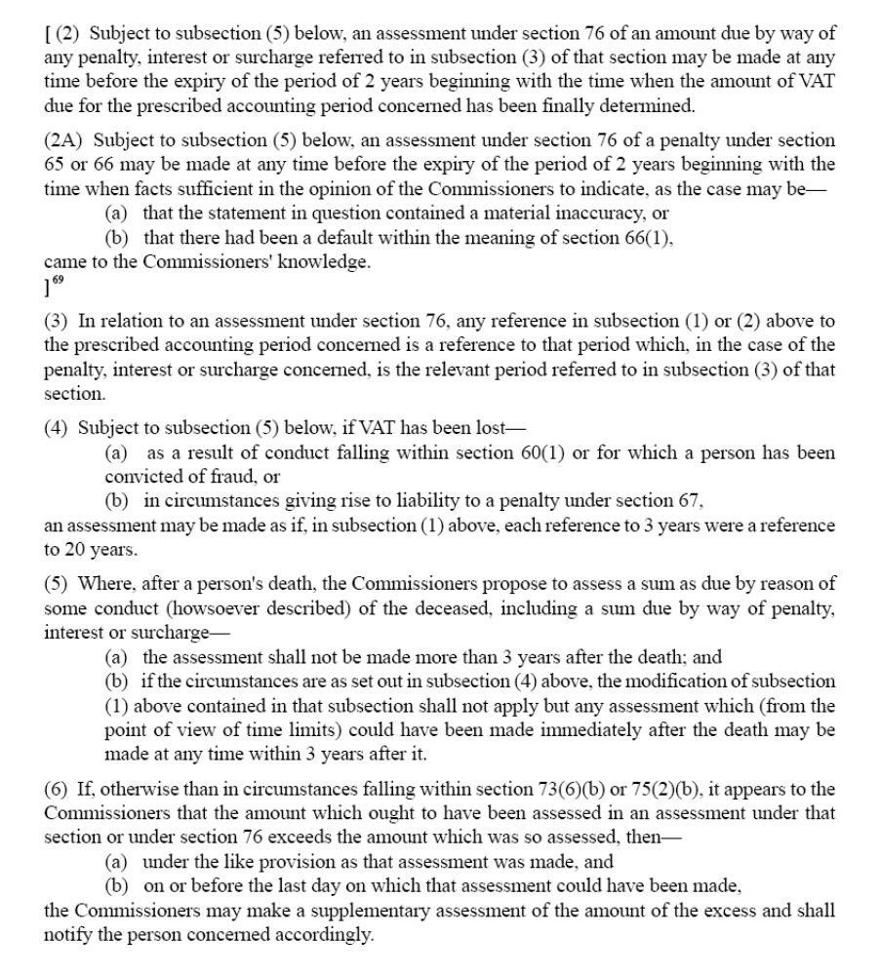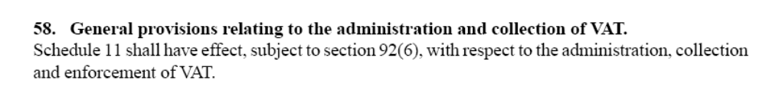
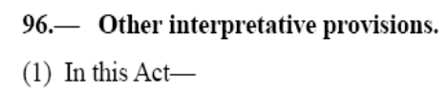
(2) …….
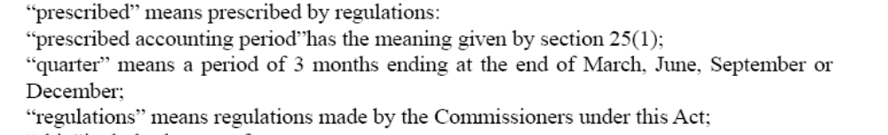
Schedule 1
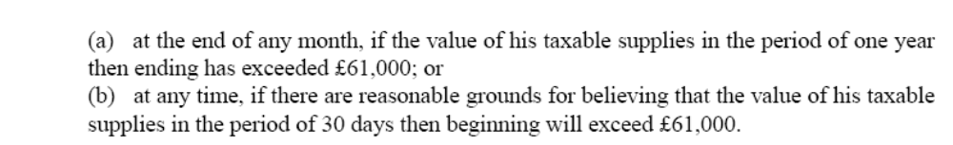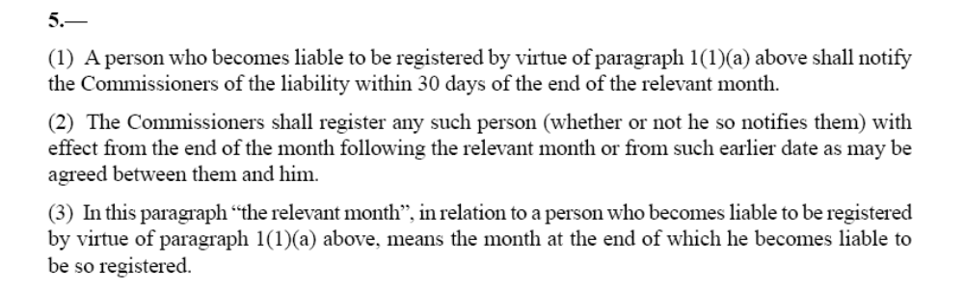
Schedule 11
…………….
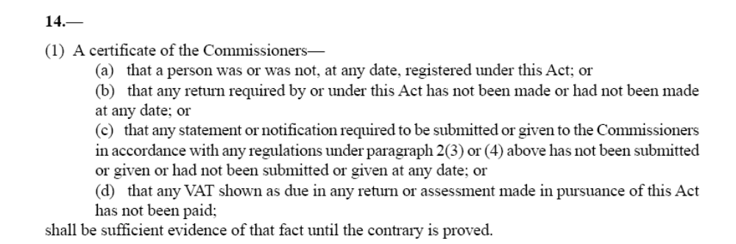

The Value Added Tax Regulations 1995 SI 1995/2518 (as amended)

(1)…………
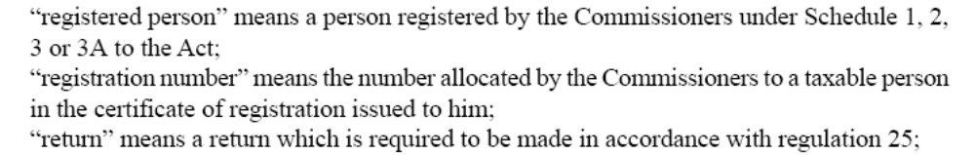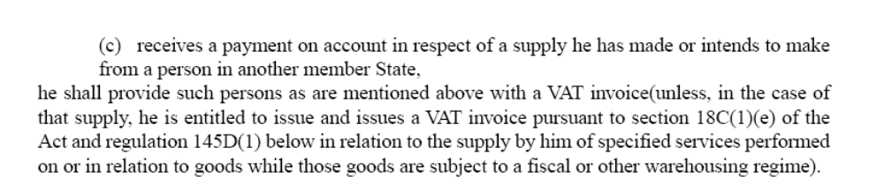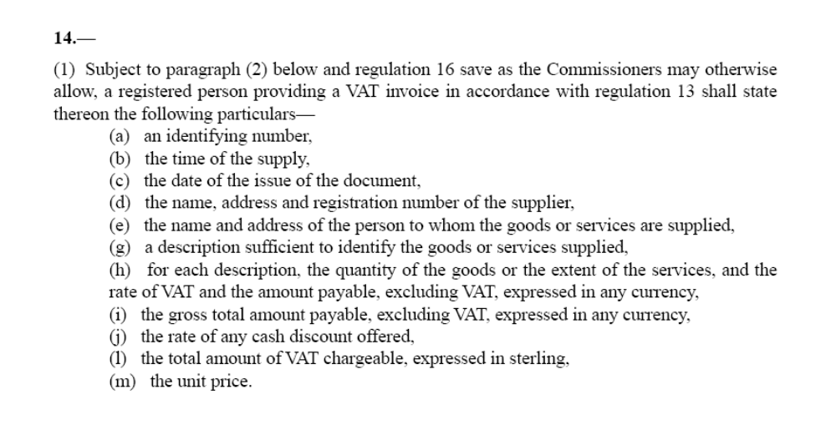
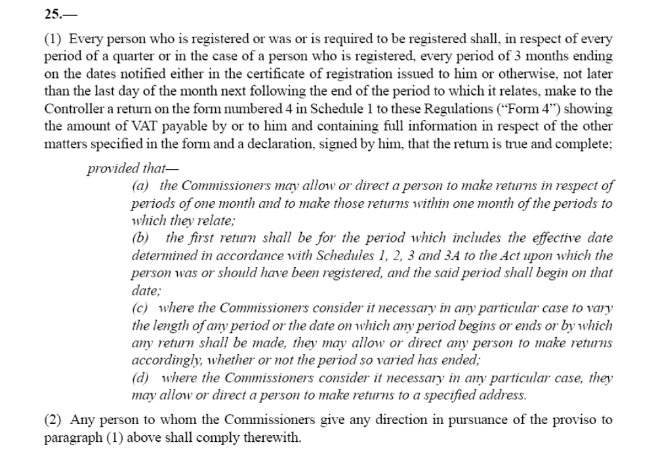

Submissions
- Mr Nawaz submitted that the Certificate of Registration was an important document. None was to be found in the voluminous productions (three arch lever files) lodged by Customs. The document now tendered came too late and should not be allowed.

- If it is allowed, then its terms rendered the Notice of Assessment to which this appeal relates invalid. The Certificate of Registration produced bears the date 30 January 2007. It directs “Returns to be made in respect of the period ending 28 February 2007 and monthly thereafter”. That is a different period from the Assessment which is from 18/9/95 to 31/7/02. he referred us to Manzoor Hussein & Anr Decision No 17526, Manchester 15/1/02 Chairman D Demack and to HK Sneller Lon/87/124, Chairman The Rt Hon Lord Grantchester CBE, QC

- Mr Nawaz also referred to Plummer v CC&E 1/12/00 MAN/99/589, Chairman JD Demack, a case relied on by Mr Artis, and submitted that it was similar to Central Taxis to the effect that Customs could only assess the Appellants in the absence of a return for a period in respect of which a requirement had been validly made. He also drew our attention to the terms of various letters namely Customs’ letter dated 28/6/02 [R3/107], Customs’ letter dated 22/7/02 [R3/118], and Customs’ letter dated 10/9/02 [R1/1] by which the assessment was notified. He submitted that the terms of that letter indicated that the assessment related to a long period. The long period had, however, never been set up. The only first period specified was the period June and July 2002 in the letter dated 28/6/02. Reference was made to regulation 25(1)(b) of the 1995 Regulations.

- Mr Nawaz also made it clear that his arguments had nothing to do with the law and practice relating to global assessments. He did not dispute the authorities on that topic cited by Mr Artis. His essential argument related to accounting periods. Mr Nawaz also pointed out that he raised the question of validity and referred to Central Taxis at the earlier hearing before the differently constituted Tribunal. We note from that Tribunal’s Decision dated 21/2/06 that Central Taxis was indeed cited (see page 4); the context is unclear as the case is not referred to again in the Tribunal’s decision.

- Mr Artis produced written submissions which he amplified. Unfortunately, some of these submissions proceed upon the view that the Appellants were arguing that the absence of a certificate of registration was fatal. However, Mr Nawaz’s argument did not proceed, at least ultimately, on that basis. He expressly accepted that the absence of a certificate of registration was not fatal. In the course of his submissions, Mr Artis tendered, without objection, a Notice of Compulsory Registration dated 1/7/02 [R3/132]

- Mr Artis submitted that (i) the issue of a certificate of registration is not a prerequisite of liability; he referred to sections 3 and 4 of and paragraph 14 of Schedule 11 to VATA; he also referred to regulations 5 and 7 of the 1995 Regulations, noting that there were very few statutory references to a certificate of registration, (ii) a certificate of registration was no more than a means of notification of registration and the allotment of the registered number, (iii) the notification of directions as to returns on the face of the certificate was a mere matter of administrative convenience (Punchwell ltd v CC&E 1981 VATTR 93), (iv) the certificate of registration, when issued, was accompanied by an email [also tendered without objection [R3/133] which qualified the terms of the certificate, (v) a certificate of registration could not invalidate an otherwise valid assessment, and (vi) the certificate was therefore irrelevant to the determination of the preliminary issue. That being so, the preliminary point raised by the appellants should be rejected.

- Mr Artis then proceeded to consider the validity of an assessment. He referred us to sections 25(1), 58, 73, 76 of and paragraph 2 of Schedule 11 to VATA, and to regulation 25 of the 1995 Regulations. He submitted that (i) notification of periods to the Appellants was otherwise than by a certificate of registration, (ii) section 73 made no direct requirement to assess by reference to accounting periods, and (iii) the Commissioners have a general power to make global assessments (SJ Grange Ltd [1979 STC 183, and House t/a P&J Autos [1996] STC 154).

- Mr Artis sought to distinguish the Central Taxis case by submitting that it turned on its own facts and that the assessment which remained extant in that case had been for the wrong period. He submitted that the invalidity of the assessment in that case did not flow from the lack of a certificate of registration. He submitted that the letter dated 22/7/02 contained only one statutory direction and that related to the requirement that VAT returns were required to be on a monthly basis. No statutory direction was required under regulation 25(1)(b).

- Mr Artis submitted that the period referred to in the Certificate of Registration issued on 30/1/07 was the period between 1/2/07 and 28/2/07, and contained a direction for the future. He indicated that he was not tendering the Certificate but had no objection to it being produced.

- We record at this point there was some confusion between the parties as to who was tendering the certificate of registration. Although Mr Nawaz submitted initially that it came too late, it was he who tendered it to the Tribunal along with (in fact it was stapled to) a copy of the decision in Central Taxis. We therefore consider that the first step is to allow the document to be received. Its authenticity was not in dispute. It emanated from Customs following several requests throughout the various appeal proceedings in this appeal for its disclosure.

Discussion and Decision
- In our opinion it is an inevitable and necessary implication from the various statutory provisions referred to above that an assessment must correspond to one or more prescribed accounting periods. A taxable person is required to be registered under VATA (section 3(1), Schedule 1 paragraphs 1 and 5). He must account for and pay VAT by reference to prescribed accounting periods (section 25(1)). He must make returns in prescribed form in respect of prescribed periods (1995 Regulations, paragraph 25). The prescribed periods are a quarter as defined (Regulation 2(1)), three months by reference to the certificate of registration or otherwise; a first return may be for a particular period (Regulation 25(1)(b)); a specific period may be prescribed by direction (Regulation 25(1)(c)). The power to asses is linked to the failure to make returns, which are themselves linked to prescribed periods. Liability for interest and penalties are linked to prescribed accounting periods (VATA section 74, and 76). Statutory time limits for making assessments are linked to prescribed accounting periods (section 77). The importance of the certificate of registration as an administrative document can be seen from the provisions relating to (i) the issue of a registered number and (ii) the contents of a VAT invoice (1995 Regulations paragraphs 2(1), 13 and 14). As a statutory certificate, it, in effect, is self proving (VATA Section 58, Schedule 11 paragraph 14).

- In our view, therefore, as a matter of statutory construction, an assessment must be linked to and correspond with one or more prescribed accounting periods. The authorities cited proceed on that basis. None proceeds on any other basis.

- We consider that the reliance placed by counsel for Customs on SJ Grange Ltd and House was misplaced. The issue in Grange was whether a taxpayer could be validly assessed in a single assessment for tax due in respect of several accounting periods. The Tribunal, and subsequently the Court of Appeal held that such an assessment was valid. The assessment covered several prescribed accounting periods but was stated as a single sum (1979 STC at 186C). The court held that the assessment was valid. The significant point decided was that an assessment need not be confined to a single prescribed accounting period but could cover several such periods (see 193e, 195b-c, 195j). Such an assessment has come to be known as a global assessment. The qualification placed on the use of such assessments by Lord Denning MR in that case (where it is impossible for the commissioners to split the assessment up into three-monthly periods -193e) was not endorsed by the other members of the court.
- In House, schedules were attached to the notice of assessment; the schedules specified how the tax was calculated, but there were no individual figure in relation to each of the prescribed accounting periods covered by the assessment. This was thus a global assessment (1996 STC at 157e) The Court of Appeal followed the broader approach of the majority of the court in Grange (160b). One of the arguments before the court was that the assessment was invalid in the absence of such a figure for each individual prescribed accounting period. It held that a global assessment was competent in respect of many prescribed accounting periods (1996 STC 156h-157a); the assessment in question was sufficiently clear in its terms and therefore valid; in fact, the sum alleged to be due in respect of each individual prescribed accounting period was capable of calculation from the detailed information provided in the schedules (157b). It is implicit in the court’s decision that it proceeded on the assumption that an assessment must correspond with one or more prescribed accounting periods applicable to the taxpayer (160g).

- The same point, namely that any assessment must be for a prescribed accounting period, is made in Central Taxis at paragraph 16. That decision stressed the importance of the production of the or at least a certificate of registration and its link with the period covered by the first return (paragraph 4). The Tribunal also pointed out, under reference to regulations 2 and 25 of The Value Added Tax Regulations 1995 (SI 1995/2518) that the power to assess must be for a “prescribed accounting period” (paragraph 16). In that case, the assessment was held to be invalid because it did not correspond with the accounting period directed in a letter issued following upon an amendment to the appellants’ certificate of registration (paragraphs 5. 17 and 18).

- The certificate is evidence of what the statutory register contains (see VATA Schedule 11 paragraph 14). It is also important because it is the statutory means by which the taxpayer’s registered number is allocated and identified, which in turn has significance for the contents of certain VAT invoices (see the definition of registered number and the provisions relating to VAT invoices in regulations 2(1), 13 and 14 of the 1995 Regulations).

- We were also referred to Plummer. There, an amended certificate of registration was issued, backdating the effective date of registration by about two years. The amended certificate also contained a statutory direction creating a long prescribed accounting period (paragraph 4). The wording of the direction specified in that certificate (paragraph 3) is in substantially the same form as the direction contained in the Certificate dated 30/1/07. The problem that led to the assessment in that case being declared invalid was that the period covered by the assessment did not correspond to the long period direction in the amended certificate of registration (see paragraphs 1, 3, & 10). The practice of specifying a prescribed accounting period direction, which may include a long period direction, in a certificate of registration is noted in Punchwell at page 97. The practice appears to have subsisted since at least the early eighties. Plummer, decided in 2000, and the Certificate dated 30/1/07 are more recent examples.

- Sneller was called to our attention essentially for the proposition that Customs cannot move the goalposts by issuing an amended assessment in the course of an appeal. The facts were largely concerned with whether the taxpayer acted as agent or principal in relation to certain transactions. However, the assessment was held to be invalid because the period covered by the assessment did not correspond with the correct prescribed accounting periods to which the tax claimed related (see pages 3-4). The Tribunal in reaching this view, followed SJ Grange Ltd.

- All these authorities either expressly or by necessary implication support the proposition that an assessment must correspond with one or more prescribed accounting periods, however such periods are prescribed.

- In our view, the guiding principle is that an assessment must be for a prescribed accounting period or periods. Bearing that principle in mind, we have considered the validity of the assessment contained in the letter dated 10/9/02 [R1/1] first of all by disregarding the Certificate of Registration and its contents, and secondly, by taking the Certificate of Registration into account.

- Disregarding the Certificate of Registration, we conclude:-

- The letter dated 22/7/02 [R3/118], properly construed, appears to direct a first return in terms of Regulation 25(1)(b) of the Value Added Tax Regulations 1995 for the monthly periods of June and July 2002. If that is a valid direction, then any assessment relating to an earlier period must be invalid. However, that direction must itself be invalid because a regulation 25(1)(b) direction must specify a first period which starts on the effective date of registration. Apart from a direction to submit monthly returns after July 2002, in response to questions from the Tribunal, it was not argued by counsel for the Respondents that the letter contained any other statutory direction prescribing an accounting period. We observe that the reference to the period 18/9/95 to 31/5/02 and to related schedules, which are not before us, does not correspond with the period of assessment contained in the letter dated 10/9/02, namely 18/9/95 to 31/7/02 (see paragraphs 7, 8 & 10 above).

- Had the letter dated 22/7/02 stated next instead of first, which was how Mr Artis invited us to construe it, different considerations might have arisen.

- There thus appears to be no direction in terms of Regulation 25(1)(b) prescribing the period of the first return. Even if no such direction is required, and reliance can be placed on the requirement in Regulation 25(1), the quarterly period would end on 30/6/02 and not on 31/5/02 or 31/7/02. The schedules attached to the letter dated10/9/02 are not confined to quarterly periods ending March, June, September and December. In these circumstances, the global assessment made does not correspond with the quarterly periods prescribed by regulation 25(1).

- In any event, we have been unable to identify a prescribed accounting period corresponding to the period 18/5/95 to 31/7/02 referred to in the letter dated 10/9/02. That letter refers specifically to an alleged failure to render a VAT return for that period. It appears to assume the existence of a long period direction of the type contemplated in paragraph 15 of the Central Taxis case (17526 Manchester 15/1/02, Chairman D Demack). There was and is no such direction.

- While an assessment may be global it must still correspond with one or more prescribed accounting periods. As the assessment set forth in the letter dated 10/9/02 does not do so, the Notice of Assessment and the underlying assessment which is being notified must be invalid.

- We turn now to consider the position on the basis that the Certificate of Registration dated 30/1/07 is taken into account in assessing the validity of assessment contained in the letter dated 10/9/02. We think it must be taken into account as it appears to be the only certificate of registration issued in relation to the partnership. The Respondents accept that they cannot prove that any other certificate of registration has been issued. On that basis we conclude as follows:-

- It is a matter of agreement between the parties that the existence of a certificate of registration is not a necessary prerequisite to the issue of a valid notice of assessment. While this may be so, it seems to us that it is a necessary implication from the definition of registration number in regulation 2(1) of the 1995 Regulations and the requirement as to the issue and contents of VAT invoices under regulation 13 and 14(1)(d) of the 1995 Regulations that a certificate of registration must be issued promptly upon registration by the Commissioners under paragraph 5 of Schedule1 to the 1994 Act. We need not dwell upon this point meantime.

- Properly construed, the Certificate of Registration contains inter alia a statutory direction specifying a prescribed accounting period. The period so prescribed is 18/9/95 to 28/2/07. It is not unusual for a certificate of registration to contain such a direction as can be seen from Punchwell Ltd v CC&E 1981 VATTR 93 at 97. However, the terms of the direction contained in this Certificate are, to say the least, unfortunate. We must reject, as untenable in the circumstances, the Respondents’ submission that the period is from 1/2/07 to 28/2/07. The document will simply not bear that construction. We note that the wording is similar to the direction in the Certificate in Plummer 16976 MAN/99/589 Chairman D Demack paragraphs 3 and 4.

- It is not suggested that the contents of any part of the certificate is invalid. It seems to us that its terms must be taken to supersede any previous inconsistent direction. The very nature of a long period direction in the case of late registration is that it is retrospective in effect. Normally, the effect is to pave the way for the issue of a valid assessment covering the prescribed long period. Here, it has had the opposite effect.

- The terms of the certificate render invalid the assessment notified in the letter dated 10/9/02 because no period in the assessment corresponds with the period specified in the certificate which period, in spite of the length of the appeal proceedings, had not yet come to an end when this appeal began in February 2007. The importance of making an assessment for the correct prescribed accounting period or periods is highlighted in a number of cases to which we were referred including Sneller LON/87/124 Lord Grantchester, pp7-8, CC&E v Grange Ltd 1979 STC 183 and Central Taxis. This reflects the guiding principle referred to above. The assessment to which the present appeal relates does not satisfy the requirements of that principle. We must therefore hold the assessment to be invalid.

- Whichever way we consider the preliminary issue of the validity of the assessment, we reach the same conclusion. The assessment is invalid and no further substantive steps can be taken in this appeal which must now be allowed.

- There was no separate, detailed argument about the validity of the Penalty assessment dated 20/12/02 [R1/2]. However, the discussion on the preliminary issue appeared to proceed on the footing that both assessments stood or fell together. We therefore allow the appeal against that assessment too.

Result
- The appeal against (i) the assessment notified by letter dated 10 September 2002 and (ii) the Penalty assessment notified by letter dated 20 December 2002 is allowed.

- Since giving our decision on Wednesday 14th February 2007, we have noted that the appeal against Customs’ decision to deregister On the Shore Limited appears still to be outstanding. We were not addressed on this issue at all. The previously constituted Tribunal do not formally refuse the appeal against Customs’ decision to deregister. However, the findings that (i) the Appellants were in business as a partnership throughout the period from 18 September 1995 to 31 July 2002 (page 28) (ii) the companies, involved, including On the Shore Ltd, were a mere sham (pages 31, & 33), (iii) the corporate veil should be lifted (page 32), (iii) the companies were a device to disguise the true ownership of the business by the Miah family, and (iv) the Respondents’ decision to register the Appellants for the purposes of VAT (page 37) should be upheld have not been appealed. It would seem therefore to be difficult, to say the least, to maintain an appeal against the decision to deregister On the Shore Ltd.

- As parties will require some time to consider the ramifications of our decision, we shall reserve all questions of expenses meantime. We hope that parties will be able to indicate within a period of six months how the question of expenses and any other residual matters should be dealt with but will make no formal order meantime.

J GORDON REID, QC., FCIArb
CHAIRMAN
RELEASE: 22 MARCH 2007
EDN/03/03

The appearance of a few footnote numbers and brackets in the quoted legislation is a consequence of cutting and pasting from the relevant internet website; these cannot be removed and should simply be ignored.

