[2011] UKFTT 330 (TC)

TC01190

Appeal number TC/2009/13713

Excise Duty – Hydrocarbon Oil Duties Act 1979, Section 6 – importation of fuel from the Republic of Ireland – Travellers Relief (Fuel and Lubricant) Order 1995 – use of standard tanks in a commercial vehicle - decanting of imported fuel – whether assessment made to best judgment – Appeal Dismissed

FIRST-TIER TRIBUNAL

TAX

W.J. BLACK & CO. Appellant

- and -

THE COMMISSIONERS FOR HER MAJESTY’S

REVENUE AND CUSTOMS ("HMRC") Respondents

TRIBUNAL: I.W. HUDDLESTON, TRIBUNAL JUDGE
A.F. HENNESSEY, ESQ.

Sitting in public at Bedford House, Belfast on 10th February 2011

Randal McKinney, Accountant, for the Appellant

Richard Chapman BL, instructed by the General Counsel and Solicitor to HM Revenue and Customs, for the Respondents

© CROWN COPYRIGHT 2011
DECISION

Appeal

- The appeal is against the disputed decision of HMRC to assess W.J. Black & Co. ("the Appellant") in the sum of £31,633, representing excess duty arrears on the importation of road fuel. The assessment was issued on the 29 May 2009 and subsequently reviewed, after which the amount of duty was reduced to £31,603. The Appellant was notified of the review and the amendment by a letter dated the 3 August 2009, and it is against that review which he now appeals.
Facts
- The Appellant carries on business as an animal feeds haulier, registered for VAT purposes under registration number 252 352 482 and trades from premises at 2 Killyclogher Road, Cookstown, County Tyrone.
- On the 17 March 2009 the Appellant's vehicle, a Volvo lorry, registration number WJI4534 ("the Vehicle") was stopped in Aughnacloy after fuelling in Southern Ireland. The Vehicle was found to have a non-standard running tank fitted, in addition to its standard tank. Both tanks were connected, but the feeder switch in the pipe which connected the two tanks was in the off position.
- The Appellant was later interviewed under caution by officers of HMRC and advised his actions in relation to the fuel and use of tanks was prohibited under the Travellers Relief (Fuel and Lubricants) Order 1995 ("the 1995 Order"). During that interview Mr. Black did accept that on occasion he decanted fuel in other vehicles used in the Appellant's business.
- On 7 April 2009 HMRC advised the Appellant that they would like to carry out a fuel audit on the business, and asked for the records for the preceding three years.
- Based on the inspection of those records, Clare Louise Spence, an officer of HMRC who appeared at the Tribunal and gave evidence, prepared a schedule detailing all of the fuel purchases for the Vehicle through the period from 6 June 2006 to the date of detection, ie 17 March 2009.
- The methodology she adopted was as follows:
  - she established from the original supplier that the standard running tank for the Vehicle had a capacity of 200 litres;
  - she therefore allowed purchases of 200 litres, but disallowed anything above that capacity, on the basis that it was fuel for the non-standard tank;
  - on days where it was indicated that there were two purchases of fuel, then she allowed the lesser quantity and disallowed the larger quantity on the basis that any larger quantity also was likely to have been bought as fuel for the non-standard tank.
- On the 6 May 2009 Ms. Spence wrote to the Appellant advising that she was proposing to assess the Appellant on the basis of the calculations which had been made.
- On the 11 May 2009 the Appellant contacted HMRC asking if he could examine the records and make a comparison with the assessment which was to be issued.
- There subsequently followed a meeting on the 21 May 2009 when HMRC explained to the Appellant the methodology which had been adopted.
- On the 26 May 2009 HMRC issued an assessment letter with a schedule of the relevant calculations. That assessment was for a total amount of £31,633.00.
- On the 26 June 2009 the Appellant requested a formal review, which was undertaken and, subject to the rectification of a small mathematical error, the assessment was upheld in the sum of £31,603.00 – being the assessment now under appeal.
Legislation
- Under Section 6 of the Hydrocarbon Oils Duties Act 1979 ("HODA") there is a charge to duty (at varying rates) on hydrocarbon oil (including diesel) imported into the United Kingdom. There is provision for relief from excise duty on the importation of fuel into the United Kingdom from other EU Member States for fuel actually used by vehicles in transit between member states. The reference to "standard tanks" arises in article 8 of Council Directive 92/81/EEC ("the Directive") where it is provided that:
"Mineral oils released for consumption in a member state, contained in standard tanks of commercial motor vehicles and intended to be used as fuel by those same vehicles as well as in special containers and intended to be used for the operation, during the course of transport, of the systems equipping those containers, shall not be subject to excise duty in any other member state."
- Article 8 goes on to define "standard tanks" as:
"The tanks permanently fixed by the manufacturer to all motor vehicles of the same type as the vehicle in question, and whose permanent fitting enables fuel to be used directly, both for the purpose of propulsion and, where appropriate, the operation, during transport, of refrigeration systems and other systems."
- The Directive, including the definition of "standard tanks", was imported into UK law by the Travellers Relief (Fuels and Lubricants) Order 1995 (Article 3).
- I should point out at this stage that the Appellant also referred the Tribunal to the Road Haulage Association guidance insofar as the concept of "standard tanks" is applied to "used or second hand" vehicles. That guidance provides for the following:
"Any tank already fitted to ……a vehicle when purchased by its current owner would satisfy the "standard tank" criteria. This means that should the original tank have been replaced by a new larger tank prior to purchaser by a subsequent owner, then that larger tank would be regarded as having been fitted by the manufacturer for the purpose of the legal definition ….. "
HMRC's Case
- HMRC's case is relatively straightforward. We heard evidence from Clare Louise Spence, the officer who originally prepared the first assessment based on the information provided by the Appellant. Ms. Spence gave evidence as to the methodology she adopted in collating the table of invoices supplied by the Appellant during the fuel audit, and how she arrived at her assessment. The salient points of Ms. Spence's evidence was that she, on the 28 April 2009, contacted the Volvo dealership from which the Vehicle had been acquired and had been able to confirm that based on the chassis number for the Vehicle that when purchased it had one standard tank fitted holding 200 litres.
- In carrying out the fuel audit she accordingly allowed 200 litres against each fill of fuel in excess of that amount, and disallowed the balance.
- Where there were two fills on a particular day, she gave evidence that she allowed the smaller of the two fills and disallowed the larger, on the basis that the larger fill was probably used to fill the non-standard tank.
- It was on that basis that she came to the conclusions which she discussed with the Appellant on the 21 May 2009 and upon which the assessment was subsequently raised. HMRC contend that nothing has been produced by the Appellant to countermand that approach.
The Appellant's Case
- In the appeal notice of the 1 September 2009, the Appellant raised the following grounds of appeal:
  - that the vehicle in question had been previously stopped, that the tanks had been reviewed on that occasion, and had been approved;
  - that the vehicle was a "used" vehicle and that to the extent, therefore, that there was a non-standard tank, the larger tank should be regarded as having been fitted by the manufacturer for the purposes of the legislation and based on the RHA quoted at paragraph 16 above;
  - that the duty evaded should be based on a calculation of the fuel decanted, and not based on a calculation of the total fuel filled in the non-standard tank.
- Mr. Norman Black appeared and gave evidence broadly in support of those grounds.
- The first ground of appeal that he adopted was that the Vehicle had been stopped on two previous occasions between 2004 and 2008 and, in addition, had been subjected to PSV examination during that period, but that no-one had raised the issue of a non-standard tank.
- The Appellant could not, however, give dates on which the Vehicle had previously been stopped and, although the question was put to HMRC's witnesses on cross-examination, HMRC had no record of those events either.
- On that basis, the Appellant argued that he had assumed the tank had become a standard part of the Vehicle.
- The second ground advanced by the Appellant was that the second tank had already been fitted to the Vehicle when he took over the business and he, therefore, on that basis, claimed that the tank would have come to be treated as "legal" under the published Road Haulage Association Guidance quoted at paragraph 16 above.
- It is worth spending some time on this point.
- The history of the Vehicle was that it was acquired by Mr. Black's parents in or around December 1997. At that point the firm of W.J. Black & Co. had two partners, namely Albert Black and Evelyn Black, Mr. Norman Black's parent. Norman Black, at that point, was employed as a civil servant.
- It appears that in 1999 an additional running tank was added to the Vehicle.
- In July 2000 Mr. Norman Black took a career break from his civil service post and became more involved in the business, to essentially give himself time to establish whether or not it was sufficiently viable for him to take it over.
- He gave evidence that he "took over" the business in July 2004.
- There was some dispute as to what this actually meant.
- Having heard from both Mr. Norman Black and his accountant on its specific points, what the Tribunal finds is that at that point Mr. Norman Black became a partner in the business, but the partnership itself and, therefore, the Appellant in these proceedings, did not actually change.
- We do not find evidence, therefore, that there was a change of ownership at any stage sufficient for the Appellant to derive any benefit from the guidance of the Road Haulage Association upon which he sought to rely. At all material times the Vehicle appears to have been owned by the firm of W.J. Black & Co.
- In addition, it was not until 2008 that the additional tank which had been fitted in 1999 was replaced with the tank which was in place when the Vehicle was stopped on the 17 March 2009.
- The Tribunal notes that Mr. Black did not refer in his interview under caution to the tank which was fitted in 1999 and, indeed, on that occasion referred only to the tank fitted in 2008. Regardless, the Tribunal did not agree with the Appellant's submission that the RHA guidance was of support to him in this case.
- The third and final point raised by the Appellant was in the alternative, namely that if the tank was found to be non-standard that the Appellant should not be assessed for the full litreage in the manner adopted by HMRC.
- In his letter of the 26 June 2009 to HMRC, Mr. Black put together a schedule for the audit period in which he estimated that the amount of the duty evaded by him was £13,177.80.
- The Tribunal quizzed MR. Black in relation to his methodology in coming to that calculation.
- In his evidence Mr. Black gave evidence that he simply estimated that he decanted 200 litres on average on each occasion that the Vehicle was filled. He also gave evidence that he decanted fuel only on an ad hoc basis and not on every fill, but he accepted that he had no corroborative evidence to support those assertions. He also accepted that he at no stage had produced any evidence to support the schedule which he had produced.
Decision
- The jurisdiction of this Tribunal arises pursuant to Section 16 of the Finance Act 2004 and is supervisory. The guidelines set out in the judgment of Carnrath LJ in Pegasus Birds v Customs and Excise Commissioners [2004] EWCA Civ 1015 in a case such as this are in point:
" ……. the Tribunal should remember that its primary task is to find the correct amount of tax, insofar as possible, on the material properly available to it, the burden resting on the tax payer."
- This is a case where, based on the Appellant's acceptance of a level of decanting, a fuel audit of the business had been carried out and an assessment issued by HMRC to "best judgment". In a case such as this, the onus falls to the Appellant to disprove that assessment.
- In the present case, based on the evidence before it, the Tribunal finds as follows:
  - the larger tank fitted to the Vehicle by the Appellant in 1999, and replaced in 2008, was a non-standard tank. Whilst it was connected to the smaller running tank by a feeder line the switch that allowed the flow of fuel between the two tanks was in the off position. It plainly was not being used to fuel the vehicle in the manner required by the Directive or pursuant to the 1995 Order;
  - the Appellant, both in the initial interview under caution, and subsequently, had accepted that some level of decanting had been undertaken by him, so there does not appear to the Tribunal to be any dispute that an offence under the 1995 Order was committed;
  - the methodology adopted by HMRC – based as it was on the fuel invoices which the Appellant supplied – cannot be faulted.
- To our mind, therefore, that is the starting point of the assessment and it is for the Appellant to establish that it is inaccurate in some material respect. That onus we find the Appellant has failed to discharge.
- We have cited the grounds of the Appeal Notice and commented on each. Beyond that all we have been presented with is a schedule estimating a contrary calculation of £13,177.80 as the "correct" figure for the amount of duty evaded.
- No information has been provided by the Appellant in support of that schedule, other than Mr. Black's verbal assertion that he "felt" that on each occasion he would have decanted no more than 200 litres on average to fuel other vehicles in the fleet.
- The Tribunal, however, does not find Mr. Black's verbal assertions, nor indeed the schedule which he produced, to be sufficiently robust to displace the analysis which HMRC had undertaken based on the fuel audit which it had carried out.
- On that basis, the Tribunal finds that HMRC's assessment is upheld and, therefore, dismisses the appeal.
- This document contains full findings of fact and reasons for the decision. Any party dissatisfied with this decision has a right to apply for permission to appeal against it pursuant to Rule 39 of the Tribunal Procedure (First-tier Tribunal) (Tax Chamber) Rules 2009. The application must be received by this Tribunal not later than 56 days after this decision is sent to that party. The parties are referred to “Guidance to accompany a Decision from the First-tier Tribunal (Tax Chamber)” which accompanies and forms part of this decision notice.
- No order as to costs.
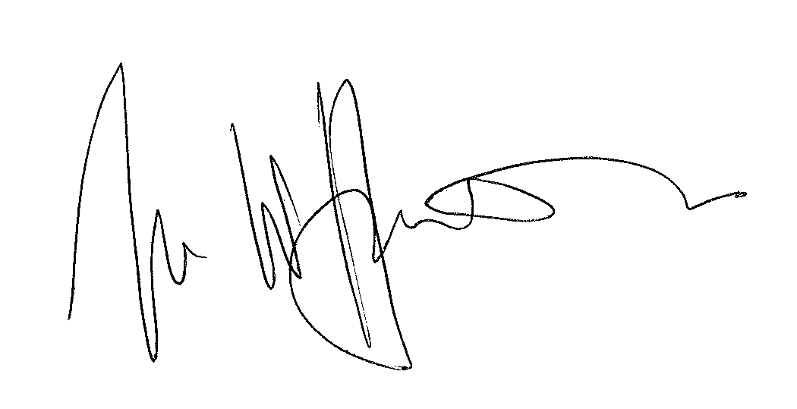

IAN WILLIAM HUDDLESTON

TRIBUNAL JUDGE

RELEASE DATE: 18 May 2011

