[2011] UKFTT 331 (TC)

TC01191

Appeal number TC/2010/03052

Excise Duty – alleged breach of S.13 HODA – seizure of vehicle containing evidence of rebated fuel – S.139 and S.141 CEMA – Appeal against review decision to levy fee for restoration – Appeal Allowed.

FIRST-TIER TRIBUNAL

TAX

MACWASTE LIMITED Appellant

- and -

THE COMMISSIONERS FOR HER MAJESTY’S

REVENUE AND CUSTOMS ("HMRC") Respondents

TRIBUNAL: IAN WILLIAM HUDDLESTON, TRIBUNAL JUDGE

Sitting in public at Bedford House, Belfast on 8 February 2011

Mr. Barry McCoy, in person for the Appellant

Mr. Mandalia BL, instructed by the General Counsel and Solicitor to HM Revenue and Customs, for the Respondents

© CROWN COPYRIGHT 2011
DECISION

Appeal

- The subject matter of this Appeal is the decision, on review, to restore a Mercedes HGV vehicle, registration number R264 OJR ("the Vehicle") which was seized by HMRC on the 12 December 2009 subject to payment of a fee in the sum of £840. The Vehicle was seized pursuant to the provisions of Sections 139 and 141 of the Customs and Excise Management Act 1979 ("CEMA") on the basis that on inspection it was found to contain evidence of rebated fuel. Section 13(1) of HODA provides that civil penalties may be levied pursuant to Section 9 of the Finance Act 1994 ("FA") subject to reasonable excuse, if established pursuant to Section 10 FA. Section 15 FA empowers review officers to confirm, vary or withdraw a reviewable decision on behalf of the HMRC. In this case, the review officer, Mrs. Maria Finnelli reviewed the original decision to restore the Vehicle subject to payment of the fee and upheld it, and communicated her decision in a letter of the 24 February 2010. In that letter she gave reasons for upholding the original decision and it is that review decision which is the subject matter of this appeal.
- The powers of this Tribunal in relation to such a matter are supervisory and it is on that basis that this Appeal comes before this Tribunal.
Facts

- The facts of the case are as follows:
  - the Vehicle was seized when it arrived (unaccompanied) at Heysham Docks on the 9 December 2009;
  - a fuel sample that was taken tested positive for Euromarker, and it seems to the Tribunal that that test result, together with the fact that the Vehicle was taxed to the 30 April 2010, led HMRC to conclude that the Vehicle had been fuelled with rebated fuel for use on a public road in breach of S.13 HODA, and accordingly HMRC detained the Vehicle under the powers vested in them under CEMA;
  - on 12 December 2009 HMRC advised the Appellant by telephone that rebated fuel had been detected and that the Vehicle had been seized under Section 139 CEMA as being liable to forfeiture under Section 141(1)(a) CEMA.;
  - a notice of seizure and a notice of sampling were faxed to the Appellant on that date. At the hearing there was some dispute as to whether or not the Appellant ever received that fax, but what is clear is that in or around the 14 December 2010 the Appellant paid the £840 restoration fee which HMRC had asked for as a condition for the return of the Vehicle. That fee was made up of £250 for using rebated heavy oil as road fuel; £250 for putting rebated fuel into the Vehicle and £340 for removal and storage costs.
- On the 15 December 2009 a Restoration Agreement was faxed to the Appellant and, whilst that does not appear to have been signed, certainly as has been noted the Appellant did make payment of the restoration fee, and the Vehicle was accordingly returned to Heysham Docks.
- On the 21 December 2009, the Appellant asked for a review of the Decision.
- That review was undertaken by Mrs. Maria Finnelli and the result communicated by way of a letter of the 24 February 2010 where the original decision was upheld.
- In that letter Mrs. Finnelli seems to have noted that the Appellant had, in the telephone conversation of the 12 December 2009, alerted HMRC to the fact that the Vehicle had been previously off road and untaxed until the beginning of November 2009. Although that fact was obviously noted (because it is referred to in her correspondence) it did not appear to form part of her decision making process.
- In a witness statement which was provided, Mrs. Finnelli set out the following reasons why she upheld the original decision, namely:
  - that the Appellant did not offer a reasonable excuse for fuelling the Vehicle with rebated fuel;
  - that the Appellant did not offer any grounds for a formal review, asking only for evidence that led to the seizure (ie. the sampling tests);
  - that the sample taken from the Vehicle had established Euromarker with a high sulphur content of 45 parts per million which, as she said "is much more than would be expected to be found in fuel that is used to propel a road vehicle".
- Mr. Barry McCoy gave evidence on behalf of the Appellant.
- He explained that the basis of the Appeal was not that he wanted to challenge the amount of the penalty per se, but to clear the name of the Appellant lest it have a negative impact on its ability to undertake certain types of work in the future.
- Mr. McCoy did not dispute the factual matrix outlined above, but argued that he had not been given a complete sample at any point in the process, although clearly he was entitled to ask for one (as the Notice of Sampling had confirmed).
- There did appear to be some dispute on the evidence as to whether or not he received faxed notification of the original detention on the 9 December 2009, but in any event this Tribunal finds that nothing much turned on that fact.
- The main thrust of Mr. McCoy's case and evidence to the Tribunal was as follows:
  - that the Vehicle had been acquired for a specific purpose to fulfil a two year contract which the Appellant had at Ballylumford Power Station in Northern Ireland;
  - that the contract required the Vehicle to be on site at Ballylumford Power Station throughout that period, and it was Mr. McCoy's evidence that during the period in question the Vehicle had been fuelled with rebated fuel simply because it at no stage needed to be on a public road and was not used on a public road;
  - that whilst the Vehicle was being used at Ballylumford, he was approached by a Mr. Paul Atkinson from Petrotech Services in Yorkshire who agreed to purchase the Vehicle.
- Mr. McCoy gave evidence that a condition to which that sale was subject was that the Vehicle be licensed in Northern Ireland to accord with the PSV licence which had issued on the 6 November 2009 (for a year). Mr. McCoy gave evidence that he thus taxed the Vehicle for a six month period, expiring in April 2010, and it was for that reason only that the Vehicle appeared at Heysham Docks to be "roadworthy" in the sense that it had both a vehicle test certificate, and a valid road tax licence.
- Mr. McCoy's evidence, however, was to the effect that after the sale had been agreed, the Vehicle was transported by low loader from Ballylumford to Warrenpoint Docks where it was then transported by Sea Truck as freight carriers to Heysham Docks where the Vehicle was subsequently tested and seized.
- As Mr. McCoy did not have any documentary evidence to support this assertion, the Tribunal adjourned its decision pending receipt of confirmatory documentary information.
- That information was provided by Macwaste Limited on foot of their letter of the 18 February 2011 to the Tribunal Service, a copy of which was directed to have been made available to HMRC.
- The additional documentary information provided confirmed:
  - that the Vehicle had a vehicle test certificate from the 6 November 2009 to the 5 November 2010;
  - that an invoice was raised on the 30 November 2009 against Pertrotech Services relating to the sale of the Vehicle;
  - that an invoice from Heaney Transport dated the 4 December 2009 was raised and purported to document the collection of the Vehicle from Ballylumford Power Station and its delivery to Warrenpoint Docks for onward transmission to Sea Truck.
- From the oral evidence of Mr. McCoy during the Tribunal Hearing and the documents subsequently made available, the case for the Appellant, therefore, distils to a blank rebuttal of HMRC's position, insofar as the Appellant makes the case that at no time was the Vehicle used on a public road. Indeed, in support of that proposition, Mr. McCoy indicated that the insurance on the Vehicle had been cancelled with effect from the 4 December 2009 – which again was advanced as another reason for the Vehicle being transported by third party haulage from the site at Ballylumford to Warrenpoint Docks.

Decision

- As mentioned at the beginning of this decision, the Tribunal's jurisdiction in matters such as this is supervisory. On the facts of the present case as outlined, I find that HMRC were perhaps understandably but too readily influenced by:
  - the detection of the rebated fuel;
  - the fact that the Vehicle had a roads fund licence, which was valid and due to expire in April 2010.
- From that position, therefore, I am of the opinion that the Review Officer took the view the Vehicle had been used on a public road notwithstanding that she had been on notice from her conversation with Mr. McCoy that that was possibly not the case. There was no subsequent investigation (nor am I suggesting that there should have been, because the onus was on the Appellant), but I do consider that the Appellant who was not represented at any stage was not actually invited at that stage to substantiate the position that he had advanced in that conversation – namely that the Vehicle had not been used on the public road.
- I further, therefore, find that the Appellant had raised the case in his conversation of the 12 December 2009 that the Vehicle had not, in fact, been used on a public road, that little or no credence had been given to that assertion in either the initial decision or, more relevant to this Appeal, the review decision. I do not blame HMRC for that, because the Appellants, for whatever reason, did not advance any of the documentary evidence to support their contention.
- Nonetheless, it was a valid contention which merited more consideration than appears to have been given to it.
- In the events which have occurred, the Appellant has now produced documentary evidence supporting its original argument and I find that documentary evidence to be credible.
- Taking all of that into account, I allow the Appeal and quash HMRC's decision to restore the Vehicle subject to the fee that was demanded.
- This document contains full findings of fact and reasons for the decision. Any party dissatisfied with this decision has a right to apply for permission to appeal against it pursuant to Rule 39 of the Tribunal Procedure (First-tier Tribunal) (Tax Chamber) Rules 2009. The application must be received by this Tribunal not later than 56 days after this decision is sent to that party. The parties are referred to “Guidance to accompany a Decision from the First-tier Tribunal (Tax Chamber)” which accompanies and forms part of this decision notice.
- No direction as to costs.

IAN WILLIAM HUDDLESTON

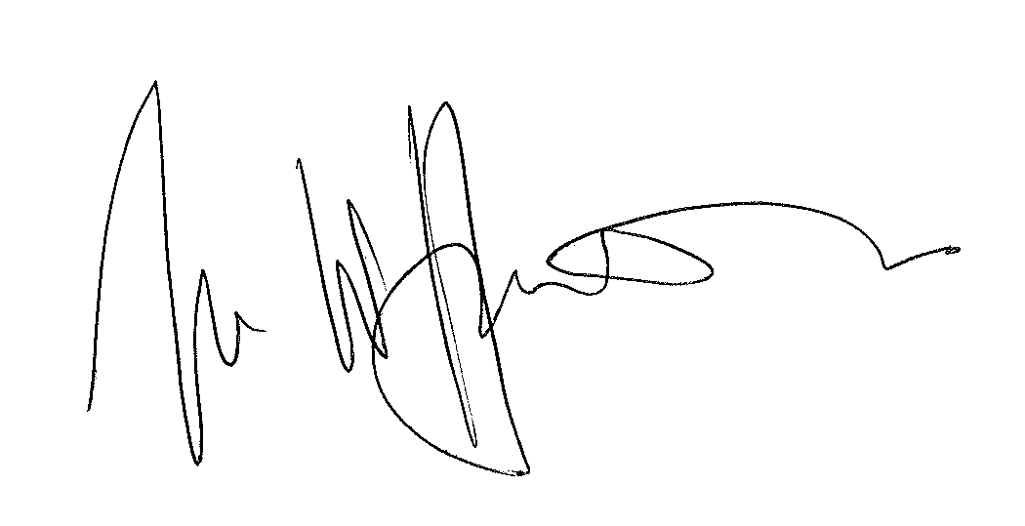

TRIBUNAL JUDGE

RELEASE DATE: 18 May 2011

