[2011] UKFTT 405 (TC)

TC01260

Appeal number TC/2010/05026

Construction Industry Scheme – withdrawal of gross payment status – Finance Act 2004 (Schedule 11) – Appeal against withdrawal – Reasonable excuse – Appeal Dismissed

FIRST-TIER TRIBUNAL

TAX

JOHN J. DUFFY Appellant

- and -

THE COMMISSIONERS FOR HER MAJESTY’S

REVENUE AND CUSTOMS ("HMRC") Respondents

TRIBUNAL: IAN WILLIAM HUDDLESTON, TRIBUNAL JUDGE

Sitting in public at Bedford House, Belfast on 12 April 2011

Mr. Corbett for HMRC
Aiden Maguire, Accountant for the Appellant

© CROWN COPYRIGHT 2011
DECISION

Appeal

- This is an appeal against the withdrawal of gross payment under the Construction Industry Scheme as notified to the Appellant originally on the 8 October 2010 and as subsequently upheld post review in a review letter dated the 4 March 2010.
- The Construction Industry Scheme is a statutory concession which allows traders to be paid without the deduction of tax, subject to their compliance with certain statutory conditions.
- The conditions for the initial registration and against which their subsequent compliance is judged are contained in Schedule 11 of the Finance Act 2004. Broadly speaking both for the initial registration and for the continued application of the concession, a trader must satisfy the statutory conditions. The one which is germane to this Appeal is the ongoing compliance test which is set out in paragraph 4 of that Schedule:
"The Applicant must, subject to sub-paragraphs (3) and (4) have complied with:

    - all obligations imposed on him in the qualifying period by or under the Tax Acts or the Taxes Management Act 1970; and
    - all request made in the qualifying period to supply to the Inland Revenue accounts of, or other information about, any business of his.
Where the compliance test is failed, HMRC have the statutory power to withdraw the gross payment status."

- In the present case, based on an annual review of the Appellant's tax affairs, HMRC discovered six breaches in the tax year 2008 / 2009. Four of those related to late payments of PAYE and two related to late payments of tax under Self Assessment. The Tribunal was presented with a Schedule which detailed the relevant breaches and provided details on the number of days for which each payment was overdue. Each of the instances fell outside the statutory concessions for late payments which are detailed in Regulation 32 of the Income Tax (Construction Industry Scheme) Regulations 2005 (SI2005/2045).
- On that basis, the failure to comply and the withdrawal of gross payment status was initially notified to the Appellant by HMRC on the 8 October 2009. That decision was reviewed, at the request of the Appellant, but was upheld – the review decision being communicated to the Appellant in a letter dated the 4 March 2010, against which the Appellant now appeals.
- The Appellant was represented by his accountant, Mr. Maguire, but he himself also gave evidence.
- In essence, the Appellant sought to advance an argument for "reasonable excuse" based on a number of factors. Those factors (and here I summarise) were as follows:
  - that in the operative period (2008 / 2009) the Appellant faced difficult trading conditions (Ground 1);
  - that in the nature of his trading activities (as a roofing contractor) the Appellant was heavily dependent upon one main contractor, who in turn had suffered cash flow difficulties which had a knock on effect on the Appellant's cash flow (Ground 2);
  - that there was greater price competition in the market generally (Ground 3); and
  - that the Appellant had acquired rental properties within the year in question which impacted considerably upon his cash flow because of the cost of those acquisitions and the slowness in obtaining satisfactory tenants (Ground 4).
- In advance of those arguments, the trading accounts of the Appellant were furnished as part of the trial bundle.
- In relation to Ground 1, HMRC, by reference to those trading accounts, pointed out that between 2007 and 2008 there was a 16% increase in turnover, and an increase in net profit of 45%.
- As regards Ground 2 (dependence on the main contactor) HMRC sought to advance (by reference to the accounts) that as at the accounts date of 31 December 2008 no debtors were actually shown in the accounts and that, therefore there was no objective evidence of the slow payments / cash flow issue alleged by the Appellant.
- Ground 3 was a statement but no evidence was advanced in relation to it.
- The Appellant sought to challenge this on the basis that the accounts date of 31 December 2008 was obviously within the winter period which was slow for construction activity, and that all debts for the earlier periods of the year had by that date been discharged.
- In relation to Ground 4 (the acquisition of rental properties), the Appellant sought to explain that the acquisition of four rental properties in Hartlepool had impacted considerably upon his cash flow and, given the market fall which all property suffered, his ability to access further credit.
- The Appellant gave evidence that drawings for his trading activities had been used to fund the initial deposits, and that the balance of the purchase price had been paid through buy to let borrowings.
- HMRC's position on that point was that that decision had been a personal decision of the Appellant, and was not a "reasonable excuse" as to why the amounts due to the Inland Revenue had not been discharged when they fell due.
- The final point advanced by HMRC was that at all times the Appellant had the benefit of an overdraft from its bankers, First Trust. That overdraft limit was placed at £10,000 and on each occasion when tax fell due, HMRC had identified the relevant "head room" within that overdraft facility which would have allowed the payment of five of the six instances of tax arrears detailed on the Schedule of Defaults.
- In that specific regard, the Appellant indicated that he, at each point, was unsure of the continued availability of overdraft facilities and therefore, rightly or wrongly, took the view that there were not sufficient funds available to allow him to discharge his tax liabilities and, simultaneously, continue to trade.
- The Appellant has sought both in its discussions with HMRC and in his arguments before this Tribunal to advance the ground of "reasonable excuse" as a reason for the failure to pay tax when it fell due and why gross payment status should not be withdrawn. The law, however, in this regard is very strict. The onus of proof lies squarely upon the Appellant, and the standard of proof which the Appellant is required to achieve is high. Mere assertions are not sufficient.
- It is clear that this Tribunal's supervising jurisdiction, in relation to these matters, is quite limited.
Decision

- In the present case, whilst the Appellant advanced Grounds 1 and 2 (and collaterally Ground 3), we do not find that they meet the requisite standard, and therefore we do not consider that "reasonable excuse" has been established to this Tribunal's satisfaction.
- Save for the accounts, no cogent evidence has been furnished to establish that the cash flow difficulties put forward as a "reasonable excuse" were sufficiently extreme to satisfy us that the standard required by the law has been met.
- In relation to Ground 4 (the acquisition of the buy to let properties), whilst this was advanced as a reason for the cash flow difficulties which the business suffered, specifically the Tribunal finds that whilst it did in all probability have the impact suggested by the Appellant, it was an extraneous cause and arose as a direct result of the Appellant's decision to purchase investment property. That decision was a personal one and, according to the Appellant's evidence, we find had the effect of preferring an investment decision over the discharge of tax liabilities as and when they fell due. We do not suggest that the Appellant intended it, but that appears to have been the result. Nonetheless, we do not feel that the Appellant can now assert his investment choices as grounds to say he should be excused from his obligation to pay tax.
- Finally, as regards the debate over the overdraft, whilst we can understand the Appellant's concern at not wishing to draw cheques up to the full limit of his overdraft limit, nonetheless when taken in the round, that again was his choice.
- In short, on each of the grounds advanced we do not find that "reasonable excuse" has been established to the standard which is required by the law.
- The Appellant eloquently (and poignantly) pointed out the risk which an adverse conclusion of this Tribunal would have on his business, and the nine people he employs.
- Whilst the Tribunal is sympathetic in that regard, nonetheless the effect of our decision is not something to which at law we can have regard. See John Grosvenor v HMRC TC00227.
- In short, we find that the onus of proof which rests on the Appellant therefore to prove reasonable excuse for the tax defaults (which he accepts occurred) has not been made to the Tribunal's satisfaction, and accordingly we dismiss the appeal.
- This document contains full findings of fact and reasons for the decision. Any party dissatisfied with this decision has a right to apply for permission to appeal against it pursuant to Rule 39 of the Tribunal Procedure (First-tier Tribunal) (Tax Chamber) Rules 2009. The application must be received by this Tribunal not later than 56 days after this decision is sent to that party. The parties are referred to “Guidance to accompany a Decision from the First-tier Tribunal (Tax Chamber)” which accompanies and forms part of this decision notice.
- No order as to costs.

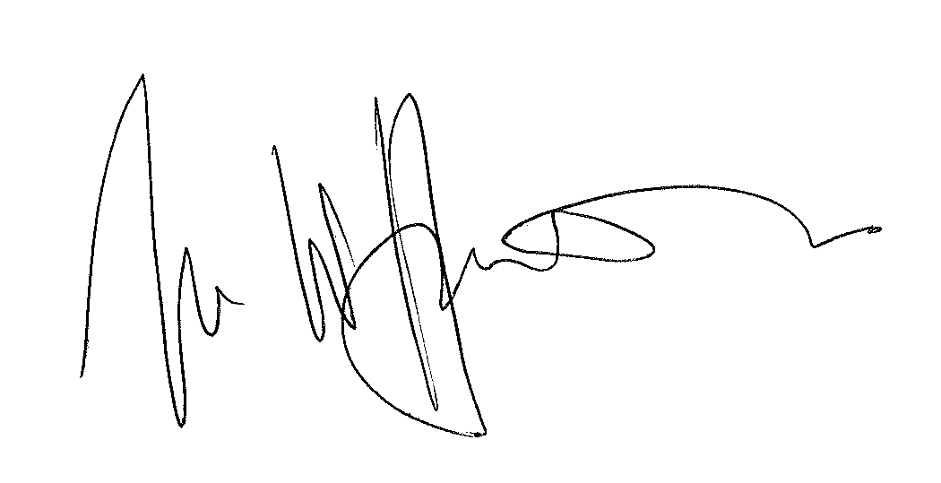

IAN WILLIAM HUDDLESTON

TRIBUNAL JUDGE

RELEASE DATE: 22 June 2011

