[2011] UKFTT 406 (TC)

TC01261

Appeal number TC/2009/16031

Section 80 VATA 1994 – Section 121 Finance Act 2004 – whether a claim was made within time – appeal dismissed

FIRST-TIER TRIBUNAL

TAX CHAMBER

WILSONS OF RATHKENNY LIMITED Appellant

- and -

THE COMMISSIONERS FOR HER MAJESTY’S

REVENUE AND CUSTOMS ("HMRC") Respondents

TRIBUNAL: IAN WILLIAM HUDDLESTON, TRIBUNAL JUDGE
MR. DAVID MOORE

Sitting in public at Bedford House, Belfast on 12 April 2011

Bernard Hayley, Officer, on behalf of HMRC
Ms. J. Stewart, Company Accountant, on behalf of the Appellant

© CROWN COPYRIGHT 2011
DECISION

Appeal

- The appeal in this case arises from HMRC's rejection of the Appellant's claim for overpaid output tax in the sum of £20,374. The Appellant's claim is dated the 30 March 2009 and what is called a "Fleming" type claim arising, as it does, as a consequence of the Court of Appeal decision in the case of Michael Fleming (t/a Bodycraft) -v- CRC (Condé Nast Publications Ltd intervening) [2006] EWCA Civ 70; [2006] STC 864; [2006] All ER (D) 199 (Feb) (Fleming).
- The claim was rejected by HMRC by way of letter dated the 29 April 2009.
The Facts
- The Appellant, Wilsons of Rathkenny Limited, is a company incorporated under the Companies Act (NI) 1960 from the 5 November 1964 under number NI 6176.
- The Appellant has been registered for VAT since the 1 April 1973 under VAT registration number 255 7624 40, and that registration remains extant. Its trading address and registered office is 371 Cushendall Road, Ballymena, County Antrim, BT43 6QB.
- The Appellant's business activity is in the motor trade and includes the sale of new motor cars.
- The Appellant submitted a "Fleming" type claim on the 13 March 2009 which related to overpaid output tax on demonstrator and courtesy cars for the period 1985 to 1996. After an exchange of correspondence between the parties, the claim was settled in the sum of £51,212.26, plus £60,233.21 statutory interest. The settlement of this claim was notified to the Appellant by HMRC in a letter of the 29 April 2009.
- At the conclusion of the negotiations leading towards settlement of that claim, it became apparent to the Appellant's in house accountant that there was a further, separate, registration for Wilsons of Rathkenny Limited (Carrickfergus) under a separate VAT registration number 392 6901 27. According to the evidence before the Tribunal, the period of that registration is not known, but it was accepted by all parties that the registration had been cancelled for some considerable time.
- It also appears accepted that the registration related to the operation of a ford franchise from premises at 30 Joymount, Carrickfergus, County Antrim, BT38 7DN. For the avoidance of doubt, there was no separate registration of a company under any such name, and it simply appears that the Appellant company used the additional word "Carrickfergus" to distinguish the different trading activities carried on at that site.
- The processing of the original claim (ie. that for VAT registration number 255 7624 40) appears to have reached the stage of final settlement when HMRC wrote to the Appellant on the 30 March 2009.
- The Appellant, through its accountant, Ms. Jackie Stewart (who appeared before the Tribunal and gave evidence) responded to that letter on the same date, 30 March 2009, broadly accepting the settlement figure that was proposed.
- In Ms. Stewart's letter she included the following paragraph:
"On further discussion of the matter it has come to my attention that a satellite ford site was run from 30 Joymount Gardens, Carrickfergus, County Antrim, from 1984 to 1994. I would therefore like to amend my claim to add five demo vehicles, changed three times a yr, and four courtesy vehicles changed twice a yr for the site for the ten yr period."
- She then included a table based on the Italian Tables Volume for substantiating that claim for the ten year period – the claim itself amounted to £20,374, being the amount which is now in dispute.
- At this point I should mention that there is a dispute on the evidence.
- Ms. Stewart indicated that she emailed her response to HMRC, but they, for their part, deny the receipt of any email and their position is that the letter was only received on the 17 April 2009 – taking the view that it therefore did not fall to be considered as it fell outside the statutory deadline of the 31 March 2009.
- In the absence of any confirmation of the email transmission, the Tribunal places reliance only on the letter.
- That, in essence, is the substance of the appeal, ie. whether or not there was a "claim" and whether it had been received by HMRC before that deadline.
Legislation
- The legislation in point is as follows:
  - Value Added Tax Act 1994, Section 80
"(1) Where a person:
    - has accounted to the Commissioners for VAT for a prescribed accounting period (whenever ended); and
    - in doing so, has brought into account as output tax an amount that was not output tax due, the Commissioners shall be liable to credit the person with that amount."
  - Value Added Tax Regulations 1995, Regulation 37:
"37. Any claim under Section 80 of the Act shall be made in writing to the Commissioners and shall, by reference to such documentary evidence as is in the possession of the claimant, state the amount of the claim and the method by which that amount was calculated."
  - Finance Act 2008, Section 121
"(1) The requirement in Section 80 of the Value Added Tax Act 1994 that a claim under that Section be made within 3 years of the relevant date does not apply to a claim in respect of an amount brought into account, or paid, for a prescribed accounting period ending before 4 December 1996 if the claim is made before the 1 April 2009."
- Very shortly, HMRC's position is that applying that legislative position the "claim" in relation to the Appellant's Carrickfergus operation was not made before the statutory deadline of the 1 April 2009 – on the basis that:
  - the claim contained in Ms. Stewart's letter was not an "amendment", but was a new claim; and
  - given that it was a new claim, it was not received before the statutory deadline of the 1 April 2009.
Decision
- In the exchanges between the parties before the Tribunal, much was said about whether or not the Carrickfergus entity was a separate "person" for the purposes of lodging a claim and, indeed, these proceedings.
- We find, quite simply, that there is no dispute on this point. There was, and is, only one company, ie. Wilsons of Rathkenny Limited, the history of which is recited above.
- In short, therefore, for the purposes of the Section 80 claim there was only one "person".
- A "person" however can have more than one claim and we find that was so in this case.
- The original claim was processed under a specific VAT registration number (registration number 255 7624 40). By virtue of the exchanges of letter of the 30 March 2009 that claim was settled.
- Ms. Stewart, in her letter of that date (by which the settlement was reached) and before this Tribunal, attempted to argue that in raising the claim in respect of the Carrickfergus operation she was doing no more than amending her original claim.
- With respect, we do not find that argument convincing. From the evidence available to us it seems quite clear that the Appellant company operated this as a separate business with a separate VAT registration. It could only have been in relation to those records (under the obsolete VAT registration of 392 6901 27) that any claim could have been progressed, and in her letter of the 30 March 2009 Ms. Stewart did not (or probably could not) identify that VAT number which would have been essential to pursue any claim.
- On that basis we therefore find any claim in respect of the Carrickfergus operation is, indeed, out of time.
- It naturally follows that the appeal is dismissed.
- This document contains full findings of fact and reasons for the decision. Any party dissatisfied with this decision has a right to apply for permission to appeal against it pursuant to Rule 39 of the Tribunal Procedure (First-tier Tribunal) (Tax Chamber) Rules 2009. The application must be received by this Tribunal not later than 56 days after this decision is sent to that party. The parties are referred to “Guidance to accompany a Decision from the First-tier Tribunal (Tax Chamber)” which accompanies and forms part of this decision notice.

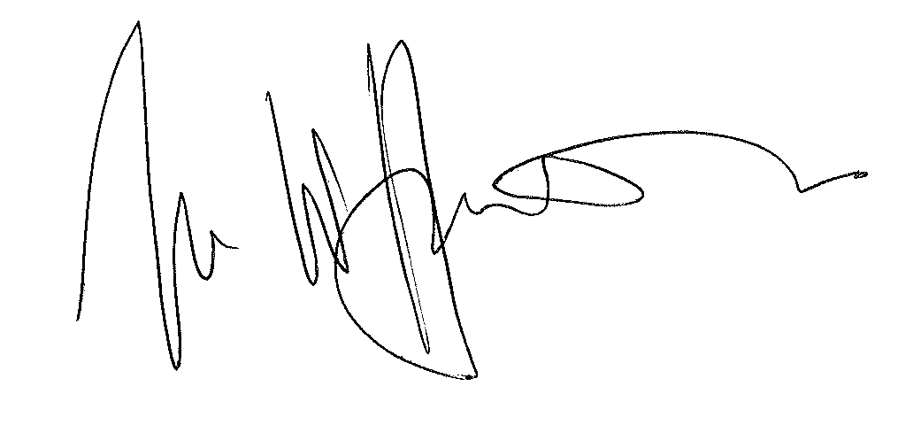

IAN WILLIAM HUDDLESTON

TRIBUNAL JUDGE

RELEASE DATE: 22 June 2011

