[2011] UKFTT 404 (TC)

TC01259

Appeal number TC/2010/03973

Taxes Management Act 1970 – Deposits to accounts in excess of declared CIS income – Discovery assessments raised – Appellant's failure to provide explanation in relation to excess credits – Assessment upheld as valid - Appeal Dismissed

FIRST-TIER TRIBUNAL

TAX

PETER DEVINE Appellant

- and -

THE COMMISSIONERS FOR HER MAJESTY’S

REVENUE AND CUSTOMS ("HMRC") Respondents

TRIBUNAL: IAN WILLIAM HUDDLESTON, TRIBUNAL JUDGE
MISS PATRICIA GORDON

Sitting in public at Bedford House, Belfast on 14 April 2011

The Appellant did not appear
Mrs. Paula O'Reilly for HMRC

© CROWN COPYRIGHT 2011
DECISION

Appeal

- This is an appeal against assessments raised under the Taxes Management Act 1970. A discovery assessment was raised against the Appellant for the year to 5 April 2004 following an enquiry which was opened on the 28 February 2005. Subsequent to that enquiry a discovery assessment was also raised in respect of the prior year to the 5 April 2003.
- The Appellant did not appear in person, but the Tribunal having confirmed that papers had been served on him, decided that it was in the best interests of justice to proceed and elected to proceed to Rule 33 of the Tribunal Rules.
Facts
- The facts of the case are as follows.
- The Appellant commenced self employment in the United Kingdom on the 15 July 2002 as a sub-contractor. On the 28 February 2005 an enquiry was opened under Section 9(a) of the Taxes Management Act 1970 into Mr. Devine's return for the year ended 5 April 2004.
- In correspondence with Mr. Devine's agent, Kelly & Co., HMRC were advised that very little information in support of the submitted accounts was available. In that telephone conversation, HMRC were advised that the Appellant used two bank accounts, one jointly held account with his wife, and the other in his wife's name.
- During a meeting which was held with the enquiry officer on the 9 October 2007 Mr. Devine stated that payments were made to him weekly by cheque, and that these were deposited either in the joint account, or in his wife's account as required.
- As a result, statements for the accounts were sought and obtained from the Appellant and, following analysis (and having excluded the wife's wages and a tax refund) the analysis disclosed that credits exceeded the Appellant's vouched Construction Industry Scheme ("CIS") income by £4,450. After that discovery, Mr. Devine's agent, Kelly & Co., accepted that there was an error on the spreadsheet of relating to the CIS vouchers, and that turnover had been understated.
- Turnover for the year was therefore increased by £6,032 based on the excess credits to the accounts in excess of declared income with a corresponding tax credit of £1,085.84.
- A closure notice was issued on the 29 January 2007 increasing the turnover figure to agree with the CIS income and to include the excess lodgements to the bank account, plus an estimate made by HMRC for cash earned, but not lodged to the bank account.
- Based on that approach for 2003/4, discovery assessments were issued on the 30 January 2007 under Section 29 of the Taxes Management Act for the years 2000 / 2001 and 2002 / 2003 using the retail prices index to scale back the alleged excess bank lodgements and cash receipts and, therefore, assumed turnover. On the 1 February 2010 following an independent review, the 2003/2004 assessment was adjusted to include only the increase on the CIS income and the excess lodgements to the bank accounts of £4,450. As result of the same review, the discovery assessments for the years 2000 / 2001 and 2001 / 2002 were reduced to nil. The assessment for 2002 / 2003 was adjusted based on the assessment 2003/4, but reduced to reflect RPI, and then apportioned from the stated date of the commencement of self-employment, ie. 22 July 2002, resulting in a figure of £3,000.
- The Appellant's case, by reference to the documents submitted to the Tribunal, appears to explain the discrepancy in the cash lodged to the bank accounts as against the CIS income by reference to two factors:
  - in the first place, the Appellant suggested that the additional lodgements came from an insurance claim received by his wife. He provided copy correspondence to show that the amount of the claim was £3,500, but HMRC's position on that point is that the documentation showed that the date of the event was 24 October 2004 and therefore some six months after the end of the tax year in question;
  - the Appellant, it would appear, has also suggested that the balance of £950 (ie. £4,450 minus the £3,500 attributable to the insurance claim) came from gifts to his children made by family members. HMRC's position is that no evidence has been made available to support that statement.
The Respondent's Case
- HMRC contends that:
  - in the absence of business records the figure for turnover is unsubstantiated;
  - that for 2003/4 the amount of £4,450 represented additional lodgements to the accounts having excluded the wife's wages and a tax refund for the enquiry year;
  - that the proffered explanation of the insurance claim had not been accepted because the event in respect of which the insurance was paid did not take place until the 24 October 2004, ie. six months after the end of the enquiry year;
  - that there was no single lodgement of £3,500 to either bank account in the period, and that the sums on which HMRC focused arose as an aggregate of smaller deposits to the account throughout the relevant enquiry period;
  - that there was no additional explanation or evidence regarding the contention that £950 was attributable to gifts made to the children.
- On that basis, HMRC contends that without documentary evidence to show the source of funds, it is reasonable to assert that the funds were attributable to Mr. Devine's business, and that the assessments for both tax periods have been raised to best judgement on that basis, under Section 29 of the Taxes Management Act 1970.
Decision
- In cases such as these the onus of proof falls squarely upon the Appellant to produce evidence to disprove the assessments which have been raised by HMRC on the information available to them.
- In this case, the Tribunal finds that there were excess lodgements over the known net CIS income (as vouched) for the year 2003/4. It therefore follows that it is for the Appellant to establish that these lodgements did not come from business income. From the papers in front of the Tribunal the Appellant has quite simply failed to discharge that onus of proof.
- It follows that the Tribunal finds that the sums in question are business receipts, and further finds that:
  - both the assessments for the years to 5 April 2004 and 5 April 2003 have been properly raised on a sensible and logical basis;
  - that for the earlier year it was appropriate to scale the figures back to reflect RPI.
- The assessments, therefore, fall within the powers of HMRC and should be upheld.
- In these circumstances, the appeal is dismissed.
- This document contains full findings of fact and reasons for the decision. Any party dissatisfied with this decision has a right to apply for permission to appeal against it pursuant to Rule 39 of the Tribunal Procedure (First-tier Tribunal) (Tax Chamber) Rules 2009. The application must be received by this Tribunal not later than 56 days after this decision is sent to that party. The parties are referred to “Guidance to accompany a Decision from the First-tier Tribunal (Tax Chamber)” which accompanies and forms part of this decision notice.
- No order as to costs.

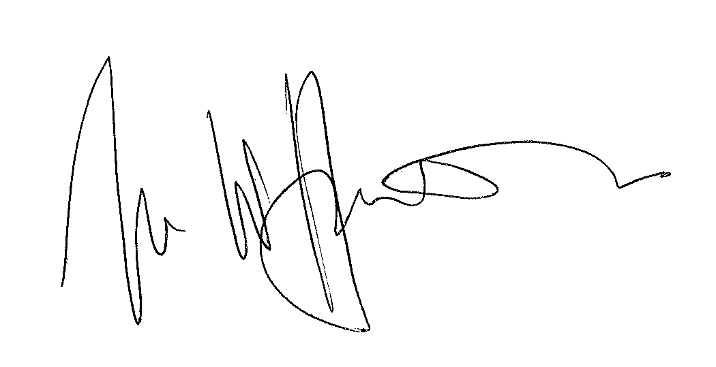

IAN WILLIAM HUDDLESTON

TRIBUNAL JUDGE

RELEASE DATE: 22 June 2011

