Last Update August 2020

User Manual for TS2CG

**Version 1.1**

Groningen Biomolecular Sciences and Biotechnology Institute and Zernike Institute for Advanced Materials University of Groningen, Groningen, The Netherlands.

**NOTE**: this version is under development and might be associated with errors and bugs. Please use the previous version if you are not in direct contact with the developers.

**Cite:**

**Backmapping Triangulated Surface to Coarse-Grained Model**

Weria Pezeshkian, Melanie König, Tsjerk A. Wassenaar and Siewert J. Marrink

*Nat Commun* **11,**2296 (2020).



Table of Contents

Introduction Error! Bookmark not defined.

Compiling 2

Pointillism 2

**Input files** 2

**Output files** 4

CG Membrane builder 5

**Input file str** 5

**Lipid library file** 5

**Output files** 6

Manuscript Example Files 6

Mixed Bilayer Tutorial 7

How to place proteins at specific positions 8

# **Introduction**

TS2CG is an algorithm to backmap a triangulated surface (TS) structure to a corresponding coarse-grained (CG) model.

TS2CG is implemented in C++ and includes two separate scripts. *Pointillism* and *CG Membrane Builder.* Both of these scripts are available on the Martini website.

## **Compiling**

For compiling, gcc version 8.3.0 or above is needed.

In the source code folder, execute the script “*compiling.sh*” as

./compiling.sh

In this folder, two binary files will be generated **PLM** and **PCG.** PLM preform pointillism (Step 1 and 2) and PCG preforms Membrane builder (Step 3 and 4).

## **Pointillism**

Read a TS file (or a dynamical triangulated surfaces simulation trajectory file) and extend the TS file based on the given rescaling factor and an approximated area per lipid. The output is two folders, 1) a folder contains few visualization files 2) a folder that can be read by *CG Membrane Builder*script (See next for more information).

Note: the approximated area per lipid does not need to be precise, it will be modified during the later processes.

### **Input files**

Triangulated surfaces file:A triangulated surface file that can be read by this script should have an extension of “.q” or “.dat”.

**The *.q file:** is formatted as shown below.

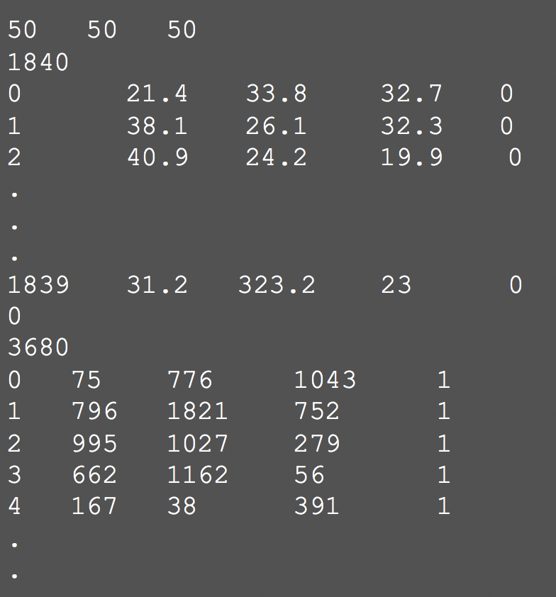

|  |
| --- |
| Line 1: Box information (3 double numbers).  Line 2: Number of vertices (1 integer number; Let’s call it NV).  Line 3 to NV+2: Vertex ID and coordinate (1 integer number and 3 double numbers).  Line NV+3: Number of triangles (1 integer number; Let’s call it NT).  Line NV+4 to NV+NT+3: Triangle ID and ID of its vertices (4 integer number). |

**The *.tsi files**, are DTS simulation trajectory outputs. It contains information about vertices, triangles and protein positions.

### **Output files**

Output files will be separated into two folders. 1) A folder contains few visualization files. 2) a folder that can be read by *CG Membrane Builder*script.

**Command line option and examples Options**

./PLM -TSfile TS.q -r PLM -Mashno 2 -rescalefactor 2 2 2 -o $path/data

-rescalefactor rescaling factor

-bilayerThickness bilayer thickness

-r function (PLM/check)

-o name of the output folder

-monolayer to generate monolayer instead (1/-1)

-shape fixed geometry (flat)

-TSfile TS file name

-Mashno number of consecutive Pointillism operations

-AlgType algorithm type for Mosaicing

-ap an approximation of lipid AP

-h help

For a flat bilayer use -shape flat option in the command line (for this, no TS file is required).

## **CG Membrane builder**

It generates a Gromacs based topology and coordinate file using the Pointillism output files. If the system contains protein, or if the user wants to add proteins, a Gromacs coordinate file (.gro file format) of the protein structure should be provided. By default, Martini forcefield lipids will be used. To backmap to another CG forcefield a lipid structure library should be provided.

### **Input file str**

The input file should be formatted as

|  |
| --- |
| include protein.gro  [Lipids List]  ; lipidname ratioup ratiodown ap  Domain 0  POPC 0.5 0.5 0.63  POPE 0.5 0.5 0.64  End  Domain 1  POPC 0.5 0.5 0.63  POPE 0.5 0.5 0.64  End  [Protein List]  ;proteinname inclusionID surface_coverage 0 0 z-position  STxB 1 0.5 0 0 -1.1  End Protein |

First line is to include gromacs formatted coordinate file of a protein. Note, if more than one protein type is needed, add a new line for each protein type.

In the [Lipids List] section, each entry defines a different lipid type and the ratio of it in the upper and lower leaflet of the bilayer. The last entry defines the area per lipid (in nm-2).

The last section [Proteins List] contains one entry per protein type. Depending on which TS file format is provided, only one of the first two number will be used: If a *.dat file is provided as input for the pointillism procedure, the protein ID (first number) has to correspond to the inclusion ID in the .dat file and the protein inclusions will be placed at the positions from the DTS simulation output. If a *.q file is used instead, the first number will be ignored and the second number will be used as the protein coverage ratio. In this case, the proteins will be placed randomly until the defined surface coverage is reached (If it is possible!!). It is also possible to place proteins at desired positions, which will be explained in another tutorial. The following two numbers, which define the rotation in plane and tilt angle, will be implemented soon. The last number defines the protein position along the membrane normal.

### **Lipid library file**

Example of lipid library file is as below

|  |
| --- |
| Description Martini Map CG  Version Martini 2  [ DOPC ]  1 NC3 0 0 1  2 PO4 0 0 0  3 GL1 0 0 -1  4 GL2 0 0.5 -1  5 C1A 0 0 -2  6 D2A 0 0 -3  7 C3A 0 0 -4  8 C4A 0 0 -5  9 C1B 0 1 -2  10 C2B 0 1 -3  11 C3B 0 1 -4  12 C4B 0 1 -5 |

**Command line option and examples Options**

|  |
| --- |
| ./PCG -str input.str -dts data -seed 34 -LLIB Martini2.LIB -Bondlength 0.15 |

-dts Pointillism output folder address

-str Input file name

-defout output files prefix

-Bondlength Initial bond guess;

-LLIB a CG lipid library file name

-renorm renormalized the lipid molar ratio

-iter iter*number of the point try to cover the surfaces

-seed seed for random number generator

### **Output files**

The output file of this command is a Gromacs coordinate file and topology file of the full system.

# **Manuscript Example Files**

The required files to perform the examples in the manuscript are available in a folder called tutorial/required_files_for_manuscript_examples:

For the vesicle growth example we provide dumbbell.q, input.str file and Martini2.LIB (the lipid structure library).

For the STxB bud formation example we provide STxBBud.dat, input.str, Martini2.LIB and STxB.gro (gromacs coordinate file for STxB with the bound Gb3 lipids in a DOPC lipid bilayer). The STxB-Gb3 complex gromacs topology file (*.itp) is also provided.

The mitochondria example includes a *.q and *.str file for each bilayer and Martini2.LIB.

Please note: The simulation procedures of the manuscript examples are complicated and computationally expensive. Therefore, we recommend you to first follow the simple tutorial below.

# **Mixed Bilayer Tutorial**

In this tutorial we are going to explain how to use TS2CG for creating a mixture of DOPC POPC lipid on a twisted vesicle. For this, first download the source code. Then

|  |
| --- |
| cd source_code  ./compile.sh |

This will create two binary files, **PLM** and **PCG**.

You can find all the files needed for this tutorial here:

|  |
| --- |
| cd tutorial/mixedbilayer |

We need a triangulated surface (TS) of the considered shape. A TS file with the name twisted.q is provided in this folder.

To see how does this TS surface look like we use PLM binary to generate vmd and paraview readable files by below command.

|  |
| --- |
| path/PLM -bilayerThickness 0 -rescalefactor 1 -Mashno 0 -o ini -TSfile twisted.q |

This command generates a folder with name inivisualization_data. Enter this folder and use vmd or paraview to have a look in the structure of the initial triangulated surface.

Next we use PLM to generate input files for membrane builder script from twisted.q TS.

|  |
| --- |
| path/PLM -bilayerThickness 4 -rescalefactor 1.5 -o point -TSfile twisted.q |

This command will generate two folders, *point* and *pointvisualization_data.* Enter *pointvisualization_data* folder and make sure that different part of surfaces does not penetrate into each other. The *point* folder will be used for membrane structure generation.

Next, we will use PCG binary to generate CG membrane structure for DOPC POPC mixture. For this, we need an input file and lipid structure library file.

To make an input file, write below text into a file with str extension (input.str).

[Lipids List]

Domain 0

POPC 0.7 0.7 0.65

DOPC 0.3 0.3 0.65

End

This file indicates that your system should contain POPC and DOPC lipids. 70% of the upper and lower monolayers lipids should be POPC and 30% should be DOPC. There is also a required field for APL of each lipids.

The lipid library should contain both DOPC and POPC lipids (Here Martini2.LIB).

Then, using below command, you can generate two files, one coordinate file (mixed.gro) and one a topology file (mixed.top).

|  |
| --- |
| Path/PCG -dts point -str input.str -seed 39 -Bondlength 0.15 -LLIB Martini2.LIB -defout mixed |

Note, the topology file does not contain any force field or molecule definition files. Include the force field header in the mixed.top and run simulations using Gromacs.

Instead of above procedure, you can just run easyrun.sh script in the tutorial folder. This script, in addition to the above procedures, It will run, an energy minimization, equilibration and a short md run.

# **How to place proteins at specific positions**

*.q triangulated surfaces file format does not include position of the proteins (inclusions) and *.dat file is very complicated an impractical. However, TS2CG allows for protein placement. For random placement, it is easy and the user can define proteins in the str file and place them randomly. For specific placement, with the current version, it requires an extra afford. Below, we explain a considerably simple procedure to do this.

PCG script, reads inclusion file “IncData.dat” in the PLM output folder and checks if this file is existing or empty. In both cases, it will then produce random distribution of inclusions based on the converge defined in the input file (*.str). Therefore, to enforce PCG to place proteins in a specific position is to manually or using script create a IncData.dat file in the PLM output folder.

An example of IncData.dat is as following

|  |
| --- |
| < Inclusion NoInc 2 >  < id typeid pointid lx ly lz >  0 1 460 0.923 -0.212 0.322  1 1 427 0.891 -0.138 -0.433 |

The first line tells, how many inclusions are in this file.

Second should be kept the same.

Third and fourth lines are line each defining one protein. The first number is an id, the second line is protein type id which must match the protein id in the *.str (PCG input file) file. Third line is the id of a vertex from the original triangulated surface that you want to place the protein there. The last 3 numbers representing a vector in 3D space that shows the orientation of the proteins. But do not worry, if you do not know what would be the orientation of the protein at that point just use (1,0,0). This will be converted to a vector in the plane of the membrane. By creating this file and placing it in the PLM output folder, you can just normally run PCG and place the proteins in the position that you prefer.

**Important note:**

For this specific case, in the PCG command you need to use *-incdirtype Local* option