

DILLLA UNIVERSITY COLLEGE OF ENGINEERING AND TECHNOLOGY

TITLE: TEXT READING BRAILLE GLOVE FOR DEAF-BLIND PERSON USING ARDUINO AND ANDROID APPLICATION

A THESIS PROPOSAL SUBMITTED TO SCHOOL OF ELECTRICAL AND COMPUTER ENGINEERING

IN PARTIAL FULFILLMENT OF THE REQUIREMENT FOR THE DEGREE OF BACHELOR OF SCINECE DEGREE IN ELECTRICAL AND COMPUTER ENGINEERING

­­­­­­­­­­­­­­­­­BY

MAHELET TESHALE 1135/15

MEKDES BEYEN 1174/15

MELAKU DEMEKE 1190/15

NATNAEL GEZAHEGN 1356/15

ADVISOR: ARFASO

SUBMITION DATE: MARCH,2020

DILLA, ETHIOPI

**DECLARATION**

As annex to our project proposal “Development of Holistic exam simulator for 4th year electrical and computer engineering students” we make the following declaration

1. we certify that data, information and documents communicated in the project proposal are complete and true.
2. we declare that, under the given topic we have not submitted any proposal for evaluation
3. we declare that we have not started the implementation of the project before submitting the proposal

This proposal is our original work and has not been presented for a degree in any other university

Name Signature Date

1, MAHELET TESHALE

2, MEKDES BEYEN

3, MELAKU DEMEKE

4, NATNAEL GEZAHEGN

This proposal has been submitted for examination with my approval as University Supervisor

Name Signature Date

ARFASO

# Abstract

People with “blindness” and “Deafness-blindness” are excluded from most forms of communication and forced to live in limited world, as they face series compound communication problems. [1] This project introduces a system to support the communication of blind and deaf-blind people, thus fostering their independence and integration in the society. This project uses small and cheap components to build a communication device that solve the previously mentioned problems. It includes a Braille-Glove that translates the braille alphabet, which is a system of raised dots that can be read with finger sensation by blind and vision impairment people all over the world. The Braille-Glove enables the blind and deaf-blind user to read a text message by pressing properly ordered push button switches located on a Braille-Glove. The message is then transmitted by Bluetooth to the mobile user. The Braille-Glove can receive incoming message using small vibration motors located on the back of the glove, which allows the blind to perceive the alphabets. A low cost and robust design will provide the deaf-blind with an affordable and reliable tool also it produces the new technique and communication method for deaf-blind person. An important advantage of the system is that it does not require people to have knowledge of braille in order to interact with the deaf-blind person.

**Contents**

Abstract ii

List of Figures v

List of Table vi

List of Acronym vii

CHAPTER ONE 1

BACKGROUND 1

1.1 STATEMENT OF THE PROBLEM 3

1.2 OBJECTIVES 3

1.2.1 General Objective 3

1.2.2 Specific Objective 3

1.3 Motivation or Significance 4

1.4 Scope 4

Chapter Two 6

Literature Review 6

2.1 Introduction 6

2.2 Theoretical review 6

2.2.1 Braille Devices 6

2.2.2 Scientific Theoretical Braille Projects 8

2.3 Research Gaps 10

CHAPTER 3 11

METHODOLOGY 11

3.1 Population 11

3.2 Instruments/ Tools 11

3.2.1 Push Button 12

3.2.2 Bluetooth Module 12

3.2.3 Arduino UNO 12

3.2.4 Vibration Motor 13

3.2.5 9V Battery with Connector 14

3.3 System Design and Analysis 15

3.4 Timeline/Workplan 16

3.5 Budget 17

References 18

# List of Figures

Figure 1.1 Representation of a Braille cell 2

Figure 1.2 The Braille Alphabet 3

Figure 2.1 Perkins Braille Writer (Six-key entry) 6

Figure 2.2 Jot-A-Dot braille 7

Figure 2.3 Braille Sense 8

Figure 2.4 Braille Band 9

Figure 2.5 Braille FAMZ 9

Figure 3.1 Push buttons 12

Figure 3.2 Bluetooth module 12

Figure 3.3 Arduino uno 13

Figure 3.4 Vibration motor 14

Figure 3.5 9v battery and connector 14

Figure 3.6 Braille glove full design 15

# List of Table

Table 2.1 comparison between devices and projects 10

Table 3.1 Task list 16

Table 3.2 Timeline 16

Table 3.3 budget 17

# List of Acronym

ADT Android Development Tool

DC Direct Current

IC Integrated Circuit

IDE Integrated Development Environment

I/0 Input/output

PWM Pulse Width Modulation

USB Universal Serial Bus

# CHAPTER ONE

# BACKGROUND

All over the world, persons with visual handicaps have used Braille as the primary means to reading information. Also, the concept of Braille has been accepted as a universal approach that works across the boundaries of the world. Different countries of the world have adapted the system of Braille to suit their languages. Irrespective of these changes or modifications, Visually Handicapped persons understand standard Braille for the Roman alphabet (English Braille) making it possible to exchange information in a consistent fashion across different countries. Standard Braille is an approach to creating documents which could be read through touch. This is accomplished through the concept of a Braille cell consisting of raised dots on thick sheet of paper. The protrusion of the dot is achieved through a process of embossing. A cell consists of six dots arranged in the form of a rectangular grid of two dots horizontally and three dots vertically. With six dots arranged his way, one can obtain sixty-three different patterns of dots.

A visually Handicapped person is taught Braille by training him or her in discerning the cells by touch, accomplished through his or her fingertips. The image below shows how this is done. Braille is a system of raised dots that can be read with the fingers by people who are blind or who have low vision. Braille is not a language. Rather, it is a code by which many languages—such as English, Spanish, Arabic, Chinese, and dozens of others— may be written and read. Braille is used by thousands of people all over the world in their native languages, and provides a means of literacy for all. The basis of the Braille system is known as a braille cell (Fig 1.1). The cell is comprised of six dots numbered in a specific order. Each cell represents a letter, numeral or punctuation mark. Some frequently used words and letter combinations also have their own single cell patterns. It was based on a tactile military code developed by Charles Barbier known as night writing or sonography. [2]

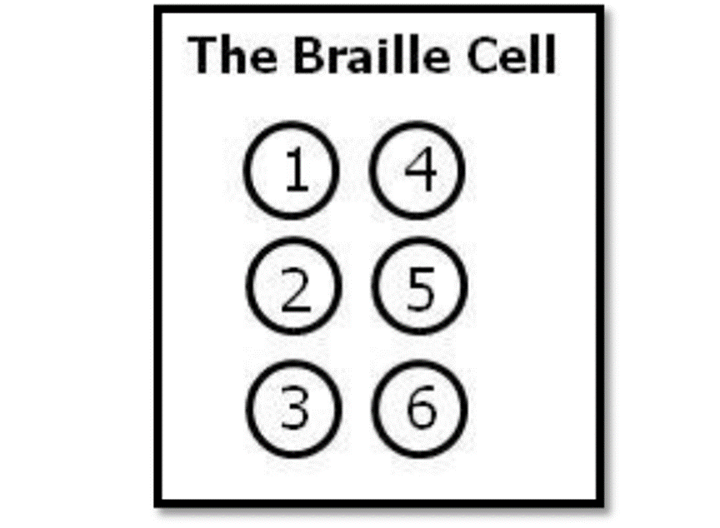

Figure 1.1 Representation of a Braille cell

Braille has become not only an effective means of communication, but also an essential avenue for achieving and enhancing literacy for people who are blind or have significant vision loss Technological developments in the computer industry have provided additional avenues of literacy for Braille users. Software programs and portable electronic Braille devices allow users to save and edit their writing, have it displayed back to them either verbally or tactually, and produce a hard copy via a desktop computer-driven Braille embosser. Because the use of computers is so common in school, children learn how to spell words out letter for letter so they can spell and write using a keyboard. Braille, combined with technology, can open up the world for the less fortunate ones. Modern technology has made many useful tools for people who read and write braille. There are some devices that produce books in braille and others that let people read information on computers and from the Internet. Some devices are simple and inexpensive and others are very complicated. [3]

The Braille system is done with the representations of each alphabet letters as below.

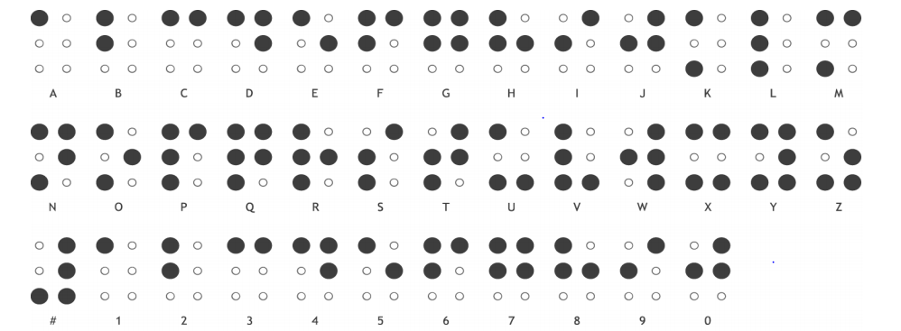

Figure 1.2 The Braille Alphabet

## 1.1 STATEMENT OF THE PROBLEM

Many developing countries have limited facilities for deaf-blind people, for that they are living isolated with no education and employment as they and their families are afraid to face and communicate with the world. At the present, message exchange is becoming one of the most important social communication media. The main problem that we focused is the difficulties that the deaf-blind person faced by the time they want to communicate with other person through text message with their phone. Also, to overcome the difficulty of communication in school between the blind and deaf-blind with their teachers and other students or even solve the problems that can face them at work. Since it’s difficult to communicate, they have faced many psychological and mental disorders. Also, they are not able to participate in many social cases by their deafness-blindness.

## 1.2 OBJECTIVES

### 1.2.1 General Objective

To design and implement a text message reading Glove for Deaf-blind people that can help the person to read a text message from his/her phone easily.

### 1.2.2 Specific Objective

We aim to design and implement a system that:

* Enable the user to receive message
* Is small and light, so blind person can carry it comfortably
* Is easy to use for blind people, where the blind person does not need to learn a new method because the project supports braille system.
* Provides a mechanism to communicate with deaf-blind people.
* Establishing a connection system between normal user and blind and deaf-blind.
* Translate braille to alphabet.

## 1.3 Motivation or Significance

We are living in the era of Digital Revolution, which is making dramatic changes to our lives every day. Leveraging these technologies can provide the deaf-blind and visually impaired affordable, unlimited access to the digital world, yet participating in the Digital Age begins with literacy. Digital audio application is useful, but listening is not literacy. Everyone, deaf-blind or sighted, must be able to read and write. Even as technology has become the primary means of communication, braille remains relevant. Those who learn braille and develop fluency with technology have a significance advantage, but it must be affordable to truly level the playing filed. There are many impaired people in the world and are challenged in their daily lives by living in sighted world. They also have equal right to education and knowledge. But their ability to learn new stuff is drastically compromised. As a result, they are unable to access the information hub and really tough to communicate with sighted world [4].

The most important motivation for the project is to overcome this communication barrier. The Braille-Glove will develop to provide the ability to deaf-blind person who use braille system to receive a text message. And enable the deaf- blind person to communicate with other people in easy way, also to overcome the difficulty of communication in school between the blind and deaf-blind with their families, teachers and other students, or even the problem that can face them in work.

## 1.4 Scope

In recent years, the combination of braille and technology has attracted attention of a lot of scientists and entrepreneurs. In the near future, advanced products prototypes have come which aim to make tactile sensing easier for the blind. The aim of our project is to reduce the cost, size, power consumption and increasing portability, reading speed, reliability and above all creating a better world for blind and deaf-blind.

* **Cost**: The further design has to be cost efficient to make the product widespread and accessible to all.
* **Size**: This is the biggest issue in designing a realizable product. Haptic QWERTY keyboards are emerging, but these are fifty times larger than a braille dot. Braille dots are very small, so it needs to be scaled down, but it’s too big a leap right now. The smallest tactile switches and keys are five times the size of the braille dot.
* **Power consumption and portability**: The successful technology needs to be low-power, portal, and cool and can’t include a heavy battery or require a main outlet.
* **Reliability**: requires a lot of care and maintenance but can provide millions of cycles when kept in good condition. Most other technologies cannot meet that bar.

# Chapter Two

# Literature Review

## 2.1 Introduction

Deaf-blind communication can be a tricky topic to tackle, since there are a number of solutions which meet different needs for deaf-blind users. Some tools are intended for face-to-face communication, while others are meant for communication at a distance. Certain tools that will work for some users will be woefully inadequate for others. Deaf-blindness, like deafness or blindness alone, is measured on a spectrum. A person may be totally deaf, totally blind, low vision, hard of hearing, or any combination of these four states. Additionally, some deaf-blind individuals will have been deaf first and be familiar with alternative techniques which focus on vision, while others may have been blind first and are therefore more comfortable with solutions that rely on hearing. Deaf-blind people may also have other advantages or disadvantages that must be considered when choosing a solution, such as poor reading skills or a higher level of tech savviness. Therefore, the spectrum of needs which must be met by solutions for deaf-blind communication are quite broad [5]. There are several types of braille systems. These types appear with many features, but nearly with the same task. In the next two sections, a discussion about the braille system that exists and the scientific topic of some braille applications is presented. In addition, we make a comparison between all of them.

## 2.2 Theoretical review

### 2.2.1 Braille Devices

This section will show the famous braille devices in the markets, their specifications, features and limitations.

#### 2.2.1.1 Perkins Braille Writer (Six-key entry)

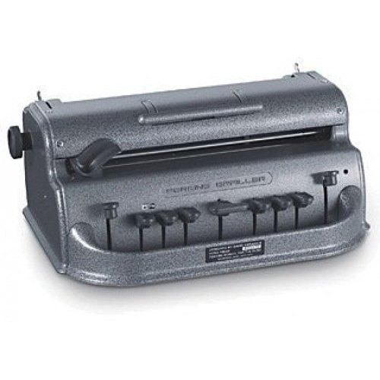

Figure 2.1 Perkins Braille Writer (Six-key entry)

*Description*

A braille Writer contains a row of keys across the lower part of the device corresponding to the six dots in the braille, which is analogous to a traditional typing machine. The writer produces a paper with raised dots. The raised braille dots that are made can be read with the fingers.

*Features*

The first type that enable braille users to read and write, and is reasonably expensive.

*Limitations*

They very heavy, not portable, difficult to learn and need special people that are familiar with braille signs to read, write and communicate with the blind person.

#### 2.2.1.2 Jot-A-Dot braille

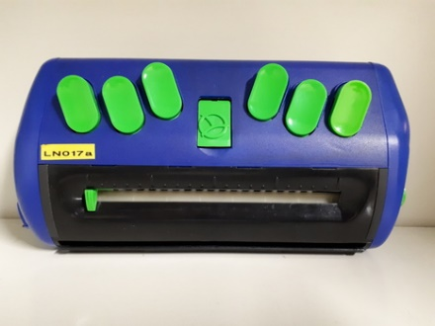

Figure 2.2 Jot-A-Dot braille

*Description*

Jot a Dot is a newer innovation in braille writing. Jot a Dot has a standard 6 dot braille keyboard. It has cell indicators showing the position of the embossing head on the line that you are writing.

*Features*

Easily carried as a personal item, light (weight less than bound), and use lightweight paper.

*Limitations*

It has the same limitation as Perkins braille writer (Six-key entry). It is very heavy, not portable, difficult to learn and need special people that are familiar with braille signs to read, write and communicate with the blind person.

#### 2.2.1.3 Braille Sense

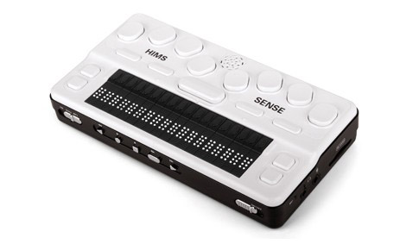

Figure 2.3 Braille Sense

*Description*

The braille Sense is a braille note taker. It is an electronic device that combines 9 key Perkins-style keyboard and 32 cell braille display, allows users to create and read files.

*Features*

The user can read texts, take notes, can communicate with other blind people who have the same device.

*Limitations*

They are very expensive, hard to learn and needs time to deal with it.

### 2.2.2 Scientific Theoretical Braille Projects

This section discusses some scientific braille projects, summarizes them and makes a comparison between them in the next section.

2.2.2.1 Braille Band: Blind support haptic wearable band for communication using braille language

It was made in 2017. The connectivity between the Braille Band and the phone is established using Bluetooth. It consists of six nodes in three bands worn on the arm to map the braille alphabet, which are actuated to give the sense of touch corresponding to the characters. It consists of a microcontroller, a Bluetooth module and six haptic motors.

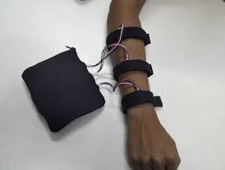

Figure 2.4 Braille Band

#### 2.2.2.2 A system to convert electronic message to braille for visually impaired.

It was made in 2004. The message received in a mobile phone is converted into braille format using an Arduino Due. It consists of Arduino Due, vibration motors and HC-05 Bluetooth module.

#### 2.2.2.3 Low cost real-time communication braille hand-glove for visually impaired using slot sensors and vibration motors.

It was made in 2014. This glove allows the person to type characters based on different braille combination using six slot sensors. The vibration in six different positions of the glove which matches to the braille code allows them to read characters. It consists of slot sensors, vibration motors, Motor Driver IC, Comparator IC Circuit, AVR Microcontroller Development Board and CC 2500 Trans Receiver (Radio Frequency Module).

#### 2.3.2.4 Braille FAMZ

In 2013, Braille FAMZ device was designed as a graduation project by a student at the Polytechnic University of Palestine. Braille FAMZ is a mechatronic device that teaches blind and visually impaired students how to read and write braille, students can learn any language in an easy way without need for a teacher help or any assistance.

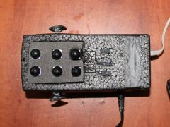

Figure 2.5 Braille FAMZ

## 2.3 Research Gaps

Now a days there are lots of devices for deaf-blind people. We have mentioned some of the well-known braille devices and braille projects. We have mentioned the limitations of the devices earlier. The gaps that we found from those devices and projects, they are very expensive, some of them are not portable and the other is the user of the device must know braille language to use the device and communicate with others. The comparison between those devices and projects is shown below on the table.

|  |  |  |  |  |  |
| --- | --- | --- | --- | --- | --- |
| Comparison | Cost/Price  (birr) | Size | portability | Communication  [Send /Receive] | Need to  Know  braille for  normal  people |
| Perkins  braille writes | 19,500-  65,850 | Big | Bad | Not possible | Need |
| Jot-A-Dot  Braille | 13,500$-  65,850 | Average | Good | Not possible | Need |
| Braille sense | cost up to  170,550 | Average | Good | Not possible | Need |
| Braille Band | Cost is not  specified | Average | Good | Possible | No need |
| Project in  (B) | Cost is not  specified | Average | Good | Not possible | No need |
| Project in  (C) | Cost is not  specified | Average | Good | Possible | No need |
| Braille  FAMZ | Cost is not  specified | Average | Good | Not possible | Need |
| Our Project | 1,000 | Small and light | good | Read text message | No need |

Table 2.1 comparison between devices and projects

As we can see from the above table most of the devices are very expensive and they are not portable. Our project will try to fill those gaps by developing a smart text reading glove for deaf-blind people. This project will minimize the cost that the person spends to buy the device and it will help the deaf-blind person to read text from his/her phone by using the glove. This project will fill the gap by developing and implementing a simple and light weight device for deaf-blind people.

# CHAPTER 3

# METHODOLOGY

## 3.1 Population

The target group in this research is those who are blind and deafblind peoples according to world health organization the estimated number of people visually impaired in the world is 285 million, 39 million blind and 246 million having low vision; 65 % of people visually impaired and 82% of all blind are 50 years and older [6]. When we came to our county there are over 1.28 million blind people and another 2.96 million people with low vision [7]. According to this data our project is very important and can be used by 2.96 million peoples in Ethiopia alone.

## 3.2 Instruments/ Tools

This project involves two major parts, the first one is the development of the android application. The android application will send a message to the braille globe through Bluetooth. To develop this application, we use a software called Android Studio. Android Studio is the official integrated development environment (IDE) for Google's Android operating system, built on JetBrains' IntelliJ IDEA software and designed specifically for Android development. It is available for download on Windows, macOS and Linux based operating systems. It is a replacement for the Eclipse Android Development Tools (ADT) as the primary IDE for native Android application development [8]. We use android studio because it is opensource, more flexible and easier to use. The main purpose of the application is to send a text message from the mobile phone to the Braille glove. The application supports the following process

* Make a Bluetooth connection
* Write and send a text message
* Receive a text message from the phone and send it to the glove

In addition, the application contains extra activities as a home page, braille learn page and about page. The other part of the project is the braille globe, this glove contains five main components those are

* Push button
* Bluetooth module
* Arduino UNO
* Vibration motor
* 9V battery with connector

### 3.2.1 Push Button

The Push buttons act as the braille dots, we will use seven push buttons, six of them uses as the six braille dots in a braille text and the other one uses to skip to the next character, when the blind person pushes the buttons corresponding to the marked braille the vibration motor will vibrate.

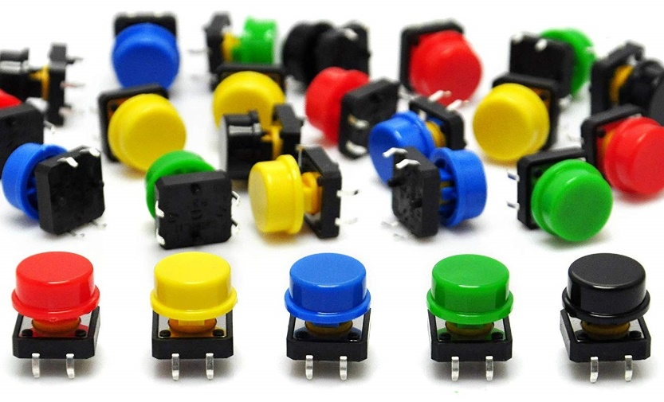

Figure 3.1 Push buttons

### 3.2.2 Bluetooth Module

The Bluetooth module is the other device we use and it is responsible for exchanging data between the android application and the glove in certain distance limit.

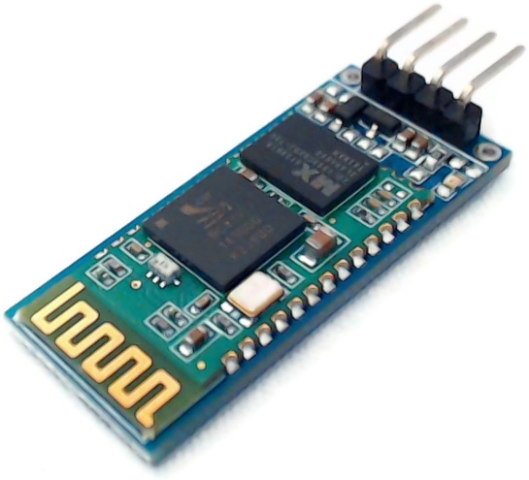

Figure 3.2 Bluetooth module

### 3.2.3 Arduino UNO

The Arduino Uno is an open-source microcontroller board based on the Microchip ATmega328P microcontroller and developed by Arduino.cc. The board is equipped with sets of digital and analog input/output (I/O) pins that may be interfaced to various expansion boards (shields) and other circuits. The board has 14 digital I/O pins (six capable of PWM output), 6 analog I/O pins, and is programmable with the Arduino IDE (Integrated Development Environment), via a type B USB cable [7]. In this project we use the Arduino to receive the text and convert it into braille language in a form of vibration.

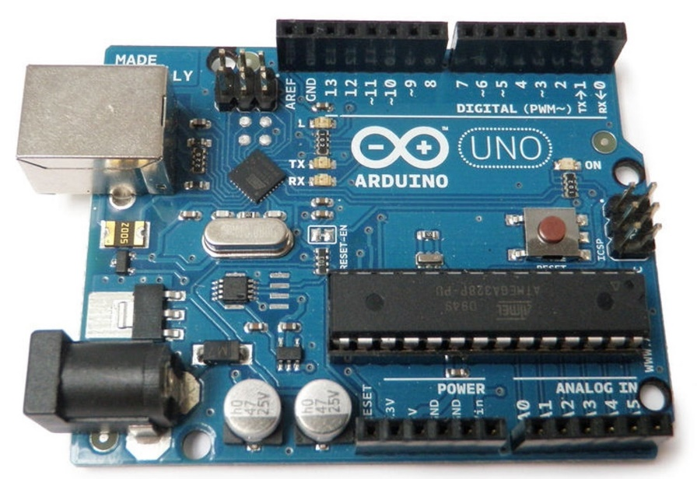

Figure 3.3 Arduino uno

### 3.2.4 Vibration Motor

Vibration motor is compact size coreless DC motor used to inform the users of receiving the signal by vibrating, no sound. Vibration motors are widely used in a variety of applications including cell phones, handsets, pagers, and so on [6]. In our project we use the Vibration motor for two purposes the first one is to indicate when a message is delivered and the second one is to show the braille spot. For example, if “A” is sent as a message and received by the Arduino, the Arduino will change the received letter A to Brail which is the first push button only cause the vibration and the other five push button will be silent which indicates it is a letter A.

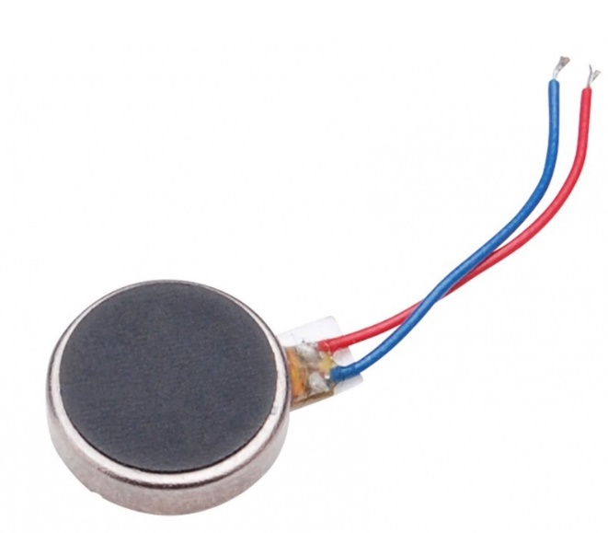

Figure 3.4 Vibration motor

### 3.2.5 9V Battery with Connector

Since this project intended to be portable, we can’t power the Arduino from a pc so we need another power source. The solution for this is to use a 9V battery, but to connect this battery to the Arduino board we need a special connector. This device is essential for the portability of the braille glove.

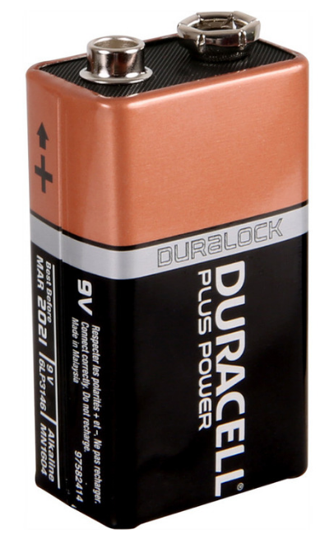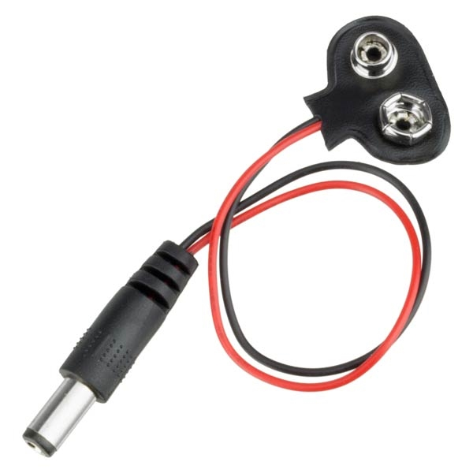

Figure 3.5 9v battery and connector

## 3.3 System Design and Analysis

Smart-Glove contains vibration motors and pushbutton switches located on the index, middle and ring finger of the glove. These are connected with the Arduino controller, which enables blind users to receive braille messages. The Bluetooth module, located on the glove, established the connection between the two system parts. The application in the mobile receive a text message and send it to the Arduino through a Bluetooth module. After receiving the message, the Arduino convert each braille points into vibration for each character.

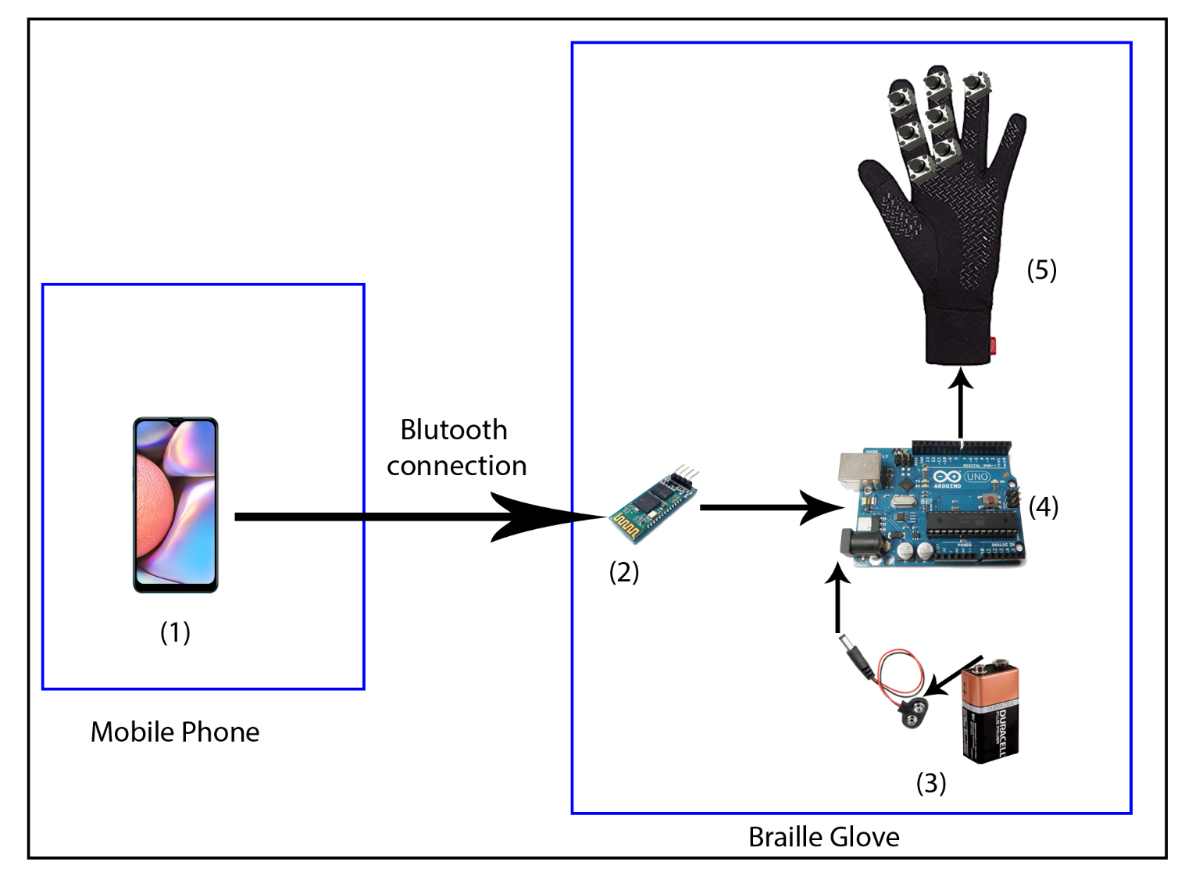

Figure 3.6 Braille glove full design

## 3.4 Timeline/Workplan

From the time we start, we just make a plan and start making this project. Starting from submitting the project title and writing the proposal for the project, we follow our time table in order to be more effective. We divide our project time line into five phases those are describe in the table below

|  |  |
| --- | --- |
| Task No | Task Name |
| 1 | Project planning |
| 2 | Determining and fulfilling project requirement |
| 3 | Analyzing and project design |
| 4 | Project development |
| 5 | Project testing and maintenance |
| 6 | Documentation |

Table 3.1 Task list

|  |  |  |  |  |  |  |  |  |  |  |  |  |  |
| --- | --- | --- | --- | --- | --- | --- | --- | --- | --- | --- | --- | --- | --- |
| Task | March | | April | | | | May | | | | June | | |
| Week | | Week | | | | Week | | | | Week | | |
| 3 | 4 | 1 | 2 | 3 | 4 | 1 | 2 | 3 | 4 | 1 | 2 |
| 1 |  |  |  |  |  |  |  |  |  |  |  |  |
| 2 |  |  |  |  |  |  |  |  |  |  |  |  |
| 3 |  |  |  |  |  |  |  |  |  |  |  |  |
| 4 |  |  |  |  |  |  |  |  |  |  |  |  |
| 5 |  |  |  |  |  |  |  |  |  |  |  |  |
| 6 |  |  |  |  |  |  |  |  |  |  |  |  |

Table 1.2 Timeline

## 3.5 Budget

|  |  |  |
| --- | --- | --- |
| Item No | Item | Price in Birr |
| 1 | Arduino | 650 |
| 2 | Bluetooth module | 350 |
| 3 | Vibrating Motor | 100 |
| 4 | Male and female cables | 150 |
| 5 | 9v battery with connector | 125 |
| 6 | Glove | 90 |
| 7 | Push Button | 35 |
| Total 1500 Birr | | |

Table 3.2 budget

# References

|  |  |
| --- | --- |
| [1] | V. c. Mukul Bandodkar, low cost real-time communication Braille Hand-glove for visually impaired using slot sensors and vibration motors, 2007. |
| [2] | l. A. Basu SG, in *Dialogue Languages and Persons with Disabilities*, IEICE transactions, 2004, pp. Vol. E87-D, No6, pp 31-43. |
| [3] | K. Ingham, Braille, the language Its machine Translation and Display, 1998. |
| [4] | M. a. M. M.ajasenathipathi, An Electronic Design of a Low Cost Braille Handglove, International Journal of Advanced Computer Science and Applications, September 2010. |
| [5] | A. mason, "Deaf-Blind Communication Technology," in *2014 CSUN Conference on Technology and Persons with Disabilities*, new york, 2004. |
| [6] | [Online]. Available: www.who.int/blindness/GLOBALDATAFINAL. [Accessed 16 march 2020]. |
| [7] | [Online]. Available: https://allafrica.com/stories/200810131273.html. [Accessed 16 March 2020]. |
| [8] | [Online]. Available: https://en.wikipedia.org/wiki/Android_Studio. [Accessed 16 march 2020]. |
| [9] | [Online]. Available: https://www.mytrendyphone.eu/shop/duracell-plus-power-9v-battery-233725p.html . [Accessed 15 march 2020]. |
| [10] | [Online]. Available: https://en.wikipedia.org/wiki/Arduino_Uno. [Accessed 14 march 2020]. |