Memorandum
Topic: | Process for Ordering Marriott Rewards Enrollment Materials for ExecuStay
Date & Time: | July 29, 2013
To:
From: | Marriott Rewards

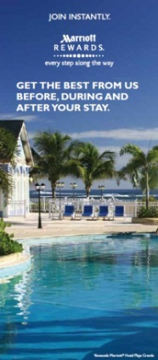
- Send email communication to: MRBulkFulfillmentServices@marriott.com

- In the email communication, indicate that you are submitting a request for Marriott Rewards Take One brochures

- Also include the following:
  - Provide official name
  - Street Address, City, State, Zip Code
  - Name of recipient (person receiving the shipment)
  - Phone number of recipient
  - Brochures are available in nine (9) languages, please indicate the required language
    - American English
    - Arabic
    - Chinese
    - French
    - French Canadian
    - German
    - Japanese
    - Queen’s English

    - Spanish

Questions? Please contact Rewards.Enrollments@Marriott.com

