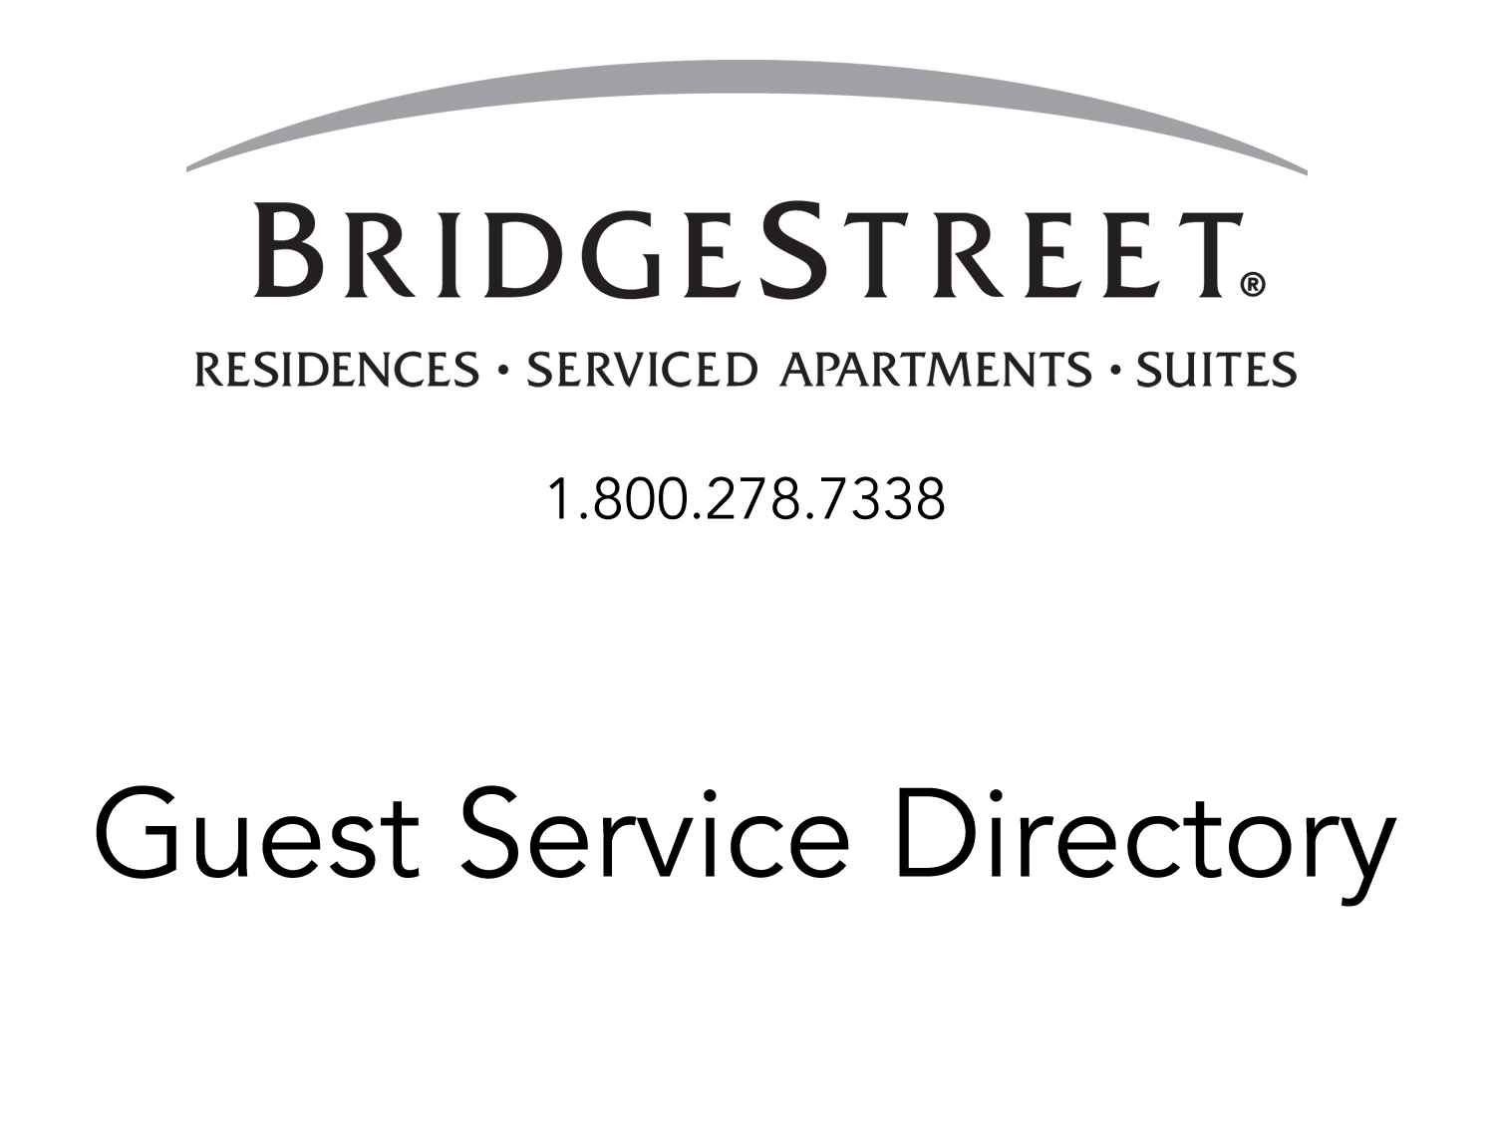

Property Name
Property Address

Dear Guest,

Welcome to your BridgeStreet serviced apartment, a refreshing hotel alternative that offers a unique experience and lifestyle. We are glad you have chosen to stay with us and we hope our accommodations and services will exceed your expectations.

With spacious living areas and well-equipped kitchens our stylishly furnished apartments have plenty of room to work and relax. Friendly and helpful staff, convenient services and a neighborhood to explore also make you feel more at home. All of which help keep you connected to the lifestyle you’re familiar with – however long your stay.

This Guest Service Directory is designed to familiarize you with BridgeStreet’s services, your apartment community and the surrounding businesses. It provides valuable information to make your stay with us an easy one and we ask that you please leave the directory for the next Guest.

Please feel free to call us if we can be of further assistance or if you have any special requests. We look forward to serving you and hope we will have the opportunity to provide you with accommodations again in the future.

Sincerely,
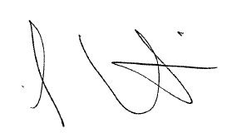

Lee Curtis
President

It is our pleasure to have you as a Guest of BridgeStreet Worldwide. Please take a moment to review the following guidelines so we may serve you in the most efficient manner possible. Should you have any questions or concerns, please call us at 1.800.278.7338.

- Maintenance
If you experience a maintenance problem in your apartment, please call BridgeStreet Worldwide and we will see that the problem is corrected.

- Emergency Maintenance
If you experience a life or property threatening maintenance problem with your apartment, please call BridgeStreet immediately! Our emergency service is available 24 hours a day, seven days a week to assist you. In the unlikely event of an emergency requiring assistance from the Police or Fire/ Life Squad Departments, dial 911 immediately to report the incident, then contact BridgeStreet as soon as possible.

- Personal Possessions
BridgeStreet Worldwide may not be held responsible for the loss of personal possessions in the event of fire, theft, etc. and/or articles left in the apartment subsequent to departure. We recommend that you maintain homeowner’s or renter’s insurance during your stay.

- Housekeeping Service
Housekeeping service is provided once every other week, Monday through Friday, excluding holidays, depending on the location. Please contact BridgeStreet if you have a question or need additional service or items. Our housekeeping service includes:

Living Room
Dust all furniture provided by BridgeStreet
Vacuum floor

Kitchen
Sanitize all counter tops and appliances
Mop floors

Bathroom(s)
Sanitize tubs, toilets
Mop floors
Replace towels

Bedroom(s)
Wash bed linens and make beds
Dust all furniture
Vacuum floor

- Departure Date
Please contact BridgeStreet with any changes to your departure date. We understand there are times when you will not have a definite date of departure. However, updating tentative dates and making us aware of definite dates enable us to accommodate your billing requirements more readily. A 30-day notice to vacate your apartment is required unless alternative arrangements were made when your reservation was confirmed.

This apartment inventory list is included for your perusal. Items are inventoried prior to each Guest’s arrival. We are very proud of the appearance of our apartments and the many amenities we have to offer. In order to maintain this level of service it is necessary for us to assess charges for any damage or loss to the apartment and/or its furnishings and contents.

Living Room
Sofa & Chair or Loveseat
Two End Tables
Coffee Table
Color TV & Stand
VCR or DVD
Lamps
Window Treatments
Artwork
Fichus or Greenery

Dining Room
Dining Table
Four Dining Chairs
Artwork

Kitchen
Microwave Oven
Coffee Maker
Toaster
Cutlery Set
Baking Set
Mixing Bowls
Pots & Pans
Dinner Plates (6) (*8)
Salad Plates (6) (*8)
Bowls (6) (*8)
Coffee Cups (6) (*8)
12 oz. Glasses (6) (*8)
9 oz. Glasses (6) (*8)
7 oz. Glasses (6) (*8)
Wine Glasses (4) (*4)
Flatware (6) (*8)
Flatware Tray
Cooking Utensil Set
Cutting Board
Measuring Cup
Measuring Spoons
Can Opener
Ice Cream Scoop
Pizza Cutter
Cookie Sheet
Vegetable Peeler
Colander
Salt & Pepper Shaker
Sugar & Creamer Set
Hot Pads
Dish Towel & Clothes
Placemats
Linen Napkins
Cork Screw
Waste Basket
Pitcher
Salad Bowl w/ Tongs
Serving Set

Master Bedroom
Queen Bed
Pillows
Blanket
Comforter/Bed Spread
Bed Linens
Dresser/Chest
Night Stands
Television
Lamps
Clock Radio
Waste Basket
Telephone
Window Treatments
Hangers/Skirt Clips
Artwork
Second Bedroom
2 Twin Beds or 1 Queen
Pillows
Blankets
Bed Spreads
Bed Linens
Dresser/Chest
Nightstand(s)
Lamp(s)
Clock Radio
Waste Basket
Window Treatments
Hangers/Skirt Clips
Artwork

Bathroom
Bath Linens
Shower Curtain & Liner
Bath Mat
Waste Basket
Soap & Tissue
Plunger
Toilet Brush
Soap Dish & Tumbler
Toothbrush Holder

Miscellaneous
Cordless Telephone
Telephone Books
Clothes Hangers
Iron& Ironing Board
Vacuum
Broom & Dust Pan
Smoke Alarms
Key Return Envelope
Clothes Basket

* Denotes quantities found in 2 & 3 bedroom apartments

Let BridgeStreet Concierge help you get more things accomplished each day. Online or by phone, BridgeStreet Concierge can assist with any task...whether it’s across town or across the globe.

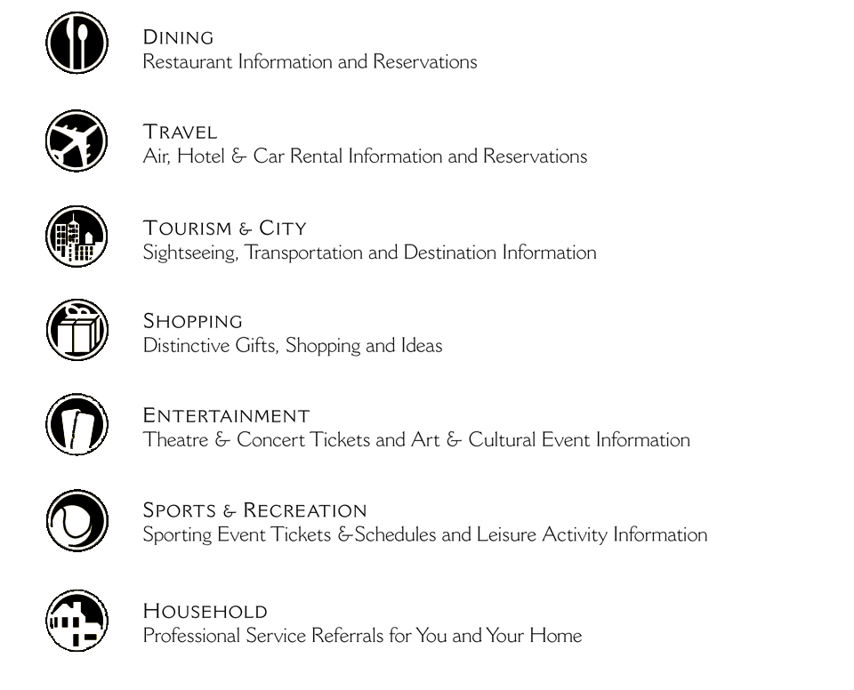

As our guest enjoy a complimentary membership - another way BridgeStreet is making corporate housing easy. To access 24/7 BridgeStreet Concierge service, please call 1.877.267.8502 or visit www.bridgestreetconcierge.com.

- Fitness Center
As our Guest, please feel free to use the fitness room. You may access the facility 24 hours a day with your key.

- Pool
The outdoor pool is open from Memorial Day Weekend through Labor Day Weekend. Hours are from x:00 a.m. to x:00 p.m. Be sure to take your pool pass. Call BridgeStreet if a pass was not included in your Welcome Packet.

- Clubhouse Services
The clubhouse can be rented for small gatherings. Call BridgeStreet for more details. There is a business center available for faxing and printing.

- Package Delivery
If you are not home when a package is delivered, the property will sign and hold it for you. Your package may be picked up at the leasing office or concierge desk during regular business hours, please present proper identification.

- Mailbox Locations
The mailboxes are located at the entrance to the community by the clubhouse your mailbox number can be found on your welcome letter in your Welcome Packet.

- Trash Pick Up
Housekeepers will remove trash during their normal visit. For daily disposal, trash compactors are located at the entrance to the property. Please contact BridgeStreet at 1.800.278.7338 if you need assistance locating the nearest one to you.

- Parking
Outdoor, unassigned parking is available. Garages and carports are available also for an additional cost, and are based on availability.

- Maintenance
Call BridgeStreet at 1.800.278.7338 during regular business hours to schedule non-emergency maintenance. We will work with your apartment community to accommodate your request as quickly as possible. In the case of an emergency please contact us and a representative will assist you or direct your call to our Associate on 24 hour call.

- Check Out Procedures
Please leave the pool pass and gate entry card on the kitchen counter. Use the keys to lock the door behind you and leave the keys at the community office or front desk.

Dry Cleaners
Company Name
Street Address
City, State Zip
website.com
xxx-xxx-xxxx

Grocery/Discount Stores
Company Name
Street Address
City, State Zip
website.com
xxx-xxx-xxxx

Medical Services
Company Name
Street Address
City, State Zip
website.com
xxx-xxx-xxxx

Pharmacies
Company Name
Street Address
City, State Zip
website.com
xxx-xxx-xxxx

Post Office
Company Name
Street Address
City, State Zip
website.com
xxx-xxx-xxxx

Restaurants/Delivery Service
Company Name
Street Address
City, State Zip
website.com
xxx-xxx-xxxx

