#### ACE Scoring Explained

|  |  |
| --- | --- |
| Overview | Each survey produces three scores: the ACE Score (“Total Score”), Product Quality (PQ), and Customer Experience (CE). |

|  |  |  |  |  |  |  |  |  |  |  |  |  |  |  |  |  |  |  |  |  |  |  |
| --- | --- | --- | --- | --- | --- | --- | --- | --- | --- | --- | --- | --- | --- | --- | --- | --- | --- | --- | --- | --- | --- | --- |
| Points and Scoring | * Guest responses to specific survey questions are tied to a particular score on a scale of 1-5. The culmination of these scores leads to each of the categorical scores captured above. * Based on guest responses, points will be assigned to two parts of the scoring formula: * *Favorable Responses*:   + Guest responses of a “4 – Satisfied” or “5 - Very Satisfied” are considered favorable and count as 1 point   + Guest responses of “1 – Very Unsatisfied”, “2 – Unsatisfied”, or “3 – Neutral” are considered unfavorable and count as 0 points * *Questions Answered*: 1 point will be assigned if the guest answered the question * Questions with no response are allotted 0 points in both parts of the scoring formula. Essentially a customer’s non-response will not affect the score negatively.  |  |  |  | | --- | --- | --- | | Response | Favorable Responses | Questions Answered | | 1 – Very Dissatisfied | 0 | 1 | | 2 – Dissatisfied | 0 | 1 | | 3 – Neutral | 0 | 1 | | 4 – Satisfied | 1 | 1 | | 5- Very Satisfied | 1 | 1 | | No Answer | 0 | 0 |  * Favorable Response points in each category (ACE (“Total”), Product Quality, and Customer Experience) are added and divided by the Questions Answered for each category to obtain the final score. |

continued on next page

ACE Scoring Explained, Continued

|  |  |
| --- | --- |
| Questions Excluded | The questions highlighted in gray within the survey below are not scored and have been omitted from the remainder of the images captured in this job aid. |

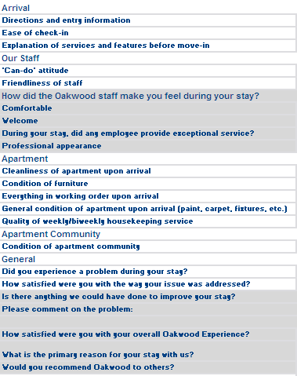

#### The ACE “Total” Score

|  |  |
| --- | --- |
| Important | Additional columns revealing point scoring have been added to survey images to serve as a visual of the formulas built into the ACE Score. |

|  |  |
| --- | --- |
| ACE (Total) Score | The responses to the following questions, on the guest satisfaction survey, equate to the ACE “Total” Score portion: |

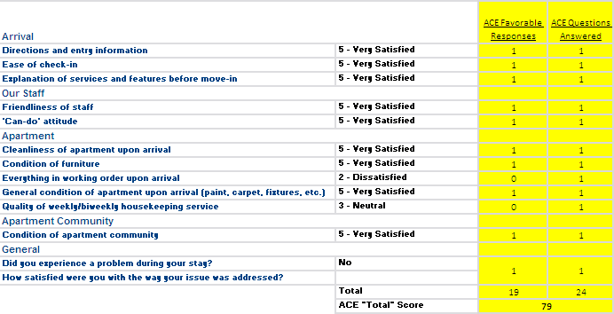

|  |  |
| --- | --- |
| ACE (Total) Score Scoring | The ACE favorable responses are added and divided by the number of ACE questions answered.  Note: In the example captured above, the customer scored two questions at a 3 or below which is why neither have a point awarded in the *ACE Favorable Responses* column. |

#### The Product Quality “PQ” Score

|  |  |
| --- | --- |
| Important | Additional columns revealing point scoring have been added to survey images to serve as a visual of the formulas built into the ACE Score. |

|  |  |
| --- | --- |
| Product Quality Score | The responses to the following questions, on the guest satisfaction survey, equate to the Product Quality score portion: |

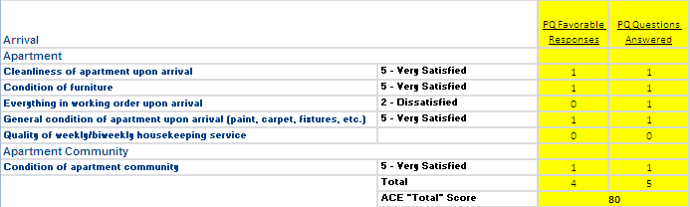

|  |  |
| --- | --- |
| Product Quality Score Formula | The PQ favorable responses are added and divided by the number of possible responses.  Notes:   * In the example captured above, the customer scored one question at a 3 or below which is why a point has not been awarded in the *PQ Favorable Responses* column. * This particular customer also had no response to the housekeeping question, highlighted above, which awarded a 0 in both *PQ Favorable Responses* and *PQ Questions Answered*. This particular question will not be visible during an Associate’s review of the survey but has been highlighted here solely for training purposes. |

#### The Customer Experience “CE” Score

|  |  |
| --- | --- |
| Important | Additional columns revealing point scoring have been added to survey images to serve as a visual of the formulas built into the ACE Score. |

|  |  |
| --- | --- |
| Customer Experience Score | The responses to the following questions, on the guest satisfaction survey, equate to the Customer Experience portion: |

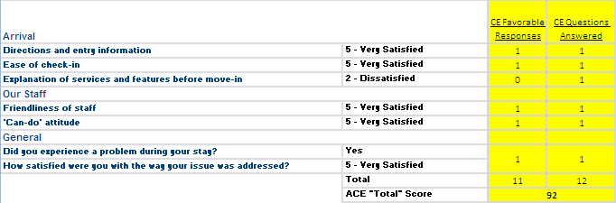

|  |  |
| --- | --- |
| Customer Experience Scoring | The CE favorable responses are added and divided by the number of questions answered.  Note: In the example created and captured above, the customer scored high on all but one question. This resulted in a point not being awarded in the *CE Favorable Responses* column. |

#### Problem Resolution Question

|  |  |
| --- | --- |
| Overview | The Problem Resolution Question is a multiple part question that affects the Customer Experience and ACE “Total” Scores as depicted in the scenarios featured on this page. |

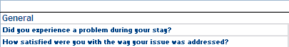

|  |  |
| --- | --- |
| Scenario 1 | If the customer answers “no” to the question of experiencing a problem, a point will be awarded and the second question will not require a response. |



|  |  |
| --- | --- |
| Scenario 2 | If the customer answers “yes” to the question of experiencing a problem, a point will be awarded if the second question is scored at a 4 or higher. |



|  |  |
| --- | --- |
| Scenario 3 | If the customer answers “yes” to the question of experiencing a problem and scores the second question at a 3 or lower, a point will not be awarded. |



|  |  |
| --- | --- |
| Scenario 4 | If the customer answers “yes” to the question of experiencing a problem, and does not respond to the second question, a point will not be awarded. |



#### Averaging Scores

|  |  |
| --- | --- |
| Averaging Multiple Surveys | In order to get the average score for multiple surveys, count up the total favorable responses of each survey and then divide by the total number of questions answered. See the example below: |

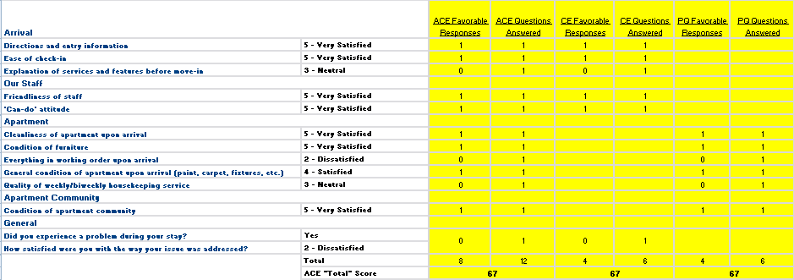

1

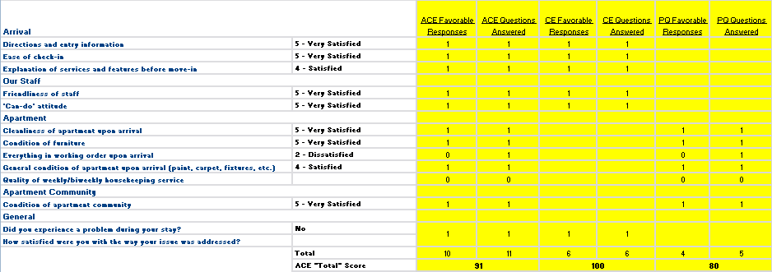

2

|  |  |  |  |  |  |  |
| --- | --- | --- | --- | --- | --- | --- |
| Survey Number | ACE Favorable | Total Possible | CE Favorable | Total Possible | PQ Favorable | Total Possible |
| 1 | 8 | 12 | 4 | 6 | 4 | 6 |
| 2 | 10 | 11 | 6 | 6 | 4 | 5 |
| Total Favorable/  Total Possible | 18/23 | | 10/12 | | 8/11 | |
| Average of Surveys | 78% | | 83% | | 73% | |

Continued on next page

Averaging Scores, Continued

|  |  |  |  |  |  |  |  |  |  |  |  |  |  |  |  |  |  |  |  |  |  |
| --- | --- | --- | --- | --- | --- | --- | --- | --- | --- | --- | --- | --- | --- | --- | --- | --- | --- | --- | --- | --- | --- |
| Important Note: Averaging Surveys | To insure accuracy when averaging multiple surveys, add the favorable responses from all of the surveys and divide by the sum of the questions answered from all of the surveys. The surveys’ final scores should never be averaged to obtain the average score for the group.  If Associates averaged the two surveys using solely their final scores, a different answer would have been obtained:   |  |  |  |  | | --- | --- | --- | --- | | Survey Number | ACE | CE | PQ | | 1 | 67 | 67 | 67 | | 2 | 91 | 100 | 80 | | **Average** | ***79%*** | ***84%*** | ***74%*** | | **Actual Score (from previous page)** | ***78%*** | ***83%*** | ***73%*** | |