PA1_template

Melanie Fische

3 Februar 2017

# Reproducible Research: Peer Assessment 1

## Loading the file

### Calculate and report the total number of missing values in the dataset

And filled it with missing data

# What is mean total number of steps taken per day?

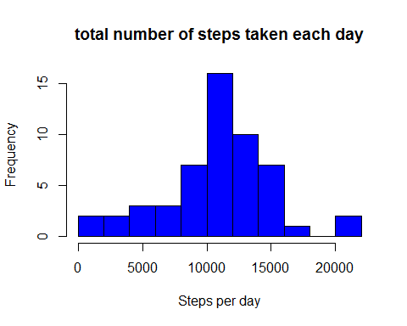

### mean /median

## [1] 10766.19

## [1] 10765

# What is the average daily activity pattern?

Print a series Plot. At first aggregate the date for series.

## Warning: package 'ggplot2' was built under R version 3.3.2

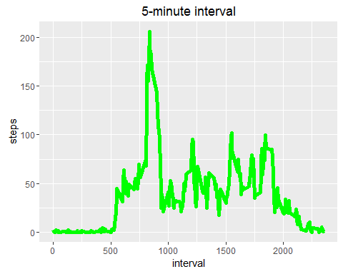 Which 5-minute interval, on average across all the days in the dataset, contains the maximum number of steps?

## interval steps  
## 104 835 206.1698

# Imputing missing values

1. Calculate the total number.

## [1] "13.115 %"

1. Devise a strategy for filling in all of the missing values in the dataset...

Replace each missing value with the mean value.

Make a histogram of the total number. 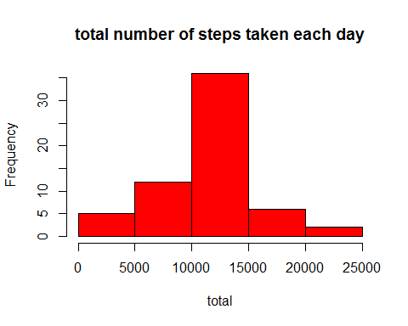 ### mean/median of the steps

## [1] 10766.19

## [1] 10766.19

# Are there differences in activity patterns between weekdays and weekends

Create a new weekday/Weekend variable in a df.

Aggregate the steps to the different days.

Plot it. 