**Contents**

1 Question 1 -------------------------------------------------------------------------------------------- 2

1.1 Device component ---------------------------------------------------------------------------- 2

1.2 Process of temperature measuring -------------------------------------------------------- 2

1.3 Main factors affecting the accuracy of the measured temperature --------------- 3

2 Question 2 -------------------------------------------------------------------------------------------- 4

3 Question 3 -------------------------------------------------------------------------------------------- 6

**Question 1**

**1.1 Device component**

The device I found has temperature, facial recognition. In order to achieve the above four functions, the device needs an infrared temperature probe, a facial recognition camera, an LED lamp for light supplement, a laser ranging compensation probe, a display screen and a control panel. Different modules on the control board are responsible for data acquisition and processing. The identity recognition module obtains the identity data by obtaining the image data of the face recognition camera. The temperature measuring module obtains the data of the infrared temperature measuring probe. The processing module, together with the above two modules and the laser ranging compensation probe, sends the processing signals to the control module under different conditions. The control module is responsible for controlling the light supplement component and the display screen. Temperature data and identity data are stored in the storage module.

**1.2 Process of temperature measuring**

The infrared temperature probe can obtain the infrared energy radiated by the object itself. This energy varies according to the temperature of the surface. In other words, we can measure the temperature of the forehead by determining the location of the forehead and then obtaining the highest temperature in that particular area. So, the facial recognition camera on the device takes information about the person's face, which is then transmitted to an ID module that clips the image data to get information about the active area, the forehead area. The location data information of this particular area will be passed to the temperature measuring module. According to the temperature data recorded by the infrared temperature probe at the same time, the temperature measurement module extracts the temperature data of a specific area and sends it to the storage module and processing module. At the same time, the identification module sends the cropped complete face image data to the storage module for storage and processing module for processing. By comparing the newly obtained face information with the previous face information, the processing module determines the identity of the person. At the same time, the processing module will judge whether the temperature is normal on the forehead temperature data.

**1.3 Main factors affecting the accuracy of the measured temperature**

I think there are two main factors. Face recognition, poor definition of the image will lead to the wrong forehead location information, and then lead to temperature errors. In terms of temperature measurement, if it is cold weather, the temperature on the forehead may be lower than the actual temperature. Girls with low body temperature are prone to temperature measurement errors.

**Question 2**

1. Photo size:

Height: 512 pixels

Width: 512 pixels

1. Memory calculation formula: width * height * channel number ( or bit depth / 8 )

Calculation: For RGB picture, the channel number is 3

512 * 512 * 3 B = 512 * 512 * 3 / 1024 KB = 768 KB

On computer: the size is 462 KB.

Obviously, the two numbers are different. That’s because the picture with .jpg suffix is in JPEG format, which is a lossy compression format. Hence, the actual size of Lena photo is smaller than the memory calculation result.

1. Memory calculation formula: width * height * channel number (or bit depth / 8)

Calculation: For gray picture, the channel number is 1.

512 * 512 * 1 B = 512 * 512 * 1 / 1024 KB = 256 KB

On computer: the size is 88.8 KB

1. The images, composed of pixels, are stored as digital images in computers. That is, each pixel is represented as value, pixel value, instead of color lump. Hence, each image is stored as the digital matrix, or channel.

From the property of JPEG images, we can find there are height, width, and bit depth. The height and width are just the amount of vertical or horizontal pixels, not the physical size. The bit depth gives the number of bits standing for each pixel. For example, in this question, the bit depth for the RGB image is 24 and 8 for the gray image. Because it’s well known that the gray image has one channel while the RGB image has 3 channels. That is, each pixel is represented with 8 bits, which gives the range of color amount per pixel is 0-255, or we can say the color intensity.

Except for the color part, the computer also compresses the images depending on different compression format. For example, JPEG is a lossy compression commonly used for digital images. The method takes advantage of the principle that human eyes are less sensitive to color than to brightness to save relative higher-quality images with less memory space by reducing the number of bits used to represent color. We can set different compression ratios based on requirements. The commonly used compression ratio ranges from 10:1 to 40:1.

**Question 3**

The acquisition of star trail images consists of two parts, shooting and post-processing. The following shooting process is based on a digital camera and is achieved by adjusting some parameter values of the camera components. The later fusion part needs to use image processing software to perform image fusion processing, which will not be repeated here.

We make camera settings from the following two aspects.

1. Lens parameters

(1) Focal length: use wide-angle or ultra-wide-angle

The focal length is actually the distance from the point where the light parallel to the main optical axis converges after passing through the lens, the focal point, to the center of the lens, the optical center. Since the lens imaging principle is pinhole imaging, the shorter the focal length, the larger the angle of view. Although the change of focal length can be achieved by lens movement (optical zoom) or by the processor to enlarge the area of each pixel in the picture (digital zoom), but because the latter reduces the image resolution and quality, cameras often use optical Zoom in to get a larger field of view.

(2) Aperture: A larger aperture.

The aperture controls the amount of light that comes in when taking pictures by how close the aperture blades (black one in figure below) are. Considering that the star trail shooting time is at night and the light is weak, using a larger aperture can allow more light to pass through the lens and fall on the CMOS, making the photo brighter.



Figure 1: Aperture blade state

2. Camera body parameters

(1) Sensitivity: Use a fixed sensitivity below ISO800

For CMOS, the higher the sensitivity, the more sensitive the CMOS is to light, and the brighter the final picture will be. However, due to the inevitable occurrence of noise in the process of CMOS processing optical signals, that is, the influence of optical electromagnetic interference, the higher the sensitivity, the earlier the appearance will be, thus reducing the picture quality. Therefore, the purpose of increasing the exposure can be achieved through a large aperture and low sensitivity. The low sensitivity setting is generally below ISO800. A fixed ISO is used to keep the overall brightness of the picture consistent.

(2) Exposure time: 30 seconds

The exposure time also becomes the shutter time, which refers to the opening time of the internal shutter component of the camera, not the button time when taking pictures. The button is a trigger device, when pressed, the shutter assembly opens, as figure 3 shown, and the CMOS receives the light signal and processes it. The longer the exposure time, the lighter the CMOS gets, and the brighter the photo. However, the photosensitive element works under the condition of electricity, and electricity will generate heat, which will lead to the generation of noise. Therefore, the exposure time needs to be shortened within a reasonable range. Therefore, choose the longest shutter time of 30 seconds, which is commonly used by most cameras. Note that there needs to be a few seconds of cool down between each exposure.

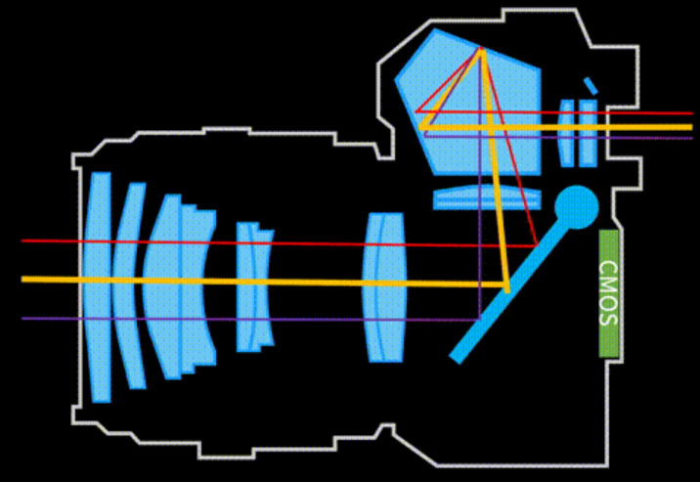 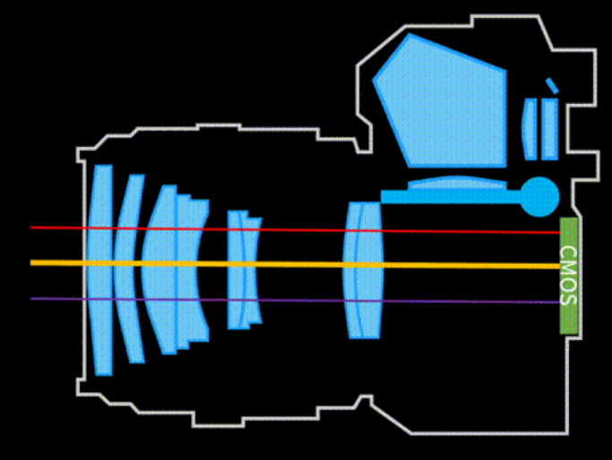

Figure 2: Shutter assembly closed state Figure 3: Shutter assembly open state

About the total filming time, several hours are enough. Although the Earth's rotation period is 24, the number of stars is so large that the rotation of stars in different positions becomes a closed circle after a few hours of shooting.

The last is the process of light obtained by CMOS, which is the digital camera imaging principle. Under the conditions of the above parameter settings, CMOS obtains a certain amount of light, and converts light into current through photodiode, and current through amplifier and A/D into digital signal. The digital signal is processed and compressed in DSP, and finally saved in SD card.

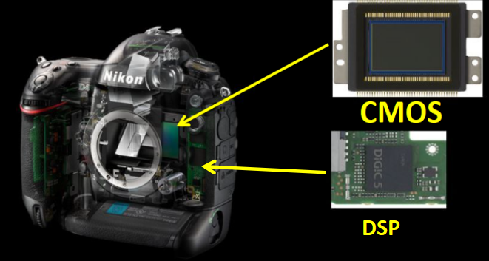

Figure 4: Position of CMOS and DSP in the camera