Dissertation_STATS_v2.R

print(sesh_ft)

## DRILL Pre-season_CI Post-season_CI Pre-season_Peaks Post-season_Peaks Pre-season_Integral Post-season_Integral  
## 1 40yd 6.97 (0.97) 7.1 (0.99) 41.92 (8.41) 40.8 (7.6) 61832 (8735) 60208 (7834)  
## 2 5-10-5 5.13 (0.88) 5.17 (0.93) 24.97 (6.29) 24.16 (5.77) 41057 (6756) 38704 (5715)  
## 3 Broad 3.15 (1.28) 3.37 (1.28) 46.19 (14.97) 46.86 (17.33) 0 (0) 0 (0)  
## 4 DNB 6.26 (1.38) 6.35 (1.37) 16.72 (6.11) 17.32 (6.25) 23658 (5721) 23818 (4905)  
## 5 M-L 5.66 (0.89) 5.78 (0.98) 27.74 (5.64) 27.65 (6.13) 40331 (5802) 39270 (5831)

print(sex_ft)

## DRILL Female_CI Male_CI Female_Peaks Male_Peaks Female_Integral  
## 1 40yd 7.05 (0.97) 7.02 (0.99) 40.73 (8.54) 41.96 (7.48) 60657 (8811)  
## 2 5-10-5 5.01 (0.9) 5.28 (0.88) 24.79 (5.98) 24.34 (6.11) 38997 (5547)  
## 3 Broad 3.27 (1.28) 3.26 (1.29) 46.24 (15.28) 46.8 (17.01) 0 (0)  
## 4 DNB 6.32 (1.36) 6.3 (1.4) 17.82 (6) 16.29 (6.27) 24657 (4828)  
## 5 M-L 5.7 (0.94) 5.73 (0.94) 26.02 (5.57) 29.29 (5.74) 38471 (5414)

print(groups_ft)

## DRILL F.1_CI F.2_CI M.1_CI M.2_CI F.1_Peaks F.2_Peaks M.1_Peaks M.2_Peaks F.1_Integral F.2_Integral M.1_Integral M.2_Integral  
## 1 40yd 6.98 (0.91) 7.11 (1.03) 6.95 (1.03) 7.08 (0.96) 41.45 (9.12) 40 (7.9) 42.36 (7.7) 41.56 (7.26) 61775 (9766) 59540 (7623) 61886 (7679) 60840 (8012)  
## 2 5-10-5 4.94 (0.82) 5.08 (0.97) 5.32 (0.9) 5.25 (0.87) 25.17 (5.78) 24.41 (6.18) 24.77 (6.77) 23.91 (5.36) 39479 (5605) 38514 (5474) 42604 (7426) 38889 (5961)  
## 3 Broad 3.16 (1.28) 3.37 (1.27) 3.15 (1.28) 3.37 (1.3) 45.69 (15.35) 46.78 (15.26) 46.67 (14.64) 46.93 (19.15) 0 (0) 0 (0) 0 (0) 0 (0)  
## 4 DNB 6.39 (1.31) 6.25 (1.4) 6.15 (1.43) 6.45 (1.35) 17.82 (5.91) 17.83 (6.11) 15.72 (6.14) 16.86 (6.37) 25328 (4500) 23987 (5069) 22140 (6284) 23665 (4770)  
## 5 M-L 5.63 (0.94) 5.78 (0.95) 5.68 (0.84) 5.78 (1.02) 26.61 (5.82) 25.43 (5.29) 28.81 (5.27) 29.76 (6.16) 39046 (5368) 37895 (5424) 41547 (5957) 40571 (5927)

# Visualize ~ PHV-----  
## 40yd----  
### CI ----  
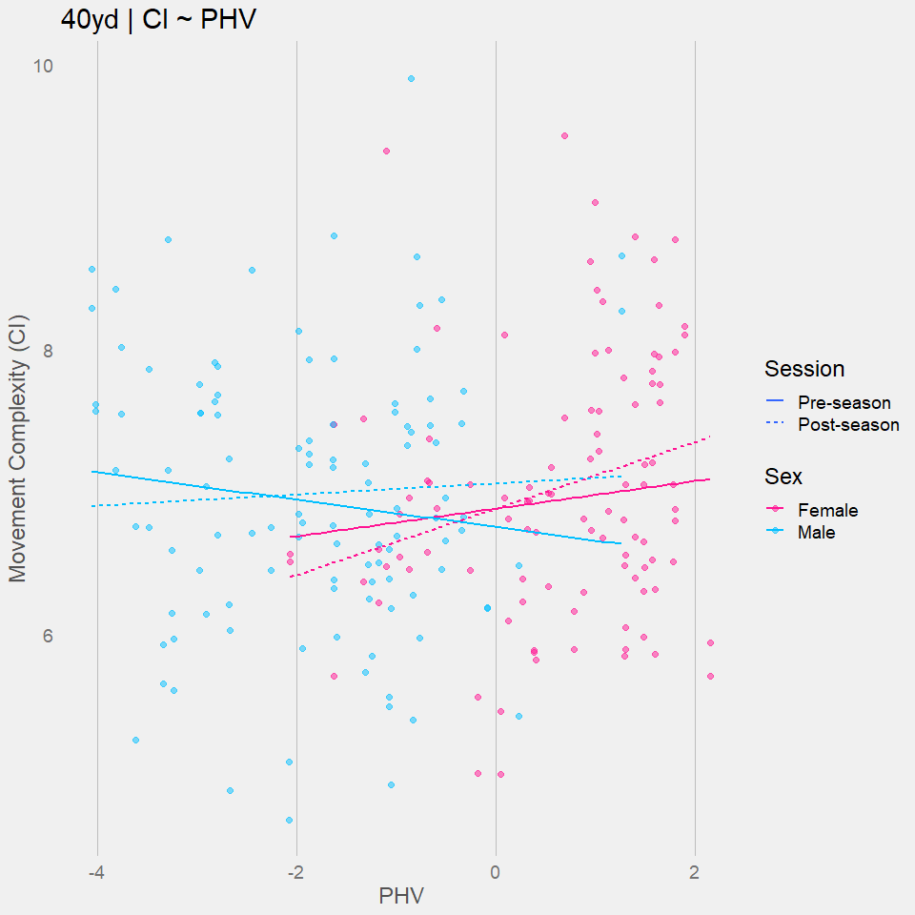

### Peaks ----

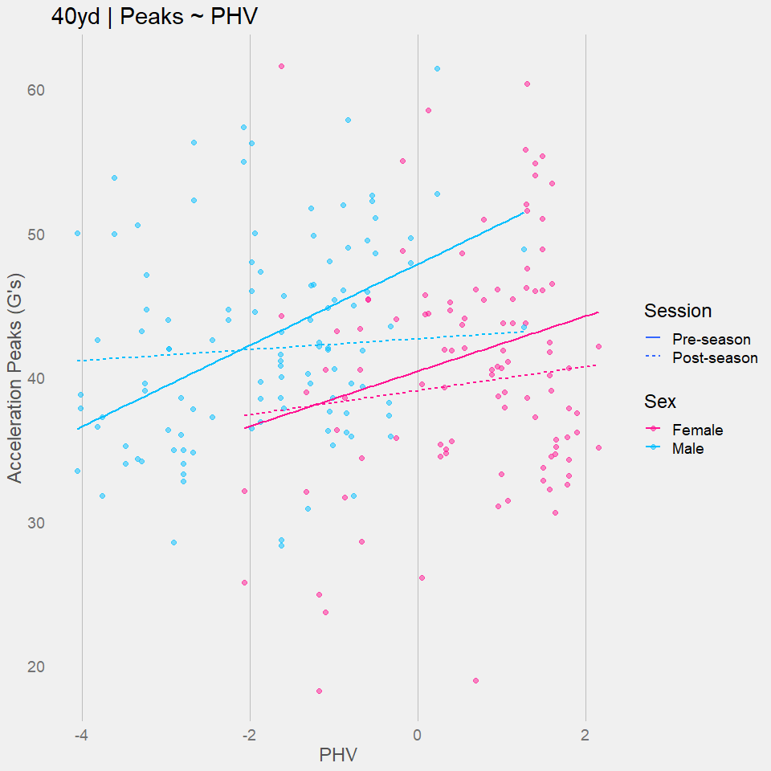

### Integrals ----

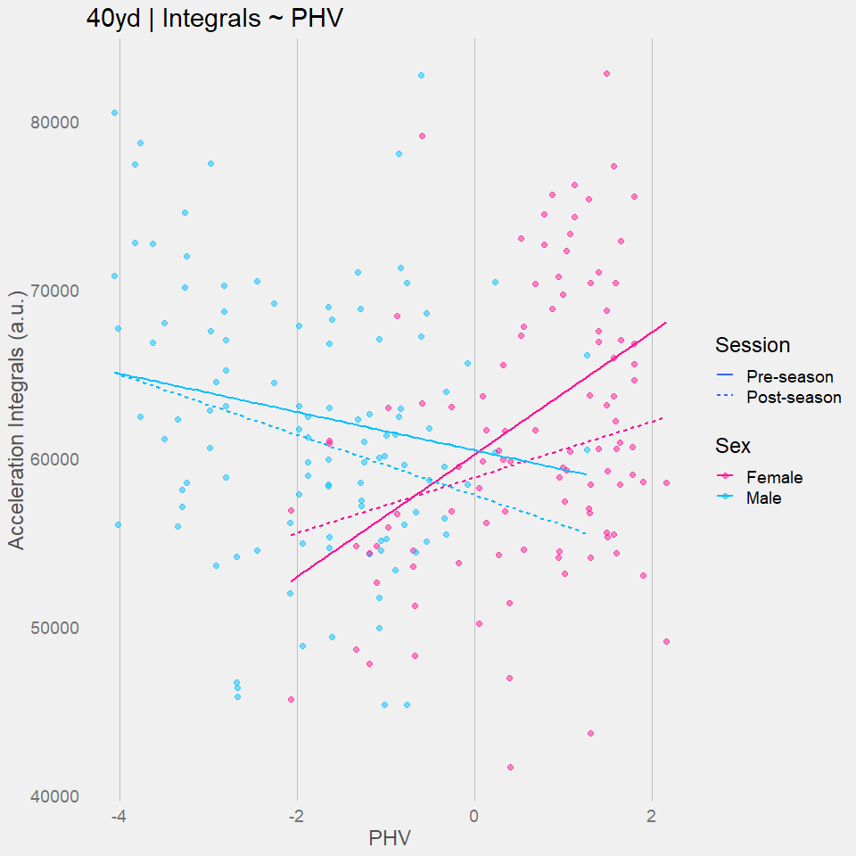

## 5-10-5----  
### CI ----

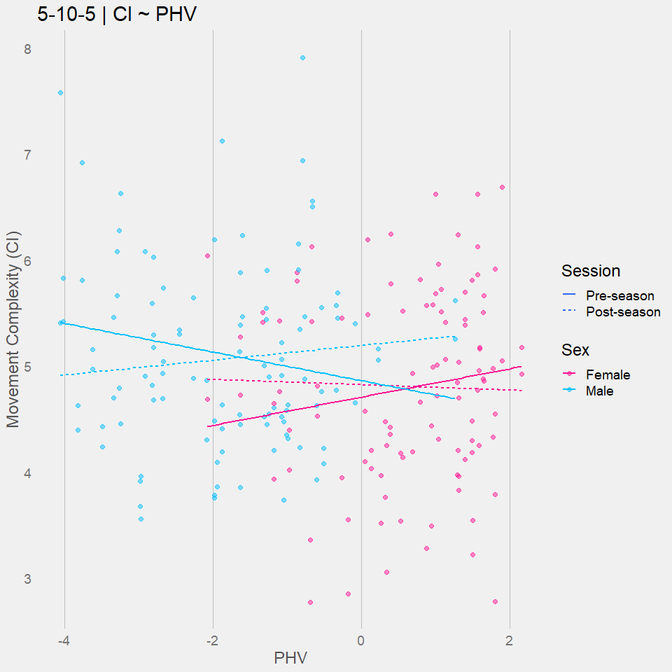

### Peaks ----

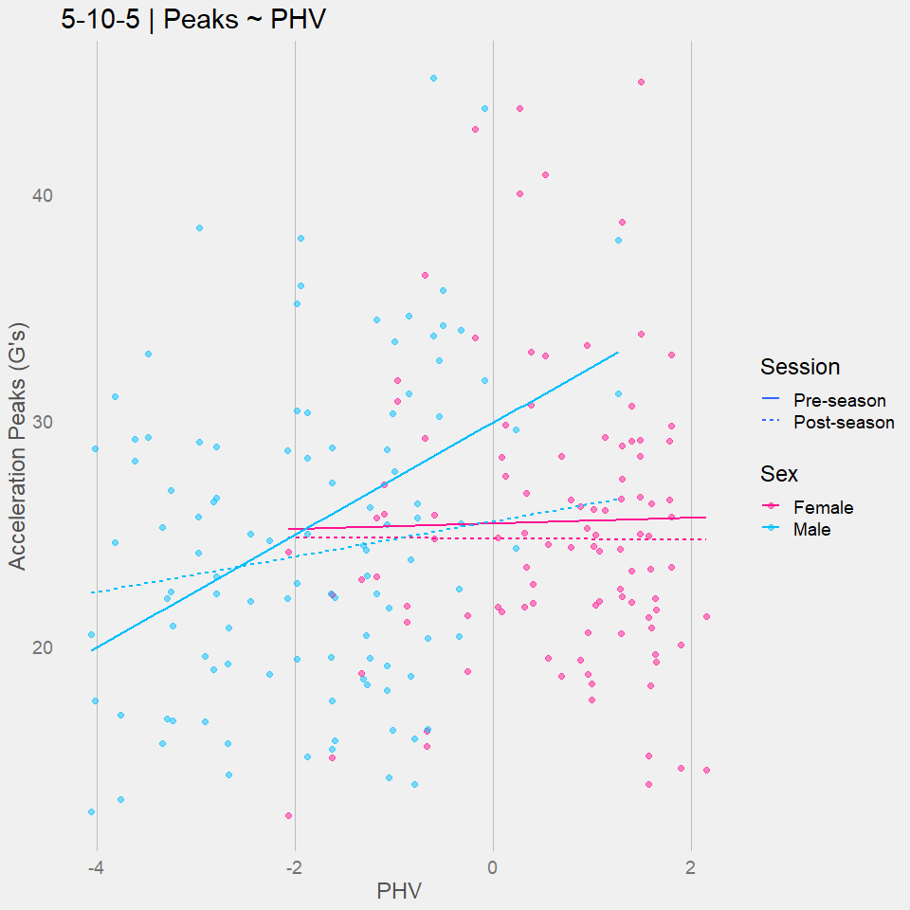

### Integrals ----

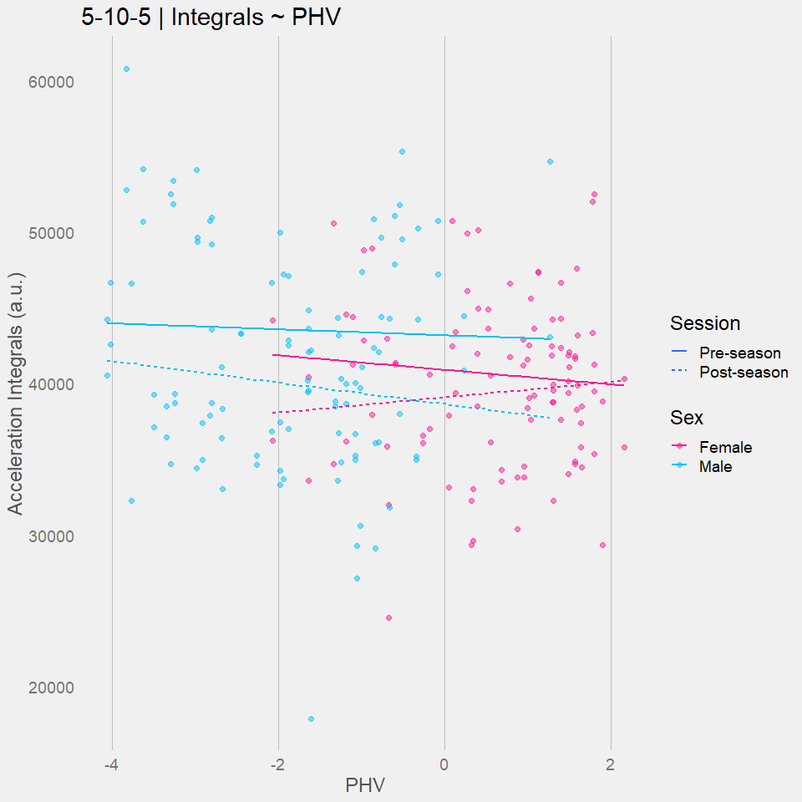

## Broad ----  
### CI ----

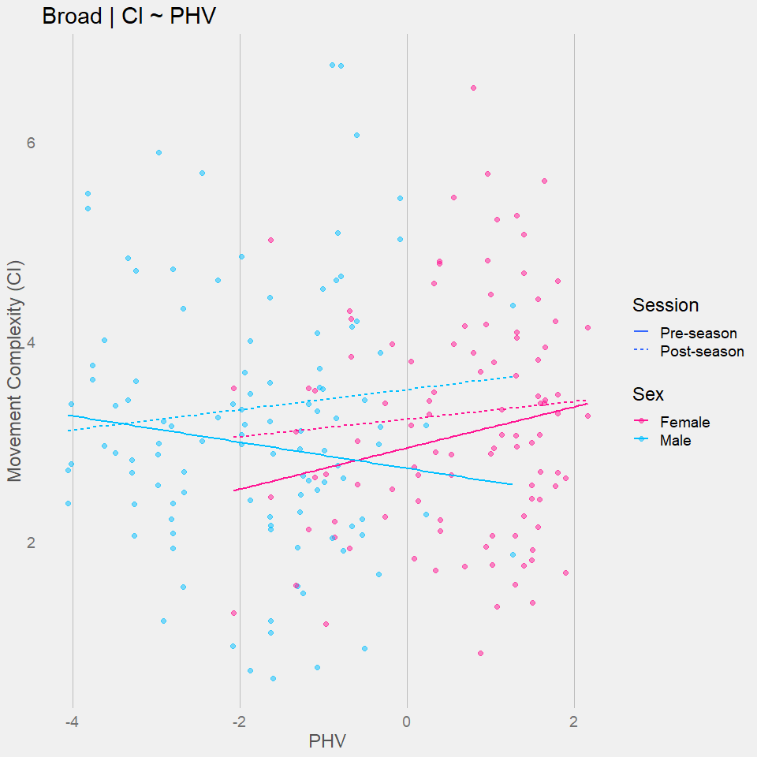

### Peaks ----  
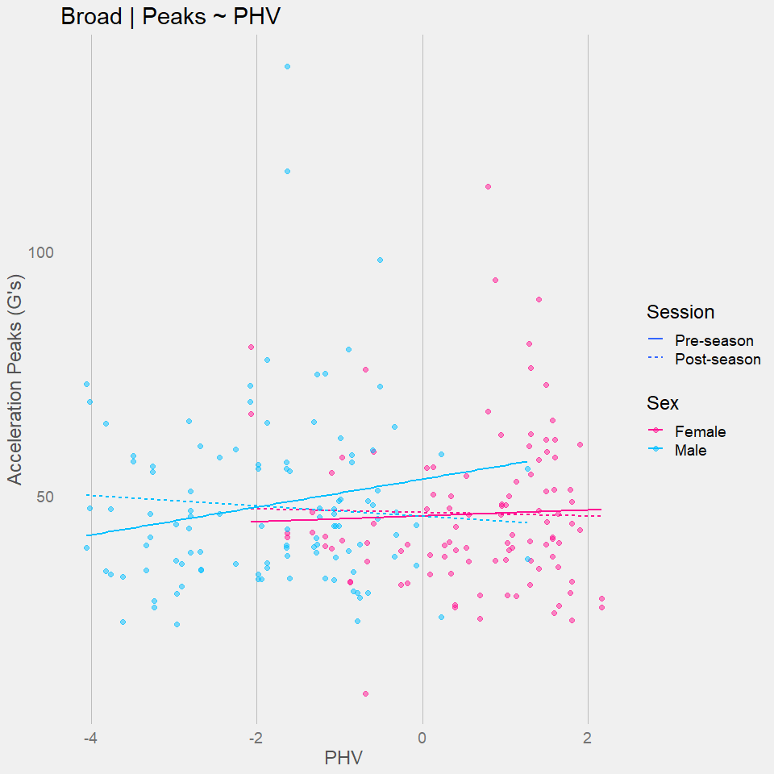

## M-L ----  
### CI ----

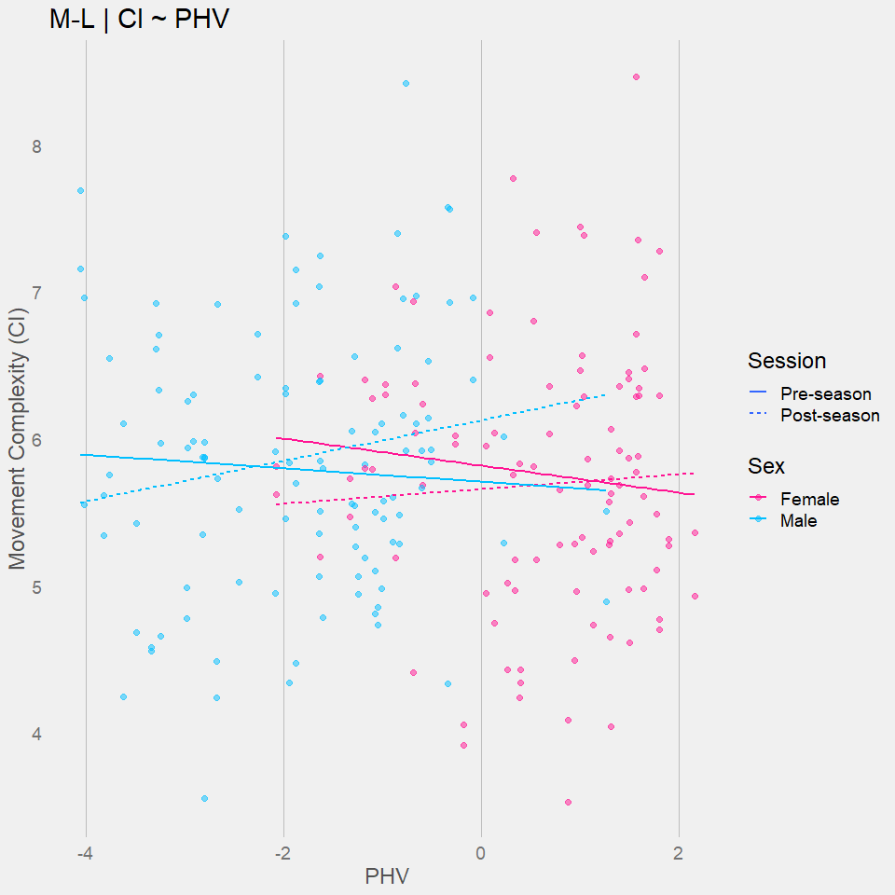

### Peaks ----

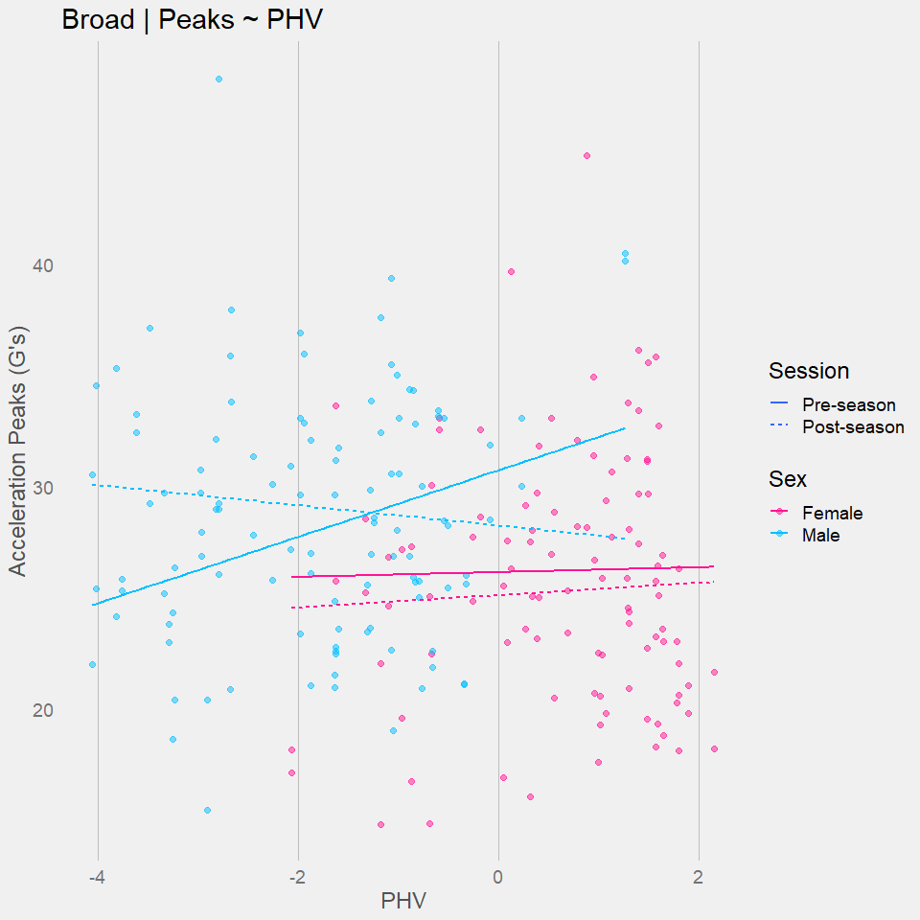

### Integrals ----

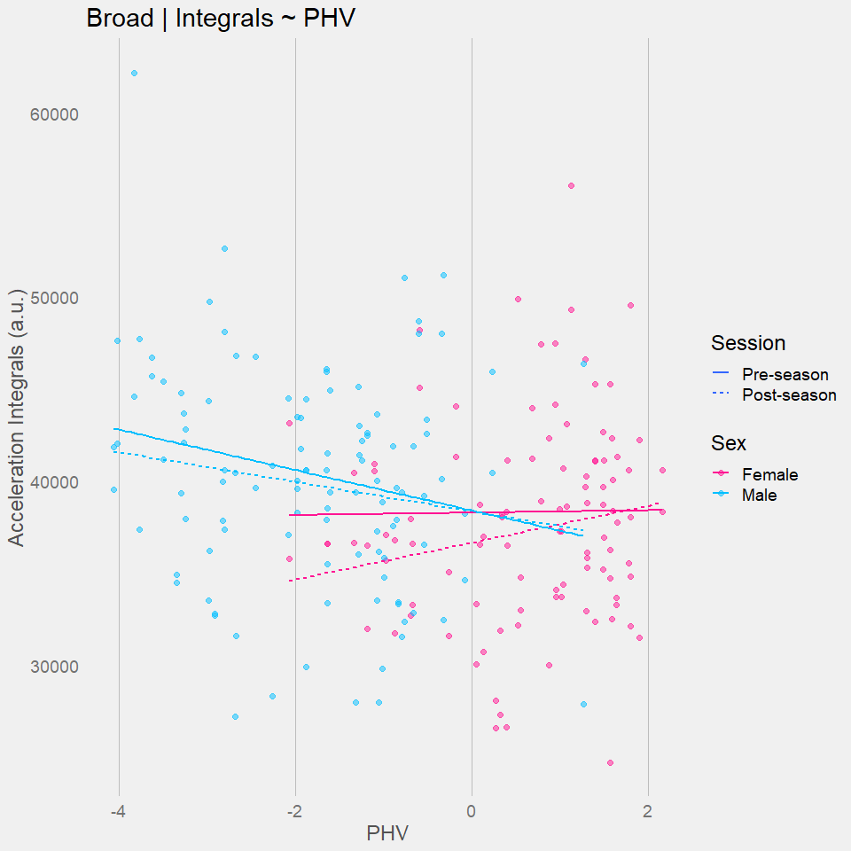

## M-R ----  
### Peaks ----

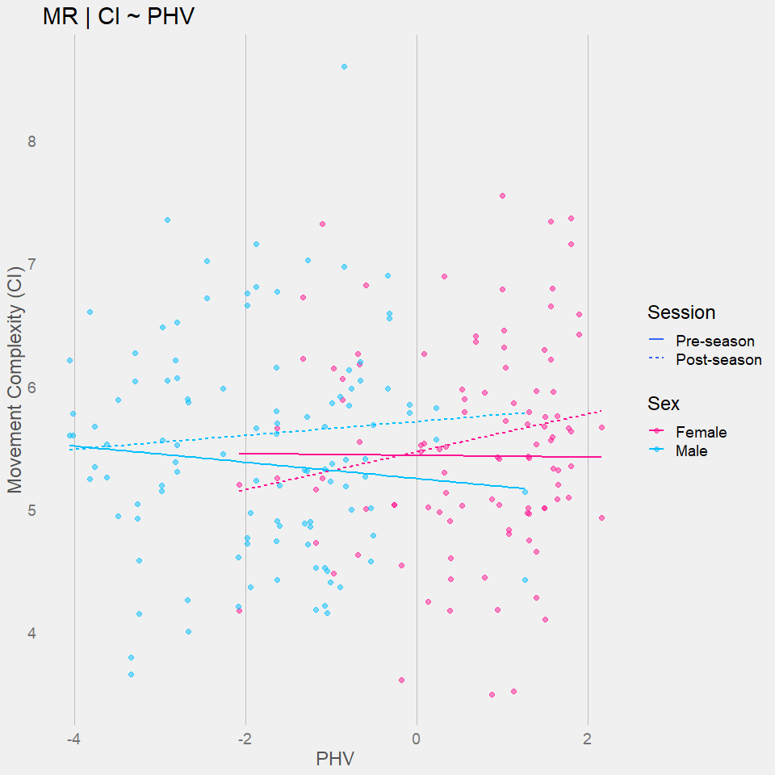

### Peaks ----

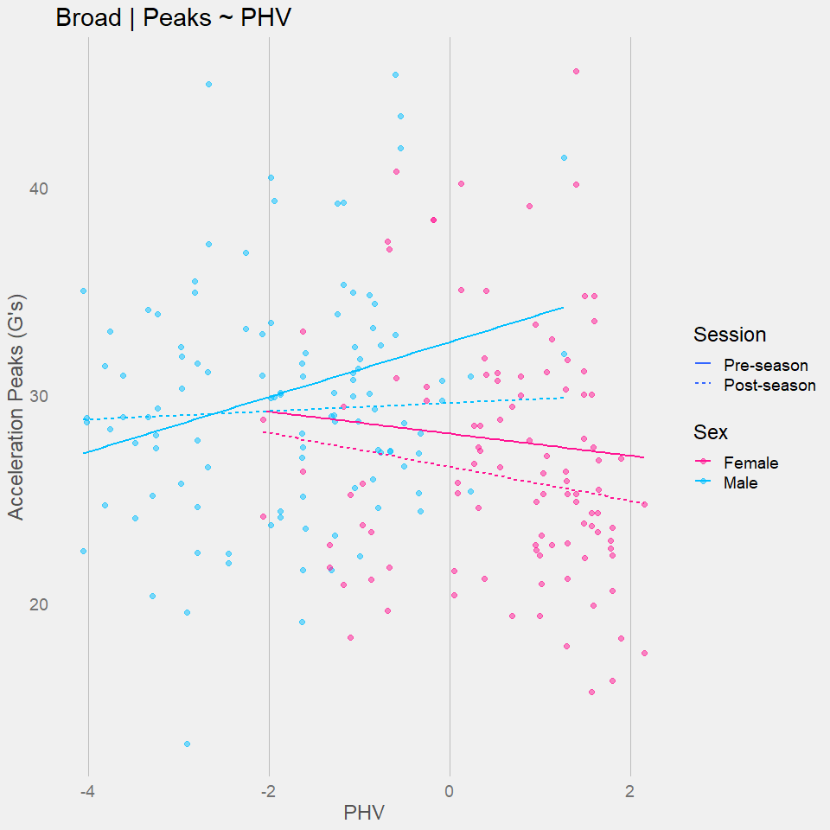

### Integrals ----

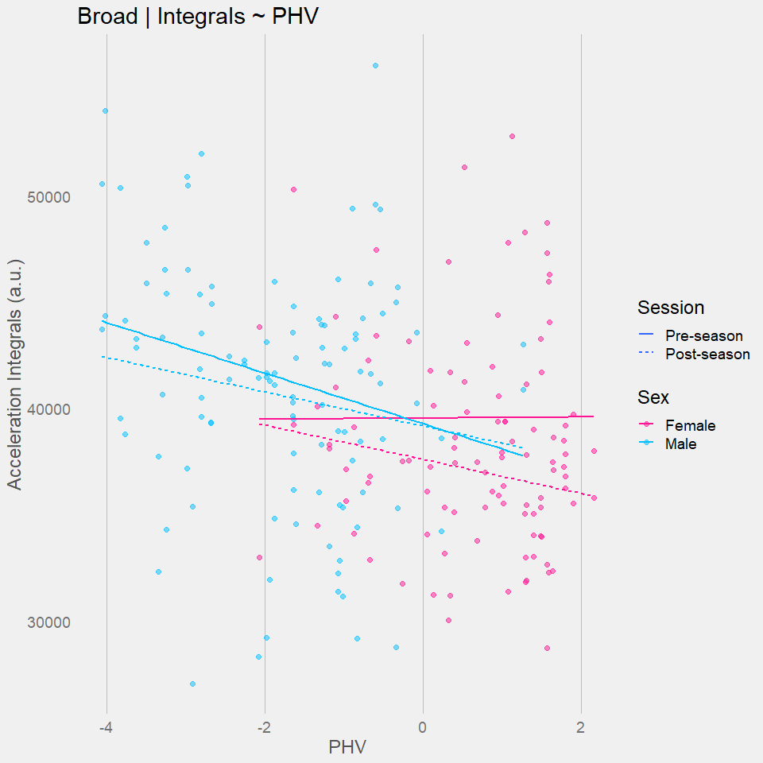

## DNB ----  
### CI ----

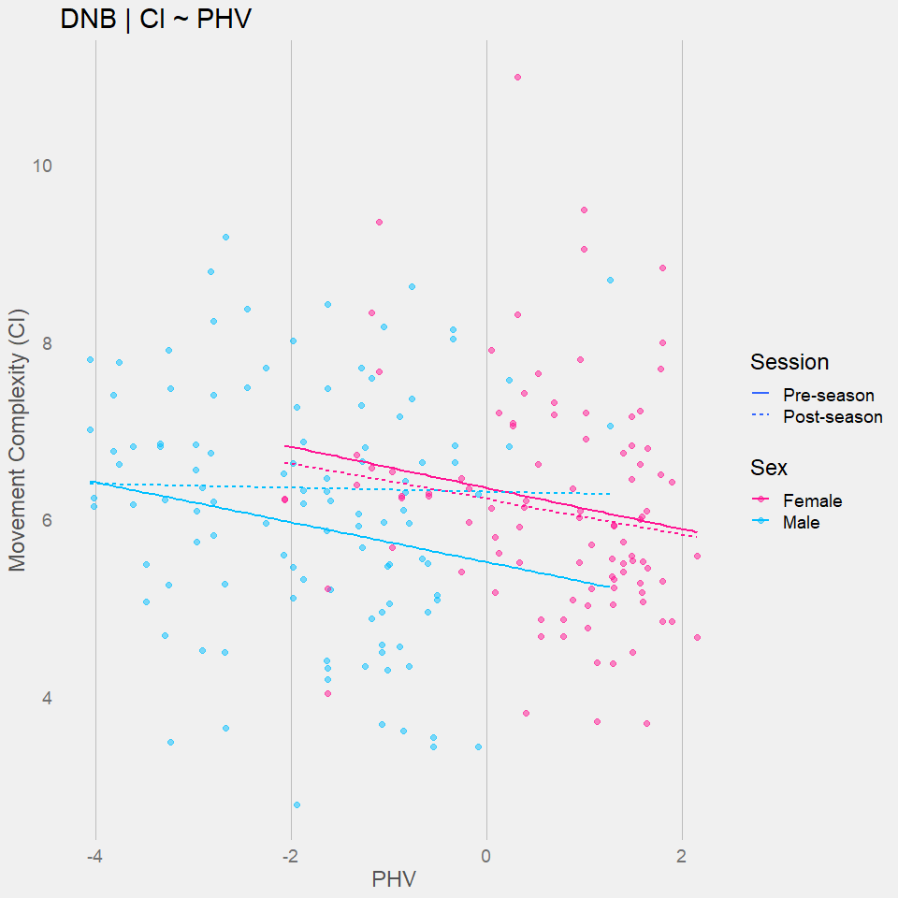

### Peaks ----

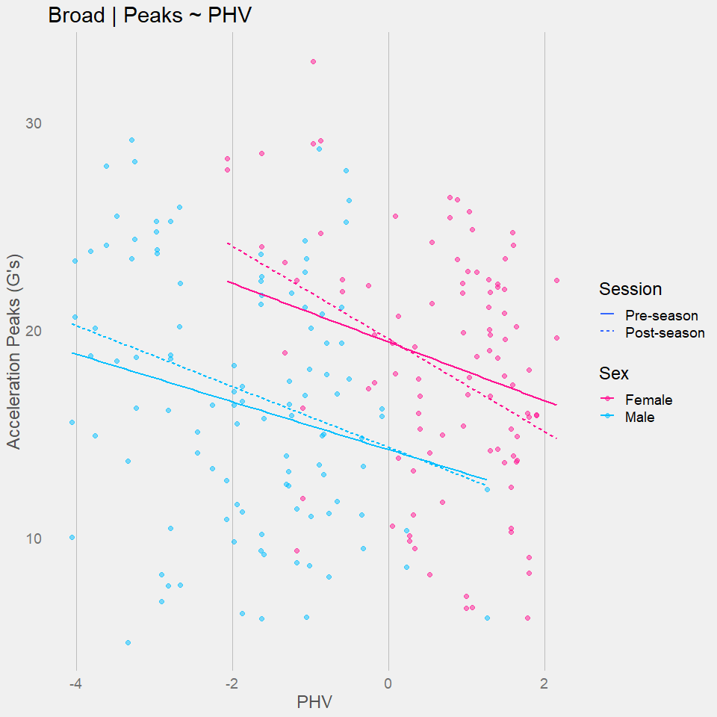

### Integrals ----

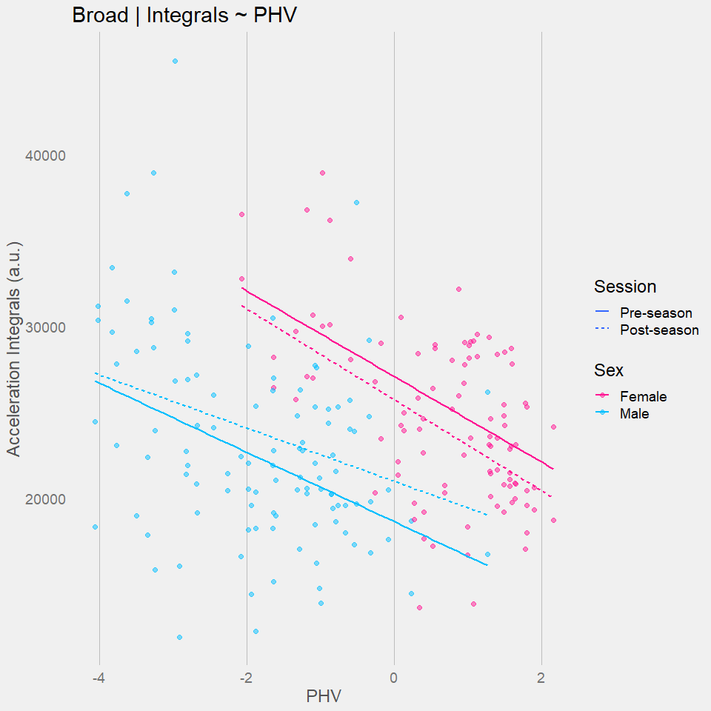

# Visualize ~ AGE-----  
## 40yd----  
### CI ----

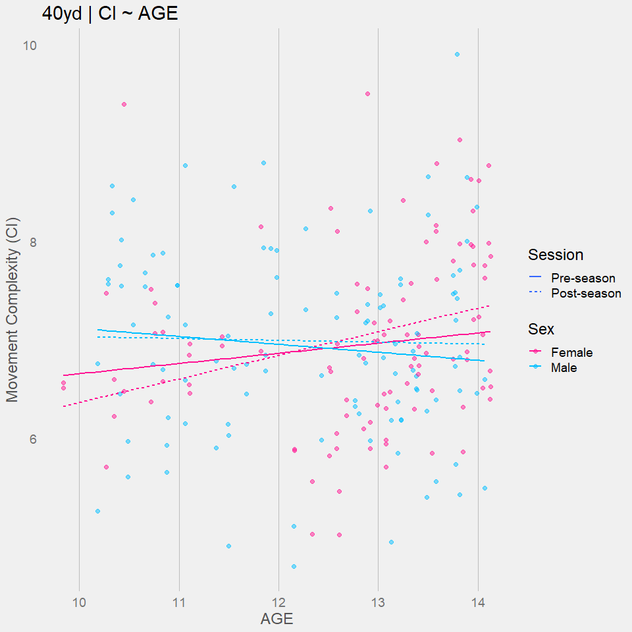

### Peaks ----

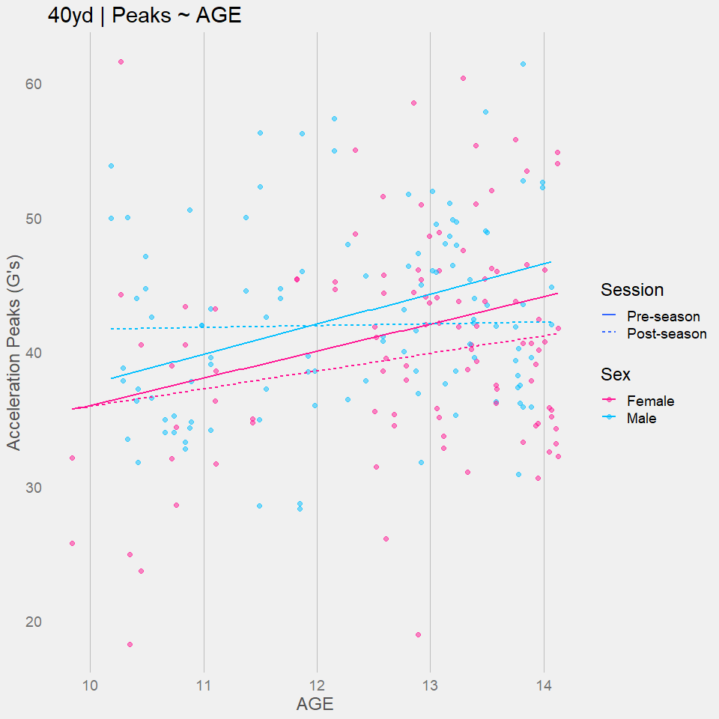

### Integrals ----

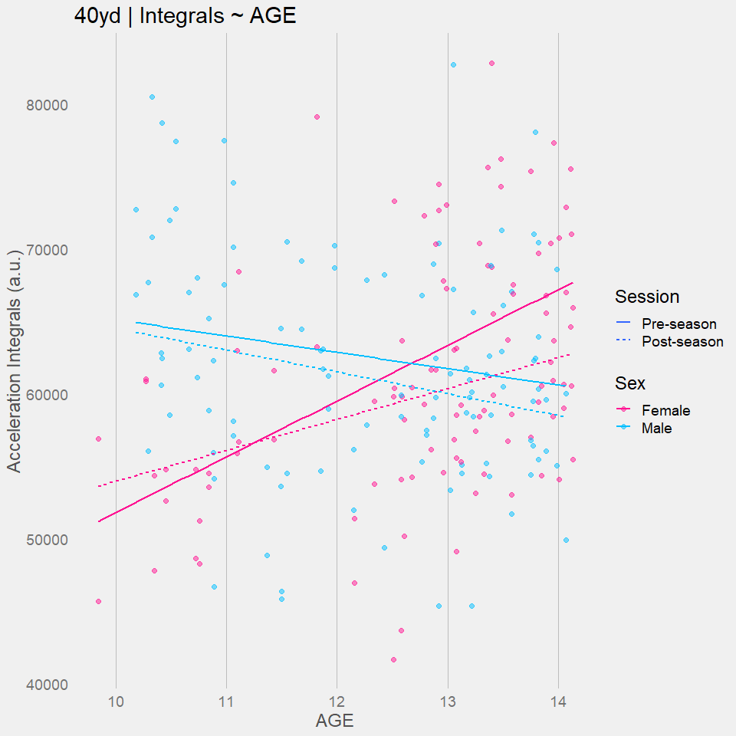

## 5-10-5----  
### CI ----

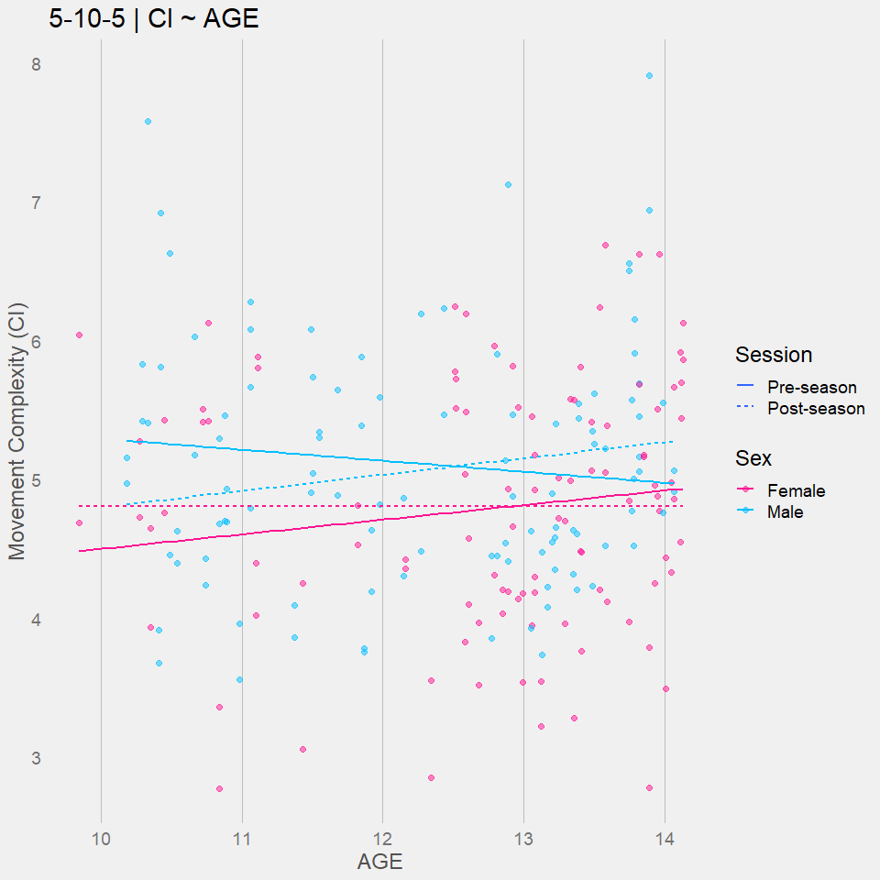

### Peaks ----  
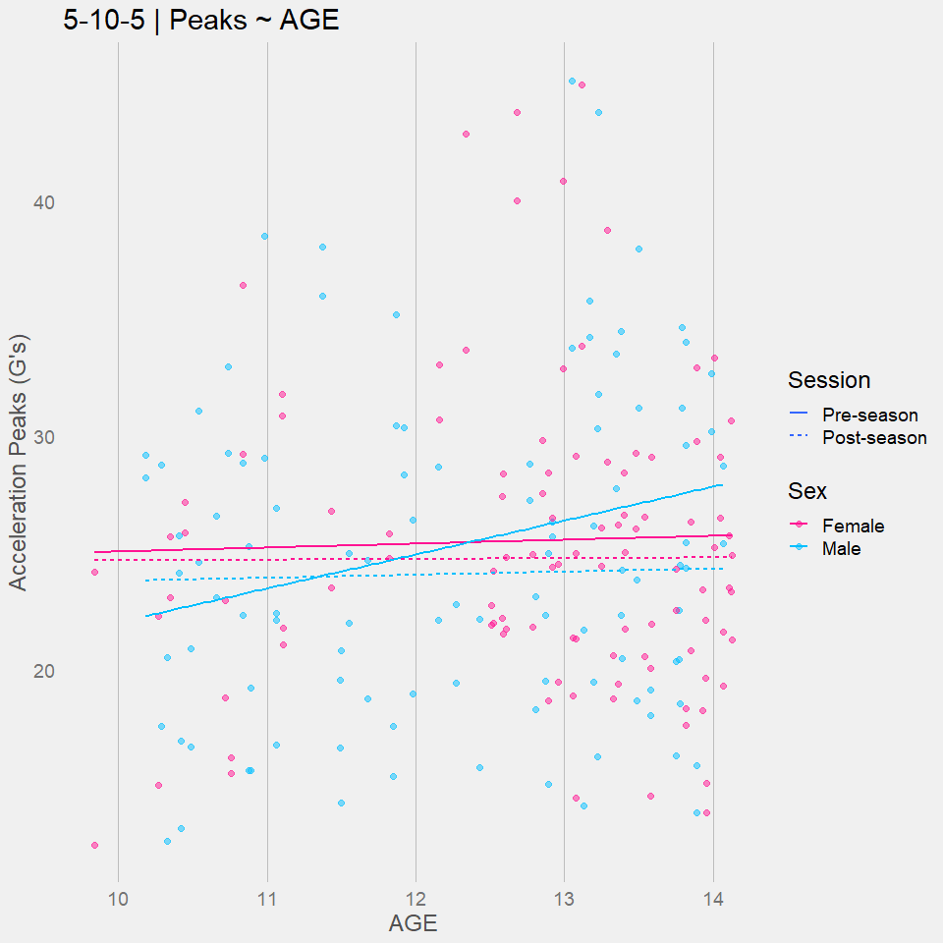

### Integrals ----  
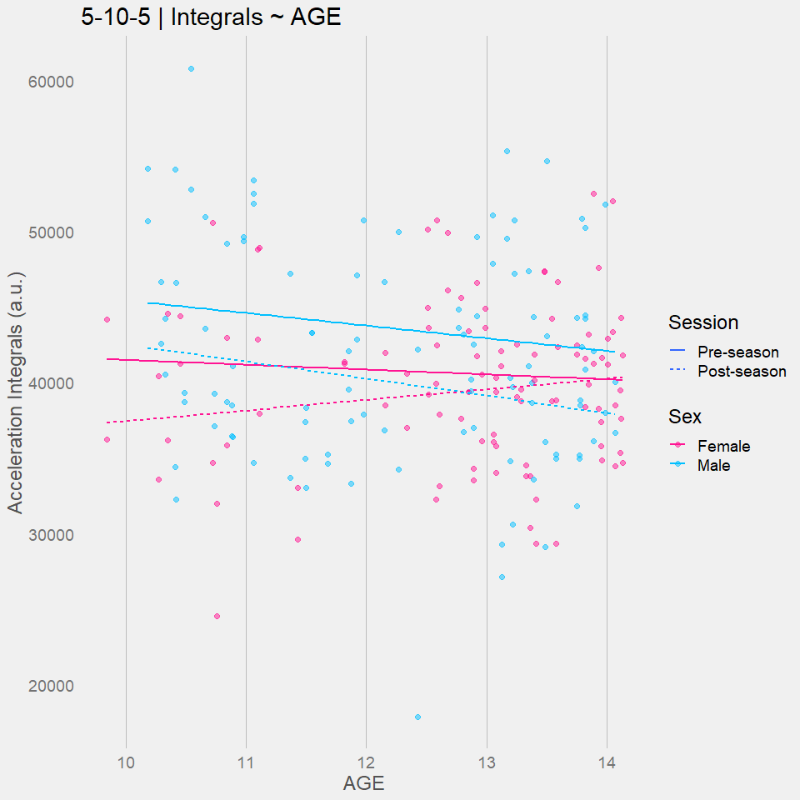

## Broad ----  
### CI ----  
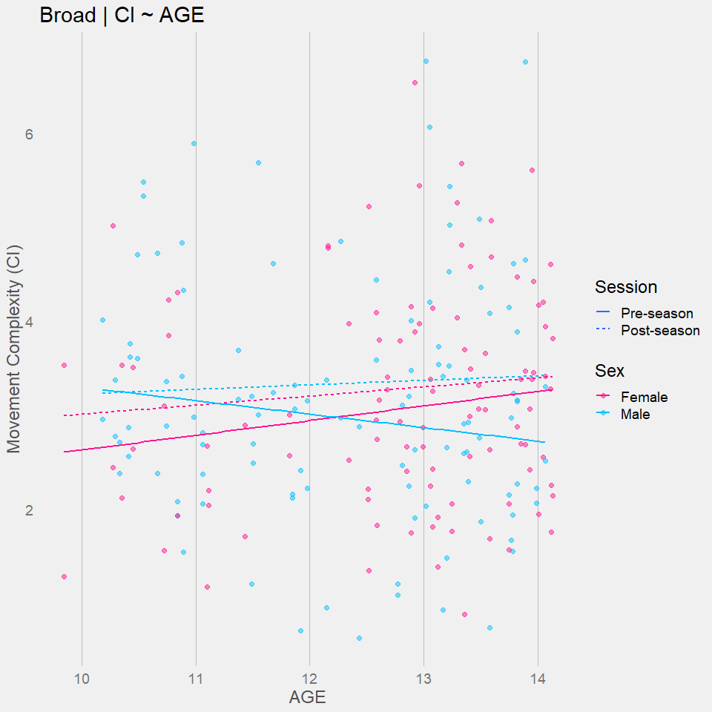

### Peaks ----

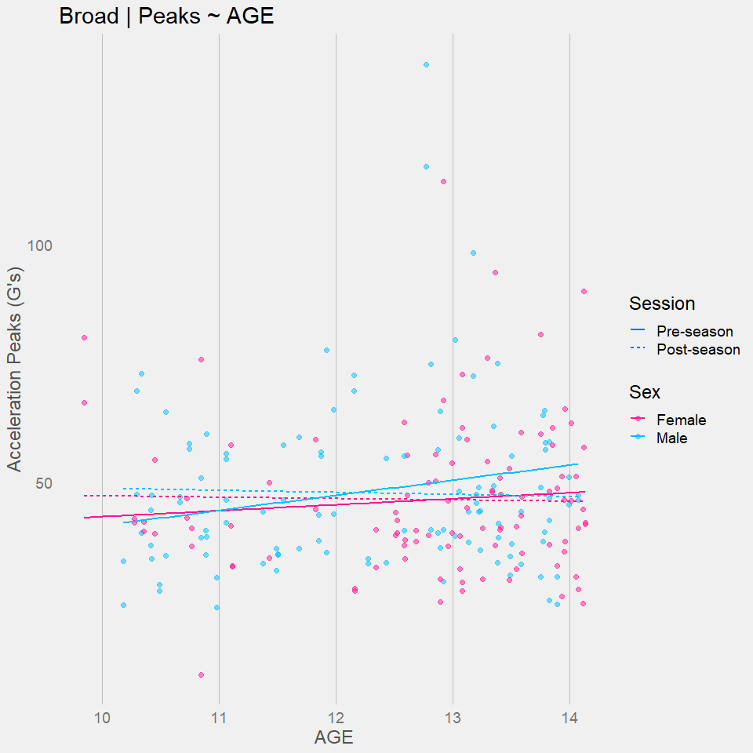

### Integrals ----

## M-L ----  
### CI ----  
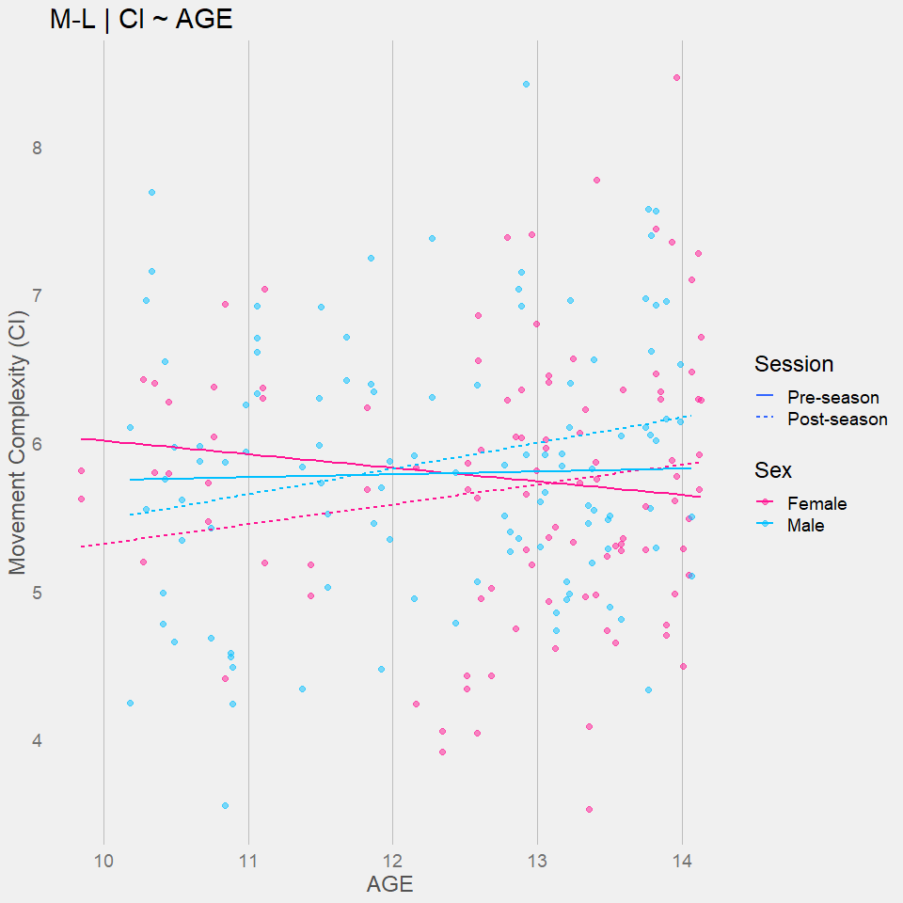

### Peaks ----  
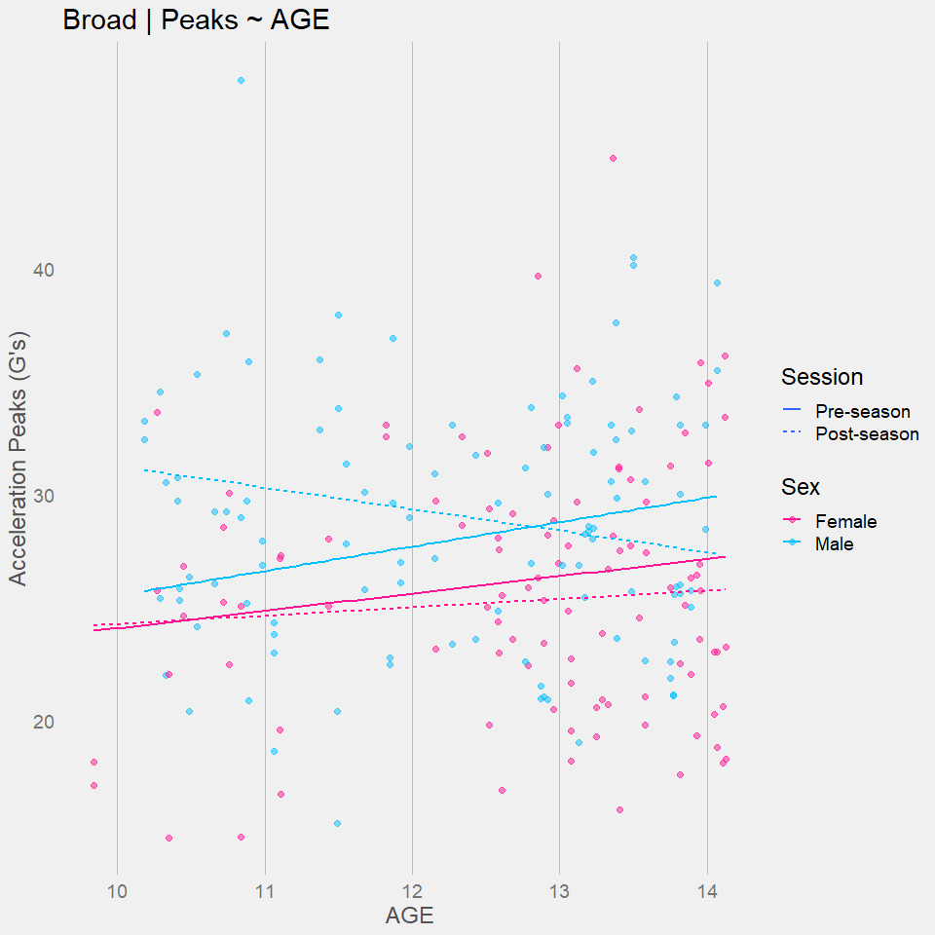

### Integrals ----  
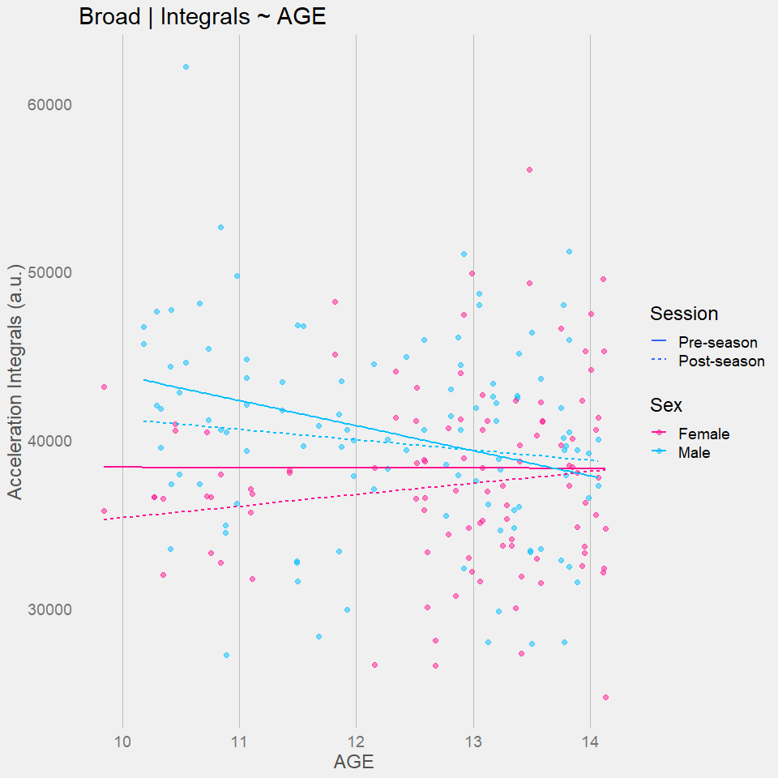

## M-R ----  
### CI ----  
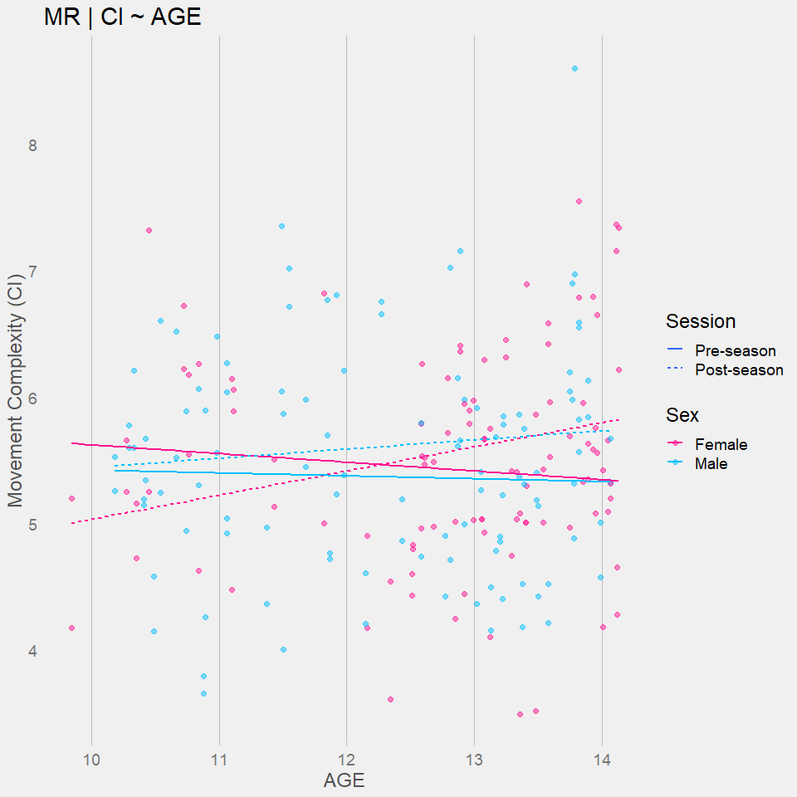

### Peaks ----  
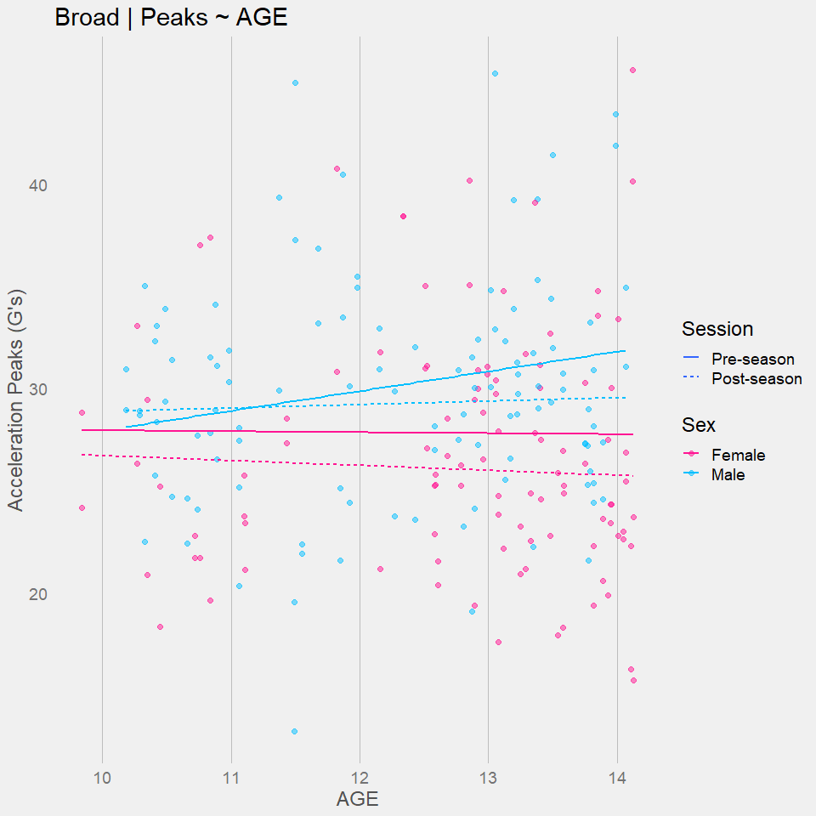

### Integrals ----  
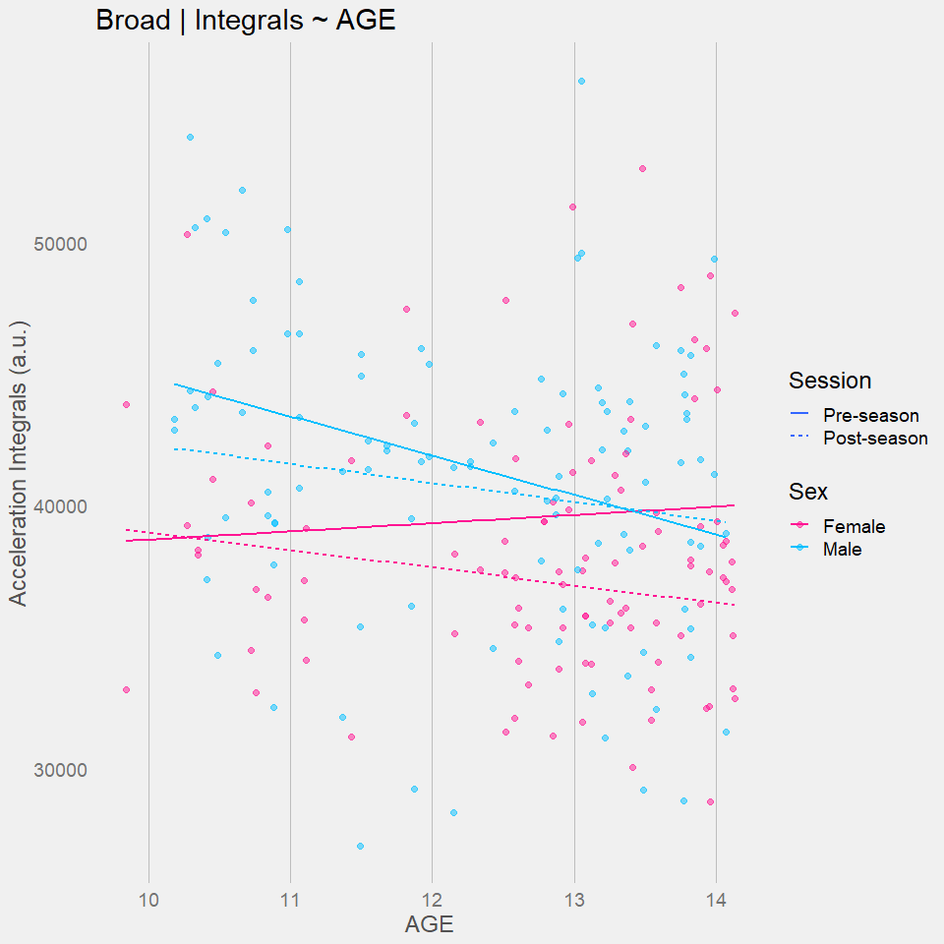

## DNB ----  
### CI ----  
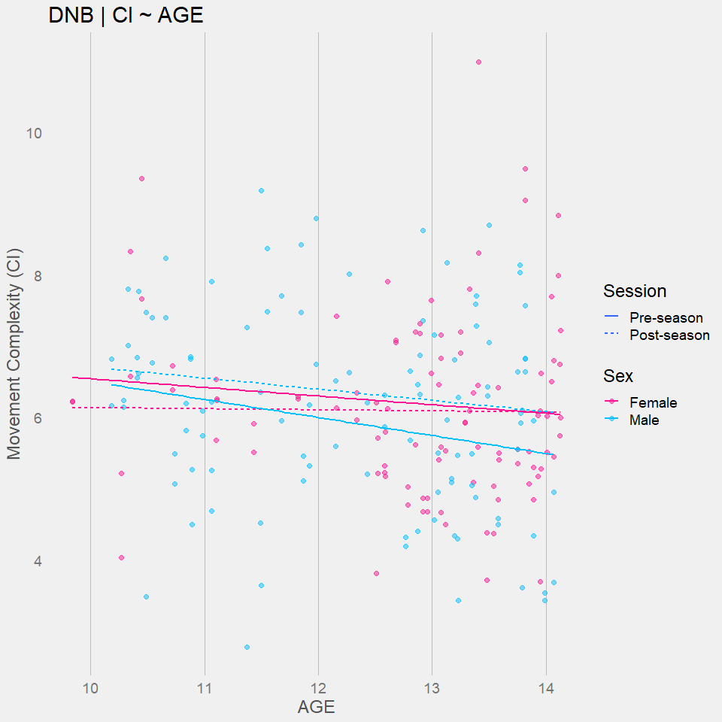

### Peaks ----  
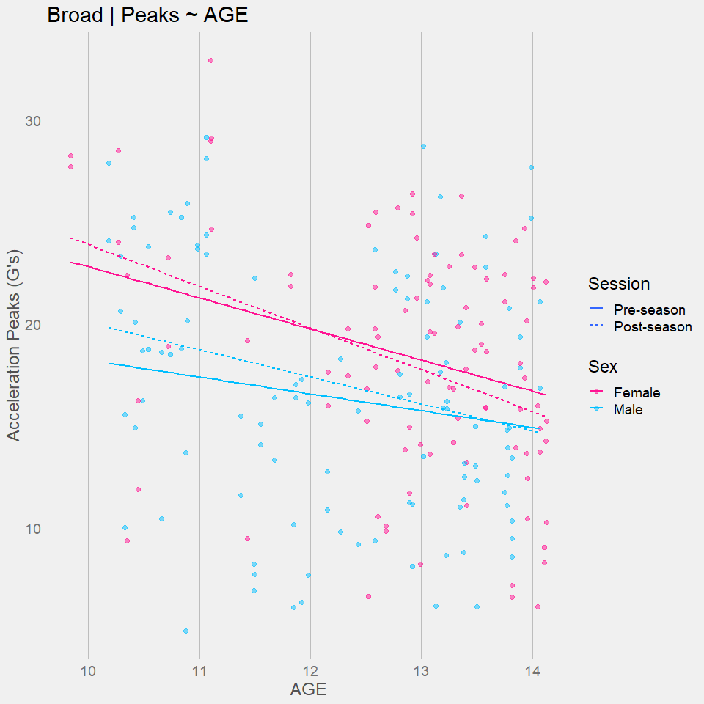

### Integrals ----  
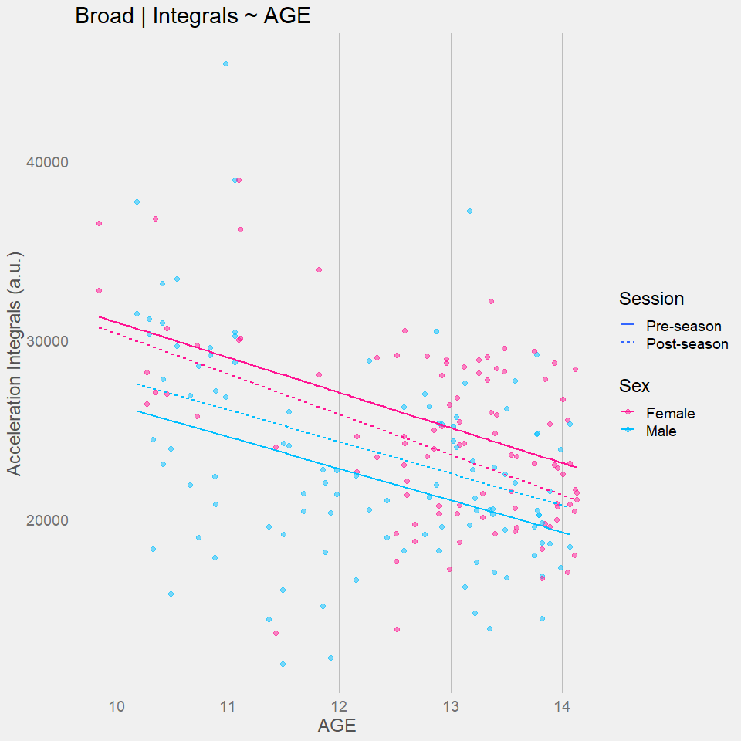

# MR MODELS ----  
## CI ~ PHV + SEX + SESSION ----  
## 40yd ----  
MR.CI.40YD <- lm(CI ~ PHV + SEX + SESSION, data = df_40yd)  
estimates(MR.CI.40YD)

## Model R squared:  
## 0.005 (-0.01, 0.03)  
##   
## Semi-Partial R squared:  
## PHV SEX SESSION   
## 0.003 0.001 0.001   
##   
## Estimates for Factors:  
## variables levels estimate lower upper  
## 1 SEX Female 6.88 6.61 7.15  
## 2 Male 6.98 6.73 7.23  
## 3 SESSION Pre-season 6.98 6.73 7.23  
## 4 Post-season 7.05 6.8 7.3  
##   
##   
## Mean Differences:  
## variables comparison difference lower upper cohens.d  
## 1 SEX Male-Female 0.10 -0.26 0.46 0.11  
## 2 SESSION Post-season-Pre-season 0.07 -0.29 0.43 0.08  
##   
##   
## Estimates for Numeric Variables =   
## variables estimate lower upper std.estimate std.lower std.upper  
## 1 (Intercept) 6.92 6.69 7.15 0.00 0.00 0.00  
## 2 PHV 0.05 -0.06 0.16 0.09 -0.11 0.29

check_model(MR.CI.40YD)

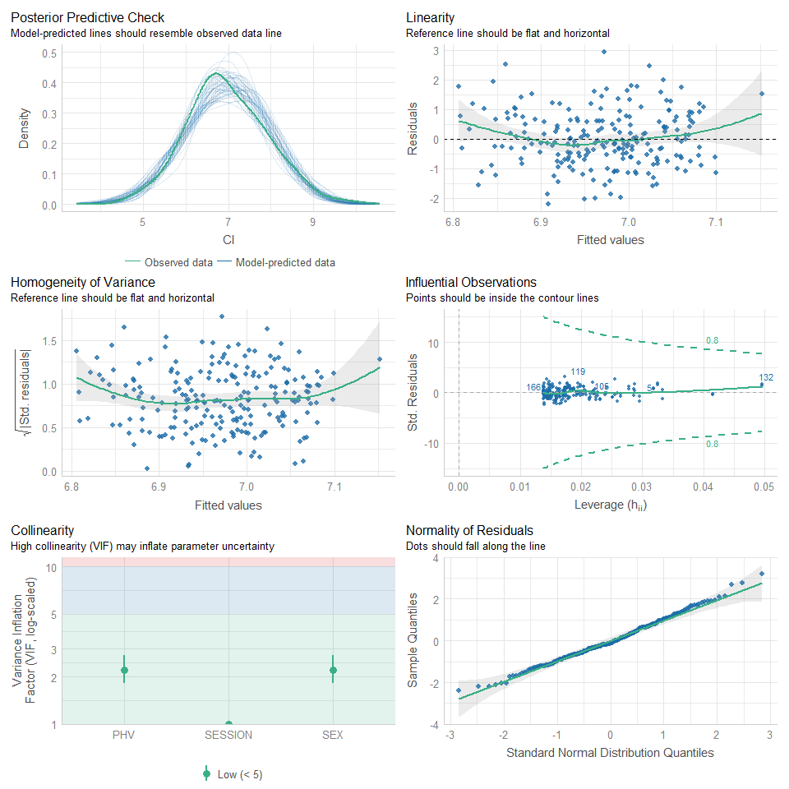

MR.Peaks.40YD <- lm(Peaks ~ PHV + SEX + SESSION, data = df_40yd)  
estimates(MR.Peaks.40YD)

## Model R squared:  
## 0.069 (0, 0.13)  
##   
## Semi-Partial R squared:  
## PHV SEX SESSION   
## 0.004 0.057 0.008   
##   
## Estimates for Factors:  
## variables levels estimate lower upper  
## 1 SEX Female 39.32 37.2 41.44  
## 2 Male 44.75 42.75 46.75  
## 3 SESSION Pre-season 44.75 42.75 46.75  
## 4 Post-season 43.38 41.38 45.38  
##   
##   
## Mean Differences:  
## variables comparison difference lower upper cohens.d  
## 1 SEX Male-Female 5.43 2.59 8.27 0.73  
## 2 SESSION Post-season-Pre-season -1.37 -4.20 1.47 -0.18  
##   
##   
## Estimates for Numeric Variables =   
## variables estimate lower upper std.estimate std.lower std.upper  
## 1 (Intercept) 40.36 38.53 42.19 0.00 0.00 0.00  
## 2 PHV 1.50 0.61 2.40 0.33 0.13 0.52

check_model(MR.Peaks.40YD)

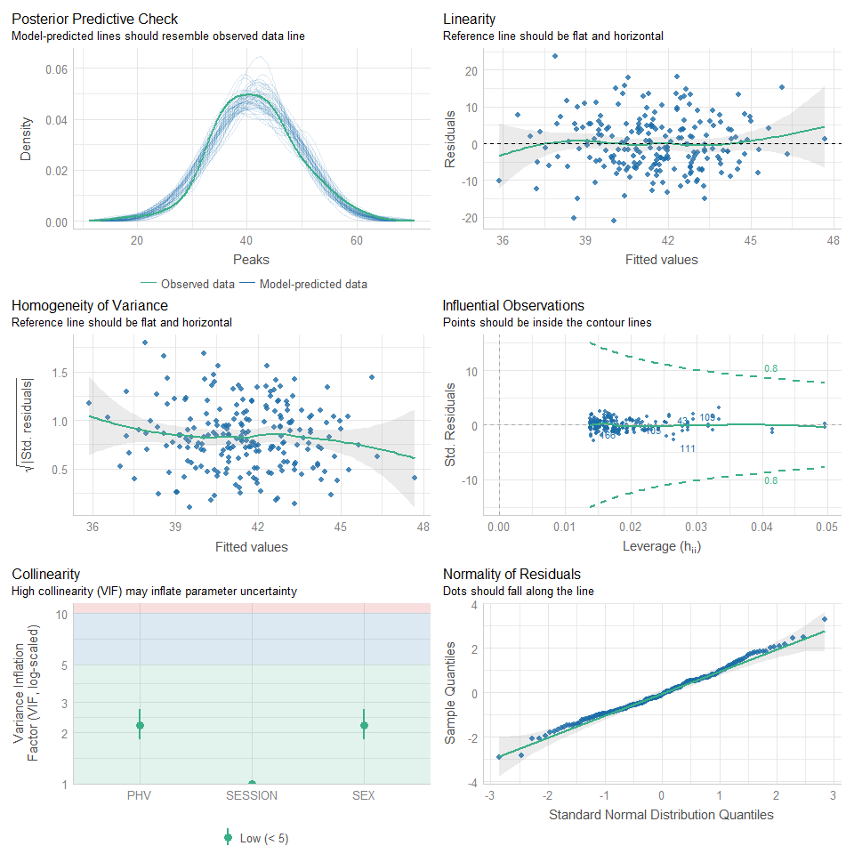

MR.Integral.40YD <- lm(Integral ~ PHV + SEX + SESSION, data = df_40yd)  
estimates(MR.Integral.40YD)

## Model R squared:  
## 0.018 (-0.02, 0.05)  
##   
## Semi-Partial R squared:  
## PHV SEX SESSION   
## 0.000 0.002 0.016   
##   
## Estimates for Factors:  
## variables levels estimate lower upper  
## 1 SEX Female 61891.2 59606.45 64175.95  
## 2 Male 63077.53 60918.1 65236.96  
## 3 SESSION Pre-season 63077.53 60918.1 65236.96  
## 4 Post-season 61058.13 58898.7 63217.55  
##   
##   
## Mean Differences:  
## variables comparison difference lower upper cohens.d  
## 1 SEX Male-Female 1186.33 -1878.84 4251.50 0.15  
## 2 SESSION Post-season-Pre-season -2019.41 -5083.37 1044.56 -0.25  
##   
##   
## Estimates for Numeric Variables =   
## variables estimate lower upper std.estimate std.lower std.upper  
## 1 (Intercept) 62050.01 60071.88 64028.15 0.00 0.00 0.00  
## 2 PHV 230.16 -733.89 1194.21 0.05 -0.15 0.25

check_model(MR.Integral.40YD)

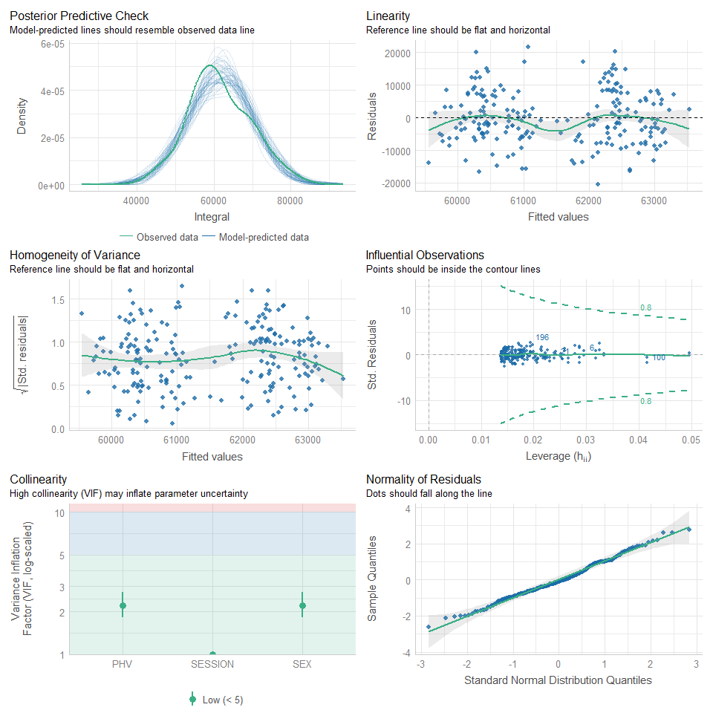

## 5-10-5 ----  
MR.CI.FTF <- lm(CI ~ PHV + SEX + SESSION, data = df_FTF)  
estimates(MR.CI.FTF)

## Model R squared:  
## 0.026 (-0.02, 0.07)  
##   
## Semi-Partial R squared:  
## PHV SEX SESSION   
## 0.014 0.013 0.000   
##   
## Estimates for Factors:  
## variables levels estimate lower upper  
## 1 SEX Female 4.8 4.55 5.05  
## 2 Male 5.1 4.86 5.35  
## 3 SESSION Pre-season 5.1 4.86 5.35  
## 4 Post-season 5.09 4.84 5.33  
##   
##   
## Mean Differences:  
## variables comparison difference lower upper cohens.d  
## 1 SEX Male-Female 0.30 -0.04 0.64 0.34  
## 2 SESSION Post-season-Pre-season -0.02 -0.36 0.33 -0.02  
##   
##   
## Estimates for Numeric Variables =   
## variables estimate lower upper std.estimate std.lower std.upper  
## 1 (Intercept) 4.81 4.59 5.02 0.00 0.00 0.00  
## 2 PHV 0.00 -0.10 0.11 0.01 -0.19 0.21

check_model(MR.CI.FTF)

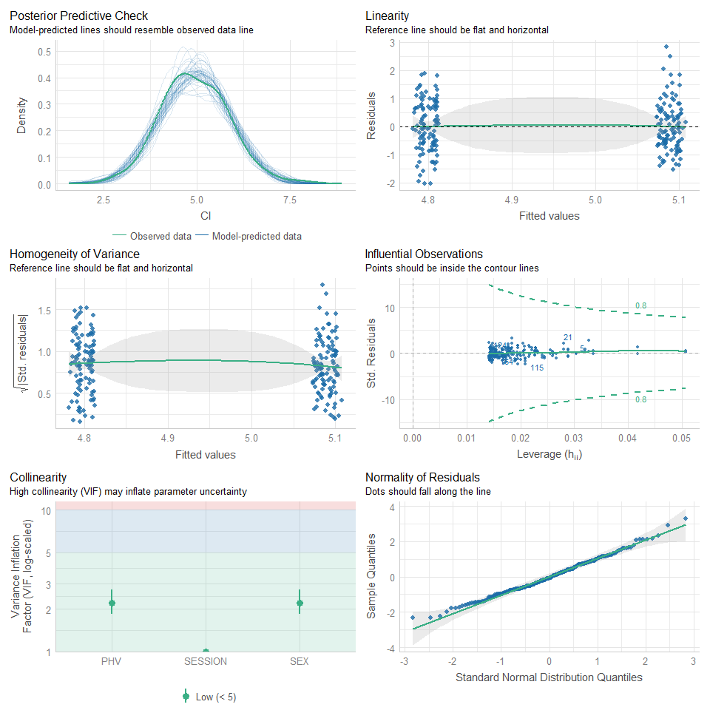

MR.Peaks.FTF <- lm(Peaks ~ PHV + SEX + SESSION, data = df_FTF)  
estimates(MR.Peaks.FTF)

## Model R squared:  
## 0.034 (-0.01, 0.08)  
##   
## Semi-Partial R squared:  
## PHV SEX SESSION   
## 0.018 0.010 0.006   
##   
## Estimates for Factors:  
## variables levels estimate lower upper  
## 1 SEX Female 24.36 22.49 26.24  
## 2 Male 26.34 24.53 28.15  
## 3 SESSION Pre-season 26.34 24.53 28.15  
## 4 Post-season 25.35 23.54 27.15  
##   
##   
## Mean Differences:  
## variables comparison difference lower upper cohens.d  
## 1 SEX Male-Female 1.98 -0.56 4.52 0.30  
## 2 SESSION Post-season-Pre-season -1.00 -3.53 1.54 -0.15  
##   
##   
## Estimates for Numeric Variables =   
## variables estimate lower upper std.estimate std.lower std.upper  
## 1 (Intercept) 25.02 23.39 26.64 0.00 0.00 0.00  
## 2 PHV 0.97 0.18 1.77 0.24 0.05 0.44

check_model(MR.Peaks.FTF)

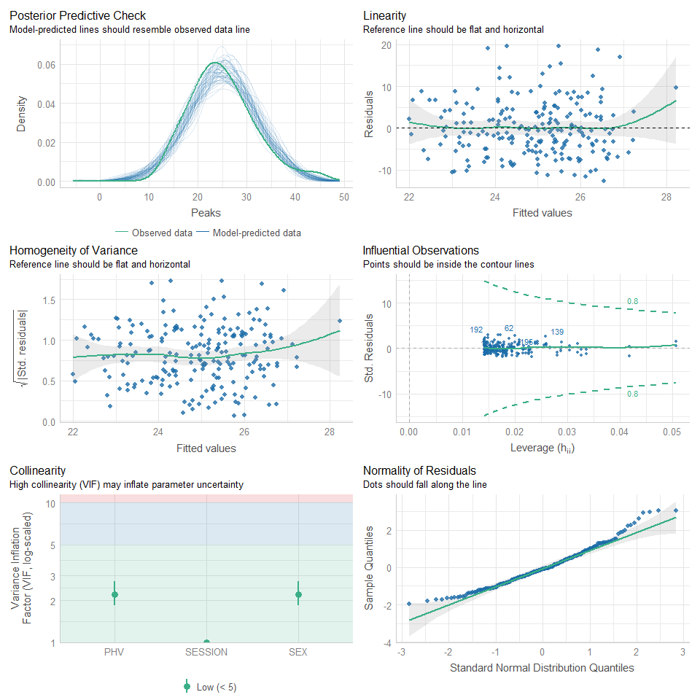

MR.Integral.FTF <- lm(Integral ~ PHV + SEX + SESSION, data = df_FTF)  
estimates(MR.Integral.FTF)

## Model R squared:  
## 0.056 (0, 0.12)  
##   
## Semi-Partial R squared:  
## PHV SEX SESSION   
## 0.017 0.003 0.035   
##   
## Estimates for Factors:  
## variables levels estimate lower upper  
## 1 SEX Female 41547.43 39763.45 43331.41  
## 2 Male 42653.73 40928.05 44379.41  
## 3 SESSION Pre-season 42653.73 40928.05 44379.41  
## 4 Post-season 40240.43 38514.75 41966.1  
##   
##   
## Mean Differences:  
## variables comparison difference lower upper cohens.d  
## 1 SEX Male-Female 1106.3 -1312.55 3525.14 0.18  
## 2 SESSION Post-season-Pre-season -2413.3 -4832.04 5.43 -0.38  
##   
##   
## Estimates for Numeric Variables =   
## variables estimate lower upper std.estimate std.lower std.upper  
## 1 (Intercept) 41373.25 39821.66 42924.85 0.00 0.00 0.00  
## 2 PHV -259.97 -1016.40 496.46 -0.07 -0.26 0.13

check_model(MR.Integral.FTF)

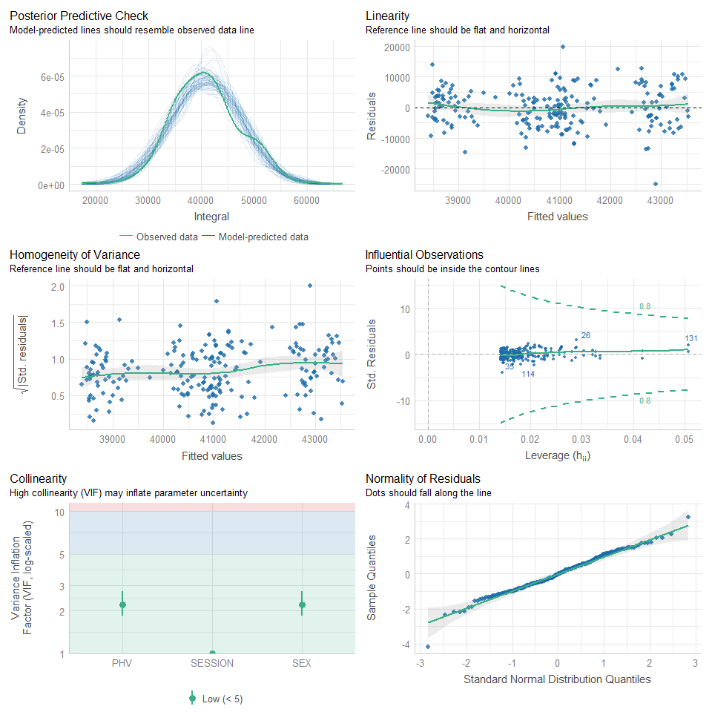

## Broad ----  
MR.CI.BROAD <- lm(CI ~ PHV + SEX + SESSION, data = df_BROAD)  
estimates(MR.CI.BROAD)

## Model R squared:  
## 0.017 (-0.02, 0.05)  
##   
## Semi-Partial R squared:  
## PHV SEX SESSION   
## 0.001 0.001 0.015   
##   
## Estimates for Factors:  
## variables levels estimate lower upper  
## 1 SEX Female 2.96 2.61 3.3  
## 2 Male 3.07 2.74 3.39  
## 3 SESSION Pre-season 3.07 2.74 3.39  
## 4 Post-season 3.36 3.03 3.68  
##   
##   
## Mean Differences:  
## variables comparison difference lower upper cohens.d  
## 1 SEX Male-Female 0.11 -0.35 0.57 0.09  
## 2 SESSION Post-season-Pre-season 0.29 -0.17 0.75 0.24  
##   
##   
## Estimates for Numeric Variables =   
## variables estimate lower upper std.estimate std.lower std.upper  
## 1 (Intercept) 2.99 2.70 3.29 0.00 0.00 0.00  
## 2 PHV 0.05 -0.09 0.20 0.07 -0.13 0.27

check_model(MR.CI.BROAD)

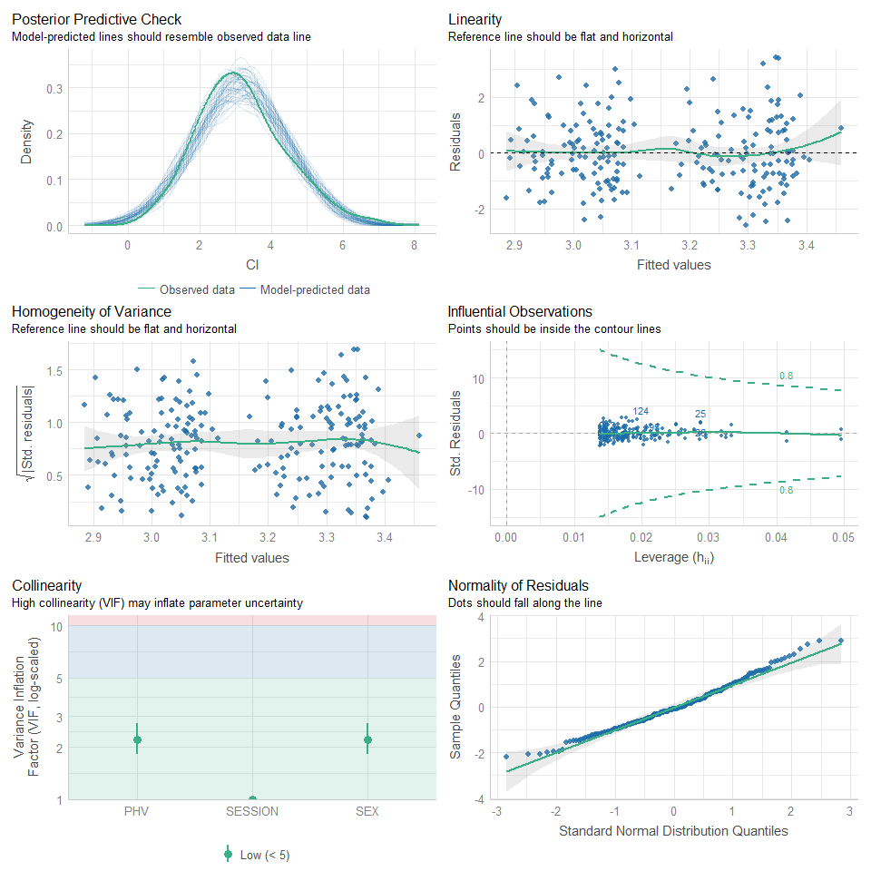

MR.Peaks.BROAD <- lm(Peaks ~ PHV + SEX + SESSION, data = df_BROAD)  
estimates(MR.Peaks.BROAD)

## Model R squared:  
## 0.004 (-0.01, 0.02)  
##   
## Semi-Partial R squared:  
## PHV SEX SESSION   
## 0.000 0.004 0.000   
##   
## Estimates for Factors:  
## variables levels estimate lower upper  
## 1 SEX Female 45.61 40.78 50.44  
## 2 Male 48.7 44.13 53.27  
## 3 SESSION Pre-season 48.7 44.13 53.27  
## 4 Post-season 48.5 43.94 53.07  
##   
##   
## Mean Differences:  
## variables comparison difference lower upper cohens.d  
## 1 SEX Male-Female 3.09 -3.39 9.58 0.18  
## 2 SESSION Post-season-Pre-season -0.20 -6.68 6.29 -0.01  
##   
##   
## Estimates for Numeric Variables =   
## variables estimate lower upper std.estimate std.lower std.upper  
## 1 (Intercept) 46.01 41.82 50.19 0.00 0.00 0.00  
## 2 PHV 0.58 -1.46 2.62 0.06 -0.14 0.26

check_model(MR.Peaks.BROAD)

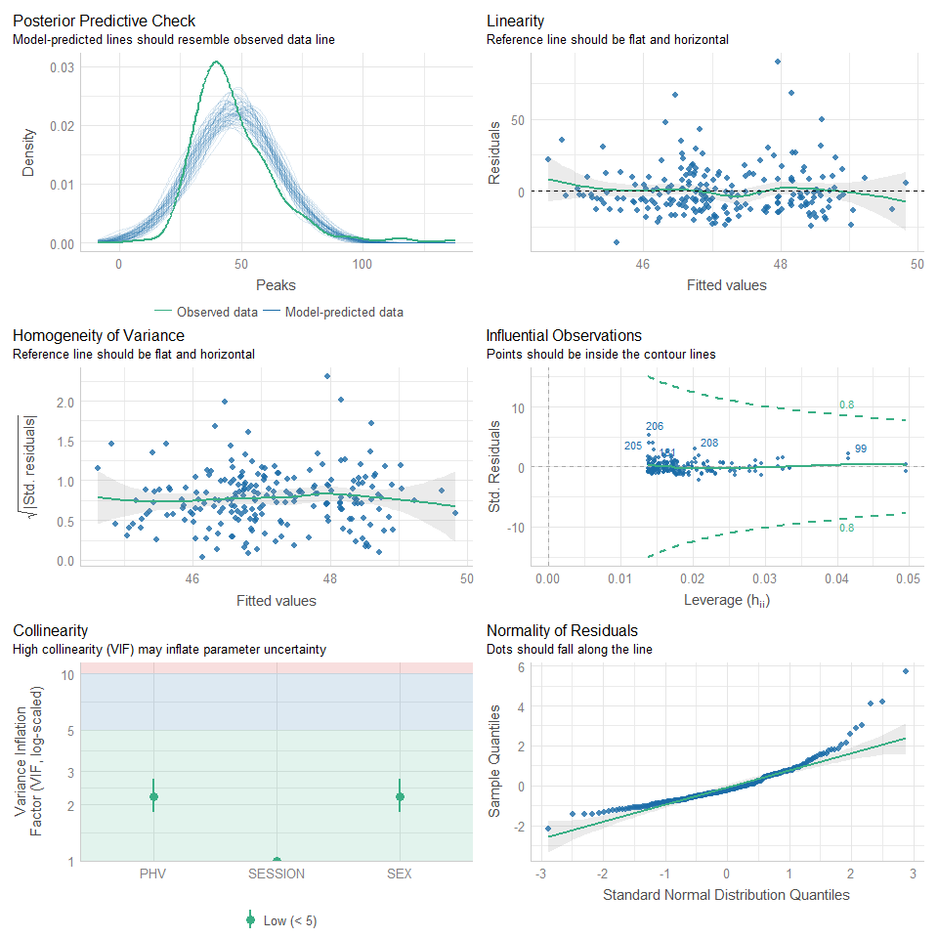

## M-L ----  
MR.CI.ML <- lm(CI ~ PHV + SEX + SESSION, data = df_ML)  
estimates(MR.CI.ML)

## Model R squared:  
## 0.004 (-0.01, 0.02)  
##   
## Semi-Partial R squared:  
## PHV SEX SESSION   
## 0.001 0.003 0.000   
##   
## Estimates for Factors:  
## variables levels estimate lower upper  
## 1 SEX Female 5.7 5.44 5.95  
## 2 Male 5.85 5.61 6.09  
## 3 SESSION Pre-season 5.85 5.61 6.09  
## 4 Post-season 5.86 5.62 6.1  
##   
##   
## Mean Differences:  
## variables comparison difference lower upper cohens.d  
## 1 SEX Male-Female 0.15 -0.19 0.50 0.17  
## 2 SESSION Post-season-Pre-season 0.01 -0.33 0.35 0.01  
##   
##   
## Estimates for Numeric Variables =   
## variables estimate lower upper std.estimate std.lower std.upper  
## 1 (Intercept) 5.71 5.49 5.93 0.00 0.00 0.00  
## 2 PHV 0.02 -0.09 0.13 0.03 -0.17 0.23

check_model(MR.CI.ML)

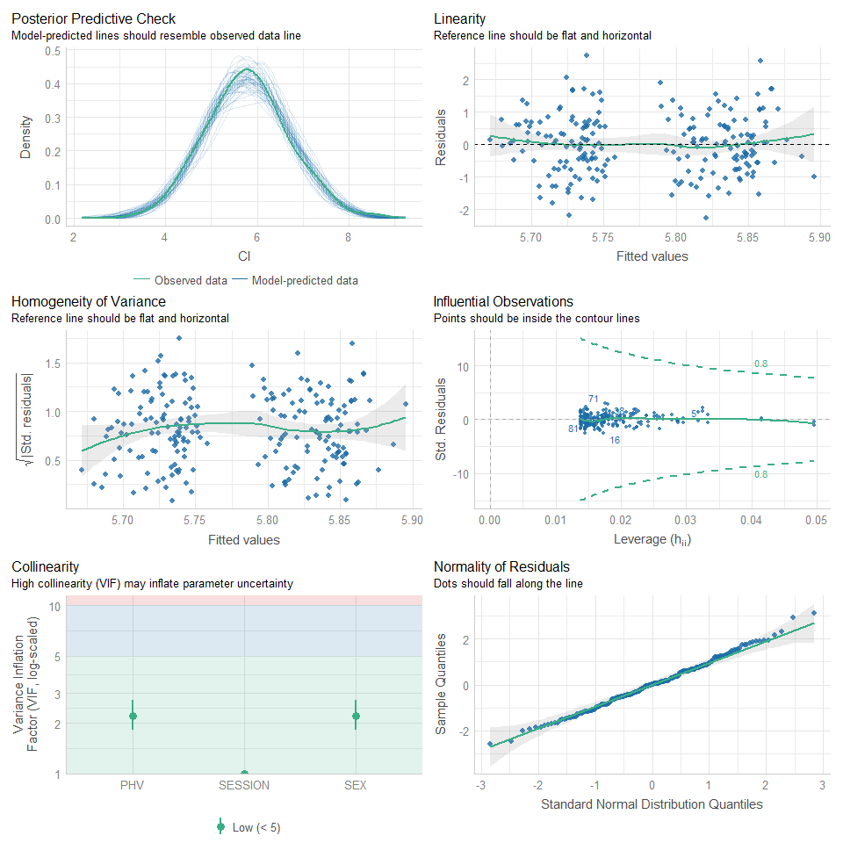

MR.Peaks.ML <- lm(Peaks ~ PHV + SEX + SESSION, data = df_ML)  
estimates(MR.Peaks.ML)

## Model R squared:  
## 0.065 (0, 0.13)  
##   
## Semi-Partial R squared:  
## PHV SEX SESSION   
## 0.017 0.049 0.000   
##   
## Estimates for Factors:  
## variables levels estimate lower upper  
## 1 SEX Female 25.19 23.6 26.77  
## 2 Male 28.92 27.42 30.42  
## 3 SESSION Pre-season 28.92 27.42 30.42  
## 4 Post-season 29.01 27.52 30.51  
##   
##   
## Mean Differences:  
## variables comparison difference lower upper cohens.d  
## 1 SEX Male-Female 3.73 1.61 5.86 0.67  
## 2 SESSION Post-season-Pre-season 0.09 -2.03 2.22 0.02  
##   
##   
## Estimates for Numeric Variables =   
## variables estimate lower upper std.estimate std.lower std.upper  
## 1 (Intercept) 25.45 24.08 26.82 0.00 0.00 0.00  
## 2 PHV 0.38 -0.28 1.05 0.11 -0.08 0.31

check_model(MR.Peaks.ML)

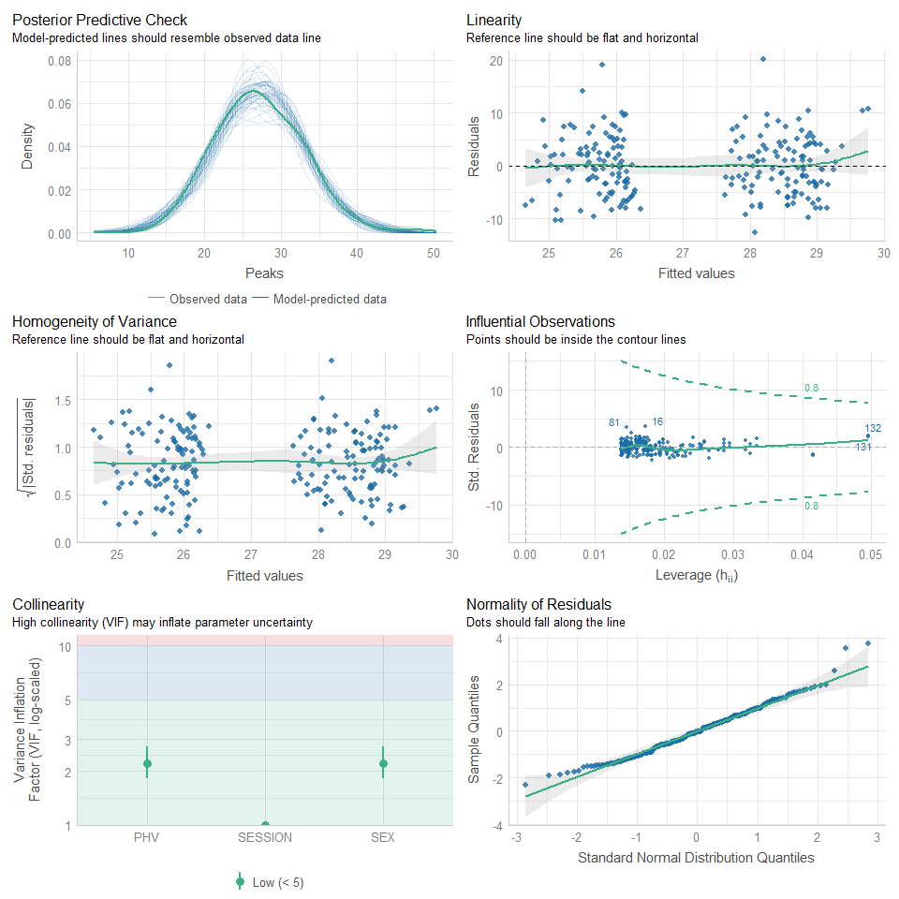

MR.Integral.ML <- lm(Integral ~ PHV + SEX + SESSION, data = df_ML)  
estimates(MR.Integral.ML)

## Model R squared:  
## 0.049 (-0.01, 0.1)  
##   
## Semi-Partial R squared:  
## PHV SEX SESSION   
## 0.037 0.007 0.005   
##   
## Estimates for Factors:  
## variables levels estimate lower upper  
## 1 SEX Female 38652.58 37025.12 40280.03  
## 2 Male 40146.11 38607.93 41684.3  
## 3 SESSION Pre-season 40146.11 38607.93 41684.3  
## 4 Post-season 39332.21 37794.02 40870.39  
##   
##   
## Mean Differences:  
## variables comparison difference lower upper cohens.d  
## 1 SEX Male-Female 1493.54 -689.82 3676.90 0.26  
## 2 SESSION Post-season-Pre-season -813.91 -2996.41 1368.59 -0.14  
##   
##   
## Estimates for Numeric Variables =   
## variables estimate lower upper std.estimate std.lower std.upper  
## 1 (Intercept) 38419.49 37010.45 39828.54 0.0 0.00 0.0  
## 2 PHV -337.80 -1024.50 348.90 -0.1 -0.29 0.1

check_model(MR.Integral.ML)

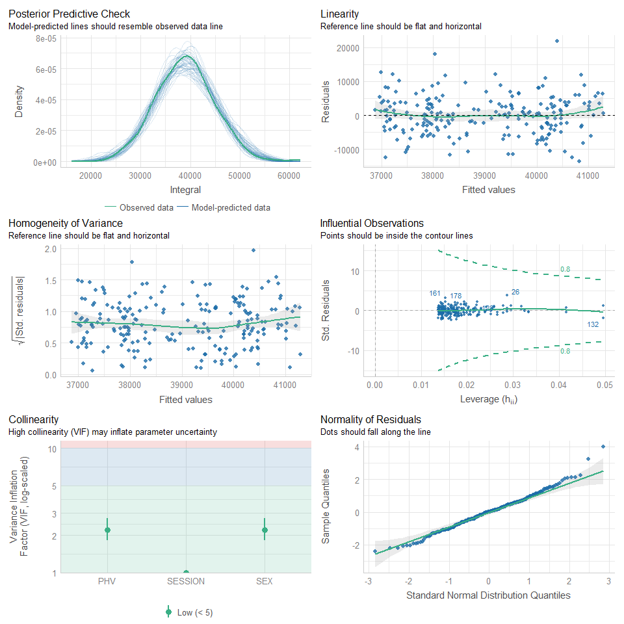

## M-R ----  
MR.CI.MR <- lm(CI ~ PHV + SEX + SESSION, data = df_MR)  
estimates(MR.CI.MR)

## Model R squared:  
## 0.013 (-0.02, 0.04)  
##   
## Semi-Partial R squared:  
## PHV SEX SESSION   
## 0.001 0.001 0.012   
##   
## Estimates for Factors:  
## variables levels estimate lower upper  
## 1 SEX Female 5.37 5.13 5.61  
## 2 Male 5.43 5.2 5.66  
## 3 SESSION Pre-season 5.43 5.2 5.66  
## 4 Post-season 5.61 5.38 5.84  
##   
##   
## Mean Differences:  
## variables comparison difference lower upper cohens.d  
## 1 SEX Male-Female 0.06 -0.27 0.39 0.07  
## 2 SESSION Post-season-Pre-season 0.19 -0.14 0.51 0.22  
##   
##   
## Estimates for Numeric Variables =   
## variables estimate lower upper std.estimate std.lower std.upper  
## 1 (Intercept) 5.39 5.18 5.60 0.00 0.00 0.00  
## 2 PHV 0.03 -0.07 0.13 0.05 -0.15 0.25

check_model(MR.CI.MR)

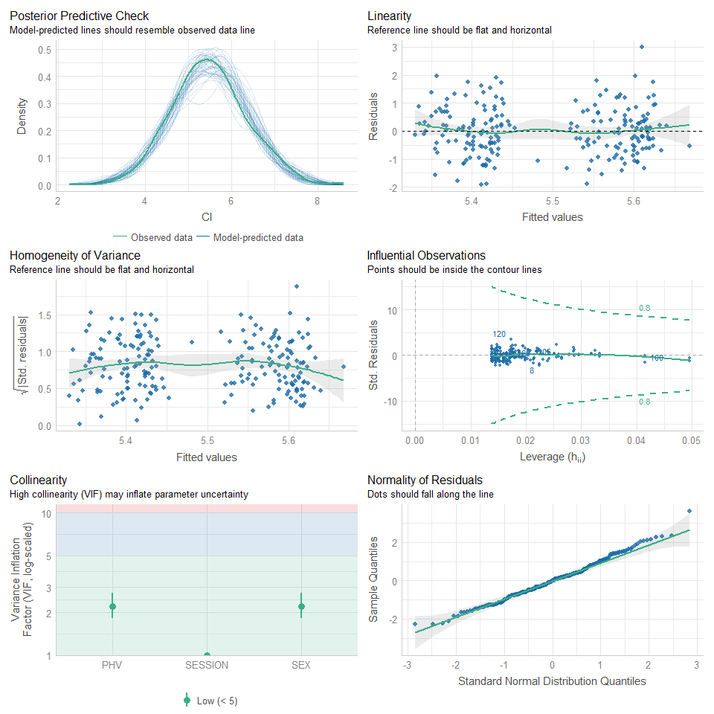

MR.Peaks.MR <- lm(Peaks ~ PHV + SEX + SESSION, data = df_MR)  
estimates(MR.Peaks.MR)

## Model R squared:  
## 0.07 (0, 0.13)  
##   
## Semi-Partial R squared:  
## PHV SEX SESSION   
## 0.023 0.033 0.013   
##   
## Estimates for Factors:  
## variables levels estimate lower upper  
## 1 SEX Female 27.38 25.76 29.01  
## 2 Male 30.57 29.03 32.1  
## 3 SESSION Pre-season 30.57 29.03 32.1  
## 4 Post-season 29.24 27.71 30.78  
##   
##   
## Mean Differences:  
## variables comparison difference lower upper cohens.d  
## 1 SEX Male-Female 3.18 1.01 5.36 0.56  
## 2 SESSION Post-season-Pre-season -1.32 -3.50 0.85 -0.23  
##   
##   
## Estimates for Numeric Variables =   
## variables estimate lower upper std.estimate std.lower std.upper  
## 1 (Intercept) 27.50 26.10 28.90 0.00 0.00 0.00  
## 2 PHV 0.17 -0.52 0.85 0.05 -0.15 0.24

check_model(MR.Peaks.MR)

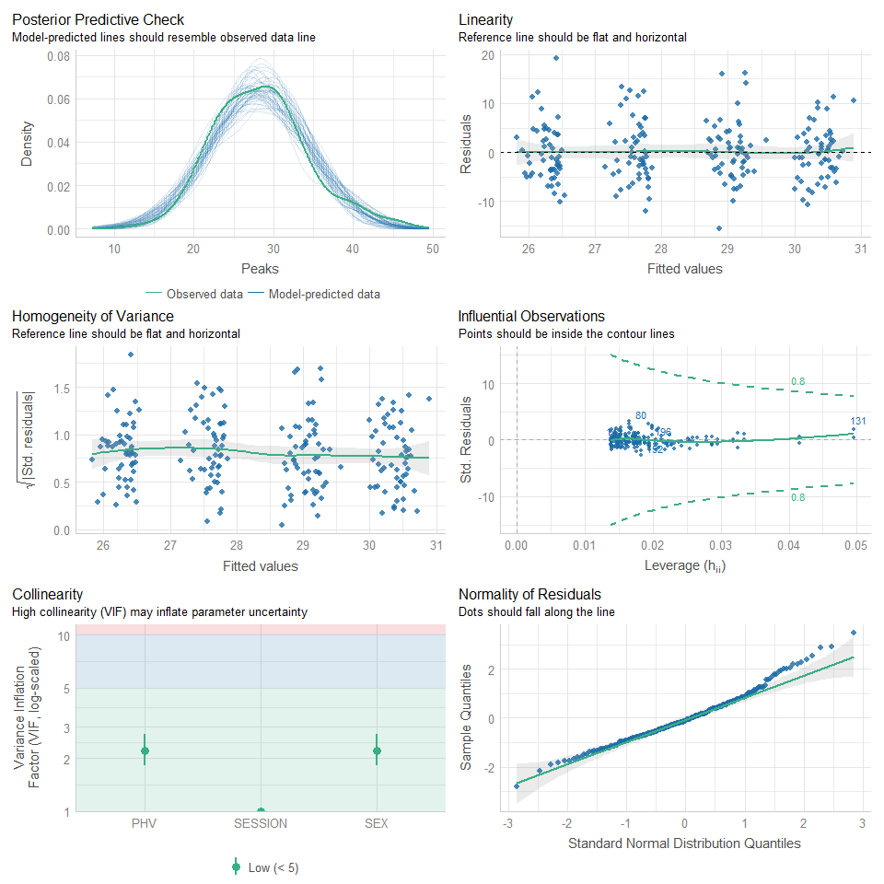

MR.Integral.MR <- lm(Integral ~ PHV + SEX + SESSION, data = df_MR)  
estimates(MR.Integral.MR)

## Model R squared:  
## 0.107 (0.03, 0.18)  
##   
## Semi-Partial R squared:  
## PHV SEX SESSION   
## 0.083 0.003 0.022   
##   
## Estimates for Factors:  
## variables levels estimate lower upper  
## 1 SEX Female 40136.06 38661.19 41610.93  
## 2 Male 41025.01 39631.04 42418.97  
## 3 SESSION Pre-season 41025.01 39631.04 42418.97  
## 4 Post-season 39417.81 38023.84 40811.77  
##   
##   
## Mean Differences:  
## variables comparison difference lower upper cohens.d  
## 1 SEX Male-Female 888.95 -1089.70 2867.59 0.17  
## 2 SESSION Post-season-Pre-season -1607.20 -3585.07 370.67 -0.31  
##   
##   
## Estimates for Numeric Variables =   
## variables estimate lower upper std.estimate std.lower std.upper  
## 1 (Intercept) 39622.08 38345.15 40899.02 0.00 0.00 0.00  
## 2 PHV -744.90 -1367.21 -122.58 -0.23 -0.42 -0.04

check_model(MR.Integral.MR)

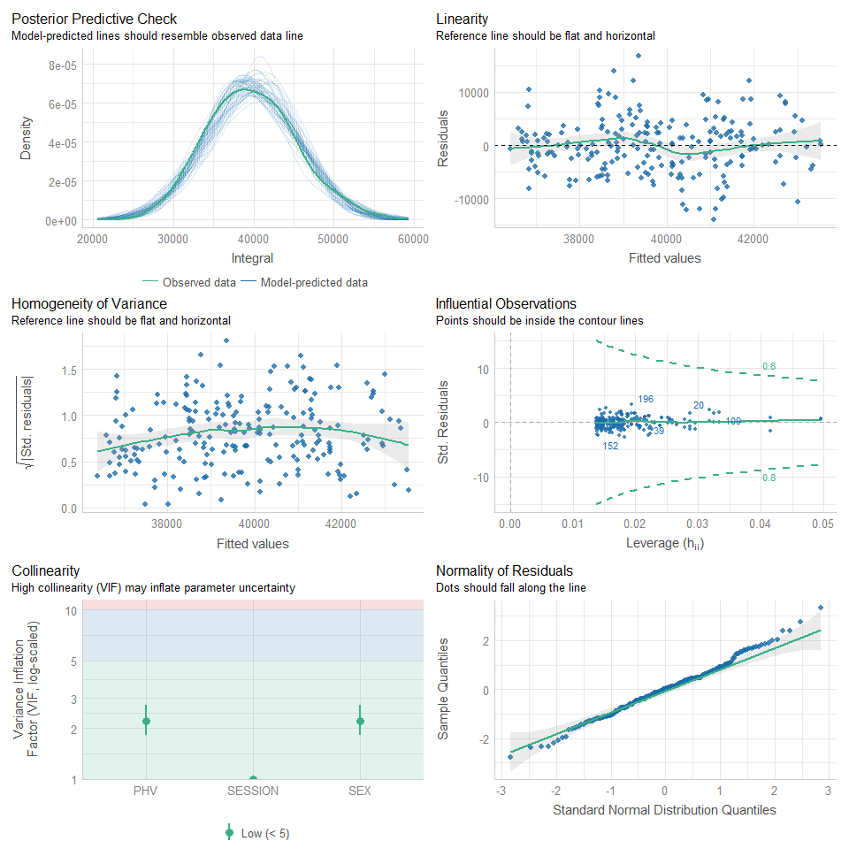

## DNB ----  
DNB.CI.DNB <- lm(CI ~ PHV + SEX + SESSION, data = df_DNB)  
estimates(DNB.CI.DNB)

## Model R squared:  
## 0.022 (-0.02, 0.06)  
##   
## Semi-Partial R squared:  
## PHV SEX SESSION   
## 0.008 0.010 0.004   
##   
## Estimates for Factors:  
## variables levels estimate lower upper  
## 1 SEX Female 6.29 5.9 6.69  
## 2 Male 5.89 5.53 6.24  
## 3 SESSION Pre-season 5.89 5.53 6.24  
## 4 Post-season 6.06 5.7 6.41  
##   
##   
## Mean Differences:  
## variables comparison difference lower upper cohens.d  
## 1 SEX Male-Female -0.41 -0.92 0.11 -0.31  
## 2 SESSION Post-season-Pre-season 0.17 -0.34 0.68 0.13  
##   
##   
## Estimates for Numeric Variables =   
## variables estimate lower upper std.estimate std.lower std.upper  
## 1 (Intercept) 6.17 5.84 6.5 0.0 0.0 0  
## 2 PHV -0.16 -0.32 0.0 -0.2 -0.4 0

check_model(DNB.CI.DNB)

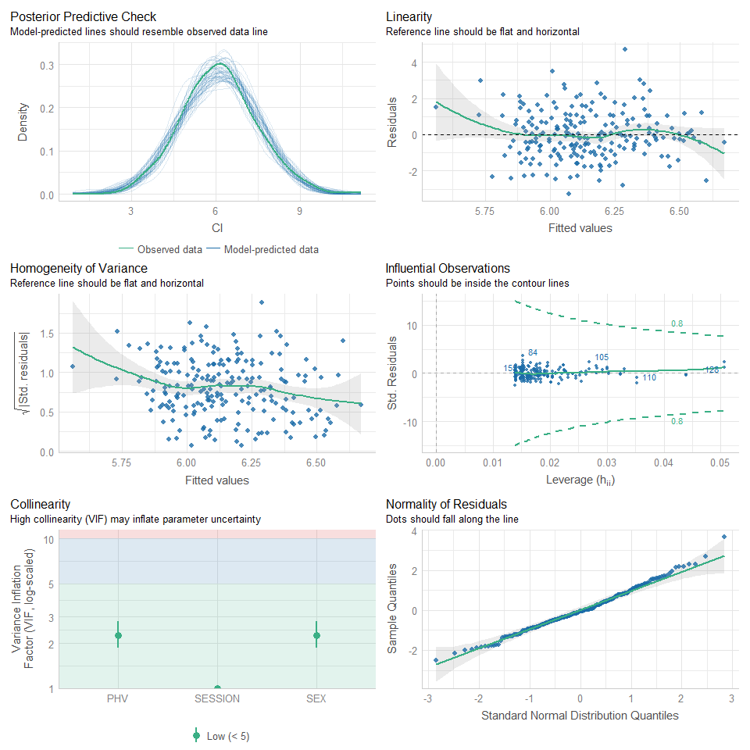

DNB.Peaks.DNB <- lm(Peaks ~ PHV + SEX + SESSION, data = df_DNB)  
estimates(DNB.Peaks.DNB)

## Model R squared:  
## 0.097 (0.02, 0.17)  
##   
## Semi-Partial R squared:  
## PHV SEX SESSION   
## 0.008 0.089 0.000   
##   
## Estimates for Factors:  
## variables levels estimate lower upper  
## 1 SEX Female 20.37 18.66 22.07  
## 2 Male 15 13.48 16.53  
## 3 SESSION Pre-season 15 13.48 16.53  
## 4 Post-season 15.17 13.64 16.7  
##   
##   
## Mean Differences:  
## variables comparison difference lower upper cohens.d  
## 1 SEX Male-Female -5.36 -7.57 -3.15 -0.93  
## 2 SESSION Post-season-Pre-season 0.17 -2.04 2.37 0.03  
##   
##   
## Estimates for Numeric Variables =   
## variables estimate lower upper std.estimate std.lower std.upper  
## 1 (Intercept) 19.22 17.77 20.66 0.00 0.00 0.00  
## 2 PHV -1.51 -2.21 -0.81 -0.42 -0.62 -0.23

check_model(DNB.Peaks.DNB)

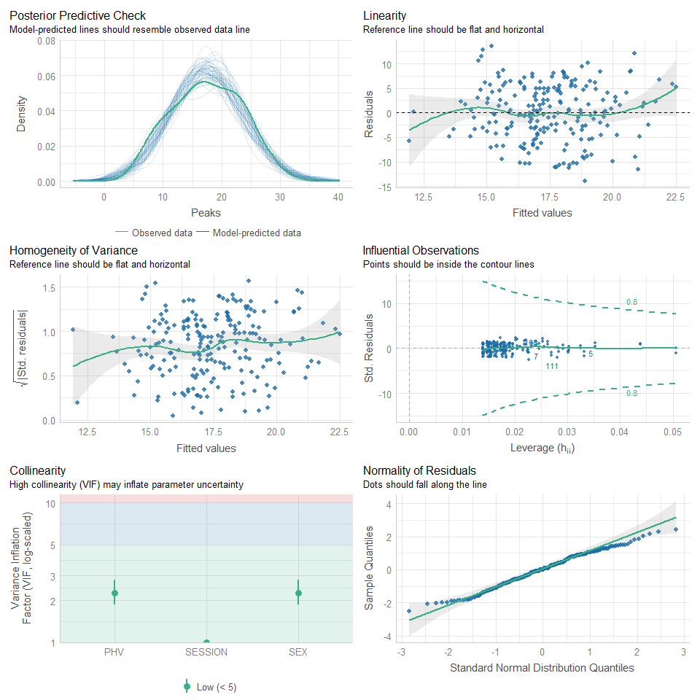

DNB.Integral.DNB <- lm(Integral ~ PHV + SEX + SESSION, data = df_DNB)  
estimates(DNB.Integral.DNB)

## Model R squared:  
## 0.204 (0.11, 0.3)  
##   
## Semi-Partial R squared:  
## PHV SEX SESSION   
## 0.031 0.174 0.000   
##   
## Estimates for Factors:  
## variables levels estimate lower upper  
## 1 SEX Female 27642.78 26183.1 29102.45  
## 2 Male 20799.1 19493.17 22105.04  
## 3 SESSION Pre-season 20799.1 19493.17 22105.04  
## 4 Post-season 20890.01 19584.08 22195.95  
##   
##   
## Mean Differences:  
## variables comparison difference lower upper cohens.d  
## 1 SEX Male-Female -6843.67 -8735.30 -4952.04 -1.39  
## 2 SESSION Post-season-Pre-season 90.91 -1798.57 1980.39 0.02  
##   
##   
## Estimates for Numeric Variables =   
## variables estimate lower upper std.estimate std.lower std.upper  
## 1 (Intercept) 26050.22 24812.52 27287.92 0.00 0.00 0.00  
## 2 PHV -2095.47 -2692.33 -1498.61 -0.64 -0.83 -0.46

check_model(DNB.Integral.DNB)

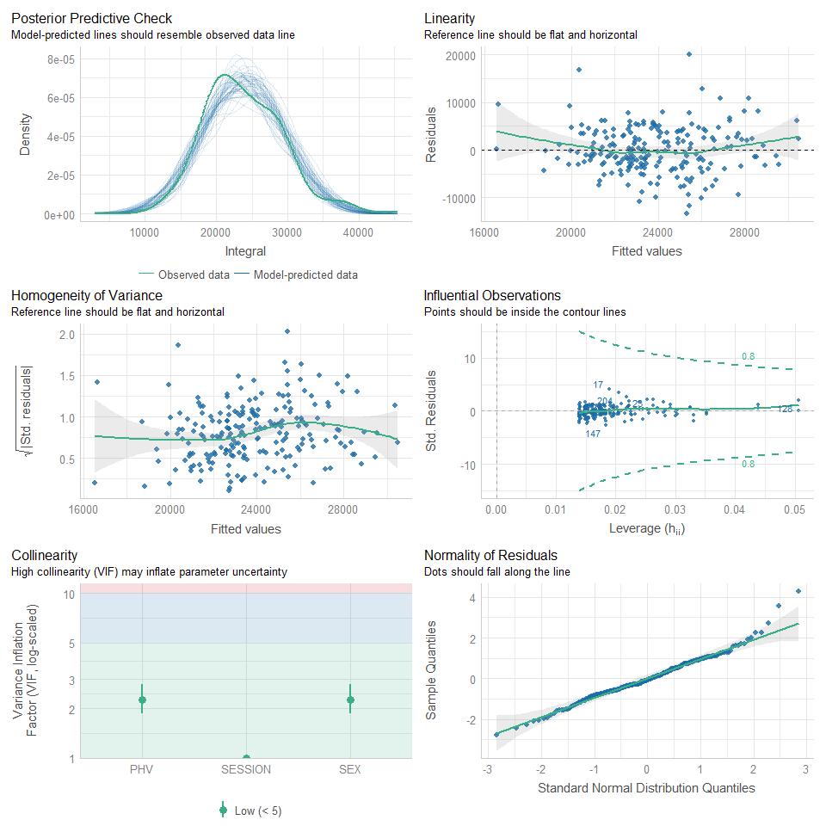

# LMER ----  
## NULL MODELs ----  
### ~ PHV + SEX + SESSION ----  
#### 40yd ----  
CI.NULL.40YD <- lmer(CI ~ 1 + (1|SUBJECT), data = df_40yd)  
summary(CI.NULL.40YD)

## Linear mixed model fit by REML ['lmerMod']  
## Formula: CI ~ 1 + (1 | SUBJECT)  
## Data: df_40yd  
##   
## REML criterion at convergence: 546.2  
##   
## Scaled residuals:   
## Min 1Q Median 3Q Max   
## -1.81458 -0.56998 0.00089 0.38306 2.73866   
##   
## Random effects:  
## Groups Name Variance Std.Dev.  
## SUBJECT (Intercept) 0.4672 0.6835   
## Residual 0.4113 0.6413   
## Number of obs: 214, groups: SUBJECT, 107  
##   
## Fixed effects:  
## Estimate Std. Error t value  
## (Intercept) 6.9706 0.0793 87.9

Peaks.NULL.40YD <- lmer(Peaks ~ 1 + (1|SUBJECT), data = df_40yd)  
summary(Peaks.NULL.40YD)

## Linear mixed model fit by REML ['lmerMod']  
## Formula: Peaks ~ 1 + (1 | SUBJECT)  
## Data: df_40yd  
##   
## REML criterion at convergence: 1435.9  
##   
## Scaled residuals:   
## Min 1Q Median 3Q Max   
## -3.1793 -0.4386 -0.0228 0.4905 2.3378   
##   
## Random effects:  
## Groups Name Variance Std.Dev.  
## SUBJECT (Intercept) 33.46 5.784   
## Residual 25.45 5.045   
## Number of obs: 214, groups: SUBJECT, 107  
##   
## Fixed effects:  
## Estimate Std. Error t value  
## (Intercept) 41.515 0.657 63.19

Integral.NULL.40YD <- lmer(Integral ~ 1 + (1|SUBJECT), data = df_40yd)  
summary(Integral.NULL.40YD)

## Linear mixed model fit by REML ['lmerMod']  
## Formula: Integral ~ 1 + (1 | SUBJECT)  
## Data: df_40yd  
##   
## REML criterion at convergence: 4426.8  
##   
## Scaled residuals:   
## Min 1Q Median 3Q Max   
## -2.20374 -0.61861 -0.04795 0.55323 2.18579   
##   
## Random effects:  
## Groups Name Variance Std.Dev.  
## SUBJECT (Intercept) 23190788 4816   
## Residual 41817149 6467   
## Number of obs: 214, groups: SUBJECT, 107  
##   
## Fixed effects:  
## Estimate Std. Error t value  
## (Intercept) 61505 642 95.8

#### 5-10-5 ----  
CI.NULL.FTF <- lmer(CI ~ 1 + (1|SUBJECT), data = df_FTF)  
summary(CI.NULL.FTF)

## Linear mixed model fit by REML ['lmerMod']  
## Formula: CI ~ 1 + (1 | SUBJECT)  
## Data: df_FTF  
##   
## REML criterion at convergence: 522.9  
##   
## Scaled residuals:   
## Min 1Q Median 3Q Max   
## -2.06772 -0.54907 -0.03809 0.52492 2.56122   
##   
## Random effects:  
## Groups Name Variance Std.Dev.  
## SUBJECT (Intercept) 0.3912 0.6255   
## Residual 0.4092 0.6397   
## Number of obs: 210, groups: SUBJECT, 105  
##   
## Fixed effects:  
## Estimate Std. Error t value  
## (Intercept) 4.94568 0.07533 65.65

Peaks.NULL.FTF <- lmer(Peaks ~ 1 + (1|SUBJECT), data = df_FTF)  
summary(Peaks.NULL.FTF)

## Linear mixed model fit by REML ['lmerMod']  
## Formula: Peaks ~ 1 + (1 | SUBJECT)  
## Data: df_FTF  
##   
## REML criterion at convergence: 1336.7  
##   
## Scaled residuals:   
## Min 1Q Median 3Q Max   
## -1.82730 -0.57383 -0.01782 0.47990 2.21902   
##   
## Random effects:  
## Groups Name Variance Std.Dev.  
## SUBJECT (Intercept) 28.23 5.313   
## Residual 16.21 4.027   
## Number of obs: 210, groups: SUBJECT, 105  
##   
## Fixed effects:  
## Estimate Std. Error t value  
## (Intercept) 24.9132 0.5883 42.35

Integral.NULL.FTF <- lmer(Integral ~ 1 + (1|SUBJECT), data = df_FTF)  
summary(Integral.NULL.FTF)

## Linear mixed model fit by REML ['lmerMod']  
## Formula: Integral ~ 1 + (1 | SUBJECT)  
## Data: df_FTF  
##   
## REML criterion at convergence: 4248.2  
##   
## Scaled residuals:   
## Min 1Q Median 3Q Max   
## -3.3555 -0.5540 -0.0510 0.4934 2.2282   
##   
## Random effects:  
## Groups Name Variance Std.Dev.  
## SUBJECT (Intercept) 15184863 3897   
## Residual 26146238 5113   
## Number of obs: 210, groups: SUBJECT, 105  
##   
## Fixed effects:  
## Estimate Std. Error t value  
## (Intercept) 40886.2 518.8 78.81

#### Broad ----  
CI.NULL.BROAD <- lmer(CI ~ 1 + (1|SUBJECT), data = df_BROAD)  
summary(CI.NULL.BROAD)

## Linear mixed model fit by REML ['lmerMod']  
## Formula: CI ~ 1 + (1 | SUBJECT)  
## Data: df_BROAD  
##   
## REML criterion at convergence: 684.2  
##   
## Scaled residuals:   
## Min 1Q Median 3Q Max   
## -2.02579 -0.59961 -0.09699 0.55384 2.96405   
##   
## Random effects:  
## Groups Name Variance Std.Dev.  
## SUBJECT (Intercept) 0.368 0.6067   
## Residual 1.099 1.0481   
## Number of obs: 214, groups: SUBJECT, 107  
##   
## Fixed effects:  
## Estimate Std. Error t value  
## (Intercept) 3.16207 0.09259 34.15

Peaks.NULL.BROAD <- lmer(Peaks ~ 1 + (1|SUBJECT), data = df_BROAD)  
summary(Peaks.NULL.BROAD)

## Linear mixed model fit by REML ['lmerMod']  
## Formula: Peaks ~ 1 + (1 | SUBJECT)  
## Data: df_BROAD  
##   
## REML criterion at convergence: 1797.6  
##   
## Scaled residuals:   
## Min 1Q Median 3Q Max   
## -2.6483 -0.5690 -0.1456 0.3929 3.4765   
##   
## Random effects:  
## Groups Name Variance Std.Dev.  
## SUBJECT (Intercept) 110.8 10.53   
## Residual 176.1 13.27   
## Number of obs: 214, groups: SUBJECT, 107  
##   
## Fixed effects:  
## Estimate Std. Error t value  
## (Intercept) 47.134 1.363 34.57

#### M-L ----  
CI.NULL.ML <- lmer(CI ~ 1 + (1|SUBJECT), data = df_ML)  
summary(CI.NULL.ML)

## Linear mixed model fit by REML ['lmerMod']  
## Formula: CI ~ 1 + (1 | SUBJECT)  
## Data: df_ML  
##   
## REML criterion at convergence: 546.2  
##   
## Scaled residuals:   
## Min 1Q Median 3Q Max   
## -2.31968 -0.60051 0.00015 0.50290 2.75972   
##   
## Random effects:  
## Groups Name Variance Std.Dev.  
## SUBJECT (Intercept) 0.2981 0.5460   
## Residual 0.5025 0.7089   
## Number of obs: 214, groups: SUBJECT, 107  
##   
## Fixed effects:  
## Estimate Std. Error t value  
## (Intercept) 5.78154 0.07165 80.69

Peaks.NULL.ML <- lmer(Peaks ~ 1 + (1|SUBJECT), data = df_ML)  
summary(Peaks.NULL.ML)

## Linear mixed model fit by REML ['lmerMod']  
## Formula: Peaks ~ 1 + (1 | SUBJECT)  
## Data: df_ML  
##   
## REML criterion at convergence: 1336  
##   
## Scaled residuals:   
## Min 1Q Median 3Q Max   
## -1.8551 -0.6050 -0.0975 0.6136 3.2853   
##   
## Random effects:  
## Groups Name Variance Std.Dev.  
## SUBJECT (Intercept) 12.61 3.550   
## Residual 20.21 4.495   
## Number of obs: 214, groups: SUBJECT, 107  
##   
## Fixed effects:  
## Estimate Std. Error t value  
## (Intercept) 27.1739 0.4607 58.98

Integral.NULL.ML <- lmer(Integral ~ 1 + (1|SUBJECT), data = df_ML)  
summary(Integral.NULL.ML)

## Linear mixed model fit by REML ['lmerMod']  
## Formula: Integral ~ 1 + (1 | SUBJECT)  
## Data: df_ML  
##   
## REML criterion at convergence: 4300.8  
##   
## Scaled residuals:   
## Min 1Q Median 3Q Max   
## -2.1899 -0.6185 -0.0411 0.5800 3.5918   
##   
## Random effects:  
## Groups Name Variance Std.Dev.  
## SUBJECT (Intercept) 5440332 2332   
## Residual 28573302 5345   
## Number of obs: 214, groups: SUBJECT, 107  
##   
## Fixed effects:  
## Estimate Std. Error t value  
## (Intercept) 38993.8 429.4 90.81

#### M-R ----  
CI.NULL.MR <- lmer(CI ~ 1 + (1|SUBJECT), data = df_MR)  
summary(CI.NULL.MR)

## Linear mixed model fit by REML ['lmerMod']  
## Formula: CI ~ 1 + (1 | SUBJECT)  
## Data: df_MR  
##   
## REML criterion at convergence: 517.1  
##   
## Scaled residuals:   
## Min 1Q Median 3Q Max   
## -2.3390 -0.4909 -0.0558 0.5570 2.6403   
##   
## Random effects:  
## Groups Name Variance Std.Dev.  
## SUBJECT (Intercept) 0.3387 0.5819   
## Residual 0.3929 0.6268   
## Number of obs: 214, groups: SUBJECT, 107  
##   
## Fixed effects:  
## Estimate Std. Error t value  
## (Intercept) 5.49381 0.07072 77.69

Peaks.NULL.MR <- lmer(Peaks ~ 1 + (1|SUBJECT), data = df_MR)  
summary(Peaks.NULL.MR)

## Linear mixed model fit by REML ['lmerMod']  
## Formula: Peaks ~ 1 + (1 | SUBJECT)  
## Data: df_MR  
##   
## REML criterion at convergence: 1337.9  
##   
## Scaled residuals:   
## Min 1Q Median 3Q Max   
## -2.05332 -0.53449 -0.02032 0.53488 2.37234   
##   
## Random effects:  
## Groups Name Variance Std.Dev.  
## SUBJECT (Intercept) 16.09 4.011   
## Residual 18.47 4.298   
## Number of obs: 214, groups: SUBJECT, 107  
##   
## Fixed effects:  
## Estimate Std. Error t value  
## (Intercept) 28.3682 0.4865 58.31

Integral.NULL.MR <- lmer(Integral ~ 1 + (1|SUBJECT), data = df_MR)  
summary(Integral.NULL.MR)

## Linear mixed model fit by REML ['lmerMod']  
## Formula: Integral ~ 1 + (1 | SUBJECT)  
## Data: df_MR  
##   
## REML criterion at convergence: 4273.5  
##   
## Scaled residuals:   
## Min 1Q Median 3Q Max   
## -2.11011 -0.65546 -0.04575 0.57743 2.64069   
##   
## Random effects:  
## Groups Name Variance Std.Dev.  
## SUBJECT (Intercept) 3670596 1916   
## Residual 26088902 5108   
## Number of obs: 214, groups: SUBJECT, 107  
##   
## Fixed effects:  
## Estimate Std. Error t value  
## (Intercept) 39746.2 395.2 100.6

#### DNB ----  
CI.NULL.DNB <- lmer(CI ~ 1 + (1|SUBJECT), data = df_DNB)  
summary(CI.NULL.DNB)

## Linear mixed model fit by REML ['lmerMod']  
## Formula: CI ~ 1 + (1 | SUBJECT)  
## Data: df_DNB  
##   
## REML criterion at convergence: 696.5  
##   
## Scaled residuals:   
## Min 1Q Median 3Q Max   
## -2.66299 -0.51444 0.01756 0.47313 2.85716   
##   
## Random effects:  
## Groups Name Variance Std.Dev.  
## SUBJECT (Intercept) 0.7641 0.8741   
## Residual 1.0110 1.0055   
## Number of obs: 210, groups: SUBJECT, 105  
##   
## Fixed effects:  
## Estimate Std. Error t value  
## (Intercept) 6.144 0.110 55.87

Peaks.NULL.DNB <- lmer(Peaks ~ 1 + (1|SUBJECT), data = df_DNB)  
summary(Peaks.NULL.DNB)

## Linear mixed model fit by REML ['lmerMod']  
## Formula: Peaks ~ 1 + (1 | SUBJECT)  
## Data: df_DNB  
##   
## REML criterion at convergence: 1318.2  
##   
## Scaled residuals:   
## Min 1Q Median 3Q Max   
## -2.26011 -0.57191 0.04303 0.61003 2.06952   
##   
## Random effects:  
## Groups Name Variance Std.Dev.  
## SUBJECT (Intercept) 17.69 4.206   
## Residual 18.34 4.282   
## Number of obs: 210, groups: SUBJECT, 105  
##   
## Fixed effects:  
## Estimate Std. Error t value  
## (Intercept) 17.4460 0.5058 34.49

Integral.NULL.DNB <- lmer(Integral ~ 1 + (1|SUBJECT), data = df_DNB)  
summary(Integral.NULL.DNB)

## Linear mixed model fit by REML ['lmerMod']  
## Formula: Integral ~ 1 + (1 | SUBJECT)  
## Data: df_DNB  
##   
## REML criterion at convergence: 4176.4  
##   
## Scaled residuals:   
## Min 1Q Median 3Q Max   
## -2.0568 -0.5608 -0.0639 0.5762 3.4402   
##   
## Random effects:  
## Groups Name Variance Std.Dev.  
## SUBJECT (Intercept) 12337567 3512   
## Residual 17591141 4194   
## Number of obs: 210, groups: SUBJECT, 105  
##   
## Fixed effects:  
## Estimate Std. Error t value  
## (Intercept) 23833.4 448.6 53.12

## Model 1s ----  
#### 40yd ----  
CI.01.40YD <- lmer(CI ~ PHV + (1|SUBJECT), data = df_40yd)  
summary(CI.01.40YD)

## Linear mixed model fit by REML ['lmerMod']  
## Formula: CI ~ PHV + (1 | SUBJECT)  
## Data: df_40yd  
##   
## REML criterion at convergence: 550.1  
##   
## Scaled residuals:   
## Min 1Q Median 3Q Max   
## -1.81073 -0.55774 0.00233 0.38228 2.73699   
##   
## Random effects:  
## Groups Name Variance Std.Dev.  
## SUBJECT (Intercept) 0.4711 0.6864   
## Residual 0.4113 0.6413   
## Number of obs: 214, groups: SUBJECT, 107  
##   
## Fixed effects:  
## Estimate Std. Error t value  
## (Intercept) 6.98920 0.08512 82.113  
## PHV 0.02950 0.04798 0.615  
##   
## Correlation of Fixed Effects:  
## (Intr)  
## PHV 0.356

Peaks.01.40YD <- lmer(Peaks ~ PHV + (1|SUBJECT), data = df_40yd)  
summary(Peaks.01.40YD)

## Linear mixed model fit by REML ['lmerMod']  
## Formula: Peaks ~ PHV + (1 | SUBJECT)  
## Data: df_40yd  
##   
## REML criterion at convergence: 1435.3  
##   
## Scaled residuals:   
## Min 1Q Median 3Q Max   
## -3.1984 -0.4435 -0.0255 0.5124 2.3510   
##   
## Random effects:  
## Groups Name Variance Std.Dev.  
## SUBJECT (Intercept) 33.66 5.801   
## Residual 25.45 5.045   
## Number of obs: 214, groups: SUBJECT, 107  
##   
## Fixed effects:  
## Estimate Std. Error t value  
## (Intercept) 41.7003 0.7046 59.18  
## PHV 0.2938 0.3971 0.74  
##   
## Correlation of Fixed Effects:  
## (Intr)  
## PHV 0.356

Integral.01.40YD <- lmer(Integral ~ PHV + (1|SUBJECT), data = df_40yd)  
summary(Integral.01.40YD)

## Linear mixed model fit by REML ['lmerMod']  
## Formula: Integral ~ PHV + (1 | SUBJECT)  
## Data: df_40yd  
##   
## REML criterion at convergence: 4413.1  
##   
## Scaled residuals:   
## Min 1Q Median 3Q Max   
## -2.20157 -0.61486 -0.05289 0.54596 2.17663   
##   
## Random effects:  
## Groups Name Variance Std.Dev.  
## SUBJECT (Intercept) 23607529 4859   
## Residual 41817149 6467   
## Number of obs: 214, groups: SUBJECT, 107  
##   
## Fixed effects:  
## Estimate Std. Error t value  
## (Intercept) 61483.09 690.30 89.067  
## PHV -34.08 389.09 -0.088  
##   
## Correlation of Fixed Effects:  
## (Intr)  
## PHV 0.356

#### 5-10-5 ----  
CI.01.FTF <- lmer(CI ~ PHV + (1|SUBJECT), data = df_FTF)  
summary(CI.01.FTF)

## Linear mixed model fit by REML ['lmerMod']  
## Formula: CI ~ PHV + (1 | SUBJECT)  
## Data: df_FTF  
##   
## REML criterion at convergence: 525.3  
##   
## Scaled residuals:   
## Min 1Q Median 3Q Max   
## -2.01939 -0.56211 -0.03516 0.53942 2.52250   
##   
## Random effects:  
## Groups Name Variance Std.Dev.  
## SUBJECT (Intercept) 0.3859 0.6212   
## Residual 0.4092 0.6397   
## Number of obs: 210, groups: SUBJECT, 105  
##   
## Fixed effects:  
## Estimate Std. Error t value  
## (Intercept) 4.90687 0.07999 61.342  
## PHV -0.06260 0.04490 -1.394  
##   
## Correlation of Fixed Effects:  
## (Intr)  
## PHV 0.348

Peaks.01.FTF <- lmer(Peaks ~ PHV + (1|SUBJECT), data = df_FTF)  
summary(Peaks.01.FTF)

## Linear mixed model fit by REML ['lmerMod']  
## Formula: Peaks ~ PHV + (1 | SUBJECT)  
## Data: df_FTF  
##   
## REML criterion at convergence: 1334.7  
##   
## Scaled residuals:   
## Min 1Q Median 3Q Max   
## -1.81675 -0.59057 -0.00208 0.48479 2.22875   
##   
## Random effects:  
## Groups Name Variance Std.Dev.  
## SUBJECT (Intercept) 27.77 5.270   
## Residual 16.21 4.027   
## Number of obs: 210, groups: SUBJECT, 105  
##   
## Fixed effects:  
## Estimate Std. Error t value  
## (Intercept) 25.2448 0.6235 40.487  
## PHV 0.5348 0.3500 1.528  
##   
## Correlation of Fixed Effects:  
## (Intr)  
## PHV 0.348

Integral.01.FTF <- lmer(Integral ~ PHV + (1|SUBJECT), data = df_FTF)  
summary(Integral.01.FTF)

## Linear mixed model fit by REML ['lmerMod']  
## Formula: Integral ~ PHV + (1 | SUBJECT)  
## Data: df_FTF  
##   
## REML criterion at convergence: 4232.2  
##   
## Scaled residuals:   
## Min 1Q Median 3Q Max   
## -3.4169 -0.5770 -0.0589 0.5269 2.1235   
##   
## Random effects:  
## Groups Name Variance Std.Dev.  
## SUBJECT (Intercept) 14734040 3838   
## Residual 26146238 5113   
## Number of obs: 210, groups: SUBJECT, 105  
##   
## Fixed effects:  
## Estimate Std. Error t value  
## (Intercept) 40573.1 548.9 73.914  
## PHV -504.9 308.1 -1.639  
##   
## Correlation of Fixed Effects:  
## (Intr)  
## PHV 0.348

#### Broad ----  
CI.01.BROAD <- lmer(CI ~ PHV + (1|SUBJECT), data = df_BROAD)  
summary(CI.01.BROAD)

## Linear mixed model fit by REML ['lmerMod']  
## Formula: CI ~ PHV + (1 | SUBJECT)  
## Data: df_BROAD  
##   
## REML criterion at convergence: 687.9  
##   
## Scaled residuals:   
## Min 1Q Median 3Q Max   
## -2.01589 -0.58293 -0.07649 0.53967 2.96301   
##   
## Random effects:  
## Groups Name Variance Std.Dev.  
## SUBJECT (Intercept) 0.3746 0.6121   
## Residual 1.0986 1.0481   
## Number of obs: 214, groups: SUBJECT, 107  
##   
## Fixed effects:  
## Estimate Std. Error t value  
## (Intercept) 3.17948 0.09945 31.971  
## PHV 0.02754 0.05605 0.491  
##   
## Correlation of Fixed Effects:  
## (Intr)  
## PHV 0.356

Peaks.01.BROAD <- lmer(Peaks ~ PHV + (1|SUBJECT), data = df_BROAD)  
summary(Peaks.01.BROAD)

## Linear mixed model fit by REML ['lmerMod']  
## Formula: Peaks ~ PHV + (1 | SUBJECT)  
## Data: df_BROAD  
##   
## REML criterion at convergence: 1796.1  
##   
## Scaled residuals:   
## Min 1Q Median 3Q Max   
## -2.6472 -0.5664 -0.1455 0.3821 3.4481   
##   
## Random effects:  
## Groups Name Variance Std.Dev.  
## SUBJECT (Intercept) 112.7 10.62   
## Residual 176.1 13.27   
## Number of obs: 214, groups: SUBJECT, 107  
##   
## Fixed effects:  
## Estimate Std. Error t value  
## (Intercept) 47.0630 1.4658 32.107  
## PHV -0.1121 0.8262 -0.136  
##   
## Correlation of Fixed Effects:  
## (Intr)  
## PHV 0.356

#### M-L ----  
CI.01.ML <- lmer(CI ~ PHV + (1|SUBJECT), data = df_ML)  
summary(CI.01.ML)

## Linear mixed model fit by REML ['lmerMod']  
## Formula: CI ~ PHV + (1 | SUBJECT)  
## Data: df_ML  
##   
## REML criterion at convergence: 550.5  
##   
## Scaled residuals:   
## Min 1Q Median 3Q Max   
## -2.33610 -0.59440 0.00026 0.50628 2.77508   
##   
## Random effects:  
## Groups Name Variance Std.Dev.  
## SUBJECT (Intercept) 0.3027 0.5501   
## Residual 0.5025 0.7089   
## Number of obs: 214, groups: SUBJECT, 107  
##   
## Fixed effects:  
## Estimate Std. Error t value  
## (Intercept) 5.7715 0.0770 74.954  
## PHV -0.0159 0.0434 -0.366  
##   
## Correlation of Fixed Effects:  
## (Intr)  
## PHV 0.356

Peaks.01.ML <- lmer(Peaks ~ PHV + (1|SUBJECT), data = df_ML)  
summary(Peaks.01.ML)

## Linear mixed model fit by REML ['lmerMod']  
## Formula: Peaks ~ PHV + (1 | SUBJECT)  
## Data: df_ML  
##   
## REML criterion at convergence: 1334.1  
##   
## Scaled residuals:   
## Min 1Q Median 3Q Max   
## -1.8688 -0.5941 -0.0643 0.5847 3.2054   
##   
## Random effects:  
## Groups Name Variance Std.Dev.  
## SUBJECT (Intercept) 12.26 3.502   
## Residual 20.21 4.495   
## Number of obs: 214, groups: SUBJECT, 107  
##   
## Fixed effects:  
## Estimate Std. Error t value  
## (Intercept) 26.8911 0.4893 54.959  
## PHV -0.4474 0.2758 -1.622  
##   
## Correlation of Fixed Effects:  
## (Intr)  
## PHV 0.356

Integral.01.ML <- lmer(Integral ~ PHV + (1|SUBJECT), data = df_ML)  
summary(Integral.01.ML)

## Linear mixed model fit by REML ['lmerMod']  
## Formula: Integral ~ PHV + (1 | SUBJECT)  
## Data: df_ML  
##   
## REML criterion at convergence: 4281  
##   
## Scaled residuals:   
## Min 1Q Median 3Q Max   
## -2.1718 -0.6111 0.0027 0.5494 3.3974   
##   
## Random effects:  
## Groups Name Variance Std.Dev.  
## SUBJECT (Intercept) 4369293 2090   
## Residual 28573303 5345   
## Number of obs: 214, groups: SUBJECT, 107  
##   
## Fixed effects:  
## Estimate Std. Error t value  
## (Intercept) 38570.0 446.9 86.310  
## PHV -670.5 251.9 -2.662  
##   
## Correlation of Fixed Effects:  
## (Intr)  
## PHV 0.356

#### M-R ----  
CI.01.MR <- lmer(CI ~ PHV + (1|SUBJECT), data = df_MR)  
summary(CI.01.MR)

## Linear mixed model fit by REML ['lmerMod']  
## Formula: CI ~ PHV + (1 | SUBJECT)  
## Data: df_MR  
##   
## REML criterion at convergence: 521.4  
##   
## Scaled residuals:   
## Min 1Q Median 3Q Max   
## -2.34968 -0.47875 -0.06128 0.55926 2.63084   
##   
## Random effects:  
## Groups Name Variance Std.Dev.  
## SUBJECT (Intercept) 0.3432 0.5858   
## Residual 0.3929 0.6268   
## Number of obs: 214, groups: SUBJECT, 107  
##   
## Fixed effects:  
## Estimate Std. Error t value  
## (Intercept) 5.50287 0.07600 72.404  
## PHV 0.01433 0.04284 0.334  
##   
## Correlation of Fixed Effects:  
## (Intr)  
## PHV 0.356

Peaks.01.MR <- lmer(Peaks ~ PHV + (1|SUBJECT), data = df_MR)  
summary(Peaks.01.MR)

## Linear mixed model fit by REML ['lmerMod']  
## Formula: Peaks ~ PHV + (1 | SUBJECT)  
## Data: df_MR  
##   
## REML criterion at convergence: 1335.1  
##   
## Scaled residuals:   
## Min 1Q Median 3Q Max   
## -2.05574 -0.54967 -0.04918 0.51043 2.39521   
##   
## Random effects:  
## Groups Name Variance Std.Dev.  
## SUBJECT (Intercept) 15.51 3.939   
## Residual 18.47 4.298   
## Number of obs: 214, groups: SUBJECT, 107  
##   
## Fixed effects:  
## Estimate Std. Error t value  
## (Intercept) 28.0263 0.5147 54.452  
## PHV -0.5408 0.2901 -1.864  
##   
## Correlation of Fixed Effects:  
## (Intr)  
## PHV 0.356

Integral.01.MR <- lmer(Integral ~ PHV + (1|SUBJECT), data = df_MR)  
summary(Integral.01.MR)

## Linear mixed model fit by REML ['lmerMod']  
## Formula: Integral ~ PHV + (1 | SUBJECT)  
## Data: df_MR  
##   
## REML criterion at convergence: 4244  
##   
## Scaled residuals:   
## Min 1Q Median 3Q Max   
## -2.70172 -0.63192 -0.02335 0.59650 2.97055   
##   
## Random effects:  
## Groups Name Variance Std.Dev.  
## SUBJECT (Intercept) 1339994 1158   
## Residual 26088902 5108   
## Number of obs: 214, groups: SUBJECT, 107  
##   
## Fixed effects:  
## Estimate Std. Error t value  
## (Intercept) 39150.3 392.4 99.772  
## PHV -942.9 221.2 -4.263  
##   
## Correlation of Fixed Effects:  
## (Intr)  
## PHV 0.356

#### DNB ----  
CI.01.DNB <- lmer(CI ~ PHV + (1|SUBJECT), data = df_DNB)  
summary(CI.01.DNB)

## Linear mixed model fit by REML ['lmerMod']  
## Formula: CI ~ PHV + (1 | SUBJECT)  
## Data: df_DNB  
##   
## REML criterion at convergence: 699  
##   
## Scaled residuals:   
## Min 1Q Median 3Q Max   
## -2.69939 -0.49799 -0.01843 0.47049 2.80131   
##   
## Random effects:  
## Groups Name Variance Std.Dev.  
## SUBJECT (Intercept) 0.7627 0.8733   
## Residual 1.0110 1.0055   
## Number of obs: 210, groups: SUBJECT, 105  
##   
## Fixed effects:  
## Estimate Std. Error t value  
## (Intercept) 6.10006 0.11746 51.934  
## PHV -0.06924 0.06567 -1.054  
##   
## Correlation of Fixed Effects:  
## (Intr)  
## PHV 0.353

Peaks.01.DNB <- lmer(Peaks ~ PHV + (1|SUBJECT), data = df_DNB)  
summary(Peaks.01.DNB)

## Linear mixed model fit by REML ['lmerMod']  
## Formula: Peaks ~ PHV + (1 | SUBJECT)  
## Data: df_DNB  
##   
## REML criterion at convergence: 1317.7  
##   
## Scaled residuals:   
## Min 1Q Median 3Q Max   
## -2.23557 -0.54694 0.05466 0.59579 2.06326   
##   
## Random effects:  
## Groups Name Variance Std.Dev.  
## SUBJECT (Intercept) 17.67 4.203   
## Residual 18.34 4.282   
## Number of obs: 210, groups: SUBJECT, 105  
##   
## Fixed effects:  
## Estimate Std. Error t value  
## (Intercept) 17.2466 0.5403 31.921  
## PHV -0.3159 0.3021 -1.046  
##   
## Correlation of Fixed Effects:  
## (Intr)  
## PHV 0.353

Integral.01.DNB <- lmer(Integral ~ PHV + (1|SUBJECT), data = df_DNB)  
summary(Integral.01.DNB)

## Linear mixed model fit by REML ['lmerMod']  
## Formula: Integral ~ PHV + (1 | SUBJECT)  
## Data: df_DNB  
##   
## REML criterion at convergence: 4158.8  
##   
## Scaled residuals:   
## Min 1Q Median 3Q Max   
## -1.9648 -0.5780 -0.0538 0.5624 3.3465   
##   
## Random effects:  
## Groups Name Variance Std.Dev.  
## SUBJECT (Intercept) 11615521 3408   
## Residual 17591141 4194   
## Number of obs: 210, groups: SUBJECT, 105  
##   
## Fixed effects:  
## Estimate Std. Error t value  
## (Intercept) 23473.7 471.2 49.816  
## PHV -569.9 263.5 -2.163  
##   
## Correlation of Fixed Effects:  
## (Intr)  
## PHV 0.353

## Model 2s ----  
### 40yd ----  
# add SEX   
CI.02.40YD <- lmer(CI ~ PHV + SEX + (1|SUBJECT), data = df_40yd)  
summary(CI.02.40YD)

## Linear mixed model fit by REML ['lmerMod']  
## Formula: CI ~ PHV + SEX + (1 | SUBJECT)  
## Data: df_40yd  
##   
## REML criterion at convergence: 551  
##   
## Scaled residuals:   
## Min 1Q Median 3Q Max   
## -1.78564 -0.55779 -0.00663 0.38431 2.76099   
##   
## Random effects:  
## Groups Name Variance Std.Dev.  
## SUBJECT (Intercept) 0.4765 0.6903   
## Residual 0.4113 0.6413   
## Number of obs: 214, groups: SUBJECT, 107  
##   
## Fixed effects:  
## Estimate Std. Error t value  
## (Intercept) 6.95229 0.12300 56.521  
## PHV 0.05152 0.07147 0.721  
## SEXMale 0.09888 0.23705 0.417  
##   
## Correlation of Fixed Effects:  
## (Intr) PHV   
## PHV -0.365   
## SEXMale -0.719 0.739

Peaks.02.40YD <- lmer(Peaks ~ PHV + SEX + (1|SUBJECT), data = df_40yd)  
summary(Peaks.02.40YD)

## Linear mixed model fit by REML ['lmerMod']  
## Formula: Peaks ~ PHV + SEX + (1 | SUBJECT)  
## Data: df_40yd  
##   
## REML criterion at convergence: 1424.2  
##   
## Scaled residuals:   
## Min 1Q Median 3Q Max   
## -3.1641 -0.4896 -0.0565 0.4828 2.6271   
##   
## Random effects:  
## Groups Name Variance Std.Dev.  
## SUBJECT (Intercept) 30.67 5.538   
## Residual 25.45 5.045   
## Number of obs: 214, groups: SUBJECT, 107  
##   
## Fixed effects:  
## Estimate Std. Error t value  
## (Intercept) 39.675 0.981 40.444  
## PHV 1.502 0.570 2.636  
## SEXMale 5.426 1.891 2.870  
##   
## Correlation of Fixed Effects:  
## (Intr) PHV   
## PHV -0.365   
## SEXMale -0.719 0.739

Integral.02.40YD <- lmer(Integral ~ PHV + SEX + (1|SUBJECT), data = df_40yd)  
summary(Integral.02.40YD)

## Linear mixed model fit by REML ['lmerMod']  
## Formula: Integral ~ PHV + SEX + (1 | SUBJECT)  
## Data: df_40yd  
##   
## REML criterion at convergence: 4395.7  
##   
## Scaled residuals:   
## Min 1Q Median 3Q Max   
## -2.23919 -0.59967 -0.06189 0.53716 2.12863   
##   
## Random effects:  
## Groups Name Variance Std.Dev.  
## SUBJECT (Intercept) 23871282 4886   
## Residual 41817149 6467   
## Number of obs: 214, groups: SUBJECT, 107  
##   
## Fixed effects:  
## Estimate Std. Error t value  
## (Intercept) 61040.3 996.6 61.250  
## PHV 230.2 579.0 0.397  
## SEXMale 1186.3 1920.6 0.618  
##   
## Correlation of Fixed Effects:  
## (Intr) PHV   
## PHV -0.365   
## SEXMale -0.719 0.739

#### 5-10-5 ----  
CI.02.FTF <- lmer(CI ~ PHV + SEX + (1|SUBJECT), data = df_FTF)  
summary(CI.02.FTF)

## Linear mixed model fit by REML ['lmerMod']  
## Formula: CI ~ PHV + SEX + (1 | SUBJECT)  
## Data: df_FTF  
##   
## REML criterion at convergence: 524.7  
##   
## Scaled residuals:   
## Min 1Q Median 3Q Max   
## -1.99307 -0.59579 -0.03433 0.51153 2.49042   
##   
## Random effects:  
## Groups Name Variance Std.Dev.  
## SUBJECT (Intercept) 0.3813 0.6175   
## Residual 0.4092 0.6397   
## Number of obs: 210, groups: SUBJECT, 105  
##   
## Fixed effects:  
## Estimate Std. Error t value  
## (Intercept) 4.797163 0.114048 42.063  
## PHV 0.003512 0.066466 0.053  
## SEXMale 0.298548 0.222050 1.345  
##   
## Correlation of Fixed Effects:  
## (Intr) PHV   
## PHV -0.366   
## SEXMale -0.715 0.740

Peaks.02.FTF <- lmer(Peaks ~ PHV + SEX + (1|SUBJECT), data = df_FTF)  
summary(Peaks.02.FTF)

## Linear mixed model fit by REML ['lmerMod']  
## Formula: Peaks ~ PHV + SEX + (1 | SUBJECT)  
## Data: df_FTF  
##   
## REML criterion at convergence: 1330.4  
##   
## Scaled residuals:   
## Min 1Q Median 3Q Max   
## -1.86252 -0.60322 -0.01382 0.50106 2.17549   
##   
## Random effects:  
## Groups Name Variance Std.Dev.  
## SUBJECT (Intercept) 27.67 5.260   
## Residual 16.21 4.027   
## Number of obs: 210, groups: SUBJECT, 105  
##   
## Fixed effects:  
## Estimate Std. Error t value  
## (Intercept) 24.5176 0.8912 27.512  
## PHV 0.9729 0.5194 1.873  
## SEXMale 1.9788 1.7351 1.140  
##   
## Correlation of Fixed Effects:  
## (Intr) PHV   
## PHV -0.366   
## SEXMale -0.715 0.740

Integral.02.FTF <- lmer(Integral ~ PHV + SEX + (1|SUBJECT), data = df_FTF)  
summary(Integral.02.FTF)

## Linear mixed model fit by REML ['lmerMod']  
## Formula: Integral ~ PHV + SEX + (1 | SUBJECT)  
## Data: df_FTF  
##   
## REML criterion at convergence: 4215.2  
##   
## Scaled residuals:   
## Min 1Q Median 3Q Max   
## -3.4402 -0.5812 -0.0704 0.5250 2.1254   
##   
## Random effects:  
## Groups Name Variance Std.Dev.  
## SUBJECT (Intercept) 14864075 3855   
## Residual 26146238 5113   
## Number of obs: 210, groups: SUBJECT, 105  
##   
## Fixed effects:  
## Estimate Std. Error t value  
## (Intercept) 40166.6 787.5 51.004  
## PHV -260.0 459.0 -0.566  
## SEXMale 1106.3 1533.3 0.722  
##   
## Correlation of Fixed Effects:  
## (Intr) PHV   
## PHV -0.366   
## SEXMale -0.715 0.740

#### Broad ----  
CI.02.BROAD <- lmer(CI ~ PHV + SEX + (1|SUBJECT), data = df_BROAD)  
summary(CI.02.BROAD)

## Linear mixed model fit by REML ['lmerMod']  
## Formula: CI ~ PHV + SEX + (1 | SUBJECT)  
## Data: df_BROAD  
##   
## REML criterion at convergence: 688.5  
##   
## Scaled residuals:   
## Min 1Q Median 3Q Max   
## -2.03646 -0.58979 -0.08908 0.52853 2.93093   
##   
## Random effects:  
## Groups Name Variance Std.Dev.  
## SUBJECT (Intercept) 0.3821 0.6182   
## Residual 1.0986 1.0481   
## Number of obs: 214, groups: SUBJECT, 107  
##   
## Fixed effects:  
## Estimate Std. Error t value  
## (Intercept) 3.13862 0.14373 21.837  
## PHV 0.05193 0.08351 0.622  
## SEXMale 0.10948 0.27699 0.395  
##   
## Correlation of Fixed Effects:  
## (Intr) PHV   
## PHV -0.365   
## SEXMale -0.719 0.739

Peaks.02.BROAD <- lmer(Peaks ~ PHV + SEX + (1|SUBJECT), data = df_BROAD)  
summary(Peaks.02.BROAD)

## Linear mixed model fit by REML ['lmerMod']  
## Formula: Peaks ~ PHV + SEX + (1 | SUBJECT)  
## Data: df_BROAD  
##   
## REML criterion at convergence: 1790.9  
##   
## Scaled residuals:   
## Min 1Q Median 3Q Max   
## -2.5930 -0.5499 -0.1301 0.3912 3.4106   
##   
## Random effects:  
## Groups Name Variance Std.Dev.  
## SUBJECT (Intercept) 113.5 10.65   
## Residual 176.1 13.27   
## Number of obs: 214, groups: SUBJECT, 107  
##   
## Fixed effects:  
## Estimate Std. Error t value  
## (Intercept) 45.9093 2.1142 21.715  
## PHV 0.5764 1.2284 0.469  
## SEXMale 3.0909 4.0744 0.759  
##   
## Correlation of Fixed Effects:  
## (Intr) PHV   
## PHV -0.365   
## SEXMale -0.719 0.739

#### M-L ----  
CI.02.ML <- lmer(CI ~ PHV + SEX + (1|SUBJECT), data = df_ML)  
summary(CI.02.ML)

## Linear mixed model fit by REML ['lmerMod']  
## Formula: CI ~ PHV + SEX + (1 | SUBJECT)  
## Data: df_ML  
##   
## REML criterion at convergence: 551.2  
##   
## Scaled residuals:   
## Min 1Q Median 3Q Max   
## -2.33315 -0.62871 -0.01235 0.54507 2.77335   
##   
## Random effects:  
## Groups Name Variance Std.Dev.  
## SUBJECT (Intercept) 0.3052 0.5525   
## Residual 0.5025 0.7089   
## Number of obs: 214, groups: SUBJECT, 107  
##   
## Fixed effects:  
## Estimate Std. Error t value  
## (Intercept) 5.71403 0.11109 51.435  
## PHV 0.01839 0.06455 0.285  
## SEXMale 0.15394 0.21409 0.719  
##   
## Correlation of Fixed Effects:  
## (Intr) PHV   
## PHV -0.365   
## SEXMale -0.719 0.739

Peaks.02.ML <- lmer(Peaks ~ PHV + SEX + (1|SUBJECT), data = df_ML)  
summary(Peaks.02.ML)

## Linear mixed model fit by REML ['lmerMod']  
## Formula: Peaks ~ PHV + SEX + (1 | SUBJECT)  
## Data: df_ML  
##   
## REML criterion at convergence: 1323.9  
##   
## Scaled residuals:   
## Min 1Q Median 3Q Max   
## -1.7070 -0.6463 -0.0873 0.5953 3.2752   
##   
## Random effects:  
## Groups Name Variance Std.Dev.  
## SUBJECT (Intercept) 10.85 3.294   
## Residual 20.21 4.495   
## Number of obs: 214, groups: SUBJECT, 107  
##   
## Fixed effects:  
## Estimate Std. Error t value  
## (Intercept) 25.4978 0.6817 37.403  
## PHV 0.3841 0.3961 0.970  
## SEXMale 3.7331 1.3138 2.842  
##   
## Correlation of Fixed Effects:  
## (Intr) PHV   
## PHV -0.365   
## SEXMale -0.719 0.739

Integral.02.ML <- lmer(Integral ~ PHV + SEX + (1|SUBJECT), data = df_ML)  
summary(Integral.02.ML)

## Linear mixed model fit by REML ['lmerMod']  
## Formula: Integral ~ PHV + SEX + (1 | SUBJECT)  
## Data: df_ML  
##   
## REML criterion at convergence: 4263.5  
##   
## Scaled residuals:   
## Min 1Q Median 3Q Max   
## -2.1823 -0.5971 0.0052 0.5441 3.4532   
##   
## Random effects:  
## Groups Name Variance Std.Dev.  
## SUBJECT (Intercept) 4288289 2071   
## Residual 28573302 5345   
## Number of obs: 214, groups: SUBJECT, 107  
##   
## Fixed effects:  
## Estimate Std. Error t value  
## (Intercept) 38012.5 641.9 59.223  
## PHV -337.8 372.9 -0.906  
## SEXMale 1493.5 1237.0 1.207  
##   
## Correlation of Fixed Effects:  
## (Intr) PHV   
## PHV -0.365   
## SEXMale -0.719 0.739

#### M-R ----  
CI.02.MR <- lmer(CI ~ PHV + SEX + (1|SUBJECT), data = df_MR)  
summary(CI.02.MR)

## Linear mixed model fit by REML ['lmerMod']  
## Formula: CI ~ PHV + SEX + (1 | SUBJECT)  
## Data: df_MR  
##   
## REML criterion at convergence: 522.6  
##   
## Scaled residuals:   
## Min 1Q Median 3Q Max   
## -2.34131 -0.48039 -0.05817 0.55639 2.60422   
##   
## Random effects:  
## Groups Name Variance Std.Dev.  
## SUBJECT (Intercept) 0.3480 0.5899   
## Residual 0.3929 0.6268   
## Number of obs: 214, groups: SUBJECT, 107  
##   
## Fixed effects:  
## Estimate Std. Error t value  
## (Intercept) 5.48075 0.10988 49.878  
## PHV 0.02753 0.06385 0.431  
## SEXMale 0.05926 0.21176 0.280  
##   
## Correlation of Fixed Effects:  
## (Intr) PHV   
## PHV -0.365   
## SEXMale -0.719 0.739

Peaks.02.MR <- lmer(Peaks ~ PHV + SEX + (1|SUBJECT), data = df_MR)  
summary(Peaks.02.MR)

## Linear mixed model fit by REML ['lmerMod']  
## Formula: Peaks ~ PHV + SEX + (1 | SUBJECT)  
## Data: df_MR  
##   
## REML criterion at convergence: 1327.5  
##   
## Scaled residuals:   
## Min 1Q Median 3Q Max   
## -1.91429 -0.54167 -0.04479 0.46338 2.29075   
##   
## Random effects:  
## Groups Name Variance Std.Dev.  
## SUBJECT (Intercept) 14.57 3.817   
## Residual 18.47 4.298   
## Number of obs: 214, groups: SUBJECT, 107  
##   
## Fixed effects:  
## Estimate Std. Error t value  
## (Intercept) 26.8387 0.7266 36.937  
## PHV 0.1679 0.4222 0.398  
## SEXMale 3.1820 1.4003 2.272  
##   
## Correlation of Fixed Effects:  
## (Intr) PHV   
## PHV -0.365   
## SEXMale -0.719 0.739

Integral.02.MR <- lmer(Integral ~ PHV + SEX + (1|SUBJECT), data = df_MR)  
summary(Integral.02.MR)

## Linear mixed model fit by REML ['lmerMod']  
## Formula: Integral ~ PHV + SEX + (1 | SUBJECT)  
## Data: df_MR  
##   
## REML criterion at convergence: 4227.5  
##   
## Scaled residuals:   
## Min 1Q Median 3Q Max   
## -2.69232 -0.61267 -0.02235 0.59158 2.88553   
##   
## Random effects:  
## Groups Name Variance Std.Dev.  
## SUBJECT (Intercept) 1386061 1177   
## Residual 26088902 5108   
## Number of obs: 214, groups: SUBJECT, 107  
##   
## Fixed effects:  
## Estimate Std. Error t value  
## (Intercept) 38818.5 565.7 68.616  
## PHV -744.9 328.7 -2.266  
## SEXMale 888.9 1090.3 0.815  
##   
## Correlation of Fixed Effects:  
## (Intr) PHV   
## PHV -0.365   
## SEXMale -0.719 0.739

#### DNB ----  
CI.02.DNB <- lmer(CI ~ PHV + SEX + (1|SUBJECT), data = df_DNB)  
summary(CI.02.DNB)

## Linear mixed model fit by REML ['lmerMod']  
## Formula: CI ~ PHV + SEX + (1 | SUBJECT)  
## Data: df_DNB  
##   
## REML criterion at convergence: 697.9  
##   
## Scaled residuals:   
## Min 1Q Median 3Q Max   
## -2.69502 -0.50557 -0.04493 0.47509 2.80507   
##   
## Random effects:  
## Groups Name Variance Std.Dev.  
## SUBJECT (Intercept) 0.7565 0.8698   
## Residual 1.0110 1.0055   
## Number of obs: 210, groups: SUBJECT, 105  
##   
## Fixed effects:  
## Estimate Std. Error t value  
## (Intercept) 6.25549 0.17241 36.282  
## PHV -0.15968 0.09853 -1.621  
## SEXMale -0.40569 0.33014 -1.229  
##   
## Correlation of Fixed Effects:  
## (Intr) PHV   
## PHV -0.388   
## SEXMale -0.734 0.747

Peaks.02.DNB <- lmer(Peaks ~ PHV + SEX + (1|SUBJECT), data = df_DNB)  
summary(Peaks.02.DNB)

## Linear mixed model fit by REML ['lmerMod']  
## Formula: Peaks ~ PHV + SEX + (1 | SUBJECT)  
## Data: df_DNB  
##   
## REML criterion at convergence: 1301.9  
##   
## Scaled residuals:   
## Min 1Q Median 3Q Max   
## -2.29715 -0.56737 0.04126 0.57635 2.30083   
##   
## Random effects:  
## Groups Name Variance Std.Dev.  
## SUBJECT (Intercept) 14.67 3.830   
## Residual 18.34 4.282   
## Number of obs: 210, groups: SUBJECT, 105  
##   
## Fixed effects:  
## Estimate Std. Error t value  
## (Intercept) 19.3007 0.7493 25.759  
## PHV -1.5111 0.4282 -3.529  
## SEXMale -5.3614 1.4347 -3.737  
##   
## Correlation of Fixed Effects:  
## (Intr) PHV   
## PHV -0.388   
## SEXMale -0.734 0.747

Integral.02.DNB <- lmer(Integral ~ PHV + SEX + (1|SUBJECT), data = df_DNB)  
summary(Integral.02.DNB)

## Linear mixed model fit by REML ['lmerMod']  
## Formula: Integral ~ PHV + SEX + (1 | SUBJECT)  
## Data: df_DNB  
##   
## REML criterion at convergence: 4112.1  
##   
## Scaled residuals:   
## Min 1Q Median 3Q Max   
## -2.1445 -0.5666 -0.0838 0.5592 3.6818   
##   
## Random effects:  
## Groups Name Variance Std.Dev.  
## SUBJECT (Intercept) 6498849 2549   
## Residual 17591141 4194   
## Number of obs: 210, groups: SUBJECT, 105  
##   
## Fixed effects:  
## Estimate Std. Error t value  
## (Intercept) 26095.7 600.2 43.477  
## PHV -2095.5 343.0 -6.109  
## SEXMale -6843.7 1149.3 -5.955  
##   
## Correlation of Fixed Effects:  
## (Intr) PHV   
## PHV -0.388   
## SEXMale -0.734 0.747

## Model 3s ----  
### 40yd ----  
# add SESSION   
CI.03.40YD <- lmer(CI ~ PHV + SEX + SESSION + (1|SUBJECT), data = df_40yd)  
summary(CI.03.40YD)

## Linear mixed model fit by REML ['lmerMod']  
## Formula: CI ~ PHV + SEX + SESSION + (1 | SUBJECT)  
## Data: df_40yd  
##   
## REML criterion at convergence: 553.3  
##   
## Scaled residuals:   
## Min 1Q Median 3Q Max   
## -1.83673 -0.58328 0.00214 0.41174 2.81364   
##   
## Random effects:  
## Groups Name Variance Std.Dev.  
## SUBJECT (Intercept) 0.4759 0.6898   
## Residual 0.4126 0.6424   
## Number of obs: 214, groups: SUBJECT, 107  
##   
## Fixed effects:  
## Estimate Std. Error t value  
## (Intercept) 6.91664 0.13061 52.958  
## PHV 0.05152 0.07147 0.721  
## SEXMale 0.09888 0.23705 0.417  
## SESSIONPost-season 0.07130 0.08782 0.812  
##   
## Correlation of Fixed Effects:  
## (Intr) PHV SEXMal  
## PHV -0.343   
## SEXMale -0.677 0.739   
## SESSIONPst- -0.336 0.000 0.000

Peaks.03.40YD <- lmer(Peaks ~ PHV + SEX + SESSION + (1|SUBJECT), data = df_40yd)  
summary(Peaks.03.40YD)

## Linear mixed model fit by REML ['lmerMod']  
## Formula: Peaks ~ PHV + SEX + SESSION + (1 | SUBJECT)  
## Data: df_40yd  
##   
## REML criterion at convergence: 1419.2  
##   
## Scaled residuals:   
## Min 1Q Median 3Q Max   
## -3.05818 -0.46343 -0.03548 0.46276 2.50139   
##   
## Random effects:  
## Groups Name Variance Std.Dev.  
## SUBJECT (Intercept) 31.02 5.569   
## Residual 24.75 4.975   
## Number of obs: 214, groups: SUBJECT, 107  
##   
## Fixed effects:  
## Estimate Std. Error t value  
## (Intercept) 40.3578 1.0383 38.871  
## PHV 1.5023 0.5700 2.636  
## SEXMale 5.4256 1.8905 2.870  
## SESSIONPost-season -1.3650 0.6801 -2.007  
##   
## Correlation of Fixed Effects:  
## (Intr) PHV SEXMal  
## PHV -0.344   
## SEXMale -0.680 0.739   
## SESSIONPst- -0.328 0.000 0.000

Integral.03.40YD <- lmer(Integral ~ PHV + SEX + SESSION + (1|SUBJECT), data = df_40yd)  
summary(Integral.03.40YD)

## Linear mixed model fit by REML ['lmerMod']  
## Formula: Integral ~ PHV + SEX + SESSION + (1 | SUBJECT)  
## Data: df_40yd  
##   
## REML criterion at convergence: 4375  
##   
## Scaled residuals:   
## Min 1Q Median 3Q Max   
## -2.32512 -0.54853 -0.09346 0.60535 2.29389   
##   
## Random effects:  
## Groups Name Variance Std.Dev.  
## SUBJECT (Intercept) 24703150 4970   
## Residual 40153412 6337   
## Number of obs: 214, groups: SUBJECT, 107  
##   
## Fixed effects:  
## Estimate Std. Error t value  
## (Intercept) 62050.0 1086.6 57.102  
## PHV 230.2 579.0 0.397  
## SEXMale 1186.3 1920.6 0.618  
## SESSIONPost-season -2019.4 866.3 -2.331  
##   
## Correlation of Fixed Effects:  
## (Intr) PHV SEXMal  
## PHV -0.334   
## SEXMale -0.660 0.739   
## SESSIONPst- -0.399 0.000 0.000

#### 5-10-5 ----  
CI.03.FTF <- lmer(CI ~ PHV + SEX + SESSION + (1|SUBJECT), data = df_FTF)  
summary(CI.03.FTF)

## Linear mixed model fit by REML ['lmerMod']  
## Formula: CI ~ PHV + SEX + SESSION + (1 | SUBJECT)  
## Data: df_FTF  
##   
## REML criterion at convergence: 527.7  
##   
## Scaled residuals:   
## Min 1Q Median 3Q Max   
## -1.99808 -0.58513 -0.04466 0.51024 2.49468   
##   
## Random effects:  
## Groups Name Variance Std.Dev.  
## SUBJECT (Intercept) 0.3794 0.6159   
## Residual 0.4131 0.6427   
## Number of obs: 210, groups: SUBJECT, 105  
##   
## Fixed effects:  
## Estimate Std. Error t value  
## (Intercept) 4.805089 0.122368 39.268  
## PHV 0.003512 0.066466 0.053  
## SEXMale 0.298548 0.222050 1.345  
## SESSIONPost-season -0.015851 0.088700 -0.179  
##   
## Correlation of Fixed Effects:  
## (Intr) PHV SEXMal  
## PHV -0.341   
## SEXMale -0.667 0.740   
## SESSIONPst- -0.362 0.000 0.000

Peaks.03.FTF <- lmer(Peaks ~ PHV + SEX + SESSION + (1|SUBJECT), data = df_FTF)  
summary(Peaks.03.FTF)

## Linear mixed model fit by REML ['lmerMod']  
## Formula: Peaks ~ PHV + SEX + SESSION + (1 | SUBJECT)  
## Data: df_FTF  
##   
## REML criterion at convergence: 1326.5  
##   
## Scaled residuals:   
## Min 1Q Median 3Q Max   
## -1.81929 -0.63677 0.04452 0.48877 2.27741   
##   
## Random effects:  
## Groups Name Variance Std.Dev.  
## SUBJECT (Intercept) 27.84 5.276   
## Residual 15.87 3.983   
## Number of obs: 210, groups: SUBJECT, 105  
##   
## Fixed effects:  
## Estimate Std. Error t value  
## (Intercept) 25.0166 0.9326 26.825  
## PHV 0.9729 0.5194 1.873  
## SEXMale 1.9788 1.7351 1.140  
## SESSIONPost-season -0.9980 0.5498 -1.815  
##   
## Correlation of Fixed Effects:  
## (Intr) PHV SEXMal  
## PHV -0.349   
## SEXMale -0.684 0.740   
## SESSIONPst- -0.295 0.000 0.000

Integral.03.FTF <- lmer(Integral ~ PHV + SEX + SESSION + (1|SUBJECT), data = df_FTF)  
summary(Integral.03.FTF)

## Linear mixed model fit by REML ['lmerMod']  
## Formula: Integral ~ PHV + SEX + SESSION + (1 | SUBJECT)  
## Data: df_FTF  
##   
## REML criterion at convergence: 4187.9  
##   
## Scaled residuals:   
## Min 1Q Median 3Q Max   
## -3.7656 -0.5759 0.0314 0.6096 2.3315   
##   
## Random effects:  
## Groups Name Variance Std.Dev.  
## SUBJECT (Intercept) 16208379 4026   
## Residual 23457630 4843   
## Number of obs: 210, groups: SUBJECT, 105  
##   
## Fixed effects:  
## Estimate Std. Error t value  
## (Intercept) 41373.3 855.5 48.361  
## PHV -260.0 459.0 -0.566  
## SEXMale 1106.3 1533.3 0.722  
## SESSIONPost-season -2413.3 668.4 -3.610  
##   
## Correlation of Fixed Effects:  
## (Intr) PHV SEXMal  
## PHV -0.337   
## SEXMale -0.659 0.740   
## SESSIONPst- -0.391 0.000 0.000

#### Broad ----  
CI.03.BROAD <- lmer(CI ~ PHV + SEX + SESSION + (1|SUBJECT), data = df_BROAD)  
summary(CI.03.BROAD)

## Linear mixed model fit by REML ['lmerMod']  
## Formula: CI ~ PHV + SEX + SESSION + (1 | SUBJECT)  
## Data: df_BROAD  
##   
## REML criterion at convergence: 686.4  
##   
## Scaled residuals:   
## Min 1Q Median 3Q Max   
## -1.99930 -0.58581 -0.07222 0.60346 2.81390   
##   
## Random effects:  
## Groups Name Variance Std.Dev.  
## SUBJECT (Intercept) 0.3984 0.6312   
## Residual 1.0661 1.0325   
## Number of obs: 214, groups: SUBJECT, 107  
##   
## Fixed effects:  
## Estimate Std. Error t value  
## (Intercept) 2.99295 0.16013 18.691  
## PHV 0.05193 0.08351 0.622  
## SEXMale 0.10948 0.27699 0.395  
## SESSIONPost-season 0.29133 0.14116 2.064  
##   
## Correlation of Fixed Effects:  
## (Intr) PHV SEXMal  
## PHV -0.327   
## SEXMale -0.646 0.739   
## SESSIONPst- -0.441 0.000 0.000

Peaks.03.BROAD <- lmer(Peaks ~ PHV + SEX + SESSION + (1|SUBJECT), data = df_BROAD)  
summary(Peaks.03.BROAD)

## Linear mixed model fit by REML ['lmerMod']  
## Formula: Peaks ~ PHV + SEX + SESSION + (1 | SUBJECT)  
## Data: df_BROAD  
##   
## REML criterion at convergence: 1787.9  
##   
## Scaled residuals:   
## Min 1Q Median 3Q Max   
## -2.5892 -0.5431 -0.1249 0.3880 3.4263   
##   
## Random effects:  
## Groups Name Variance Std.Dev.  
## SUBJECT (Intercept) 112.7 10.62   
## Residual 177.7 13.33   
## Number of obs: 214, groups: SUBJECT, 107  
##   
## Fixed effects:  
## Estimate Std. Error t value  
## (Intercept) 46.0077 2.3022 19.984  
## PHV 0.5764 1.2284 0.469  
## SEXMale 3.0909 4.0744 0.759  
## SESSIONPost-season -0.1968 1.8225 -0.108  
##   
## Correlation of Fixed Effects:  
## (Intr) PHV SEXMal  
## PHV -0.335   
## SEXMale -0.661 0.739   
## SESSIONPst- -0.396 0.000 0.000

#### M-L ----  
CI.03.ML <- lmer(CI ~ PHV + SEX + SESSION + (1|SUBJECT), data = df_ML)  
summary(CI.03.ML)

## Linear mixed model fit by REML ['lmerMod']  
## Formula: CI ~ PHV + SEX + SESSION + (1 | SUBJECT)  
## Data: df_ML  
##   
## REML criterion at convergence: 554  
##   
## Scaled residuals:   
## Min 1Q Median 3Q Max   
## -2.33480 -0.62580 -0.01289 0.54407 2.77456   
##   
## Random effects:  
## Groups Name Variance Std.Dev.  
## SUBJECT (Intercept) 0.3029 0.5503   
## Residual 0.5072 0.7122   
## Number of obs: 214, groups: SUBJECT, 107  
##   
## Fixed effects:  
## Estimate Std. Error t value  
## (Intercept) 5.709802 0.121291 47.075  
## PHV 0.018388 0.064548 0.285  
## SEXMale 0.153935 0.214092 0.719  
## SESSIONPost-season 0.008462 0.097365 0.087  
##   
## Correlation of Fixed Effects:  
## (Intr) PHV SEXMal  
## PHV -0.334   
## SEXMale -0.659 0.739   
## SESSIONPst- -0.401 0.000 0.000

Peaks.03.ML <- lmer(Peaks ~ PHV + SEX + SESSION + (1|SUBJECT), data = df_ML)  
summary(Peaks.03.ML)

## Linear mixed model fit by REML ['lmerMod']  
## Formula: Peaks ~ PHV + SEX + SESSION + (1 | SUBJECT)  
## Data: df_ML  
##   
## REML criterion at convergence: 1323  
##   
## Scaled residuals:   
## Min 1Q Median 3Q Max   
## -1.6940 -0.6507 -0.0795 0.5888 3.2602   
##   
## Random effects:  
## Groups Name Variance Std.Dev.  
## SUBJECT (Intercept) 10.76 3.280   
## Residual 20.39 4.516   
## Number of obs: 214, groups: SUBJECT, 107  
##   
## Fixed effects:  
## Estimate Std. Error t value  
## (Intercept) 25.45116 0.74835 34.010  
## PHV 0.38415 0.39609 0.970  
## SEXMale 3.73310 1.31377 2.842  
## SESSIONPost-season 0.09325 0.61740 0.151  
##   
## Correlation of Fixed Effects:  
## (Intr) PHV SEXMal  
## PHV -0.332   
## SEXMale -0.655 0.739   
## SESSIONPst- -0.413 0.000 0.000

Integral.03.ML <- lmer(Integral ~ PHV + SEX + SESSION + (1|SUBJECT), data = df_ML)  
summary(Integral.03.ML)

## Linear mixed model fit by REML ['lmerMod']  
## Formula: Integral ~ PHV + SEX + SESSION + (1 | SUBJECT)  
## Data: df_ML  
##   
## REML criterion at convergence: 4247.2  
##   
## Scaled residuals:   
## Min 1Q Median 3Q Max   
## -2.2588 -0.5665 0.0239 0.5273 3.5293   
##   
## Random effects:  
## Groups Name Variance Std.Dev.  
## SUBJECT (Intercept) 4320683 2079   
## Residual 28508514 5339   
## Number of obs: 214, groups: SUBJECT, 107  
##   
## Fixed effects:  
## Estimate Std. Error t value  
## (Intercept) 38419.5 738.4 52.033  
## PHV -337.8 372.9 -0.906  
## SEXMale 1493.5 1237.0 1.207  
## SESSIONPost-season -813.9 730.0 -1.115  
##   
## Correlation of Fixed Effects:  
## (Intr) PHV SEXMal  
## PHV -0.317   
## SEXMale -0.625 0.739   
## SESSIONPst- -0.494 0.000 0.000

#### M-R ----  
CI.03.MR <- lmer(CI ~ PHV + SEX + SESSION + (1|SUBJECT), data = df_MR)  
summary(CI.03.MR)

## Linear mixed model fit by REML ['lmerMod']  
## Formula: CI ~ PHV + SEX + SESSION + (1 | SUBJECT)  
## Data: df_MR  
##   
## REML criterion at convergence: 520.9  
##   
## Scaled residuals:   
## Min 1Q Median 3Q Max   
## -2.21511 -0.54698 -0.07366 0.53192 2.45276   
##   
## Random effects:  
## Groups Name Variance Std.Dev.  
## SUBJECT (Intercept) 0.3549 0.5958   
## Residual 0.3790 0.6156   
## Number of obs: 214, groups: SUBJECT, 107  
##   
## Fixed effects:  
## Estimate Std. Error t value  
## (Intercept) 5.38732 0.11767 45.785  
## PHV 0.02753 0.06385 0.431  
## SEXMale 0.05926 0.21176 0.280  
## SESSIONPost-season 0.18686 0.08416 2.220  
##   
## Correlation of Fixed Effects:  
## (Intr) PHV SEXMal  
## PHV -0.340   
## SEXMale -0.672 0.739   
## SESSIONPst- -0.358 0.000 0.000

Peaks.03.MR <- lmer(Peaks ~ PHV + SEX + SESSION + (1|SUBJECT), data = df_MR)  
summary(Peaks.03.MR)

## Linear mixed model fit by REML ['lmerMod']  
## Formula: Peaks ~ PHV + SEX + SESSION + (1 | SUBJECT)  
## Data: df_MR  
##   
## REML criterion at convergence: 1321.6  
##   
## Scaled residuals:   
## Min 1Q Median 3Q Max   
## -2.10479 -0.50981 -0.07278 0.52432 2.46028   
##   
## Random effects:  
## Groups Name Variance Std.Dev.  
## SUBJECT (Intercept) 14.92 3.863   
## Residual 17.76 4.214   
## Number of obs: 214, groups: SUBJECT, 107  
##   
## Fixed effects:  
## Estimate Std. Error t value  
## (Intercept) 27.4999 0.7816 35.183  
## PHV 0.1679 0.4222 0.398  
## SEXMale 3.1820 1.4003 2.272  
## SESSIONPost-season -1.3224 0.5762 -2.295  
##   
## Correlation of Fixed Effects:  
## (Intr) PHV SEXMal  
## PHV -0.339   
## SEXMale -0.669 0.739   
## SESSIONPst- -0.369 0.000 0.000

Integral.03.MR <- lmer(Integral ~ PHV + SEX + SESSION + (1|SUBJECT), data = df_MR)  
summary(Integral.03.MR)

## Linear mixed model fit by REML ['lmerMod']  
## Formula: Integral ~ PHV + SEX + SESSION + (1 | SUBJECT)  
## Data: df_MR  
##   
## REML criterion at convergence: 4207.2  
##   
## Scaled residuals:   
## Min 1Q Median 3Q Max   
## -2.51018 -0.59728 0.02164 0.52392 3.01346   
##   
## Random effects:  
## Groups Name Variance Std.Dev.  
## SUBJECT (Intercept) 1914864 1384   
## Residual 25031297 5003   
## Number of obs: 214, groups: SUBJECT, 107  
##   
## Fixed effects:  
## Estimate Std. Error t value  
## (Intercept) 39622.1 661.1 59.936  
## PHV -744.9 328.7 -2.266  
## SEXMale 888.9 1090.3 0.815  
## SESSIONPost-season -1607.2 684.0 -2.350  
##   
## Correlation of Fixed Effects:  
## (Intr) PHV SEXMal  
## PHV -0.312   
## SEXMale -0.616 0.739   
## SESSIONPst- -0.517 0.000 0.000

#### DNB ----  
CI.03.DNB <- lmer(CI ~ PHV + SEX + SESSION + (1|SUBJECT), data = df_DNB)  
summary(CI.03.DNB)

## Linear mixed model fit by REML ['lmerMod']  
## Formula: CI ~ PHV + SEX + SESSION + (1 | SUBJECT)  
## Data: df_DNB  
##   
## REML criterion at convergence: 698.5  
##   
## Scaled residuals:   
## Min 1Q Median 3Q Max   
## -2.61678 -0.52481 -0.07419 0.49214 2.72655   
##   
## Random effects:  
## Groups Name Variance Std.Dev.  
## SUBJECT (Intercept) 0.759 0.8712   
## Residual 1.006 1.0030   
## Number of obs: 210, groups: SUBJECT, 105  
##   
## Fixed effects:  
## Estimate Std. Error t value  
## (Intercept) 6.16995 0.18579 33.210  
## PHV -0.15968 0.09853 -1.621  
## SEXMale -0.40569 0.33014 -1.229  
## SESSIONPost-season 0.17106 0.13842 1.236  
##   
## Correlation of Fixed Effects:  
## (Intr) PHV SEXMal  
## PHV -0.361   
## SEXMale -0.681 0.747   
## SESSIONPst- -0.373 0.000 0.000

Peaks.03.DNB <- lmer(Peaks ~ PHV + SEX + SESSION + (1|SUBJECT), data = df_DNB)  
summary(Peaks.03.DNB)

## Linear mixed model fit by REML ['lmerMod']  
## Formula: Peaks ~ PHV + SEX + SESSION + (1 | SUBJECT)  
## Data: df_DNB  
##   
## REML criterion at convergence: 1301  
##   
## Scaled residuals:   
## Min 1Q Median 3Q Max   
## -2.3079 -0.5544 0.0423 0.5802 2.3146   
##   
## Random effects:  
## Groups Name Variance Std.Dev.  
## SUBJECT (Intercept) 14.58 3.819   
## Residual 18.50 4.301   
## Number of obs: 210, groups: SUBJECT, 105  
##   
## Fixed effects:  
## Estimate Std. Error t value  
## (Intercept) 19.2175 0.8059 23.846  
## PHV -1.5111 0.4282 -3.529  
## SEXMale -5.3614 1.4347 -3.737  
## SESSIONPost-season 0.1662 0.5936 0.280  
##   
## Correlation of Fixed Effects:  
## (Intr) PHV SEXMal  
## PHV -0.361   
## SEXMale -0.682 0.747   
## SESSIONPst- -0.368 0.000 0.000

Integral.03.DNB <- lmer(Integral ~ PHV + SEX + SESSION + (1|SUBJECT), data = df_DNB)  
summary(Integral.03.DNB)

## Linear mixed model fit by REML ['lmerMod']  
## Formula: Integral ~ PHV + SEX + SESSION + (1 | SUBJECT)  
## Data: df_DNB  
##   
## REML criterion at convergence: 4097.5  
##   
## Scaled residuals:   
## Min 1Q Median 3Q Max   
## -2.1482 -0.5596 -0.0839 0.5645 3.6891   
##   
## Random effects:  
## Groups Name Variance Std.Dev.  
## SUBJECT (Intercept) 6416362 2533   
## Residual 17756115 4214   
## Number of obs: 210, groups: SUBJECT, 105  
##   
## Fixed effects:  
## Estimate Std. Error t value  
## (Intercept) 26050.22 666.94 39.059  
## PHV -2095.47 343.00 -6.109  
## SEXMale -6843.67 1149.29 -5.955  
## SESSIONPost-season 90.91 581.56 0.156  
##   
## Correlation of Fixed Effects:  
## (Intr) PHV SEXMal  
## PHV -0.350   
## SEXMale -0.660 0.747   
## SESSIONPst- -0.436 0.000 0.000

## Summaries ----  
# save results to html or doc table  
# 40YD  
## CI  
modelsummary::msummary(  
 list(  
 "CI - PHV" = CI.NULL.40YD,  
 "Model 1" = CI.01.40YD,  
 "Model 2" = CI.02.40YD,  
 "Model 3" = CI.03.40YD),  
 stars = TRUE  
 )

|  | CI - PHV | Model 1 | Model 2 | Model 3 |
| --- | --- | --- | --- | --- |
| (Intercept) | 6.971*** | 6.989*** | 6.952*** | 6.917*** |
|  | (0.079) | (0.085) | (0.123) | (0.131) |
| PHV |  | 0.030 | 0.052 | 0.052 |
|  |  | (0.048) | (0.071) | (0.071) |
| SEXMale |  |  | 0.099 | 0.099 |
|  |  |  | (0.237) | (0.237) |
| SESSIONPost-season |  |  |  | 0.071 |
|  |  |  |  | (0.088) |
| SD (Intercept SUBJECT) | 0.684 | 0.686 | 0.690 | 0.690 |
| SD (Observations) | 0.641 | 0.641 | 0.641 | 0.642 |
| Num.Obs. | 214 | 214 | 214 | 214 |
| R2 Marg. | 0.000 | 0.003 | 0.004 | 0.005 |
| R2 Cond. | 0.532 | 0.535 | 0.539 | 0.538 |
| AIC | 552.2 | 558.1 | 561.0 | 565.3 |
| BIC | 562.3 | 571.6 | 577.8 | 585.5 |
| ICC | 0.5 | 0.5 | 0.5 | 0.5 |
| RMSE | 0.52 | 0.52 | 0.52 | 0.51 |
| + p < 0.1, * p < 0.05, ** p < 0.01, *** p < 0.001 | | | | |

## Peaks  
modelsummary::msummary(  
 list(  
 "Peaks - CHV" = Peaks.NULL.40YD,  
 "Model 1" = Peaks.01.40YD,  
 "Model 2" = Peaks.02.40YD,  
 "Model 3" = Peaks.03.40YD),  
 stars = TRUE  
)

|  | Peaks - CHV | Model 1 | Model 2 | Model 3 |
| --- | --- | --- | --- | --- |
| (Intercept) | 41.515*** | 41.700*** | 39.675*** | 40.358*** |
|  | (0.657) | (0.705) | (0.981) | (1.038) |
| PHV |  | 0.294 | 1.502** | 1.502** |
|  |  | (0.397) | (0.570) | (0.570) |
| SEXMale |  |  | 5.426** | 5.426** |
|  |  |  | (1.891) | (1.891) |
| SESSIONPost-season |  |  |  | -1.365* |
|  |  |  |  | (0.680) |
| SD (Intercept SUBJECT) | 5.784 | 5.801 | 5.538 | 5.569 |
| SD (Observations) | 5.045 | 5.045 | 5.045 | 4.975 |
| Num.Obs. | 214 | 214 | 214 | 214 |
| R2 Marg. | 0.000 | 0.004 | 0.060 | 0.068 |
| R2 Cond. | 0.568 | 0.571 | 0.574 | 0.586 |
| AIC | 1441.9 | 1443.3 | 1434.2 | 1431.2 |
| BIC | 1452.0 | 1456.8 | 1451.1 | 1451.4 |
| ICC | 0.6 | 0.6 | 0.5 | 0.6 |
| RMSE | 4.02 | 4.02 | 4.04 | 3.96 |
| + p < 0.1, * p < 0.05, ** p < 0.01, *** p < 0.001 | | | | |

## Integral  
modelsummary::msummary(  
 list(  
 "Integral - CHV" = Integral.NULL.40YD,  
 "Model 1" = Integral.01.40YD,  
 "Model 2" = Integral.02.40YD,  
 "Model 3" = Integral.03.40YD),  
 stars = TRUE  
)

|  | Integral - CHV | Model 1 | Model 2 | Model 3 |
| --- | --- | --- | --- | --- |
| (Intercept) | 61504.631*** | 61483.088*** | 61040.309*** | 62050.013*** |
|  | (641.984) | (690.303) | (996.581) | (1086.649) |
| PHV |  | -34.084 | 230.161 | 230.161 |
|  |  | (389.089) | (579.043) | (579.043) |
| SEXMale |  |  | 1186.332 | 1186.332 |
|  |  |  | (1920.570) | (1920.570) |
| SESSIONPost-season |  |  |  | -2019.407* |
|  |  |  |  | (866.332) |
| SD (Intercept SUBJECT) | 4815.681 | 4858.758 | 4885.825 | 4970.226 |
| SD (Observations) | 6466.618 | 6466.618 | 6466.618 | 6336.672 |
| Num.Obs. | 214 | 214 | 214 | 214 |
| R2 Marg. | 0.000 | 0.000 | 0.002 | 0.018 |
| R2 Cond. | 0.357 | 0.361 | 0.365 | 0.392 |
| AIC | 4432.8 | 4421.1 | 4405.7 | 4387.0 |
| BIC | 4442.9 | 4434.5 | 4422.6 | 4407.2 |
| ICC | 0.4 | 0.4 | 0.4 | 0.4 |
| RMSE | 5543.39 | 5526.80 | 5513.39 | 5351.44 |
| + p < 0.1, * p < 0.05, ** p < 0.01, *** p < 0.001 | | | | |

# 5-10-5  
## CI  
modelsummary::msummary(  
 list(  
 "CI - PHV" = CI.NULL.FTF,  
 "Model 1" = CI.01.FTF,  
 "Model 2" = CI.02.FTF,  
 "Model 3" = CI.03.FTF),  
 stars = TRUE  
)

|  | CI - PHV | Model 1 | Model 2 | Model 3 |
| --- | --- | --- | --- | --- |
| (Intercept) | 4.946*** | 4.907*** | 4.797*** | 4.805*** |
|  | (0.075) | (0.080) | (0.114) | (0.122) |
| PHV |  | -0.063 | 0.004 | 0.004 |
|  |  | (0.045) | (0.066) | (0.066) |
| SEXMale |  |  | 0.299 | 0.299 |
|  |  |  | (0.222) | (0.222) |
| SESSIONPost-season |  |  |  | -0.016 |
|  |  |  |  | (0.089) |
| SD (Intercept SUBJECT) | 0.625 | 0.621 | 0.617 | 0.616 |
| SD (Observations) | 0.640 | 0.640 | 0.640 | 0.643 |
| Num.Obs. | 210 | 210 | 210 | 210 |
| R2 Marg. | 0.000 | 0.014 | 0.026 | 0.026 |
| R2 Cond. | 0.489 | 0.492 | 0.496 | 0.492 |
| AIC | 528.9 | 533.3 | 534.7 | 539.7 |
| BIC | 538.9 | 546.7 | 551.4 | 559.8 |
| ICC | 0.5 | 0.5 | 0.5 | 0.5 |
| RMSE | 0.52 | 0.52 | 0.52 | 0.52 |
| + p < 0.1, * p < 0.05, ** p < 0.01, *** p < 0.001 | | | | |

## Peaks  
modelsummary::msummary(  
 list(  
 "Peaks - PHV" = Peaks.NULL.FTF,  
 "Model 1" = Peaks.01.FTF,  
 "Model 2" = Peaks.02.FTF,  
 "Model 3" = Peaks.03.FTF),  
 stars = TRUE  
)

|  | Peaks - PHV | Model 1 | Model 2 | Model 3 |
| --- | --- | --- | --- | --- |
| (Intercept) | 24.913*** | 25.245*** | 24.518*** | 25.017*** |
|  | (0.588) | (0.624) | (0.891) | (0.933) |
| PHV |  | 0.535 | 0.973+ | 0.973+ |
|  |  | (0.350) | (0.519) | (0.519) |
| SEXMale |  |  | 1.979 | 1.979 |
|  |  |  | (1.735) | (1.735) |
| SESSIONPost-season |  |  |  | -0.998+ |
|  |  |  |  | (0.550) |
| SD (Intercept SUBJECT) | 5.313 | 5.270 | 5.260 | 5.276 |
| SD (Observations) | 4.027 | 4.027 | 4.027 | 3.983 |
| Num.Obs. | 210 | 210 | 210 | 210 |
| R2 Marg. | 0.000 | 0.018 | 0.028 | 0.033 |
| R2 Cond. | 0.635 | 0.638 | 0.641 | 0.649 |
| AIC | 1342.7 | 1342.7 | 1340.4 | 1338.5 |
| BIC | 1352.8 | 1356.1 | 1357.2 | 1358.6 |
| ICC | 0.6 | 0.6 | 0.6 | 0.6 |
| RMSE | 3.15 | 3.15 | 3.15 | 3.09 |
| + p < 0.1, * p < 0.05, ** p < 0.01, *** p < 0.001 | | | | |

## Integral  
modelsummary::msummary(  
 list(  
 "Integral - PHV" = Integral.NULL.FTF,  
 "Model 1" = Integral.01.FTF,  
 "Model 2" = Integral.02.FTF,  
 "Model 3" = Integral.03.FTF),  
 stars = TRUE  
)

|  | | Integral - PHV | Model 1 | Model 2 | Model 3 |
| --- | --- | --- | --- | --- | --- |
| (Intercept) | | 40886.200*** | 40573.136*** | 40166.604*** | 41373.255*** |
|  | | (518.771) | (548.924) | (787.525) | (855.511) |
| PHV | |  | -504.942 | -259.968 | -259.968 |
|  | |  | (308.092) | (458.959) | (458.959) |
| SEXMale | |  |  | 1106.296 | 1106.296 |
|  | |  |  | (1533.300) | (1533.300) |
| SESSIONPost-season | |  |  |  | -2413.302*** |
|  | |  |  |  | (668.440) |
| SD (Intercept SUBJECT) | | 3896.776 | 3838.494 | 3855.396 | 4025.963 |
| SD (Observations) | | 5113.339 | 5113.339 | 5113.339 | 4843.308 |
| Num.Obs. | | 210 | 210 | 210 | 210 |
| R2 Marg. | | 0.000 | 0.017 | 0.020 | 0.055 |
| R2 Cond. | | 0.367 | 0.371 | 0.375 | 0.441 |
| AIC | | 4254.2 | 4240.2 | 4225.2 | 4199.9 |
| BIC | | 4264.2 | 4253.6 | 4241.9 | 4220.0 |
| ICC | | 0.4 | 0.4 | 0.4 | 0.4 |
| RMSE | | 4366.19 | 4370.60 | 4360.72 | 4049.75 |
| + p < 0.1, * p < 0.05, ** p < 0.01, *** p < 0.001 | | | | |

# Broad  
## CI  
modelsummary::msummary(  
 list(  
 "CI - PHV" = CI.NULL.BROAD,  
 "Model 1" = CI.01.BROAD,  
 "Model 2" = CI.02.BROAD,  
 "Model 3" = CI.03.BROAD),  
 stars = TRUE  
)

|  | CI - PHV | Model 1 | Model 2 | Model 3 |
| --- | --- | --- | --- | --- |
| (Intercept) | 3.162*** | 3.179*** | 3.139*** | 2.993*** |
|  | (0.093) | (0.099) | (0.144) | (0.160) |
| PHV |  | 0.028 | 0.052 | 0.052 |
|  |  | (0.056) | (0.084) | (0.084) |
| SEXMale |  |  | 0.109 | 0.109 |
|  |  |  | (0.277) | (0.277) |
| SESSIONPost-season |  |  |  | 0.291* |
|  |  |  |  | (0.141) |
| SD (Intercept SUBJECT) | 0.607 | 0.612 | 0.618 | 0.631 |
| SD (Observations) | 1.048 | 1.048 | 1.048 | 1.033 |
| Num.Obs. | 214 | 214 | 214 | 214 |
| R2 Marg. | 0.000 | 0.001 | 0.002 | 0.017 |
| R2 Cond. | 0.251 | 0.255 | 0.260 | 0.284 |
| AIC | 690.2 | 695.9 | 698.5 | 698.4 |
| BIC | 700.3 | 709.4 | 715.3 | 718.5 |
| ICC | 0.3 | 0.3 | 0.3 | 0.3 |
| RMSE | 0.94 | 0.93 | 0.93 | 0.91 |
| + p < 0.1, * p < 0.05, ** p < 0.01, *** p < 0.001 | | | | |

## Peaks  
modelsummary::msummary(  
 list(  
 "Peaks - PHV" = Peaks.NULL.BROAD,  
 "Model 1" = Peaks.01.BROAD,  
 "Model 2" = Peaks.02.BROAD,  
 "Model 3" = Peaks.03.BROAD),  
 stars = TRUE  
)

|  | Peaks - PHV | Model 1 | Model 2 | Model 3 |
| --- | --- | --- | --- | --- |
| (Intercept) | 47.134*** | 47.063*** | 45.909*** | 46.008*** |
|  | (1.363) | (1.466) | (2.114) | (2.302) |
| PHV |  | -0.112 | 0.576 | 0.576 |
|  |  | (0.826) | (1.228) | (1.228) |
| SEXMale |  |  | 3.091 | 3.091 |
|  |  |  | (4.074) | (4.074) |
| SESSIONPost-season |  |  |  | -0.197 |
|  |  |  |  | (1.822) |
| SD (Intercept SUBJECT) | 10.528 | 10.616 | 10.654 | 10.615 |
| SD (Observations) | 13.268 | 13.268 | 13.268 | 13.330 |
| Num.Obs. | 214 | 214 | 214 | 214 |
| R2 Marg. | 0.000 | 0.000 | 0.004 | 0.004 |
| R2 Cond. | 0.386 | 0.390 | 0.394 | 0.390 |
| AIC | 1803.6 | 1804.1 | 1800.9 | 1799.9 |
| BIC | 1813.7 | 1817.6 | 1817.7 | 1820.1 |
| ICC | 0.4 | 0.4 | 0.4 | 0.4 |
| RMSE | 11.25 | 11.22 | 11.20 | 11.23 |
| + p < 0.1, * p < 0.05, ** p < 0.01, *** p < 0.001 | | | | |

# M-L  
## CI  
modelsummary::msummary(  
 list(  
 "CI - PHV" = CI.NULL.ML,  
 "Model 1" = CI.01.ML,  
 "Model 2" = CI.02.ML,  
 "Model 3" = CI.03.ML),  
 stars = TRUE  
)

|  | CI - PHV | Model 1 | Model 2 | Model 3 |
| --- | --- | --- | --- | --- |
| (Intercept) | 5.782*** | 5.771*** | 5.714*** | 5.710*** |
|  | (0.072) | (0.077) | (0.111) | (0.121) |
| PHV |  | -0.016 | 0.018 | 0.018 |
|  |  | (0.043) | (0.065) | (0.065) |
| SEXMale |  |  | 0.154 | 0.154 |
|  |  |  | (0.214) | (0.214) |
| SESSIONPost-season |  |  |  | 0.008 |
|  |  |  |  | (0.097) |
| SD (Intercept SUBJECT) | 0.546 | 0.550 | 0.552 | 0.550 |
| SD (Observations) | 0.709 | 0.709 | 0.709 | 0.712 |
| Num.Obs. | 214 | 214 | 214 | 214 |
| R2 Marg. | 0.000 | 0.001 | 0.004 | 0.004 |
| R2 Cond. | 0.372 | 0.376 | 0.380 | 0.377 |
| AIC | 552.2 | 558.5 | 561.2 | 566.0 |
| BIC | 562.3 | 571.9 | 578.0 | 586.2 |
| ICC | 0.4 | 0.4 | 0.4 | 0.4 |
| RMSE | 0.60 | 0.60 | 0.60 | 0.60 |
| + p < 0.1, * p < 0.05, ** p < 0.01, *** p < 0.001 | | | | |

## Peaks  
modelsummary::msummary(  
 list(  
 "Peaks - PHV" = Peaks.NULL.ML,  
 "Model 1" = Peaks.01.ML,  
 "Model 2" = Peaks.02.ML,  
 "Model 3" = Peaks.03.ML),  
 stars = TRUE  
)

|  | Peaks - PHV | Model 1 | Model 2 | Model 3 |
| --- | --- | --- | --- | --- |
| (Intercept) | 27.174*** | 26.891*** | 25.498*** | 25.451*** |
|  | (0.461) | (0.489) | (0.682) | (0.748) |
| PHV |  | -0.447 | 0.384 | 0.384 |
|  |  | (0.276) | (0.396) | (0.396) |
| SEXMale |  |  | 3.733** | 3.733** |
|  |  |  | (1.314) | (1.314) |
| SESSIONPost-season |  |  |  | 0.093 |
|  |  |  |  | (0.617) |
| SD (Intercept SUBJECT) | 3.550 | 3.502 | 3.294 | 3.280 |
| SD (Observations) | 4.495 | 4.495 | 4.495 | 4.516 |
| Num.Obs. | 214 | 214 | 214 | 214 |
| R2 Marg. | 0.000 | 0.017 | 0.064 | 0.064 |
| R2 Cond. | 0.384 | 0.388 | 0.391 | 0.387 |
| AIC | 1342.0 | 1342.1 | 1333.9 | 1335.0 |
| BIC | 1352.1 | 1355.6 | 1350.7 | 1355.2 |
| ICC | 0.4 | 0.4 | 0.3 | 0.3 |
| RMSE | 3.82 | 3.82 | 3.85 | 3.86 |
| + p < 0.1, * p < 0.05, ** p < 0.01, *** p < 0.001 | | | | |

## Integral  
modelsummary::msummary(  
 list(  
 "Integral - PHV" = Integral.NULL.ML,  
 "Model 1" = Integral.01.ML,  
 "Model 2" = Integral.02.ML,  
 "Model 3" = Integral.03.ML),  
 stars = TRUE  
)

|  | Integral - PHV | Model 1 | Model 2 | Model 3 |
| --- | --- | --- | --- | --- |
| (Intercept) | 38993.755*** | 38569.977*** | 38012.538*** | 38419.491*** |
|  | (429.377) | (446.879) | (641.852) | (738.371) |
| PHV |  | -670.475** | -337.803 | -337.803 |
|  |  | (251.883) | (372.935) | (372.935) |
| SEXMale |  |  | 1493.539 | 1493.539 |
|  |  |  | (1236.951) | (1236.951) |
| SESSIONPost-season |  |  |  | -813.908 |
|  |  |  |  | (729.979) |
| SD (Intercept SUBJECT) | 2332.452 | 2090.285 | 2070.818 | 2078.625 |
| SD (Observations) | 5345.400 | 5345.400 | 5345.400 | 5339.336 |
| Num.Obs. | 214 | 214 | 214 | 214 |
| R2 Marg. | 0.000 | 0.036 | 0.044 | 0.048 |
| R2 Cond. | 0.160 | 0.164 | 0.168 | 0.173 |
| AIC | 4306.8 | 4289.0 | 4273.5 | 4259.2 |
| BIC | 4316.9 | 4302.5 | 4290.3 | 4279.4 |
| ICC | 0.2 | 0.1 | 0.1 | 0.1 |
| RMSE | 4953.44 | 5002.28 | 4996.69 | 4975.23 |
| + p < 0.1, * p < 0.05, ** p < 0.01, *** p < 0.001 | | | | |

# M-R  
## CI  
modelsummary::msummary(  
 list(  
 "CI - PHV" = CI.NULL.MR,  
 "Model 1" = CI.01.MR,  
 "Model 2" = CI.02.MR,  
 "Model 3" = CI.03.MR),  
 stars = TRUE  
)

|  | CI - PHV | Model 1 | Model 2 | Model 3 |
| --- | --- | --- | --- | --- |
| (Intercept) | 5.494*** | 5.503*** | 5.481*** | 5.387*** |
|  | (0.071) | (0.076) | (0.110) | (0.118) |
| PHV |  | 0.014 | 0.028 | 0.028 |
|  |  | (0.043) | (0.064) | (0.064) |
| SEXMale |  |  | 0.059 | 0.059 |
|  |  |  | (0.212) | (0.212) |
| SESSIONPost-season |  |  |  | 0.187* |
|  |  |  |  | (0.084) |
| SD (Intercept SUBJECT) | 0.582 | 0.586 | 0.590 | 0.596 |
| SD (Observations) | 0.627 | 0.627 | 0.627 | 0.616 |
| Num.Obs. | 214 | 214 | 214 | 214 |
| R2 Marg. | 0.000 | 0.001 | 0.001 | 0.013 |
| R2 Cond. | 0.463 | 0.467 | 0.470 | 0.490 |
| AIC | 523.1 | 529.4 | 532.6 | 532.9 |
| BIC | 533.2 | 542.9 | 549.4 | 553.1 |
| ICC | 0.5 | 0.5 | 0.5 | 0.5 |
| RMSE | 0.52 | 0.52 | 0.52 | 0.50 |
| + p < 0.1, * p < 0.05, ** p < 0.01, *** p < 0.001 | | | | |

## Peaks  
modelsummary::msummary(  
 list(  
 "Peaks - PHV" = Peaks.NULL.MR,  
 "Model 1" = Peaks.01.MR,  
 "Model 2" = Peaks.02.MR,  
 "Model 3" = Peaks.03.MR),  
 stars = TRUE  
)

|  | Peaks - PHV | Model 1 | Model 2 | Model 3 |
| --- | --- | --- | --- | --- |
| (Intercept) | 28.368*** | 28.026*** | 26.839*** | 27.500*** |
|  | (0.487) | (0.515) | (0.727) | (0.782) |
| PHV |  | -0.541+ | 0.168 | 0.168 |
|  |  | (0.290) | (0.422) | (0.422) |
| SEXMale |  |  | 3.182* | 3.182* |
|  |  |  | (1.400) | (1.400) |
| SESSIONPost-season |  |  |  | -1.322* |
|  |  |  |  | (0.576) |
| SD (Intercept SUBJECT) | 4.011 | 3.939 | 3.817 | 3.863 |
| SD (Observations) | 4.298 | 4.298 | 4.298 | 4.214 |
| Num.Obs. | 214 | 214 | 214 | 214 |
| R2 Marg. | 0.000 | 0.023 | 0.056 | 0.068 |
| R2 Cond. | 0.466 | 0.469 | 0.472 | 0.494 |
| AIC | 1343.9 | 1343.1 | 1337.5 | 1333.6 |
| BIC | 1354.0 | 1356.6 | 1354.3 | 1353.8 |
| ICC | 0.5 | 0.5 | 0.4 | 0.5 |
| RMSE | 3.55 | 3.55 | 3.57 | 3.47 |
| + p < 0.1, * p < 0.05, ** p < 0.01, *** p < 0.001 | | | | |

## Integral  
modelsummary::msummary(  
 list(  
 "Integral - PHV" = Integral.NULL.MR,  
 "Model 1" = Integral.01.MR,  
 "Model 2" = Integral.02.MR,  
 "Model 3" = Integral.03.MR),  
 stars = TRUE  
)

|  | Integral - PHV | Model 1 | Model 2 | Model 3 |
| --- | --- | --- | --- | --- |
| (Intercept) | 39746.233*** | 39150.267*** | 38818.482*** | 39622.081*** |
|  | (395.241) | (392.399) | (565.734) | (661.078) |
| PHV |  | -942.901*** | -744.896* | -744.896* |
|  |  | (221.175) | (328.708) | (328.708) |
| SEXMale |  |  | 888.946 | 888.946 |
|  |  |  | (1090.259) | (1090.259) |
| SESSIONPost-season |  |  |  | -1607.198* |
|  |  |  |  | (684.014) |
| SD (Intercept SUBJECT) | 1915.880 | 1157.581 | 1177.311 | 1383.786 |
| SD (Observations) | 5107.730 | 5107.730 | 5107.730 | 5003.129 |
| Num.Obs. | 214 | 214 | 214 | 214 |
| R2 Marg. | 0.000 | 0.082 | 0.085 | 0.106 |
| R2 Cond. | 0.123 | 0.127 | 0.131 | 0.169 |
| AIC | 4279.5 | 4252.0 | 4237.5 | 4219.2 |
| BIC | 4289.6 | 4265.4 | 4254.3 | 4239.4 |
| ICC | 0.1 | 0.0 | 0.1 | 0.1 |
| RMSE | 4809.29 | 4965.14 | 4950.29 | 4790.53 |
| + p < 0.1, * p < 0.05, ** p < 0.01, *** p < 0.001 | | | | |

# DNB  
## CI  
modelsummary::msummary(  
 list(  
 "CI - PHV" = CI.NULL.DNB,  
 "Model 1" = CI.01.DNB,  
 "Model 2" = CI.02.DNB,  
 "Model 3" = CI.03.DNB),  
 stars = TRUE  
)

|  | CI - PHV | Model 1 | Model 2 | Model 3 |
| --- | --- | --- | --- | --- |
| (Intercept) | 6.144*** | 6.100*** | 6.255*** | 6.170*** |
|  | (0.110) | (0.117) | (0.172) | (0.186) |
| PHV |  | -0.069 | -0.160 | -0.160 |
|  |  | (0.066) | (0.099) | (0.099) |
| SEXMale |  |  | -0.406 | -0.406 |
|  |  |  | (0.330) | (0.330) |
| SESSIONPost-season |  |  |  | 0.171 |
|  |  |  |  | (0.138) |
| SD (Intercept SUBJECT) | 0.874 | 0.873 | 0.870 | 0.871 |
| SD (Observations) | 1.005 | 1.005 | 1.005 | 1.003 |
| Num.Obs. | 210 | 210 | 210 | 210 |
| R2 Marg. | 0.000 | 0.008 | 0.018 | 0.022 |
| R2 Cond. | 0.430 | 0.434 | 0.438 | 0.442 |
| AIC | 702.5 | 707.0 | 707.9 | 710.5 |
| BIC | 712.6 | 720.4 | 724.6 | 730.6 |
| ICC | 0.4 | 0.4 | 0.4 | 0.4 |
| RMSE | 0.84 | 0.84 | 0.84 | 0.83 |
| + p < 0.1, * p < 0.05, ** p < 0.01, *** p < 0.001 | | | | |

## Peaks  
modelsummary::msummary(  
 list(  
 "Peaks - PHV" = Peaks.NULL.DNB,  
 "Model 1" = Peaks.01.DNB,  
 "Model 2" = Peaks.02.DNB,  
 "Model 3" = Peaks.03.DNB),  
 stars = TRUE  
)

|  | Peaks - PHV | Model 1 | Model 2 | Model 3 |
| --- | --- | --- | --- | --- |
| (Intercept) | 17.446*** | 17.247*** | 19.301*** | 19.218*** |
|  | (0.506) | (0.540) | (0.749) | (0.806) |
| PHV |  | -0.316 | -1.511*** | -1.511*** |
|  |  | (0.302) | (0.428) | (0.428) |
| SEXMale |  |  | -5.361*** | -5.361*** |
|  |  |  | (1.435) | (1.435) |
| SESSIONPost-season |  |  |  | 0.166 |
|  |  |  |  | (0.594) |
| SD (Intercept SUBJECT) | 4.206 | 4.203 | 3.830 | 3.819 |
| SD (Observations) | 4.282 | 4.282 | 4.282 | 4.301 |
| Num.Obs. | 210 | 210 | 210 | 210 |
| R2 Marg. | 0.000 | 0.008 | 0.095 | 0.095 |
| R2 Cond. | 0.491 | 0.495 | 0.497 | 0.494 |
| AIC | 1324.2 | 1325.7 | 1311.9 | 1313.0 |
| BIC | 1334.2 | 1339.1 | 1328.6 | 1333.1 |
| ICC | 0.5 | 0.5 | 0.4 | 0.4 |
| RMSE | 3.50 | 3.50 | 3.55 | 3.56 |
| + p < 0.1, * p < 0.05, ** p < 0.01, *** p < 0.001 | | | | |

## Integral  
modelsummary::msummary(  
 list(  
 "Integral - PHV" = Integral.NULL.DNB,  
 "Model 1" = Integral.01.DNB,  
 "Model 2" = Integral.02.DNB,  
 "Model 3" = Integral.03.DNB),  
 stars = TRUE  
)

|  | Integral - PHV | Model 1 | Model 2 | Model 3 |
| --- | --- | --- | --- | --- |
| (Intercept) | 23833.434*** | 23473.741*** | 26095.674*** | 26050.219*** |
|  | (448.629) | (471.214) | (600.215) | (666.941) |
| PHV |  | -569.907* | -2095.469*** | -2095.469*** |
|  |  | (263.467) | (343.002) | (343.002) |
| SEXMale |  |  | -6843.672*** | -6843.672*** |
|  |  |  | (1149.294) | (1149.294) |
| SESSIONPost-season |  |  |  | 90.910 |
|  |  |  |  | (581.560) |
| SD (Intercept SUBJECT) | 3512.487 | 3408.155 | 2549.284 | 2533.054 |
| SD (Observations) | 4194.179 | 4194.179 | 4194.179 | 4213.800 |
| Num.Obs. | 210 | 210 | 210 | 210 |
| R2 Marg. | 0.000 | 0.030 | 0.202 | 0.202 |
| R2 Cond. | 0.412 | 0.416 | 0.417 | 0.414 |
| AIC | 4182.4 | 4166.8 | 4122.1 | 4109.5 |
| BIC | 4192.4 | 4180.1 | 4138.8 | 4129.6 |
| ICC | 0.4 | 0.4 | 0.3 | 0.3 |
| RMSE | 3524.40 | 3537.45 | 3702.60 | 3714.80 |
| + p < 0.1, * p < 0.05, ** p < 0.01, *** p < 0.001 | | | | |

# Pre-post Peak Changes ----  
## Plots ----

