Melat M Gebreegziabher

**Excel and VBA Programming**

**Project**

1. **Creating a bar chart from data of sales in an Excel file**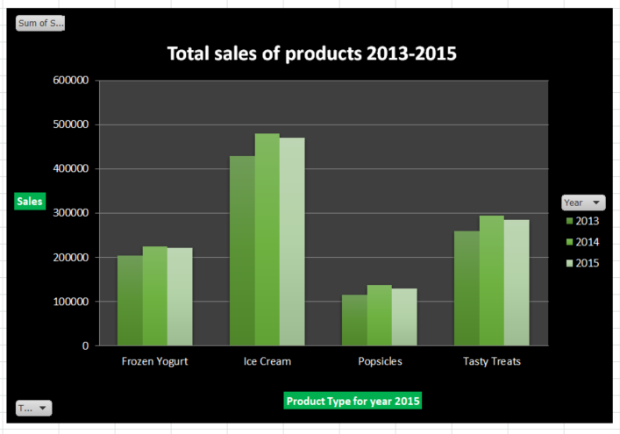

2. **Creating a pivot table and group data**

A pivot table showing product sales grouped in years. 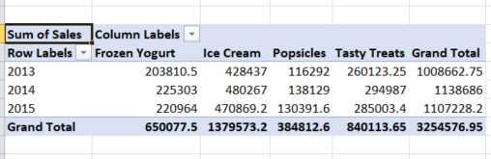

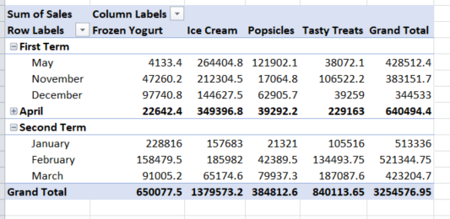

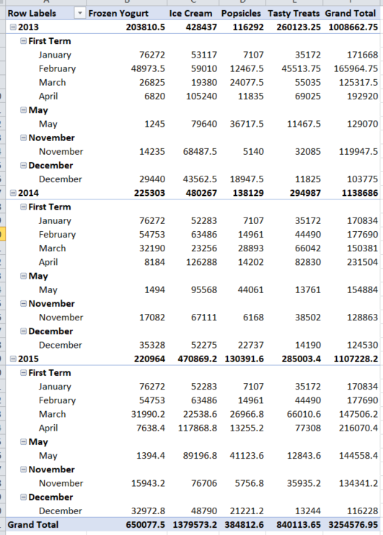

3. **Creating a shape object and assign a macro to it that displays in a message**

**the current date**

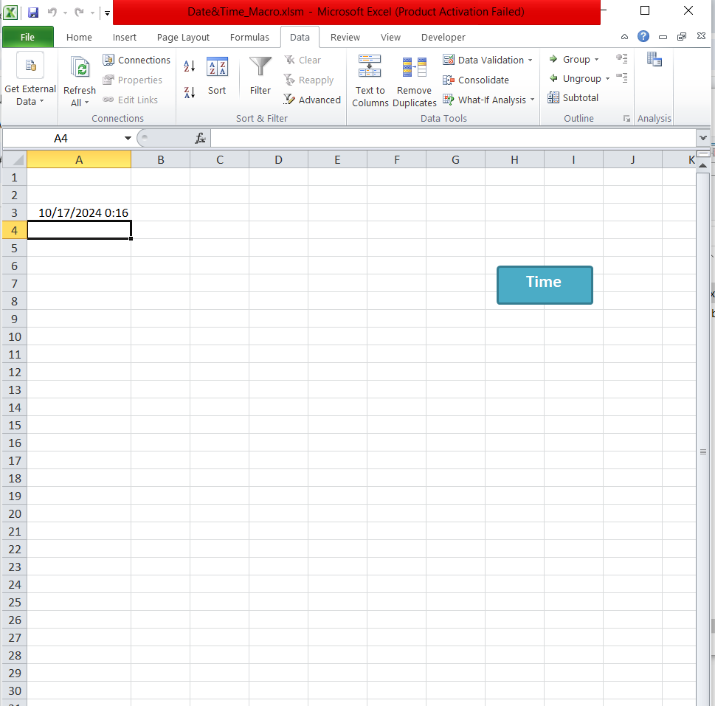

4. **Creating a procedure that declares variables of type string and integer**

Sub str()

Dim Name As String

Dim Age As Integer

MsgBox "Declaring variables of type string and integer"

End Sub

5. **Creating a VBA procedure that changes the font color of the table to bold**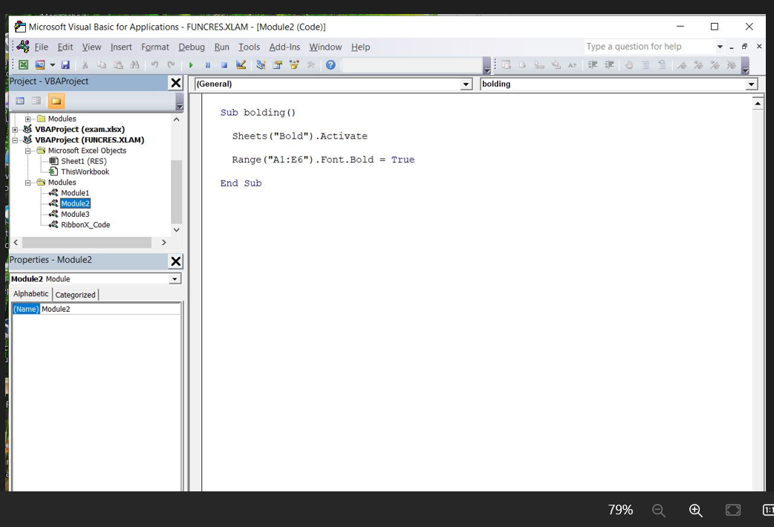

6. **Creating a VBA procedure that adds a yellow explanation column to the right of the table. (the header of that column is the explanation and fill that column with yellow)**

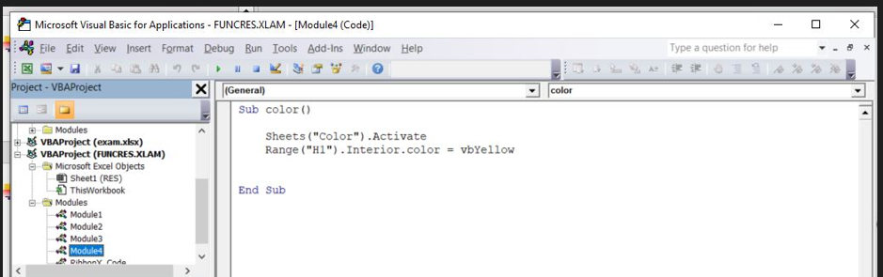

7. **Creating a VBA procedure that uses a loop**

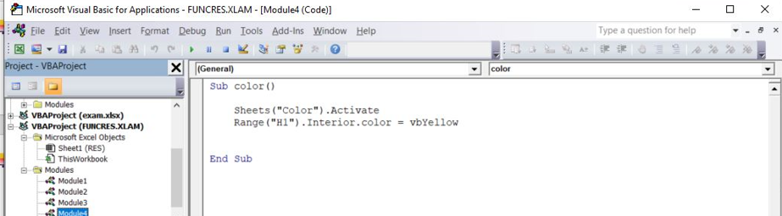

8 **Creating a message box that displays the number of executions of one procedure**

