CA3203
FULL STACK SOFTWARE DEVELOPMENT
WORKING WITH GIT

ANTONY MELBERN J
2025178022
M.C.A (R) (1ST YEAR)

Aim of the exercise:

System Configuration:
Operating System: Windows 10 Pro
Git Version: git version 2.52.0.windows.1
UserName: Melbern_2004

ScreenShots:

Git initialization:
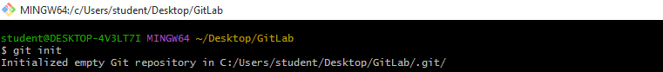

Commit history:
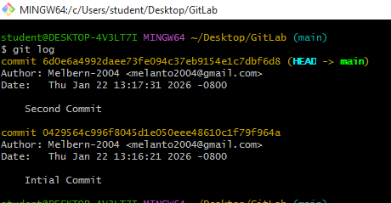

Branch creation and merge: 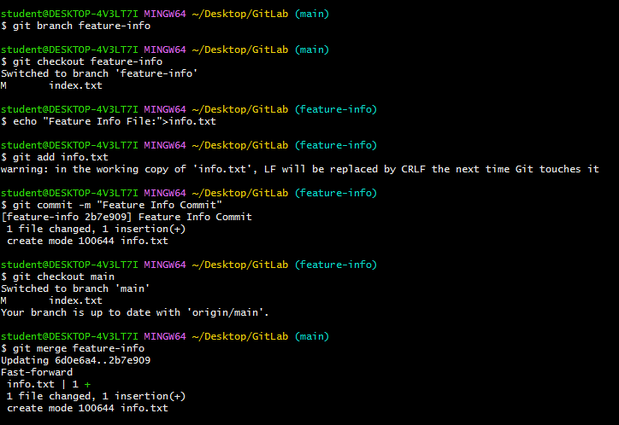

Repository:
