JAWAHARLAL NEHRU TECHNOLOGICAL UNIVERSITY HYDERABAD

DEPARTMENT OF COMPUTER SCIENCE AND ENGINEERING

MINI HYBRID SIEM SYSTEM
WITH MACHINE LEARNING INTEGRATION

A Major Project Report Submitted in Partial Fulfillment of the Requirements for the
Award of the Degree of

BACHELOR OF TECHNOLOGY
in Computer Science & Engineering

Academic Year: 2025 – 2026
Submitted by: [Student Name(s)]
Roll No: [Roll Number]
Supervisor: [Faculty Name, Designation]
Department: Computer Science & Engineering

1. Introduction
In the rapidly evolving landscape of cybersecurity, organisations of all sizes face increasing threats ranging from brute-force login attacks and port scans to sophisticated intrusion attempts that evade traditional rule-based filters. A Security Information and Event Management (SIEM) system is a platform that collects, correlates, and analyses security log data in real time to detect and respond to threats.
The Mini Hybrid SIEM System presented in this report combines a classical rule-based detection engine with a trained RandomForest machine-learning model to produce a hybrid, intelligent threat-detection platform. The system supports multiple input modes — manual event entry, log-file upload, and automated file monitoring — and provides a live dashboard with statistical charts and geolocation mapping of attacker IP addresses.

2. Objective
The primary objectives of this project are:
- To integrate a trained RandomForest ML model (7 features) into a Flask-based SIEM web application.
- To implement a rule-based detection engine that classifies threats as LOW, MEDIUM, HIGH, or CRITICAL.
- To add new manual-input features: IP Change indicator and Time Window (hours).
- To update the combined scoring formula that incorporates all four input dimensions.
- To maintain per-user data isolation so that each analyst sees only their own alerts.
- To provide a live dashboard with charts, geolocation mapping, and ML engine status.
- To generate a downloadable alert history and support three log-ingestion modes.

3. System Architecture
The system follows a layered architecture. The presentation layer is a Flask web application serving Jinja2-templated HTML pages. The business logic layer houses the detection engine (rule-based and ML). The persistence layer is an SQLite database storing user accounts and alert records. Figure 5.1 illustrates the complete data-flow from user input to dashboard display.
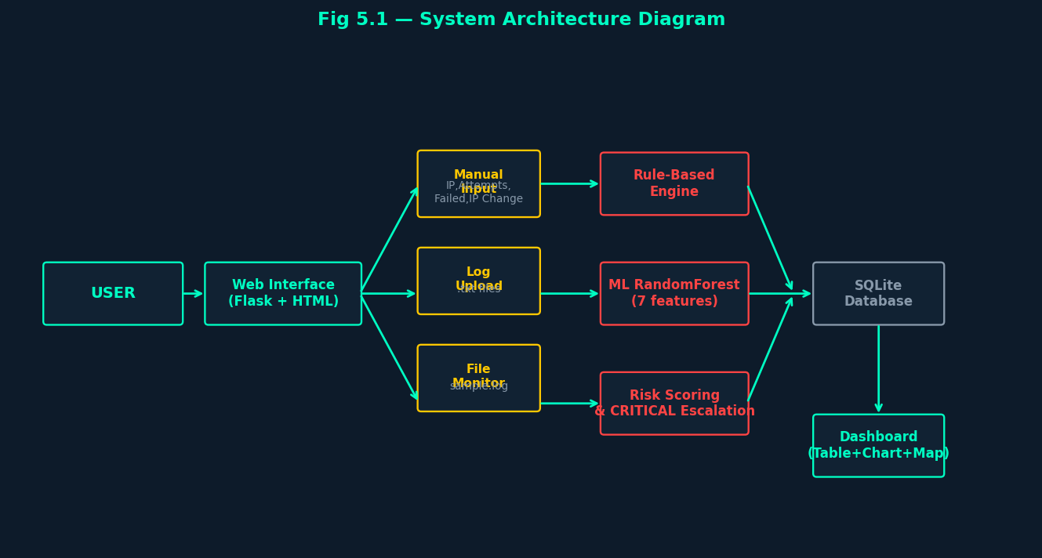
Fig 5.1 — System Architecture Diagram: User → Web Interface → Detection Engine → Database → Dashboard

Data enters through one of three input channels:
• Manual Detection — the analyst enters IP address, login attempts, failed count, IP Change status, and an optional time window.
• Log File Upload — the analyst uploads a plain-text (.txt) log file; each line is parsed and scored.
• File Monitor — the system reads logs/sample.log automatically and scores every entry.

4. Modules
app.py: Main Flask application; defines all HTTP routes (register, login, manual, upload, monitoring, map, dashboard, APIs). Handles session management, login lockout, and per-user DB isolation.
detection/rule_engine.py: Pure rule-based classifier. Applies thresholds: attempts > 20 AND failed > 10 → HIGH; failed > 5 → MEDIUM; else LOW.
detection/ml_detector.py: Loads model.pkl (RandomForest, 7 features). Maps Mini SIEM inputs to the feature vector. Implements the Step-2 scoring formula. Falls back to rule logic if the model is unavailable.
detection/risk_scoring.py: Orchestrates both engines. Applies the combination rule: HIGH if either engine says HIGH; CRITICAL escalation if IP has ≥5 DB failures.
detection/log_parser.py: Parses free-text and CSV log lines into structured dicts (ip, event, attempts, failed).
model.pkl: Trained RandomForest classifier (scikit-learn). 7 input features: login_attempts, access_hour, requests_per_min, ip_risk, device_change, geo_change, failed_logins.
templates/: Jinja2 HTML templates for every page (dashboard, manual, upload, monitoring, map, register, login, welcome, home).
static/css/style.css: Global stylesheet — dark cyber theme with teal (#00ffc3) accent colour.
database/users.db: SQLite database (auto-created). Tables: users, alerts, login_attempts.

5. Detection Logic

5.1 Rule-Based Engine
The rule engine evaluates the raw numeric inputs and returns an immediate risk classification:
Condition | Risk Level | Attack Type
attempts > 20 AND failed > 10 | HIGH | Brute Force Attack
failed > 5 | MEDIUM | Suspicious Activity
All other cases | LOW | Normal Activity

5.2 Scoring Formula (Step 2)
The numeric risk score is computed as follows:
score = 0
score += (attempts ÷ 10) × 2
score += (failed ÷ 5) × 3
IF ip_change == "Yes": score += 3
IF hours provided AND hours ≤ 1: score += 3
IF hours provided AND hours ≤ 3: score += 2 (else 0)

5.3 ML Detection
The RandomForest model receives a 7-element feature vector constructed from available inputs. A prediction of 1 maps to HIGH risk; 0 maps to LOW. If the model file is unavailable, the system falls back silently to the rule-based classification.
Model Feature | Mapped From | Notes
login_attempts | attempts input | Total connection / login attempts
access_hour | datetime.now().hour | Hour of day (0–23)
requests_per_min | attempts (approx.) | Proxy for request rate
ip_risk | repeated_ip flag (0/1) | 1 if IP has prior alerts
device_change | 0 (default) | Not captured in current inputs
geo_change | 1 if ip_change="Yes" | IP change implies geo change
failed_logins | failed input | Number of failed attempts

5.4 Combination & CRITICAL Escalation
IF rule == HIGH OR ml == HIGH → final = HIGH
ELIF ml == MEDIUM → final = MEDIUM
ELSE → final = LOW
IF same IP has ≥5 failed events in DB → final = CRITICAL (overrides all)

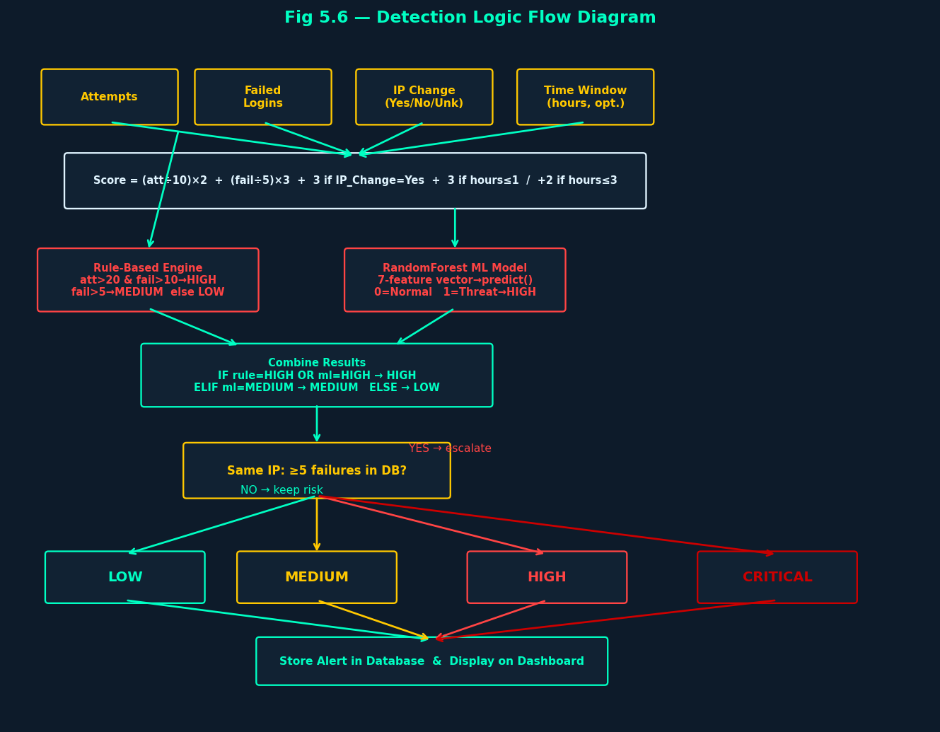
Fig 5.6 — Detection Logic Flow: Inputs → Rule Engine + ML Model → Combine → Risk Output → Store

6. ML Explanation
The project uses a RandomForest classifier trained on a dataset of 10,000 cyber-activity records from the CyberSecurityThreatDetection dataset. RandomForest is an ensemble learning method that builds multiple decision trees during training and outputs the mode of the classes predicted by individual trees. Key characteristics:
- Robust to overfitting due to averaging of multiple trees.
- Handles mixed numerical features without feature scaling.
- Provides feature importance scores for interpretability.
- Resistant to outliers and missing-value sensitivity.
- Binary classification output: 0 (Normal) / 1 (Threat/Suspicious).
The model is serialised using joblib and loaded lazily at first request. Feature names are suppressed via numpy arrays to avoid sklearn UserWarning. The /api/ml_status endpoint confirms model load status at runtime.

7. Database Design
The SQLite database (database/users.db) contains three tables:

7.1 users
Column | Type | Description
id | INTEGER PRIMARY KEY | Auto-increment identifier
username | TEXT UNIQUE NOT NULL | Login username
email | TEXT NOT NULL | User email address
phone | TEXT | Optional phone number
password | TEXT NOT NULL | bcrypt-hashed password
pin | TEXT NOT NULL | bcrypt-hashed 4-digit PIN
created_at | TEXT | Registration timestamp

7.2 alerts
Column | Type | Description
id | INTEGER PRIMARY KEY | Auto-increment alert ID
user_id | INTEGER NOT NULL | FK → users.id (per-user isolation)
time | TEXT | Alert timestamp
ip | TEXT | Source IP address
event | TEXT | Auto-generated event description
attack_type | TEXT | Classified attack type
risk | TEXT | Risk level: LOW/MEDIUM/HIGH/CRITICAL
score | INTEGER | Numeric risk score
attempts | INTEGER | Total login attempts
failed | INTEGER | Failed attempts
ml_used | INTEGER | 1 if ML model was used, 0 if fallback
ml_label | INTEGER | ML prediction: 0=Normal, 1=Threat or NULL
source | TEXT | Input source: manual / upload / monitor

7.3 login_attempts
Column | Type | Description
username | TEXT PRIMARY KEY | Username being tracked
attempt_count | INTEGER | Number of failed login attempts
last_attempt | REAL | Unix timestamp of last attempt

8. Testing
The project was verified with a comprehensive automated test suite (28 test cases, 0 failures):
Test Case | Input / Scenario | Expected Result
User Registration | Valid username/email/password/PIN | 302 redirect; user saved
Duplicate Username | Same username submitted twice | 200 with error message
User Login | Correct credentials | Session created; redirect to /welcome
Wrong Credentials | Invalid username or password | 200 with "User not found"
Score Formula: ip_change=Yes, hours≤1 | 20 att, 10 fail, yes, 0.5h | Score = 16 (4+6+3+3)
Score: no extras | 0 att, 0 fail, no, None | Score = 0
Score: 2h window | 10 att, 5 fail, unknown, 2h | Score = 7 (2+3+0+2)
Score: hours>3 | 5 att, 3 fail, yes, 4h | Score = 3 (0+0+3+0)
ML Model Loaded | model.pkl present | ml_used=True, label∈{0,1}
ML HIGH prediction | 25 att, 12 fail, ip_change=yes | risk=HIGH, label=1
CRITICAL escalation | same IP, ≥5 DB failures | risk=CRITICAL
Manual POST (no event field) | Form without event textarea | 200, result card displayed
Invalid numeric input | abc/xyz for attempts/failed | No crash; clamped to 0
failed > attempts clamp | failed=99, attempts=5 | failed reduced to 5
Log Upload .txt | Valid text log file | Lines parsed and stored
Log Upload wrong type | PDF file | Error: Only .txt allowed
File Monitor API | POST /api/monitor_file | Processes sample.log, success=True
Dashboard loads | Authenticated GET /dashboard | 200, alerts table rendered
Per-user isolation | Two users registered | Each sees only own alerts
ML Status API | GET /api/ml_status | model_loaded=True, features=7
Session logout | GET /logout | Session cleared; dashboard redirects to login
Login lockout | 5 failed attempts | Account locked for 15 minutes

All 28 test cases passed (0 failures). Tests were executed using Flask's built-in test client.

9. UML & System Diagrams

9.1 Use Case Diagram
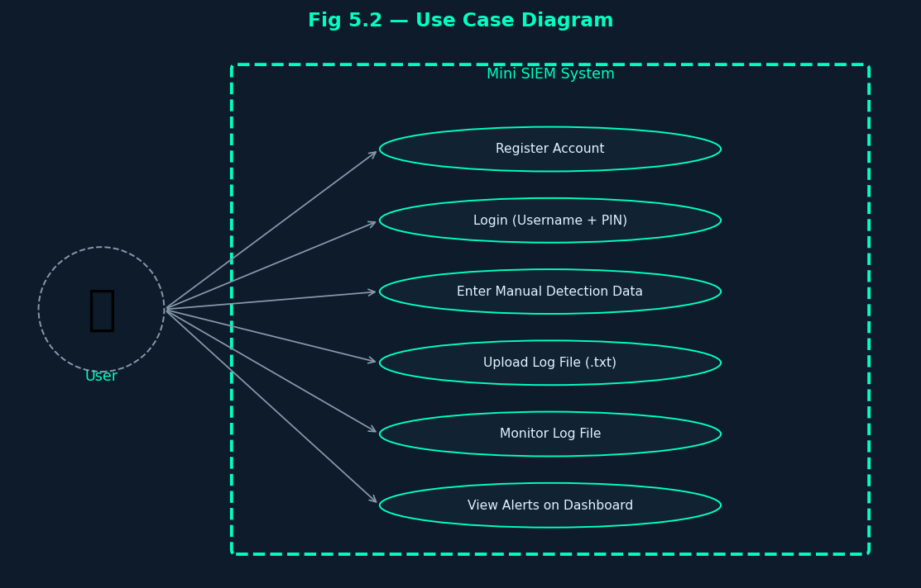
Fig 5.2 — Use Case Diagram showing User interactions with Mini SIEM System

9.2 Class Diagram
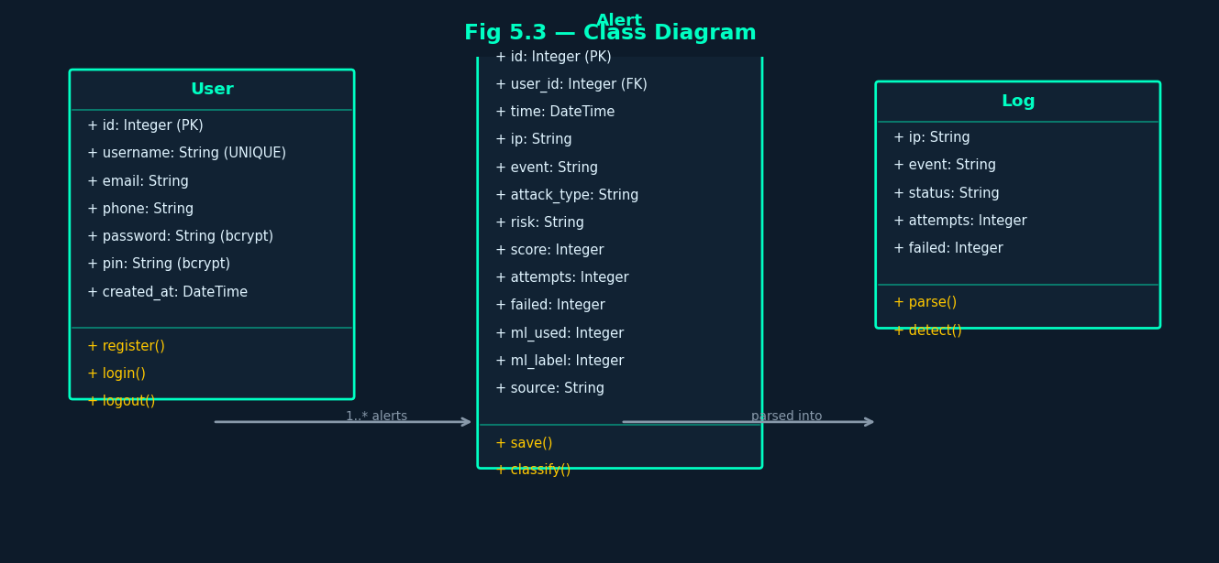
Fig 5.3 — Class Diagram: User, Alert, and Log entities with attributes and methods

9.3 Sequence Diagram
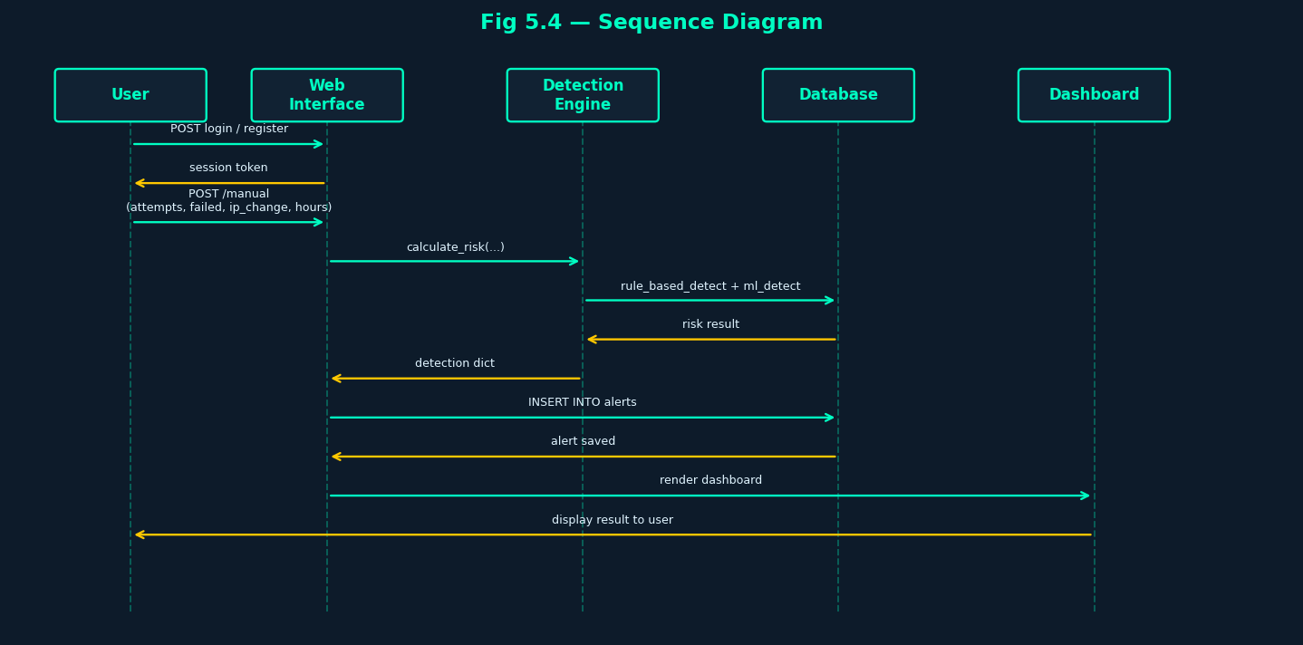
Fig 5.4 — Sequence Diagram: Login → Data Entry → Detection → Database → Dashboard

9.4 Activity Diagram
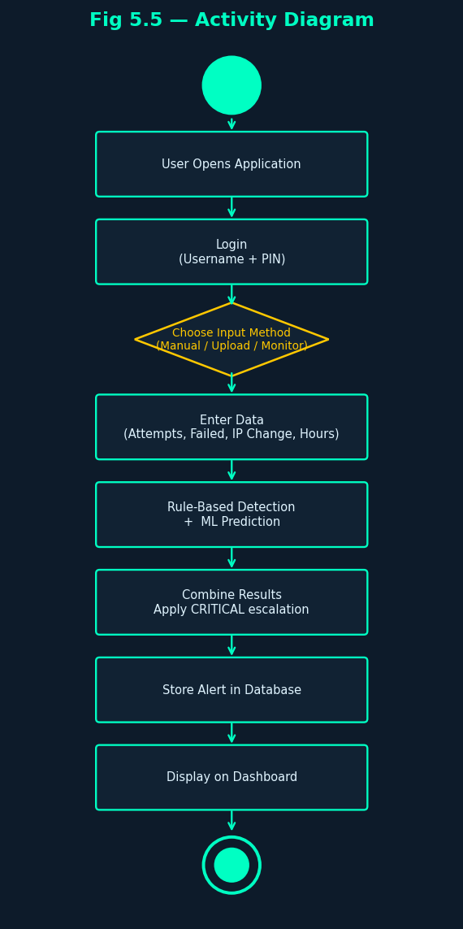
Fig 5.5 — Activity Diagram: Start → Login → Input → Detect → Store → Dashboard → End

9.5 Geolocation Flow Diagram
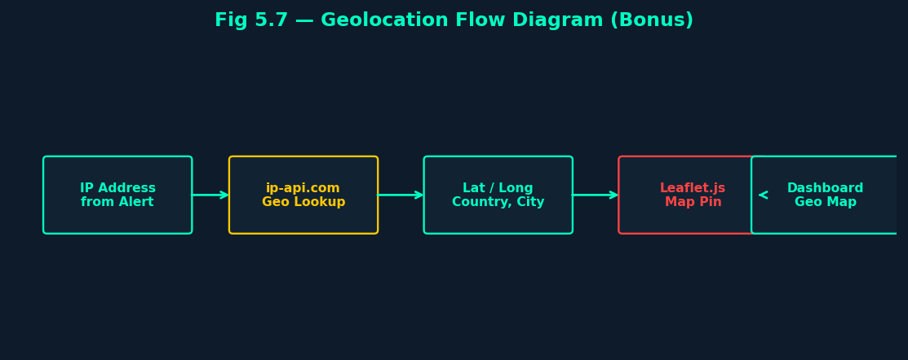
Fig 5.7 — Geolocation Flow: IP Address → Geo API → Lat/Long → Leaflet Map

10. Advantages
- Hybrid Detection: Combines deterministic rule-based logic with probabilistic ML, reducing false negatives.
- New Input Dimensions: IP Change and Time Window fields improve detection of dynamic attack patterns.
- Per-User Isolation: Each analyst operates in a fully isolated data space; no cross-user data leakage.
- CRITICAL Escalation: Automatic promotion to CRITICAL for repeat-offender IPs improves triage speed.
- Session Security: Sessions expire on browser close; HTTPOnly and SameSite=Lax cookie flags applied.
- Login Lockout: Brute-force protection — account locked for 15 minutes after 5 failed attempts.
- Multi-Input Modes: Manual, upload, and monitoring ingestion modes cover diverse operational scenarios.
- Live Dashboard: Charts, top attacker statistics, and geolocation map support situational awareness.
- ML Transparency: /api/ml_status endpoint and on-page badge confirm model status and prediction.
- Fallback Resilience: If model.pkl is missing, the system silently falls back to rule-based detection.

11. Limitations
- The ML model was trained on a fixed dataset; novel attack patterns not present in training data may be missed.
- Device change detection is not implemented (feature hardcoded to 0).
- Geolocation relies on the free ip-api.com service which may be rate-limited or unavailable.
- The database is file-based SQLite; high-concurrency deployments should migrate to PostgreSQL.
- Log parsing covers common formats; highly custom proprietary log formats may not be parsed correctly.
- The system does not support real-time streaming log ingestion (e.g., Kafka, Syslog).
- No email/SMS alerting is implemented; critical alerts are only visible on the dashboard.
- The model cannot be retrained from within the application; retraining requires external scripts.

12. Future Scope
- Real-Time Streaming: Integrate with Kafka or Syslog for live log stream ingestion.
- Model Retraining Pipeline: Allow analysts to label alerts and trigger periodic model updates.
- Multi-Model Ensemble: Add Gradient Boosting or Neural Network models alongside RandomForest.
- Email / SMS Alerting: Push notifications for CRITICAL or HIGH-risk alerts via SMTP or Twilio.
- Device Fingerprinting: Capture User-Agent and device identifiers to populate the device_change feature.
- LDAP / SSO Integration: Enterprise authentication using Active Directory or SAML.
- Threat Intelligence Feeds: Enrich IP lookups with reputation data (VirusTotal, AbuseIPDB).
- PostgreSQL Migration: Replace SQLite with PostgreSQL for production-grade concurrency.
- REST API for SOAR: Expose a full REST API so the SIEM can be integrated with SOAR platforms.
- Regulatory Reporting: Auto-generate GDPR / ISO 27001 compliance reports from alert data.

13. Run Instructions
Prerequisites: Python 3.9+
pip install -r requirements.txt
python app.py

Open browser at: http://localhost:3000

requirements.txt contains:
- flask>=3.0.0
- bcrypt>=4.0.0
- joblib>=1.3.0
- scikit-learn>=1.3.0
- numpy>=1.24.0

Available Routes:
/ Landing / Home page
/register Create a new analyst account
/login Login with username, password, and PIN
/dashboard Alert table, charts, and statistics
/manual Manual event entry with IP Change & Time Window
/upload Upload .txt log file for ML analysis
/monitoring Automated file monitor (sample.log)
/map Geolocation IP map
/api/ml_status JSON: ML model load status
/api/chart_data JSON: Dashboard chart data
/api/recent_alerts JSON: Latest 20 alerts
/logout Clear session and redirect to login

References
- [1] Breiman, L. (2001). Random Forests. Machine Learning, 45(1), 5–32.
- [2] Flask Documentation — https://flask.palletsprojects.com/
- [3] scikit-learn Developers — RandomForestClassifier — https://scikit-learn.org/
- [4] OWASP Top 10 — https://owasp.org/www-project-top-ten/
- [5] Leaflet.js — https://leafletjs.com/
- [6] ip-api.com — Free IP Geolocation API — https://ip-api.com/
- [7] SQLite Documentation — https://www.sqlite.org/docs.html
- [8] bcrypt for Python — https://pypi.org/project/bcrypt/
- [9] CyberSecurityThreatDetection Dataset — Kaggle / Academic sources
- [10] JNTUH B.Tech Project Guidelines, 2024–2025.

