7MR10070: Software and Robotic Integration

Semester 2

Final Project

Written by Alexandros Megalemos

# ROS-Slicer integration and robotic control

# Introduction

Before describing why integrating image processing and robotic simulation is useful in medical applications, we need to describe if they are useful on their own.

## Image Processing

Image processing (i.e. segmentation, registration, image guided systems) has proven to be a vital tool in the medical field. Some of its uses include:

* Improving/Restoring the quality of images in order to help physicians pick out important details/diseases in them
* Through machine learning and neural network techniques, extracting features from the image and learning how to detect said details/diseases automatically or separating different tissues from each other again in order to assist physicians
* In combination with machine learning techniques, assisting untrained physicians in figuring out how pick out certain details in unseen scenarios by learning how to generate new examples[1]
* Assisting surgeons in surgeries by providing visual guidance for procedures

## Robot Simulation

There is a huge need of robotic assistance in the medical field. Whether it is in surgery or in assistive robotics, robots will start playing a bigger role in medicine. There is a multitude of reasons for this and some of them are:

* Robots provide high precision movement
* Assuming a model/procedure has been figured out, creating a new robot takes far less time than training a new physician/surgeon
* Fills in certain roles that people lack interest in doing so themselves (such as nursing positions)
* Reduces the bus factor[1] the field currently suffers from by heavily relying on individual people

Given the sensitive subject and that the intended use of robots can have long lasting or even fatal consequences if something does not go as planned, simulations help figure out certain problems before using a robot on an actual person. More specifically, robotic simulations can be used to:

* Determine if the specifications provided satisfy the task at hand
* Identify any design flaws early on
* Provide the ability to test multiple configurations to decide which configuration is better for the task
* By isolating software and hardware components, help figure out which part of the robot might cause/is causing an issue

## Integrating the two

Integrating image processing and robotic simulation allows us to optimise our system, improving performance both in terms of accuracy and execution time. For example, using image processing techniques we can plan a path or choose the best starting point in a surgery simulation and then have the robot perform the task based on that optimisation. Furthermore, using proper image processing techniques, we can recognise important/vulnerable areas that the robot can be programmed to take better care around.

## Developing an end-to-end pipeline

Developing an end-to-end pipeline is probably one of the most important parts of robotic and imaging integration. By developing an end-to-end pipeline, we can figure out certain problems that will arise to individual parts of the pipeline right from the beginning. For example, if we know that a specific part of our image processing algorithm consistently underperforms (and can’t fix it), we can configure our robot to take that into account. This would not have been possible if the two parts of the system were designed in isolation.

Moreover, designing the architecture and how different modules and components interact with each other, we allow for better scaling of the system when new features need to be added. Furthermore, proper design and implementation can help make certain components re-usable, speeding up the process of development as well as allow other developers/organisations to take advantage of said components in order to solve greater problems faster.

After designing the pipeline, we can then use automated (and manual) validation techniques in order to assess the accuracy and robustness of our whole system. Using unit testing we can see how each individual part performs and once we are sure every part works well on its own, we can start using integration testing. Here all (or multiple) components are tested together, thus ensuring that our framework can work well from one end to the other. Of course, we must still be cautious as if we have not designed our tests or model correctly, we can miss important issues in the system and under the false assumption of passing tests go into manufacturing which might be a waste of time and money. In even worse cases, we can cause serious harm to a person in a real-life scenario.

# Methodology

## 3D slicer path planning

The path planning aspect of the pipeline is separated into 4 different tasks, performed in the following order:

1. Avoidance of a critical structure
2. Placement of the tool into a target structure
3. Trajectory is below a certain length
4. Maximizing distance from critical structures

The path planning steps are executed in the order specified above. We start with the least complex (in terms of time and space) algorithm and work our way down to the most complex. Therefore:

1. First, create the OBB trees required for each task
2. Then, filter for targets that are within the hippocampus
3. After that, filter for entry/target trajectories that do not pass through the ventricles
4. After that, we filter for entry/target trajectories that do not pass through blood vessels
5. Finally, we filter so that only trajectories of a certain angle (degrees) are accepted

By doing this, we rule out most of the trajectories before we reach the more expensive checks in our overall algorithm. This is clearly demonstrated by the total time taken of ~25 seconds, whereas before filtering just for valid angles would take more than 100 seconds.

**Note:** Where pseudocode is provided, it is written in a generic form and does not contain any language/library specific syntax. Moreover, the provided .vtk files were converted to labelmaps using the “Model to Label Map” module.

### Avoidance of a critical structure

We transform the input node to an IKJ matrix and then loop over each target image. To decide if a target point is within our target area, we iterate over all the target points and retrieve the pixel value for each one. If its value is greater than zero (or 1), it is a valid target. The function used to do this is called **getFilteredTargets(targets, area)** and should accept any area we want to filter for.

Time complexity: $O\left(N_{tp}*R_{pv}\right)$

$$where N_{tp} is the total number of target points, R_{pv} is the lookup time for the pixel value$$

Pseudocode:

For each point in target points:

Get the coordinates (x, y, z) of the point

Retrieve the pixel value of (x, y, z) in the image

If pixel value == 1:

Add the point to the list

### Placement of the tool into a target structure

We first create an oriented bounding box tree (OBBTree) of the ventricles. We then iterate over each entry and target pair and check if the pair intersects any of the bounding boxes defined by the OBBTree. If there is an intersection, we reject the path. The function used to do this is called **getTrajectoriesAvoidingArea(entriesAndTargets, area)** and should accept any area we want to avoid. It is important to note that this function uses **isPassThroughArea(tree, entry, target)** which is where the actual intersection check is made. I chose to separate the check so that it can be used in combination with the other constraints, without having to loop through each entry target pair for each one every time.

Time complexity:

Pseudocode:

For each entry point in entry points:

For each target point in target points:

Get the line between the two points

Get the points of the line

validLine = true

For each point on the line:

If point passes through ventricle:

validLine = false

break

if validLine:

add (entry, target) point to valid points list

### Trajectory is below a certain length

We first create an oriented bounding box tree (OBBTree) of the blood vessels. We then iterate over each entry and target pair and check if the pair intersects any of the bounding boxes defined by the OBBTree. If there is an intersection, we reject the path. The function used to do this is called **getTrajectoriesAvoidingArea(entriesAndTargets, area)** and should accept any area we want to avoid. It is important to note that this function uses **isPassThroughArea(tree, entry, target)** which is where the actual intersection check is made. I chose to separate the check so that it can be used in combination with the other constraints, without having to loop through each entry target pair for each one every time.

Time complexity:

Pseudocode:

For each entry point in entry points:

For each target point in target points:

Get the line between the two points

Get the points of the line

validLine = true

For each point on the line:

If point passes through blood vessel:

validLine = false

break

if validLine:

add (entry, target) point to valid points list

### Maximizing distance from critical structures

We first create an oriented bounding box tree (OBBTree) of the cortex. We then iterate over each entry and target pair and check if the pair intersects any of the bounding boxes defined by the OBBTree. If there is an intersection, we create a line perpendicular to the intersection. We then create two vectors, one for our entry/target pair and one for the intersecting points and calculate the angle between the two. If the angle is below the specified limit (55), we accept the path. The function used to do this is called

**getTrajectoriesWithSpecifiedAngle (entriesAndTargets, area, specifiedAngle)** and should accept any area we want check the angles for. It is important to note that this function uses **isValidAngle()** which is where the actual check for the angle is made. I chose to separate the check so that it can be used in combination with the other constraints, without having to loop through each entry target pair for each one every time.

Time complexity: $O\left({2*N}_{ep}*N_{tp}*log\left(N_{cp}\right)*T_{a}+N_{cp}log\left(N_{cp}\right)\right)$

$$where N_{ep} is the number of entry points, NP_{tp} is the number of target points and N_{cp} is the$$

$$number of points cortex points and T_{a} is the time needed to calculate the angle$$

$between two vectors$

Pseudocode:

For each entry point in entry points:

For each target point in target points:

Get the line, lineET, between the two points

For each point on line:

If point connects with the cortex:

Get perpendicular line where lineET passes through the cortex

Calculate the angle between the two lines

If angle < 55:

Add (entry, target) point to valid points list

## OpenIGTLink

In order to send messages between the two we use the OpenIGTLink protocol. OpenIGTLink defines the message format that is used to transfer data between Slicer and ROS. The message consists of a header, an extended header, the content and some meta data. Furthermore, we need to define an importer in order to interpret the above message format. In order to achieve two-way communication, we an define an exporter that sends the current location of the end effector back to Slicer. Finally, we define a Calibrator in order to correctly transform the points between Slicer and ROS.

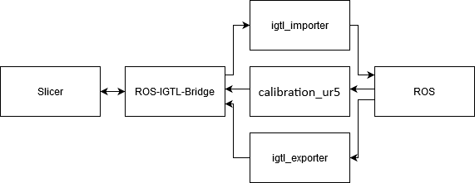

Figure 1: Connection between Slicer and ROS

## Data transfer from 3D Slicer to ROS: igtl_importer.py

The data transfer from 3D Slicer to ROS works using the igtl_importer.py file. It takes an entry point (named ‘Entry’) and a target point (named ‘Target’) and operates as follows:

* It receives the two points and moves to the “Entry” point
* Waits for user input to perform the operation by moving to the target point. It moves the robot to the target point by creating a line/trajectory between the two. This is done by breaking said line to smaller points and forming a cartesian path. The reason it is implemented this way (the straight line) is because we are moving the robot’s end effector (i.e. a needle) in a straight line through the brain
* It should be noted that the orientation has to be calculated based on the vector between entry and target point. This is done by creating two perpendicular vectors to the entry-target vector and calculating the quaternion of the three.

Furthermore, it converts points from millimetres (Slicer’s configuration) to meters (ROS’ configuration). Finally, the kinematics are solved and executed through the use of the move_it framework.

## Data transfer from ROS to 3D Slicer: igtl_exporter.py

This is a rather simpler implementation. The exporter reads the robot’s current pose in real time, using the move_it package and sends the coordinates of the end effector to Slicer. This is mainly done for validation/sanity checks.   
Furthermore, similarly to the importer, it converts the points from meters (ROS’s configuration) to millimetres (Slicer’s configuration)

## ROS (to move the robot)

For simplicity, we use the robot provided by ismr19_moveit package in “demo.launch”. It provides:

* As mentioned above, a RobotModel that is built for ROS and visualised in RVIZ
* A kinematics model for the robot as well as various kinematic solvers to automate the calculation of kinematics based on the used RobotModel

The core classes of this are RobotModel and RobotState.

The RobotModel contains relations between all links and joints including their limits (collision, safety limits, etc), as defined by the URDF and SDRF files.

The RobotState contains information about the robot at any point in time. It is used to obtain kinematic information about the robot depending on its current state.

Furthermore, we modify the robot to include a needle are required for our task.

## Calibration (to translate points between ROS and Slicer)

The calibration (and therefore the transformation) occurs after we have calculated the entry and target points using the Path Planner module. This is done using the following steps:

1. Create 8 markups/points around the provided models (i.e. the critical structures and the cortex, forming a bounding box) in Slicer.
2. Create 8 points that form a bounding box in ROS, using the same measurements as the bounding box we created in Slicer (note: These are currently hard coded in calibration_ur5.py in the robot_control package and might have to be changed for completely different configurations).
3. Then we run the calibration_ur5.py script, which prompts the user to save each calibration point in Slicer, one by one.
4. We then go to Slicer, where we can build a linear transformation matrix using the Fiducial Registration Wizard which is found in the IGT extension/module. The Fiducial Registration Wizard maps the 8 fiducials created in Slicer to the 8 points sent by ROS through the calibrator.
5. Then, we invert the transformation matrix and we transform the critical structures, the cortex, the entry points and target points. In order to send the transformed items, we need to use the ‘harden’ functionality provided by Slicer.

# Validation

## 3D slicer path planning

For each part of the Path Planner module, following overall process was used:

1. Pick a small subset of the data
2. Visually look for a trajectory / point that is obviously valid for a task and for one that is obviously invalid for a task. For example, when filtering for targets within the hippocampus, the invalid point could be one outside the image.
3. Run the algorithm
4. Inspect the output in slicer
5. Increase the subset of data gradually

Furthermore, we use unit testing to provide automated tests as well. These can be found in PathPlanner.py and are the following:

**testLoadAllData(path):** check that data has been loaded successfully**testGetFilteredHippocampusValidTargets():** check that targets are correctly filtered down to hippocampus targets

**testGetFilteredHippocampusInvalidTargets():** check that targets are correctly rejects invalid targets

**testAvoidBloodVesselsDilateValidPath()**: check that the algorithm accepts a path that doesn’t pass through the blood vessels dilate **testAvoidBloodVesselsDilateInvalidPath()**: check that the algorithm rejects a path that passes through the blood vessels dilate

**testAvoidBloodVesselsValidPath()**: check that the algorithm accepts a path that doesn’t pass through the blood vessels **testAvoidBloodVesselsInvalidPath()**: check that the algorithm rejects a path that passes through the blood vessels

**testAngleValidPath():** check that the algorithm accepts a path that hits the cortex at the correct angle

**testAngleInvalidPath():** check that the algorithm rejects a path that hits the cortex at an incorrect angle**testCountRejectedTrajectories(True):** To count rejected trajectories and time each part. This is a slow test**testAllTogether():** Just to see if everything is able to run together (pseudo test for task 4). This is a slow test

## ROS (to move the robot and confirm connection)

### Setting up the connection

#### Slicer Part

1. Launch Slicer 4.8.1
2. Go to your favourite IGTLink extension (SlicerIGT in this case)
3. Create a connection with Slicer as the server on port 18944

#### ROS Part

1. Start the VM (if using one. I run this on Ubuntu, so it was not required) with the appropriate configuration for two-way communication
2. Launch the bridge file of the *ros_igtl_bridge*
3. Choose to run as client
4. Set IP to the appropriate IP found by writing “ifconfig” in your terminal
5. Set port to 18944

A connection should be now established.

### Sending data from Slicer to ROS

First initialize the connection as mentioned in the methods section. Then:

### Step 1:

1. In Slicer 4.8.1
2. Go to Markups
3. Create a new MarkupFiducials called “Entry” and/or “Target”
4. Place a point in the workspace (I did this the other way around. I manually moved the robot in RVIZ and those coordinates instead)

### Step 2:

1. Launch a new terminal
2. Go to your workspace and source it
3. Enter “roslaunch ismr19_moveit demo.launch”

### Step 3:

1. Launch a new terminal
2. Go to your workspace and source it
3. Enter “rosrun robot_control igtl_importer.py”

### Step 4:

1. Launch a new terminal
2. Go to your workspace and source it
3. Enter “rosrun robot_control igtl_exporter.py”

### Step 5:

1. Go back to slicer
2. Go to IGT -> IGTLinkIF
3. Scroll down to I/O Configuration
4. Click on either “Entry” or “Target” (if you used the supplied scene) and click send

### Input Validation

### Valid Input (moves to a point)

*Figure 9: Robot's end effector at a random point (RVIZ)*

This figure shows our robot moved to a random position from the default one. This is to validate that the kinematics work as intended

### Invalid Input (can’t get to the point)

*Figure 10: Invalid position sent to ROS*

This figure shows the error message the robot publishes if an invalid configuration is requested. If the kinematics can’t be resolved, the robot simply passes message stating so.

## Slicer Scene

The images concerning the Slicer scene contain many elements.

* Green dots with blue background: The blue represents the points set on Slicer for the bounding box and the green ones within them are the ones sent by ROS. This clearly shows that the calibration was successful.
* Red dots: All the possible entry points
* Cyan dots: All the possible target point
* Yellow background surrounding a dot: The current position of the end-effector (as sent by ROS)
* Green dot: Best entry point
* Blue dot: Best target point

## Position Validation

### Default Position

Figure 11: Slicer with models loaded

This figure shows the Slicer scene with all the models and the best entry-target pair loaded.

### At Entry position

*Figure 2: End effector at entry point (view 1)*

*Figure 3: End effector at entry point (view 2)*

Here we have both a top and bottom view of the brain. As mentioned in the instructions above, we can see the yellow background around the entry point (green dot) which represents the end-effectors position. The yellow background is set only when we hit the “Send” button through the IGT extension.

### At Target Position

*Figure 4: End effector at target point (view 1)*

*Figure 5: End effector at target point (view 2)*

Here we have both a top and bottom view of the brain. As mentioned in the instructions above, we can see the yellow background around the target point (blue dot) which represents the end-effectors position. The yellow background is set only when we hit the “Send” button through the IGT extension.

## Ros Scene

### At default position

*Figure 6: Robot at default position (RVIZ)*

Here we can see our robot in its default position. The red part represents the needle that will be used to enter the brain

### At Entry position

*Figure 7: Robot's end effector at entry point (RVIZ)*

Here the cyan dot represents the entry point where the end-effector is currently position. The robot moves here once we send the entry point to the robot.

### At Target Position

*Figure 8: Robot's end effector at target point (RVIZ)*

Finally, we once we send the target point (the blue point within the brain), we can see that the robot correctly moves in a straight like and enters the brain at the desired point as requested.

## Whole system

The whole pipeline is a multistep process. Most parts require some manual observations, and this serves to provide extra safety/protection, assuming this would be translated to a real-life scenario. The steps required to run it are as follows:

1. We launch Slicer and load all our volumes (critical structures, cortex and entry-target points)
2. We convert the critical structures from “.vtk” format to labelMaps/markupFiducials using Slicer’s “Model to Label Map” module using as reference volumes the labelMaps given from the previous coursework.
3. We run our PathPlanner algorithm in order to calculate and save the best entry-target pair. Our scene should now resemble figures 2-4 (without the yellow background on the entry-target points)
4. We then initialise the connection and launch our robot in RVIZ as described in the *ROS (to move the robot and confirm connection)* section.
5. We then start the calibration process as mentioned in the *Calibration (to translate points between ROS and Slicer)* section.
6. Then using the resulting transformation matrix, we transform the critical structures, cortex and entry-target points of Slicer to match the workspace of ROS.
7. We use the ‘harden’ functionality on Slicer to have a correct representation of the structures/points and send the correct entry-target points to ROS.
8. We load the cortex (converted to .stl format using Slicer) as a marker node to RVIZ through RVIZ’s interface, using a scale factor of 0.001 to match Slicer’s and ROS’ measurements.
9. The cortex’s origin point in RVIZ is set according to the bounding box created during the calibration step. Once we ensure that the robot is placed correctly around the structure, we can start sending our entry and target point.
10. We go again to IGT in Slicer and click “Send” on the “Entry” point. We should now be able to see the robot’s end effector moving to the entry point in RVIZ (Figure 7: Robot's end effector at entry point (RVIZ)). The “Entry” point is loaded as a cyan marker.
11. At the same time, we can check the Slicer scene to confirm that the end effector is at the correct entry point. This is shown by the yellow background around the optimal entry position (Figure 2: End effector at entry point (view 1))
12. We then select the “Target” point Slicer and again click “Send”. We should now see the robot’s end effector moving to the target point from the entry point in a straight line (Figure 8: Robot's end effector at target point (RVIZ)). The “Target” point is loaded as a blue marker.
13. At the same time, we can check the Slicer scene to confirm that the end effector is at the correct target point. This is shown by the yellow background around the optimal target position Figure 4: End effector at target point (view 1)

These should be all the steps required to perform the whole pipeline. Scenes of these steps and saved models can be found within the repository under the “models and scenes” folders.

# Conclusions

## What was achieved

Through this project, we managed to correctly calculate the best trajectory that avoids critical structures based on the length, angle and distance from critical structures. This is achieved by employing various image processing techniques that optimise the traversal between points within large data structures using packages such as VTK, numpy and Slicer. Furthermore, we describe and set up a connection between Slicer 3D and ROS in order to perform the operation. Using the move_it and igtl_bridge packages, we successfully command a robot and transfer points and information between Slicer and ROS. We’ve also learned how to create a custom RobotModel even though we use the one provided by ismr19_moveit for simplicity. Finally, we learned how to calibrate models between different workspaces (Slicer and ROS) and how to set up markers in RVIZ to demonstrate the entry and target points and load cortex as an object in the scene.

## Future improvements

While the overall system performs the desired task, there is still a lot of room for improvement in various parts of the pipeline.

### Path planner module

The path planner module seems to work well. Still, we could have further optimised our code in order to speed up the process. Another point worth mentioned is the way we calculate the best trajectory. Here we weigh all critical structures as equal. Perhaps here we could have used a weighting system to better calculate the distance from multiple structures instead. Furthermore, after calculating the optimal entry-target, we could have automatically sent it to ROS but perhaps this might be risky if this was a real-case scenario.

### RobotModel

The chosen robot was appropriate as it includes a needle and is specialised for our task at hand. The robot is part of an open source project found on Github for a workshop meant to demonstrate a connection between Slicer and ROS [4]

### Calibration

An obvious improvement here is an automated bounding box calculator as we are currently choosing the points manually.

### Importer & Exporter

These are mostly fine. Here we could have split the code in more files/classes in order to make some parts reusable and separate some of the robot’s repositioning logic and IGTL logic.

### Overall

As mentioned above, while everything works and the pipeline is complete, we could have automated some of the manual parts (such as the calibration and sending points to ROS). Although, perhaps it is better this way as if it was a real case scenario, we would have to oversee each step individually in order to make sure everything is done safely.

# Code / Git Repository

https://github.com/Meldanen/kcl/tree/master/robotics/final

# References

[1] A. B. L. Larsen, S. K. Sønderby, H. Larochelle, and O. Winther, “Autoencoding beyond pixels using a learned similarity metric,” *33rd Int. Conf. Mach. Learn. ICML 2016*, vol. 4, pp. 2341–2349, 2016.

[2] A. Mohammed, L. Wang, and R. X. Gao, “Integrated image processing and path planning for robotic sketching,” *Procedia CIRP*, vol. 12, pp. 199–204, 2013, doi: 10.1016/j.procir.2013.09.035.

[3] A. Norouzi *et al.*, “Medical image segmentation methods, algorithms, and applications,” *IETE Tech. Rev. (Institution Electron. Telecommun. Eng. India)*, vol. 31, no. 3, pp. 199–213, 2014, doi: 10.1080/02564602.2014.906861.

[4] ISMR19 workshop.

Available at: <https://github.com/rosmed/rosmed.github.io/wiki/ISMR2019>

# Appendix

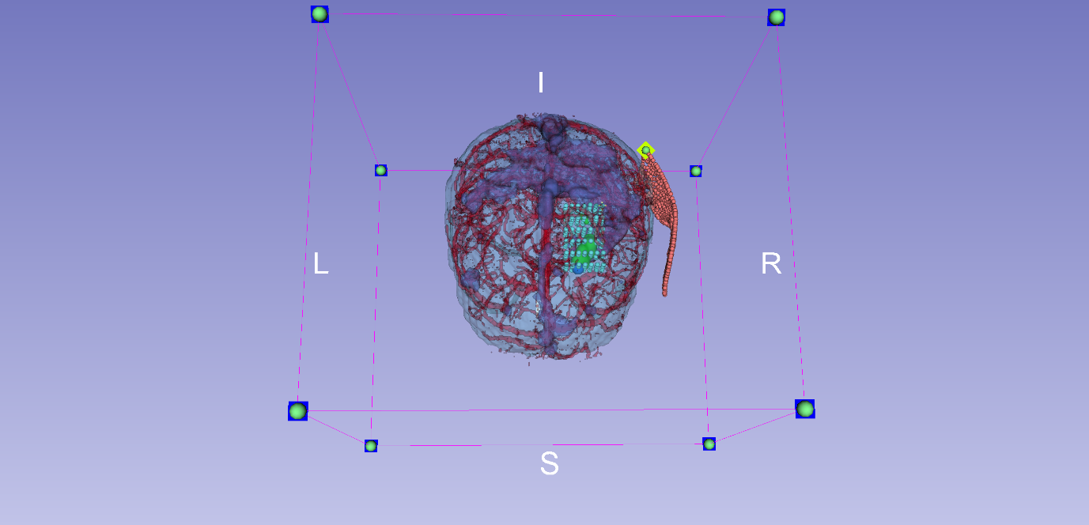

Figure : End effector at entry point (view 1)

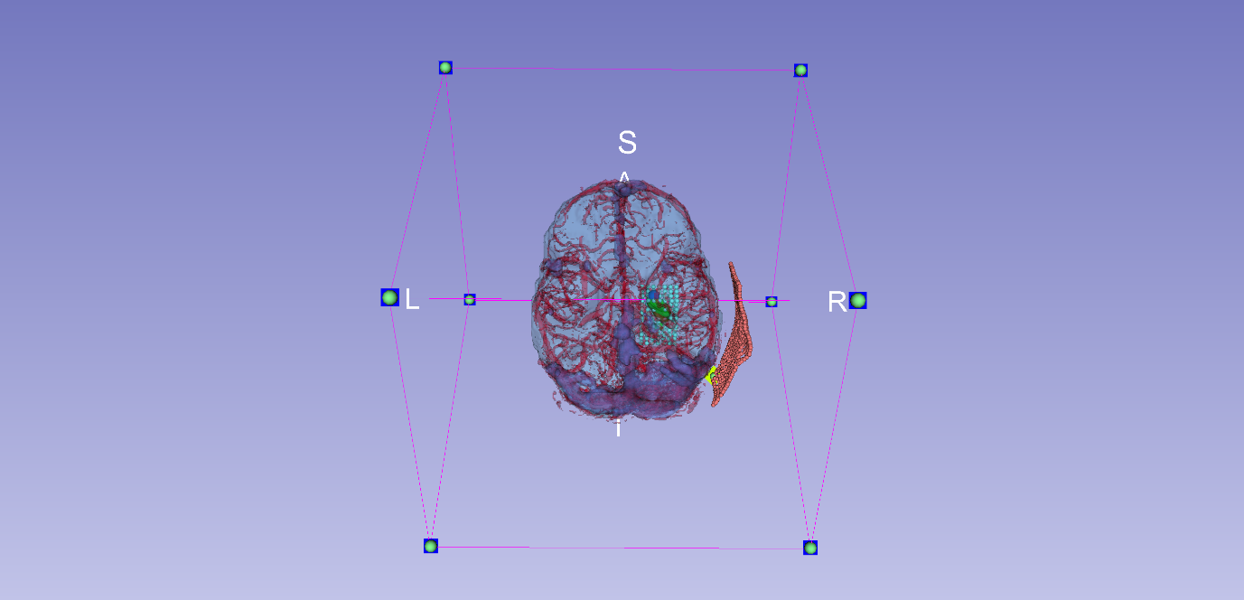

Figure : End effector at entry point (view 2)

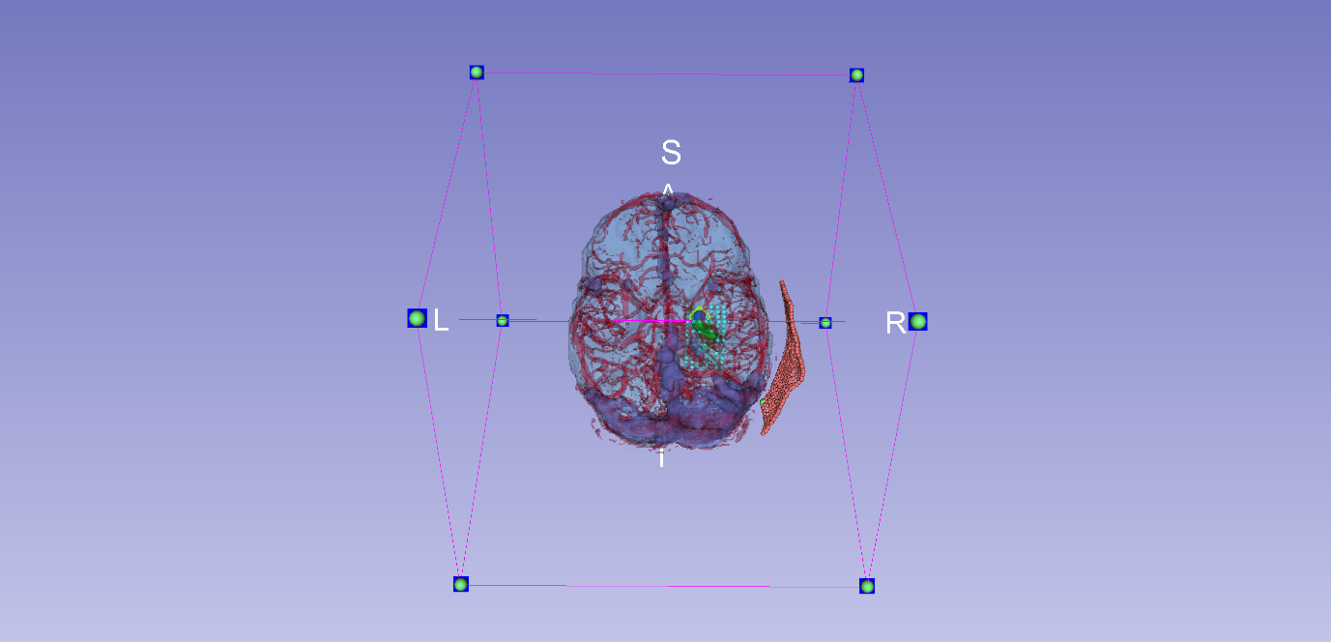

Figure : End effector at target point (view 1)

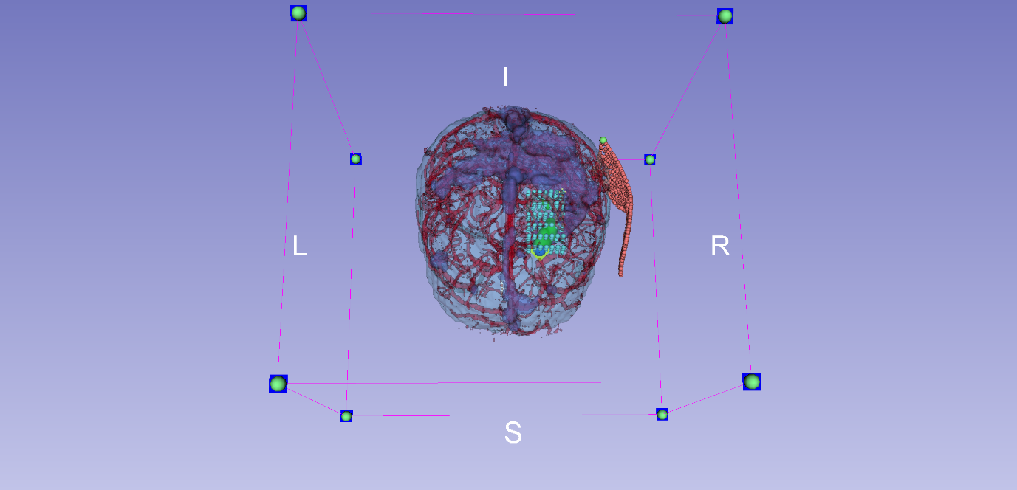

Figure : End effector at target point (view 2)

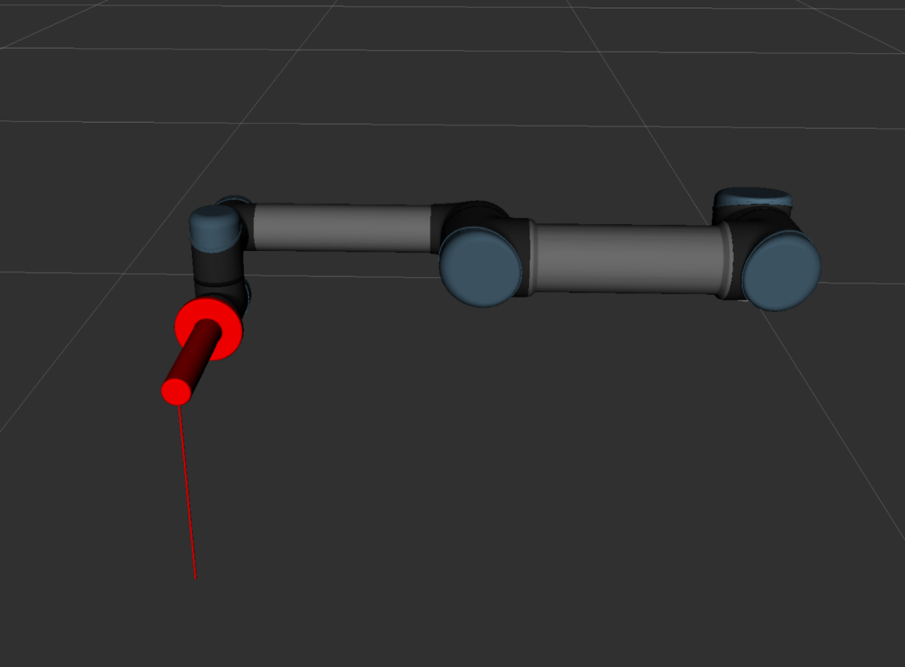

Figure : Robot at default position (RVIZ)

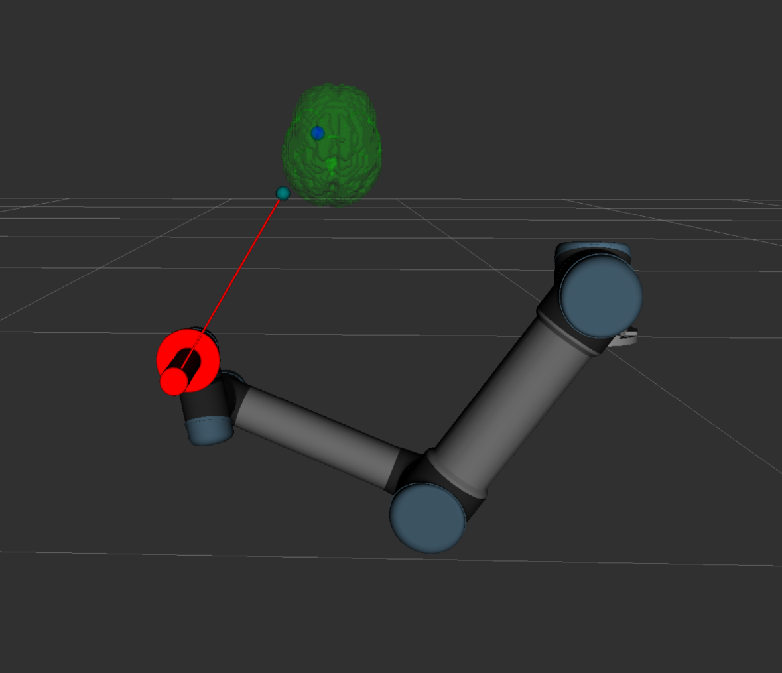

Figure : Robot's end effector at entry point (RVIZ)

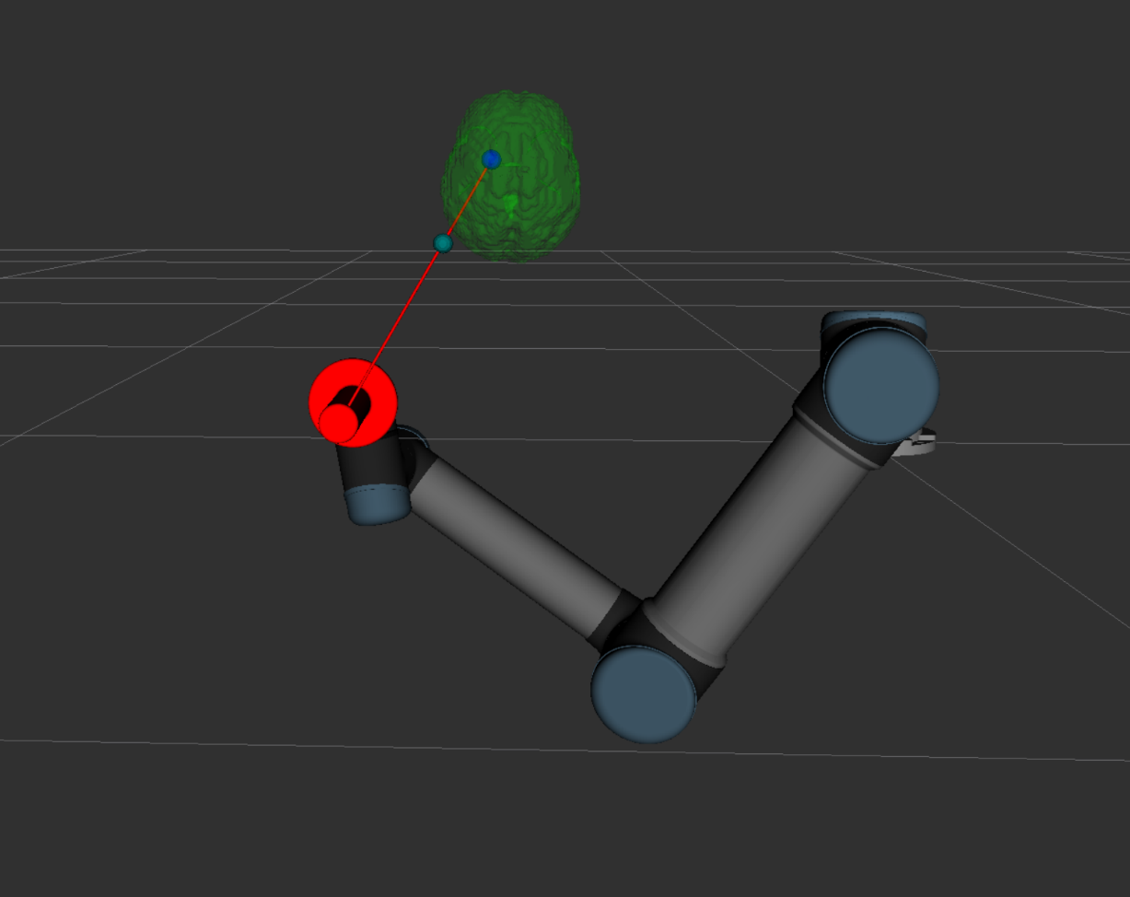

Figure : Robot's end effector at target point (RVIZ)

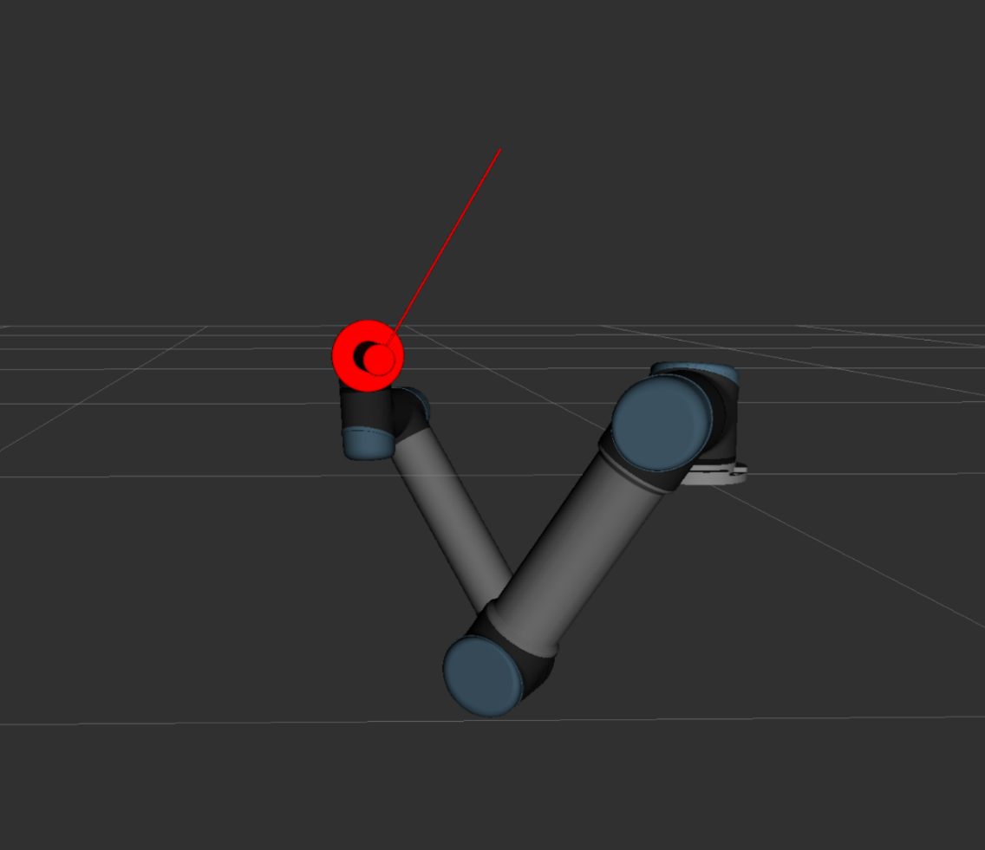

Figure : Robot's end effector at a random point (RVIZ)

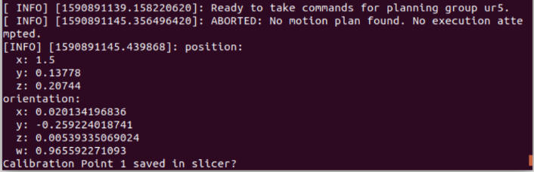

Figure : Invalid position sent to ROS

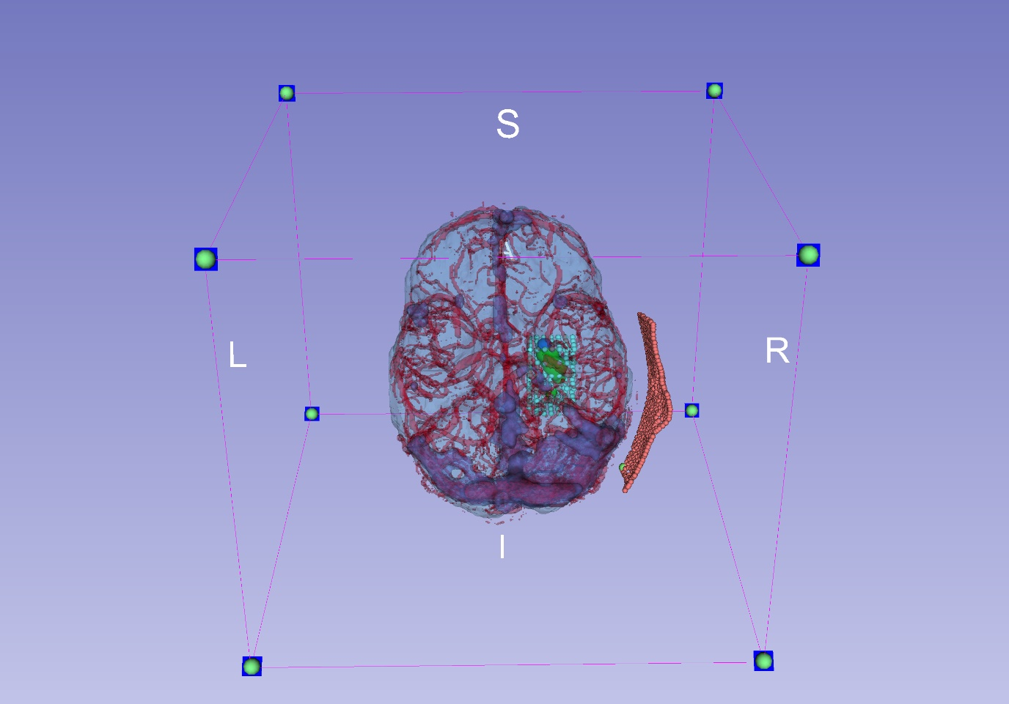

Figure : Slicer with models loaded

1. The risk resulting from information and capabilities not being shared among/by enough team members either because of lack of planning or long training times