7MR10070: Software and Robotic Integration

Semester 2

Assignment 1

Written by Alexandros Megalemos

# Path Planning Part 1

# Task 1

### Algorithm (a)

Point p = (x, y, z)

List of points $P=[p_{1},…, p_{n}]$

List of output points $O=[o_{1},…, o_{n}]$

For each p in $p ∈P$:

Retrieve pixel intensity c, where $c ∈[0,1]$

If c = 1 then $O←p$

### Algorithm (b)

Point $p = (x, y, z)$

Point ep is a point p representing an entry point

Point tp is a point p representing a target point

List of entry points $EP=[{ep}_{1},…, {ep}_{n}]$

List of target points $TP=[{tp}_{1},…, {tp}_{n}]$

List of ventricle points $VP=[p_{1},…, p_{n}]$

List of output points $O=[{(ep}_{1},tp_{1}),…, {(ep}_{n},tp_{n})]$

Line l is a line between two points

For each ep in $p ∈EP$:

For each tp in $p ∈TP$:

$l =\vec{eptp}$

For each p in $p ∈\vec{eptp}$

If does not $p ∈VP$ then $O←(ep, tp)$

### Algorithm (c)

Point $p = (x, y, z)$

Point ep is a point p representing an entry point

Point tp is a point p representing a target point

List of entry points

List of target points $TP=[{tp}_{1},…, {tp}_{n}]$

List of blood vessel points $BVP=[p_{1},…, p_{n}]$

List of output points $O=[{(ep}_{1},tp_{1}),…, {(ep}_{n},tp_{n})]$

Line l is a line between two points

For each ep in $p ∈EP$:

For each tp in $p ∈TP$:

$l =\vec{eptp}$

For each p in $p ∈\vec{eptp}$

If does not $p ∈BVP$ then $O←(ep, tp)$

### Algorithm (d)

Point $p = (x, y, z)$

Point ep is a point p representing an entry point

Point tp is a point p representing a target point

List of entry points

List of target points $TP=[{tp}_{1},…, {tp}_{n}]$

List of blood vessel points $BVP=[p_{1},…, p_{n}]$

List of output points $O=[{(ep}_{1},tp_{1}),…, {(ep}_{n},tp_{n})]$

Line l is a line between two points

For each ep in $p ∈EP$:

For each tp in $p ∈TP$:

$l =\vec{eptp}$

$l_{p}= ⊥\vec{eptp}$

$angle = ∠ll_{p}$

If angle < 55 then $O←(ep, tp)$

# Task 2

The constants included in the following algorithms represent the time taken by ***if-statements***. Perhaps they could have been omitted

### Algorithm (a)

For each point in target points:

Get the coordinates (x, y, z) of the point

Retrieve the pixel value of (x, y, z) in the image

If pixel value == 1:

Add the point to the list

$Big O=O\left(N_{tp}*R_{pv}\right)$ $where N_{tp} is the total number of target points, R_{pv} is the lookup time for the pixel value$

### Algorithm (b)

For each entry point in entry points:

For each target point in target points:

Get the line between the two points

Get the points of the line

validLine = true

For each point on the line:

If point passes through ventricle:

validLine = false

break

if validLine:

add (entry, target) point to valid points list

$Big O=O\left(2*N_{ep}*N_{tp}*N_{pl}\right)$ $where N_{ep} is the number of entry points, NP_{tp} is the number of target points and N_{Pl} is the$

$$number of points in the line$$

### Algorithm (c)

For each entry point in entry points:

For each target point in target points:

Get the line between the two points

Get the points of the line

validLine = true

For each point on the line:

If point passes through blood vessel:

validLine = false

break

if validLine:

add (entry, target) point to valid points list

$Big O=O\left(2*N_{ep}*N_{tp}*N_{pl}\right)$ $where N_{ep} is the number of entry points, NP_{tp} is the number of target points and N_{Pl} is the$

$$number of points in the line$$

### Algorithm (d)

For each entry point in entry points:

For each target point in target points:

Get the line, lineET, between the two points

For each point on line:

If point connects with the cortex:

Get perpendicular line where lineET passes through the cortex

Calculate the angle between the two lines

If angle < 55:

Add (entry, target) point to valid points list

$Big O=O\left(2*N_{ep}*N_{tp}*N_{c}*T_{a}\right)$

$$where N_{ep} is the number of entry points, NP_{tp} is the number of target points, N_{c} is the$$

$$number of cortex points and T_{a}is the time needed to calculate the angle between the$$

$$entry-target line and the perpendicular line where it connects on the cortex$$

# Task 3

Tests were run using the full data because the test files were crashing for some reason. As in the previous tasks, constants represent the time taken by ***if-statements***.

## Validation for each algorithm

For each algorithm in this report the following overall process was used.

1. Pick a small subset of the data
2. Visually look for a trajectory / point that is obviously valid for a task and for one that is obviously invalid for a task. For example, when filtering for targets within the hippocampus, the invalid point could be one outside the image.
3. Run the algorithm
4. Inspect the output in slicer
5. Increase the subset of data gradually

## Algorithm (a)

**Introduction and Methods:** This one is straight forward. We simply transform the input node to an IKJ matrix and then loop over each target image. To decide if a target point is within our target area, we iterate over all the target points and retrieve the pixel value for each one. If its value is greater than zero (or 1), it is a valid target. The function used to do this is called **getFilteredTargets(targets, area)** and should accept any area we want to filter for.

**Validation:** Here I used the steps specified above.

$Big O=O\left(N_{tp}*R_{pv}\right)$ $where N_{tp} is the total number of target points, R_{pv} is the lookup time for the pixel value$.

**Changes made to the algorithm affecting the time complexity:** No fundamental changes were made. Here we use the GetRASTToIJKMatrix function to represent the image in a different structure.

**Time taken:** 0.001s (average of 10 runs)

**Rejected trajectories:** 78336

### Algorithm (b)

**Introduction and Methods:** This one had to change a bit from the original pseudocode. We first create an oriented bounding box tree (OBBTree) of the ventricles. We then iterate over each entry and target pair and check if the pair intersects any of the bounding boxes defined by the OBBTree. If there is an intersection, we reject the path. The function used to do this is called **getTrajectoriesAvoidingArea(entriesAndTargets, area)** and should accept any area we want to avoid. It is important to note that this function uses **isPassThroughArea(tree, entry, target)** which is where the actual intersection check is made. I chose to separate the check so that it can be used in combination with the other constraints, without having to loop through each entry target pair for each one every time.

**Validation:** Here I used the steps specified above

$$Big O=O\left({2*N}_{ep}*N_{tp}*log\left(N_{vp}\right)+ N_{vp}log\left(N_{vp}\right)\right)$$

$$where N_{ep} is the number of entry points, NP_{tp} is the number of target points and N_{vp} is the$$

$$number of ventricle points$$

**Changes made to the algorithm affecting the time complexity:** Instead of traversing through all the points in the line between the entry and target point, we instead search using a tree whose lookup time should be $log\left(N_{vp}\right)$ instead of $N_{vp}$. However, we’ll need to create the tree (once), and that should take $N_{vp}log\left(N_{vp}\right)$.

**Time taken:** 3s (average of 10 runs)

**Rejected trajectories:** 10205

### Algorithm (c)

**Introduction and Methods:** This one had to change a bit from the original pseudocode. We first create an oriented bounding box tree (OBBTree) of the blood vessels. We then iterate over each entry and target pair and check if the pair intersects any of the bounding boxes defined by the OBBTree. If there is an intersection, we reject the path. The function used to do this is called **getTrajectoriesAvoidingArea(entriesAndTargets, area)** and should accept any area we want to avoid. It is important to note that this function uses **isPassThroughArea(tree, entry, target)** which is where the actual intersection check is made. I chose to separate the check so that it can be used in combination with the other constraints, without having to loop through each entry target pair for each one every time.

**Validation:** Here I used the steps specified above.

**Changes made to the algorithm affecting the time complexity:** Instead of traversing all the points in the line between the entry and target point, we instead search using a tree whose lookup time should be $log\left(N_{bvp}\right)$ instead of $N_{bvp}$. However, we’ll need to create the tree (once), and that should take $N_{vp}log\left(N_{bvp}\right)$.

**Time taken:** 60s (average of 10 runs)

**Rejected trajectories:** 47855

### Algorithm (d)

**Introduction and Methods:** This one had to change a bit from the original pseudocode. We first create an oriented bounding box tree (OBBTree) of the cortex. We then iterate over each entry and target pair and check if the pair intersects any of the bounding boxes defined by the OBBTree. If there is an intersection, we create a line perpendicular to the intersection. We then create two vectors, one for our entry/target pair and one for the intersecting points and calculate the angle between the two. If the angle is below the specified limit (55), we accept the path. The function used to do this is called **getTrajectoriesWithSpecifiedAngle (entriesAndTargets, area, specifiedAngle)** and should accept any area we want check the angles for. It is important to note that this function uses **isValidAngle()** which is where the actual check for the angle is made. I chose to separate the check so that it can be used in combination with the other constraints, without having to loop through each entry target pair for each one every time.

**Validation:** Here I used the steps specified above.

**Changes made to the algorithm affecting the time complexity:** Instead of traversing all the points in the line between the entry and target point, we instead search using a tree whose lookup time should be $log\left(N_{cp}\right)$ instead of $N_{cp}$. However, we’ll need to create the tree (once), and that should take $N_{cp}log\left(N_{cp}\right)$.

**Time taken:** 105s (average of 10 runs)

**Rejected trajectories:** 17426

# Task 4

Here we combine all three constrains under the same nested for loop (between entry and target points). We start with the least complex (in terms of time and space) algorithm and work our way down to the most complex. Therefore:

1. First, create the OBB trees required for each task
2. Then, filter for targets that are within the hippocampus
3. After that, filter for entry/target trajectories that do not pass through the ventricles
4. After that, we filter for entry/target trajectories that do not pass through blood vessels
5. Finally, we filter so that only trajectories of a certain angle (degrees) are accepted

By doing this, we rule out most of the trajectories before we reach the more expensive checks in our overall algorithm. This is clearly demonstrated by the total time taken of ~25 seconds, whereas before filtering just for valid angles would take more than 100 seconds.

**Time taken:** 25s (average of 10 runs)

**Rejected trajectories:** 88603

# Path Planning Part 2

# Task 1

(a) A naïve/brute-force solution to the problem. It iterates over all possible points and finds the minimum distance between a vessel and a point in the path

minDistance = +infinity

closestVessel = null

allPoints = getAllPointsInPath(entry, target)

for each point in allPoints:

for each bloodVesselPoint:

Calculate distance (e.g. Euclidean) between the line point and blood vessel point

If distance < minDistance:

minDistance = distance

closestVessel = bloodVesselPoint

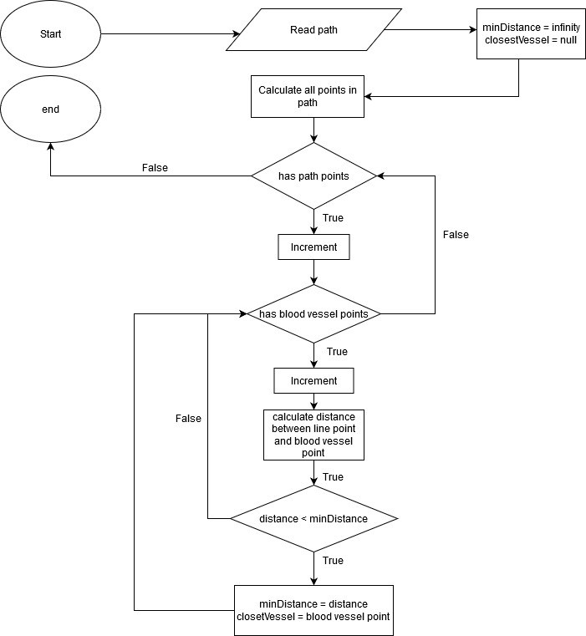

1:simplified flowchart of the algorithm

(b) In order to test that my code works, I used a subset of the data outputted by combining all the hard constraints. I visually chose a trajectory with obviously large distance from the blood vessels and another one with an obviously small distance from the blood vessels. I then inspected the output and seeing that it was as expected, I started using more trajectories and larger sets of data.

# Code / Git Repository

<https://github.com/Meldanen/kcl/tree/master/robotics/slicerTutorials/Tutorial%202%20and%203>

The tests should be able to run all code required for the assignment. If you wish you run smaller parts of the code, you can either comment out some of them, or go to *Assignment1Logic.run()* and again, comment/uncomment the parts you want to run.   
The submitted version of this only runs the combination of all three constraints when using the GUI to save time.

## Tests

**testLoadAllData(path):** check that data has been loaded successfully**testGetFilteredHippocampusTargets():** check that targets are correctly filtered down to hippocampus targets**testAvoidVentriclesValidPath()**: check that the algorithm accepts a path that doesn’t pass through the ventricles

**testAvoidVentriclesInvalidPath():** check that the algorithm rejects a path that passes through the ventricles

**testAvoidBloodVesselsValidPath()**: check that the algorithm accepts a path that doesn’t pass through the blood vessels **testAvoidBloodVesselsInvalidPath()**: check that the algorithm rejects a path that passes through the blood vessels

**testAngleValidPath():** check that the algorithm accepts a path that hits the cortex at the correct angle

**testAngleInvalidPath():** check that the algorithm rejects a path that hits the cortex at an incorrect angle**testCountRejectedTrajectories(True):** To count rejected trajectories and time each part. This is a slow test**testAllTogether():** Just to see if everything is able to run together (pseudo test for task 4). This is a slow test