Basic elements of HTML language. Paragrapgh and headings in HTML.

HTML stands for Hypertext Markup Language, and it is the most widely used language to

write Web Pages.

• Hypertext refers to the way in which Web pages (HTML documents) are linked

together. Thus, the link available on a webpage is called Hypertext.

• As its name suggests, HTML is a Markup Language which means you use HTML to

simply "mark-up" a text document with tags that tell a Web browser how to structure

it to display.

Originally, HTML was developed with the intent of defining the structure of documents like

headings, paragraphs, lists, and so forth to facilitate the sharing of scientific information

between researchers.

Now, HTML is being widely used to format web pages with the help of different tags available

in HTML language.

Basic HTML Document

In its simplest form, following is an example of an HTML document:

<!DOCTYPE html>

<html>

<head>

<title>This is document title</title>

</head>

<body>

<h1>This is a heading</h1>

<p>Document content goes here.....</p>

</body>

</html>

Finally open it using a web browser like Internet Explorer or Google Chrome, or Firefox

etc.

As told earlier, HTML is a markup language and makes use of various tags to format the

content. These tags are enclosed within angle braces <Tag Name>. Except few tags, most

of the tags have their corresponding closing tags. For example, <html> has its closing

tag</html> and <body> tag has its closing tag </body> tag etc.

Above example of HTML document uses the following tags:

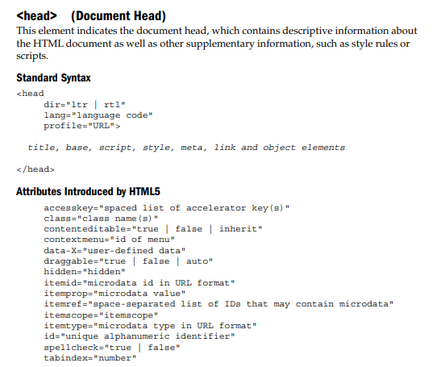

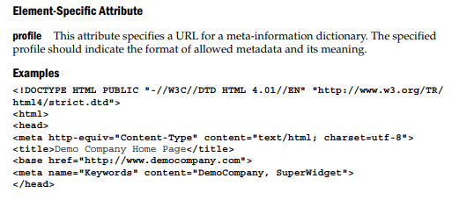

Body

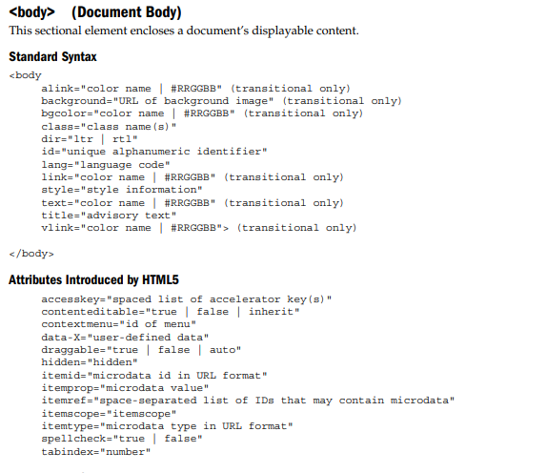

Element-Specific Attributes

alink This attribute sets the color for active links within the document. Active links represent the state of a link as it is being clicked. The value of the attribute can be either a named color like red or a color specified in the hexadecimal #RRGGBB format like #FF0000. The CSS pseudo-class a:active should be used instead. background This attribute contains a URL for an image file, which will be tiled to provide the document background. The CSS background-image property should be used instead. bgcolor This attribute sets the background color for the document. Its value can be either a named color like red or a color specified using the hexadecimal #RRGGBB format like #FF0000. The CSS background-color property should be used instead. bgproperties This attribute, first introduced in Internet Explorer 2, has one value, fixed, which causes the background image to act as a fixed watermark and not to scroll. The CSS property background-attachment provides similar functionality

bottommargin This attribute specifies the bottom margin for the entire body of the page and overrides the default margin. When set to 0 or "", the bottom margin is the bottom edge of the window or frame the content is displayed in. CSS margin properties should be used instead. leftmargin This Internet Explorer–specific attribute sets the left margin for the page, in pixels, overriding the default margin. When set to 0 or "", the left margin is the left edge of the window or the frame. CSS margin properties should be used instead. link This attribute sets the color for hyperlinks within the document that have not yet been visited. Its value can be either a browser-dependent named color or a color specified using the hexadecimal #RRGGBB format. The CSS pseudo-class a:link should be used instead. marginheight This Netscape-specific attribute sets the top margin for the document, in pixels. If set to 0 or "", the top margin will be exactly on the top edge of the window or frame. It is equivalent to combining the Internet Explorer attributes bottommargin and topmargin. CSS margin properties should be used instead. marginwidth This Netscape-specific attribute sets the left and right margins for the page, in pixels, overriding the default margin. When set to 0 or "", the left margin is the left edge of the window or the frame. It is equivalent to combining the Internet Explorer attributes leftmargin and rightmargin. CSS margin properties should be used instead. nowrap This Internet Explorer–specific attribute is used to control the wrapping of text body width. If set to yes, text should not wrap. The default is no. rightmargin This Internet Explorer–specific attribute sets the right margin for the page in pixels, overriding the default margin. When set to 0 or "", the right margin is the right edge of the window or the frame. CSS margin properties should be used instead. scroll This Internet Explorer–specific attribute turns the scroll bars on or off. The default value is yes.

text This attribute sets the text color for the document. Its value can be either a named color like red or a color specified using the hexadecimal #RRGGBB format. The CSS property color should be used on the body element instead of this attribute.

vlink This attribute sets the color for hyperlinks within the document that have already been visited. Its value can be either a browser-dependent named color or a color specified using the hexadecimal #RRGGBB format. The CSS pseudo-class a:visited should be used instead

(Paragraph) This block element is used to define a paragraph of text. Standard Syntax

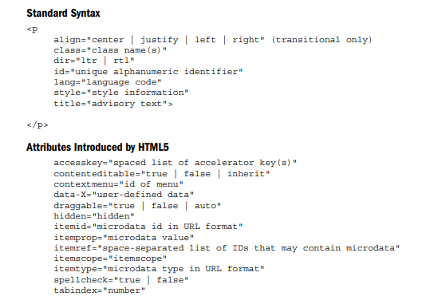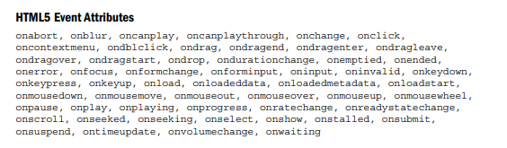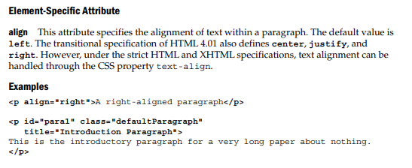

Notes • Because p is a block element, browsers typically insert a blank line, but this rendering should not be assumed, given the rise of style sheets, which can use the display property to override this action.

• Under the strict (X)HTML and HTML5 specifications, the align attribute is not supported. Alignment of text can instead be accomplished using CSS properties like text-align.

• The closing tag for the

tag is optional under the HTML specification; however, under the XHTML 1.0 specification, the closing tag

is required for XHTML compatibility.

• As a logical element, empty paragraphs are ignored by browsers, so do not try to use multiple

tags in a row, like

, to add blank lines to a Web page.

• Often, nonbreaking space entities are used to hold open empty paragraphs, like so:

. The value of this markup is questionable.

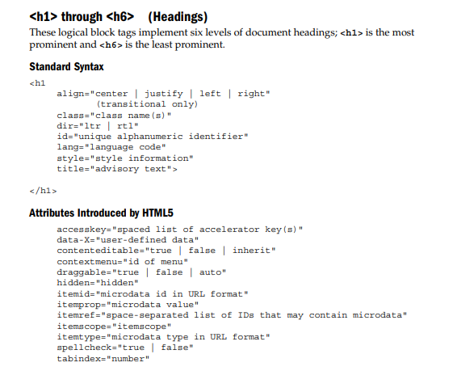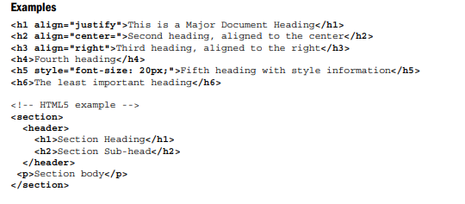

Notes

• In most implementations, heading numbers correspond inversely with the six font sizes supported by the font element. For example,

corresponds to . The default font size is 3. However, this approach to layout is not encouraged, and page designers should consider using styles to set even relative sizes. Interestingly, the HTML5 specification also clearly indicates the font size of various headings like h1 (2em), h2 (1.5em), and so on, which is really not any different from the relative nature of older tags.

• The strict definitions of HTML 4 and XHTML do not include support for the align attribute. Style sheet properties like text-align should be used instead. • Under HTML5, these heading elements are used to form an outline of the document

Exam Questions

1.Basic elements of HTML

2.Paragrapgh and headings in HTML

3.Paragraphs in html, standart syntax of paragraph

4.Headings in html, , standart syntax of headings

5. Head and body tags in html

6. Standart syntax of htnl