Introduction to web technologies. HTMl language

Web Technology refers to the various tools and techniques that are utilized in the process of communication between different types of devices over the internet. A web browser is used to access web pages. Web browsers can be defined as programs that display text, data, pictures, animation, and video on the Internet. Hyperlinked resources on the World Wide Web can be accessed using software interfaces provided by Web browsers.

Web Technology can be classified into the following sections:

World Wide Web (WWW): The World Wide Web is based on several different technologies : Web browsers, Hypertext Markup Language (HTML) and Hypertext Transfer Protocol (HTTP).

Web Browser: The web browser is an application software to explore www (World Wide Web). It provides an interface between the server and the client and requests to the server for web documents and services.

Web Server: Web server is a program which processes the network requests of the users and serves them with files that create web pages. This exchange takes place using Hypertext Transfer Protocol (HTTP).

Web Pages: A webpage is a digital document that is linked to the World Wide Web and viewable by anyone connected to the internet has a web browser.

Web Development: Web development refers to the building, creating, and maintaining of websites. It includes aspects such as web design, web publishing, web programming, and database management. It is the creation of an application that works over the internet i.e. websites.

Web Development can be classified into two ways:

Frontend Development: The part of a website that the user interacts directly is termed as front end. It is also referred to as the ‘client side’ of the application.

Backend Development: Backend is the server side of a website. It is the part of the website that users cannot see and interact. It is the portion of software that does not come in direct contact with the users. It is used to store and arrange data.

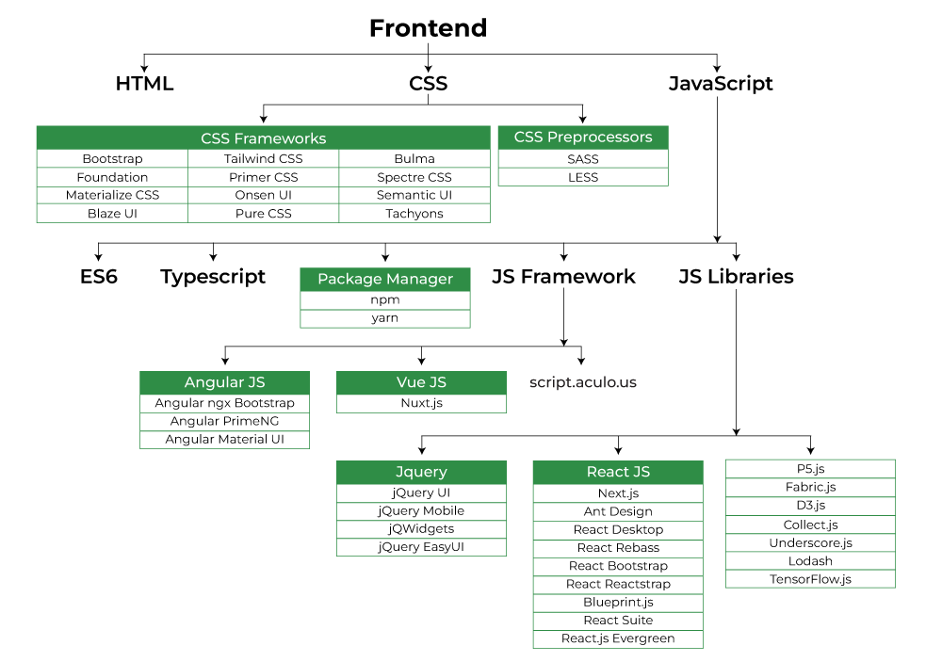

Frontend Languages: The front end portion is built by using some languages which are discussed below:

HTML: HTML stands for Hypertext Markup Language. It is used to design the front-end portion of web pages using a markup language. HTML is the combination of Hypertext and Markup language. Hypertext defines the link between the web pages. The markup language is used to define the text documentation within the tag which defines the structure of web pages.

CSS: Cascading Style Sheets fondly referred to as CSS is a simply designed language intended to simplify the process of making web pages presentable. CSS allows you to apply styles to web pages. More importantly, CSS enables you to do this independent of the HTML that makes up each web page.

JavaScript: JavaScript is a famous scripting language used to create magic on the sites to make the site interactive for the user. It is used to enhancing the functionality of a website to running cool games and web-based software.

AJAX: Ajax is an acronym for Asynchronous Javascript and XML. It is used to communicate with the server without refreshing the web page and thus increasing the user experience and better performance.

There are many other languages through which one can do front-end development depending upon the framework for example Flutter user Dart, React uses JavaScript and Django uses Python, and much more.

# Web Technology

## Introduction to Web Technology

* Web technologies refers to the way computers/devices communicate with each other using mark up languages. It invo It is communication across the web, and create, deliver or manage web content using hypertext markup language (HTML).
* A web page is a web document which is written in in HTML (hypertext markup language)
* It is said to have brought the world into a small village where people and devices can communicate to each other seamlessly.
* WWW has allowed for the access of information that would have been impossible to find or may have been difficult to find without the [www.](http://www/)

## The Internet & World Wide Web(WWW)

* + The terms Internet and the World Wide Web are synonymous in the minds of many, but they have different meanings.

***The Internet is a massive network of networks that connects millions of computers worldwide.***

* + Computers connected to the Internet can communicate with one another with a number of protocols such as HTTP, SMTP (Simple Mail Transfer Protocol), FTP (File Transfer Protocol), IRC (Internet relay chat), IM (instant messaging), Telnet, and P2P (peer-to-peer).

***The World Wide Web is a system of interlinked hypertext documents and programs that can be accessed via the Internet primarily by using HTTP***

## Important terms of Web Technology

* + Web page
  + HTML
  + Web Server
  + Web Browser
  + URL
  + Protocol
  + Internet Protocol (IP) Address
  + HTTP
  + XML
  + Gateway
  + API

## Some web components

* **Web – Page** A document which can be displayed in a web browser such as Firefox, Google Chrome, Opera, Microsoft Internet Explorer or Edge, or Apple's Safari. These are also often called just "pages.
* **WebSite** A collection of web pages which are grouped together and usually connected together in various ways. Often called a "web site" or simply a "site.“
* **Web Server** A special high end computer that hosts a website on the Internet. Today we have Cloud services that act as web servers.

## Dynamic v/s Static Pages

* + **Static pages** show the same content each time they are viewed.
  + **Dynamic pages** have content that can change each time they are accessed.
  + Dynamic pages are typically written in scripting languages such as PHP, Perl, ASP, or JSP. The scripts in the pages run functions on the server that return things like the date and time, and database information.
  + All the information is returned as HTML code, so when the page gets to your browser, all the browser has to do is translate the HTML.

## HTML

* + - HTML is a language which is used to create static web pages.
    - HTML is the Language of Web Pages on the World Wide Web.
    - HTML uses bracketed commands called ‘HTML tags’ that are integrated into a text document.
    - HTML code can be written in a text editor (like Notepad).
    - Save the text editor file with “.htm” or “.html” extension.
    - Open the file with any web browser(Like Internet Explorer, Firefox) to see the HTML page output.

## Basic HTML Tags

* + - **HTML**
    - **HEAD**
    - **BODY**

**title** (page title),

**style** (rendering style), **link** (related documents), **meta** (data about the document),

**script** (client-side scripting

## Web Browser

* + - * A web browser is an application program for retrieving, presenting and traversing information resources on the World Wide Web.
      * An information resource is identified by a Uniform Resource Identifier (URI) and may be a web page, image, video or other piece of content.
      * Some examples of web browser:
        + Internet Explorer
        + Google Chrome,
        + Firefox,
        + Opera,
        + Safari

## Web Server

* + - * A Web server is a program or computer machine that generates and transmits responses to client requests for Web resources using HTTP protocol.
      * Every computer on the Internet that contains a Web site must have a Web server program.
      * Any computer can be turned into a Web server by installing server software and connecting the machine to the Internet

**Some Examples of Web Server**

* + - * **Apache HTTP Server:**
* The Apache HTTP Server, commonly referred to as Apache is a web server software program which gave the initial boost for the growth of the World Wide Web.
* In 2009, it became the first web server software to surpass the 100 million website milestone.
* The server is aimed at serving a great deal of widely popular modern web platforms/operating systems such as Unix, Windows, Linux, Solaris, Novell NetWare, FreeBSD, Mac OS X, Microsoft Windows, OS/2, etc.
  + - * **Microsoft Internet Information Services (IIS):**
* IIS is one of the components of Microsoft Windows and is Microsoft's implementation of a web server.
* The protocols supported include HTTP, HTTPS, FTP, FTPS & SMTP .
* It's estimated that around 25% of all websites utilize IIS.

## URL

* + - * URL stands for Uniform Resource Locator.
      * A URL is a formatted text string used by Web browsers, email clients and other software to identify a *network resource* on the Internet.
      * Network resources are files that can be plain Web pages, other text documents, graphics, or programs.

## URL..continued

* URL strings consist of three parts (*substrings*):
  1. **network protocol:** Typical URL protocols include

*http:// and ftp:// .*

* 1. **host name or address:** identifies a computer or other network device. Hosts come from standard Internet databases such as DNS and can be names or IP addresses.
  2. **file or resource location:**
* These substrings are separated by special characters as follows:

**protocol :// host / location**

## URL

* + - * **Example:**
      * **In** [**http://www.uneca.org/acs**](http://www.uneca.org/acs)

## Protocol

* + - * A protocol is a set of rules that govern data communications.
      * A protocol defines what is communicated, how it is communicated, and when it is communicated.
      * It represents an agreement between the communicating devices.
      * Without a protocol, two devices may be connected but not communicating, just as a person speaking Portuguese cannot be understood by a person who speaks only English.

## HTTP

* + - * HTTP stands for HyperText Transfer Protocol
      * it is the language of the Web.
* HTTP is a protocol used for communication between web browsers and web servers.
* When a web page has this prefix, then your links, text, and pictures should work in your web browser
* HTTP functions as a request-response protocol in the client-server computing model.

## HTTP.. continued

* A web browser, for example, may be the *client* and an application running on a computer hosting a web site may be the *server*.
* The client submits an HTTP *request* message to the server.
* The server, which provides *resources* such as HTML files and other content, or performs other functions on behalf of the client, returns a *response* message to the client.

## API (Application Programming Interface )

* + - * Application Programming Interface (API) which constitutes a language and message format is set of data structures, routines or protocols used by an application to communicate with other control program, communication protocol or operating system. Exampled would be a “Places API” which is called by many web based applications.

## Web Technologies

* + - * + HTML (HyperText Markup Language)
        + XML (Extensible Markup Language)
        + CSS (Cascading Style Sheets)
        + JavaScript
        + Java
        + VBScript
        + PHP
        + C#
        + ASP.NET

Exam Question

1. Introduction to Web technologies
2. İmportant terms of web technology
3. Some web components, Web pages and Web sites