**Graphical objects in HTML. HTML tables**

HTML's multimedia features allow authors to include images, applets (programs that are automatically downloaded and run on the user's machine), video clips, and other HTML documents in their pages.

For example, to include a PNG image in a document, authors may write:

**Including an image: the****IMG element**

<!-- To avoid problems with text-only UAs as well as

to make image content understandable and navigable

to users of non-visual UAs, you need to provide

a description with ALT, and avoid server-side image maps -->

<!ELEMENT [IMG](https://www.w3.org/TR/html401/struct/objects.html#edef-IMG) - O EMPTY -- Embedded image -->

<!ATTLIST IMG

[%attrs;](https://www.w3.org/TR/html401/sgml/dtd.html#attrs) -- [%coreattrs](https://www.w3.org/TR/html401/sgml/dtd.html#coreattrs), [%i18n](https://www.w3.org/TR/html401/sgml/dtd.html#i18n), [%events](https://www.w3.org/TR/html401/sgml/dtd.html#events) --

[src](https://www.w3.org/TR/html401/struct/objects.html#adef-src-IMG) [%URI;](https://www.w3.org/TR/html401/sgml/dtd.html#URI) #REQUIRED -- URI of image to embed --

[alt](https://www.w3.org/TR/html401/struct/objects.html#adef-alt) [%Text;](https://www.w3.org/TR/html401/sgml/dtd.html#Text) #REQUIRED -- short description --

[longdesc](https://www.w3.org/TR/html401/struct/objects.html#adef-longdesc-IMG) [%URI;](https://www.w3.org/TR/html401/sgml/dtd.html#URI) #IMPLIED -- link to long description

(complements alt) --

[name](https://www.w3.org/TR/html401/struct/objects.html#adef-name-IMG) [CDATA](https://www.w3.org/TR/html401/types.html#type-cdata) #IMPLIED -- name of image for scripting --

[height](https://www.w3.org/TR/html401/struct/objects.html#adef-height-IMG) [%Length;](https://www.w3.org/TR/html401/sgml/dtd.html#Length) #IMPLIED -- override height --

[width](https://www.w3.org/TR/html401/struct/objects.html#adef-width-IMG) [%Length;](https://www.w3.org/TR/html401/sgml/dtd.html#Length) #IMPLIED -- override width --

[usemap](https://www.w3.org/TR/html401/struct/objects.html#adef-usemap) [%URI;](https://www.w3.org/TR/html401/sgml/dtd.html#URI) #IMPLIED -- use client-side image map --

[ismap](https://www.w3.org/TR/html401/struct/objects.html#adef-ismap) (ismap) #IMPLIED -- use server-side image map --

*Start tag:****required****, End tag:****forbidden***

*Attribute definitions*

**src =**[***uri***](https://www.w3.org/TR/html401/types.html#type-uri)[**[CT]**](https://www.w3.org/TR/html401/types.html#see-type-for-case)

This attribute specifies the location of the image resource. Examples of widely recognized image formats include GIF, JPEG, and PNG.

**longdesc =**[***uri***](https://www.w3.org/TR/html401/types.html#type-uri)[**[CT]**](https://www.w3.org/TR/html401/types.html#see-type-for-case)

This attribute specifies a link to a long description of the image. This description should supplement the short description provided using the [alt](https://www.w3.org/TR/html401/struct/objects.html#adef-alt) attribute. When the image has an associated [image map](https://www.w3.org/TR/html401/struct/objects.html#include-maps), this attribute should provide information about the image map's contents. This is particularly important for server-side image maps. Since an [IMG](https://www.w3.org/TR/html401/struct/objects.html#edef-IMG) element may be within the content of an [A](https://www.w3.org/TR/html401/struct/links.html#edef-A) element, the user agent's mechanism in the user interface for accessing the "longdesc" resource of the former must be different than the mechanism for accessing the [href](https://www.w3.org/TR/html401/struct/links.html#adef-href) resource of the latter.

**name =**[***cdata***](https://www.w3.org/TR/html401/types.html#type-cdata)[**[CI]**](https://www.w3.org/TR/html401/types.html#case-insensitive)

This attribute names the element so that it may be referred to from style sheets or scripts. **Note.** This attribute has been included for backwards compatibility. Applications should use the [id](https://www.w3.org/TR/html401/struct/global.html#adef-id) attribute to identify elements.

* [id](https://www.w3.org/TR/html401/struct/global.html#adef-id), [class](https://www.w3.org/TR/html401/struct/global.html#adef-class) ([document-wide identifiers](https://www.w3.org/TR/html401/struct/global.html#id-and-class))
* [alt](https://www.w3.org/TR/html401/struct/objects.html#adef-alt) ([alternate text](https://www.w3.org/TR/html401/struct/objects.html#alternate-text))
* [lang](https://www.w3.org/TR/html401/struct/dirlang.html#adef-lang) ([language information](https://www.w3.org/TR/html401/struct/dirlang.html#language-info)), [dir](https://www.w3.org/TR/html401/struct/dirlang.html#adef-dir) ([text direction](https://www.w3.org/TR/html401/struct/dirlang.html#bidirection))
* [title](https://www.w3.org/TR/html401/struct/global.html#adef-title) ([element title](https://www.w3.org/TR/html401/struct/global.html#title))
* [style](https://www.w3.org/TR/html401/present/styles.html#adef-style) ([inline style information](https://www.w3.org/TR/html401/present/styles.html#style-element))
* [onclick](https://www.w3.org/TR/html401/interact/scripts.html#adef-onclick), [ondblclick](https://www.w3.org/TR/html401/interact/scripts.html#adef-ondblclick), [onmousedown](https://www.w3.org/TR/html401/interact/scripts.html#adef-onmousedown), [onmouseup](https://www.w3.org/TR/html401/interact/scripts.html#adef-onmouseup), [onmouseover](https://www.w3.org/TR/html401/interact/scripts.html#adef-onmouseover), [onmousemove](https://www.w3.org/TR/html401/interact/scripts.html#adef-onmousemove), [onmouseout](https://www.w3.org/TR/html401/interact/scripts.html#adef-onmouseout), [onkeypress](https://www.w3.org/TR/html401/interact/scripts.html#adef-onkeypress), [onkeydown](https://www.w3.org/TR/html401/interact/scripts.html#adef-onkeydown), [onkeyup](https://www.w3.org/TR/html401/interact/scripts.html#adef-onkeyup) ([intrinsic events](https://www.w3.org/TR/html401/interact/scripts.html#events))
* [ismap](https://www.w3.org/TR/html401/struct/objects.html#adef-ismap), [usemap](https://www.w3.org/TR/html401/struct/objects.html#adef-usemap) ([client side image maps](https://www.w3.org/TR/html401/struct/objects.html#client-side-maps))
* [align](https://www.w3.org/TR/html401/struct/objects.html#adef-align-IMG), [width](https://www.w3.org/TR/html401/struct/objects.html#adef-width-IMG), [height](https://www.w3.org/TR/html401/struct/objects.html#adef-height-IMG), [border](https://www.w3.org/TR/html401/struct/objects.html#adef-border-IMG), [hspace](https://www.w3.org/TR/html401/struct/objects.html#adef-hspace), [vspace](https://www.w3.org/TR/html401/struct/objects.html#adef-vspace) ([visual presentation of objects, images, and applets](https://www.w3.org/TR/html401/struct/objects.html#visual))
* The [IMG](https://www.w3.org/TR/html401/struct/objects.html#edef-IMG) element embeds an image in the current document at the location of the element's definition. The [IMG](https://www.w3.org/TR/html401/struct/objects.html#edef-IMG) element has no content; it is usually replaced inline by the image designated by the [src](https://www.w3.org/TR/html401/struct/objects.html#adef-src-IMG) attribute, the exception being for left or right-aligned images that are ["floated"](https://www.w3.org/TR/html401/present/graphics.html#floating) out of line.
* In an earlier example, we defined a link to a family photo. Here, we insert the photo directly into the current document:
* <BODY>
* <P>I just returned from vacation! Here's a photo of my family at the lake:
* <IMG src="http://www.somecompany.com/People/Ian/vacation/family.png"
* alt="A photo of my family at the lake.">
* </BODY>
* This inclusion may also be achieved with the [OBJECT](https://www.w3.org/TR/html401/struct/objects.html#edef-OBJECT) element as follows:
* <BODY>
* <P>I just returned from vacation! Here's a photo of my family at the lake:
* <OBJECT data="http://www.somecompany.com/People/Ian/vacation/family.png"
* type="image/png">
* A photo of my family at the lake.
* </OBJECT>
* </BODY>

**Video**

Example

<video width="320" height="240" controls>  
  <source src="movie.mp4" type="video/mp4">  
  <source src="movie.ogg" type="video/ogg">  
Your browser does not support the video tag.  
</video>

## How it Works

The controls attribute adds video controls, like play, pause, and volume.

It is a good idea to always include width and height attributes. If height and width are not set, the page might flicker while the video loads.

The <source> element allows you to specify alternative video files which the browser may choose from. The browser will use the first recognized format.

The text between the <video> and </video> tags will only be displayed in browsers that do not support the <video> element.

## HTML Video Formats

There are three supported video formats: MP4, WebM, and Ogg. The browser support for the different formats is:

|  |  |  |  |
| --- | --- | --- | --- |
| **Browser** | **MP4** | **WebM** | **Ogg** |
| Edge | YES | YES | YES |
| Chrome | YES | YES | YES |
| Firefox | YES | YES | YES |
| Safari | YES | YES | NO |
| Opera | YES | YES | YES |

## HTML Video - Media Types

|  |  |
| --- | --- |
| **File Format** | **Media Type** |
| MP4 | video/mp4 |
| WebM | video/webm |
| Ogg | video/ogg |

## HTML Video Tags

|  |  |
| --- | --- |
| **Tag** | **Description** |
| [<video>](https://www.w3schools.com/tags/tag_video.asp) | Defines a video or movie |
| [<source>](https://www.w3schools.com/tags/tag_source.asp) | Defines multiple media resources for media elements, such as <video> and <audio> |
| [<track>](https://www.w3schools.com/tags/tag_track.asp) | Defines text tracks in media players |

**Audio**

The HTML <audio> element is used to play an audio file on a web page.

## The HTML <audio> Element

To play an audio file in HTML, use the <audio> element

<audio controls>  
  <source src="horse.ogg" type="audio/ogg">  
  <source src="horse.mp3" type="audio/mpeg">  
Your browser does not support the audio element.  
</audio>

## HTML Audio - How It Works

The controls attribute adds audio controls, like play, pause, and volume.

The <source> element allows you to specify alternative audio files which the browser may choose from. The browser will use the first recognized format.

The text between the <audio> and </audio> tags will only be displayed in browsers that do not support the <audio> element.

## HTML Audio Formats

There are three supported audio formats: MP3, WAV, and OGG. The browser support for the different formats is:

|  |  |  |  |
| --- | --- | --- | --- |
| **Browser** | **MP3** | **WAV** | **OGG** |
| Edge/IE | YES | YES | YES |
| Chrome | YES | YES | YES |
| Firefox | YES | YES | YES |
| Safari | YES | YES | NO |
| Opera | YES | YES | YES |

**Tables**

Element-Specific Attributes align This attribute specifies the alignment of the table with respect to surrounding text. The HTML 4.01 specification defines center, left, and right. Some browsers also might support alignment values, such as absmiddle, that are common to block objects

background This nonstandard attribute, which is supported by nearly every browser, specifies the URL of a background image for the table. The image is tiled if it is smaller than the table dimensions. Note that some early versions of Netscape display the background image in each table cell rather than behind the complete table. bgcolor This attribute specifies a background color for a table. Its value can be either a named color, such as red, or a color specified in the hexadecimal #RRGGBB format, such as #FF0000. border This attribute specifies, in pixels, the width of a table’s borders. A value of 0 makes a borderless table, which is useful for graphics layout. bordercolor This attribute, supported by Internet Explorer and Netscape, is used to set the border color for a table. The attribute should be used only with a positive value for the border attribute. The value of the attribute can be either a named color, such as green, or a color specified in the hexadecimal #RRGGBB format, such as #00FF00. The color applications may be slightly different in browsers, since Netscape colors only the outer border of the table. CSS should be used for border styling instead of this attribute. bordercolordark This Internet Explorer–specific attribute specifies the darker of two border colors used to create a three-dimensional effect for cell borders. It must be used with the border attribute set to a positive value. The attribute value can be either a named color, such as blue, or a color specified in the hexadecimal #RRGGBB format, such as #0000FF. CSS should be used for border styling instead of this attribute. bordercolorlight This Internet Explorer–specific attribute specifies the lighter of two border colors used to create a three-dimensional effect for cell borders. It must be used with the border attribute set to a positive value. The attribute value can be either a named color, such as red, or a color specified in the hexadecimal #RRGGBB format, such as #FF0000. CSS should be used for border styling instead of this attribute. cellpadding This attribute sets the width, in pixels, between the edge of a cell and its content. cellspacing This attribute sets the width, in pixels, between individual cells. cols This attribute specifies the number of columns in the table and is used to help quickly calculate the size of the table. This attribute was part of the preliminary specification of HTML 4.0, but was later dropped. A few browsers, notably Netscape and Internet Explorer, support it. datapagesize The value of this Microsoft-specific attribute is the number of records that can be displayed in the table when data binding is used. frame This attribute specifies which edges of a table are to display a border frame. A value of above indicates only the top edge; below indicates only the bottom edge; and border and d box indicate all edges, which is the default when the border attribute is a positive integer. A value of hsides indicates only the top and bottom edges should be displayed; lhs indicates the left edge should be displayed; rhs indicates the right edge should be displayed; vsides indicates the left and right edges both should be displayed; and void indicates no border should be displayed

height This attribute specifies the height of the table, in pixels or as a percentage of the browser window. Be careful, because some browser versions may not support percentage values for height or may have variations in this calculation when they do support it. hspace This Netscape-specific attribute indicates the horizontal space, in pixels, between the table and surrounding content, similar to the same attribute on **Error! Filename not specified.**. rules This attribute controls the display of dividing rules within a table. A value of all specifies dividing rules for rows and columns. A value of cols specifies dividing rules for columns only. A value of groups specifies horizontal dividing rules between groups of table cells defined by the thead, tbody, tfoot, or colgroup elements. A value of rows specifies dividing rules for rows only. A value of none indicates no dividing rules and is the default. summary This attribute is used to provide a text summary of the table’s purpose and structure. This element is used for accessibility, and its presence is important for nonvisual user agents. vspace This Netscape attribute indicates the vertical space, in pixels, between the table and surrounding content, similar to the same attribute on **Error! Filename not specified.**. width This attribute specifies the width of the table, either in pixels or as a percentage of the enclosing window

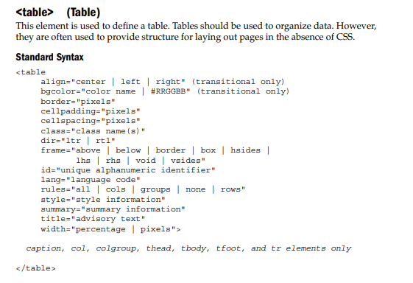

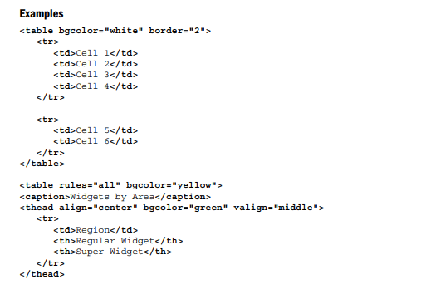

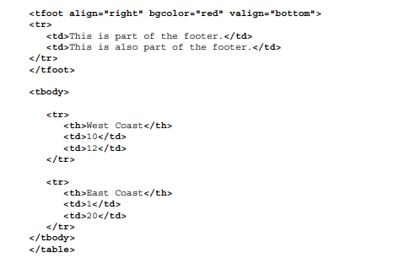

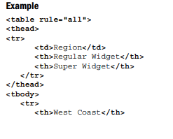

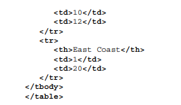

**Exam Questions**

1. **Video tag in html**
2. **Image tag in html**
3. **Audio tag in html**