Forms in Html.

An HTML form is used to collect user input. The user input is most often sent to a server for processing.

Top of Form

(Form for User Input) The element defines a fill-in form that can contain labels and form controls, such as menus and text entry boxes that might be filled in by a user

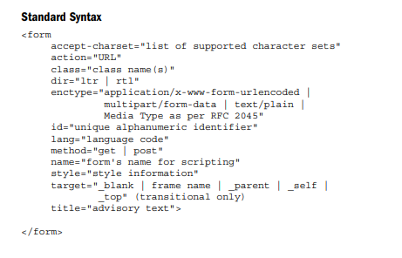

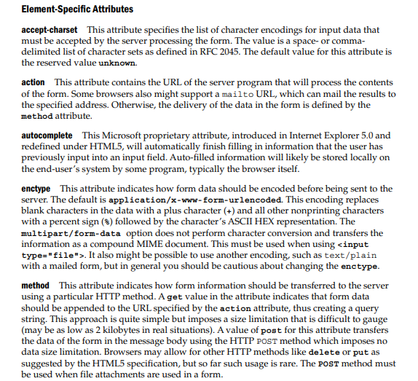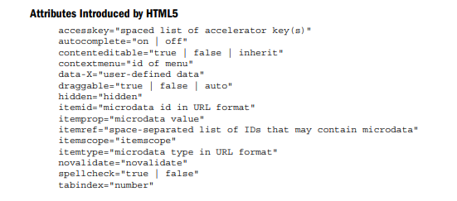

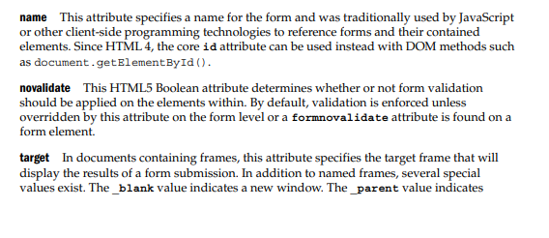

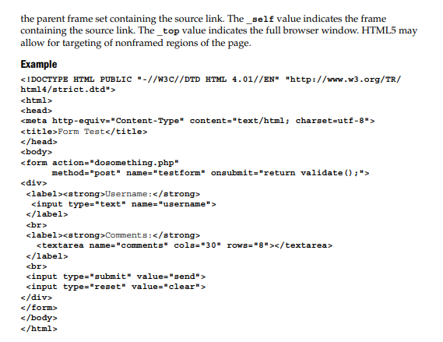

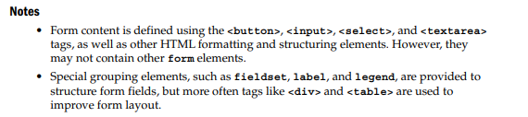

Exam Questions

1.Forms in html