# Lists in HTML. Styles in HTML

• <li>(List Item)

This element is used to indicate a list item as contained in an ordered list (ol), unordered list (<ul>), or older list styles such as <dir> and <menu>

HTML lists allow web developers to group a set of related items in lists.

An unordered HTML list:

* Item
* Item
* Item
* Item

An ordered HTML list:

1. First item
2. Second item
3. Third item
4. Fourth item

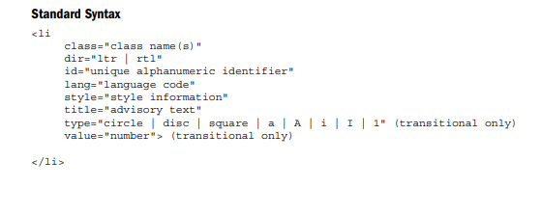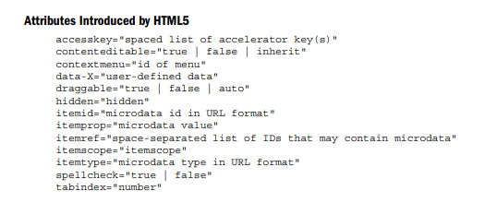

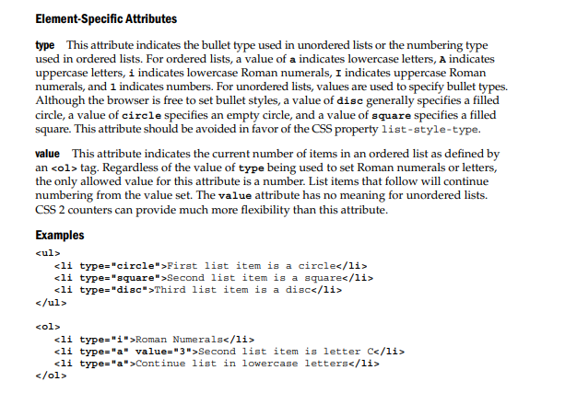

Notes

• Under the strict HTML and XHTML definitions, the li element loses the type and value attributes, as these presentation styles can be emulated with CSS properties like list-item-style and CSS counters.

• HTML5 reintroduces the value attribute to list items but CSS should be used instead.

• Whereas bullet styles can be set explicitly, browsers tend to change styles for bullets when

lists are nested. However, ordered lists generally do not change style automatically, nor do they support outline-style numbering (1.1, 1.1.1, and so on). CSS rules, of course, can do this.

• The closing tag is optional under HTML specifications, including HTML5. However, it is required under XHTML and should always be used

Unordered list

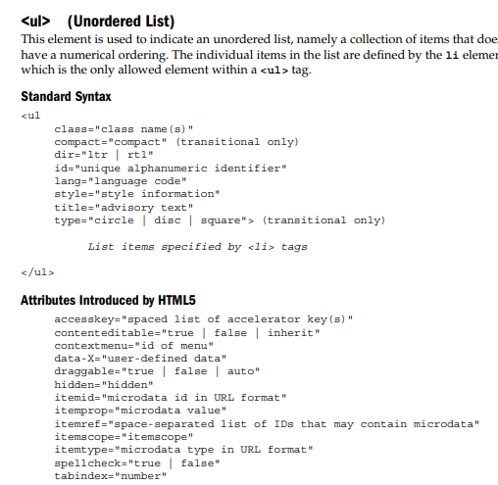

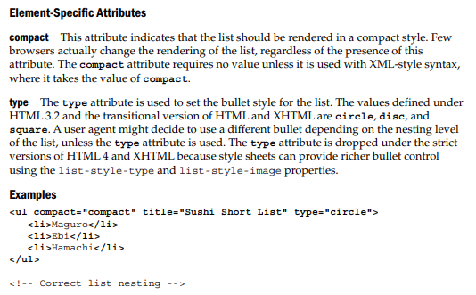

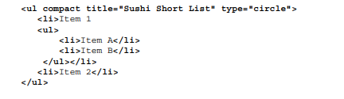

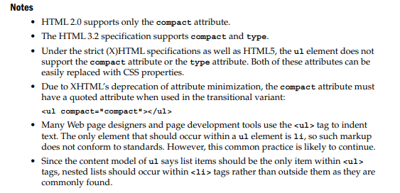

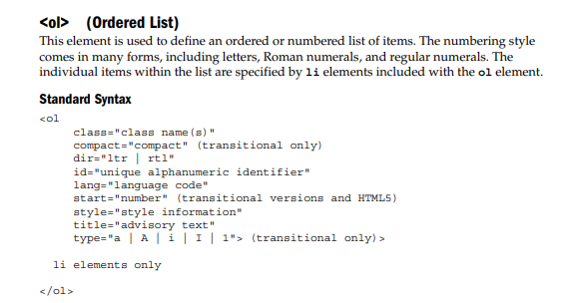

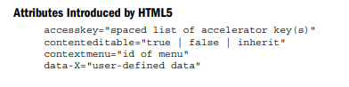

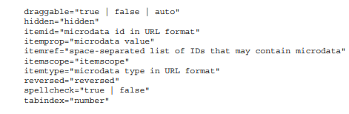

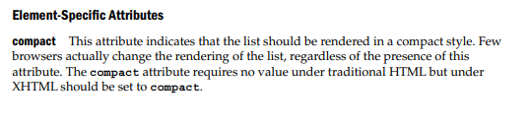

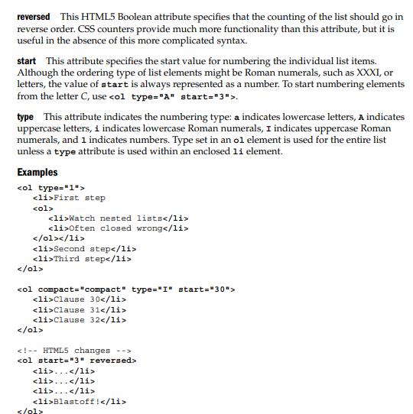

Notes

• Under the strict HTML and XHTML specifications, the ol element no longer supports the compact, start, and type attributes. These aspects of lists can be controlled with style sheet rules.

• HTML5 returns the start attribute to ordered lists and adds the reversed attribute.

• Under the XHTML 1.0 specification, the compact attribute must have a quoted attribute value:

• The HTML 3.2 specification supports only the compact, start, and type attributes.

• The HTML 2.0 specification supports only the compact attribute

# Styles in html

The HTML style attribute is used to add styles to an element, such as color, font, size, and more.

Setting the style of an HTML element, can be done with the style attribute.

The HTML style attribute has the following syntax:

<tagname style="property:value;">

The ***property*** is a CSS property. The ***value*** is a CSS value.

For example

<body style="background-color:powderblue;">  
  
<h1>This is a heading</h1>  
<p>This is a paragraph.</p>  
  
</body>

