

IT342-G4 SYSTEMS INTEGRATION AND

ARCHITECTURE 1

FUNCTIONAL REQUIREMENTS SPECIFICATION (FRS)

Project Title: BarberConnect
Prepared By: Ma. Melessa V. Cabasag Date of Submission: February 18, 2026
Version: 1.1
Table of Contents
- Introduction 3
  - Purpose 3
  - Scope 3
  - Definitions, Acronyms, and Abbreviations 3
- Overall Description 3
  - System Perspective 3
  - User Classes and Characteristics 3
  - Operating Environment 4
  - Assumptions and Dependencies 4
- System Features and Functional Requirements 4
  - Feature 1: 4
  - Feature 2: 4
- Non-Functional Requirements 5
- System Models (Diagrams) 5
  - ERD 5
  - Use Case Diagram 6
  - Activity Diagram 7
  - Class Diagram 8
  - Sequence Diagram 8
- Appendices 9

Introduction

Purpose
The purpose of BarberConnect is to provide a secure and integrated barbershop management system for both mobile and web platforms. This document is intended for developers, project evaluators, and stakeholders to understand the system’s design, features, and technical requirements for Final Defense.

Objectives

  - Implement secure authentication using JWT and BCrypt.

  - Enforce role-based access control for Barbers and Customers.

  - Provide full CRUD operations for the Appointment core module.

  - Integrate external services including Google OAuth, payment gateway (sandbox), email (SMTP), and public API consumption.

  - Follow proper layered backend architecture for maintainability and scalability.

Scope
BarberConnect allows users to register and log in securely using JWT authentication and Google OAuth. Customers can browse barbers, book appointments, and complete sandbox payments, while barbers can manage profiles, upload service images, and handle bookings. The system excludes video uploads and live production payment mode.

Definitions, Acronyms, and Abbreviations
List and define
- JWT – JSON Web Token used for secure authentication
- BCrypt – Password hashing algorithm
- OAuth – Third-party authentication protocol (Google Login)
- CRUD – Create, Read, Update, Delete operations
- API – Application Programming Interface
- DTO – Data Transfer Object
- SMTP – Simple Mail Transfer Protocol

Overall Description

System Perspective
BarberConnect is a full-stack application composed of:
- Spring Boot (Java) backend API
- Kotlin Android mobile frontend
- HTML web frontend
- Firebase (Authentication & Storage)
- The backend follows a Layered Architecture (Controller, Service, Repository, DTO, Security).

User Classes and Characteristics
Customer
- Books appointments
- Makes payments
- Views barber profiles
Barber
- Manages services and pricing
- Uploads service images
- Accepts and updates appointments
Admin (Future Extension)
- System monitoring and data management

Operating Environment

Hardware: Android smartphones, Desktop/Laptop

Software: Android Studio (Mobile), Visual Studio (Web), Intelli J (Backend), Web Browser (Chrome/Edge/Firefox)

Backend: Spring Boot (Java), MySQL Database

Services: Firebase, Stripe Sandbox, SMTP Mail Server

Assumptions and Dependencies

Internet connection is required

Users provide valid email accounts

Stripe sandbox keys are configured

SMTP server credentials are available

Firebase project is configured

System Features and Functional Requirements
  - Feature 1: Authentication & Security
Description:
Provides secure user registration, login, role-based access control, and protected endpoints using JWT.

Functional Requirements:
- Users must register with unique email and password
- Passwords must be hashed using BCrypt
- System must generate JWT upon login
- System must implement /me endpoint to retrieve authenticated user
- Protected routes must require valid JWT
- Role-based restrictions must be enforced (BARBER, CUSTOMER)
- Google OAuth login must generate internal JWT
  - Feature 2: Role-Based Access Control (RBAC)
Description:
Implements role restrictions at API and UI levels to separate permissions between BARBER and CUSTOMER.
Functional Requirements:
- System must support at least two roles (BARBER, CUSTOMER)
- API endpoints must restrict access using role validation
- UI must display features based on user role
- Unauthorized role access must return HTTP 403
  - Feature 2: Appointment Management (Core Business Module)
Description:
Allows customers to book barbers and complete sandbox payments. Barbers manage bookings and upload service images.

Functional Requirements:

- Customers can create appointments (Create)
- Users can view appointments (Read)
- Barbers can update appointment status (Update)
- Users can cancel appointments (Delete)
- Payment must be processed via Stripe Sandbox
- Payment result must be recorded in database
- Booking confirmation email must be sent via SMTP
- Barber images must be uploaded to Firebase Storage and linked to database
- System must consume one public API (e.g., weather API) and display data on dashboard.

  - Feature 4: Payment Gateway Integration (Sandbox)
Description:
Integrates Stripe Sandbox to process appointment payments securely.
Functional Requirements:
- System must connect to Stripe Sandbox API
- Payment success and failure must be handled
- Transaction ID and status must be saved in database
- Payment confirmation must update appointment status
  - Feature 5: File Upload System
Description:
Allows barbers to upload service images stored in Firebase Storage and linked to database records.

Functional Requirements:
- Users can upload image files (JPEG/PNG)
- Files must be stored securely in Firebase Storage
- File URL must be saved in database
- Uploaded images must be viewable in app
  - Feature 6: Email Notification System (SMTP)
Description:
Sends automated emails for account and booking notifications.

Functional Requirements:
- System must send welcome email after registration
- System must send booking confirmation email after payment
- Email must be sent using SMTP server (not console print)
  - Feature 7: External API Integration
Description:
Consumes a public API (e.g., weather API) and displays real-time information on the dashboard.

Functional Requirements:
- System must connect to a public API
- API data must be parsed and displayed in dashboard
- API errors must be handled gracefully

Non-Functional Requirements
Performance
- API response time ≤ 2 seconds
- Supports at least 100 concurrent users
Security
- HTTPS communication
- JWT authentication
- BCrypt password hashing
- No plain-text password storage
Usability
- Responsive web and mobile design
- Clear validation and error messages
- Intuitive navigation
Reliability
- 99% uptime during testing phase
- Error handling and graceful degradation
Maintainability
- Layered architecture for backend
- DTO usage to prevent exposing sensitive data
- Global exception handling
- Modular code structure for future updates
Scalability
- Supports increasing number of users without performance degradation
- Designed to allow addition of new features easily

System Models (Diagrams)
Insert the necessary diagrams for the system:

ERD
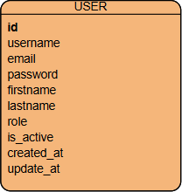

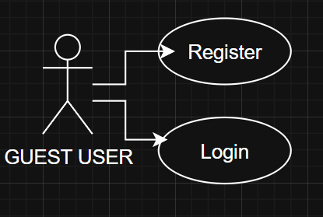
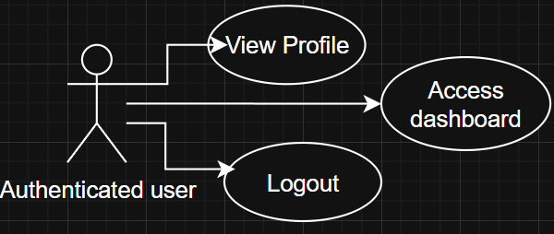
Use Case Diagram

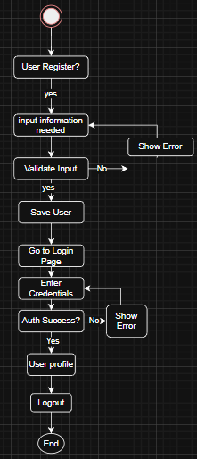
Activity Diagram

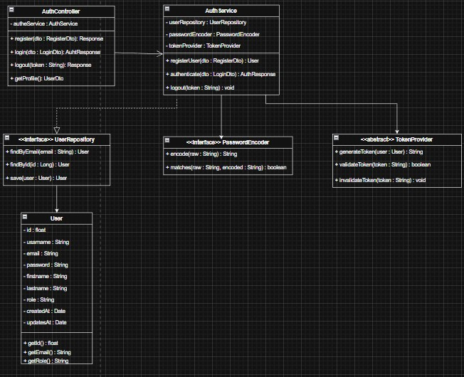
Class Diagram

Sequence Diagram
Register Sequence Diagram
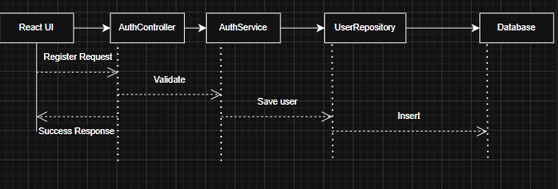

Login Sequence Diagram

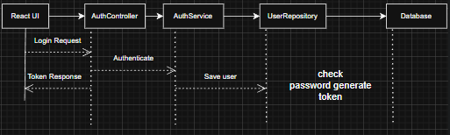
Logout Sequence Diagram
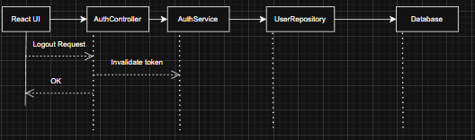

Appendices
Include any additional information, references, or support materials.

