

IT342-G4 SYSTEMS INTEGRATION AND

ARCHITECTURE 1

FUNCTIONAL REQUIREMENTS SPECIFICATION (FRS)

Project Title: Laboratory Activity: Mini App – User Registration & Authentication
Prepared By: Ma. Melessa V. Cabasag Date of Submission: February 3, 2026
Version: 1.1

Table of Contents
- Introduction 3
  - Purpose 3
  - Scope 3
  - Definitions, Acronyms, and Abbreviations 3
- Overall Description 3
  - System Perspective 3
  - User Classes and Characteristics 3
  - Operating Environment 4
  - Assumptions and Dependencies 4
- System Features and Functional Requirements 4
  - Feature 1: 4
  - Feature 2: 4
- Non-Functional Requirements 5
- System Models (Diagrams) 5
  - ERD 5
  - Use Case Diagram 6
  - Activity Diagram 7
  - Class Diagram 8
  - Sequence Diagram 8
- Appendices 9

Introduction

Purpose
The purpose of this system is to provide a secure and reliable authentication mechanism for a mobile and web-based application. The system will manage user registration, login, session management, and account validation. This document is intended for software developers, project stakeholders, and QA testers who will design, implement, and maintain the authentication system.

Scope
The authentication system will:

    - Allow users to register an account with unique credentials.
    - Authenticate users through login and maintain sessions securely.
    - Provide password validation and error handling.
Boundaries: The system does not include advanced user management features like role-based access control, third-party authentication (OAuth), or user activity tracking. It focuses solely on secure authentication and session management.

Definitions, Acronyms, and Abbreviations
List and define

    - Auth System – Authentication System for user login and registration.
    - User – Any person accessing the application.
    - Session – Temporary data storage to maintain user login state.
    - PWD – Password.
    - UI – User Interface.
    - API – Application Programming Interface.

Overall Description

System Perspective
The authentication system is a core component of the larger application ecosystem, connecting both the mobile app (Kotlin) and web interface (HTML/PHP) and spring boot for backend interacting to database. It acts as a gatekeeper to ensure only verified users can access protected features. It interacts with the database for storing and validating user credentials and sessions.

User Classes and Characteristics
    - Regular Users: Users who register to access app features. Familiar with basic smartphone/web usage.

    - Admin (Optional Future Use): Oversees user accounts and system health. More technical knowledge.

Operating Environment
    - Hardware: Android devices for mobile app, PC or mobile browser for web access.
    - Software: Visual Studio or Android Studio (Kotlin), Web server with PHP, MySQL database.
    - Tools/Frameworks: Firebase (optional for notifications), Session management classes, PHP/SQL and Spring boot for backend operations.

Assumptions and Dependencies
    - Internet connectivity is required to communicate with the database.
    - Users will provide valid email addresses or usernames.
    - Database schema is pre-configured to store user credentials securely.
    - External dependencies include the Android SDK, PHP runtime, MySQL server, and Firebase (if used).

System Features and Functional Requirements
  - Feature 1: User Registration
Description:
Allows new users to create an account by entering a unique username/email and password. Validates the input to ensure security.

Functional Requirements:
- Users must provide a unique username or email.
- Passwords must meet security criteria (e.g., minimum length, alphanumeric).
- System must check if the user already exists and return an appropriate message.
  - Feature 2: User Login
Description:
Allows registered users to log in and create a session. Validates credentials against the database.
Functional Requirements:
- Users must enter correct username/email and password.
- System verifies credentials and initiates a session upon success.
- Displays an error message for invalid login attempts.

Non-Functional Requirements
- Performance: Login and registration requests should complete within 2 seconds.
- Security: Passwords must be hashed before storing; sessions must be secured.
- Usability: Intuitive UI with clear messages for errors or validation.
- Reliability: 99% uptime of authentication services.
- Scalability: Able to handle multiple concurrent users without performance degradation.
- Maintainability: Code should be modular for easy updates or addition of new features.

System Models (Diagrams)
Insert the necessary diagrams for the system:

ERD
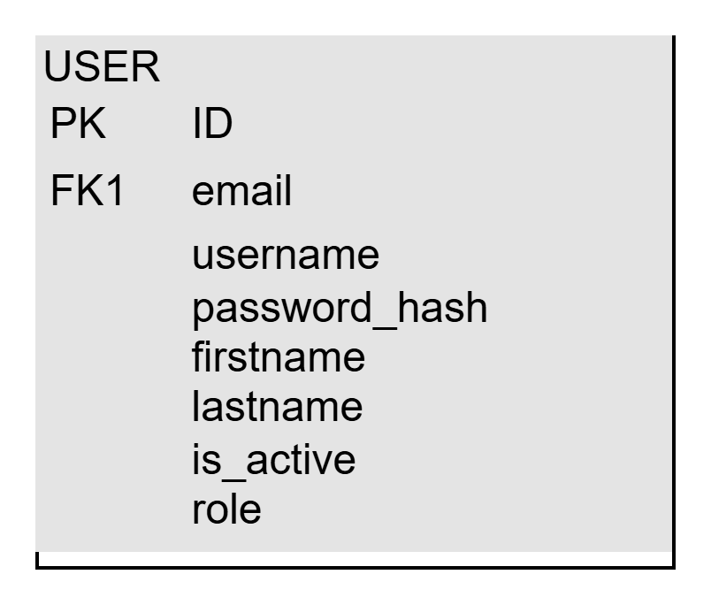

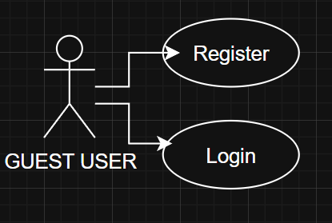
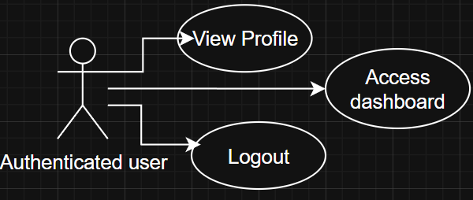
Use Case Diagram

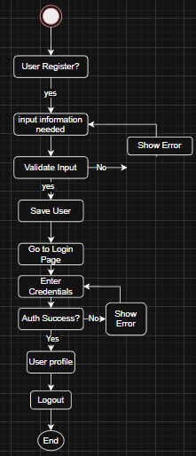
Activity Diagram

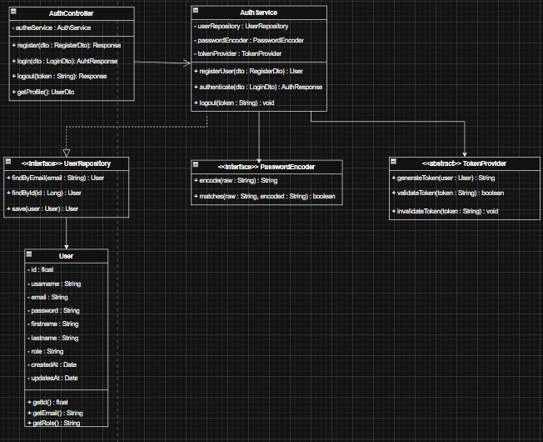
Class Diagram

Sequence Diagram
Register Sequence Diagram
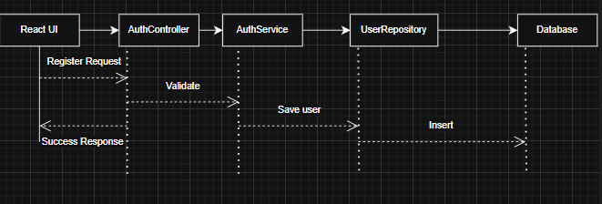

Login Sequence Diagram

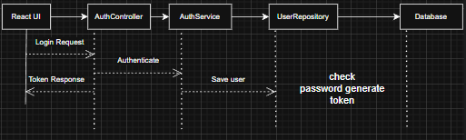
Logout Sequence Diagram
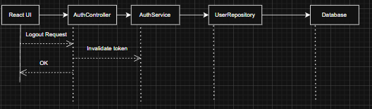

Appendices
Include any additional information, references, or support materials.

- Documentation

Register Page:
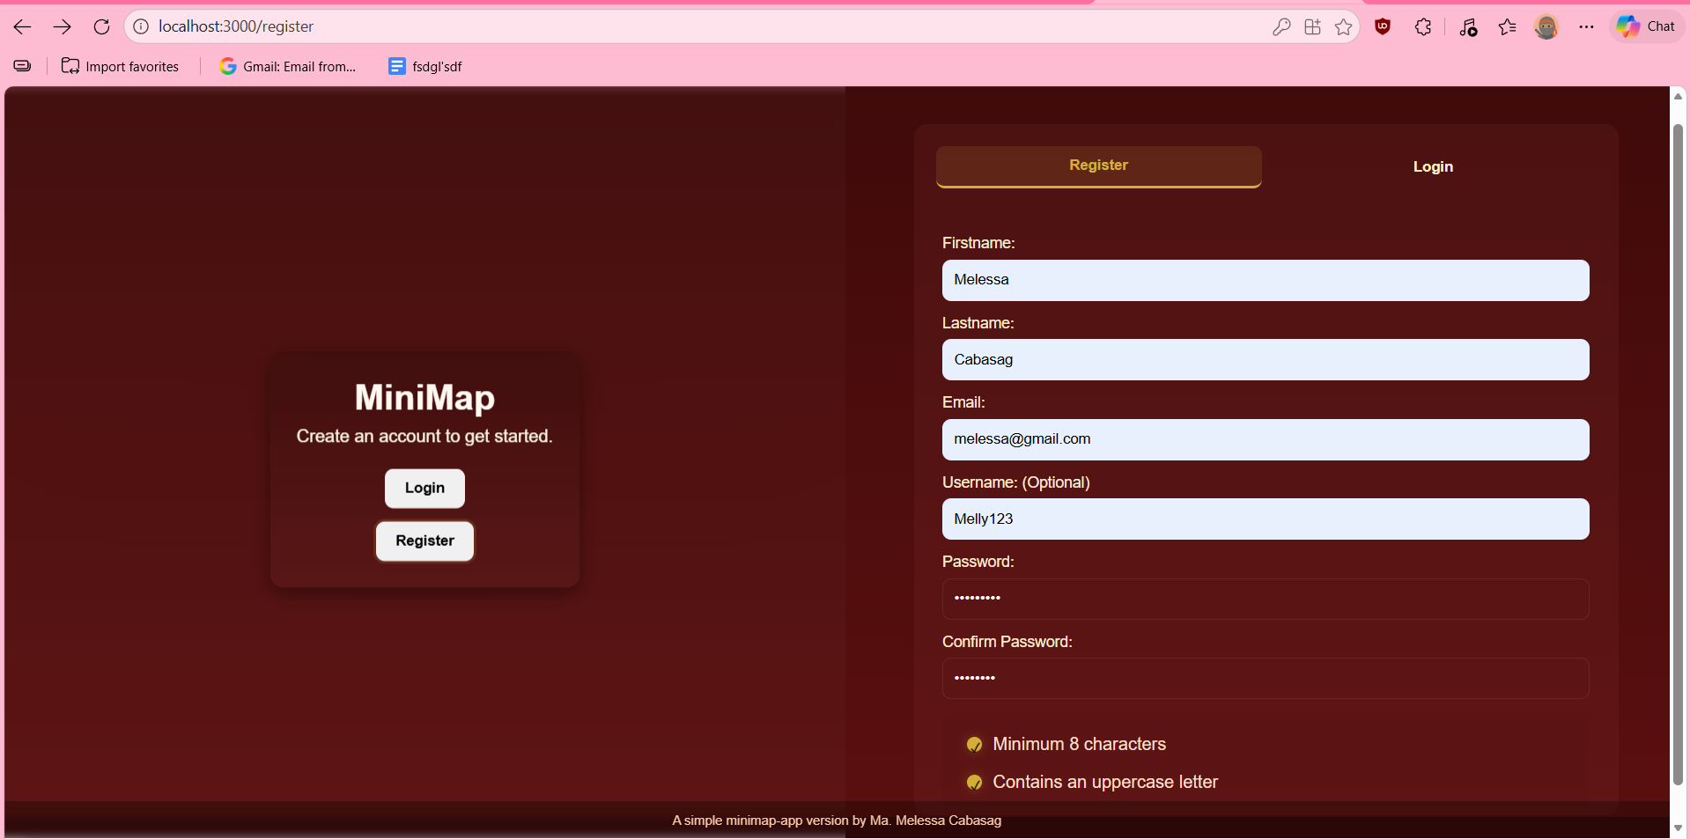

Login page:
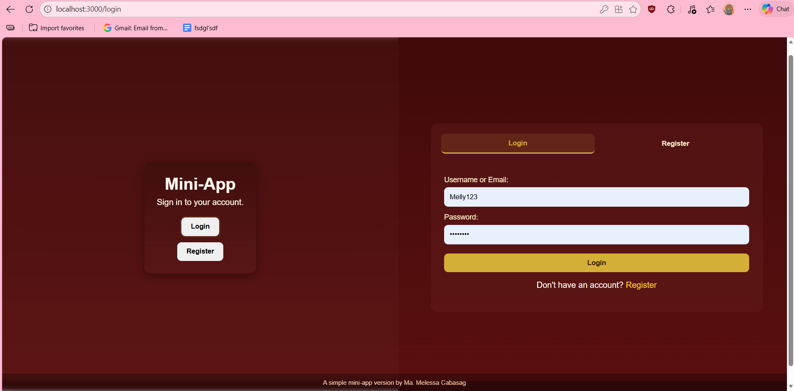

Dashboard Page:
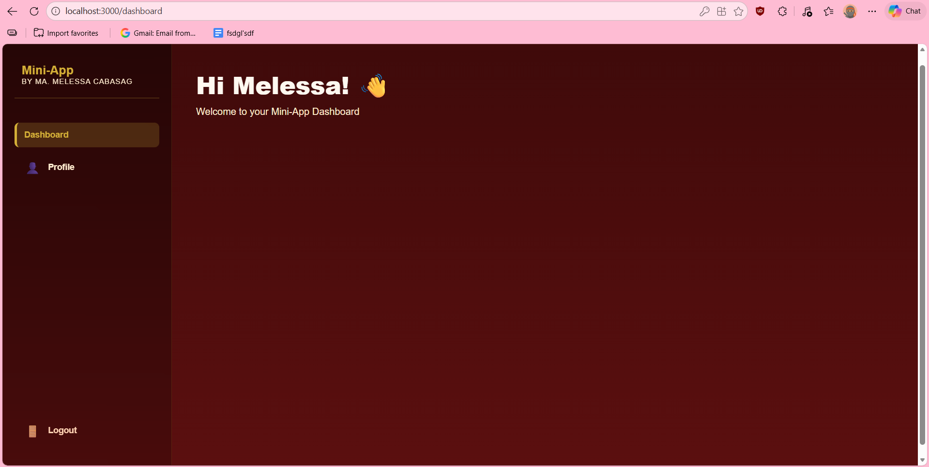

Profile Page:
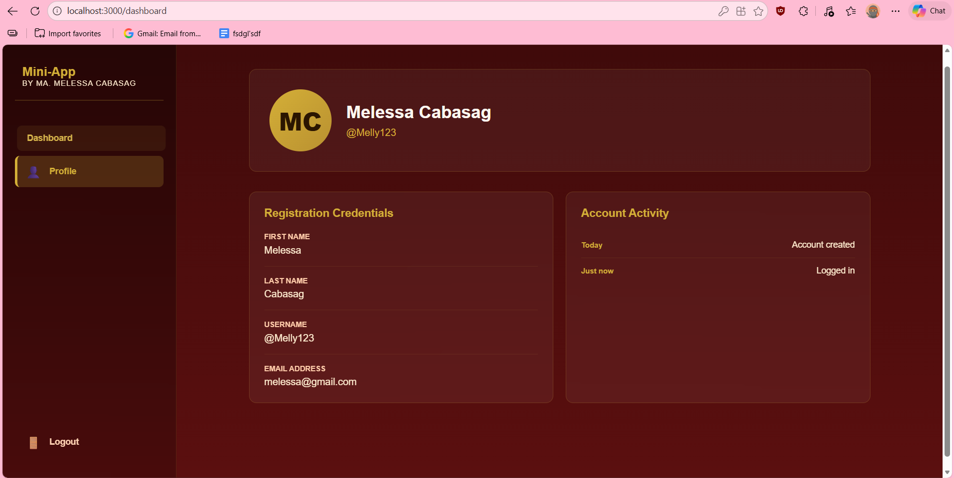

Logout Page:
