SPECIES OF SEAWEEDS IN ALO, OSLOB, CEBU

Research Paper Presented to the Faculty of the
Patronage of Mary Development School
Poblacion, Boljoon, Cebu

In Partial Fulfillment of the Requirements in the Subject
Capstone Research

by
Debbie Maica M. Lunday
Clyde C. Benolirao
Keith Carro
Princess Ann G. Culong
Janine M. Tarongoy

FEBRUARY 2023

Chapter 1
The Problem and Its Scope
INTRODUCTION
Rationale
The word "seaweed" is a catch-all name for plants and algae that develop in bodies of water including the ocean, rivers, lakes, and streams. According to recent studies, seaweeds have the potential to produce novel biologically active compounds and substances that are essential for human growth and nutrition. As a result of these properties, marine algae are highly valuable in the pharmaceutical, nutraceutical, and human health industries (Smit, 2004; Cardozo et al., 2007; MacArtain et al., 2007).
In many maritime nations, seaweeds are employed as a food source, in industrial processes, and as fertilizer. In Asia, particularly in Japan, Korea, and China, where seaweed production has become a major industry, these plants are mostly used as food. There hasn't been much motivation to improve seaweed growing methods in the majority of western nations because food and animal consumption are restricted. These are some current and future uses for seaweeds. The majority of industrial use currently only involves the extraction of phycocolloids and, to a much lesser extent, a few fine biochemicals. Although they are not currently used on an industrial basis, fermentation and pyrolysis are potential solutions for the twenty-first century. Seaweeds are currently used as human meals, cosmetics, fertilizers, and to extract industrial chemicals and gums. They may be exploited as a source of long- and short-chain compounds for both industrial and medical applications.

According to the National Ocean Service, seaweeds are utilized for medical purposes because they contain components that are anti-inflammatory, anti-microbial, and cancer-fighting in addition to being a significant food source in some regions of the world. From ancient times, seaweeds have been valued for their ability to improve health. Seaweeds are crucial to the functioning of aquatic environments. Fish and other marine creatures like sea urchins and crustaceans can eat and live in them. They are the base of the food chain and provide habitat for a wide variety of aquatic species.

Seaweeds synthesize oxygen as a by-product of photosynthesis, much like other photosynthetic organisms do. According to estimates, algae generates between 30 and 50 percent of the oxygen needed by humans and other creatures to survive on land and in the ocean. By removing extra nutrients and pollutants from the water, such as organic compounds and heavy metals, seaweeds help to reduce pollution. They are a superior farm fertilizer because they absorb minerals and antioxidants from pure water. Seaweeds are utilized in animal feeds, human diets, medications, and cosmetics. Multicellular marine plants called seaweed are particularly abundant close to the seafloor. They are thus a type of benthic organism that can be found in or close to marine sedimentary ecosystems, such as the foreshore and the depths of the ocean. A seawater habitat, light that can reach the bottom since it is necessary for photosynthesis, and a substrate to connect to are some of the basic requirements for seaweeds to flourish. Nonetheless, certain species that are classified as seaweed yet are freely floating.
In this research, youth will learn the different species of seaweeds, their characteristics, scientific names, how they are used or how they are useful by humans and everything we want them to know about seaweed.

Literature Background
Industrial use of algal biomass has shifted over the years from using seaweed as a fertilizer and source of potash to iodine production and hydrocolloid extraction (Synytsya et al., 2015). At all stages, the “potential” of the future industry has been viewed as larger than it actually is. This is as important today as it was over 100 years ago, when the industry was very different (Hafting et al., 2015). Many researchers predict a future in which seaweed is cultivated for more valuable purposes than ordinary food and fodder (Neori, 2016). These include higher value applications as raw materials for special polysaccharides (agar, carrageen, alginate, etc.).
Bixler & Porse, 2011) or converting biomass into products for special technical and agricultural uses (Buschmann et al., 2008; Craigie, Citation2011). Further up the value pyramid are valuable raw materials for food and feed (Fleurence, 2016), cosmeceuticals (Balboa et al., 2015), dietary supplements (Himaya & Kim, 2015), pharmaceuticals (Thanh- Sang Vo et al., 2012; Cao et al., 2016; Anis et al., 2017) and bioenergy as a low-value but very high-volume application (Korzen et al., 2015; Fernand et al., 2016) . As these different applications can complement each other, various processing options (see, for example, Camus et al., 2016) have been developed, including holistic approaches. A holistic “biorefinery approach” extracts the most valuable components from the algal biomass, one after the other, and uses the rest as is. Trivedi et al., 2015).

Although human-algae interactions appear to date back to the Neolithic period (Dillehay et al., 2008; Ainis et al., 2014; Erlandson et al., 2015), the earliest record of their human use is is from China, circa 1700. year (Yang et al., 2017). Over the centuries, coastal inhabitants have harvested various seaweeds from all seaweed groups. Initially, algae were most commonly used for domestic purposes as food and feed, but later industrial uses (gels, fertilizers) emerged (Delaney et al., 2016). Early examples of the medicinal use of seaweed include the Chinese use of brown seaweed for goiter (16th-century Chinese herb, Peng Tsae Kang Mu), and geranium for intestinal ailments. and used dehydrated laminaria stalks for cervical dilatation during dystocia (Levine, 2016).
Seaweed farming is gaining worldwide popularity and currently is a well-established industry (Buschmann et al., 2017). Seaweed farming brings foreign currency and offers an opportunity of income earning for the coastal marginalized communities. Taking this into account globally seaweed farming is promoted to the coastal rural community by international development organizations to uplift their poverty (Campbell et al., 2019; Rimmer et al., 2021). Since seaweed farming has short culture cycle and simple low-cost farming technologies are available, seaweed farming has high economic returns (García-Poza et al., 2020).

Throughout the world, suitable are for seaweeds culture area covers 48 million km² of marine ecosystem in 132 countries, though only 37–44 countries are currently active in seaweed production (Froehlich et al., 2019). Seaweed farming contributes significantly to sustainable aquatic food production. In addition, farming of seaweed also offers ecosystem services, for example habitats for fisheries as well as sequestration of nutrients (Hasselström et al., 2018). Seaweed production does not need fertilizer or pesticide but extracts nutrients from the water, purifying surrounding water and maintains ecosystem health. For instance, uptake of phosphorus from large seaweed farming activities significantly contribute in mitigation of eutrophication in coastal area (Xiao et al., 2017).

Worldwide food and fertilizer are produced from seaweed. In addition, seaweeds are also used in industrial sectors (García-Poza et al., 2020). Seaweeds are rich with nutrients (i.e. proteins, carbohydrate, lipids and fibers) (Sánchez-Machado et al., 2004). Seaweeds are found as important source of bioactive compounds and have antioxidant activities (Wang et al., 2012). Seaweed industry is expanding rapidly throughout the globe for high economic returns. It is estimated that global seaweed production already exceeded 32.4 million tonnes which is three times more than the production of 2000 (FAO 2020). Most of the global seaweed productions (about 97.1%) comes from the offshore and onshore cultivation sites, and only 2.9% are harvested from wild sources (FAO 2020). It is interesting that, eastern and southeastern Asia is contributing in most of the seaweed production which is about 99.6% of global production. Only China is contributing about 58% of global seaweed production (FAO 2020). However, other countries (i.e. Indonesia, Philippines, South Korea, Japan and North Korea) are also producing seaweeds.

Algae referred to in this document include seaweeds (i.e. marine macroalgae) and microalgae, which are photosynthetic aquatic organisms. Algae play a vital role in the aquatic ecosystem by forming the energy base of the food web for all aquatic organisms; they provide various environmental benefits and ecosystem services, such as eutrophication mitigation, carbon capture or sequestration, ocean acidification amelioration, habitat provision and shoreline protection, among others. Seaweeds, however, are not well known in many parts of the world, as their production is mostly concentrated in Eastern and South-eastern Asia. On the demand side, while in Eastern Asia seaweeds have become widely and frequently consumed human foods, in other parts of the world seaweeds are largely niche or novel foods, mostly eaten in some coastal communities as traditional foods or by a relatively small number of consumers for various purposes, which could be dietary (e.g. as exotic foods from Oriental cuisine), nutritional (e.g. supplementing micronutrients), environmental (e.g. as products with a low environmental footprint) and/or social (e.g. plant-based diets for animal welfare). Seaweeds have multiple other uses in food and non-food industries, such as food additives, animal feeds, pharmaceuticals, nutraceuticals, cosmetics, textiles, biofertilizer/ biostimulants, bio-packaging, and biofuel, among others (McHugh, 2003; FAO, 2018). However, knowledge of their contribution to these products is generally confined to seaweed-related industries and the scientific community.

In the Philippines, over 200,000 coastal families like Gimotea’s engage in commercial seaweed farming, which was first introduced in the country in the early 1970s. Five decades later, the Philippines emerged as the world’s fourth largest producer of aquatic plants, including seaweed. In 2020, the country produced 1.48 million tonnes (1.63 million tons) of aquatic plants, or 4.56% of the total world production of 32.4 million tonnes (35.7 million tons). The Philippines’ seaweeds are exported to the United States, China, Spain, Russia and Belgium, where they are prized for carrageenan, a gelatin-like additive used as a thickening agent and stabilizer for many food and cosmetic products. In many coastal communities, seaweed farming also has proven its value as a way to help address poverty and environmental issues, such as illegal, unreported and unregulated fishing (IUUF), and degradation of quality of habitat for endangered marine life. However, climate change that triggers seaweed disease and pest problems is becoming a threat to this industry, leaving Gimotea and many others worried about their families’ futures.
Indonesia, located in the Coral Triangle region, is the largest commercial seaweed producer in the tropics and the second in the world after China. The commercial cultivation of seaweed in Indonesia was established first in 1987 in Bali with the efforts of the Copenhagen Pectin Factory. This endeavor was achieved by Adnan and Porse after several trials in the 1980s. By 2007 Indonesia replaced the Philippines as the leading producer of carrageenophyte algae due to the increase in the number of Indonesian farmers and farming areas. At the same time, the Philippines suffered several disease outbreaks and a declining quality of propagules under extreme weather conditions. By 2009, the island of Sulawesi had become the main seaweed producer in Indonesia with 66% of the total dry seaweed production in the country. Since then, seaweed farming has expanded to almost all regions in Indonesia.
“Brown seaweed has been an important part of the Japanese diet for centuries; it is used in soups, as an additive to change the taste of other foods and as a wrap for the raw fish and rice 6 combinations known as sushi” (What when how 2010). Furthermore, Indergaard (1983, pp.137-167) states that seaweed has been eaten since prehistoric times as part of a staple human diet in most Asian countries. According to Indergaard, cited in Guiry (Guiry 2015a), a Chinese scholar called Sze Teu wrote in 600 BC that “Some algae are a delicacy fit for the most honoured guests, even for the King himself”. Indergaard (1983) explains that 21 species of seaweeds are used in everyday cookery in Japan today, six of which have been used since the 8th century. Kombu, wakame, nori and, in particular, kaiso seaweed, accounted for more than 10% of the Japanese seaweed diet until relatively recently. Seaweed consumption reached an average of 3.5 kg per household in 1973, in Japan, representing a 20% increase over 10 years (Indergaard 1983, pp.137-167). In Ireland, it is assumed that, at most, merely three to six tonnes of domestically produced seaweed food products are consumed annually (Walsh and Watson 2010). Stein and Borden (1984), cited in Seaweed.ie (2015), refer to regulations for the harvesting of Palmaria palmata (dulse, dillisk), a red seaweed, which is mentioned in the 10th century Icelandic sagas. Laver (Porphyra) has been eaten in Wales since at least AD 1600 (Allen and Hatfield 2004, p.1021). It is still eaten today and produced commercially for sale in Wales, for local and export trade. The consumption of edible seaweed has also been documented in Ireland for a very long time (Bliss 1985, pp.141-166; Guiry 2015a). In Collén et.al. (2004), Bliss (1985) articulates that the domestic use of Irish moss was documented at least as early as 1809. Mitchell and Guiry support this by observing, in Collén (2014, p.57) that, in 1829, the name “Chondrus Crispus” (for Irish moss) alluded to its putative therapeutic properties. Furthermore, it was acclaimed for wellbeing as a remedy in Ireland at this time (Allen 2004). Collén (2014) indicates that a traditional treatment in Ireland for chest and lung ailments involved Irish moss, which was boiled in milk or water. “Various red algae have also been used in the Mediterranean as sources of dyeing agents and as anthelmintic and other health remedies since pre-Christian times” (Stein and Borden 1983, pp.485-501). While seaweed has had many uses in the past, the study will examine the main types and modern uses of seaweed in the next section.

The Food and Agriculture Organization reports revealed that worldwide seaweed production has risen from 44 in 1996 to 51.3 % in 2018. Countries such as the United Kingdom, Spain, Norway, France, Philippines, Vietnam, China and Japan account for about 90% of the overall seaweed production. Other countries, including Ireland, Canada, the United States, and New Zealand, are also involved in producing seaweeds (Fleurence, 2016; Chopin and Tacon, 2020). Seaweeds have become an integral part of the coastal ecosystem, supporting aquatic life. In several Asian countries, seaweeds were eaten as food; however, in India, seaweeds are exclusively used to produce hydrocolloids (Ganesan et al., 2019a). Out of 10,000 seaweed species reported to exist, only a few seaweed species are aqua-cultured for human consumption (Mac Monagail et al., 2017). China, Japan, and the Republic of Korea predominantly consume seaweed. Recently, North America, South America, and Europe have adopted seaweeds in their cuisine (Černá, 2011).

A study on the amino acid composition of various seaweed species revealed that aspartic and glutamic acids were present in abundance, whereas methionine was scarcely present (Lafarga et al., 2020). Apart from high-quality protein, seaweeds represent an excellent collection of bioactive compounds such as essential fatty acids, dietary fibres, carotenoids, phenolic compounds, water-soluble and liposoluble vitamins (Nunes et al., 2017). The bioactive compounds possess antioxidant, antibacterial, anticancer, antidiabetic, antitumor, antiviral, anti-inflammatory, and anticoagulant properties that potentially contribute to functional food products development (Ganesan et al., 2019b). Seaweeds are employed as active prebiotic ingredients to improve the fermentability of gut microorganisms by limiting the proliferation of pathogenic organisms in the human gut (Vidhya Hindu et al., 2018). However, in vivo studies, metabolism, bioavailability, and clinical trials are necessary before direct human consumption (Wijesekara and Karunarathna, 2017). The mineral profile of seaweeds reports the presence of high calcium, magnesium, phosphorus, potassium, sodium, and iron contents (Serge and Joel, 1993). The quality and yield of protein extracted from seaweeds are based on the aquaculture system's location, season, and other environmental conditions.

Public and private Food Safety Organizations mandatorily adhere to the Hazard Analysis and Critical Control Point (HACCP) principles (Banach et al., 2020). Seaweeds' product diversification is essential to reach out to consumers belonging to different demographics and cultures. Innovative snack products and ready-to-eat meals such as flavoured tidbits, noodles, health drinks, cookies, crackers, sweets, salad and condiments are manufactured in the European Union, USA, and South Asian countries (FAO, 2018). Seaweeds are known to possess the fifth basic taste, "umami". The presence of organic acids, amino acid salts and short peptides is a prominent feature of the umami taste of seaweeds. Globally, there is a considerable elevation in the consumption of seaweed-based food products because of the unique flavours (Milinovic et al., 2021). Drying is considered the best method of preserving seaweeds as it maintains the organoleptic quality and reduces the weight of the product, which in turn reduces the shipping cost. When soaked in water, the dried seaweeds tend to regain their original shape with minor loss of nutrients. Post-drying, the seaweed undergoes other unit operations such as size reduction, blending, and packaging based on the requirement (Ahmed et al., 2017). Seaweeds can be labelled as "alternative protein" as they can fulfil the drawbacks of existing protein and maintain a sustainable, nutritious diet. Including seaweeds as an everyday food source in functional foods and nutraceuticals may potentially contribute to future global food security. Seaweeds are macroscopic and predominantly marine algae found from the intertidal zone to 300 m deep (Levine, 2016). These marine plants are fast-growing–can grow up to 60 m in length–and have diverse habitats (Pina-Pérez et al., 2017). They do not require arable land, freshwater, and fertilizers for their growth (Tiwari & Troy, 2015) and can be cultivated in massive amounts in oceans. Currently, most aquatic plants are farmed (around 97%), and half of the produce is used for human consumption (Costello et al., 2019).

According to the FAO report (2021), the world capture production of aquatic plants (majorly seaweeds) was 1.1 million tonnes in 2019, while the aquaculture production was 34.7 million tonnes. The primary producer countries identiﬁed are China, Indonesia, the Korea Republic, the Philippines, and Democratic People’s Republic of Korea. The seaweeds are classiﬁed mainly into three subclasses–brown (Phaeophyta), green (Chlorophyta), and red (Rhodophyta), based on the signiﬁcant pigment present (Hanjabam et al., 2019; Pandey et al., 2020). The primary pigments are fucoxanthin and chlorophyll a and c in brown seaweeds, chlorophyll a and b in green seaweeds, and phycobilins along with chlorophyll a and d in red seaweeds. The production of brown, red, and green seaweeds in 2019 stood at 16.4 million tonnes, 18.3 million tonnes, and 0.16 million tonnes, respectively (FAO, 2021). The consumption of seaweeds, per se, is not a new phenomenon. Seaweeds have been a part of the human diet for ages. The seaweeds can be added to food matrices by supplementation either in the form of suitable extract/ingredient or whole. The incorporation presumably alters the food’s technological, nutritional, and sensorial characteristics, thus giving rise to new/novel foods having desired attributes.

The current utility of seaweeds includes developing new food products and obtaining relevant high-value ingredients for food and pharmaceutical purposes. Seaweed or the compounds isolated from these plants can perform various roles in food systems–preservative, pigment, nutritional/bioactive agent, and technological improver (Barba, 2017). Further, the low cost, sustainability, and low environmental footprint make seaweeds relevant in changing scenarios for optimal utilization of their functionality for dietary beneﬁts. Supplementation by seaweeds is expected to perform nutri-tional, technological, or organoleptic functions in the desired food product and alter the food product’s nutritional content, technological functionality, and organoleptic attributes. Seaweeds can be utilized to tailor various food products’ functional and technological attributes to our requirements for healthy, palatable, and convenience foods. The present review brieﬂy discusses the utilization of seaweeds in food product development during the last decade. The review also highlights signiﬁcant concerns associated with the acceptance and consumption of seaweed in the diet.

The use of seaweed as food has been traced back to the fourth century in Japan and the sixth century in China. In 1750’s, an English physician successfully used ash from kelp (Phaeophyceae) which is rich in iodine to treat goiter. Kelp was also used to treath obesity in 19 th. century, and agar was used as a laxative. Seaweeds were used as a source of iodine. And their crude extracts were used for clarification in brewing. Another hydrocolloid, carrageen, found initially in the red seaweed Chondrus crispus was known in Ireland since 1810. Alginic acid, a hydrocolloid found in all brown seaweeds, was discovery first by Charles Stanford in the 1880s. Development of a large scale alginate industry began California and in Scotland in the late 1920s and early 1930s, respectively. Laminaria japonica was cultivated in China from the 1950s. The hydrocolloids have found increasing industrial and food applications in those years. Today China, Japan and the Republic of Korea are the largest consumers of seaweed as food. However, as nationals from these countries have migrated to other parts of the world, the demand for seaweed for food has followed them, as, for example, in some parts of the United States of America and South America. Increasing demand over the last fifty years outstripped the ability to supply requirements from natural (wild) stocks. Research into the life cycles of these seaweeds has led to the development of cultivation industries that now produce more than 90 percent of the market's demand. In Ireland, Iceland and Nova Scotia (Canada), a different type of seaweed has traditionally been eaten, and this market is being developed. Some government and commercial organizations in France have been promoting seaweeds for restaurant and domestic use, with some success. An informal market exists among coastal dwellers in some developing countries where there has been a tradition of using fresh seaweeds as vegetables and in salads. Various red and brown seaweeds are used to produce three hydrocolloids: agar, alginate and carrageenan. A hydrocolloid is a non-crystalline substance with very large molecules and which dissolves in water to give a thickened (viscous) solution. Alginate, agar and carrageenan are water-soluble carbohydrates that are used to thicken (increase the viscosity of) aqueous solutions, to form gels (jellies) of varying degrees of firmness, to form water-soluble films, and to stabilize some products, such as ice cream (they inhibit the formation of large ice crystals so that the ice cream can retain a smooth texture). Seaweeds as a source of these hydrocolloids dates back to 1658, when the gelling properties of agar, extracted with hot water from a red seaweed, were first discovered in Japan. Extracts of Irish Moss, another red seaweed, contain carrageenan and were popular as thickening agents in the nineteenth century. It was not until the 1930s that extracts of brown seaweeds, containing alginate, were produced commercially and sold as thickening and gelling agents. Industrial uses of seaweed extracts expanded rapidly after the Second World War, but were sometimes limited by the availability of raw materials. In the 1950’s, it was found that Gracilaria spp. treated with alkali produced higher strengthgels. After several years, Gracilaria can be cultivated successfully on a commercial scale, it is now used more widely. Once again, research into life cycles has led to the development of cultivation industries that now supply a high proportion of the raw material for some hydrocolloids. Today, approximately 1 million tonnes of wet seaweed are harvested and extracted to produce the above three hydrocolloids. Total hydrocolloid production is about 55 000 tonnes, with a value of US $ 585 million. Alginate production (US $ 213 million) is by extraction from brown seaweeds, all of which are harvested from the wild; cultivation of brown seaweeds is too expensive to provide raw material for industrial uses. Agar production (US $ 132 million) is principally from two types of red seaweed, one of which has been cultivated since the 1960-70s, but on a much larger scale since 1990, and this has allowed the expansion of the agar industry. Carrageenan production (US $ 240 million) was originally dependent on wild seaweeds, especially Irish Moss, a small seaweed growing in cold waters, with a limited resource base. However, since the early 1970s the industry has expanded rapidly because of the availability of other carrageenan-containing seaweeds that have been successfully cultivated in warm-water countries with low labour costs. Today, most of the seaweed used for carrageenan production comes from cultivation, although there is still some demand for Irish Moss and some other wild species from South America. Seaweed meal, used an additive to animal feed, has been produced in Norway, where its production was pioneered in the 1960s. It is made from brown seaweeds that are collected, dried and milled. Drying is usually by oil-fired furnaces, so costs are affected by crude oil prices. Approximately 50 000 tonnes of wet seaweed are harvested annually to yield 10 000 tonnes of seaweed meal, which is sold for US $ 5 million. Fertilizer uses of seaweed date back at least to the nineteenth century. Early usage was by coastal dwellers, who collected storm-cast seaweed, usually large brown seaweeds, and dug it into local soils. The growth area in seaweed fertilizers is in the production of liquid seaweed extracts. These can be produced in concentrated form for dilution by the user. Several can be applied directly onto plants or they can watered in, around the root areas. There have been several scientific studies that prove these products can be effective. In 1991, it was estimated that about 10 000 tonnes of wet seaweed were used to make 1 000 tonnes of seaweed extracts with a value of US $ 5 million. However, the market has probably doubled in the last decade because of the wider recognition of the usefulness of the products and the increasing popularity of organic farming, where they are especially effective in the growing of vegetables and some fruits. Cosmetic products, such as creams and lotions, sometimes show on their labels that the contents include "marine extract", "extract of alga", "seaweed extract" or similar. Usually this means that one of the hydrocolloids extracted from seaweed has been added. Alginate or carrageenan could improve the skin moisture retention properties of the product. Pastes of seaweed, made by cold grinding or freeze crushing, are used in thalassotherapy, where they are applied to the person's body and then warmed under infrared radiation. This treatment, in conjunction with seawater hydrotherapy, is said to provide relief for rheumatism and osteoporosis (De Roeck-Holtzhauer, 1991).
THE PROBLEM
Statement of the Problem
This study aims to determine the different species of seaweeds in Alo, Oslob,Cebu.
Specifically, this study will answer the following questions:

- What are the species of seaweeds found in Alo,Oslob, Cebu?
- Which of the seaweeds that are edible and non-edible?
- What are the characteristics of seaweeds in terms of:
3.1) Texture;
3.2) Size;
3.3) Shape; and
3.4) Medicinal properties

Significance of the Study
The results of this research will benefit the following:
Community - This study can give awareness to communities who consume seaweeds. They will earn knowledge about the medicinal properties of seaweeds.
Fisherman and Seafarer - They will learn about protecting the species of the seaweeds from their dynamites and oil spills. They will avoid using these things to ensure the safety of seaweeds and other marine life.
Other Researchers - This study will be a reference for other researchers who would like to conduct research related to the species of seaweeds. They can use this as their guide for better results in their research.

RESEARCH METHODOLOGY
Design
The method used in this study is descriptive-qualitative to define and in-depth analysis of the various dimensions and values ​​or lessons of the study. It also aims to find out the species of seaweeds in Alo, Oslob, Cebu.

Research Environment
The research was conducted at Alo, Oslob, Cebu. Alo is a barangay in the municipality of Oslob, in the province of Cebu. According to the 2023 Census, Alo had a total population of
1 367.

Research Procedure
In conducting this research, the researchers went to the seashore to look for species of seaweeds in Alo, Oslob,Cebu. Then after that, the researchers have research the seaweeds’ scientific names, common names, local names and their characteristics.

DEFINITION OF TERMS
The following key terms are operationally defined to understand more about the research study:
Seaweeds – is the common name for countless species of marine plants and algae that grow in the ocean as well as in rivers, lakes, and other water bodies.
Species – A species is often defined as a group of individuals that actually or potentially interbreed in nature. In this sense, a species is the biggest gene pool possible under natural conditions.
Edible. This refers to the species of seaweeds that can be ingested by a person.
Non- edible. This refers to the species of seaweeds that can not be ingested by a person.
Medicinal property. This refers to the tending or used to sure disease or relieve pain.

CHAPTER TWO
RESULTS AND DISCUSSIONS
This chapter shows and presents the species of Seaweeds found in Alo, Oslob, Cebu. The description of the species of seaweeds are categorized by their scientific name, common name, local name, shape, texture, size, edibility, non- edible and medicinal properties.
      - Acanthophora specifera
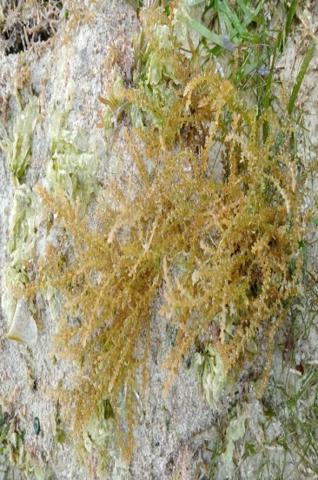
Scientific name: Acanthophora specifera
Common name: Spiny algae
Local name: galaw-galaw
Size: 5 – 10 cm long
Texture: spiny
Shape: cylindrical (branches); spur-like (spines)
Medicinal property: cytotoxicity

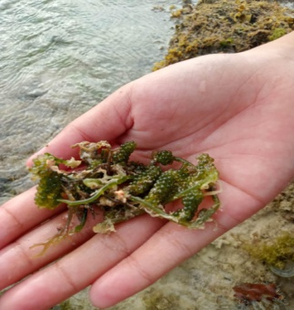
- Caulerpa lentillifera
Scientific name: Caulerpa lentillifera
Common name: sea grapes; green caviar
Local name: lato
Size: 0.1 cm (each grape); 2 cm long (sausage)
Texture: soft; succulent
Shape: sausage-like; spherical and translucent (grape)
Medicinal property: anti-fungal, anti-tumor, high blood pressure and goiter
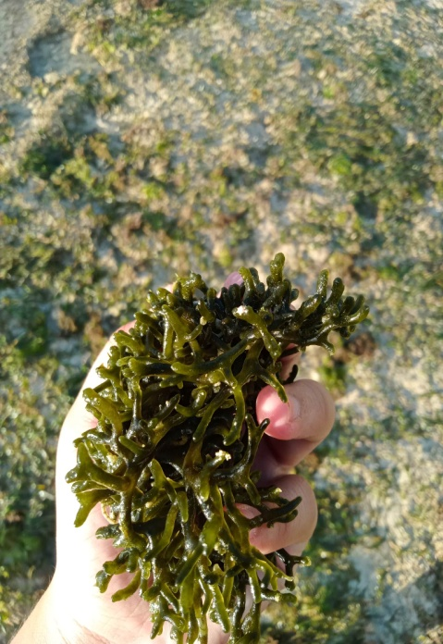
- Codium vermilara
Scientific name: Codium vermilara
Common name: Green sea fingers
Local name: Ambalang
Size: 7 cm long (branches)
Texture: spongy
Shape: cylindrical branches; finger- like
Medicinal property: Antibacterial; Antioxidant

- Eucheuma cottoni
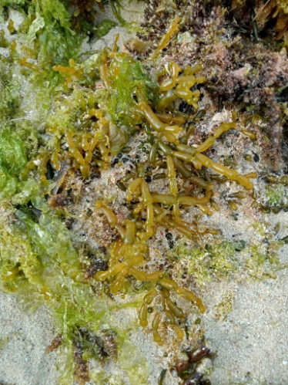
Scientific name: Eucheuma cottonii
Common name:
Local name: Guso sa bato
Size: 5-10 cm long
Texture: crunchy; greenish or brownish
Shape: cylindrical (branch); oblong
Medicinal property: anti- inflammatory and immunomodulatory

- Sargassum
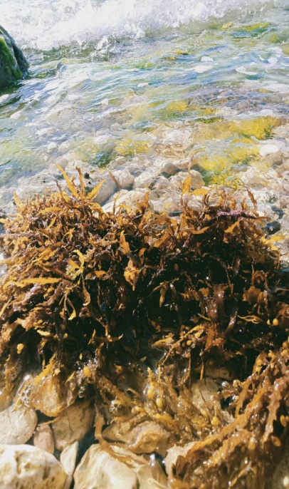
Scientific name: Sargassum
Common name: Gulfweed; sea holly
Local name: Layog - layog
Size: 40 cm long
Texture: rough; flexible; brown(color)
Shape: acute or ovate apices (leaves); monopodial
Medicinal property: antioxidant, anti- cancer and anti- inflammatory
- Padina pavonica
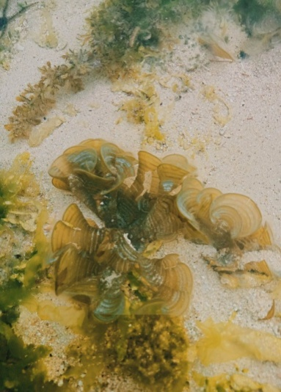
Scientific name: Padina pavonica
Common name: Peacock’s tail
Local name: unidentified
Size: 10 cm wide(upper)
Texture: brown; thin; slimy (upper layer) and flexible
Shape: ovoid; fan-shaped; funnel-shaped
Medicinal property: antimicrobial, insecticidal, antioxidants, antibiotics, anti-inflammatory, hypo-allergenic, hepatoprotective and antidiabetic

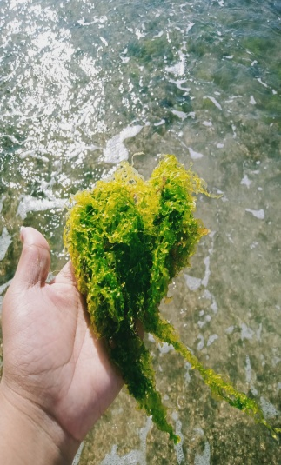
- Ulva intestinalis
Scientific name: Ulva intestinalis
Common name: Sea lettuce
Local name: Habol - habol
Size: 10-30 cm long
Texture: soft; long
Shape: intestine-like; tubular Medicinal property: Biostimulant

CHAPTER III
SUMMARY, CONCLUSIONS, AND RECOMMENDATIONS
This chapter provides the summary of findings corresponding to its specific problem in this study. Conclusions were drawn based on the findings which led to the recommendations and implications offered by the researchers.
Summary of Findings
- Species of seaweeds found in Alo, Oslob,Cebu.
There are 7 selected species of seaweeds found in Alo, Oslob, Cebu. The 7 selected species are Acanthophora specifera, Caulerpa lentillifera, Codium vermilara, Eucheuma cottoni, Sargassum, Padina pavonica, Ulva intestinalis.
- Seaweeds that are edible and non- edible.
The species of seaweed that are edible are Caulerpa lentillifera (lato), Codium vermilara (ambalang), and Euceuma cottoni (guso sa bato). Moreover, the species of seaweed that are non-edible are Acanthophora specifera, Sargassum, Padina pavonica, Ulva intestinalis.
- The characteristics of seaweed in terms of:
  - Texture;
Acanthophora specifera- spiny
Caulerpa lentillifera- soft; succulent
Codium vermilara- spongy
Eucheuma cottoni- crunchy; greenish or brownish
Sargassum- rough; flexible; brown(color)
Padina pavonica- brown; thin; slimy (upper layer) and flexible
Ulva intestinalis- soft; long
  - Size;
Acanthophora specifera- 5-10 cm tall
Caulerpa lentillifera- 0.1cm (each grape); 2 cm long
(sausage)
Codium vermilara- 7cm tall (branches)
Eucheuma cottoni- 5-10 cm
Sargassum- 40 cm tall
Padina pavonica- 10 cm (upper)
Ulva intestinalis- 10-30 cm long
  - Shape; and
Acanthophora specifera- cylindrical (branches); spur – like (spines)
Caulerpa lentillifera- sausage- like; spherical and translucent (grape)
Codium vermilara- cylindrical branches; finger- like
Eucheuma cottoni- cylindrical (branch); oblong
Sargassum- acute or ovate apices (leaves): monopodial
Padina pavonica- ovoid; fan- shaped; funnel- shaped
Ulva intestinalis- intestine-like; tubular
  - Medicinal properties
Acanthophora specifera- cytotoxicity
Caulerpa lentillifera- anti-fungal,anti-tumor,high blood pressure and goiter
Codium vermilara- Antibacterial; Antioxidant
Eucheuma cottoni- anti-inflammatory and immunomodulatory
Sargassum- antioxidant, anti-cancer and anti-inflammatory
Padina pavonica- antimicrobial, insecticidal, antioxidants, antibiotics, anti-inflammatory, hypo-allergenic, hepatoprotective and antidiabetic
Ulva intestinalis- Biostimulant

Conclusions
Based on the findings of this study Alo Oslob Cebu is among of the many places in Southern Cebu with abundant species of seaweeds. A total of 7 species were identified with their own unique characteristics.

Moreover, these seaweeds do not only provide aesthetic value but also provide an important role to human beings which is the medicinal properties it offers.

Finally, it can be concluded that not all species of seaweeds are edible and have many benefits that are not known.

Recommendations
Based on the findings and conclusions, the following recommendations are offered:
1. The people in the community should be aware of which types of seaweeds are edible and non-edible to help prevent short-term health conditions and avoid the poisonous effects of the seaweeds.
2. Youth should seek professional help when trying to intake medicinal benefits of seaweeds.
3. Medicinal properties of seaweeds should be taught to the youth.
4. Scientist should experiment with the benefits of seaweeds and share their knowledge with the public based on evidences.

REFERENCES
Buschmann, A. H., Camus, C., Infante, J., Neori, A., Israel, L., Hernández-González, M. C., Pereda, S. V., Gomez-Pinchetti, J. L., Golberg, A., Tadmor-Shalev, N., & Critchley, A. T. (2017, October 2). Seaweed production: overview of the global state of exploitation, farming and emerging research activity. European Journal of Phycology, 52(4), 391–406. https://doi.org/10.1080/09670262.2017.1365175
Choudhary, B., Chauhan, O. P., & Mishra, A. (2021, October 5). Edible Seaweeds: A Potential Novel Source of Bioactive Metabolites and Nutraceuticals With Human Health Benefits. Frontiers in Marine Science, 8. https://doi.org/10.3389/fmars.2021.740054
Esterman, I. (2022, September 1). Seaweed an increasingly fragile lifeline for Philippine farmers. Mongabay Environmental News. https://news.mongabay.com/2022/09/seaweed-an-increasingly-fragile-lifeline-for-philippine-farmers/
Facts About Seaweed. (2021, September 30). Sciencing. https://sciencing.com/seaweed-5422393.html

Facts About Seaweed. (2021, September 30). Sciencing. https://sciencing.com/seaweed-5422393.html

Klnc, B., Cirik, S., Turan, G., Tekogul, H., & Koru, E. (2013, January 16). Seaweeds for Food and Industrial Applications. Food Industry. https://doi.org/10.5772/53172
Kumar, A., Hanjabam, M. D., Kishore, P., Uchoi, D., Panda, S. K., Mohan, C. O., Chatterjee, N. S., Zynudheen, A. A., & Ravishankar, C. N. (2023, February 20). Exploitation of Seaweed Functionality for the Development of Food Products. Food and Bioprocess Technology. https://doi.org/10.1007/s11947-023-03023-2
Mouritsen, O. (2018, June 19). The science of seaweeds. American Scientist. Retrieved February 28, 2023, from https://www.americanscientist.org/article/the-science-of-seaweeds#
Seaweed Culture - an overview | ScienceDirect Topics. (n.d.). Seaweed Culture - an Overview | ScienceDirect Topics. https://doi.org/10.1016/B978-0-12-816229-3.00001-6

Seaweed Facts for Kids. (2019, July 30). Sciencing. https://sciencing.com/seaweed-kids-8642059.html
What is seaweed. (n.d.). Retrieved from https://www.msc.org/what-you-can-do/eat-sustainable-seafood/fish-to-eat/seaweed

APPENDICES

Appendix A
TRANSMITTAL LETTER TO THE BRGY. CAPTAIN
HON. FAUSTO DUMAYHAG
Brgy. Captain, Brgy. Alo
Municipality of Oslob
Province of Cebu

Greetings!
We, the senior high school students from Science, Technology, Engineering, and Mathematics strand from Patronage of Mary Development School, are currently conducting a community-based research. This research is entitled SPECIES OF SEAWEEDS IN ALO, OSLOB, CEBU. This research will involve explorations of the seashores inside your barangay. Hence, this research will be free of charge and rest assured that the forestland chosen for this research will be treated with utmost care and no harm to the natural environment will be taken.
With this being said, we hereby ask your permission to conduct this research in this peaceful community, Brgy. Alo, Municipality of Oslob, Province of Cebu.
In addition, we would also like to conduct a survey. We promise that the information once gathered will be used solely for this research and will be treated with full confidentiality.
Respectfully yours,
The Researchers
My entire questions and concerns about this study have been addressed. I choose voluntarily to allow these students to conduct this research in our barangay.
______________________________________ ____
Signature over Printed Name of the Respondent Date
______________________________________ ____
Signature over Printed Name of the Researcher Date
Appendix E

Alo, Oslob, Cebu

(View from the right)

(View from the left)

