Frequency-dependent cheating in a cooperatively breeding bird

Julian Melgar^{1,*}, Mads F. Schou², Maud Bonato³, Zanell Brand⁴, Anel Engelbrecht⁴, Schalk Cloete⁵, Pfunzo T. Muvhali^{4,5}, Bengt Hansson¹, Anna Danielsson⁶, Mikael Åkesson⁶ & Charlie K. Cornwallis^{1,*}

¹Department of Biology, Lund University, Lund, Sweden. ²Department of Biology, Aarhus University, Aarhus C, Denmark. ³Department of Biological Sciences, University of Venda, Thohoyandou, South Africa. ⁴Directorate Animal Sciences, Western Cape Department of Agriculture, Elsenburg, South Africa. ⁵Department of Animal Sciences, Stellenbosch University, Matieland, South Africa. ⁶Department of Ecology, Grimsö Wildlife Research Station, Swedish University of Agricultural Sciences, Riddarhyttan, Sweden.
*e-mail: julian.melgar@outlook.com; charlie.cornwallis@biol.lu.se

Abstract
Cooperation has profoundly influenced life on earth across all levels of organisation, from genomes to animal societies^{1,2}. Cooperative systems are, however, continually challenged by cheating, where individuals reap the benefits of cooperation without bearing its costs^{3–5}. Despite this critical challenge to the evolution of cooperation, the conditions under which cheating persists without causing cooperative groups to collapse, remain poorly understood outside microbial systems⁶. Here we address this in the ostrich, Struthio camelus, which breeds in groups that share incubation of a communal nest, in which some females lay eggs but never incubate (“cheats”)⁷. We identified the conditions under which cheating arose, and when it was associated with the collapse of cooperative groups, across 80 experimentally established breeding groups monitored over seven years. Cheating was conditional: 23 of 26 females that cheated in a breeding season, cooperated in another. Cheats maximized their reproductive benefits in larger groups, where their frequency was lowest relative to cooperators. In small groups, the relative frequency of cheats was higher, and cheating led to nest failure because cooperators reduced their incubation effort. These findings demonstrate that the persistence of cheats is driven by frequency-dependent benefits and costs of cheating. These results parallel work on microbial public goods^{8,9}, suggesting that frequency-dependent cheating may be a general feature of social evolution, present in organisms as different as bacteria and birds.

Introduction
Cheating is a ubiquitous threat to the stability of cooperative groups. It arises when individuals reap the rewards of cooperation while avoiding its costs, which can cause cooperation to collapse^{3–5}. Selection against cheating has favoured an elaborate range of adaptations, from the silencing of selfish genetic elements, to worker policing of reproduction in eusocial insects¹⁹.
Despite the omnipresent and destructive force of cheating, the conditions where it persists remain poorly understood⁶. In W. D. Hamilton’s foundational model of social evolution, the fitness effects of social behaviour are additive²⁰. Under these conditions, the selective advantage of cheating does not depend on the frequency of cooperators in the population^{21,22}. Consequently, cheating is either never favoured or, if favoured, it spreads until cooperation disappears, leaving no opportunities to cheat. Cheats and cooperators should therefore not coexist. Yet cheating occurs in a wide range of cooperative systems^{6,19}.
A possible explanation for the widespread occurrence of cheating is that, contrary to Hamilton’s original model, its payoffs can depend on the frequency of cooperators. Several processes that generate such frequency-dependence, and thereby allow the stable coexistence of cheats and cooperators, have been proposed. These include: (i) conditional cheating, where individuals switch between cheating and cooperating depending on opportunities to exploit cooperators²³; (ii) diminishing returns on cooperative investment, where cheats get large benefits when cooperators are common, and small benefits when they are rare, which generates negative frequency-dependent selection^{8,9,24}; and (iii) threshold effects, where groups become resilient to cheating once they contain enough cooperators⁸. These processes have been examined almost exclusively in microorganisms, where public goods such as secreted enzymes, siderophores and toxins are readily exploited, leaving it unclear whether the same processes also operate in the cooperative societies of multicellular organisms⁶.
Here we test these ideas in a vertebrate cooperative breeder, the ostrich, Struthio camelus, by examining whether cheating is conditional on social context, whether the payoffs to cheating depend on the frequency of cooperators, how cooperators respond to cheats, and whether the consequences of cheating for groups depend on threshold numbers of cooperators. Ostriches breed in groups of unrelated males and females that all attempt to reproduce in a communal nest where they share incubation^{25–27}. Cooperative incubation allows nests to be attended for longer, protecting eggs from predators and thermal stress, which increases hatching success²⁸. Some females, however, lay eggs in the nest but never incubate^{7,27}. We classify these females as cheats.
We manipulated the opportunities for cooperation and cheating by experimentally setting up groups with different numbers of male and female adults in a captive population^{see also 28}. Over seven years, we quantified female incubation effort from behavioural observations and estimated individual female reproductive success in 80 groups using genetic parentage analysis. Combining these measures, we classified each female as a cooperator (contributed to incubation, regardless of whether or not she laid eggs), a cheat (laid eggs but did not incubate), or other (neither laid eggs nor incubated). We restrict our analyses to females for two reasons. First, maternity is unambiguous, so females have information about their reproductive contribution to the nest, as eggs were never seen being ejected from nests by other females. Second, because females mate with multiple males, a male’s failure to incubate could reflect perceived low paternity rather than cheating, and these alternatives cannot be distinguished.

Results

Prevalence of cheats changes with group size
Cheating was common and dependent on group size (Fig. 1). In 32% of breeding groups (26 out of 80) there was at least one female cheat that laid eggs in the communal nest but did not incubate. The number of cheats increased with the number of females in groups (Fig. 1B. Posterior mode (PM) and credible interval (CI) = 0.32 (0.02, 0.72), pMCMC = 0.042. Extended Data Table 1). However, the relative frequency of cheats was lower in larger groups because the number of cooperators also increased with group size (Fig. 1C. PM (CI) = 0.27 (0.13, 0.39), pMCMC < 0.001. Extended Data Table 1), resulting in a lower proportion of cheats relative to cooperators (Fig. 1D. PM (CI) = -1.02 (-1.70, -0.64), pMCMC < 0.001. Extended Data Table 2). No cheats were found in groups with two females, whereas 11% of females in groups with three or more females cheated (34 out of 312).
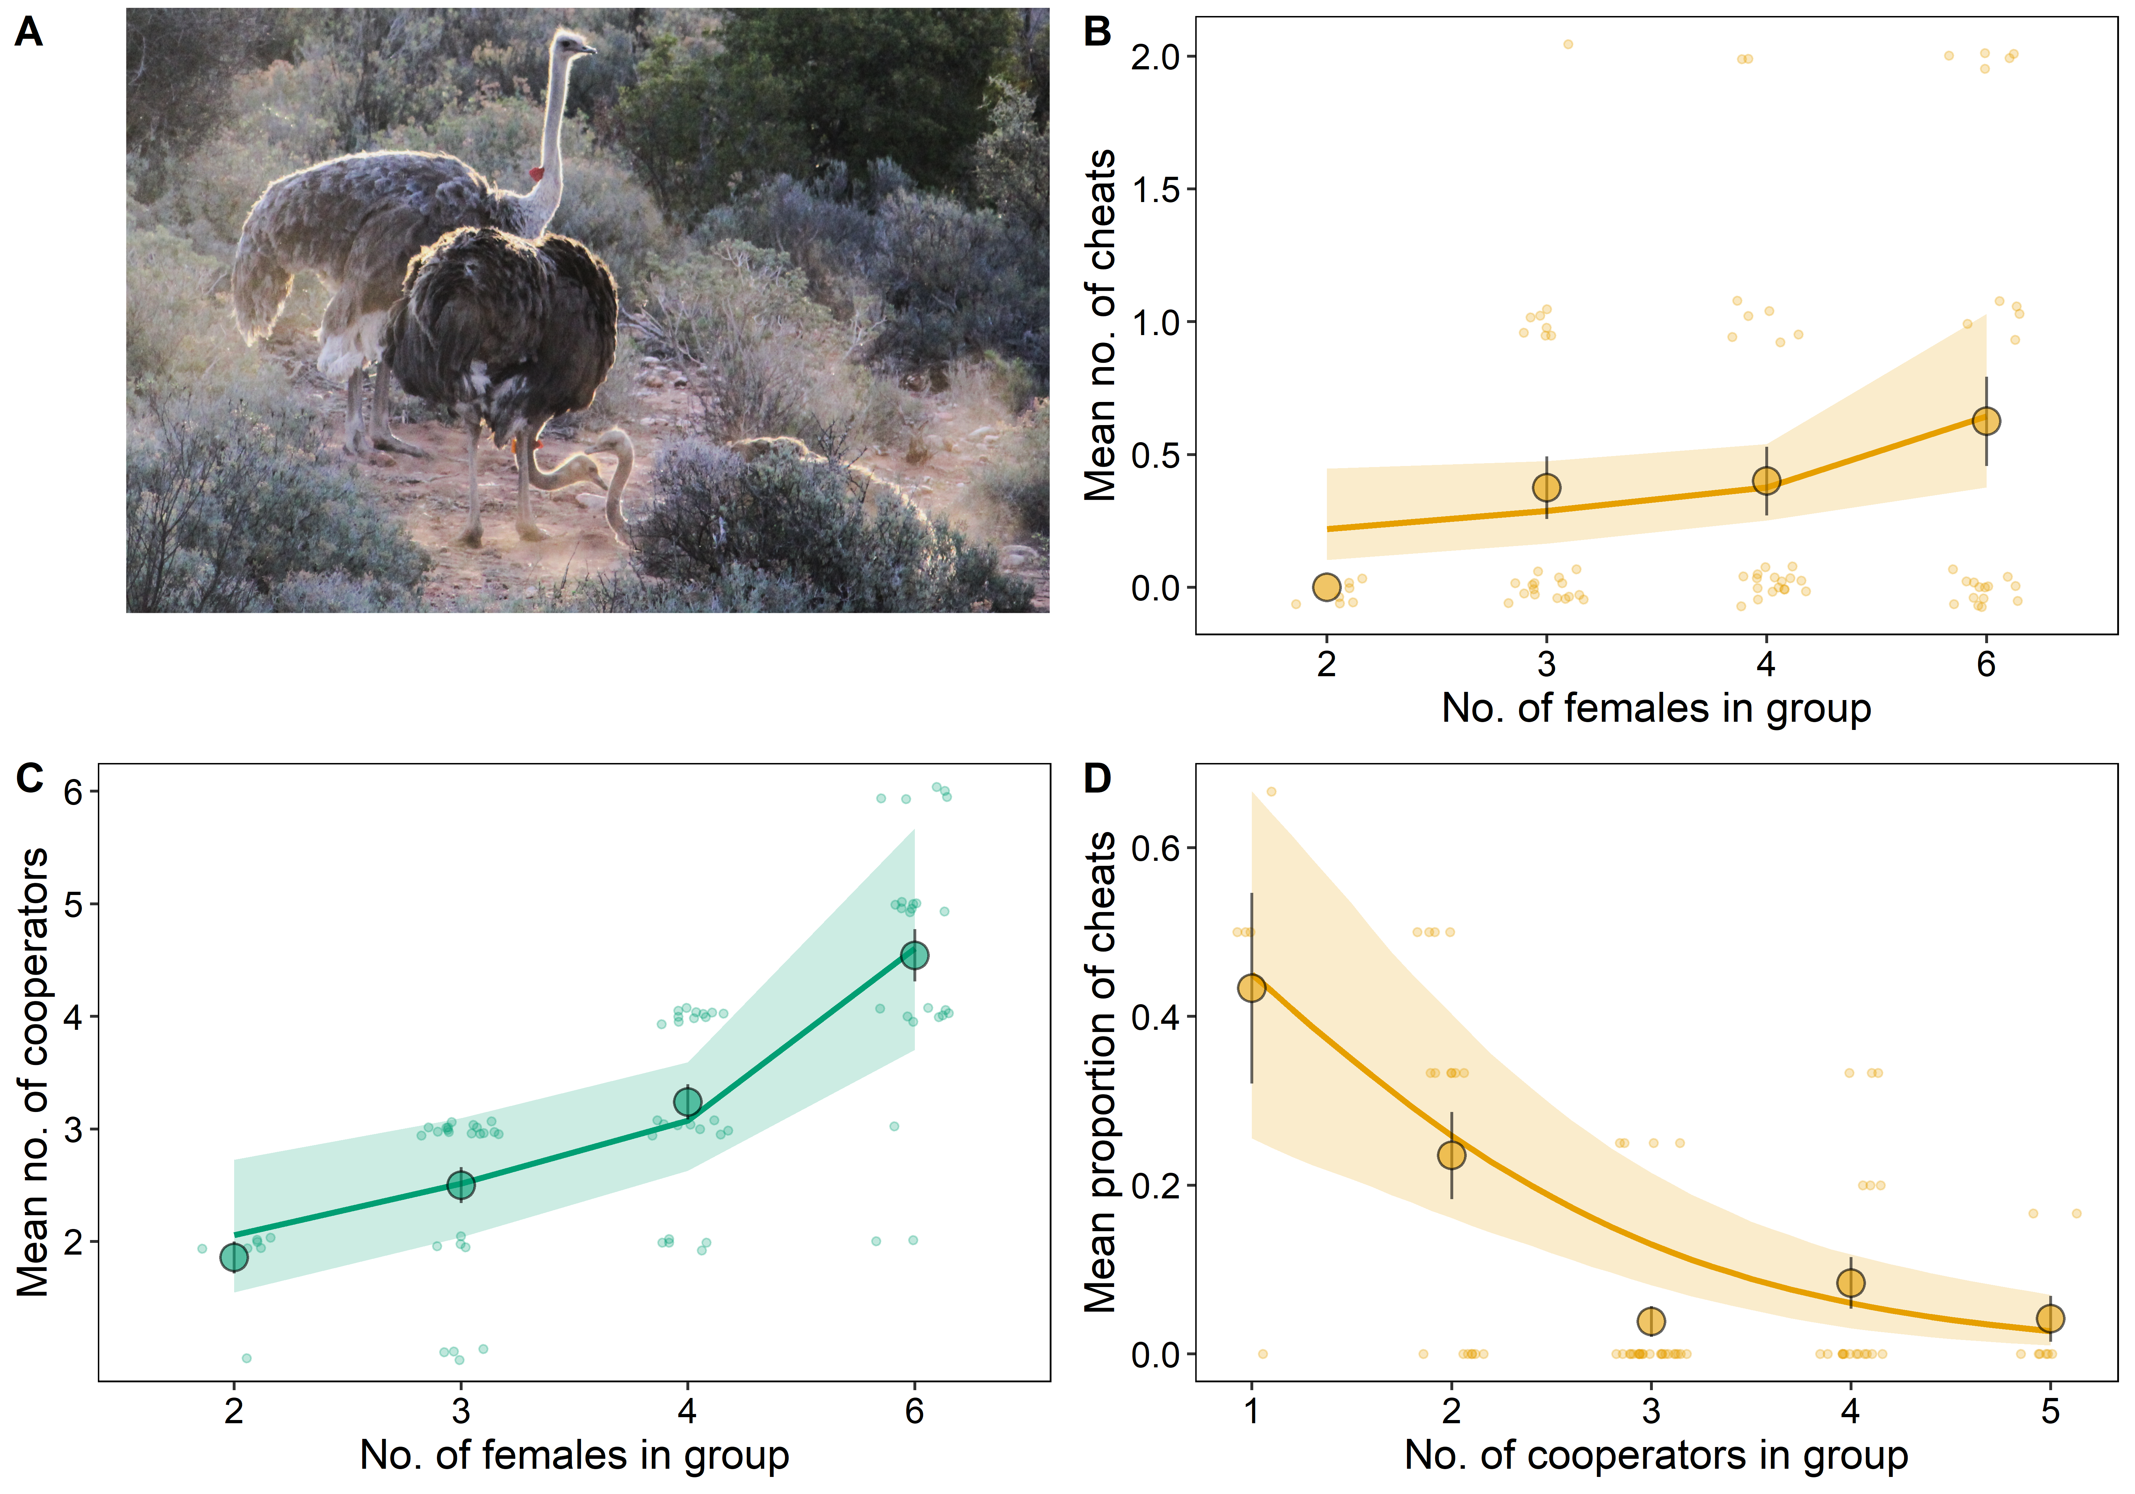
Figure 1: The frequency of cheats and cooperators in experimentally established breeding groups of ostriches. (A) Three female ostriches at a communal nest, with the female on the right incubating. Most female ostriches cooperate by taking turns incubating, but some cheat this cooperative system and never incubate. (B) The mean number of cheats and (C) the mean number of cooperators per group increased with number of females in groups. (D) The mean proportion of females in a group that were cheats, was lower in groups with more females. Circles show means across groups and error bars show means +/- one standard error; solid lines show fitted values from Bayesian mixed models (B, C: Extended Data Table 1; D: Extended Data Table 2) with shaded 95% credible intervals. Sample sizes: n = 80 groups across seven years in B-D.

Cheating is conditional
To test whether some individuals consistently cheat, or whether cheating was conditional on social context, we placed females in groups of different sizes across successive breeding seasons (N_{females} = 108). Of the 26 females that cheated in at least one breeding season, only three (12%) always cheated, with 23 cooperating in other seasons. Consequently, repeatability in the probability of cheating was low, indicating that cheating is context-dependent (variation in the probability of cheating explained by individual, I²% (CI) = 0.12 (0.01, 31.15). Extended Data Table 3). Furthermore, neither age nor body mass predicted whether a female cheated (pMCMC > 0.05. Extended Data Table 3), suggesting that social context rather than individual attributes determines the emergence of cheating.

Reproductive consequences of cheating
To test if cheats and cooperators invested differently in egg production, we monitored female egg-laying. We found that cheats laid similar numbers of eggs than both cooperators in groups with cheats (PM (CI) = 0.14 (-0.18, 0.55), pMCMC = 0.354. Extended Data Table 5), and cooperators in groups without cheats (PM (CI) = 0.11 (-0.32, 0.39), pMCMC = 0.746. Extended Data Table 5). Females that adopted both strategies also laid comparable numbers of eggs when they cheated and when they cooperated (PM (CI) = -0.15 (-0.70, 0.29), pMCMC = 0.389. Extended Data Fig. 1. Extended Data Table 6).
The number of eggs cheats and cooperators laid did, however, depend on how many cooperators were present in groups. Cheats laid more eggs than cooperators sharing the same nest, but only in the largest groups. In groups with five cooperators, cheats laid PM (CI) = 1.55 (0.11, 5.48) more eggs per female than cooperators in the same groups (pMCMC = 0.006. Fig. 2A, middle panel. Extended Data Table 5), whereas in groups with one to four cooperators the two did not differ (Extended Data Table 5). The number of eggs cooperators laid did not increase with the number of cooperators in groups, regardless of the presence of cheats (Groups without cheats: PM (CI) = -0.06 (-0.26, 0.13), pMCMC = 0.552; groups with cheats: PM (CI) = 0.07 (-0.19, 0.32), pMCMC = 0.487. Extended Data Fig. 2 and Extended Data Table 5). On average, cheats laid three eggs in groups with one to three cooperators, compared to an average of seven eggs, more than double, in groups with five cooperators (Extended Data Fig. 2). In contrast, cooperators laid fewer eggs in the presence of cheats, but only in the smallest groups. In groups containing a single cooperator, those with cheats laid fewer eggs than those without cheats (Fig. 2A, left panel. Difference in fitted number of eggs laid by cooperators with and without cheats: PM (CI) = 1.02 (0.13, 3.95), pMCMC = 0.014. Extended Data Table 5), but this difference diminished when more cooperators were present. This pattern was also captured by a significant difference in the quadratic term for the relationship between egg number and number of cooperators for cooperators with and without cheats (PM (CI) = 0.36 (0.06, 0.67), pMCMC = 0.020. Extended Data Table 5).
At the group level, the presence of cheats was associated with slower completion of the clutch. Egg-laying rates were initially similar between groups with and without cheats but diverged over time, with groups containing cheats accumulating eggs more slowly (Fig. 2B. Difference in quadratic time terms: PM (CI) = -0.21 (-0.37, -0.08), pMCMC = 0.004. Extended Data Table 7). This group-level pattern reflected differences in when individual females laid. Cheats and cooperators did not differ in the overall probability of laying (PM (CI) = -0.01 (-0.45, 0.25), pMCMC = 0.638. Extended Data Table 8), but the probability declined more steeply across the laying period in cooperators than in cheats (difference in quadratic terms: PM (CI) = 1.56 (1.12, 1.99), pMCMC < 0.001. Extended Data Table 8), such that cheats continued laying late in the period when cooperators had largely stopped. As a result, the switch from egg-laying to incubation took 25 days (CI = 22.95, 27.29, segmented regression) in groups with cheats, as opposed to 14 days (CI = 11.99, 15.91) in groups without cheats (Fig. 2C. Extended Data Table 14).
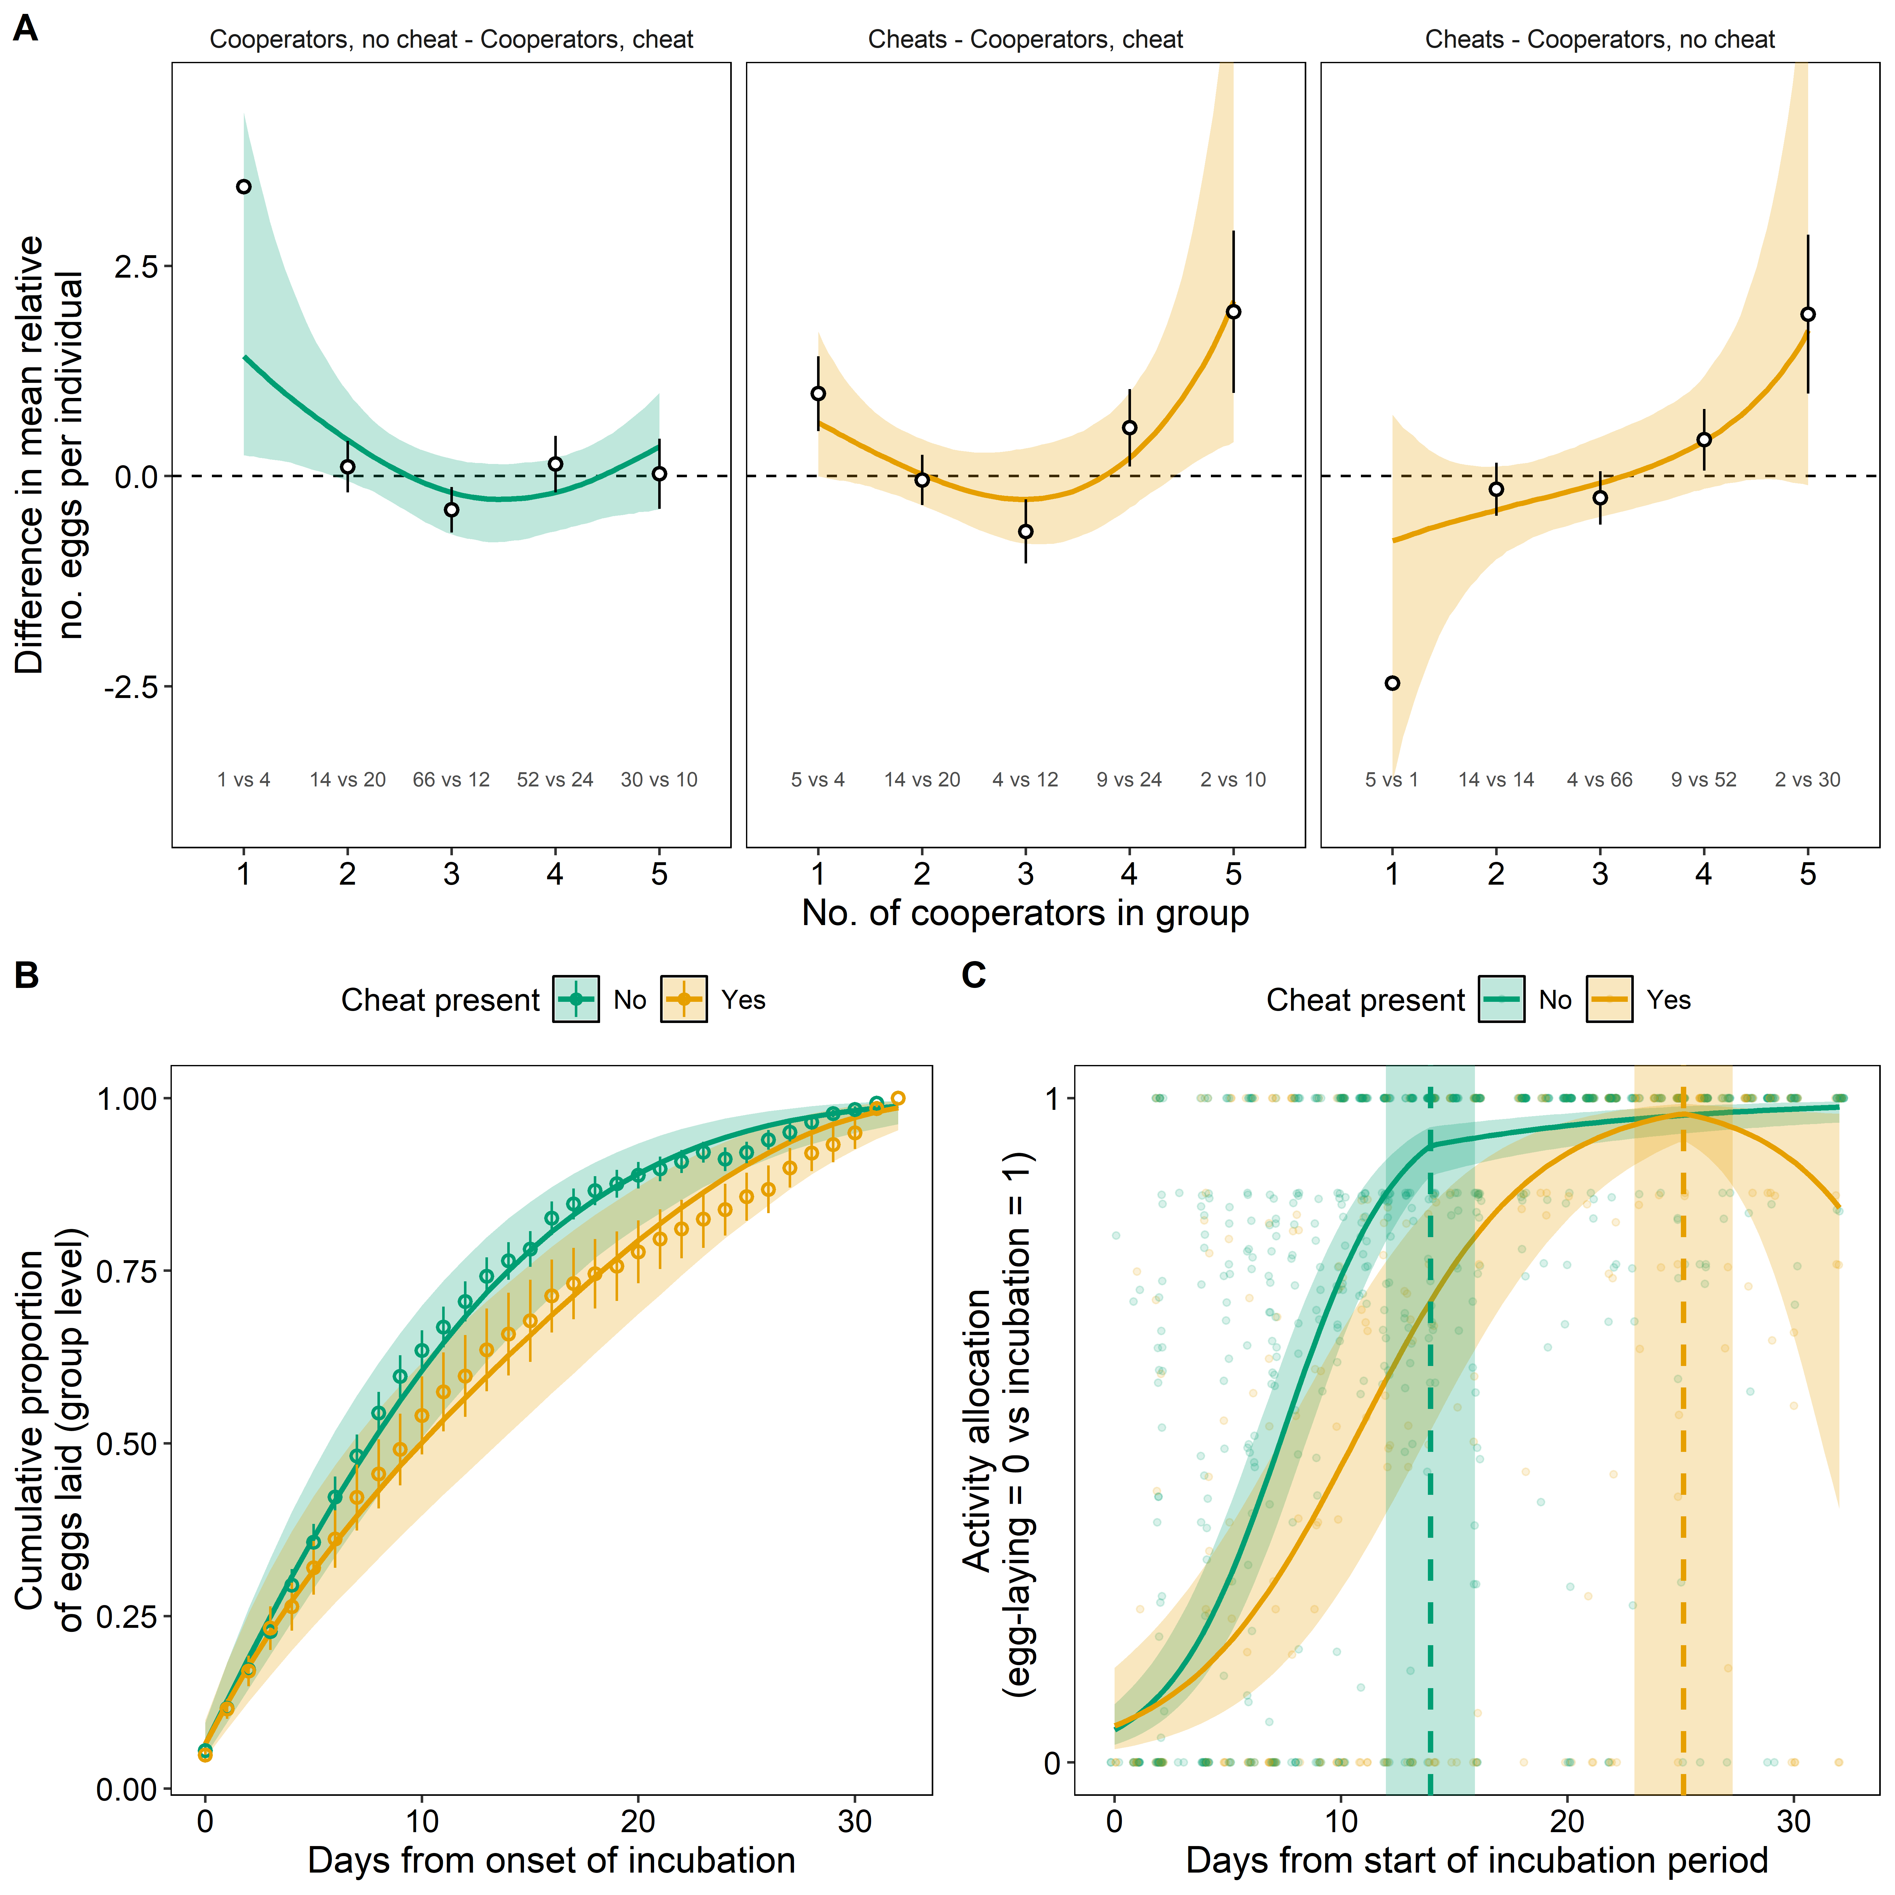
Figure 2: The reproductive consequences of cheating. (A) Differences in the number of eggs laid between each pair of breeding strategies, in relation to the number of cooperators in groups, calculated within each posterior sample. The number of eggs laid was modelled as a count with year as a random effect, and differences are expressed relative to the annual mean. The dashed line indicates no difference. Credible intervals (shaded ribbons) that do not overlap the dashed line indicate group sizes at which two strategies differ. Open circles show differences between the observed means of two strategies, with error bars giving the standard error of the difference (the square root of the sum of the two squared standard errors). The numbers inside each panel give the sample sizes contributing to each comparison. (B) Cumulative proportion of eggs laid by breeding groups with (orange) and without (green) cheats across time. Circles and error bars show mean +/- one standard error. (C) Allocation of group activity between egg-laying (0) and incubating (1) over time in groups with cheats (orange) and without cheats (green). Activity allocation is the time spent incubating divided by that time plus the proportion of the daily maximum of six eggs that were laid, so with at least one egg laid it cannot exceed 6/7 for any group size, resulting in an empty band between 0.86 and 1. Solid lines show fitted values from Bayesian mixed models in A (Poisson, Extended Data Table 5) and B (binomial, Extended Data Table 7), and from segmented (breakpoint) mixed models in C (Extended Data Table 14). Shaded ribbons show 95% credible intervals (A, B) and 95% confidence intervals (C). Sample sizes: (A) n = 267 observations from 138 females in 75 groups; (B) n = 2550 group-days from 80 groups; (C) n = 1071 group-days from 78 groups.

Cooperators reduce incubation in response to cheats
Next, we examined how cooperators responded to cheats by monitoring their behaviour. Cooperators did not punish cheats through increased aggression (aggression towards cheats vs towards cooperators: PM (CI) = -0.15 (-1.00, 1.01), pMCMC = 0.932. Extended Data Fig. 3 and Extended Data Table 9). Instead, the presence of cheats was associated with a general reduction in incubation effort, measured as the proportion of time that individuals spent incubating. Consequently, groups containing cheats incubated their nests for less time than groups without cheats (Fig. 3A. PM (CI) = 0.76 (0.12, 1.36), pMCMC = 0.014. Extended Data Table 10). This reduction in incubation effort was consistent across all group sizes and persisted through the entire incubation period (Fig. 3B. PM (CI) = 2.16 (0.31, 3.97), pMCMC = 0.025. Extended Data Table 11).
Although the per-individual reduction in incubation effort did not vary with group size, the total time nests were incubated increased with the number of cooperators both in groups with cheats (Fig. 3A. PM (CI) = 0.54 (0.11, 0.95), pMCMC = 0.012. Extended Data Table 10), and without cheats (Fig. 3A. PM (CI) = 0.57 (0.12, 0.86), pMCMC = 0.008. Extended Data Table 10). Groups with more cooperators were therefore partially buffered from the costs of cheating, and small groups containing cheats had the lowest total incubation time (Fig. 3A).
To assess whether cooperators’ response to cheats reflected individual variation in the costs of reduced incubation, we tested whether a female’s egg investment predicted her reduction in incubation effort. Cooperators that laid more eggs spent more time incubating, irrespective of whether there were cheats in the group or not (cheats present: PM (CI) = 0.51 (0.21, 0.90), pMCMC = 0.004; cheats absent: PM (CI) = 0.76 (0.24, 1.20), pMCMC = 0.003. Extended Data Table 12). However, in small groups where cheats were present, females that laid fewer eggs reduced their incubation effort more than females that laid more eggs (Fig. 3C. Number of eggs x group size x presence of cheats: PM (CI) = 0.42 (0.02, 1.08), pMCMC = 0.053. Extended Data Table 12). This pattern was not observed in large groups, where the relationship between incubation effort and eggs laid was similar regardless of whether cheats were present or not (Fig. 3D).
These results suggest that cooperators make fine-scale decisions based on their predicted reproductive returns from breeding events, and invest in offspring care accordingly. Females with more eggs invested in the nest maintained incubation regardless of the contribution of other females, presumably because the costs of nest failure are higher for them. In contrast, for females that laid fewer eggs, deserting incubation in response to cheating appears to be a viable option, particularly in small groups where per-capita incubation costs are highest.
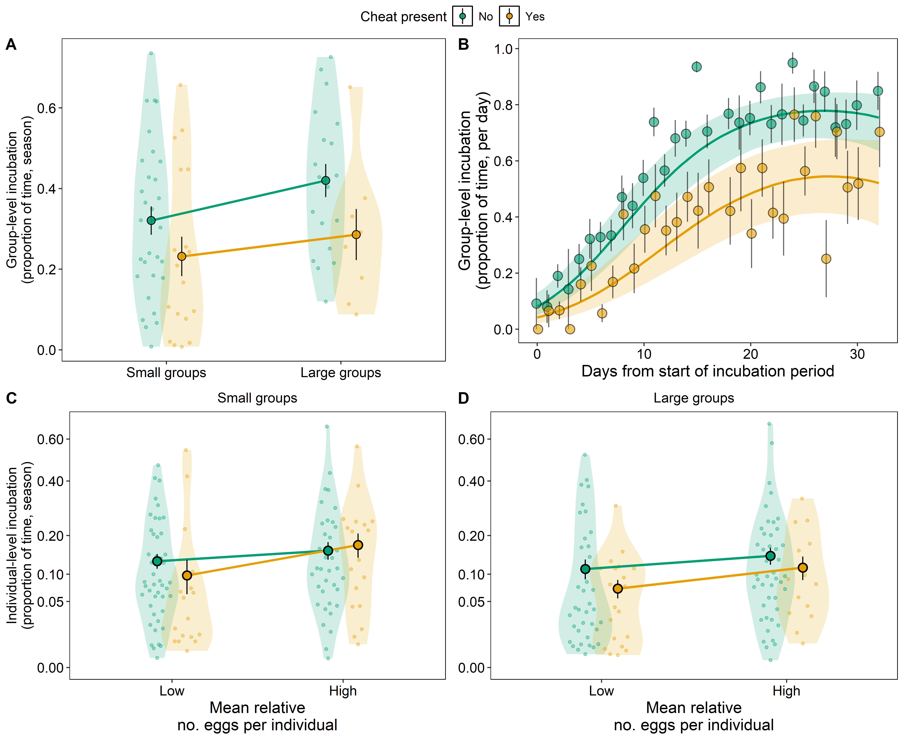
Figure 3: Cooperators reduce incubation effort in the presence of cheats. (A) Group-level incubation effort across the season in small (up to three cooperators) and large (more than three cooperators) groups with (orange) and without (green) cheats. (B) Group-level incubation effort per day across the season. (C, D) Individual incubation effort across the season for females that laid more (High) or fewer eggs (Low) than their group average, in small (C) and large (D) groups. Group size and relative egg numbers were dichotomized for presentation purposes only. Violins show the distribution of the data with small points representing the individual groups (A) or females (C, D). Large circles and error bars show the mean +/- one standard error, joined by lines. In (B) circles and error bars show the mean +/- one standard error per day, and the solid lines show fitted values from the Bayesian mixed model (Extended Data Table 11) with shaded 95% credible intervals. The y axis of (C) and (D) is on a square-root scale because individual incubation effort was right-skewed. Sample sizes: (A) n = 75 groups; (B) n = 1252 group-days from 78 groups; (C, D) n = 233 observations from 131 females in 75 groups.

Cooperation attenuates the costs of cheating in large groups
The consequences of cheating for hatching success depended on the number of cooperators, and operated through complete nest failure rather than through a gradual reduction in the proportion of hatched eggs. In groups containing a cheat, the probability that a nest failed dropped steeply as the number of cooperators increased (PM (CI) = -3.34 (-6.32, -1.13), pMCMC = 0.001), whereas in groups without cheats it was unrelated to the number of cooperators (PM (CI) = -0.27 (-1.23, 0.66), pMCMC = 0.597); the two slopes differed significantly (PM (CI) = 2.88 (0.64, 6.29), pMCMC = 0.009; Fig. 4A. Extended Data Table 13). All four groups containing a cheat and a single cooperator failed completely, hatching none of their 67 eggs, whereas every group with a cheat and four or five cooperators successfully produced one or more offspring. Among nests that produced offspring, the proportion of eggs that hatched did not differ between groups with and without cheats (PM (CI) = -0.23 (-0.82, 0.41), pMCMC = 0.489) and did not vary differently with the number of cooperators (PM (CI) = 0.14 (-0.54, 0.75), pMCMC = 0.747; Fig. 4B. Extended Data Table 13). These results indicate that cheating did not incrementally influence hatching success, but was instead associated with complete nest failure when there were few cooperators.
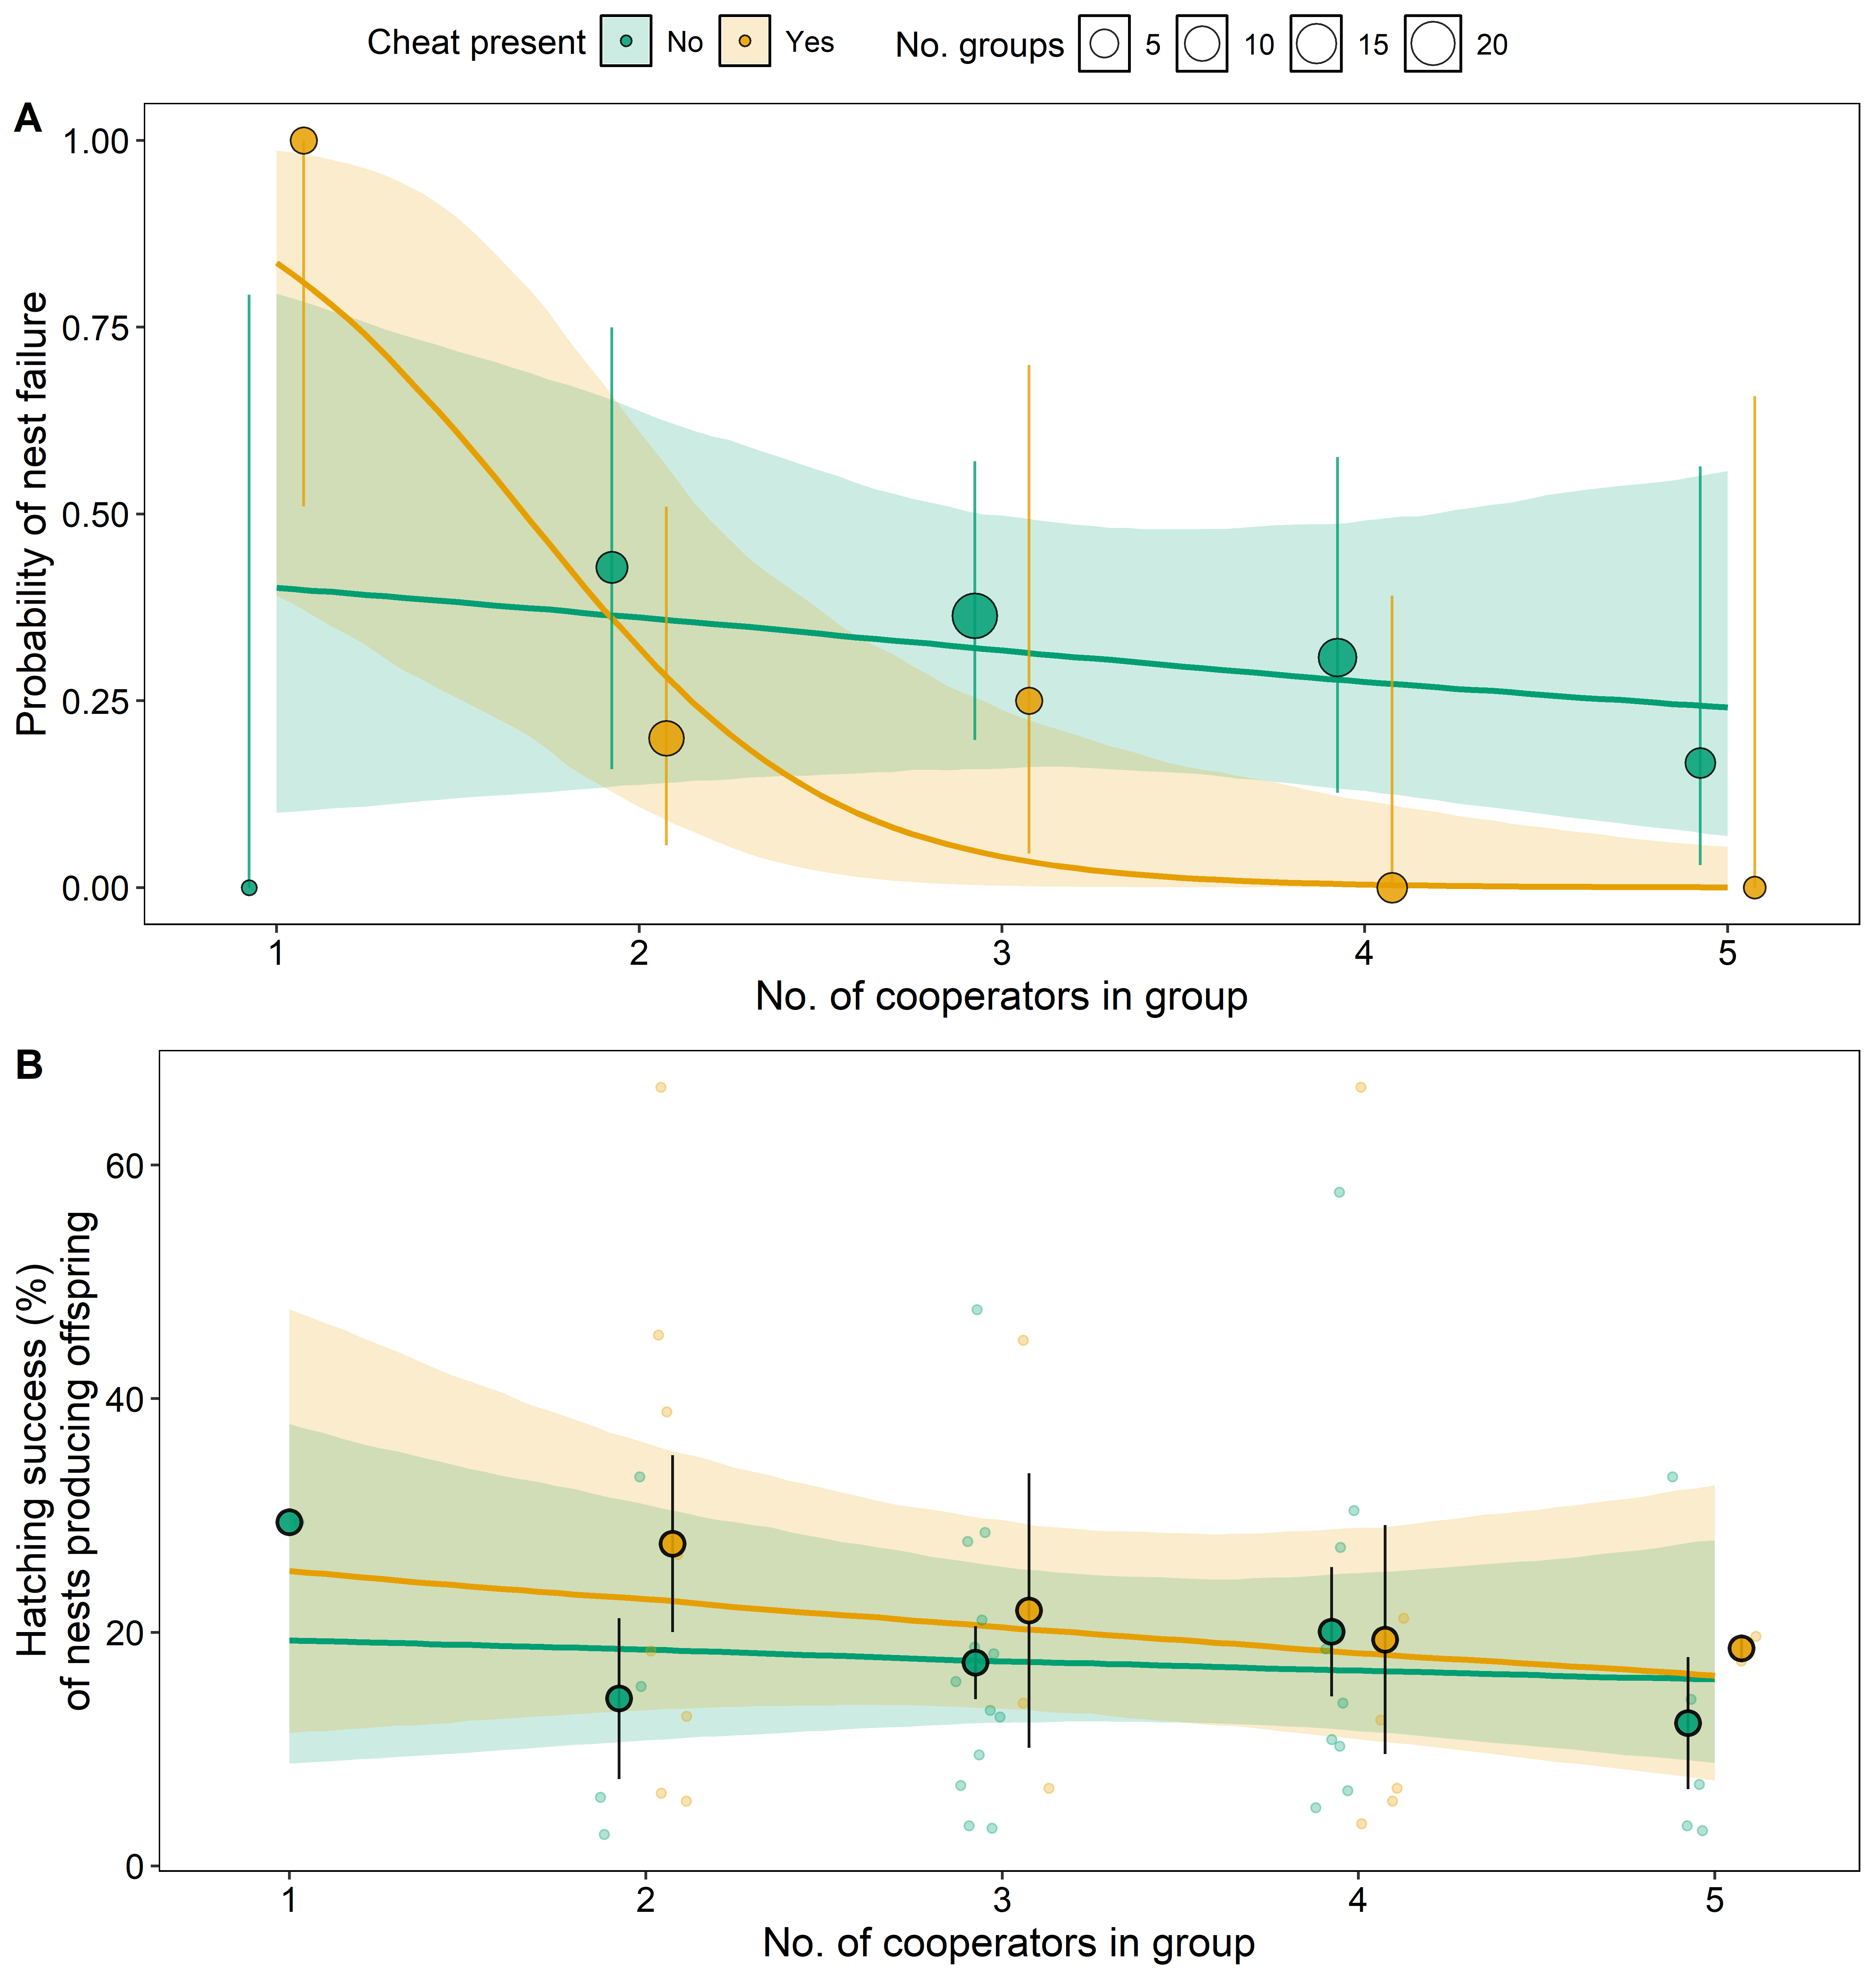
Figure 4: Complete hatching failure occurred in small groups with cheats. (A) Percentage of nests producing no offspring in groups with (orange) and without (green) cheats as a function of the number of cooperators. Circle area is proportional to the number of groups with vertical lines showing 95% Wilson binomial confidence intervals. (B) Hatching success among nests that produced at least one offspring. Circles and error bars show means ± one standard error. Solid lines show fitted values from Bayesian generalised linear mixed models (Extended Data Table 13); shaded ribbons show 95% credible intervals. Sample sizes: (A) n = 75 groups; (B) n = 52 groups, those that hatched at least one egg.

Discussion
Despite cheating occurring across diverse taxa, the conditions under which it can persist without driving cooperation to collapse remain unclear⁶. Our results show that cheats maximize their reproductive success in large groups, where they are relatively rare, suggesting that the public goods provided by cooperators, principally incubation of the communal nest, allow cheating to proliferate (Fig. 2A). This relationship appears to involve a threshold, where the costs imposed by cheats are minimised when two cooperators or more are present in groups (Fig. 2A & 4A). Individual strategies were also highly flexible, with females adjusting whether they cheated or cooperated in response to their social environment. This flexibility suggests that cheating is not a fixed individual strategy but an emergent and persistent feature of ostrich societies.
These findings are consistent with theory predicting that cheats and cooperators can coexist when the fitness of cheats is negatively frequency-dependent and enough cooperators are present to buffer the costs of cheating^{29,30}. Support for this prediction comes mainly from experimental work on microorganisms, where cheating is typically studied as a genetically determined, relatively fixed phenotype^{8,9,23,24,31,32}, although facultative cheating has been described³³. The conditional cheating observed here may strengthen negative frequency dependence beyond what fixed strategies produce, because individuals can exploit cooperative groups when cheats are rare and avoid the costs of cheating in less favourable social environments. The same logic underlies the flexible tactics of producer–scrounger games^{34,35} and the conditional parasitism of communal nests in the cooperatively breeding greater ani, Crotophaga major³⁶.
The primary behavioural mechanism underlying our results is reduced incubation effort, and in some cases apparent desertion by cooperators in small groups containing cheats. Abandoning incubation likely harms cooperators’ current reproductive success, given they have invested eggs in nests. However, individuals are expected to base investment decisions on anticipated future benefits rather than sunk past investments³⁷, resulting in a trade-off between the immediate costs of desertion and the potential for future reproductive success^{38–40}. Ostriches are long-lived and breed over many years²⁵, so the chances of reproducing in the future are likely high. At the same time, the costs of compensating for others’ reduced effort can be substantial, as they are often exposed to extreme temperatures and intense predation pressure^{25,26,41}. Reducing investment in breeding attempts where cheats elevate current costs at the expense of future reproduction may therefore represent an adaptive response in long-lived species.
The cues that female ostriches use to detect cheats remain unknown. Because egg laying and incubation overlap (Fig. 2C), a female’s failure to incubate may only become apparent once incubation has begun. Consistent with this, cooperators reduced their incubation effort in response to cheats mainly later in incubation (Fig. 3B). This suggests that cooperators respond to the behaviour of other females during early incubation rather than to egg laying itself. Non-breeding females, which neither laid eggs nor incubated (classified as other), provide an indirect test of this idea. In groups without cheats, cooperators incubated less as the number of non-breeding females increased (PM (CI) = -0.32 (-0.55, -0.08), pMCMC = 0.010. Extended Data Table 12). This suggests that cooperators adjust their incubation to the number of females that do not incubate, without necessarily distinguishing cheats from other non-contributors. Such a rule requires no recognition of individuals or eggs. Comparably simple rules reduce the costs of parasitism in other communally breeding birds. For example, greater anis (Crotophaga major) eject eggs laid later than the rest of the clutch, which removes most parasitic eggs without the need to recognise them⁴².
In summary, by experimentally allocating individuals to groups of different sizes, our study identifies the conditions under which cheating can persist in a vertebrate cooperative system without causing its collapse. Although cheating is often expected to destabilise cooperation, our results suggest that cheats and cooperators can coexist when cheating is expressed conditionally and its benefits decline as cheats become more common. The greater resilience to cheats of groups with more cooperators is consistent with growing evidence that negative frequency-dependent selection can maintain cheating without undermining cooperation^{e.g. 9,43,44}.

Methods

Study population
The research was conducted on a captive population of ostriches kept in fenced areas (range: 2400 - 70600 m2, median = 4700 m2) of Karoo habitat at the Oudtshoorn Research Farm, South Africa (33° 38’ 21.5“S, 22° 15’ 17.4”E). The population was established in 1990 with founding individuals from different farms across South Africa. The ostriches in this population are of a farmed breed that is genetically similar to southern African populations⁴⁵, and are commonly referred to as South African Blacks (Struthio camelus var. domesticus). The study included 135 male and 170 female ostriches of breeding age (range = 2-11 years) that were allowed to breed in groups between May and December over a seven-year period (2012 to 2018). Birds were fed a balanced ostrich breeder diet (90–120 g protein, 7.5–10.5 MJ metabolisable energy, 26 g calcium, and 6 g phosphorus per kg feed) and ad libitum water during the breeding season.

Experimental design
We manipulated group composition by experimentally establishing 95 groups (10-17 groups per year) with different numbers of males (1 to 3) and females (2 to 6). Not all combinations of male and female group sizes were represented due to constraints on number of birds and enclosures available. Sample size was reduced by the exclusion of 15 groups for the following reasons: i) one or more group members were removed from the group (due to death, injury or aggressive behaviour), and not replaced, within two weeks from the experimental onset of natural incubation (see Egg collection and incubation section below. n_{groups} = 2); ii) no eggs were laid in the group during the time incubation was monitored (n_{groups} = 2); iii) no females were observed incubating in the group (n_{groups} = 1); and iv) it was not possible to obtain any genetic samples for parentage analysis from the group (n_{groups} = 10). This resulted in a final sample of 80 groups, 121 males, and 159 females. Of these, 49 males and 108 females were included in multiple years.

Classification of breeding strategies
Females were classified as cooperators, cheats or other depending on whether they laid eggs in the nest and whether they contributed to incubation. Cooperators were females that contributed to incubation, regardless of whether they laid eggs in the nest or not. Cheats laid eggs in the nest, but did not incubate. Other females did not lay any eggs or contribute to incubation. We estimated individual egg laying through genetic parentage analyses of a sample of eggs and chicks (see Genetic determination of parentage below). Incubation bouts of one minute or less were excluded to avoid recording egg-laying behaviour as incubation. As a complete site scan required approximately three minutes, individuals with three or less minutes of cumulative incubation time across the season were classified as non-incubators, preventing classification based on a single brief detection.

Measuring reproduction

Egg collection and incubation
During the first approximate five months of the experiment, eggs were collected from nests twice a day and incubated artificially. Each egg was marked with the time of collection and group identity, and exposed to UV light for 20 minutes for disinfection. Eggs were incubated in weekly batches, and prior to incubation they were stored for 1–6 days under conditions that maintain hatching success⁴⁶: placed on turning trays (two daily 180° rotations) in a cold room (17°C) with relative humidity between 80% and 90%. Eggs were transferred to incubators set at 36.2°C and a relative humidity of 24% with automatic rotation of 60° around their long axis every hour. At day 39 of incubation, eggs were moved to hatching cabinets and thereafter inspected daily for signs of pipping.
During the final approximate 50 days of the experiment (mean = 47; range = 23-61 days), eggs were no longer collected, and birds were allowed to incubate naturally. This phase, referred to as the “incubation period”, allowed us to monitor the natural incubation behaviour of females. During the incubation period, nests were checked daily, and newly laid eggs were marked with the date and a unique egg identification number. The presence or absence of previously laid eggs was recorded to track the fate of each egg. In the first three years (2012–2014), birds were allowed to incubate eggs through to hatching. If no hatching was observed after 50 days of incubation, eggs were removed. From 2015 onwards, contact between adults and chicks had to be reduced following legislation aimed at reducing the spread of avian flu. Eggs were removed from nests just before the anticipated hatching date, approximately 40 days after the onset of the incubation period, and placed in artificial incubators to determine hatching success. In 2018, egg theft meant that groups had to restart their clutches and eggs had to be removed after 28 days, instead of 40 days, when birds were removed from their breeding enclosures.

Genetic determination of parentage
Blood samples were collected from adults prior to being placed in experimental groups and their offspring at hatching. Unhatched eggs were dissected to obtain blood or tissue samples. All procedures were approved by the Departmental Ethics Committee for Research on Animals (DECRA) of the Western Cape Department of Agriculture (project no. AP/BR/O/SC14).
During the first three years of the study (2012–2014), parentage of 1794 offspring was determined using seven highly polymorphic microsatellites previously shown to assign parentage with high confidence in ostriches⁴⁷. The number of samples genotyped per group was chosen to be proportional to the number of females in the group (aiming for 10 samples per female where possible), spread across the breeding season (range of samples per group = 5–72). See Melgar et al., 2022²⁸ for details on the microsatellite protocol for parentage analysis.
In the final four years of the study (2015–2018), parentage was determined using single-nucleotide polymorphisms (SNPs) from up to 35 offspring per group (we targeted 20 eggs during the artificial incubation phase, and 20 eggs during the natural incubation phase. Total samples = 893, range of samples per group = 1–35). See Melgar et al., 2022²⁸ for details on DNA extraction, identification of markers, and parentage analysis using SNPs.

Individual reproductive success
Genetic parentage data from eggs laid during the incubation period were used to estimate the reproductive success of individual females. However, as egg laying rates decline during incubation, and many eggs are broken when left in the nests²⁸, parentage sample sizes from the incubation period were low. We therefore included eggs from the 28 days prior to the onset of incubation, which produced a more reliable estimate of the females that laid eggs in each group. This period of 28 days prior to the onset of incubation together with the incubation period is refereed to as the “laying period”.
The estimated number of eggs laid by an individual provided a proxy for reproductive success. To account for between-year variation, this value was then divided by the mean number of eggs laid by females in the same year, referred to as relative number of eggs in the paper.

Group reproductive success
The reproductive output of groups was measured as the number of eggs produced during the incubation period. Group-level hatching success was defined as the percentage of these eggs that hatched, either in the nest or in artificial incubators.

Monitoring incubation behaviour
Incubation behaviour was monitored through approximately three-hour observations at least three times per week using binoculars (10 x 40) and a telescope (20-60 x 80). Three observers rotated shifts from a camouflaged 10 m observation tower in the center of the groups. Each group was observed for 47 to 91 hours in total. Individual incubation effort was defined as the proportion of time each individual spent incubating (total time observed incubating divided by total observation time). Individuals were identified by colour-tags.

Monitoring aggressive behaviour
Aggressive interactions between females were recorded during observation sessions using the following classifications: 1) hissing or grunting against another individual; 2) 1 + pursuing with lifted wings; 3) 2 + trotting and chasing; 4) 2 + running and chasing; 5) 2 + chasing by persistently sprinting; 6) kicking.

Statistical analyses

General approach
Data were analysed in R using Bayesian Linear Mixed Models (BLMM) with Markov chain Monte Carlo (MCMC) estimation in the package MCMCglmm⁴⁸. For all non-binary response variable models, we used default fixed effect priors (independent normal priors with zero mean and large variance of 10¹⁰) and inverse gamma priors for random effects. For binary response variable models, fixed effect priors were specified as mu = 0, V = 1 + π2 / 3 (relatively flat on the logit scale), while parameter expanded priors were used for random effects (V = 1, nu = 0.002, alpha.mu = 0, alpha.V = 1000)⁴⁸. The residual variance was fixed at 1 in binary models as it is not identifiable. Each analysis was run for 2000000 iterations with a burn-in of 200000 and a thinning interval of 500, retaining 3600 samples per chain. A random number seed was set before each model was fitted, so that every analysis reported here is exactly reproducible from the archived code. Convergence was checked by running models three times and visually examining the overlap of traces, levels of autocorrelation, and Gelman and Rubin’s convergence diagnostic (potential scale reduction factors <1.1 support model convergence).
Fixed effects estimates were reported from models that included all terms of the same order and lower: all main-effect estimates are from models containing all other main effects, estimates of two-way interactions are from models including all two-way interactions and main effects, and so forth. Continuous explanatory variables were z-standardised (zero-centred with unit standard deviation) using the scale() function in R, if nothing else is specified. Curvilinear relationships were modelled using the quadratic terms that were computed from the z-standardised predictors before running the models. Quadratic terms were tested in models that included main effects, other quadratic effects and two-way interactions.
Effect magnitudes were quantified using model coefficients and, where specified, posterior contrasts between coefficients. Fixed-effect coefficients and their contrasts are reported as posterior modes with 95% highest-posterior-density credible intervals (CIs), on the model’s linear-predictor scale. A fixed effect was considered significant when its 95% CI did not overlap with 0 and pMCMC was less than 0.05. Two-sided pMCMC values were calculated as twice the smaller of the proportions of posterior samples greater than zero and less than or equal to zero, with a minimum value of 1/N, where N is the number of retained posterior samples. To obtain absolute estimates and 95% CIs for each factor level and to facilitate custom contrasts between levels, we removed the global intercept from all models with fixed factors (unless otherwise specified below) and present absolute estimates. Differences between factor levels were estimated by subtracting corresponding posterior samples between levels and calculating the posterior mode, 95% CI, and pMCMC. Non-independence due to multiple data points per individual, group, camp (enclosure used repeatedly across years), and year was accounted for using random effects. The magnitude of random effects was quantified by calculating the percentage of variation explained by each random term (I2%: (Vi/V_{total})x100, where V_{total} is the sum of the random-effect and residual variance components)⁴⁹ after accounting for variation attributable to fixed effects. To account for distribution-specific variance, this variance was included in the denominator (Vi/(V_{total} + Vd) x100), where Vd is π2/3 for binomial models with a logit link, 1 for models with a probit link, and ln(1 + 1/λ) for Poisson models with a log link, with λ the fitted mean on the data scale. Random effect estimates are reported from models that included the highest order fixed effect terms.
Most breeding groups contained a single communal nest, but in 29 of the 80 groups a second nest was present. Additional nests resulted when more than one male dug a nest, when a nest was abandoned and another started, or when individuals laid sporadically outside the primary nest. We therefore included the number of nests in a group as a fixed effect in Models 1 and 2, and found that it had no effect on the frequency of cheating (Extended Data Tables 1 and 2). The number of nests was therefore not included in subsequent analyses.

Specific analyses
Model 1: Effect of group size on numbers of cheats and cooperators (Extended Data Table 1)
We fitted a model with Poisson error distribution of the counts of individuals adopting different breeding strategies (cheat versus cooperator) within each group. The analysis included 160 strategy-specific counts from 80 breeding groups, with each group contributing one count of cheats and one count of cooperators. Group size was defined as the number of females in the group, including non-breeding females (classified as other in later models). We fitted an interaction between breeding strategy and number of females, which allowed us to estimate separate slopes for cheats and cooperators. The number of nests in the group was also included as a fixed effect (see General approach). Year, camp and group were included as random effects.
Model 2: Effect of group size on the proportion of cheats in groups (Extended Data Table 2)
We modelled the proportion of cheats in relation to cooperators as draws from a binomial distribution with family = “multinomial2”. The response variable was the number of cheating females in each group versus the number of cooperators. The analysis included 80 breeding groups. Note that group size was modelled with two separate fixed effects: number of cooperators, and number of other females. This allowed us to test how the proportion of cheats changed with number of cooperators while controlling the presence of non-breeding females. Number of nests in the group was included as a fixed effect (see General approach). As none of the fixed effects were factorial, we kept the global intercept in the model. Year and camp were included as random effects.
Model 3: Effects of group composition, age and body mass on cheating probability (Extended Data Table 3)
We modelled the probability of a female being a cheat each year as a binary variable using a Bernoulli error distribution with a probit link function (family = “threshold”). The analysis included 271 observations of 108 females distributed across 80 breeding groups. Only females that appeared in more than one year were included in this analysis. We included the number of cooperators (excluding the focal female), and number of other females (excluding the focal female) in each group as fixed effects. Excluding the focal female from these ensured that the social environment was defined independently of the focal female’s breeding strategy. Age, and body mass (kg) at the start of the breeding season were included as fixed effects. Year, camp, group and individual were included as random effects. As none of the fixed effects were factorial, we kept the global intercept in the model.
Model 4: Effects of breeding strategy and group composition on end of season body mass (Extended Data Table 4)
We modelled whether cheats and cooperators differed in their body condition at the end of the breeding season by modelling female body mass at the end of incubation with a Gaussian error distribution, fitting breeding strategy together with its interactions with the number of cooperators, the number of other females, and body mass at the start of the season as fixed effects. The analysis included 293 observations of 147 females distributed across 80 breeding groups. Only cheats and cooperators were included in this analysis, and individuals were excluded if they had no recorded start of season body mass (three individuals) or end of season body mass (one individual). Year, camp, group and individual were included as random effects. Cheats and cooperators did not differ in body mass at the end of the season (PM (CI) = 2.19 (-1.67, 6.64), pMCMC = 0.255. Extended Data Table 4).
Model 5: Effect of cheating and group composition on number of eggs laid (Extended Data Table 5)
We modelled the number of eggs females laid each year using a Poisson error distribution with year as a random effect to account for year-to-year differences in the number of eggs laid. The analysis included 267 observations of 138 females distributed across 75 breeding groups. Only cheats and cooperators were included in this analysis, and since we were interested in comparing number of eggs produced by cheats and cooperators at different number of cooperators per group, groups with six cooperators were excluded (six was the maximum number of females included in a group). We fitted breeding strategy (a three-level factorial effect: 1) Cheats, 2) Cooperator in a group without a cheat, 3) Cooperator in a group with a cheat), number of other, and proportion of eggs broken in the nest as fixed effects. To test the effect of group size on egg production of cheats and cooperators, we fitted interactions between breeding strategy and both the linear and quadratic terms of the number of cooperators. Year, camp, group and individual were included as random effects.
We also included a second version of model 5, which was specified in the same way, but data were filtered to exclude groups with only one cooperator (Extended Data Table 5). This resulted in 257 observations of 137 females distributed across 70 breeding groups. This additional analysis allowed us to test whether the effects observed in Model 5 were robust to the exclusion of the smallest groups. The results confirmed that groups with only one cooperator were important in explaining the significant effect of cheats on differences in cooperators’ reproductive output across group sizes.
Model 6: The reproductive success of individuals when they cheat and when they cooperate (Extended Data Table 6)
We modelled the estimated number of eggs produced by females that were both cheats and cooperators across years. We modelled the number of eggs females laid each year using a Poisson error distribution with year as a random effect to account for year-to-year differences in the number of eggs laid. The analysis included 62 observations of 23 females distributed across 40 breeding groups. Breeding strategy (cheats or cooperates), number of females in the group, and age were included as fixed effects. Only individuals that cheated in some years and cooperated in others were included in this analysis. Year, camp, group and individual were included as random effects.
Model 7: Group-level egg laying over time (Extended Data Table 7)
The cumulative proportion of the total number of eggs laid in a nest that were present each day was modelled with a binomial error distribution and logit link function (family = “multinomial2”). The response variable was the eggs laid each day versus the remaining eggs to be laid that season. The analysis included 2550 observations in 80 groups across 222 observation days. The number of cooperators, number of other females, presence of cheats (two-level factorial effect: Yes or No), and the linear and quadratic effects of time in days since the start of the incubation period were included as fixed effects. Interactions between the presence of cheats and both the linear and quadratic effects of time were fitted to test the effect of cheats on the egg-laying patterns across time. Similarly, we fitted interactions between the number of cooperators and both the linear and quadratic effects of time to test the effect of number of cooperators on the temporal patterns of egg-laying. Egg counts were based on the first 32 days of the period with natural incubation, as some years did not have any data for later days (e.g. 2018). Year, camp and group were included as random effects.
Model 8: Effect of breeding strategy on the timing of egg laying (Extended Data Table 8)
We examined whether cheats and cooperators differed in the timing of egg-laying by modelling whether a female laid an egg within a given two-day window of the laying period (ostriches lay at most every second day). We used a binomial error distribution (family = “categorical”). The analysis included 8977 observations of 147 females distributed across 80 groups and 212 two-day windows. Only cheats and cooperators were included in this analysis. Breeding strategy and the number of females in the group were included as fixed effects, together with interactions between breeding strategy and both the linear and quadratic effects of window position within the laying period. Year, camp, group, and individual were included as random effects.
Model 9: Aggression by cooperators (Extended Data Table 9)
To test whether cooperators directed more aggression towards cheats than toward other cooperators, we modelled the number of aggressive interactions initiated by cooperators with a Poisson error distribution. The analysis included 81 aggressive interactions (29 against cheats and 52 against cooperators) in 22 groups, with each group contributing one count of aggressive interactions against cheats and one count of aggressive interactions against cooperators. Only groups with cheats and with more than one cooperator were included. Victim breeding strategy, observation time, the number of potential victims of the corresponding breeding strategy, and the number of females in the group were fitted as fixed effects, together with an interaction between victim breeding strategy and the number of females. Potential victims were defined as the number of cheats in the group when the victim was a cheat, and as the number of cooperators minus one when the victim was a cooperator, because aggressors were always cooperators and they could not be aggressive towards themselves. For the same reason, groups with only one cooperator were excluded from the analyses. Year, camp, and group were fitted as random effects.
Model 10: Effect of cheating and group composition on group-level incubation effort (Extended Data Table 10)
The proportion of time nests were incubated (time incubated vs time not incubated) was modelled with a binomial error distribution and logit link function (family = “multinomial2”). The analysis included the primary nests of 75 groups across seven years. Since we were interested in comparing incubation effort by groups with and without cheats at different number of cooperators per group, groups with six cooperators (no cheats possible) were excluded. The presence of cheats (Yes or No) was included as a fixed effect along with interactions between presence of cheats and number of cooperators, and between presence of cheats and number of other females. Year and camp were included as random effects.
Model 11: Effects of cheating on group-level incubation effort over time (Extended Data Table 11)
The proportion of time groups spent incubating each day (incubation time vs time not incubating) was modelled with a binomial error distribution and logit link function (family = “multinomial2”). The analysis included 1252 observations in the primary nest of 78 groups. Only data from the first 32 days of the incubation period each year were included for this analysis, as some years had no observations beyond this time. Only groups where female incubation was recorded during this time were included. We included presence of cheats (Yes or No), number of cooperators, number of other females, and the linear and quadratic effects of time (days from onset of incubation period) as fixed effects. We tested the effects of cheating on temporal dynamics of incubation by fitting interactions between the presence of cheats and both the linear and quadratic effects of time. Similarly, we fitted interactions between number of cooperators and both the linear and quadratic effects of time to test if patterns of incubation through time changed in relation of numbers of cooperators. Year, camp and group were included as random effects.
Model 12: Effects of cheating, group composition and reproductive investment on individual incubation effort (Extended Data Table 12)
The proportion of time females spent incubating per year (incubation time vs time not incubating) was modelled with a binomial error distribution and logit link function (family = “multinomial2”). The analysis included 233 individual-year observations of incubations effort from 131 individuals in 75 groups. Groups with six cooperators were excluded from this analysis. The presence of cheats (Yes or No) was included as a fixed effect. An interaction between presence of cheats and relative reproductive investment (square root-transformed) was fitted to test whether females adjusted their incubation behaviour in response to cheats depending on the number of eggs they had in the nest. We also fitted interactions between presence of cheats and both the number of other females and the number of cooperators. Finally, a three-way interaction between presence of cheats, relative reproductive success and number of cooperators was fitted. Year, camp, group and individual were included as random effects.
Model 13: Effect of cheating on hatching success (Extended Data Table 13)
Hatching success was modelled in two parts, because cheating affected whether a nest hatched any eggs at all and the proportion of eggs that hatched among successful nests differently. First, we modelled complete nest failure (no eggs hatched) as a binary response using a binomial error distribution with a logit link. This analysis included nests of 75 groups. The presence of cheats, its interaction with the number of cooperators, and the number of other females were included as fixed effects. Second, among nests that hatched at least one egg (n = 52), we modelled the number of hatched eggs out of the total number of eggs laid using a binomial error distribution with the same fixed effects. Year and camp were included as random effects in both models. The quadratic of the number of cooperators was investigated but not included in the final model. Every group containing a cheat and a single cooperator failed completely, and because these groups sit at the low end of the cooperator range, they exerted strong leverage on the estimated curvature, producing a predicted decline in hatching success in the largest groups that is not present in the data. Removing single-cooperator groups eliminated the difference in curvature between groups with and without cheats. Groups with six cooperators, where cheating never occurs were excluded from both analyses.
Model 14: Effect of cheating on activity allocation of groups (Extended Data Table 14)
We used segmented (breakpoint) regression to test how the allocation of activity between egg-laying and incubation changed over the course of the incubation period (days since the experimental onset of incubation), and whether the timing of the transition between egg-laying and incubation differed depending on whether a cheat was present in the group or not. Activity allocation (act_alloc) was calculated as propsit / (propsit + prop_eggs), where propsit is the proportion of observation time spent incubating (minutes incubating / minutes observed) and prop_eggs is the number of eggs laid by a group during in a given day, divided by the population maximum eggs laid by a group in a day (number of eggs laid / 6). Expressing egg-laying as a proportion, rather than as a raw egg count, placed prop_eggs on the same 0–1 scale as propsit, allowing the two measures to be combined into a single, comparable index of relative activity allocation. This index ranges from 0 (activity allocated entirely to egg-laying) to 1 (activity allocated entirely to incubation).
We used a different statistical framework from the rest of our analyses in this model, as Bayesian MCMC estimation of breakpoint location is not currently supported by available R packages. Instead, models were fitted as linear mixed-effects models in the package nlme⁵⁰, with the breakpoint estimated using maximum likelihood via the segmented package’s extension for mixed models, segmented.lme^{51,52}. This method estimates the location of a breakpoint in the effect of a continuous predictor together with the change in slope occurring at that point, by iteratively linearizing the breakpoint term and refitting the model until convergence.
Because the segmented package does not support bounded proportion-response distributions, we applied a logit transformation to activity allocation (natural log of the odds ratio, using R’s qlogis() function, with proportions constrained to the interval [0.01, 0.99] to avoid undefined values at the boundaries). As in our Bayesian models, day since incubation onset and covariates were z-transformed using the scale() function in R prior to analysis. As segmented regression cannot straightforwardly accommodate an interaction between a categorical grouping variable and the location of a breakpoint, we fitted two separate segmented mixed-effects models (one for groups without a cheat and one for groups with a cheat) rather than a single combined model. Each model estimated a single breakpoint in the effect of days since incubation onset, allowing the slope of the day effect to differ before and after the estimated breakpoint, and included the number of cooperating females and number of other females present as covariates. Group was included as the only random effect; because nlme, unlike MCMCglmm, cannot fit crossed random effects, year and camp could not be modelled as separate random terms as in our other group-level analyses.
This analysis included 1071 observations (739 in groups without cheats, and 332 in groups with cheats) of 78 groups (25 with and 53 without cheats) across 116 observation days. Only data from the first 32 days of the incubation period each year were included in this analysis, and only groups where female incubation was recorded during this time were included.
Fixed effects are reported as parameter estimates with standard errors, 95% Wald-type confidence intervals, t-statistics, denominator degrees of freedom, and p-values from two-sided t-tests using the degrees of freedom estimated by nlme. Fixed effects were considered significant when the 95% CI did not overlap with 0 and p was less than 0.05. An exception applies to the two parameters directly describing the breakpoint itself, the change in slope (U) and the breakpoint location (G0), for which standard hypothesis testing is not valid, because the location of a breakpoint is not identifiable under the null hypothesis of no breakpoint⁵³. We therefore report only point estimates and 95% CIs for U and G0, without associated p-values.

Data availability
All data generated or analysed during this study are available at GitHub: https://github.com/MelgarJulian/Ostrich_cheating.git

Code availability
All scripts used for data processing, statistical analyses and generating figures are available at GitHub: https://github.com/MelgarJulian/Ostrich_cheating.git

References
1. Maynard Smith, J. & Szathmary, E. The Major Transitions in Evolution. (Oxford University Press, 1997).
2. Bourke, A. F. G. Principles of Social Evolution. (Oxford University Press, 2011).
3. Wade, M. J. & Breden, F. The evolution of cheating and selfish behavior. Behavioral Ecology and Sociobiology 7, 167–172 (1980).
4. Michod, R. E. & Herron, M. D. Cooperation and conflict during evolutionary transitions in individuality. Journal of Evolutionary Biology 19, 1406–1409 (2006).
5. Ghoul, M., Griffin, A. S. & West, S. A. Toward an Evolutionary Definition of Cheating. Evolution 68, 318–331 (2014).
6. West, S. A., Cooper, G. A., Ghoul, M. B. & Griffin, A. S. Ten recent insights for our understanding of cooperation. Nature Ecology & Evolution 5, 419–430 (2021).
7. Bertram, B. C. R. Ostriches recognise their own eggs and discard others. Nature 279, 233–234 (1979).
8. Patel, M., Raymond, B., Bonsall, M. B. & West, S. A. Crystal toxins and the volunteer’s dilemma in bacteria. Journal of Evolutionary Biology 32, 310–319 (2019).
9. Ross‐Gillespie, A., Gardner, A., West, S. A. & Griffin, A. S. Frequency Dependence and Cooperation: Theory and a Test with Bacteria. The American Naturalist 170, 331–342 (2007).
10. Hardin, G. The Tragedy of the Commons. Science 162, 1243–1248 (1968).
11. Rankin, D. J., Bargum, K. & Kokko, H. The tragedy of the commons in evolutionary biology. Trends in Ecology & Evolution 22, 643–651 (2007).
12. Ratnieks, F. L. W. & Visscher, P. K. Worker policing in the honeybee. Nature 342, 796–797 (1989).
13. Reeve, H. K. & Nonacs, P. Social contracts in wasp societies. Nature 359, 823–825 (1992).
14. Mulder, R. A. & Langmore, N. E. Dominant males punish helpers for temporary defection in superb fairy-wrens. Animal Behaviour 45, 830–833 (1993).
15. Foster, K. R. & Ratnieks, F. L. W. Facultative worker policing in a wasp. Nature 407, 692–693 (2000).
16. Foster, K. R. & Ratnieks, F. L. W. Convergent evolution of worker policing by egg eating in the honeybee and common wasp. Proceedings of the Royal Society of London. Series B: Biological Sciences 268, 169–174 (2001).
17. Travisano, M. & Velicer, G. J. Strategies of microbial cheater control. Trends in Microbiology 12, 72–78 (2004).
18. Fischer, S., Zöttl, M., Groenewoud, F. & Taborsky, B. Group-size-dependent punishment of idle subordinates in a cooperative breeder where helpers pay to stay. Proceedings of the Royal Society B: Biological Sciences 281, 20140184 (2014).
19. Riehl, C. & Frederickson, M. E. Cheating and punishment in cooperative animal societies. Philosophical Transactions of the Royal Society B: Biological Sciences 371, 20150090 (2016).
20. Hamilton, W. D. The genetical evolution of social behaviour. I. Journal of Theoretical Biology 7, 1–16 (1964).
21. Queller, D. C. Kin selection and frequency dependence: A game theoretic approach. Biological Journal of the Linnean Society 23, 133–143 (1984).
22. Queller, D. C. Kinship, reciprocity and synergism in the evolution of social behaviour. Nature 318, 366–367 (1985).
23. Gore, J., Youk, H. & Oudenaarden, A. van. Snowdrift game dynamics and facultative cheating in yeast. Nature 459, 253–256 (2009).
24. Luján, A. M., Gómez, P. & Buckling, A. Siderophore cooperation of the bacterium Pseudomonas fluorescens in soil. Biology Letters 11, 20140934 (2015).
25. Bertram, B. C. R. The Ostrich Communal Nesting System: (Princeton University Press, 1992). doi:10.2307/j.ctt7ztm99.
26. Magige, F. J., Stokke, B. G., Sortland, R. & Røskaft, E. Breeding biology of ostriches (Struthio camelus) in the Serengeti ecosystem, Tanzania. African Journal of Ecology 47, 400–408 (2009).
27. Kimwele, C. N. & Graves, J. A. A molecular genetic analysis of the communal nesting of the ostrich (Struthio camelus). Molecular Ecology 12, 229–236 (2003).
28. Melgar, J. et al. Experimental evidence that group size generates divergent benefits of cooperative breeding for male and female ostriches. eLife 11, e77170 (2022).
29. Doebeli, M., Hauert, C. & Killingback, T. The Evolutionary Origin of Cooperators and Defectors. Science 306, 859–862 (2004).
30. Archetti, M. & Scheuring, I. Review: Game theory of public goods in one-shot social dilemmas without assortment. Journal of Theoretical Biology 299, 9–20 (2012).
31. Foster, K. R., Parkinson, K. & Thompson, C. R. L. What can microbial genetics teach sociobiology? Trends in Genetics 23, 74–80 (2007).
32. Asfahl, K. L. & Schuster, M. Social interactions in bacterial cell–cell signaling. FEMS Microbiology Reviews 41, 92–107 (2017).
33. Santorelli, L. A. et al. Facultative cheater mutants reveal the genetic complexity of cooperation in social amoebae. Nature 451, 1107–1110 (2008).
34. Barnard, C. J. & Sibly, R. M. Producers and scroungers: A general model and its application to captive flocks of house sparrows. Animal Behaviour 29, 543–550 (1981).
35. Giraldeau, L.-A. & Caraco, T. Social Foraging Theory. (Princeton University Press, 2000).
36. Riehl, C. & Strong, M. J. Social parasitism as an alternative reproductive tactic in a cooperatively breeding cuckoo. Nature 567, 96–99 (2019).
37. Sargent, R. C. & Gross, M. R. Parental investment decision rules and the Concorde fallacy. Behavioral Ecology and Sociobiology 17, 43–45 (1985).
38. Williams, G. C. Natural Selection, the Costs of Reproduction, and a Refinement of Lack’s Principle. The American Naturalist 100, 687–690 (1966).
39. McNamara, J. M., Barta, Z. & Houston, A. I. Variation in behaviour promotes cooperation in the Prisoner’s Dilemma game. Nature 428, 745–748 (2004).
40. Nielsen, C. R., Parker, P. G. & Gates, R. J. Intraspecific nest parasitism of cavity-nesting wood ducks: Costs and benefits to hosts and parasites. Animal Behaviour 72, 917–926 (2006).
41. Schou, M. F. et al. Extreme temperatures compromise male and female fertility in a large desert bird. Nature Communications 12, 666 (2021).
42. Riehl, C. A Simple Rule Reduces Costs of Extragroup Parasitism in a Communally Breeding Bird. Current Biology 20, 1830–1833 (2010).
43. Babajanyan, S. G., Wolf, Y. I., Koonin, E. V. & Rochman, N. D. The key role of cheaters in the persistence of cooperation. BMC Biology 24, 29 (2026).
44. Özkaya, Ö., Balbontín, R., Gordo, I. & Xavier, K. B. Cheating on Cheaters Stabilizes Cooperation in Pseudomonas aeruginosa. Current Biology 28, 2070–2080.e6 (2018).
45. Davids, A. H. et al. Genetic variation within and among three ostrich breeds, estimated by using microsatellite markers. South African Journal of Animal Science 42, 156–163 (2012).
46. Brand, Z., Cloete, S. W. P., Brown, C. R. & Malecki, I. A. Systematic factors that affect ostrich egg incubation traits. South African Journal of Animal Science 38, 315–325 (2008).
47. Bonato, M., Evans, M. R. & Cherry, M. I. Investment in eggs is influenced by male coloration in the ostrich, Struthio camelus. Animal Behaviour 77, 1027–1032 (2009).
48. Hadfield, J. D. MCMCglmm Course Notes. (2021).
49. de Villemereuil, P., Schielzeth, H., Nakagawa, S. & Morrissey, M. General Methods for Evolutionary Quantitative Genetic Inference from Generalized Mixed Models. Genetics 204, 1281–1294 (2016).
50. Pinheiro, J. et al. Nlme: Linear and Nonlinear Mixed Effects Models. (2026).
51. Muggeo, V. M. R. The R Journal: Segmented: An R package to fit regression models with broken-line relationships. R News 8, 20–25 (2008).
52. Muggeo, V. M., Atkins, D. C., Gallop, R. J. & Dimidjian, S. Segmented mixed models with random changepoints: A maximum likelihood approach with application to treatment for depression study. Statistical Modelling 14, 293–313 (2014).
53. DAVIES, R. B. Hypothesis testing when a nuisance parameter is present only under the alternative. Biometrika 74, 33–43 (1987).

Acknowledgements
We are thankful to Stuart West for comments on the manuscript, to Per Unneberg for advice and assistance with sequencing and parentage analysis, to all the staff at Oudtshoorn Research Farm for assistance with data collection and maintenance of the birds, and to the Western Cape Government for use of their resources.

Funding
This research was funded by the Swedish Research Council (grant number 2017-03880), the Knut and Alice Wallenberg Foundation (Wallenberg Academy fellowship numbers 2013.0129 and 2018.0138), Carl Tryggers (grant numbers 12: 92 and 19: 71) to C.K.C., and a stipend from the Carlsberg Foundation to M.F.S. and by the Jörgen Lindström stipendium to J.M. The maintenance and development of the ostrich population used in this study was funded by the Western Cape Department of Agriculture and supported by grants from the Western Cape Agricultural Research Trust (Grant number 0070/000VOLSTRUISE: Cloete), as well as the Technology and Human Resources for Industry program (THRIP – Grant number TP14081390585) of the South African National Research Foundation to S.C

Author contributions
Conceptualization: J.M., S.C, C.K.C.; Data curation: J.M., M.F.S., M.B., Z.B., A.E., S.C, C.K.C; Formal analysis: J.M., M.F.S., C.K.C; Investigation: J.M., M.F.S., M.B., P.T.M., C.K.C; Methodology: J.M., M.F.S., M.B., Z.B., A.E., S.C, B.H., M.Å., A.D., C.K.C; Project administration: S.C, C.K.C; Writing—original draft: J.M., C.K.C.; Writing—reviewing and editing: J.M., M.F.S., M.B., Z.B., A.E., S.C, P.T.M, B.H., M.Å., A.D., C.K.C.

Competing interests
The authors declare no competing interests.

Materials & Correspondence
Correspondence and material requests should be addressed to J.M. (e-mail: julian.melgar@outlook.com) and C.K.C. (e-mail: charlie.cornwallis@biol.lu.se).

Extended data figures and tables
Extended data items and tables are included in the Extended Data file.

