Extended Data: Frequency-dependent cheating in a cooperative breeding bird
Julian Melgar^{1,*}, Mads F. Schou², Maud Bonato³, Zanell Brand⁴, Anel Engelbrecht⁴, Schalk Cloete⁵, Pfunzo T. Muvhali^{4,5}, Bengt Hansson¹, Anna Danielsson⁶, Mikael Åkesson⁶ & Charlie K. Cornwallis^{1,*}

¹Department of Biology, Lund University, Lund, Sweden. ²Department of Biology, Aarhus University, Aarhus C, Denmark. ³Department of Biological Sciences, University of Venda, Thohoyandou, South Africa. ⁴Directorate Animal Sciences, Western Cape Department of Agriculture, Elsenburg, South Africa. ⁵Department of Animal Sciences, Stellenbosch University, Matieland, South Africa. ⁶Department of Ecology, Grimsö Wildlife Research Station, Swedish University of Agricultural Sciences, Riddarhyttan, Sweden.
*e-mail: julian.melgar@outlook.com; charlie.cornwallis@biol.lu.se

This file includes: Extended Data Figures 1 to 3 and Extended Data Tables 1 to 14

Extended Data Figures
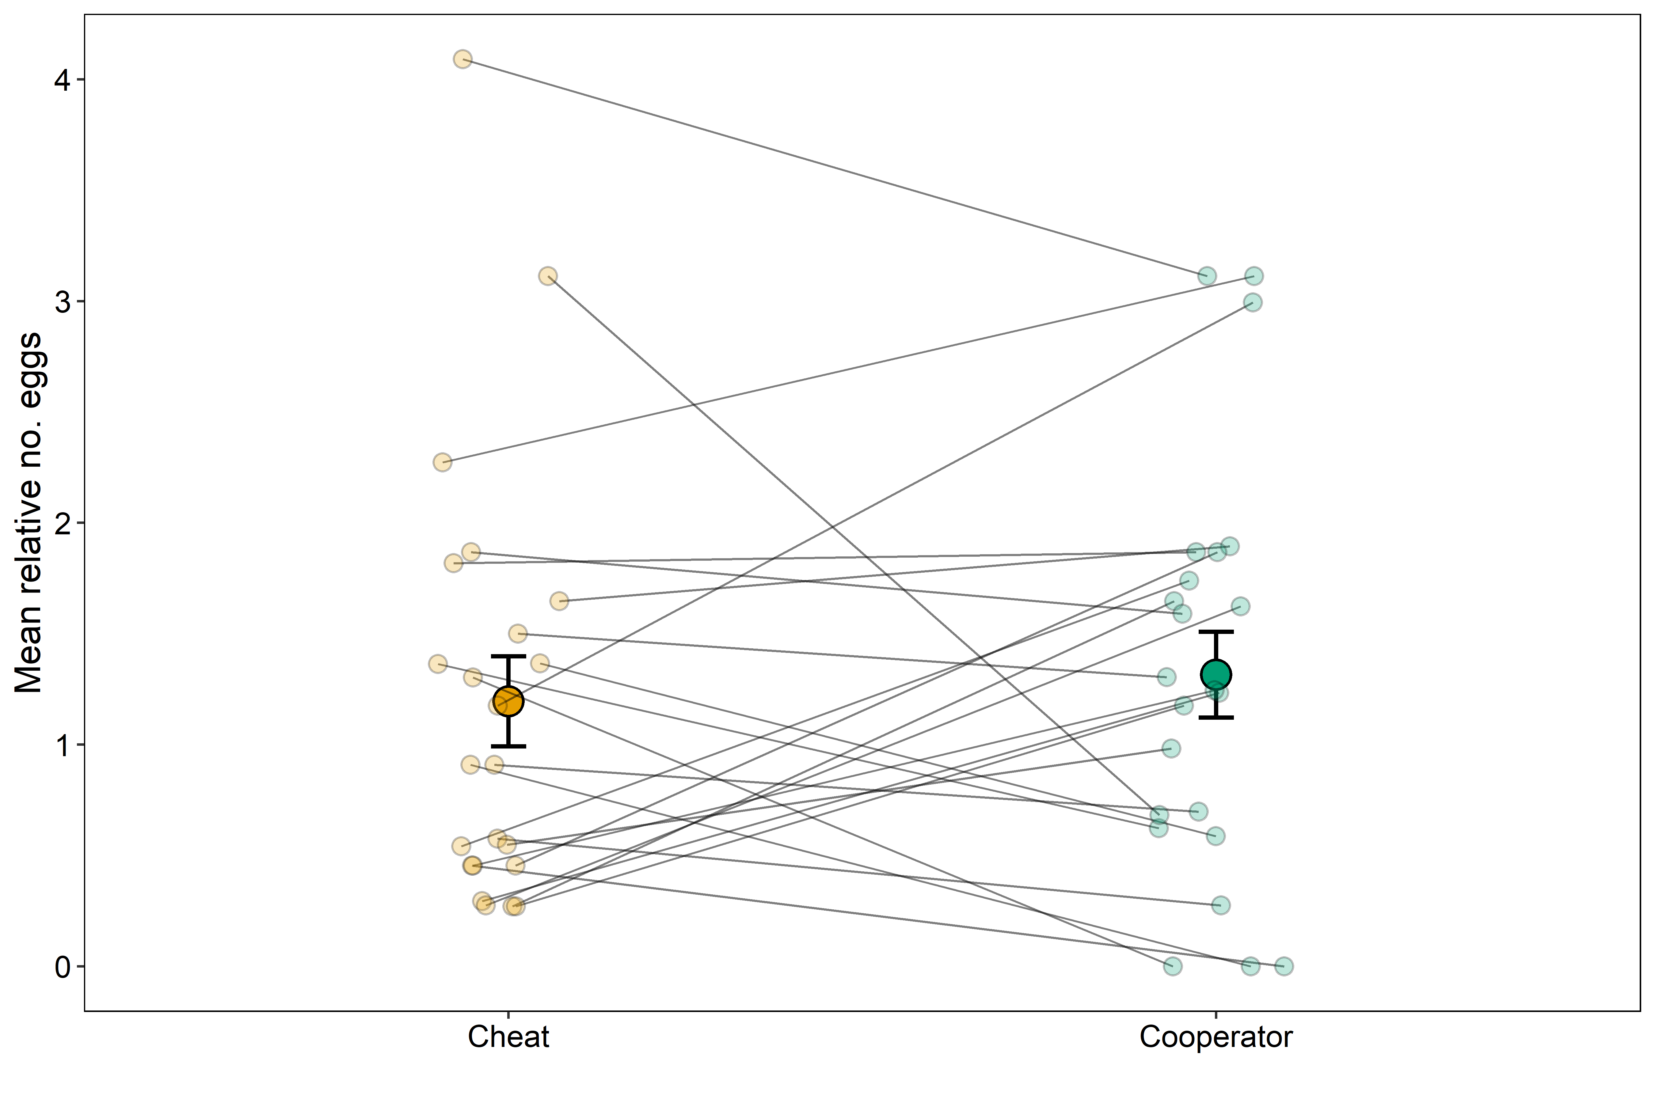
Extended Data Figure 1: The reproductive investment of individuals that cheated in some years and cooperated in others. Relative number of eggs females produced when they cheated (orange) and when they cooperated (green). Number of eggs is relative to mean number of eggs produced by females during the same year. Bigger points and error bars show means +/- one standard errors per breeding strategy. Smaller points show mean per individual and breeding strategy, and lines connect data belonging to the same individual. Sample size: n = 62 observations from 23 females.
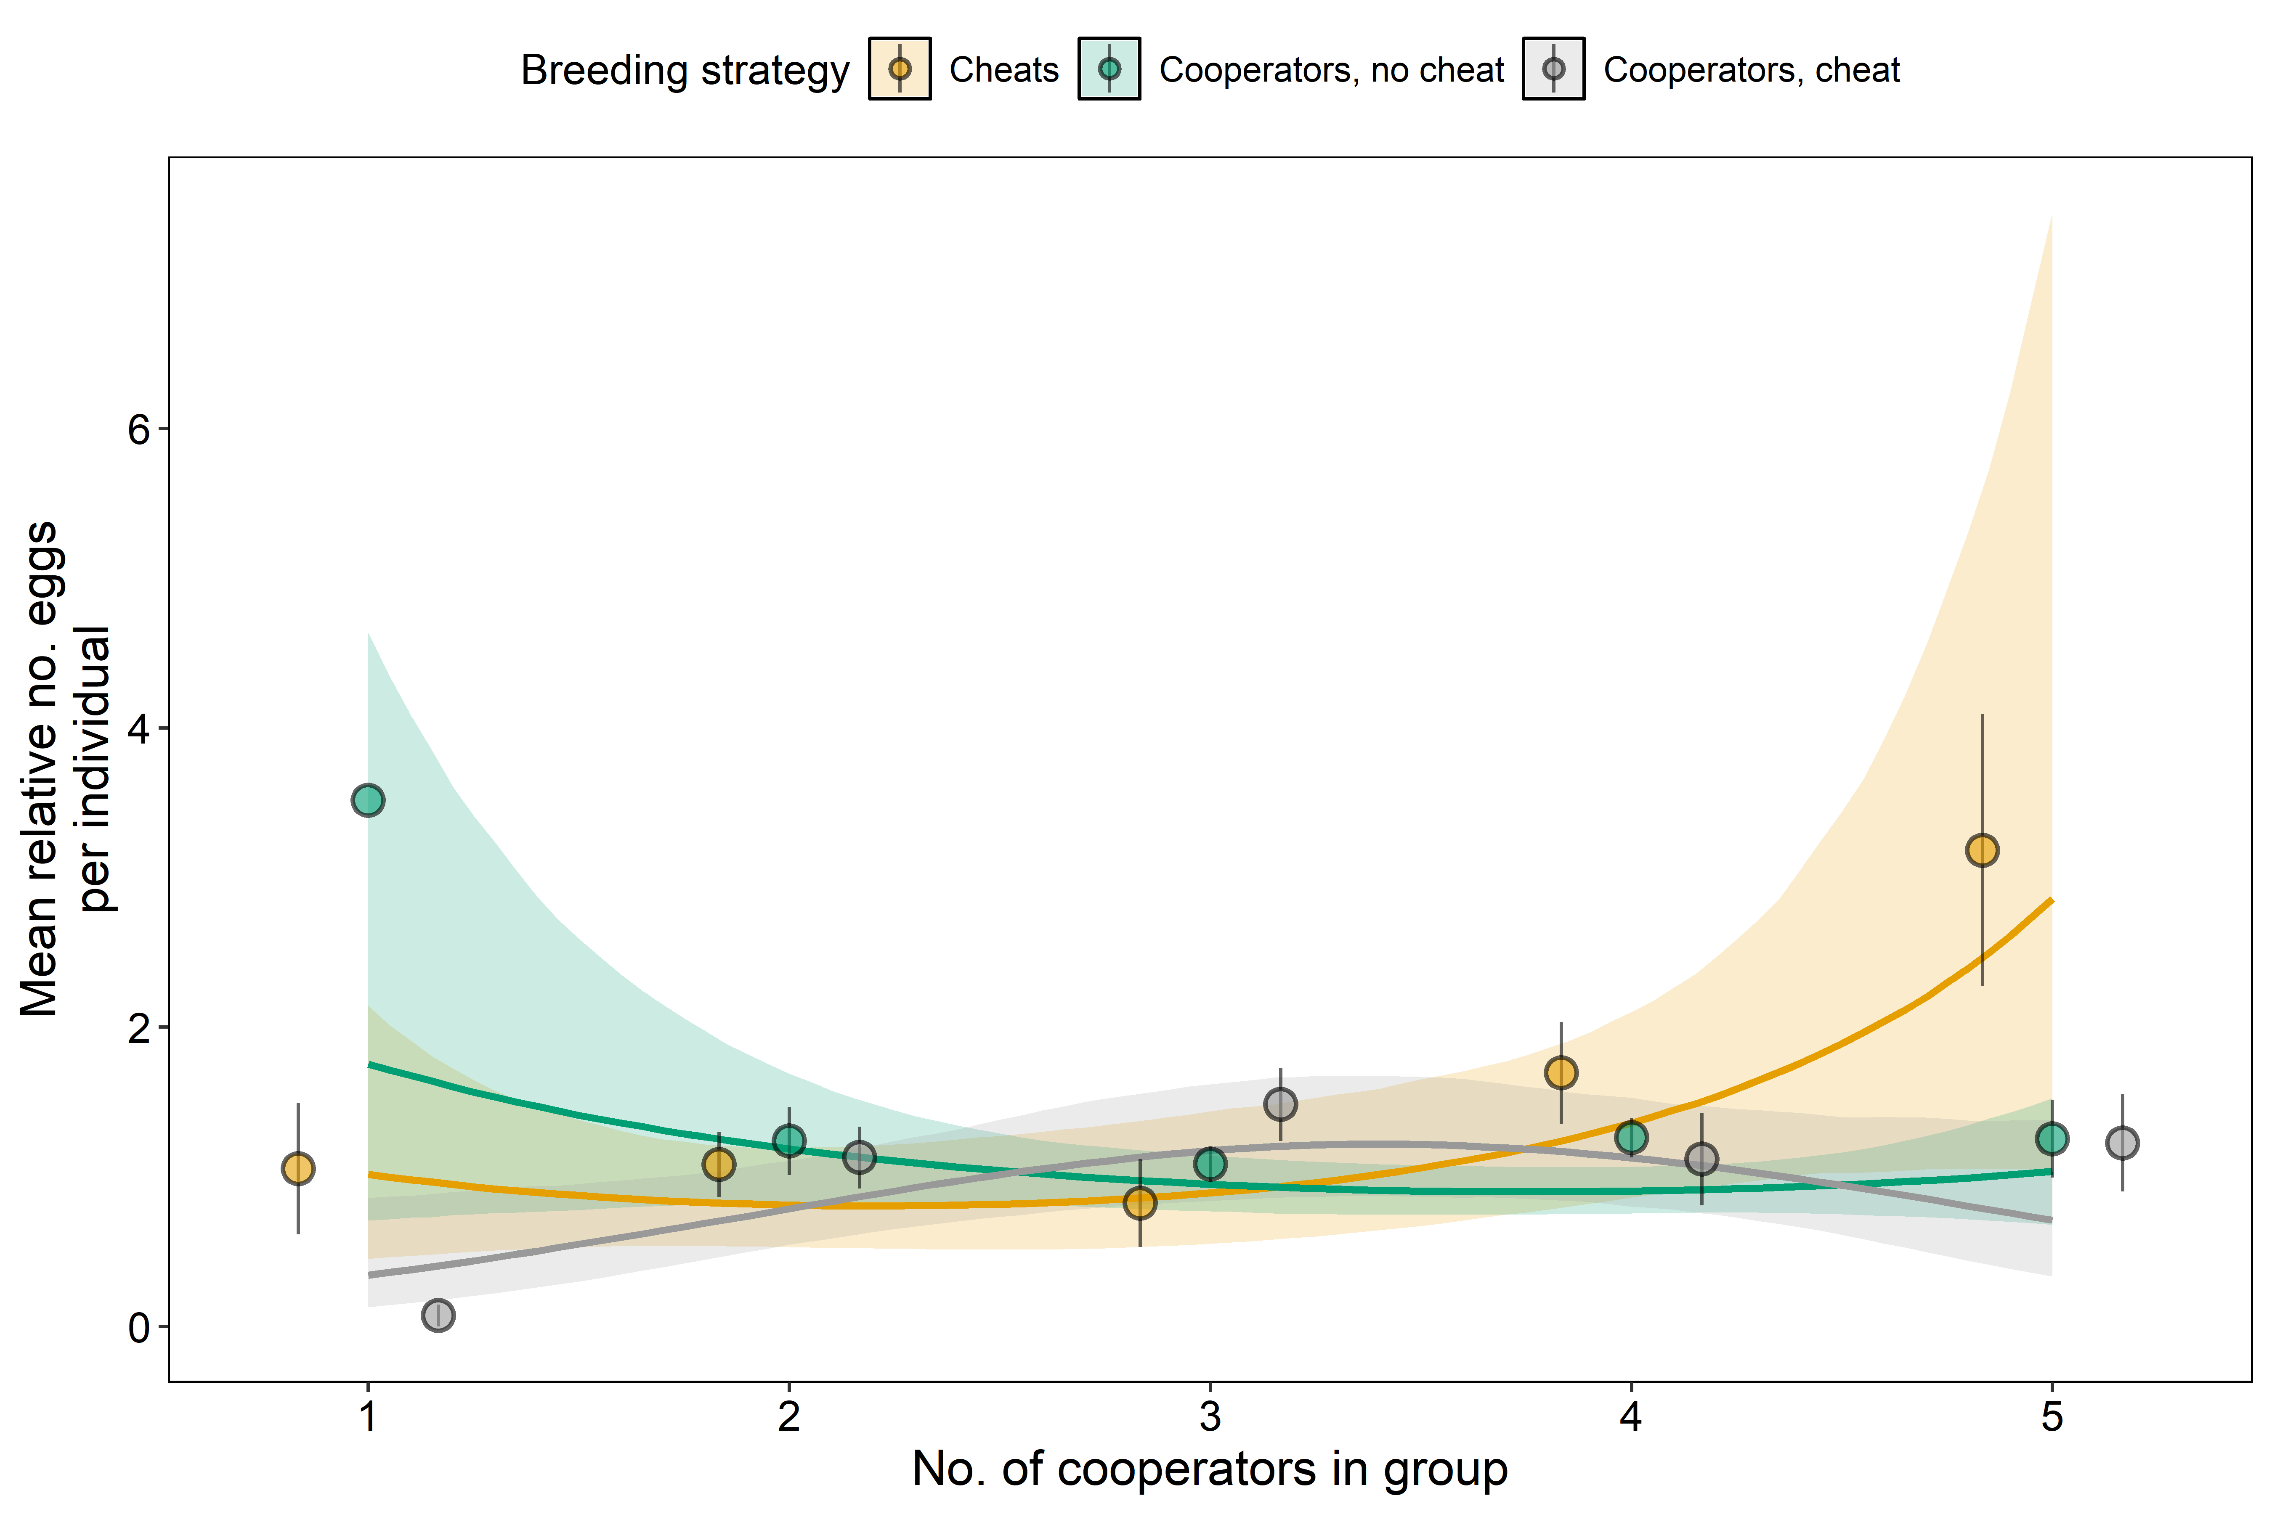
Extended Data Figure 2: The number of eggs laid by each breeding strategy in relation to the number of cooperators in the group. The number of eggs laid by cheats (orange), cooperators in groups without cheats (green) and cooperators in groups with cheats (grey). The number of eggs laid was modelled as a count with year as a random effect, and fitted values are shown relative to the annual mean so that they are comparable with the observed data, which are also expressed relative to the annual mean. Circles and error bars show the mean +/- one standard error, solid lines show fitted values from the Bayesian mixed model (Extended Data Table 5), and shaded ribbons show 95% credible intervals. The differences between these fitted curves are shown in Fig. 2A. Sample size: n = 267 observations from 138 females in 75 groups.
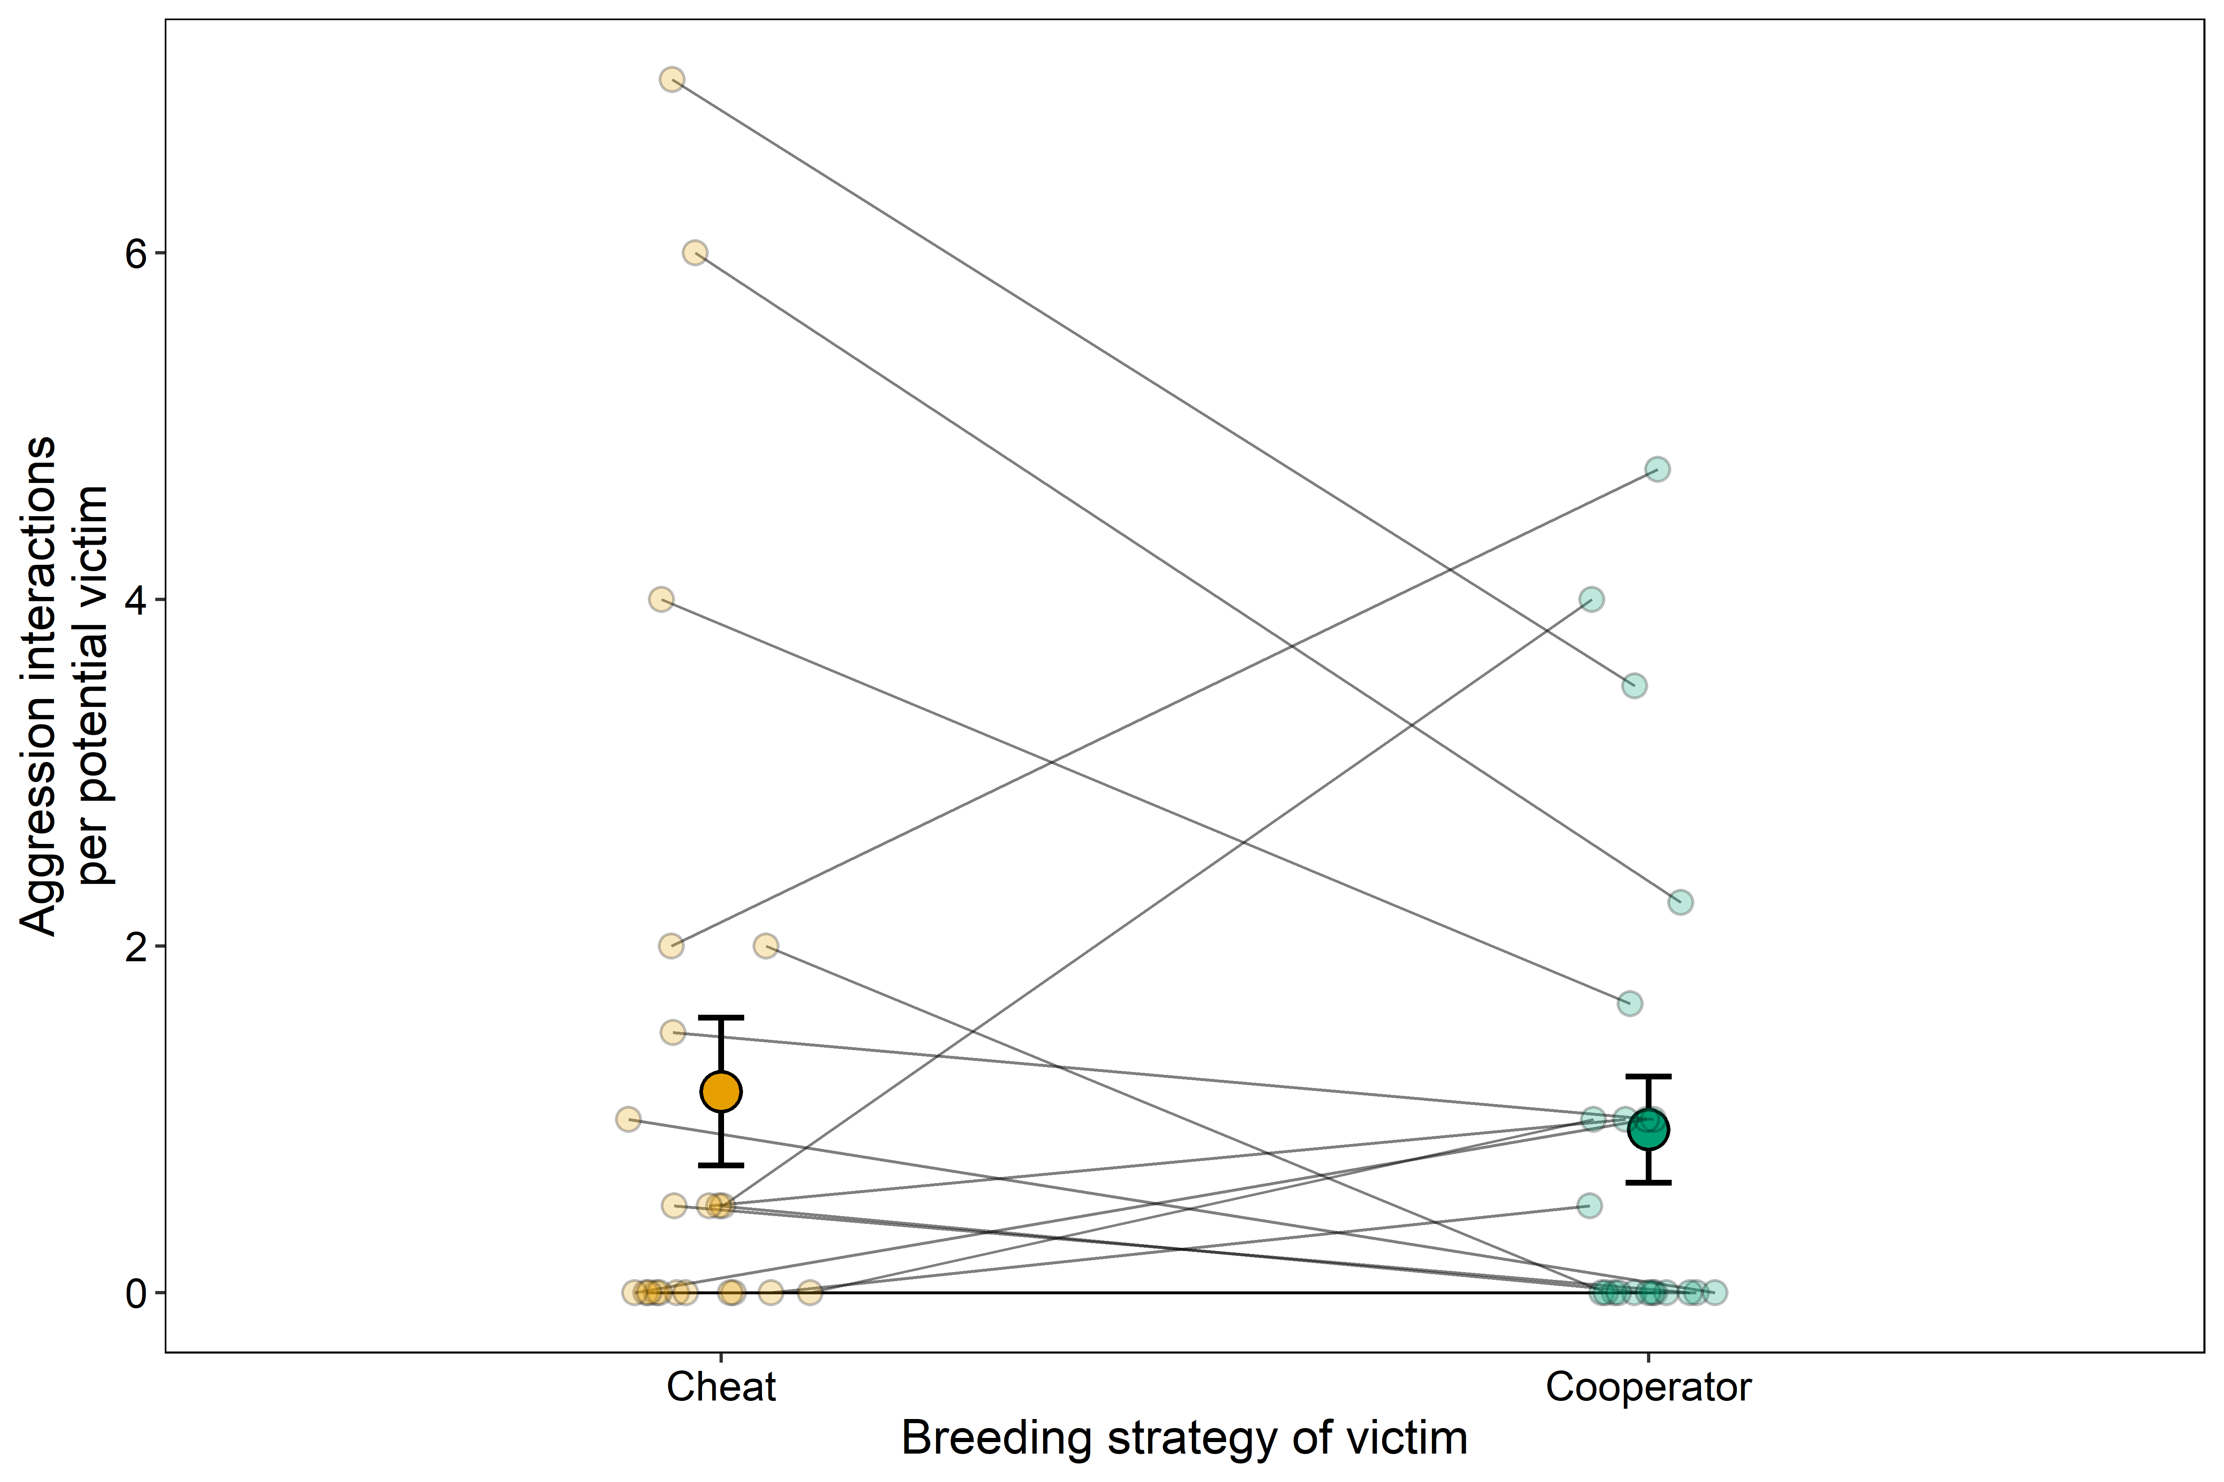
Extended Data Figure 3: Group-level cooperator aggression. Number of aggressive interactions where the aggressor was a cooperator, corrected by number of potential victims: the number of aggressive interactions in a group was divided by the number of cheats in the group when the victims were cheats, and by the number of cooperators minus one when the victims were other cooperators. Bigger points and error bars show mean +/- one standard error. Smaller points show raw data. Lines connect data points from the same breeding group. Sample size: n = 22 groups.

Extended Data Tables
Extended Data Table 1. Effect of group size on the number of cooperators and cheats per group, analysed using a Poisson generalized linear mixed-effects model. Group size includes all females, including non-breeders.
Fixed Effects | Posterior Mode (CI) | pMCMC
Cheats | -0.87 (-1.24, -0.51) | 0.001
Cooperators | 1.17 (1.01, 1.37) | < 0.001
ZNumber of nests | 0.09 (-0.03, 0.21) | 0.146
Cheats : ZNumber of females | 0.32 (0.02, 0.72) | 0.042
Cooperators : ZNumber of females | 0.27 (0.13, 0.39) | < 0.001
Fixed Effect Comparisons | Posterior Mode (CI) | pMCMC
Cheats : ZNumber of females vs Cooperators : ZNumber of females | 0.07 (-0.26, 0.46) | 0.601
Random Effects | Posterior Mode (CI) | I2 % (CI)
Year | 0.00 (0.00, 0.03) | 0.21 (0.05, 6.51)
Camp | 0.00 (0.00, 0.02) | 0.21 (0.04, 4.22)
Group | 0.00 (0.00, 0.02) | 0.22 (0.04, 3.67)
Residual | 0.00 (0.00, 0.02) | 0.30 (0.04, 4.28)

Extended Data Table 2. Effects of the numbers of cooperators and non-breeding females on the proportion of cheats among breeding females per group, analysed using a binomial mixed-effects model.
Fixed Effects | Posterior Mode (CI) | pMCMC
Intercept | -2.20 (-2.94, -1.67) | < 0.001
ZNumber of cooperators | -1.02 (-1.70, -0.64) | < 0.001
ZNumber of other | -0.03 (-0.55, 0.32) | 0.685
ZNumber of nests | 0.22 (-0.22, 0.63) | 0.394
Random Effects | Posterior Mode (CI) | I2 % (CI)
Year | 0.01 (0.00, 0.96) | 0.17 (0.00, 21.43)
Camp | 0.01 (0.00, 0.66) | 0.14 (0.01, 15.64)
Residual | 0.00 (0.00, 0.43) | 0.05 (0.00, 10.71)

Extended Data Table 3. Effects of the numbers of cooperators and non-breeding females, age, and initial body mass on a female’s annual probability of being a cheat, analysed using a Bernoulli mixed-effects model with a probit link. Counts exclude the focal female. Initial body mass (kg) was measured at the start of the breeding season.
Fixed Effects | Posterior Mode (CI) | pMCMC
Intercept | -1.61 (-2.54, -1.08) | < 0.001
ZNumber of cooperators | 0.12 (-0.22, 1.31) | 0.323
ZNumber of other | 0.12 (-0.21, 0.66) | 0.288
ZAge | -0.01 (-0.33, 0.32) | 0.921
ZInitial mass | -0.06 (-0.37, 0.21) | 0.634
Random Effects | Posterior Mode (CI) | I2 % (CI)
Year | 0.01 (0.00, 1.33) | 0.09 (0.01, 25.56)
Camp | 0.00 (0.00, 0.82) | 0.11 (0.01, 19.99)
Group | 0.01 (0.00, 2.77) | 0.28 (0.01, 51.81)
Individual | 0.01 (0.00, 1.15) | 0.12 (0.01, 31.15)
Residual | 1.00 (1.00, 1.00) | 29.81 (14.89, 47.21)

Extended Data Table 4. Effects of breeding strategy and group composition on female body mass at the end of incubation, analysed using a Gaussian mixed-effects model with body mass at the start of the breeding season as a covariate.
Fixed Effects | Posterior Mode (CI) | pMCMC
Cheats | 117.20 (111.14, 123.48) | < 0.001
Cooperators | 114.89 (109.65, 119.97) | < 0.001
Cheats : ZNumber of cooperators | -0.61 (-4.58, 4.51) | 0.958
Cooperators : ZNumber of cooperators | -0.16 (-1.86, 1.60) | 0.871
Cheats : ZNumber of other | 2.21 (-1.26, 6.87) | 0.168
Cooperators : ZNumber of other | 0.02 (-1.27, 1.86) | 0.731
Cheats : ZMass at start of season | 7.12 (2.51, 10.85) | 0.002
Cooperators : ZMass at start of season | 9.01 (7.72, 10.90) | < 0.001
Fixed Effect Comparisons | Posterior Mode (CI) | pMCMC
Cheats vs Cooperators | 2.19 (-1.67, 6.64) | 0.255
Random Effects | Posterior Mode (CI) | I2 % (CI)
Camp | 0.04 (0.00, 24.25) | 0.05 (0.00, 13.01)
Year | 34.35 (9.30, 183.80) | 30.33 (10.55, 62.57)
Group | 0.01 (0.00, 6.65) | 0.01 (0.00, 3.85)
Individual | 0.03 (0.00, 47.01) | 0.06 (0.00, 27.16)
Residual | 72.15 (58.49, 107.27) | 49.95 (23.33, 72.05)

Extended Data Table 5. Effect of group composition on reproductive investment, for all groups and excluding groups with a single female cooperator. The response variable is the number of eggs produced by every female during a given year, with year fitted as a random effect to account for year-to-year differences in the number of eggs laid. The right-hand columns repeat the analysis without groups containing one cooperator, to test whether those groups drive the effect. Fixed effect comparisons: fitted values give the differences between the fitted curves shown in Fig. 2A, evaluated at each number of cooperators with all other covariates held at their overall mean; each comparison is the first strategy named minus the second, so positive values indicate that the first laid more eggs. These are the three comparisons plotted in Fig. 2A. Only one female contributed to the fitted value for cooperators in groups without cheats when there was one cooperator in the group, so this comparison should be interpreted with caution.
 | All groups |  | Excluding groups with one cooperator
Fixed Effects | Posterior Mode (CI) | pMCMC | Posterior Mode (CI) | pMCMC
Cheats | 0.78 (0.25, 1.48) | 0.016 | 0.93 (0.26, 1.51) | 0.016
Cooperators in groups without cheats | 0.80 (0.23, 1.35) | 0.016 | 0.80 (0.24, 1.37) | 0.018
Cooperators in groups with cheats | 0.78 (0.07, 1.26) | 0.033 | 0.79 (0.19, 1.39) | 0.021
ZNumber of other | -0.07 (-0.18, 0.10) | 0.546 | -0.08 (-0.21, 0.07) | 0.386
Logit_Proportion of broken eggs | -0.09 (-0.21, 0.01) | 0.084 | -0.08 (-0.18, 0.04) | 0.175
Cheats : ZNumber of cooperators | 0.22 (-0.03, 0.56) | 0.083 | 0.32 (-0.05, 0.66) | 0.091
Cooperators in groups without cheats : ZNumber of cooperators | -0.06 (-0.26, 0.13) | 0.552 | 0.01 (-0.22, 0.19) | 0.802
Cooperators in groups with cheats : ZNumber of cooperators | 0.07 (-0.19, 0.32) | 0.487 | -0.05 (-0.34, 0.20) | 0.610
Cheats : Znumber of cooperators^2 | 0.16 (-0.10, 0.45) | 0.193 | 0.25 (-0.22, 0.66) | 0.333
Cooperators in groups without cheats : ZNumber of cooperators^2 | 0.11 (-0.08, 0.28) | 0.262 | 0.06 (-0.18, 0.26) | 0.805
Cooperators in groups with cheats : ZNumber of cooperators^2 | -0.20 (-0.49, 0.01) | 0.044 | -0.05 (-0.34, 0.25) | 0.751
Fixed Effect Comparisons | Posterior Mode (CI) | pMCMC | Posterior Mode (CI) | pMCMC
Cheats vs Cooperators in groups without cheats | 0.11 (-0.32, 0.39) | 0.746 | 0.03 (-0.29, 0.44) | 0.646
Cheats vs Cooperators in groups with cheats | 0.14 (-0.18, 0.55) | 0.354 | 0.10 (-0.27, 0.48) | 0.545
Cooperators in groups without cheats vs Cooperators in groups with cheats | 0.09 (-0.18, 0.40) | 0.428 | 0.00 (-0.24, 0.34) | 0.836
Cheats : ZNumber of cooperators vs Cooperators in groups without cheats : ZNumber of cooperators | 0.34 (-0.02, 0.67) | 0.068 | 0.34 (-0.08, 0.71) | 0.108
Cheats : ZNumber of cooperators vs Cooperators in groups with cheats : ZNumber of cooperators | 0.17 (-0.19, 0.49) | 0.306 | 0.39 (0.00, 0.74) | 0.052
Cooperators in groups without cheats : ZNumber of cooperators vs Cooperators in groups with cheats : ZNumber of cooperators | -0.13 (-0.44, 0.16) | 0.315 | 0.06 (-0.26, 0.36) | 0.789
Cheats : Znumber of cooperators^2 vs Cooperators in groups without cheats : ZNumber of cooperators^2 | 0.10 (-0.23, 0.41) | 0.617 | 0.13 (-0.30, 0.68) | 0.447
Cheats : Znumber of cooperators^2 vs Cooperators in groups with cheats : ZNumber of cooperators^2 | 0.54 (0.08, 0.75) | 0.009 | 0.29 (-0.19, 0.77) | 0.277
Cooperators in groups without cheats : ZNumber of cooperators^2 vs Cooperators in groups with cheats : ZNumber of cooperators^2 | 0.36 (0.06, 0.67) | 0.020 | 0.11 (-0.31, 0.44) | 0.704
Fixed Effect Comparisons: fitted values | Posterior Mode (CI) | pMCMC
Cooperators in groups without cheats vs Cooperators in groups with cheats : 1 cooperators in group | 1.02 (0.13, 3.95) | 0.014
Cooperators in groups without cheats vs Cooperators in groups with cheats : 2 cooperators in group | 0.34 (-0.04, 1.01) | 0.083
Cooperators in groups without cheats vs Cooperators in groups with cheats : 3 cooperators in group | -0.21 (-0.64, 0.25) | 0.378
Cooperators in groups without cheats vs Cooperators in groups with cheats : 4 cooperators in group | -0.14 (-0.64, 0.23) | 0.365
Cooperators in groups without cheats vs Cooperators in groups with cheats : 5 cooperators in group | 0.40 (-0.34, 1.04) | 0.312
Cheats vs Cooperators in groups with cheats : 1 cooperators in group | 0.56 (-0.05, 1.62) | 0.051
Cheats vs Cooperators in groups with cheats : 2 cooperators in group | -0.01 (-0.37, 0.41) | 0.917
Cheats vs Cooperators in groups with cheats : 3 cooperators in group | -0.31 (-0.77, 0.37) | 0.330
Cheats vs Cooperators in groups with cheats : 4 cooperators in group | 0.19 (-0.44, 0.92) | 0.500
Cheats vs Cooperators in groups with cheats : 5 cooperators in group | 1.55 (0.11, 5.48) | 0.006
Cheats vs Cooperators in groups without cheats : 1 cooperators in group | -0.76 (-3.16, 0.95) | 0.318
Cheats vs Cooperators in groups without cheats : 2 cooperators in group | -0.32 (-0.93, 0.16) | 0.121
Cheats vs Cooperators in groups without cheats : 3 cooperators in group | -0.14 (-0.52, 0.42) | 0.731
Cheats vs Cooperators in groups without cheats : 4 cooperators in group | 0.29 (-0.15, 1.18) | 0.161
Cheats vs Cooperators in groups without cheats : 5 cooperators in group | 1.33 (-0.50, 5.22) | 0.071
Random Effects | Posterior Mode (CI) | I2 % (CI) | Posterior Mode (CI) | I2 % (CI)
Camp | 0.00 (0.00, 0.04) | 0.09 (0.01, 4.14) | 0.00 (0.00, 0.05) | 0.10 (0.01, 5.07)
Year | 0.25 (0.05, 1.52) | 42.56 (14.86, 76.04) | 0.25 (0.05, 1.35) | 25.68 (10.74, 70.85)
Group | 0.00 (0.00, 0.17) | 0.23 (0.01, 16.59) | 0.00 (0.00, 0.16) | 0.16 (0.02, 15.06)
Individual | 0.00 (0.00, 0.20) | 0.22 (0.01, 18.73) | 0.00 (0.00, 0.20) | 0.21 (0.02, 19.16)
Residual | 0.29 (0.09, 0.50) | 28.36 (6.44, 49.70) | 0.32 (0.09, 0.50) | 31.31 (7.91, 50.55)
Extended Data Table 6. Effects of breeding strategy, group size, and age on the estimated number of eggs produced per female per year, analysed using a Poisson mixed-effects model. Only females that cheated in some years and cooperated in others were included. Year was fitted as a random effect to account for annual variation in egg production.
Fixed Effects | Posterior Mode (CI) | pMCMC
Cheats | 0.67 (-0.31, 1.45) | 0.142
Cooperates | 1.01 (0.01, 1.81) | 0.064
ZNumber of females | 0.00 (-0.30, 0.43) | 0.727
ZAge | 0.05 (-0.28, 0.36) | 0.718
Fixed Effect Comparisons | Posterior Mode (CI) | pMCMC
Cheats vs Cooperates | -0.15 (-0.70, 0.29) | 0.389
Random Effects | Posterior Mode (CI) | I2 % (CI)
Camp | 0.00 (0.00, 0.11) | 0.12 (0.00, 10.28)
Year | 0.02 (0.00, 3.48) | 0.57 (0.04, 90.85)
Group | 0.00 (0.00, 0.32) | 0.25 (0.01, 31.57)
Individual | 0.00 (0.00, 0.28) | 0.12 (0.01, 27.10)
Residual | 0.01 (0.00, 0.72) | 0.45 (0.01, 83.63)

Extended Data Table 7. Effects of cheating, group composition, and time on the cumulative proportion of eggs laid per nest, analysed using a binomial mixed-effects model with a logit link. Interactions between cheat presence and linear and quadratic time terms (days) tested differences in laying patterns. The analysis included the first 32 days from the start of the incubation period.
Fixed Effects | Posterior Mode (CI) | pMCMC
Cheats in camp - No | -1.61 (-2.01, -1.31) | < 0.001
Cheats in camp - Yes | -1.86 (-2.23, -1.45) | < 0.001
ZNumber of cooperators | 0.20 (0.01, 0.35) | 0.038
ZNumber of other | -0.02 (-0.18, 0.13) | 0.861
ZDays | 0.75 (0.69, 0.83) | < 0.001
Cheats in camp - Yes : ZDays | -0.02 (-0.15, 0.13) | 0.798
ZnoCoops : ZDays | -0.03 (-0.11, 0.04) | 0.349
Cheats in camp - No : ZDays^2 | 0.02 (-0.09, 0.10) | 0.846
Cheats in camp - Yes : ZDays^2 | 0.20 (0.13, 0.34) | < 0.001
ZnoCoops : ZDays^2 | -0.10 (-0.18, -0.03) | 0.005
Fixed Effect Comparisons | Posterior Mode (CI) | pMCMC
Cheats in camp - No vs Cheats in camp - Yes | 0.20 (-0.17, 0.50) | 0.261
Cheats in camp - No : ZDays^2 vs Cheats in camp - Yes : ZDays^2 | -0.21 (-0.37, -0.08) | 0.004
Random Effects | Posterior Mode (CI) | I2 % (CI)
Year | 0.05 (0.00, 0.43) | 1.39 (0.01, 10.53)
Camp | 0.00 (0.00, 0.08) | 0.04 (0.00, 2.12)
Group | 0.31 (0.18, 0.48) | 8.45 (4.97, 12.31)
Residual | 0.00 (0.00, 0.04) | 0.05 (0.01, 0.92)

Extended Data Table 8. Effects of breeding strategy, group size, and time on the probability of a female laying an egg within a two-day window, analysed using a binomial mixed-effects model. ZWindow denotes window position within the laying period. Interactions between breeding strategy and its linear and quadratic terms tested differences in laying patterns between cheats and cooperators.
Fixed Effects | Posterior Mode (CI) | pMCMC
Cheats | -3.00 (-3.68, -2.51) | < 0.001
Cooperators | -3.03 (-3.46, -2.51) | < 0.001
ZNumber of females | -0.09 (-0.30, 0.09) | 0.338
Cheats : ZWindow | -0.55 (-0.77, -0.24) | < 0.001
Cooperators : ZWindow | -0.82 (-0.92, -0.72) | < 0.001
Cheats : ZWindow^2 | -0.56 (-0.91, -0.21) | < 0.001
Cooperators : ZWindow^2 | -2.16 (-2.38, -1.86) | < 0.001
Fixed Effect Comparisons | Posterior Mode (CI) | pMCMC
Cheats vs Cooperators | -0.01 (-0.45, 0.25) | 0.638
Cheats : ZWindow vs Cooperators : ZWindow | 0.39 (0.03, 0.59) | 0.042
Cheats : ZWindow^2 vs Cooperators : ZWindow^2 | 1.56 (1.12, 1.99) | < 0.001
Random Effects | Posterior Mode (CI) | I2 % (CI)
Year | 0.18 (0.02, 1.55) | 3.79 (0.07, 22.78)
Camp | 0.00 (0.00, 0.08) | 0.02 (0.00, 1.40)
Group | 0.31 (0.13, 0.56) | 4.54 (2.47, 9.78)
Individual | 0.43 (0.24, 0.78) | 8.16 (4.49, 13.49)
Residual | 1.00 (1.00, 1.00) | 18.42 (14.83, 20.13)

Extended Data Table 9. Effects of victim breeding strategy and group size on the number of aggressive interactions initiated by cooperators towards cheats or other cooperators, analysed at group level using a Poisson mixed-effects model accounting for observation time and the number of potential victims. Groups with only one cooperator were excluded.
Fixed Effects | Posterior Mode (CI) | pMCMC
Aggression towards cheats | -0.43 (-2.41, 0.55) | 0.260
Aggression towards cooperators | -0.77 (-2.30, 0.62) | 0.248
ZObservation time | 0.02 (-1.21, 1.17) | 0.813
ZNumber of potential victims | 0.25 (-0.16, 0.77) | 0.171
ZNumber of females | 0.92 (-0.39, 2.24) | 0.127
Aggression towards cooperators : ZNumber of females | 0.02 (-1.51, 0.91) | 0.786
Fixed Effect Comparisons | Posterior Mode (CI) | pMCMC
Aggression towards cheats vs Aggression towards cooperators | -0.15 (-1.00, 1.01) | 0.932
Random Effects | Posterior Mode (CI) | I2 % (CI)
Year | 0.40 (0.00, 6.54) | 0.40 (0.01, 78.88)
Camp | 0.02 (0.00, 3.47) | 0.29 (0.00, 73.37)
Group | 0.02 (0.00, 4.94) | 0.34 (0.00, 92.79)
Residual | 0.01 (0.00, 2.50) | 0.24 (0.00, 64.38)

Extended Data Table 10. Effects of cheating and group composition on the proportion of time nests were incubated, analysed using a binomial mixed-effects model with a logit link. Interactions tested whether the effects of the number of cooperators and the number of non-breeding females on incubation effort differed between groups with and without cheats.
Fixed Effects | Posterior Mode (CI) | pMCMC
Cheat in camp - No | -0.75 (-1.18, -0.32) | 0.006
Cheat in camp - Yes | -1.45 (-2.07, -0.98) | < 0.001
Cheat in camp - No : ZNumber of cooperators | 0.57 (0.12, 0.86) | 0.008
Cheat in camp - Yes : ZNumber of cooperators | 0.54 (0.11, 0.95) | 0.012
Cheat in camp - No : ZNumber of other | -0.42 (-0.72, -0.09) | 0.012
Cheat in camp - Yes : ZNumber of other | -0.37 (-0.81, 0.19) | 0.169
Fixed Effect Comparisons | Posterior Mode (CI) | pMCMC
Cheat in camp - No vs Cheat in camp - Yes | 0.76 (0.12, 1.36) | 0.014
Cheat in camp - No : ZNumber of cooperators vs Cheat in camp - Yes : ZNumber of cooperators | 0.00 (-0.55, 0.53) | 0.940
Cheat in camp - No : ZNumber of other vs Cheat in camp - Yes : ZNumber of other | 0.04 (-0.62, 0.51) | 0.847
Random Effects | Posterior Mode (CI) | I2 % (CI)
Year | 0.00 (0.00, 0.44) | 0.08 (0.00, 8.87)
Camp | 0.00 (0.00, 0.20) | 0.06 (0.00, 4.17)
Residual | 1.06 (0.76, 1.59) | 23.96 (17.79, 32.43)

Extended Data Table 11. Effects of cheat presence, group composition, and time (days) on the daily proportion of time groups spent incubating, analysed using a binomial mixed-effects model with a logit link. Interactions between cheat presence and linear and quadratic time terms tested whether incubation patterns differed between groups with and without cheats. The analysis included the first 32 days from the onset of incubation.
Fixed Effects | Posterior Mode (CI) | pMCMC
Cheats in camp - No | -0.10 (-1.17, 1.35) | 0.862
Cheats in camp - Yes | -2.00 (-3.75, -0.40) | 0.024
ZNumber of cooperators | 1.98 (1.00, 2.75) | < 0.001
ZNumber of other | -0.56 (-1.47, 0.25) | 0.182
ZDays | 3.04 (2.77, 3.32) | < 0.001
Cheats in camp - Yes : ZDays | -0.41 (-0.91, 0.23) | 0.227
ZnoCoops : ZDays | 0.27 (0.01, 0.54) | 0.034
Cheats in camp - No : ZDays^2 | -1.19 (-1.53, -0.88) | < 0.001
Cheats in camp - Yes : ZDays^2 | -1.01 (-1.55, -0.64) | < 0.001
ZnoCoops : ZDays^2 | -0.08 (-0.36, 0.19) | 0.557
Fixed Effect Comparisons | Posterior Mode (CI) | pMCMC
Cheats in camp - No vs Cheats in camp - Yes | 2.16 (0.31, 3.97) | 0.025
Cheats in camp - No : ZDays^2 vs Cheats in camp - Yes : ZDays^2 | -0.12 (-0.65, 0.48) | 0.729
Random Effects | Posterior Mode (CI) | I2 % (CI)
Year | 0.06 (0.00, 5.54) | 0.08 (0.00, 16.56)
Camp | 0.01 (0.00, 1.34) | 0.02 (0.00, 4.39)
Group | 10.54 (6.72, 15.05) | 34.43 (24.06, 44.96)
Residual | 15.26 (13.34, 17.08) | 50.92 (41.13, 58.43)

Extended Data Table 12. Effects of cheating, group composition, and relative reproductive investment on the proportion of time individual females spent incubating, analysed using a binomial mixed-effects model with a logit link. Relative reproductive investment was the annual number of eggs produced per female, corrected for the annual mean. Interactions tested whether the effects of reproductive investment, the number of cooperators, and the number of non-breeding females on incubation effort differed between groups with and without cheats. A three-way interaction further tested whether the effect of reproductive investment differed between groups with and without cheats depending on the number of cooperators.
Fixed Effects | Posterior Mode (CI) | pMCMC
Cheat in camp - No | -2.56 (-3.02, -2.12) | < 0.001
Cheat in camp - Yes | -2.74 (-3.32, -2.29) | < 0.001
Cheat in camp - No : sqrt(Relative RS) | 0.51 (0.21, 0.90) | 0.004
Cheat in camp - Yes : sqrt(Relative RS) | 0.76 (0.24, 1.20) | 0.003
Cheat in camp - No : ZNumber of cooperators | -0.08 (-0.38, 0.15) | 0.407
Cheat in camp - Yes : ZNumber of cooperators | -0.14 (-0.45, 0.17) | 0.351
Cheat in camp - No : ZNumber of other | -0.32 (-0.55, -0.08) | 0.010
Cheat in camp - Yes : ZNumber of other | -0.24 (-0.69, 0.11) | 0.233
Cheat in camp - No : sqrt(Relative RS) : ZNumber of cooperators | 0.39 (-0.01, 0.70) | 0.061
Cheat in camp - Yes : sqrt(Relative RS) : ZNumber of cooperators | -0.13 (-0.59, 0.23) | 0.402
Fixed Effect Comparisons | Posterior Mode (CI) | pMCMC
Cheat in camp - No vs Cheat in camp - Yes | 0.29 (-0.17, 0.69) | 0.317
Cheat in camp - No : sqrt(Relative RS) vs Cheat in camp - Yes : sqrt(Relative RS) | -0.16 (-0.75, 0.42) | 0.554
Cheat in camp - No : ZNumber of cooperators vs Cheat in camp - Yes : ZNumber of cooperators | 0.08 (-0.36, 0.43) | 0.852
Cheat in camp - No : ZNumber of other vs Cheat in camp - Yes : ZNumber of other | -0.05 (-0.51, 0.38) | 0.785
Cheat in camp - No : sqrt(Relative RS) : ZNumber of cooperators vs Cheat in camp - Yes : sqrt(Relative RS) : ZNumber of cooperators | 0.42 (0.02, 1.08) | 0.053
Random Effects | Posterior Mode (CI) | I2 % (CI)
Year | 0.00 (0.00, 0.26) | 0.08 (0.00, 4.49)
Camp | 0.00 (0.00, 0.16) | 0.04 (0.01, 2.96)
Group | 0.00 (0.00, 0.21) | 0.04 (0.00, 3.87)
Individual | 0.79 (0.35, 1.25) | 14.28 (7.08, 22.07)
Residual | 1.17 (0.84, 1.58) | 21.31 (15.45, 28.29)

Extended Data Table 13. Effects of cheating and group composition on hatching success, analysed using two binomial mixed-effects models with logit links: (1) the probability of complete nest failure (no eggs hatched) and (2) the proportion of eggs that hatched among nests where at least one egg hatched. Interactions tested whether the effect of the number of cooperators differed between groups with and without cheats.
 | Probability of nest failure |  | Hatching success of nests that hatched
Fixed Effects | Posterior Mode (CI) | pMCMC | Posterior Mode (CI) | pMCMC
Cheat in camp - No | -1.08 (-3.53, 0.26) | 0.061 | -1.78 (-2.26, -1.36) | < 0.001
Cheat in camp - Yes | -1.56 (-3.97, 0.18) | 0.055 | -1.50 (-2.16, -1.06) | < 0.001
ZNumber of other | 0.30 (-0.59, 1.18) | 0.517 | -0.16 (-0.52, 0.09) | 0.166
Cheat in camp - No : ZNumber of cooperators | -0.27 (-1.23, 0.66) | 0.597 | -0.05 (-0.50, 0.34) | 0.751
Cheat in camp - Yes : ZNumber of cooperators | -3.34 (-6.32, -1.13) | 0.001 | -0.15 (-0.67, 0.36) | 0.484
Fixed Effect Comparisons | Posterior Mode (CI) | pMCMC | Posterior Mode (CI) | pMCMC
Cheat in camp - No vs Cheat in camp - Yes | 0.20 (-1.10, 1.73) | 0.658 | -0.23 (-0.82, 0.41) | 0.489
Cheat in camp - No : ZNumber of cooperators vs Cheat in camp - Yes : ZNumber of cooperators | 2.88 (0.64, 6.29) | 0.009 | 0.14 (-0.54, 0.75) | 0.747
Random Effects | Posterior Mode (CI) | I2 % (CI) | Posterior Mode (CI) | I2 % (CI)
Year | -0.03 (0.00, 5.92) | 0.11 (0.00, 56.78) | 0.00 (0.00, 0.46) | 0.07 (0.01, 10.04)
Camp | 0.01 (0.00, 0.73) | 0.11 (0.00, 12.76) | 0.00 (0.00, 0.27) | 0.07 (0.00, 6.27)
Residual | 1.00 (1.00, 1.00) | 23.21 (9.59, 23.30) | 0.61 (0.29, 1.28) | 16.23 (8.31, 28.00)
The negative posterior mode for the year variance (−0.03) in the nest-failure model is a boundary artifact of kernel density estimation and does not represent a negative model variance.

Extended Data Table 14. Changes in activity allocation between egg-laying and incubation over time, analysed using segmented linear mixed-effects models fitted separately for groups with and without cheats. The response variable was a logit-transformed activity allocation index, ranging from 0 (entirely egg-laying) to 1 (entirely incubation) before transformation.
Row | No-cheat: Estimate (SE) | No-cheat: 95% CI | No-cheat: df | No-cheat: t | No-cheat: p | Yes-cheat: Estimate (SE) | Yes-cheat: 95% CI | Yes-cheat: df | Yes-cheat: t | Yes-cheat: p
Fixed effects
(Intercept) | 2.89 (0.29) | 2.33, 3.46 | 683 | 10.03 | < 0.001 | 1.03 (0.42) | 0.21, 1.86 | 304 | 2.46 | 0.015
ZDay | 3.41 (0.23) | 2.96, 3.86 | 683 | 14.87 | < 0.001 | 2.26 (0.23) | 1.80, 2.72 | 304 | 9.63 | < 0.001
ZnoCoops | 0.56 (0.22) | 0.12, 1.00 | 50 | 2.50 | 0.016 | 0.26 (0.40) | -0.52, 1.04 | 22 | 0.65 | 0.523
ZnoOther | -0.08 (0.21) | -0.50, 0.34 | 50 | -0.38 | 0.705 | -0.69 (0.42) | -1.51, 0.14 | 22 | -1.64 | 0.116
U | -2.59 (0.32) | -3.21, -1.97 | – | – | – | -4.92 (1.20) | -7.28, -2.57 | – | – | –
G0 | -0.09 (0.12) | -0.32, 0.13 | – | – | – | 1.20 (0.13) | 0.95, 1.46 | – | – | –
Timing of transition (days)*
Breakpoint (days since incubation onset) | 13.95 | 11.99, 15.91 | – | – | – | 25.12 | 22.95, 27.29 | – | – | –
Random effects
Group – (Intercept) | Var = 2.04, SD = 1.43 | – | – | – | – | Var = 2.86, SD = 1.69 | – | – | – | –
Residual – Residual | Var = 4.76, SD = 2.18 | – | – | – | – | Var = 7.67, SD = 2.77 | – | – | – | –
*ZDay = (day − day_mean) / day_sd, where day_mean = 14.76 and day_sd = 8.60 days. The breakpoint back-transforms the G0 estimate and 95% CI to days since incubation onset using this relationship. df denotes denominator degrees of freedom for the coefficient t tests. Test statistics, degrees of freedom and P values are omitted for U and G0.

