Computation Physics
Phys 6312

Example 1,2,3,4
Using Fortran

Done By:
Mohammed K. El-habbash
120080242

Supervisor:
Dr. Maher O. El-Ghossain
Associate Professor

Example (1):

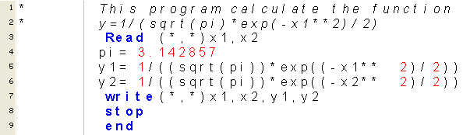

Result:
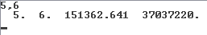

+++++++++++++++++++++++++++++++++++++++++++++++++++++++++++

Example (2):

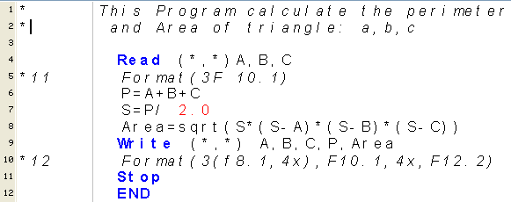

Result:
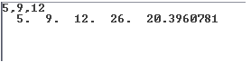

Example (3):

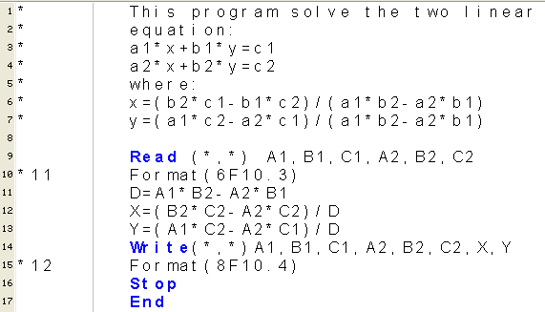

Result:

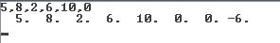

+++++++++++++++++++++++++++++++++++++++++++++++++++++++++++++
Example (4):

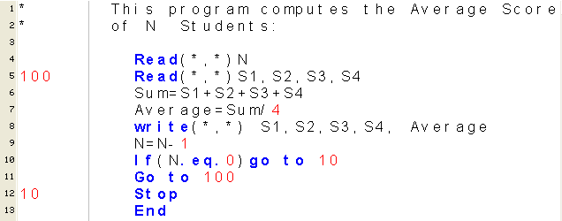

Result:
